## ASSIGNMENT – 2

## Akshat Sharma(20BCE2496) VIT VELLORE

## SMARTBRIDGE EXTERNSHIP Modern Application Development (Java Spring Boot)

Q2) Create table, update, delete, commands, perform joins in mysql.  
Create update delete commands in mongo

SOLUTION:

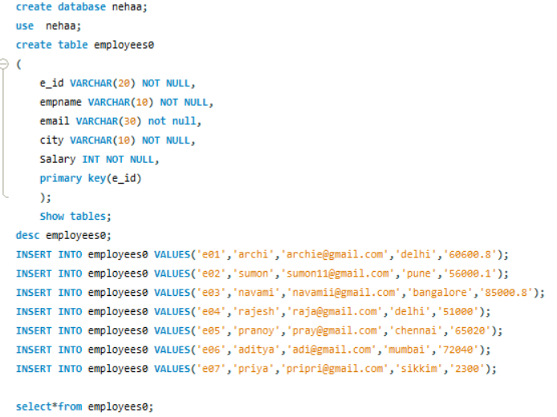

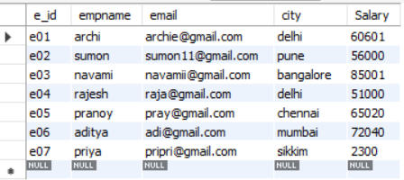

**DELETE:**

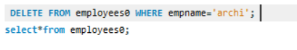

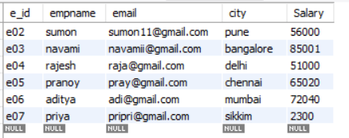

**UPDATE:**

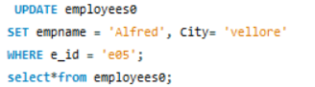

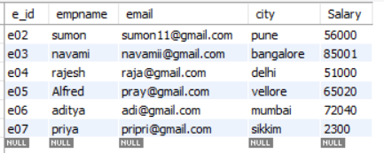

**MONGO DB:**  
  
