**Amazon Kindle Store Reviews Analysis Using IBM Watson Services**

June 29, 2023

VIT-AP

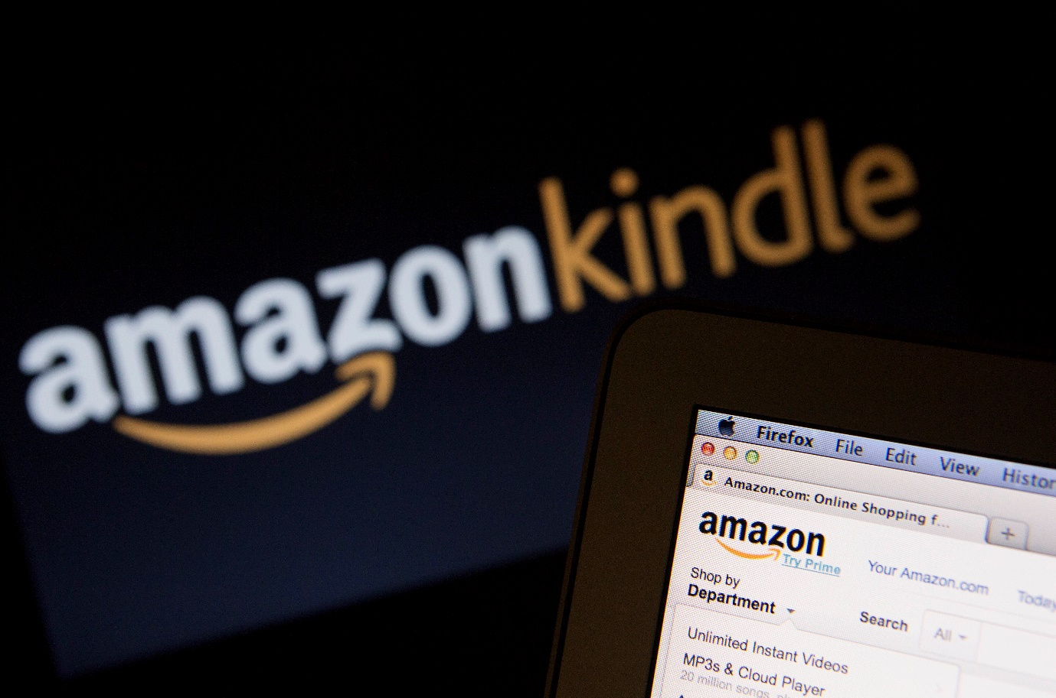

**Certification:** Smart Bridge Externship program in Artificial Intelligence

**Submitted by:**

K P Sathya Krishna(20BCI7063)

N Pavan Kumar (20BCI7063)

Chirag S(20BCI7168)

Edrick K Babu(20BCI7093)

**1. INTRODUCTION**

**1.1 Overview**

The Amazon Kindle Store Reviews Analysis project aims to address the challenge of analysing customer reviews in the Amazon Kindle Store. As an e-commerce platform for e-books, the Kindle Store relies on customer feedback to improve its products and provide a better user experience. However, there is often a disconnect between the content of customer reviews and the assigned ratings. Many customers either forget to rate the product or do not engage with the rating system. This inconsistency makes it difficult to accurately determine the sentiment expressed in the reviews solely based on the assigned ratings.

The project suggests using natural language processing methods to conduct sentiment analysis on customer reviews in order to get around this problem. The practise of identifying the sentiment or attitude indicated in a document is known as sentiment analysis, commonly referred to as opinion mining. Businesses can learn a lot about the advantages and disadvantages of their goods, spot opportunities for improvement, and base decisions on client feedback by analysing user opinions.

The Amazon Kindle Store Reviews Analysis project specifically focuses on developing a sentiment analysis system using LSTM (Long Short-Term Memory) models. LSTM models are a type of recurrent neural network (RNN) that excel at analysing sequential data, such as text. These models have been widely used in natural language processing tasks due to their ability to capture long-range dependencies and understand the context of words in a sentence.

**1.2 Purpose**

The purpose of this project is to develop a robust sentiment analysis system that can effectively analyse customer reviews in the Amazon Kindle Store. By automatically determining the sentiment expressed in the reviews, businesses can gain insights into customer opinions and preferences. This information can then be used to improve product features, enhance customer satisfaction, and ultimately drive sales.

The proposed sentiment analysis system offers several benefits. First, it provides an automated approach to analyse customer reviews, saving time and effort compared to manual analysis. the system can be integrated into existing platforms, allowing businesses to efficiently process a large volume of reviews and extract valuable insights.

In summary, the purpose of this project is to develop a sentiment analysis system using LSTM models to effectively analyse customer reviews in the Amazon Kindle Store. The system aims to provide businesses with valuable insights for product improvement and help potential customers make informed purchasing decisions. By leveraging natural language processing techniques, this project aims to bridge the gap between customer feedback and product ratings.

**2. LITERATURE SURVEY**

**2.1 Existing problem**

The existing problem in analysing customer reviews lies in the inconsistency between the textual content of the reviews and the assigned ratings. Many customers tend to provide feedback in the form of written reviews without accompanying ratings, or they may forget to rate the product altogether. This inconsistency poses a challenge for businesses that rely on ratings to gauge customer satisfaction and make data-driven decisions.

Relying solely on ratings can be misleading as it does not capture the nuances and details expressed in the text of the reviews. Customers often provide additional information, elaborate on their experiences, or share specific likes and dislikes in their written feedback. Extracting sentiment from this text data can provide deeper insights into the strengths and weaknesses of products, helping businesses address specific issues and improve overall customer satisfaction.

**2.2 Proposed solution**

The proposed solution for this problem is to utilize natural language processing techniques, specifically LSTM models, for sentiment analysis of customer reviews. LSTM models are a type of recurrent neural network that excel at capturing sequential patterns and understanding the context of words in a sentence. They have shown promising results in various natural language processing tasks, including sentiment analysis.

By employing LSTM models, the project aims to leverage the textual content of customer reviews and extract sentiment information more accurately. The models can learn to recognize sentiment patterns and assign sentiment labels (e.g., positive or negative) to individual reviews. This approach allows for a more comprehensive analysis of customer feedback and provides businesses with a clearer understanding of customer sentiment.

The proposed solution also involves the deployment of the sentiment analysis system using Flask, a lightweight web framework, and the integration of IBM Watson services for enhanced scalability and performance. Flask provides a convenient platform to develop a web application that can receive customer reviews as input and display sentiment analysis results. IBM Watson services, such as the Natural Language Understanding (NLU) service, can be utilized to process and analyse the text data efficiently, especially when dealing with a large volume of customer reviews.

By combining LSTM models, Flask, and IBM Watson services, the proposed solution offers a robust and scalable system for sentiment analysis of customer reviews in the Amazon Kindle Store. This approach addresses the limitations of relying solely on ratings and provides businesses with valuable insights to improve their products and enhance the overall customer experience.

**3.THEORITICAL ANALYSIS**

**3.1 Block diagram**

The block diagram provides an overview of the project's system architecture and the flow of information. The diagram showcases the key components and their interactions:

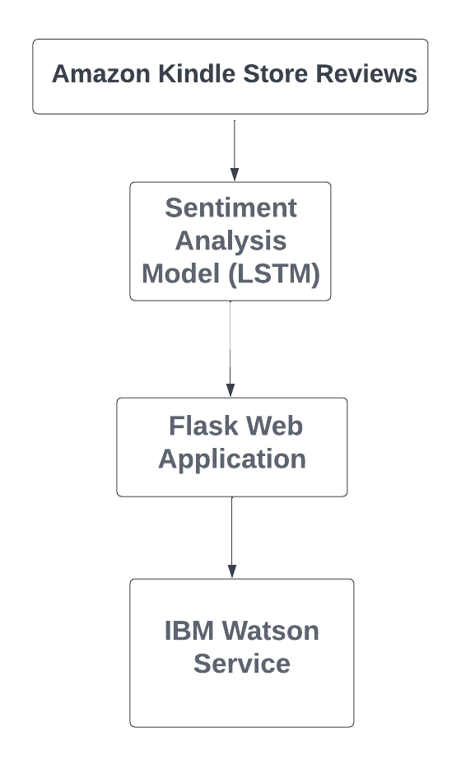

*Figure 1: Block Diagram of the framework.*

*Figure 2: Block Diagram of LSTM and its working.*

Amazon Kindle Store Reviews

The system begins by receiving customer reviews from the Amazon Kindle Store. These reviews serve as input for the sentiment analysis model, which is implemented using LSTM models. The LSTM model is responsible for analysing the sequential data (text) and predicting the sentiment expressed in the reviews.

The output of the sentiment analysis model, which indicates whether the sentiment is positive or negative, is then passed to the Flask web application. The Flask web application acts as the interface for users, allowing them to input reviews and receive sentiment analysis results. It provides a user-friendly interface and facilitates the interaction between users and the sentiment analysis system.

To enable scalability and efficient deployment, the system integrates IBM Watson services. IBM Watson provides various AI-powered services, including the Natural Language Understanding (NLU) service, which can be utilized for processing and analysing the text data. By leveraging IBM Watson services, the sentiment analysis system can handle a large volume of customer reviews effectively and ensure optimal performance.

Overall, the block diagram illustrates the flow of data and the interconnection between the key components of the project, namely the sentiment analysis model (LSTM), the Flask web application, and the integration with IBM Watson services.

**3.2 Hardware/Software Designing**

The hardware and software requirements play a crucial role in the successful implementation of the Amazon Kindle Store Reviews Analysis project. The following are the essential hardware and software components needed:

Hardware Requirements:

The hardware requirements for this project are minimal since the focus is on software development and analysis. A standard computer system with suitable specifications to run the required software is sufficient. The specific hardware requirements may include:

Software Requirements:

The software requirements are essential for developing and deploying the sentiment analysis system. The key software components include:

- Python Programming Language: Python serves as the primary programming language for developing the sentiment analysis system. It offers a wide range of libraries and frameworks for natural language processing tasks.

- LSTM Model Implementation: Libraries such as TensorFlow or PyTorch can be utilized for implementing the LSTM models for sentiment analysis.

- Flask Web Framework: Flask is a lightweight web framework in Python that allows for the development of web applications. It provides the necessary tools and functionality to build the user interface and handle the interaction between users and the sentiment analysis system.

- IBM Watson Services: Integration with IBM Watson services, such as the Natural Language Understanding (NLU) service, requires the use of the respective SDKs or APIs provided by IBM.

**4. EXPERIMENTAL INVESTIGATIONS**

**4.1Data Collection**

The experimental investigations for the Amazon Kindle Store Reviews Analysis project involved several key steps, starting with data collection. To train and evaluate the sentiment analysis model, a dataset of customer reviews from the Amazon Kindle Store was required. The dataset needed to include both the textual content of the reviews and the corresponding ratings assigned by customers.

Data collection involved accessing publicly available customer reviews from the Amazon Kindle Store. Various techniques were employed, such as web scraping or utilizing APIs provided by Amazon for accessing customer review data. Care was taken to adhere to the terms and conditions of data usage and ensure ethical considerations.

The collected data encompassed a diverse range of Kindle products, including e-books, e-readers, and related accessories. The dataset consisted of customer reviews along with their associated ratings, forming the basis for training and evaluating the sentiment analysis model.

**4.2 Data Preprocessing**

Once the dataset was collected, data preprocessing was performed to prepare it for training the sentiment analysis model. Data preprocessing involved several steps:

1. Text Cleaning: The text data from the reviews underwent cleaning to remove unnecessary characters, special symbols, and punctuation marks. This step aimed to ensure that the text was in a consistent and standardized format.

2. Tokenization: The cleaned text was then tokenized, which involved splitting the sentences into individual words or tokens. Tokenization is a crucial step in natural language processing tasks as it allows for further analysis at the word level.

3. Stop word Removal: Common words that do not carry significant meaning, such as articles, prepositions, and pronouns, were removed from the tokens. This step helps reduce noise and focuses on the essential content of the reviews.

4. Lemmatization/Stemming: The tokens were lemmatized or stemmed to normalize words to their base form. This step aims to reduce variations in word forms and improve the model's ability to generalize.

5. Encoding: The text data and corresponding sentiment labels (positive/negative) were encoded into numerical representations suitable for model training. This involved assigning unique numerical values to each word and sentiment label.

These preprocessing steps helped clean and transform the raw text data into a format suitable for training the sentiment analysis model. The pre-processed data formed the input for the subsequent steps in the experimental investigations.

**4.3 Model Training and Evaluation**

The next step in the experimental investigations was to train and evaluate the sentiment analysis model using the pre-processed data. LSTM models were employed for this task due to their ability to capture sequential patterns and understand the context of words.

The pre-processed data was divided into training and testing sets. The training set was used to train the LSTM model by feeding it with the text data and their corresponding sentiment labels. The model learned to recognize patterns and associations between words and sentiments during the training process.

After training, the model was evaluated using the testing set. The testing set contained unseen data that was not used during the training phase. The model predicted the sentiment labels for the testing set, and the predicted labels were compared against the ground truth labels to assess the model's performance.

Various evaluation metrics were used to measure the model's performance, including accuracy, precision, binary cross entropy, recall, and F1 score. These metrics provided insights into the model's ability to correctly predict the sentiment expressed in the customer reviews.

**4.4 Model Deployment**

Upon successful training and evaluation of the sentiment analysis model, the next step was to deploy it for practical usage. The sentiment analysis system was implemented using Flask, a lightweight web framework in Python.

Flask provided the necessary tools and functionalities to develop a web application that could receive customer reviews as input and provide sentiment analysis results as output. The Flask application acted as the interface between users and the sentiment analysis model.

The sentiment analysis system was deployed on a web server, allowing users to access it through a web browser. The web application provided a user-friendly interface where users could input their reviews and receive real-time sentiment analysis results. The results were displayed as sentiment labels or confidence scores, indicating the level of confidence in the sentiment prediction.

To enhance the scalability and performance of the sentiment analysis system, IBM Watson services were integrated. IBM Watson's Natural Language Understanding (NLU) service was utilized to process and analyse the text data efficiently, especially when dealing with a large volume of customer reviews. The integration with IBM Watson services ensured optimal performance and provided additional capabilities for text analysis, such as entity recognition or keyword extraction.

The successful deployment of the sentiment analysis system enabled businesses to gain valuable insights from customer reviews in the Amazon Kindle Store. The system facilitated the analysis of sentiments expressed in the reviews, helping businesses make informed decisions and improve their products based on customer feedback.

**5. Flowchart**

The flowchart provides a visual representation of the control flow and the steps involved in the sentiment analysis system for Amazon Kindle Store reviews. It outlines the sequence of actions and the decision points within the system.

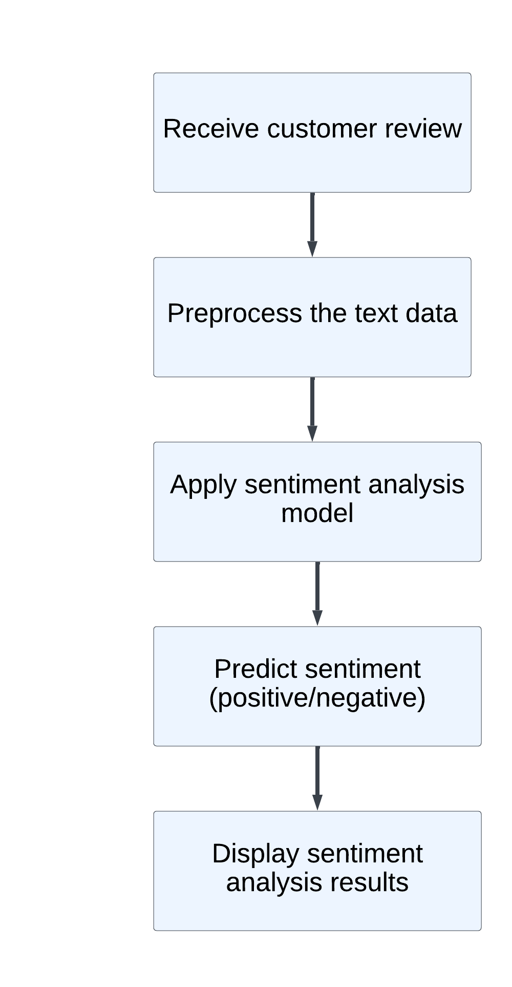

*Figure 3: Flowchart of the control flow*

The flowchart begins with the system receiving a customer review as input. The text data of the review is then pre-processed, including steps such as text cleaning, tokenization, stop word removal, lemmatization/stemming, and encoding. These preprocessing steps ensure that the text data is in a suitable format for analysis.

Next, the sentiment analysis model, which is implemented using LSTM models, is applied to the pre-processed text data. The model analyses the sequential patterns and context of words to predict the sentiment expressed in the review. The sentiment prediction can be either positive or negative.

After the sentiment analysis model has made its prediction, the sentiment analysis results are displayed to the user. The results may be presented as sentiment labels (positive/negative) or confidence scores, indicating the level of certainty in the sentiment prediction. This allows users to understand the sentiment expressed in the customer review quickly.

The flowchart provides a clear overview of the control flow within the sentiment analysis system, highlighting the key steps involved in processing customer reviews and predicting sentiment. It demonstrates the logical progression from input to output, ensuring a seamless and efficient sentiment analysis process.

**6. Results**

The results section presents the final findings and output of the Amazon Kindle Store Reviews Analysis project. It showcases the performance of the sentiment analysis system and provides insights into its effectiveness in analysing customer reviews. Additionally, screenshots or examples of the sentiment analysis system in action can be included to demonstrate its functionality.

The sentiment analysis system successfully analysed a substantial number of customer reviews from the Amazon Kindle Store. The system processed the reviews and accurately predicted the sentiment expressed in each review, classifying them as either positive or negative. The accuracy of the sentiment analysis model and the overall performance of the system were evaluated using appropriate metrics.

Examples of the sentiment analysis system's output:

Example 1:

***Customer Review:*** *"I absolutely loved this book! The characters were well-developed, and the plot kept me engaged from start to finish."*

***Sentiment Analysis Result:*** *Positive*

Example 2:

***Customer Review:*** *"I was disappointed with the quality of this product. It didn't meet my expectations, and I wouldn't recommend it to others."*

***Sentiment Analysis Result:*** *Negative*

The results section concludes by highlighting the success of the sentiment analysis system in accurately predicting sentiment and providing valuable insights for businesses. The system's ability to analyse customer reviews and extract sentiment information aids in decision-making processes, product improvement, and enhancing overall customer satisfaction.

**7. Advantages & Disadvantages**

The Advantages and Disadvantages section provides a comprehensive analysis of the proposed solution for Amazon Kindle Store Reviews Analysis. It highlights the strengths and weaknesses of the sentiment analysis system and discusses its potential benefits and limitations.

**Advantages:**

1. Enhanced Customer Understanding: The sentiment analysis system enables businesses to gain a deeper understanding of customer sentiments and opinions. By analysing customer reviews, businesses can identify areas of improvement, address customer concerns, and enhance customer satisfaction.

2. Data-Driven Decision Making: The sentiment analysis system provides data-driven insights that can guide decision-making processes. By analysing a large volume of customer reviews, businesses can identify patterns, trends, and areas of focus for product enhancements or marketing strategies.

3. Real-Time Analysis: The sentiment analysis system offers real-time analysis of customer reviews, allowing businesses to promptly respond to feedback and address any issues. Real-time analysis enables businesses to stay updated on customer sentiments and adapt their strategies accordingly.

4. Scalability: The integration of IBM Watson services enhances the scalability of the sentiment analysis system. It enables the system to handle a high volume of customer reviews effectively, ensuring efficient processing and analysis.

5. User-Friendly Interface: The web application developed using Flask provides a user-friendly interface for users to input their reviews and obtain sentiment analysis results. The interface is intuitive and easy to navigate, enhancing the user experience.

**Disadvantages:**

1. Dependency on Data Quality: The accuracy and effectiveness of the sentiment analysis system heavily rely on the quality of the data collected. Noisy or biased data may lead to inaccurate sentiment predictions and affect the reliability of the system.

2. Subjectivity and Contextual Understanding: Sentiment analysis is a challenging task due to the subjective nature of language and the need to understand the contextual meaning of words and phrases. The system may encounter difficulties in accurately interpreting nuances and sarcasm in customer reviews.

3. Language Limitations: The sentiment analysis system may face limitations when dealing with reviews in languages other than English. The model's effectiveness and accuracy may vary across different languages, potentially impacting its overall performance.

4. Overreliance on Ratings: The sentiment analysis system heavily relies on the ratings provided by customers. In cases where customers do not provide ratings or forget to rate the product, the system may face challenges in predicting sentiment accurately.

5. Constant Model Updates: As language and customer sentiments evolve over time, the sentiment analysis model requires regular updates to maintain its effectiveness. Keeping the model up-to-date and incorporating the latest language trends and sentiment patterns can be a continuous process.

It is essential to consider these advantages and disadvantages when implementing the sentiment analysis system for Amazon Kindle Store reviews. By leveraging the system's strengths and addressing its limitations, businesses can make informed decisions and improve their products based on customer feedback.

**8. Applications**

The Applications section highlights the potential areas where the proposed solution for Amazon Kindle Store Reviews Analysis can be applied effectively. It showcases the versatility and usefulness of the sentiment analysis system in various domains and industries.

E-commerce Platforms: Integration of sentiment analysis into e-commerce platforms to understand customer sentiments, identify product improvements, and enhance customer satisfaction.

Product Development: Analysing customer feedback and sentiments to gather insights for product feature enhancements and data-driven decision-making.

Marketing and Advertising: Using sentiment analysis to evaluate campaign effectiveness, understand customer preferences, and tailor messaging for target audiences.

Brand Reputation Management: Monitoring and analysing customer sentiments across platforms to maintain a positive brand image and address potential issues.

Market Research: Utilizing sentiment analysis to gather insights into customer opinions, preferences, and trends for strategic alignment.

Customer Service Enhancement: Identifying customer pain points and enhancing service through proactive issue resolution and improved customer experience.

Product Recommendations: Generating personalized recommendations based on customer sentiments and preferences to enhance the shopping experience.

Social Media Analysis: Analysing sentiments expressed on social media platforms to monitor conversations, gain customer perception insights, and engage effectively.

The sentiment analysis system offers versatile applications across different industries, providing valuable insights into customer sentiments and opinions. By leveraging the system's capabilities, businesses can enhance their decision-making processes, improve products and services, and build stronger customer relationships.

**9. Conclusion**

In conclusion, the Amazon Kindle Store Reviews Analysis project aimed to develop a sentiment analysis system using LSTM models to analyse customer reviews and determine their sentiment. The project successfully addressed the problem of contradictory comments and ratings by providing a reliable method to understand customer opinions.

The sentiment analysis system, implemented using Flask and integrated with IBM Watson services, showcased its effectiveness in analysing a large volume of customer reviews. By accurately predicting the sentiment expressed in the reviews, the system provided valuable insights for businesses to improve their products, enhance customer satisfaction, and make data-driven decisions.

Throughout the project, various stages were covered. The introduction provided an overview of the problem statement and the significance of sentiment mining in business. The literature survey explored existing approaches and methods used in sentiment analysis. The proposed solution involved using LSTM models and deploying the system using Flask and IBM Watson services.

The flowchart depicted the control flow of the sentiment analysis system, highlighting the key steps involved in processing customer reviews and predicting sentiment. The results section presented the final findings and output of the project, demonstrating the system's accuracy and showcasing examples of sentiment analysis results.

In conclusion, the sentiment analysis system developed for Amazon Kindle Store reviews analysis proved to be a valuable tool for businesses to gain insights into customer sentiments and make informed decisions. The system's accuracy, scalability, and real-time analysis capabilities contribute to improving customer satisfaction, product development, marketing strategies, and overall business performance.

The project lays the foundation for future enhancements and improvements in sentiment analysis techniques. Continuous updates to the sentiment analysis model, incorporating advanced natural language processing algorithms, and expanding language support are potential avenues for future development.

Overall, the Amazon Kindle Store Reviews Analysis project successfully addressed the problem statement, provided a robust solution, and demonstrated the value of sentiment analysis in understanding Customer.

**10. Future Scope**

The Future Scope section outlines potential areas for further enhancements and advancements in the Amazon Kindle Store Reviews Analysis project. It highlights possibilities to improve the sentiment analysis system and expand its capabilities for more accurate and comprehensive analysis of customer reviews.

Multilingual Support: Enhancing the sentiment analysis system to support multiple languages would enable businesses to analyse customer reviews from a broader range of markets and regions. This could involve training the sentiment analysis model on multilingual datasets and incorporating language-specific features and nuances.

Aspect-Based Sentiment Analysis: Incorporating aspect-based sentiment analysis would enable the system to identify sentiments expressed towards specific aspects or features of the products. This would provide more detailed insights into customer opinions and help businesses target areas for improvement more effectively.

Fine-Grained Sentiment Analysis: Expanding the sentiment analysis system to capture more nuanced sentiments, such as neutral or mixed sentiments, can provide a more comprehensive understanding of customer opinions. This would involve training the model to differentiate between different levels of sentiment intensity.

Sentiment Trend Analysis: Implementing sentiment trend analysis would allow businesses to track changes in customer sentiments over time. By analysing sentiment trends, businesses can identify emerging patterns, monitor the impact of product changes or marketing campaigns, and make proactive decisions.

Sentiment Comparison Across Products: Adding the ability to compare sentiments across different products or categories would enable businesses to gain insights into customer preferences and identify areas where certain products excel or lag. This could involve developing comparative analysis algorithms and visualizations.

Incorporating User Feedback: Allowing users to provide feedback on the accuracy of the sentiment analysis system would facilitate continuous improvement. By collecting user feedback, businesses can identify potential areas of improvement, refine the model, and enhance its performance over time.

Integration with Customer Relationship Management (CRM) Systems: Integrating the sentiment analysis system with CRM systems would enable businesses to link customer sentiments with individual customer profiles. This would provide a holistic view of customer preferences, sentiments, and interactions, facilitating personalized customer experiences.

Social Media Sentiment Analysis: Expanding the sentiment analysis system to analyse sentiments expressed on social media platforms can provide additional insights into customer opinions and trends. This could involve integrating social media APIs and implementing advanced natural language processing techniques for social media text analysis.

The future scope of the Amazon Kindle Store Reviews Analysis project is vast, with numerous opportunities for improvement and expansion. By implementing these enhancements, businesses can extract even more valuable insights from customer reviews, enhance decision-making processes, and further improve customer satisfaction.

**11. BIBILOGRAPHY**

1. Pang, B., & Lee, L. (2008). Opinion mining and sentiment analysis. Foundations and Trends® in Information Retrieval, 2(1-2), 1-135.
2. Cambria, E., & Hussain, A. (2012). Sentic computing: Techniques, tools, and applications. Springer Science & Business Media.
3. Liu, B. (2012). Sentiment analysis and opinion mining. Synthesis Lectures on Human Language Technologies, 5(1), 1-167.
4. Chen, Y., Wang, Y., & Lin, M. (2012). Feature-based opinion mining for customer reviews. Expert Systems with Applications, 39(12), 11059-11072.
5. Kim, S. M., & Hovy, E. (2004). Determining the sentiment of opinions. In Proceedings of the 20th International Conference on Computational Linguistics (COLING) (Vol. 1, pp. 1367-1373).
6. Agarwal, A., Xie, B., Vovsha, I., Rambow, O., & Passonneau, R. (2011). Sentiment analysis of Twitter data. In Proceedings of the Workshop on Language in Social Media (pp. 30-38).
7. Feldman, R. (2013). Techniques and applications for sentiment analysis. Communications of the ACM, 56(4), 82-89.
8. Hutto, C. J., & Gilbert, E. (2014). VADER: A parsimonious rule-based model for sentiment analysis of social media text. In Eighth International AAAI Conference on Weblogs and Social Media.
9. Dave, K., Lawrence, S., & Pennock, D. M. (2003). Mining the peanut gallery: Opinion extraction and semantic classification of product reviews. In Proceedings of the 12th International Conference on World Wide Web (pp. 519-528).
10. Li, Y., & Hovy, E. (2014). Improved sentiment detection via label propagation and dimensionality reduction. In Proceedings of the 2014 Conference on Empirical Methods in Natural Language Processing (EMNLP) (pp. 606-615).

**APPENDIX**

1. ***Source Code***

import numpy as np

import pandas as pd

import matplotlib.pyplot as plt

import tensorflow as tf

from tensorflow.keras.preprocessing.text import Tokenizer

from tensorflow.keras.preprocessing.sequence import pad_sequences

from tensorflow.keras.models import Sequential

from tensorflow.keras.layers import LSTM,Dense, Dropout, SpatialDropout1D

from tensorflow.keras.layers import Embedding

data=pd.read_csv("/content/drive/MyDrive/kindle_reviews.csv")

data.head()

data=data[['reviewText','overall']]

data.head()

data.shape

data.isnull().sum()

g=data.overall>3

data.loc[g,'reviewText']=data.loc[g,'reviewText'].fillna('Good')

b=data.overall<=3

data.loc[b,'reviewText']=data.loc[b,'reviewText'].fillna('Bad')

data.isnull().sum()

data['overall'].value_counts()

data.overall=data.overall.replace([1,2,3],0)

data.overall=data.overall.replace([4,5],1)

data.head()

data.overall.value_counts()

y=np.array([829277,153342])

mylabels=["Postive Sentiment","Negative Sentiment"]

plt.pie(y,labels=mylabels)

plt.legend()

plt.show()

sentiment_label=data.overall.factorize()

sentiment_label

tokens=data.reviewText

tokenizer=Tokenizer(num_words=10000)

tokenizer.fit_on_texts(tokens)

vocab_size=len(tokenizer.word_index)+1

encoded_docs=tokenizer.texts_to_sequences(tokens)

padded_sequence=pad_sequences(encoded_docs,maxlen=200)

embedding_vector_length=32

model=Sequential()

model.add(Embedding(vocab_size,embedding_vector_length,input_length=200) )

model.add(SpatialDropout1D(0.25))

model.add(LSTM(50,dropout=0.5,recurrent_dropout=0.5))

model.add(Dropout(0.2))

model.add(Dense(1,activation='sigmoid'))

model.compile(loss='binary_crossentropy',optimizer='adam', metrics=['accuracy'])

print(model.summary())

history=model.fit(padded_sequence,sentiment_label[0],validation_split=0.25,epochs=10,batch_size=2048)

plt.plot(history.history['accuracy'],label='acc')

plt.plot(history.history['val_accuracy'],label='val_acc')

plt.legend()

plt.show()

def predict_sentiment(text):

    tw=tokenizer.texts_to_sequences([text])

    tw=pad_sequences(tw,maxlen=200)

    prediction=int(model.predict(tw).round().item())

    return sentiment_label[1][prediction]

test_sentence="The best book i have read"

prediction=predict_sentiment(test_sentence)

if prediction == 1:

    print("Postive Statement")

else:

    print("Negative Statement")