**DETECTING PARKINSON’S DISEASE USING MACHINE LEARNING**

***by***

**NITHISH P - 20BEC1053**

**ROSHAN NV - 20BEC1125**

**BALAMADHAN S - 20BEC1354**

**AISHWAR HARIS J - 20BEC1361**

***to***

**SMARTINTERNZ**

**APPLIED DATA SCIENCE**

**1. INTRODUCTION**

**1.1 Overview**

Parkinson's disease is a central nervous system neurodegenerative condition that is largely characterised by the progressive loss of dopamine-producing brain cells. Movement is impacted by this chronic illness, which can cause a range of motor and non-motor symptoms. For those with Parkinson's disease, personalised treatment regimens can be created with the aid of machine learning algorithms. The model can suggest recommendations for personalised interventions, optimise therapeutic outcomes, by analysing patient data such as symptom severity, responsiveness to particular drugs, or disease progression.

**1.2 Purpose**

Early detection of Parkinson's Disease is crucial for effective treatment and management. Early diagnosis enables the implementation of effective treatments and interventions, which can lessen symptoms, delay the progression of the disease, and enhance patient outcomes generally. A strategy that shows promise for identifying Parkinson's disease is machine learning. These methods may examine big datasets containing a variety of data kinds, such as voice recordings, wearable device sensor data, and medical records. Patterns and correlations that might be diagnostic of Parkinson's Disease can be found by extracting pertinent characteristics and training machine learning models.

**2. LITERATURE SURVEY**

**2.1 Existing problem**

|  |  |  |
| --- | --- | --- |
| **S.NO** | **JOURNAL DETAILS** | **INFERENCE** |
| **1** | Early detection of Parkinson’s disease using machine learning - Aditi Govindua, Sushila Palweb | In this paper, several studies are taken in a high-level summary, providing access to information including (a) machine learning methods that have been used in the diagnosis of PD and associated outcomes, (b) types of clinical, behavioural and biometric data that could be used for rendering more accurate diagnoses, (c) potential biomarkers for assisting clinical decision making, and (d) other highly relevant information, including databases that could be used to enlarge and enrich smaller datasets and realization of machine learning-assisted diagnosis of PD yields high potential for a more systematic clinical decision-making system, while adaptation of novel biomarkers may give rise to easier access to PD diagnosis at an earlier stage. Machine learning approaches therefore have the potential to provide clinicians with additional tools to screen, detect or diagnose PD. |
| 2 | Parkinson's disease detection using machine learning techniques - DR. C K Gomathy, Mr. B. Dheeraj Kumar Reddy, Ms. B. Varsha, Ms. B. Varshini | In this paper, they predicted Parkinson's disease in a patient's body using machine learning technology and this method makes the process easy for the user. Their analysis provide very accurate performance in detecting Parkinson's disease using XGBOOST algorithm. |
| 3 | Early Detection Of Parkinson’s Disease Using Machine Learning - Anitha R, Nandhini T, Sathish Raj S, Nikitha V | This paper aimed to cover a broader space of imaging and machine learning technologies for mental illness diagnostics such that researchers in the field could readily identify the state of the art in the domain. The predicted output based on Random forest Classification and confusion matrix is with an accuracy of 83% with their hybrid architecture, integrating image processing (spiral drawing analyzing) using image processing technique. |

**2.2 Proposed solution**

In this project, Random Forest is used to classify whether the patient has Parkinson disease or not.

**RANDOM FOREST:**

Random forest creates an ensemble of decision trees, where each tree is trained on a random subset of the training data and a random subset of the input features. This random sampling helps in reducing overfitting and improves the generalisation ability of the model.

The random forest algorithm uses a technique called bagging (bootstrap aggregating). It creates multiple bootstrap samples by randomly selecting data points with replacement from the original training set. Each bootstrap sample is used to train an individual decision tree.

In addition to sampling data points, random forest also randomly selects a subset of features for each tree. This helps to introduce diversity among the trees and prevents them from relying too heavily on a specific subset of features.

Each decision tree in the random forest is constructed using a training subset created through bagging. At each node of the tree, the algorithm selects the best split among a random subset of features, rather than considering all features. This process continues recursively until a stopping criterion

Once all the trees are trained, predictions are made by aggregating the individual predictions of each tree. For classification tasks, the random forest uses majority voting to determine the final class label. For regression tasks, it takes the average or the weighted average of the predicted values from the individual trees.

The performance of the random forest model is typically evaluated using appropriate evaluation metrics such as accuracy, precision, recall, F1-score, mean squared error (MSE), or mean absolute error (MAE), depending on the nature of the problem (classification or regression)

Random forest has several hyper parameters that can be tuned to optimise its performance. These include the number of trees in the forest, the maximum depth of each tree, the number of features to consider at each split, and others. Grid search, random search, or other optimization techniques can be used to find the optimal combination of hyperparameters.

**3. THEORETICAL ANALYSIS**

**3.1 Block diagram**

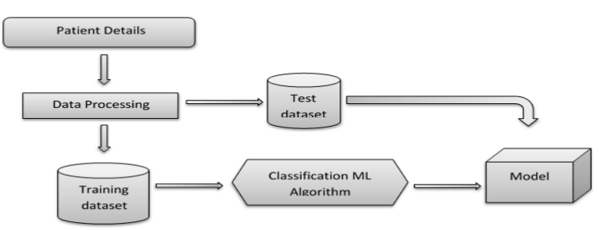

**3.2 Software designing**

**JUPYTER NOTEBOOK:**

Jupyter Notebook is an open-source web application that allows you to create and share documents containing live code, visualisations, explanatory text used for data science and machine learning purposes.

**LIBRARIES:**

**Numpy**:

NumPy (Numerical Python) is a popular open-source Python library used for scientific computing and data manipulation. It provides a powerful and efficient array object called ndarray, which is used to store and manipulate large sets of numerical data.

**Scikit-learn:**

Scikit-learn is a widely used open-source machine learning library for Python. It provides a range of tools and algorithms for various machine learning tasks.

**Scikit-image:**

Scikit-image is an open-source Python library built on top of NumPy for image processing and computer vision tasks. It provides a collection of algorithms and functions for performing various operations on images.

**Imutils:**

Imutils is a convenience library for OpenCV that provides a set of utility functions to simplify common image processing tasks.

**OpenCV:**

OpenCV is a popular open-source computer vision and image processing library. It provides a set of functions and algorithms for tasks such as image processing and machine learning.

**Flask:**

Web framework used for building Web applications.

**4. EXPERIMENTAL INVESTIGATIONS**

During the investigation of classifying input images as drawn by healthy individuals or individuals with Parkinson's disease using Random Forest and implementing it as a web application with Flask, several analyses and investigations were conducted. The dataset of drawings by healthy and Parkinson's disease individuals was collected, preprocessed, and relevant features were extracted, focusing on visual characteristics that differentiate between the two groups. Feature selection techniques were applied to identify the most discriminative features. A Random Forest classifier was trained using the selected features, and its performance was evaluated using accuracy, precision, recall, and F1 score.

The Flask framework was utilised to develop a web application where users can upload their drawings, which are processed and classified using the trained model. The application was deployed and tested for functionality, accuracy, and user experience. User feedback was gathered to improve the application, and continuous improvement efforts included exploring advanced techniques, such as deep learning models, and incorporating additional features to enhance classification accuracy and usability. Throughout the investigation, ethical considerations, data privacy, and regulatory compliance were carefully addressed.

**5. FLOWCHART**

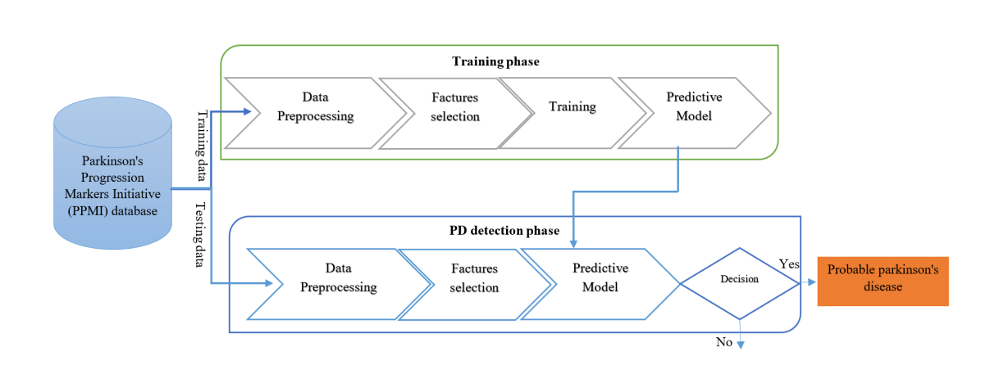

**6. RESULT**

**Classification of healthy or parkinson affected:**

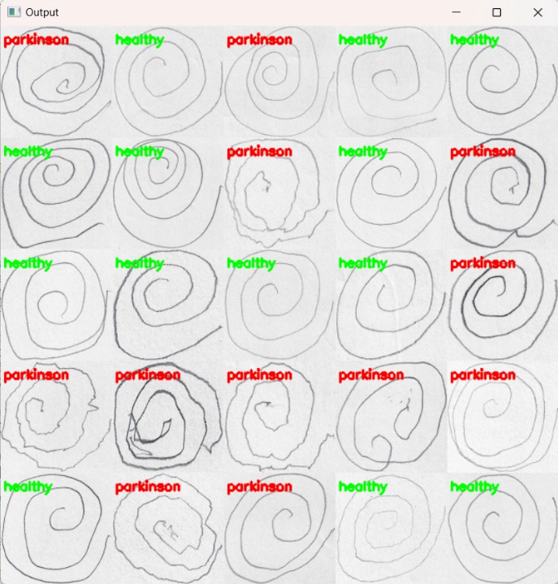

**Application:**

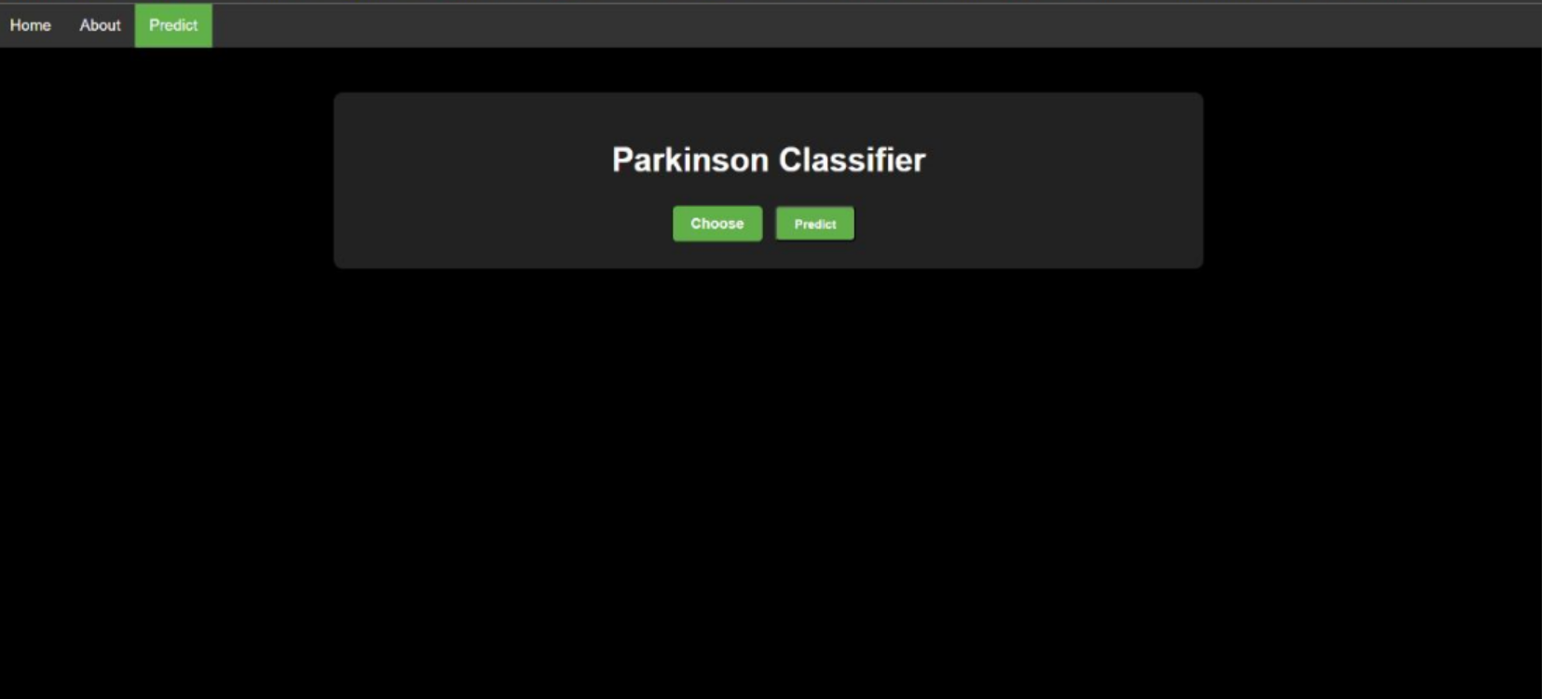

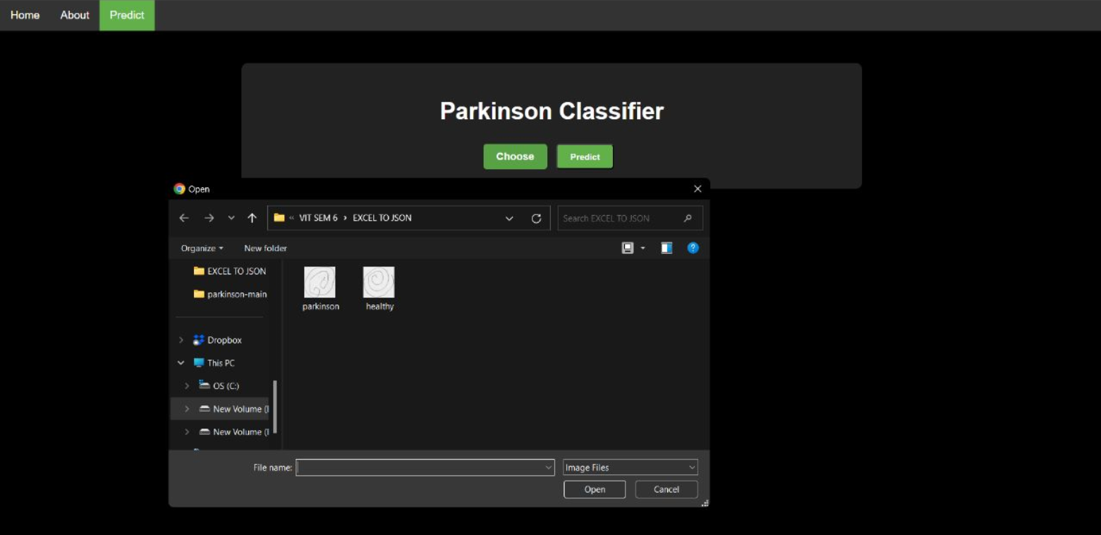

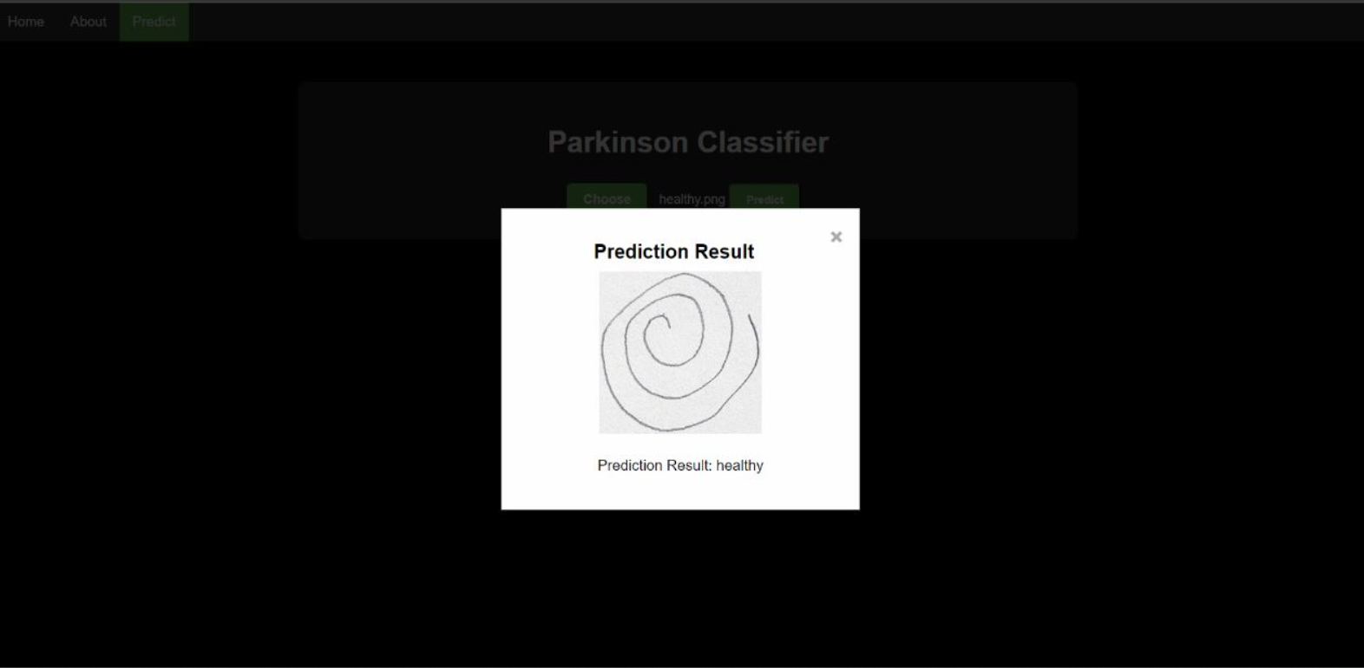

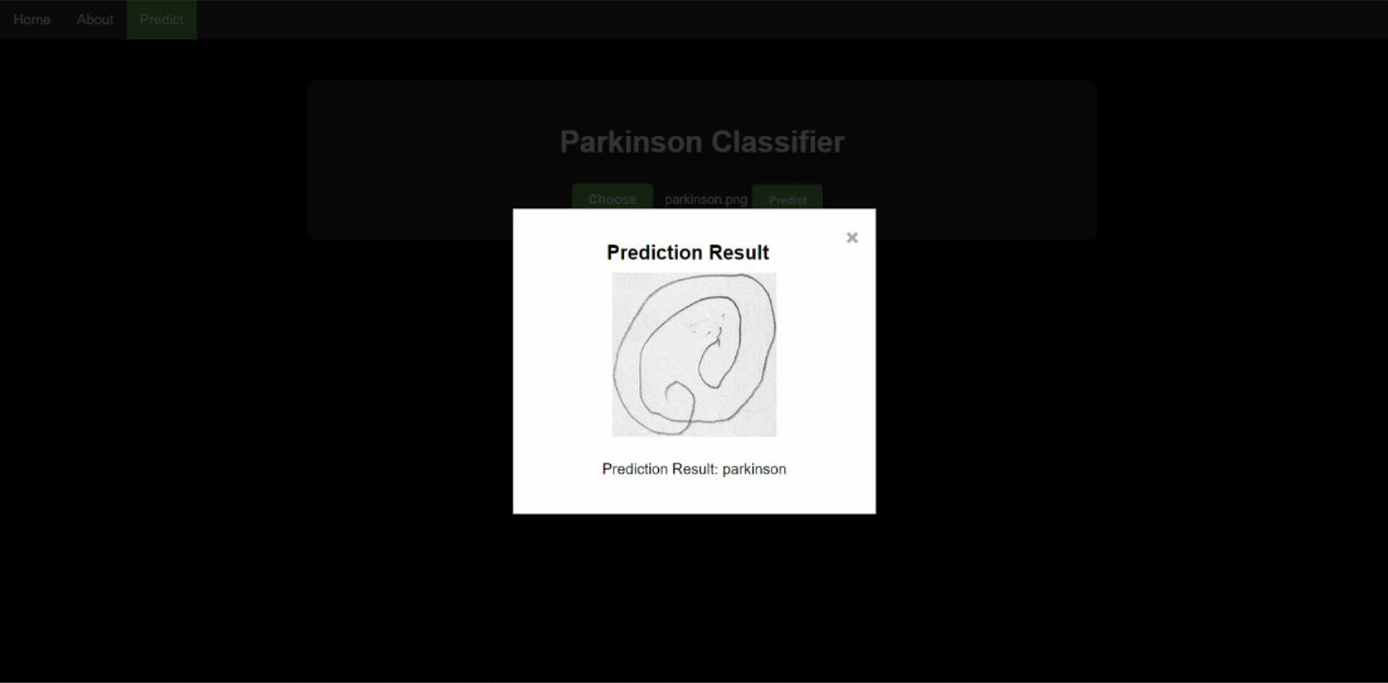

**7. ADVANTAGES AND DISADVANTAGES**

**ADVANTAGES:**

**Robustness against overfitting:**

Random forest is designed to mitigate overfitting, which occurs when a model performs well on the training data but fails to generalise to unseen data.

**Handling of high-dimensional data:**

It randomly selects a subset of features at each split, ensuring that all features have an opportunity to contribute to the predictions. This feature randomization reduces the impact of irrelevant or noisy features, making random forest robust in high-dimensional settings.

**Handling of missing data:**

When making predictions for a sample with missing values, the algorithm uses the available features and their associated splits to traverse the trees and provide a prediction. This property simplifies the preprocessing step by avoiding the need for complex imputation techniques.

**Outlier detection:**

Outliers often have different patterns compared to the majority of the data, causing them to be isolated in decision trees. By examining the proximity or distance of instances to other instances in the forest, outliers can be detected and flagged.

**DISADVANTAGES:**

**Computational complexity and memory usage:**

Random forest can be computationally expensive, especially for large datasets or a high number of trees in the forest. Training and predicting with a large number of decision trees require more computational resources and can increase memory usage.

**Biased towards features with more levels:**

In the presence of such features, the algorithm may assign higher importance to them, even if they are not necessarily more informative or predictive. This bias can impact the feature importance measures and potentially influence the model's performance.

**Potential for overfitting hyperparameters:**

Although random forest is designed to mitigate overfitting, there is still a risk of overfitting if the hyperparameters are not properly tuned. The number of trees, maximum tree depth, and other hyperparameters should be optimised to achieve the best performance on the specific dataset.

**8. APPLICATIONS**

In the area of data science, there are various useful applications for applying machine learning to identify Parkinson's disease. The following are some particular examples of how machine learning is being used to identify Parkinson's disease:

**Early Detection and Intervention:** The early diagnosis of Parkinson's disease can be facilitated by machine learning algorithms. Early disease detection allows for the fast initiation of therapies, which may improve patient quality of life and treatment outcomes.

**Automated Diagnosis:** Through the analysis of patient data, machine learning algorithms can automate the diagnosis process and reliably determine whether a person has Parkinson's disease or not. This can help medical practitioners diagnose patients more quickly and correctly.

**Personalised Treatment Plans:** Machine learning techniques can analyse patient data, including symptoms, medication history, and response to treatment, to develop personalised treatment plans. This can optimise therapeutic strategies by tailoring interventions to individual patient needs.

**Predictive Analytics:** Machine learning algorithms can be trained to predict the progression of Parkinson's Disease based on patient data. This can help healthcare professionals anticipate disease trajectory and plan appropriate interventions accordingly.

**Remote Monitoring and Telemedicine:** Patients with Parkinson's disease can be remotely monitored using machine learning. Machine learning models can be integrated into wearable technology or mobile applications to continuously gather and analyse data, enabling remote consultations and real-time monitoring of symptoms and treatment success.

**Feature Selection and Biomarker Discovery:** Machine learning algorithms can aid in feature selection, identifying the most relevant features from a large dataset that contribute to Parkinson's Disease detection. This can help uncover potential biomarkers or novel indicators that further our understanding of the disease.

**9. CONCLUSION**

The use of machine learning in the field of data science to identify Parkinson's disease has a wide range of practical applications, including automated diagnosis, early detection, individualised treatment planning, remote monitoring, predictive analytics, biomarker discovery, decision support systems, and population studies. These programmes could increase Parkinson's disease management in general, boost medical research, and enhance patient care. The Random Forest algorithm, in detecting Parkinson's disease through data science techniques offers significant potential and benefits. Random Forest is a powerful and widely adopted algorithm that can effectively handle complex data and provide accurate predictions. Random Forest is known for its ability to handle high-dimensional data and capture complex relationships within the data. This enables more accurate detection of Parkinson's disease compared to traditional diagnostic methods.

**10. FUTURE SCOPE**

The future scope of detecting Parkinson's disease using machine learning techniques is promising and holds significant potential.

**Early Detection:** Machine learning algorithms can be trained on various data sources such as medical records, voice samples, movement data, and sensor readings to detect early signs of Parkinson's disease. This could enable early intervention and improved treatment outcomes.

**Non-Invasive Diagnosis:** Machine learning can aid in developing non-invasive diagnostic methods for Parkinson's disease. For example, by analyzing voice patterns or facial expressions, algorithms can detect subtle changes that may be associated with the disease. This could potentially replace or complement invasive procedures like brain imaging.

**Objective Monitoring:** Machine learning algorithms can help in developing wearable devices and sensors to continuously monitor Parkinson's disease symptoms. By analyzing data such as gait, tremor, or speech patterns, algorithms can provide objective measurements of disease progression and treatment effectiveness, facilitating personalized care.

**Treatment Optimization:** Machine learning algorithms can assist in optimizing treatment strategies for Parkinson's disease patients. By analyzing patient data, including medication history, symptom severity, and lifestyle factors, algorithms can generate personalized treatment plans, reducing trial and error and improving patient outcomes.

**Data Integration:** Machine learning can integrate data from multiple sources, such as genetic data, medical records, and environmental factors, to identify underlying risk factors and potential causes of Parkinson's disease. This holistic approach can provide deeper insights into the disease's complexity and aid in developing targeted interventions.

**Remote Monitoring and Telemedicine:** Machine learning algorithms can enable remote monitoring of Parkinson's disease patients, allowing healthcare professionals to assess symptoms and provide timely interventions without the need for in-person visits. This can improve accessibility to care, especially for patients in remote areas.

**Drug Development:** Machine learning algorithms can help accelerate the drug discovery process for Parkinson's disease. By analyzing large-scale biomedical data, including genomics, proteomics, and neuroimaging, algorithms can identify potential therapeutic targets, predict drug efficacy, and optimize drug development pipelines.

**11. BIBLIOGRAPHY**

[1] Early detection of Parkinson’s disease using machine learning - Aditi Govindua, Sushila Palweb

[2] Parkinson's disease detection using machine learning techniques - DR. C K Gomathy, Mr. B. Dheeraj Kumar Reddy, Ms. B. Varsha, Ms. B. Varshini

[3] Early Detection Of Parkinson’s Disease Using Machine Learning - Anitha R, Nandhini T, Sathish Raj S, Nikitha V

<https://www.analyticsvidhya.com/blog/2021/07/parkinson-disease-onset-detection-using-machine-learning/>

<https://www.researchgate.net/publication/357448942_THE_PARKINSON'S_DISEASE_DETECTION_USING_MACHINE_LEARNING_TECHNIQUES>

<https://www.kaggle.com/code/vikasukani/detecting-parkinson-s-disease-machine-learning>

<https://ieeexplore.ieee.org/document/9768002>

<https://www.frontiersin.org/articles/10.3389/fnagi.2021.633752/full>

<https://data-flair.training/blogs/python-machine-learning-project-detecting-parkinson-disease/>

**APPENDIX**

from sklearn.ensemble import RandomForestClassifier

from sklearn.preprocessing import LabelEncoder

from sklearn.metrics import confusion_matrix

from skimage import feature

from imutils import build_montages

from imutils import paths

import numpy as np

import cv2

import os

import pickle #importing the pickle file

def quantify_image(image):

features = feature.hog(image, orientations=9, pixels_per_cell=(10, 10), cells_per_block=(2, 2), transform_sqrt=2, block_norm="L1")

return features

# Function to load split data

def load_split(path):

imagePaths = list(paths.list_images(path))

# Initialize lists to store images and labels

data = []

labels = []

# Iterate over the image paths

for imagePath in imagePaths:

label = imagePath.split(os.path.sep)[-2]

image = cv2.imread(imagePath)

image = cv2.cvtColor(image, cv2.COLOR_BGR2GRAY)

image = cv2.resize(image, (200, 200))

image = cv2.threshold(image, 0, 255, cv2.THRESH_BINARY_INV | cv2.THRESH_OTSU)[1

features = quantify_image(image)

data.append(features)

labels.append(label)

# Return the loaded data as NumPy arrays

return np.array(data), np.array(labels)

# Path to the training and testing directories

trainingPath = 'E:/parkinson-main/spiral/training'

testingPath = 'E:/parkinson-main/spiral/training'

print("[INFO] Loading data...")

X_train, y_train = load_split(trainingPath)

X_test, y_test = load_split(testingPath)

le = LabelEncoder()

y_train = le.fit_transform(y_train)

y_test = le.fit_transform(y_test)

print(X_train.shape, y_train.shape)

print (" [INFO] training model")

model = RandomForestClassifier(n_estimators=100)

model.fit (X_train,y_train)

testingPaths = list(paths.list_images (testingPath))

idxs = np.arange(0, len (testingPaths))

idxs = np.random.choice (idxs, size=(25,), replace=False)

images = []

for i in idxs:

# Load the testing image, clone it, and resize it

image = cv2.imread(testingPaths[i])

output = image.copy()

output = cv2.resize(output, (128, 128))

# Pre-process the image

image= cv2.cvtColor(image, cv2.COLOR_BGR2GRAY)

image = cv2.resize(image, (200, 200))

image = cv2.threshold(image, 0, 255, cv2.THRESH_BINARY_INV | cv2.THRESH_OTSU)[1]

features = quantify_image(image)

preds = model.predict([features])

label = le.inverse_transform(preds)[0]

color = (0, 255, 0) if label=="healthy" else (0, 0, 255)

cv2.putText(output, label, (3, 20), cv2.FONT_HERSHEY_SIMPLEX, 0.5, color, 2)

images.append(output)

montage = build_montages(images, (128, 128), (5, 5))[0]

cv2.imshow('Output', montage)

cv2.waitKey(0)

predictions = model.predict(X_test)

cm = confusion_matrix(y_test,predictions).flatten()

print(cm)

(tn, fp, fn, tp) = cm

accuracy = (tp + tn) / float(cm.sum())

print(accuracy)

model_path = 'E:/parkinson-main/spiral/model.pkl'

# Save the model using pickle

with open(model_path, 'wb') as file:

pickle.dump(model, file)

import os

from skimage import feature

# Function to quantify the image using histogram-based features

def quantify_image(image):

# Compute histogram of oriented gradients (HOG) features

features = feature.hog(image, orientations=9, pixels_per_cell=(8, 8), cells_per_block=(2, 2))

return features

# Path to the training and testing directories

trainingPath = 'E:/parkinson-main/spiral/training'

testingPath = 'E:/parkinson-main/spiral/testing'

# Get the list of image paths in the training directory

trainingImagePaths = list(paths.list_images(trainingPath))

# Initialize lists to store images and labels

data = []

labels = []

# Iterate over the training image paths

for imagePath in trainingImagePaths:

# Load the image, convert it to grayscale, and resize it

image = cv2.imread(imagePath)

image = cv2.cvtColor(image, cv2.COLOR_BGR2GRAY)

image = cv2.resize(image, (200, 200))

# Quantify the image

features = quantify_image(image)

# Extract the label from the file name

label = imagePath.split(os.path.sep)[-2]

# Append the features and label to the lists

data.append(features)

labels.append(label)

# make predictions on the testing data

predictions=model.predict(X_test)

print(predictions)

# compute the confusion matrix and and use it to derive the raw

# accuracy

from sklearn.metrics import confusion_matrix

cm = confusion_matrix(y_test,predictions).flatten()

print(cm)

(tn, fp, fn, tp) = cm

accuracy = (tp + tn) / float(cm.sum())

print(accuracy)

import pickle

# Specify the file path to save the model

model_path = 'E:/parkinson-main/spiral/model.pkl'

# Save the model using pickle

with open(model_path, 'wb') as file:

pickle.dump(model, file)