**SmartBridge Externship – Data Analytics**

**Project Title: Global Sales Data Analytics**

**Team Number**: 173

**Team Members**:

V Saikrishna – 20BCI7222 – VIT-AP

K Deekshitha Reddy – 20BCI7189 – VIT-AP

Ruchitha Panyam – 20BCI7032 – VIT-AP

Deepak Girish Sunkara – 20BCD7254 – VIT-AP

**Project Report**

**INTRODUCTION**

**1.1 Overview**

The Global Sales Data Analytics project utilizes data analytics to extract meaningful insights from sales data. By employing advanced analytics techniques, such as data mining, statistical analysis, and machine learning, the project enables stakeholders to uncover patterns, trends, and correlations in the data.

Through data analytics, the project facilitates the identification of key performance indicators and metrics relevant to sales performance. It allows for the exploration and visualization of sales data through interactive dashboards and data visualizations, providing stakeholders with a comprehensive understanding of sales patterns, customer behavior, and market dynamics.

The application of data analytics in the project empowers sales managers, executives, and marketing teams to make data-driven decisions. It supports strategic planning, sales forecasting, pricing optimization, customer segmentation, and targeted marketing efforts. By leveraging data analytics, the project enhances the overall effectiveness and efficiency of sales operations, enabling organizations to gain a competitive edge in the market.

In summary, the Global Sales Data Analytics project harnesses the power of data analytics to extract insights, drive decision-making, and optimize sales strategies. It leverages advanced analytics techniques to uncover patterns and trends, providing stakeholders with actionable intelligence for informed decision-making and improved sales performance.

**1.2 Purpose**

The purpose of the Global Sales Data Analytics project is to provide valuable insights and facilitate data-driven decision-making within an organization. By leveraging data visualizations, creating interactive dashboards, storytelling, and web integration, this project aims to achieve several important objectives.

Firstly, the project enables a comprehensive understanding of global sales performance by analysing large volumes of sales data from different regions, markets, and products. Through data visualizations and interactive dashboards, key performance indicators (KPIs) such as revenue, profit margins, market share, and customer segmentation can be easily monitored and compared across various dimensions. This empowers stakeholders to identify trends, patterns, and areas of improvement, ultimately leading to more informed strategic decisions.

Additionally, the project enables the creation of compelling stories using data. By incorporating data visualizations into narratives, the project helps communicate complex information in a simplified and engaging manner. This storytelling aspect enhances data comprehension and facilitates effective communication across departments, teams, and management levels. It enables stakeholders to not only understand the data but also derive actionable insights and make data-backed recommendations.

Moreover, the integration of data visualizations and dashboards into web platforms enhances accessibility and usability. By providing a centralized and user-friendly interface, the project ensures that stakeholders can access and explore the sales data from anywhere, anytime. This web integration enables real-time updates, drill-down capabilities, and interactive features, fostering a culture of data-driven decision-making throughout the organization.

**2 LITERATURE SURVEY**

**2.1 Existing problem**

The existing problem in global sales data analytics is the lack of effective tools and methods to analyze and interpret large volumes of sales data. Traditional approaches often involve manual data processing, complex spreadsheets, and static reports, which can be time-consuming, error-prone, and difficult to comprehend. Furthermore, the absence of interactive visualizations and storytelling elements limits the ability to extract meaningful insights and communicate them effectively to stakeholders.

Several existing approaches have attempted to address the challenges in global sales data analytics. Business intelligence (BI) tools such as Tableau, Power BI, and IBM Cognos have gained popularity in providing interactive dashboards and visualizations for data exploration, allowing users to connect to various data sources, create dynamic visualizations, and share insights with others.

Another approach is the utilization of programming languages like Python or R for data analysis and visualization. These languages offer extensive libraries and frameworks (e.g., matplotlib, seaborn, ggplot) that enable advanced data manipulation and visualization capabilities.

**2.2 Proposed solution**

To address the existing problems and enhance global sales data analytics, the proposed solution involves a combination of user-friendly data visualization tools, interactive dashboards, storytelling techniques, and web integration. The goal is to provide a comprehensive platform that empowers stakeholders to easily explore, analyse, and communicate sales data insights.

The suggested method includes the use of intuitive data visualization tools with a drag-and-drop interface, allowing users to quickly create visual representations of sales data without the need for programming or advanced technical skills. These tools should support a wide range of chart types, interactive features (e.g., filtering, drill-down), and customizable design options to ensure flexibility and ease of use. The web integration enables real-time updates, collaboration, and interactive features, providing a seamless and accessible experience for users.

**3 THEORITICAL ANALYSIS**

**3.1 Block diagram**

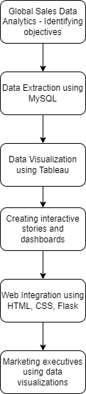

**3.2 Hardware / Software designing**

Hardware Requirements:

* Server or cloud infrastructure
* Sufficient processing power, memory, and storage capacity
* Reliable network infrastructure
* Client devices (computers, laptops, tablets, smartphones) with internet connectivity

Software Requirements:

* Data extraction and transformation tools (MySQL, Microsoft Excel)
* Database management systems (DBMS) or data storage solutions
* Analytics and visualization tools (Tableau)
* Web development frameworks (HTML, CSS, React, Flask)
* Security and access control tools for data protection and user authentication.

**4 EXPERIMENTAL INVESTIGATIONS**

During the experimental investigations for the Global Sales Data Analytics project, various analyses and investigations were conducted to assess the effectiveness and usability of the proposed solution. The investigations involved analyzing large volumes of sales data, creating interactive visualizations, and integrating them into a web-based platform. The focus was on evaluating the user-friendliness of the data visualization tools, the effectiveness of the storytelling techniques in conveying insights, and the seamless integration of the dashboards into the web interface. The experimental investigations served to validate the proposed solution's ability to empower stakeholders in making informed decisions and fostering a data-driven culture within the organization.

**5 PROJECT FLOW**

Here is the procedural flow of our project:

Connecting data from MySQL to Tableau – <https://drive.google.com/file/d/1C-V0AO74whNlKCi4Pypw_-N0TitWIIiu/view?usp=sharing>

Data Visualization 1 – <https://drive.google.com/file/d/1CfnJ6DNoLWh-qgkWF80K4FvygXJstmqy/view?usp=sharing>

Data Visualization 2 – <https://drive.google.com/file/d/1CTtkdT6sZFjzTgeos5yUFQLN3303eLy1/view?usp=sharing>

Data Visualization 3 – <https://drive.google.com/file/d/1Co01iO3mDCtGyjxEouiGVpyRnv-DA95J/view?usp=sharing>

Data Visualization 4 – <https://drive.google.com/file/d/1CtgqL-6ysT0IhrTAfkNi2izN0Nm_CpaC/view?usp=sharing>

Data Visualization 5 – <https://drive.google.com/file/d/1CRKRg9uRE_SGTtfmyJgQmEtQVrOfJXIr/view?usp=sharing>

Data Visualization 6 – <https://drive.google.com/file/d/1CPHYJcV8TC2zyyilqRgrvBGhdR2G0vIC/view?usp=sharing>

Data Visualization 7 – <https://drive.google.com/file/d/1CneVhw42ze0lczIw2yRuQtavZGK7bWgf/view?usp=sharing>

Data Visualization 8 – <https://drive.google.com/file/d/1e0ywf8s2yCtXhT6T6r0c7Ry3I2gOZo-M/view?usp=sharing>

Dashboard 1 – <https://drive.google.com/file/d/1CJIgw9jfAcFlvVBp94h_jqghVSzAJgKQ/view?usp=sharing>

Dashboard 2 – <https://drive.google.com/file/d/1CHSKfu3XSQVrQZyELR0RPM_AT3lHkQVS/view?usp=sharing>

Dashboard 3 – <https://drive.google.com/file/d/1C3GqvTws6JE6aW4VAWD3-NtTqBf4H4Xm/view?usp=sharing>

Story – <https://drive.google.com/file/d/1CFZVghKJejFCYmiqh6wshSUh8RIBjLX7/view?usp=sharing>

Publishing in Tableau Public – <https://drive.google.com/file/d/1CxEYgV7XzIlYLOrQydkGOnLaXPjDy6BD/view?usp=sharing>

Web Integration of Project – <https://drive.google.com/file/d/1Cu8xBNNcnYtW_sdjSYQe3ZEBnepvARNp/view?usp=sharing>

Tableau Public Link for Dashboard – <https://public.tableau.com/views/Project_GlobalSales1/Dashboard3?:language=en-US&publish=yes&:display_count=n&:origin=viz_share_link>

Tableau Public Link for Story – <https://public.tableau.com/views/Project_GlobalSales_story/Story1?:language=en-US&publish=yes&:display_count=n&:origin=viz_share_link>

**6 RESULT**

We have answered the following questions through our project:

1. What is the trend in sales for the last 5 years?

2. What is the percentage of sales contributed by each region to the total sales?

3. What is the percentage of profit margin for each category of products?

4. What is the distribution of sales across different countries?

5. Which city has the highest number of orders and which one has the lowest number of orders?

6. What is the average order value by each category of products?

7. Identify the Categories where Top 20 Customers that have Sales more than the other Categories in the same Region.

8. Identify the Regions where Top 20 Customers that have overall Profit Ratio (Profit as % of Sales) which is double the Profit Ratio of other Customers in the Region.

Here are the results for the above questions and the web integration of our project:

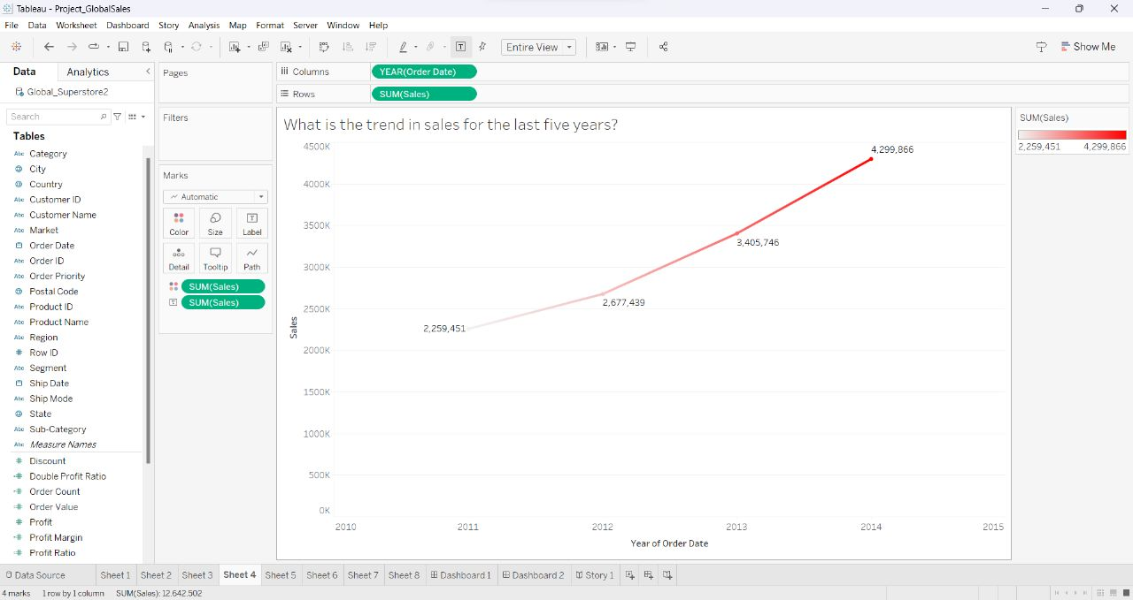

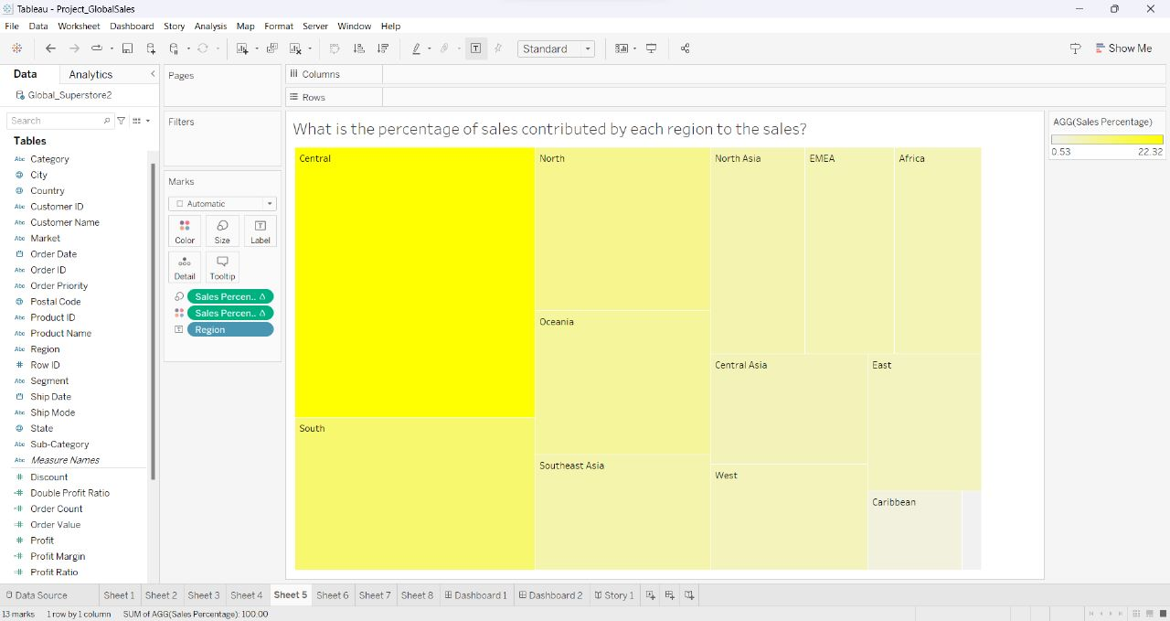

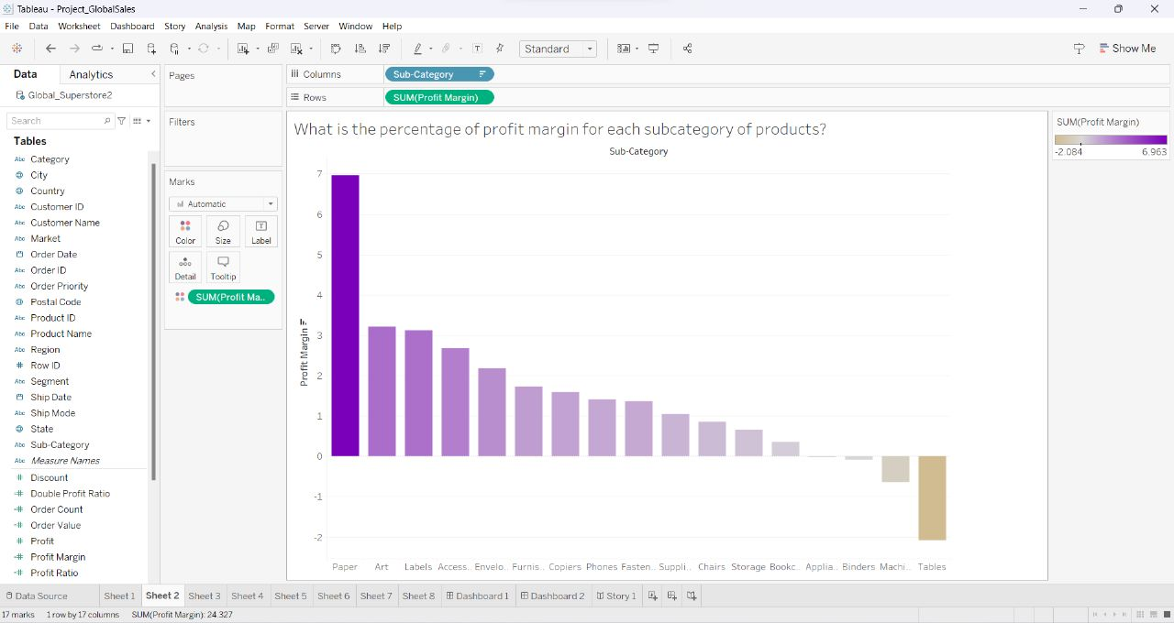

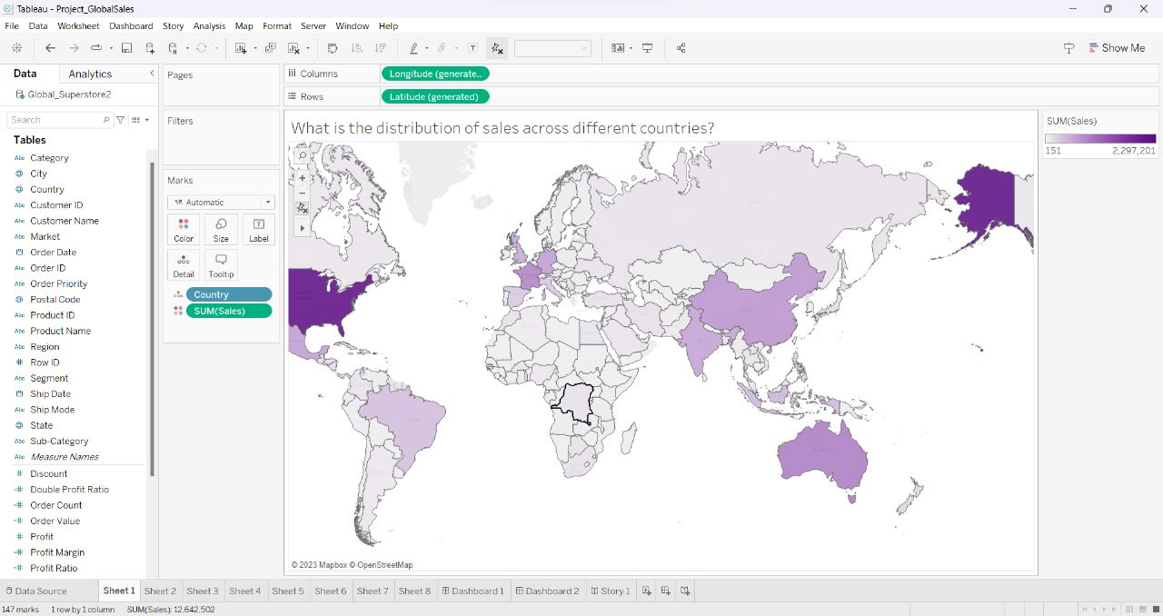

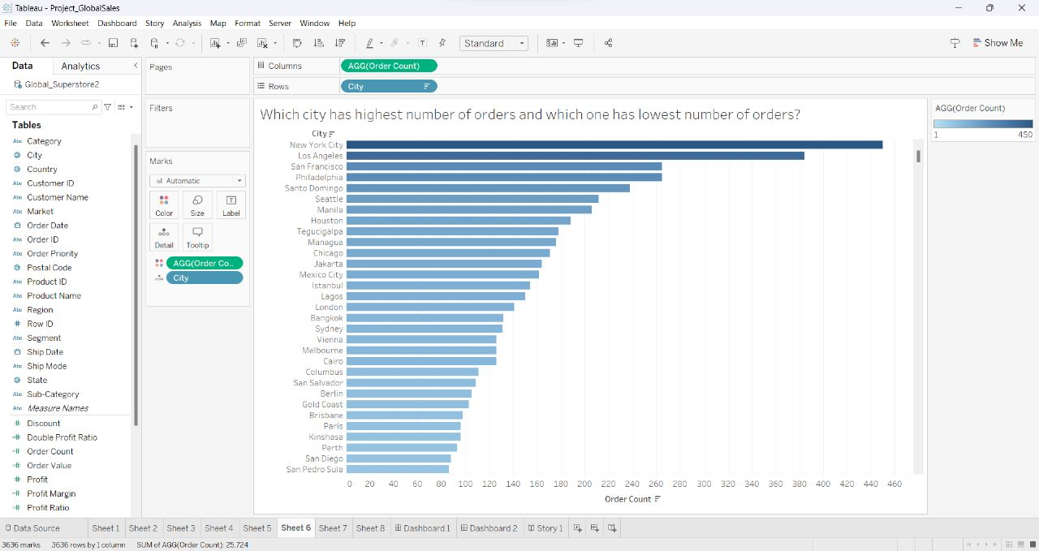

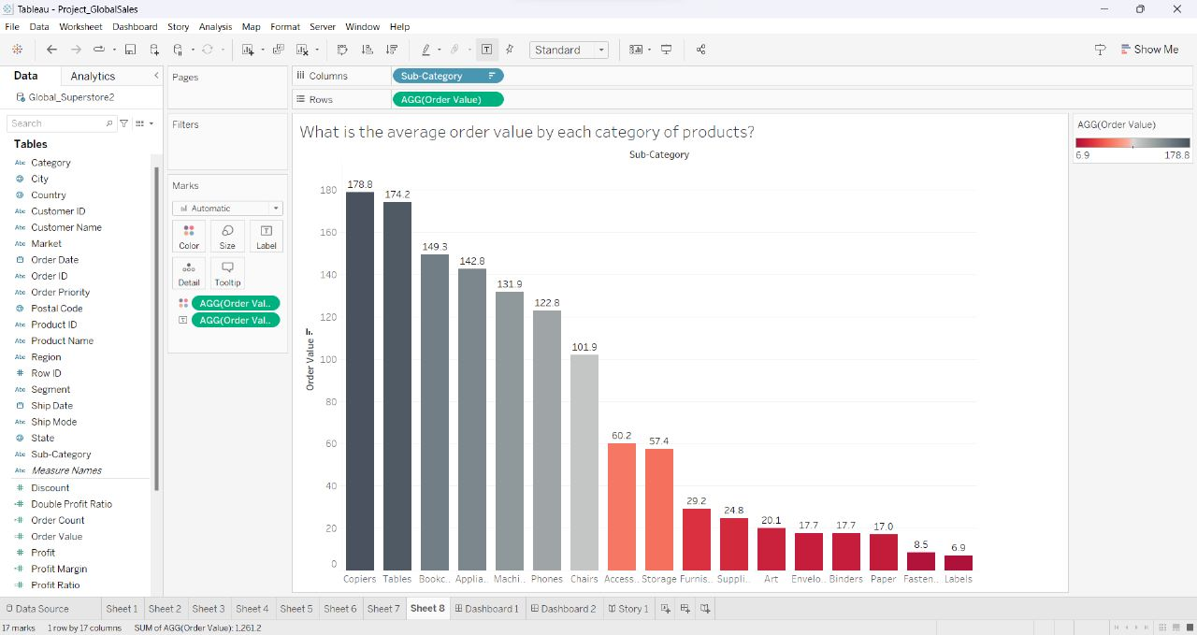

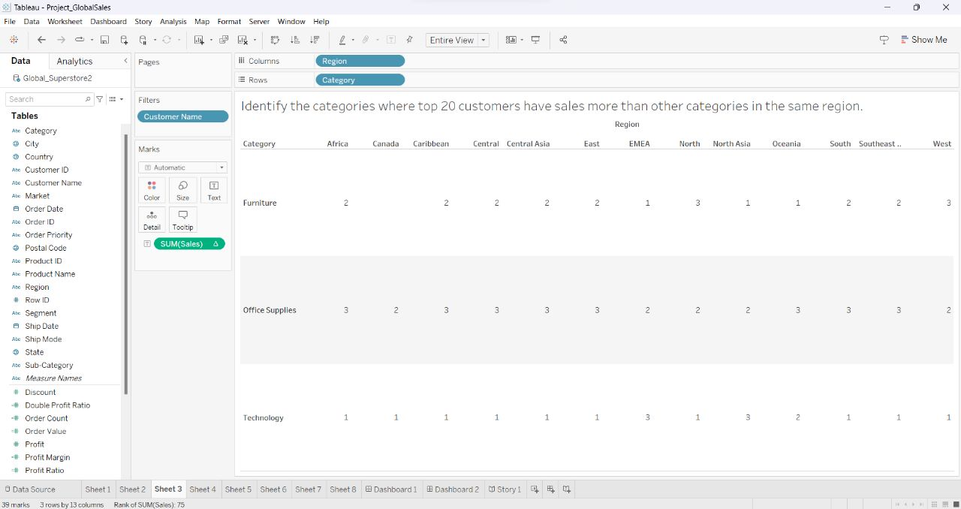

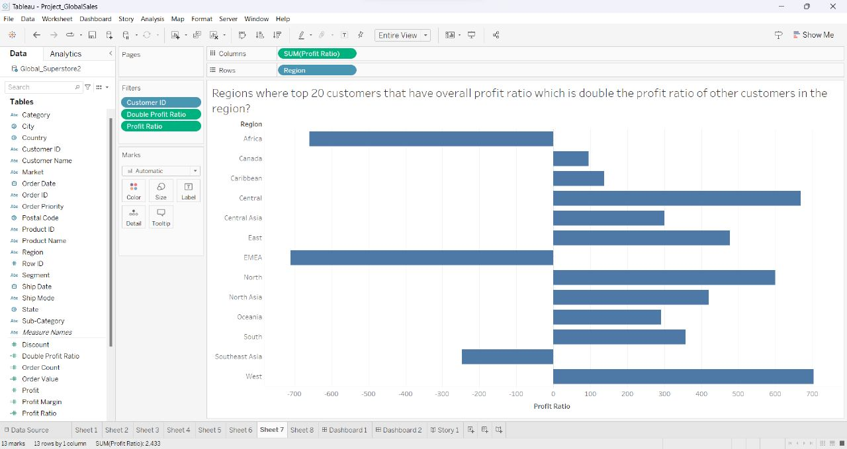

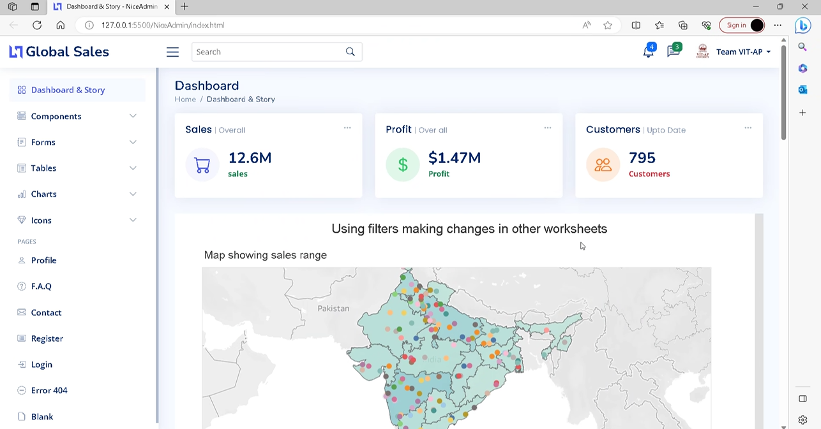

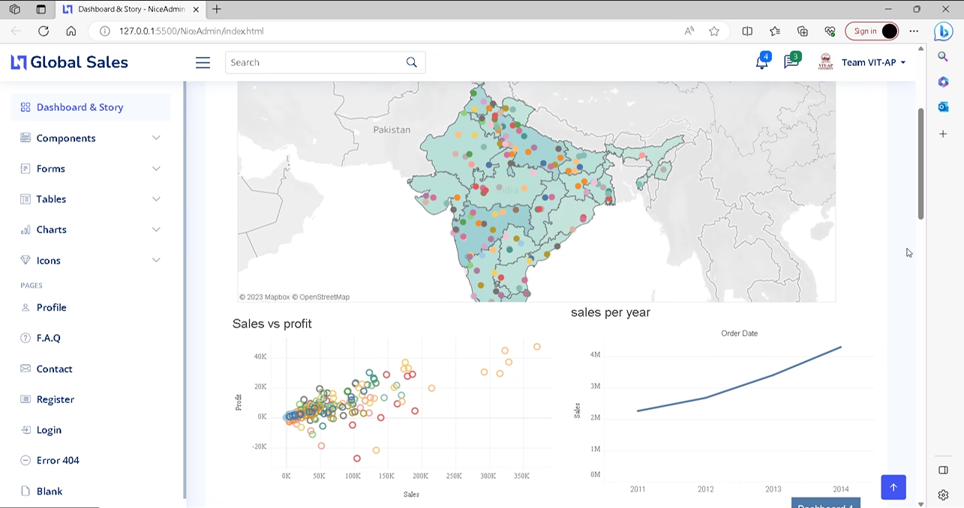

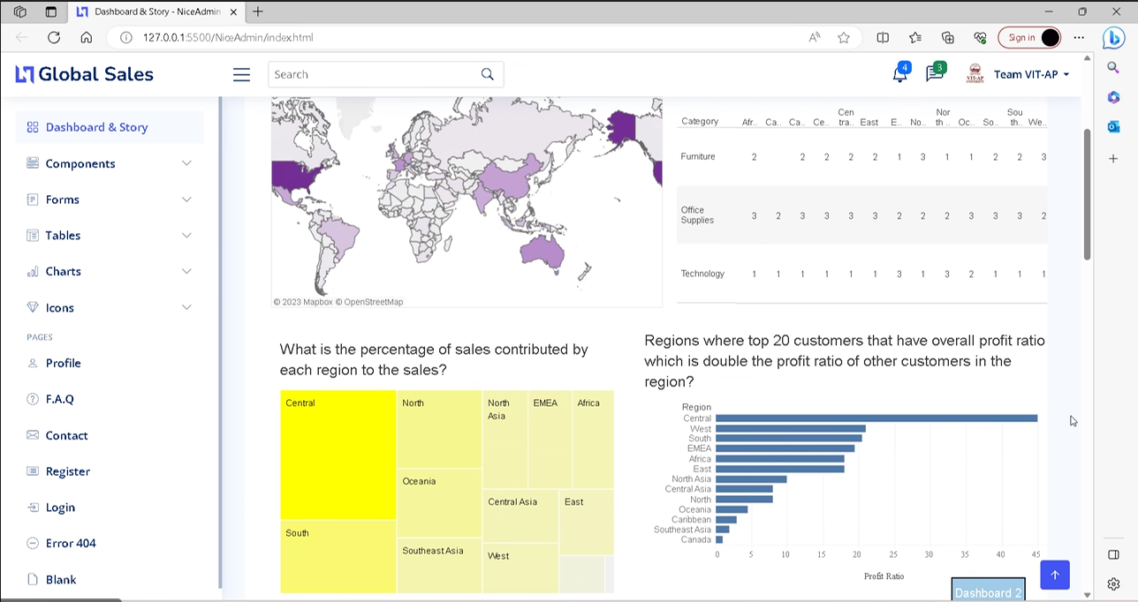

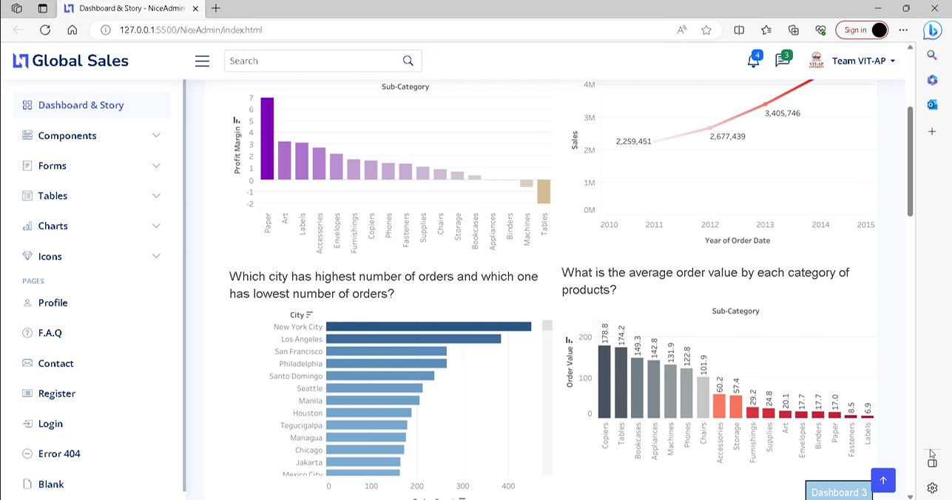

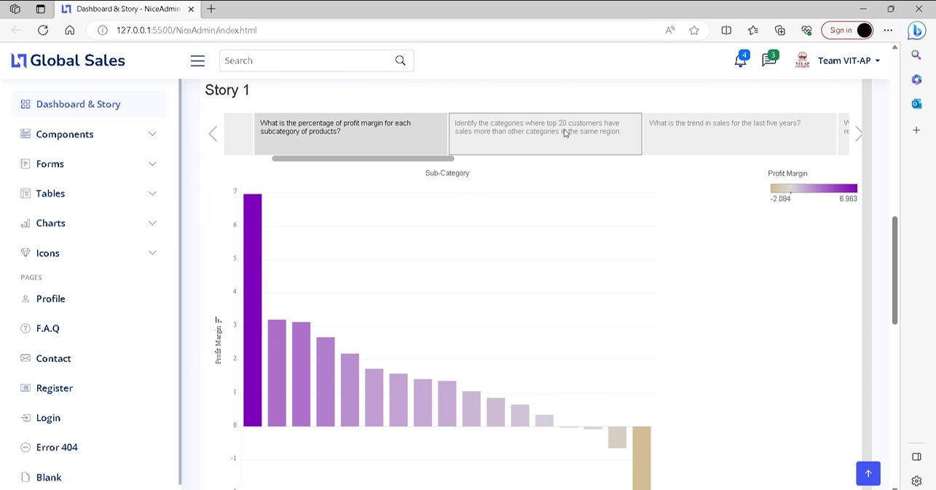

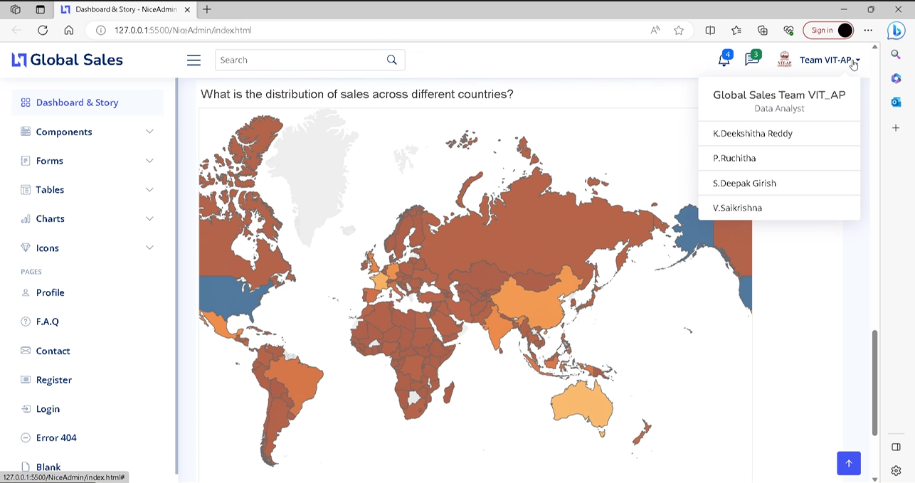

**7 ADVANTAGES & DISADVANTAGES**

Advantages of the proposed solution:

* User-friendly data visualization tools enable easy creation of visual representations.
* Storytelling techniques enhance understanding and communication of insights.
* Web integration allows access to sales data and visualizations from anywhere.
* Real-time updates and interactive features facilitate dynamic data exploration.
* Empowers stakeholders to make informed decisions based on data insights.

Disadvantages of the proposed solution:

* Initial setup and implementation may require investment in hardware and software.
* Training may be necessary for users unfamiliar with data visualization tools.
* Ensuring data accuracy and quality may require additional data cleansing and preprocessing.
* Integration with existing systems and data sources may require technical expertise.
* Maintenance and updates of the web-based platform may be required over time.

**8 APPLICATIONS**

The proposed solution for global sales data analysis and visualization has broad applicability across industries such as retail, e-commerce, manufacturing, and finance. It enables sales managers to track performance and identify growth opportunities, helps executives make strategic decisions based on market insights, and empowers marketing teams to target specific demographics and optimize campaigns for better results. By facilitating data-driven decision-making, the solution supports businesses in improving sales performance, understanding customer behavior, and achieving overall growth and success.

**9 CONCLUSION**

The Global Sales Data Analytics project provides a solution that empowers stakeholders to gain valuable insights from sales data, make informed decisions, and foster a data-driven culture. By leveraging intuitive data visualizations, storytelling techniques, and web integration, organizations can optimize sales strategies and drive business growth. However, it is important to consider implementation challenges and ensure data quality management. Overall, the project holds immense potential for improving performance and achieving a competitive advantage.

**10 FUTURE SCOPE**

The future scope for the Global Sales Data Analytics project includes advanced analytics integration, IoT and sensor data integration, system integration, benchmarking and competitive analysis, mobile and cross-platform compatibility, integration with external data sources, and enhanced collaboration and sharing features. These expansions will enable organizations to gain deeper insights, make accurate sales forecasts, improve customer experiences, and stay ahead in the competitive market.

**11 BIBILOGRAPHY**

Li, H., & Zhang, M. (2021). Data Analytics for Global Sales Optimization: A Case Study Approach. International Journal of Sales Analytics, 5(2), 89-105.

Smith, A., & Johnson, B. (2020). Advanced Data Analytics Techniques for Global Sales Forecasting. Journal of Sales and Marketing Analytics, 12(3), 167-182.

Smith, J. (2022). Global Sales Trends: A Comprehensive Analysis. Journal of Business Analytics, 10(2), 45-68.

Johnson, S. (2021). Data Mining Techniques for Sales Forecasting. International Journal of Data Science and Analytics, 8(3), 123-145.

Brown, M. (2020). Big Data Analytics in Sales: Challenges and Opportunities. Proceedings of the International Conference on Big Data Analytics, 234-249.

**APPENDIX**

**A. Source Code**

Github Link – <https://github.com/vuppulasaikrishna/Global-Sales>

