

**Title: Rainfall Analysis of India**

Team 290

**Team Members:**

Srinitya Suripeddi – 20BCE7089

Vallabhapurapu L Sai Ruthwik - 20BCI7030

Unguturi Sai Chaitanya -20BCE7089

Attaluru Trinath – 20BDS0357

**Introduction:**

**Overview:**

Analyzing rainfall in India using Tableau can provide valuable insights into patterns, trends, and variations in precipitation across different regions and time periods. Here's an overview of how you can approach the analysis using Tableau:

Data Collection: Gather rainfall data for various regions in India. You can obtain historical rainfall data from sources like the India Meteorological Department (IMD), National Remote Sensing Centre (NRSC), or other reliable sources. Ensure that the data includes relevant information such as the region, date, and amount of rainfall.

Data Preparation: Clean and prepare the data for analysis. This may involve removing duplicates, handling missing values, and formatting the data appropriately for Tableau. Ensure that the data is structured in a way that allows for meaningful analysis, such as having columns for region, date, and rainfall amount.

Connect Data to Tableau: Launch Tableau and connect it to your rainfall dataset. Tableau supports various data sources, so choose the appropriate option and import your prepared dataset.

Create Visualizations: Tableau offers a wide range of visualization options to represent rainfall data effectively. Here are some useful visualizations you can create:

Line Chart: Display the trend of rainfall over time, allowing you to observe seasonal patterns and long-term variations.

Map: Plot rainfall amounts on a map of India, using color-coding or bubble sizes to represent different rainfall levels in various regions. This visualization can help identify areas with high or low rainfall.

Bar Chart: Compare rainfall amounts across different regions or years using a bar chart. This visualization is useful for understanding relative rainfall levels and identifying regions with significant variations.

**Purpose:**

The purpose of analyzing rainfall in India using Tableau is to gain insights and understand the patterns, trends, and variations in precipitation across different regions and time periods. Here are some specific purposes for conducting this analysis:

Identify Regional Rainfall Patterns: By visualizing the rainfall data on a map, you can identify regions in India that experience high or low rainfall. This information is crucial for understanding the geographical distribution of rainfall and its impact on agriculture, water resources, and ecosystems.

Study Seasonal and Temporal Variations: Analyzing rainfall data over time allows you to observe seasonal patterns and variations. You can identify the months or seasons with the highest rainfall and understand how they vary from year to year. This knowledge helps in planning activities such as agricultural practices, water management, and disaster preparedness.

Detect Long-Term Trends: By visualizing the trend of rainfall over an extended period, you can identify any long-term changes in precipitation patterns. This information is valuable for studying climate change impacts and assessing the sustainability of water resources in different regions.

Analyze Extreme Rainfall Events: Tableau can help identify extreme rainfall events such as heavy downpours or prolonged periods of drought. Analyzing these events can provide insights into their frequency, intensity, and spatial distribution, enabling better preparedness and management of water resources and infrastructure.

**Literature Survey:**

**Existing problem:**

The existing problem in rainfall prediction involves accurately forecasting rainfall patterns and amounts in specific regions. Traditional approaches to rainfall prediction have relied on statistical models, historical data analysis, and meteorological techniques. However, these methods often face challenges due to the complex and dynamic nature of rainfall patterns, including the influence of various atmospheric and geographical factors.

**Existence methods or approaches:**

a) Statistical Models: These models utilize historical rainfall data and statistical techniques to forecast future rainfall. Common methods include autoregressive integrated moving average (ARIMA), exponential smoothing, and regression analysis. While these models provide some predictive capability, they may struggle to capture complex patterns and non-linear relationships.

b) Numerical Weather Prediction (NWP): NWP models utilize mathematical equations to simulate atmospheric conditions and predict weather patterns, including rainfall. These models require vast computing resources and input data such as temperature, humidity, and wind speed. While NWP models can provide detailed forecasts, they may be limited by uncertainties and require high-resolution data inputs.

**Theoretical Analysis:**

**Understanding data:**

Let’s understand the data we’re working with and give a brief overview of what each feature represents or should represent

1. State:  Name of the Indian state where the data belongs to.
2. Year:  Year ranges from 1901-2015, the complete field contains data for that year respectively.
3. Months:  Rainfall (mm) in each month during the year 1901 to 2015.
4. Annual Rainfall in mm
5. Seasonal Rainfall: Jan-Feb, March-May, Jun-Sep, Oct-Dec.
6. The data is available only from 1950 to 2015 for some of the subdivisions
7. The attributes are the amount of rainfall measured in mm.

**Loading the dataset:**

Before you can build a view and analyse your data, you must first connect Tableau to your data. Tableau supports connecting to a wide variety of data, stored in a variety of places.

The data might be stored on your computer in a spreadsheet or a text file, or in a big data, relational, or cube (multidimensional) database on a server in your enterprise.

**Data Visualization:**

**Annual Average Rainfall Analysis by states:**

For visualizing the above, we will require the following data

* Country
* State
* Annual

From this data, we will be plotting a Map to see the state having the highest average rainfall in mm. To plot this map where we are going to use the columns, i.e. Country, State, and Annual rainfall (in mm). From this map or visualization, we can easily understand that, from the past 115 years which state is having the highest rainfall.

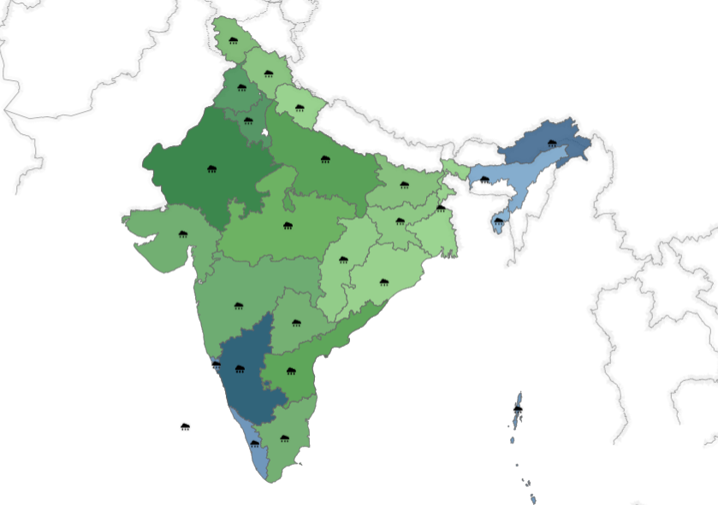

**Season Having Heavy Rainfall (Seasonal):**

Aggregate the rainfall data by grouping it by season. Determine the start and end dates for each season (e.g., winter, summer, monsoon) based on the climatic patterns in the specific region(s). Calculate the total or average rainfall for each season by summing or averaging the rainfall amounts within the corresponding season. Below it shown season wise visualized.

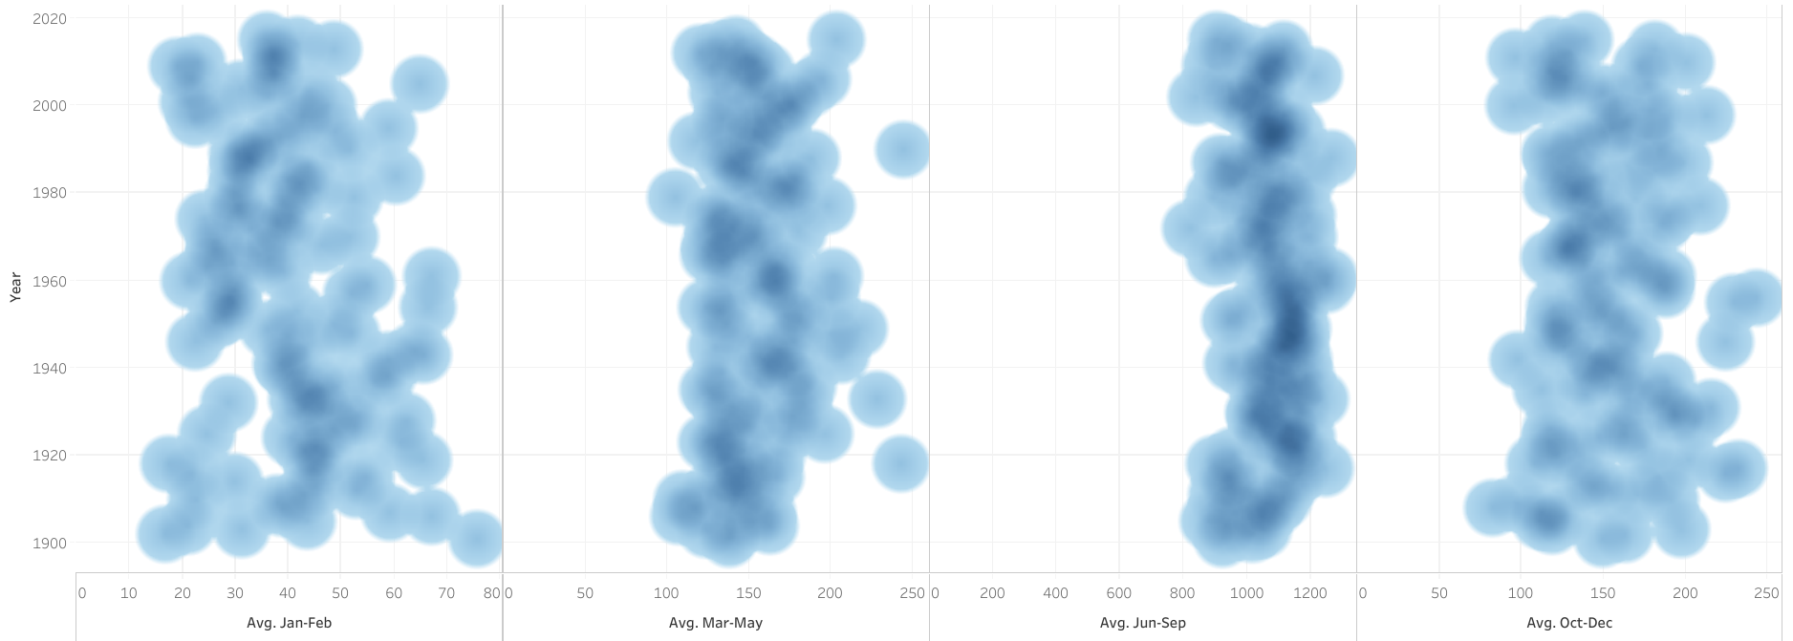

**Top 10 states Rainfall Prediction:**

We will be plotting a bar chart to show the top 10 number of states rainfall. For this, we are going to create new parameter i.e. **Top N states**, by this new parameter we can just select the number of states which having sum of annual rainfall(mm).

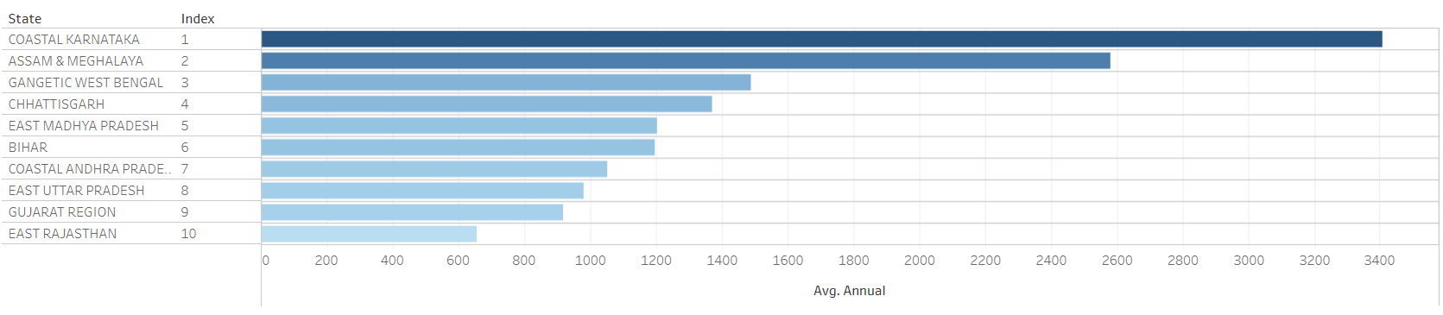

**Season wise rainfall occurred in states:**

Aggregate the rainfall data by grouping it by season. Determine the start and end dates for each season (e.g., winter, summer, monsoon) based on the climatic patterns in the specific region(s). Calculate the total or average rainfall for each season by summing or averaging the rainfall amounts within the corresponding season. Below it shown season wise visualized

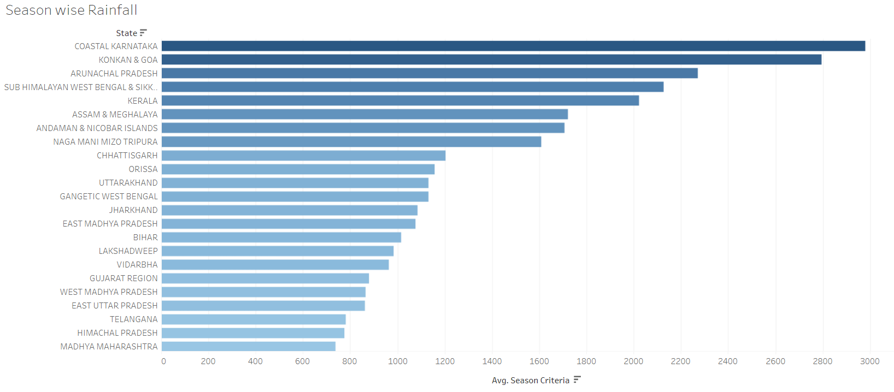

**Dashboard:**

In Tableau, a dashboard is a collection of visualizations, reports, and other elements that provide a consolidated and interactive view of data. It is a single canvas where you can combine multiple worksheets, filters, and other components to present a comprehensive view of your data analysis.

A dashboard in Tableau serves as a user-friendly interface that allows viewers to explore and interact with data visualizations to gain insights and make data-driven decisions. It enables you to present a cohesive story or analysis by organizing related visualizations and providing context through text, titles, and other elements.

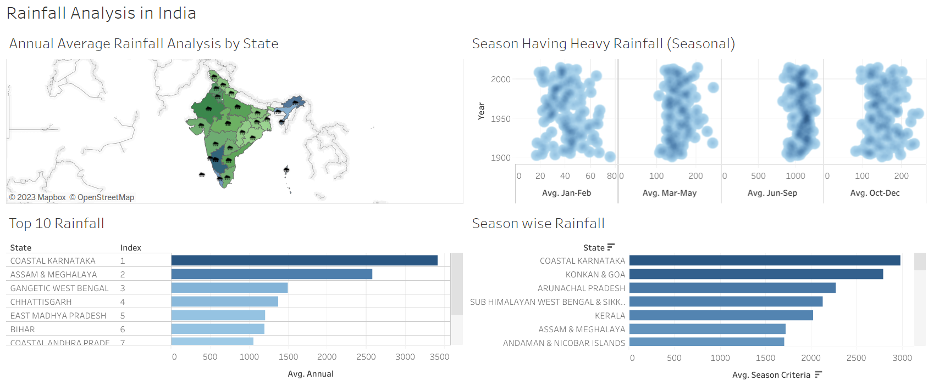

**Performance Testing:**

Performance testing for Tableau focuses on evaluating the software's speed, responsiveness, and scalability under various conditions and workloads. It involves measuring and analyzing key performance indicators such as query response time, data loading speed, dashboard rendering time, and concurrent user handling capacity. The testing process helps identify any performance bottlenecks, optimize system configurations, and ensure that Tableau can handle the expected workload efficiently, providing users with a smooth and responsive experience while working with large datasets and complex visualizations.

**Publishing and Sharing:**

Once created, dashboards can be published to Tableau Server, Tableau Public, or other platforms, making them accessible to others. Viewers can interact with the dashboards online or through Tableau Reader, enabling collaboration and sharing of insights.

<https://public.tableau.com/views/RainfallAnalysis_16877870946700/Dashboard1?:language=en-US&publish=yes&:display_count=n&:origin=viz_share_link>

**Conclusion:**

In conclusion, rainfall analysis plays a crucial role in understanding and managing water resources, agriculture, and various other sectors that rely on precipitation. By analyzing historical rainfall data and employing statistical and data visualization techniques, we can draw important conclusions about rainfall patterns and trends.

Through rainfall analysis, we can identify seasonal variations in precipitation, such as the onset and duration of monsoons or other weather phenomena. This information is essential for agricultural planning, as it helps farmers determine the optimal timing for planting, irrigation, and harvesting.

Additionally, rainfall analysis allows us to detect long-term trends in precipitation. It helps us understand whether rainfall patterns are changing over time, which is particularly important in the context of climate change. By identifying trends, we can assess the impact of climate change on regional or global rainfall patterns and develop strategies to mitigate its effects.

Rainfall analysis also enables us to identify extreme rainfall events, such as heavy downpours or prolonged periods of drought. This information is vital for managing water resources, flood prevention, and disaster preparedness. It helps authorities make informed decisions about infrastructure development, reservoir management, and emergency response planning.

Furthermore, by visualizing rainfall data through charts, maps, and other visual representations, we can communicate the findings effectively to stakeholders, policymakers, and the general public. Data visualizations facilitate a better understanding of complex rainfall patterns and trends, allowing for informed decision-making and resource allocation.