Home Automation using Telegram

**Abstract:** The Internet of Things (IoT)has generated excitement for a few years now, with start-ups and established businesses placing bets on the industry‟s growth. Along with the business solutions, IoT has been very vital in connecting things to the internet. Thereby achieving a communication among the connected devices. In this Thesis, I have conducted a research on opportunities and challenges of IoT. In the research study, I explored the need of IoT, possible ways to implement IoT, various sensors and devices etc. The study has been well explained in this thesis. Internet of Things has << definition, pros and cons>>. Various implementations of IoT could be done by using both proprietary hardware and open hardware. To implement a home automation, I need to study the insides of the hardware, which could not be possible by proprietary hardware. So I found the freedom and chose open hardware for the implementation of an instance of applications of IoT. PI boards has been very cost effective and easy to implement. Upon few software instructions, the Pi board would work as per the instructions with the connected devices. I have place a PI board with an OS and an application called “Telegram” to deploy the IoT software to sense and state the temperature and humidity of a location. Accordingly, I have recorded the values against the reports generated by the bot of telegram. In mere future I see this to be connected to the entire house and can be centrally operated by the bot technology of telegram application .This implements IoT to automate the control of connected thing in a house.

# INTRODUCTION

Technology has become a fundamental part of human life increasingly facilitating daily tasks. The Internet of Things (IoT) is supported by new information exchange technologies, that provides not only People-To-Machine communication but also Machine-To-Machine (M2M). The IoT is responsible for information request and/or executing commands remotely over hardware with different features and purposes. On the other hand, advances in technology also allow to users with no specific knowledge to create hardware prototypes, as automation to be used in daily situations, and the Raspberry pi platform is a good example of technology that supports the Do It Yourself (DIY) concept. The Raspberry pi is one of the most known and used platform regarding hardware prototypes construction, being used even for some final projects. This platform is very effective for small-scale projects construction, it is open source and it does not require specific knowledge for projects development. In this context, the IoT and platforms such as Raspberry pi allow common users to create their own hardware and communicate remotely with them through the Internet, as already highly used among people via smartphone messenger applications like WhatsApp or Telegram.The main contribution of this paper is to introduce the potential of the Telegram application applied to the IoT through Telegram Bot API on the communication between people and the Raspberry pi platform, exploring technologies that allow an application originally used in communication between people to be used in the communication between people and machines.

The idea of a fully functional smart home has been a dream since the mid of the twentieth century. The first trials started in the 1960s with the use of domestic smart devices, but this has become a reality only during the last decades. Smart home, as a term, was also introduced in 1984 by the American Association of House builders. Since then, things have dramatically changed with significant advances in the domain of intelligent building control. More specifically, houses, schools, and offices security can be drastically enhanced through electrical and electronic equipment while their energy footprint minimized with inner climate control which maximizes the comfort and safety of the occupant. Evolution of internet has taken a very long time. Internet is powerful social weapon which can be used in versatile ways. From sharing of data, multimedia messaging, browsing to online shopping and reservation.Its difficult to imagine life without internet. In the internet world, people are mostly spending their time with apps so we don‟t need to shift to another arena to control the appliances in our homes. We can control the online services at home from anywhere with these apps .It provides an interactive and user friendly interface on the client side, and the devices can be controlled and monitored very easily.

Home automation or smart home (also known as domotics) is [building automation](https://en.wikipedia.org/wiki/Building_automation) for the home. It involves the control and automation of lighting, heating (such as [smart thermostats)](https://en.wikipedia.org/wiki/Smart_thermostat), ventilation, air conditioning ([HVAC)](https://en.wikipedia.org/wiki/HVAC), and security, as well as [home appliances](https://en.wikipedia.org/wiki/Home_appliance) such as washer/dryers, ovens or refrigerators/freezers. [Wi-Fi](https://en.wikipedia.org/wiki/Wi-Fi) is often used for remote monitoring and control. Home devices, when remotely monitored and controlled via the Internet, are an important constituent of the [Internet of Things.](https://en.wikipedia.org/wiki/Internet_of_Things) Modern systems generally consist of switches and sensors connected to a central hub sometimes called a "gateway" from which the system is controlled with a [user interface](https://en.wikipedia.org/wiki/User_interface) that is interacted either with a wall-mounted terminal, mobile phone software, [tablet computer](https://en.wikipedia.org/wiki/Tablet_computer) or a web interface, often but not always via Internet cloud services.

# RELATED WORK

Telegram is a free cloud-based instant messaging service. Telegram clients exist for both mobile and desktop systems .Users can send messages and exchange photos, videos, stickers, audio, and files of any type. Telegram also provides optional end-to-end encrypted messaging. It also provides bot service by creating a new bot using the telegram app one can control the appliances present in the home or office by just chatting to the bot. we can configure the GPIO pins of raspberry pi to control different devices at home or office. It is very easy to control the devices at home because of its flexibility and easy to install. This app is used to communicate between the people but also, we are able to control the devices which also read the status from sensors and are logged to twitter and Gmail.

The Internet of things (IoT) is the inter-networking of physical devices, vehicles (also referred to as "connected art devices"), buildings, and other items embedded with electronics, software, sensors, actuators, and network connectivity which enable these objects to collect and exchange data. In 2013 the Global Standards Initiative on Internet of Things (IoT-GSI) defined the IoT as "a global infrastructure for the information society, enabling advanced services by interconnecting (physical and virtual) things based on existing and evolving interoperable information and communication technologies" and for these purposes a "thing" is "an object of the physical world (physical things) or the information world (virtual things), which is capable of being identified and integrated into communication networks". The IoT allows objects to be sensed or controlled remotely across existing network infrastructure, creating opportunities for more direct integration of the physical world into computer-based systems, and resulting in improved efficiency, accuracy and economic benefit in addition to reduced human intervention. When IoT is augmented with sensors and actuators, the technology becomes an instance of the more general class of cyber-physical systems, which also encompasses technologies such as smart grids, virtual power plants, smart homes, intelligent transportation and smart cities. Each thing is uniquely identifiable through its embedded computing system but is able to interoperate within the existing Internet infrastructure. Experts estimate that the IoT will consist of about 30 billion objects by 2020. Ishan Krishna, K. Lavanya explained in the proposed system is very useful for elderly and physically disabled persons who are in need of a physical assistance for daily needs. It eliminates the limitation of wiring complications also the range of voice commands can be extended by using wireless routers and lOT. On the off chance the viable usefulness and the cost of home automation decrease will enable compatibility with future technologies for customized user support. It implies that creation capacity as well as innovation level ought to enhance increasingly. In Future, the use of Aurdino can enable the control via., centralized server through smart mobile phones. Home Automation Systems (HAS) have gained world-wide popularity these days. It guarantees security, surveillance and solace to the user and make their life more comfortable. In developed countries, many households have smart home automation systems which detect their surroundings and act on the data to trigger home appliances such as fan, air conditioners etc. But these systems are not very popular in developing nations as compared to developed nations because of their pricing. Also, almost all of these systems are hard coded so they just make some decisions based on iterative conditions. The system has neither user defined nor conditional control. There comes the need of Voice Controlled Home Automation Systems (VCHAS). The proposed ZigBee based home automation system and Wi-Fi network are unified through a mutual home gateway. The combinatory offers network interoperability, a simple and supple user interface, and distant access to the system.

# SYSTEM DESIGN

**Taxonomy:**

Let us now propose taxonomy for research in IoT technologies (see below figure). Our taxonomy is based on the architectural elements of IoT as presented in above section.

The first architectural component of IoT is the perception layer. It collects data using sensors, which are the most important drivers of the Internet of Things. There are various types of sensors used in diverse IoT applications. The most generic sensor available today is the smartphone. The smartphone itself has many types of sensors embedded in it such as the location sensor (GPS), movement sensors (accelerometer, gyroscope), camera, light sensor, microphone, proximity sensor, and magnetometer. These are being heavily used in different IoT applications. Many other types of sensors are beginning to be used such as sensors for measuring temperature, pressure, humidity, medical parameters of the body, chemical and biochemical substances, and neural signals. A class of sensors that stand out is infrared sensors that predate smartphones. They are now being used widely in many IoT applications: IR cameras, motion detectors, measuring the distance to nearby objects, presence of smoke and gases, and as moisture sensors. We shall discuss the different types of sensors used in IoT applications.

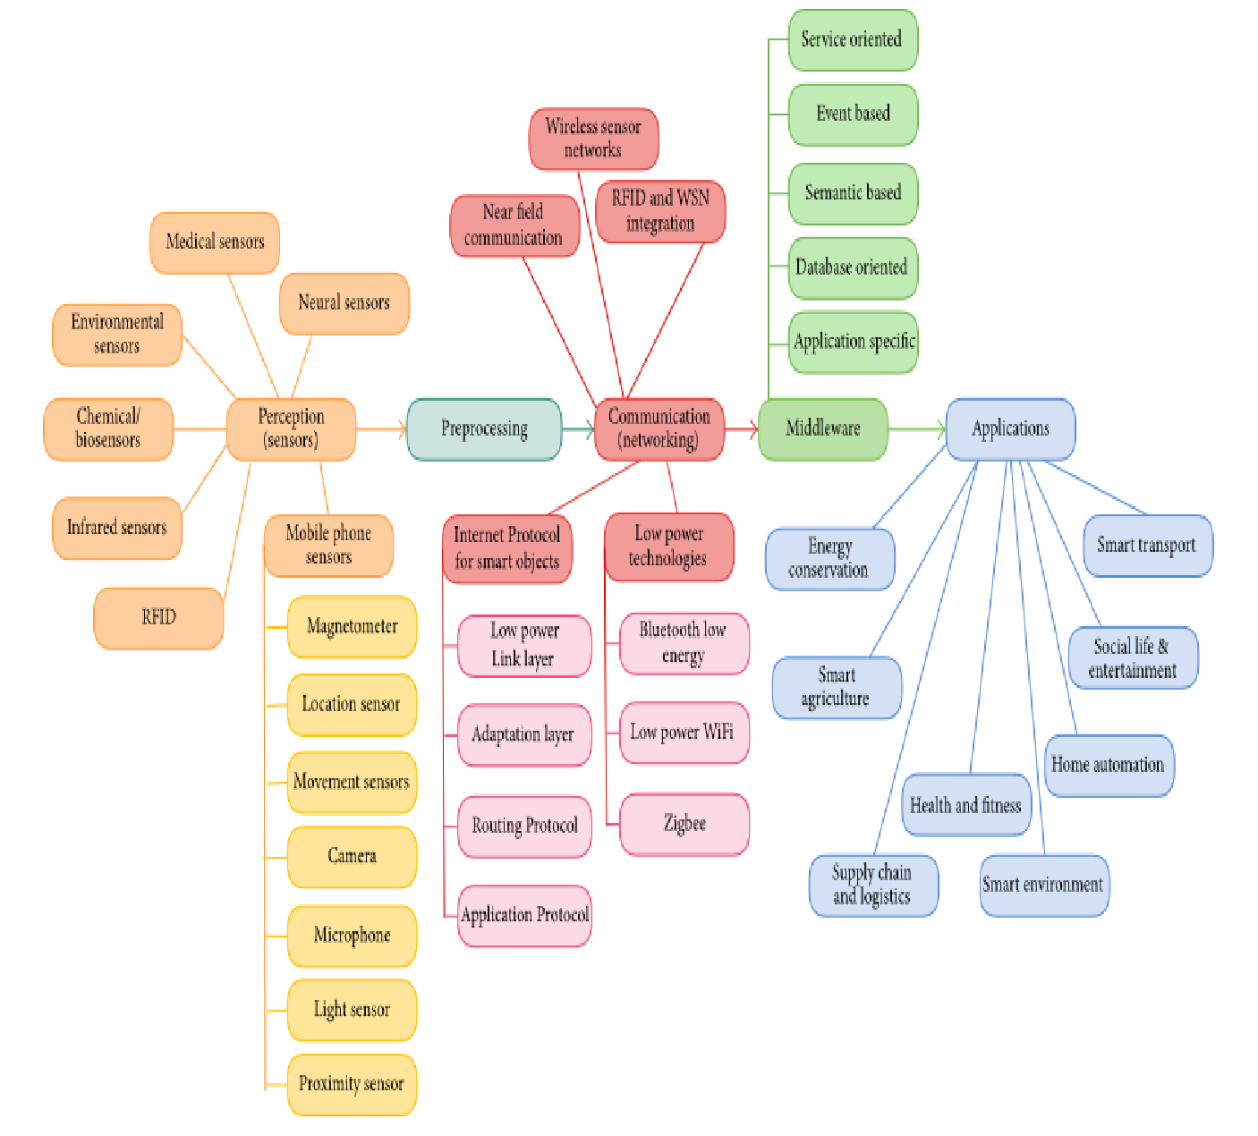

**Raspberry pi:**

Several generations of Raspberry Pis have been released. The first generation (Raspberry Pi 1 Model B) was released in February 2012. It was followed by a simpler and inexpensive model Model A. In 2014 the foundation released a board with an improved design in Raspberry Pi 1 Model B+. The model laid the current "mainline" form-factor. Improved A+ and B+ models were released a year later. A cut down "compute" model was released in April 2014, and a Raspberry Pi Zero with smaller size and limited input/output (I/O) and general-purpose input/output (GPIO) abilities was released in

November 2015 for US$5. The Raspberry Pi 2 which added more RAM was released in February 2015. Raspberry Pi 3 Model B released in February 2016 is bundled with on-board WiFi and Bluetooth. As of 2016, Raspberry Pi 3 Model B is the newest mainline Raspberry Pi. These boards are priced between US $20–35.

All models feature a Broadcom system on a chip (SoC), which includes an ARM compatible central processing unit (CPU) and an on chip graphics processing unit (GPU, a Video Core IV). CPU speed ranges from 700 MHz to 1.2 GHz for the Pi 3 and on board memory range from 256 MB to 1 GB RAM. Secure Digital (SD) cards are used to store the operating system and program memory in either the SDHC or Micro SDHC sizes. Most boards have between one and four USB slots, HDMI and composite video output, and a 3.5 mm phone jack for audio.

Lower level output is provided by a number of GPIO pins which support common protocols like I²C. The B-models have an 8P8C Ethernet port and the Pi 3 has on board Wi-Fi 802.11n and Bluetooth.

The Foundation provides Raspbian, a Debian-based Linux distribution for download, as well as third party s 10 IOT Core, RISC OS, and specialised media center distributions. It promotes Python and Scratch as the main programming language, with support for many other languages. The default firmware is closed source, while an unofficial open source is available.

In February 2016, the Raspberry Pi Foundation announced that they had sold eight million devices, making it the bestselling UK personal computer, ahead of the Amstrad PCW. Sales reached ten million in September 2016.

The Raspberry Pi hardware has evolved through several versions that feature variations in memory capacity and peripheral-device support.

The block diagram depicts Models A, B, A+, and B+. Model A, A+, and the Pi Zero lack the Ethernet and USB hub components. The Ethernet adapter is internally connected to an additional USB port. In Model A, A+, and the PI Zero, the USB port is connected directly to the system on a chip (SoC). On the Pi 1 Model B+ and later models the USB/Ethernet chip contains a five-point USB hub, of which four ports are available, while the Pi 1 Model B only provides two. On the Pi Zero, the USB port is also connected directly to the SoC, but it uses a micro USB (OTG) port.

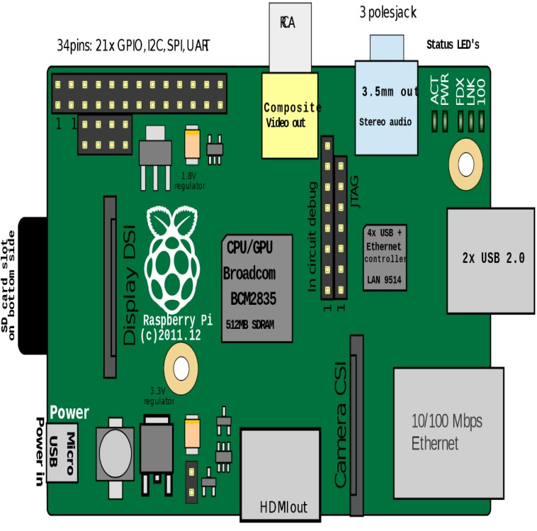

# SYSTEM IMPLEMENTATION

**Setting up pi**

An essential PC. I didn't understand that you can't simply get the Pi running without as of now owning another PC, Mac or PC. Ideally you as of now have one of these, or this venture just got significantly more costly. A SD memory card reader. The Raspberry Pi needn't bother with this, yet your essential PC does as such you can exchange establishments from it to the Pi. A great deal of PCs accompany an inherent card reader, however in the event that yours wouldn't, you may like to put resources into one. Presently, we should quick forward to the day when your Raspberry Pi and every one of its embellishments touch base via the post office. This is what to do, and when to do it. Put your Raspberry Pi for its situation. Unless it's exceptionally altered, it ought to keep on having openings in it for the greater part of the Pi's inputs1. Set the Pi aside and go to your essential PC. Embed your SD card and organization itaccording to the Foundation's bearings. This will introduce a recuperation program on it so you can spare your card regardless of the possibility that you break it with your tinkering. Download NOOBS on your essential PC. Short for New Out Of Box Software, it's the Raspberry Pi Foundation's fittingly named distro for first-time Pi clients. A distro is a bundle establishment of Linux and its related programming.

Stack your NOOBS download onto the recently arranged SD card. Time to begin with the Raspberry Pi. Slide the SD card into the underside of the Raspberry Pi, and ensure it's situated effectively; it'd be terrible to break your Pi before you turn it on! Associate it to the power supply, screen, console, and mouse. The Raspberry Pi will boot up and take you the NOOBS screen. On the off chance that it doesn't, check your energy supply and HDMI links and ensure they're secure. Select an OS to introduce. On the off chance that you select the default Raspbian, prescribed for apprentices, Adafruit has an extraordinary instructional exercise on the procedure. This introduce will take a while (20 minutes for me) so this is a decent time to go accomplish something else. Once the record duplicates, you'll get a notice that says, "Picture connected effectively." Press return, and the Pi will reboot. Presently it will boot into the working framework's graphical UI, which looks a ton like Windows 98.

**Requirements:** C library for Broadcom BCM 2835 as used in Raspberry Pi This is a C library for Raspberry Pi (RPi). It provides access to GPIO and other IO functions on the Broadcom BCM 2835 chip, as used in the RaspberryPi, allowing access to the GPIO pins on the 26 pin IDE plug on the RPi board so you can control and interface with various external devices.

# RESULTS AND DISCUSSIONS

Open the telegram on the raspberry board and open the home automation temperature sensor bot and then list of command ,/getouts-shows the status of the two relays /setout1ON|OFF,/setout2ON|OFF sets one of the outputs to ON or OFF,/gettemp-shows the actual temperature,/gethum-shows the actual humidity.

# CONCLUSION

In a intense study of Internet of Things, I found it to be hypothetical based on its purpose of application. It means IoT provides a lot of automation by connecting things. Connecting things has been made easy by the various sensors and embedding them them to the devices. In my instance of application with telegram messenger, I have used bots to communicate with the connected things in a house. Later by the statistical report given by the bot any user can take the decision on automation of house. With the emerging technologies, I have been successful in exploring the connectivity of various things in a house and also as a network specialist I also reported the pros and cons of connecting things. In future I would see the connected things at a different applicative arena, where it could be used in all contingency situations. It is found that IoT can be implemented and integrated with any software application. So this thesis is just an instance of IoT's implementation using a messenger application.

# REFERENCES

1. Ishan Krishna, K. Lavanya,”Intelligent Home Automation System using BitVoicer”, 11th International Conference on Intelligent Systems and Control, 2017.
2. Ramón Alcarria, Diego Martín de Andrés, “A Service-Oriented Monitoring System Based on Rule Evaluation for Home Automation”, IEEE 2016.
3. Hattie Clougherty, Alec Brown, Margaret Stonerock, “Home Automation and Personalization through Individual Location Determination”, IEEE 978-1-5386-1848-6/17/$31.00 2017.
4. ShibliNisar, Muhammad Asadullah, “Home Automation Using Spoken Pashto Digits Recognition”, IEEE 978-1-5090-3310-2/17/$3\.00 2017.
5. Sukhen Das, souvikghosh, RishirajSarker, “A Bluetooth Based Sophisticated Home Automation system Using Smartphone”, international conference on intelligent power and instrumentation, 2016.
6. Juan Carlos de Oliveira, Danilo Henrique Santos,” Chatting with Arduino Platform through Telegram Bot”, IEEE International Symposium on Consumer Electronics, 2016.
7. Vedan rattan vasta , Gopal singh, “Raspberry Pi based Implementation of Internet of Things using Mobile Messaging Application - „Telegram‟”, International Journal of Computer Applications (0975 – 8887), Volume 145 – No.14, July 2016.
8. Ankush B.powar, shasikanth gumhre, “A SURVEY ON IoT APPLICATIONS, SECURITY CHALLENGES AND COUNTER MEASURES”, international conference on computing, dec 19-21, 2016.