**<- An Android Dev Project ->**

### “An Android Application To Search Nearby Business Using Kotlin - Project 1”

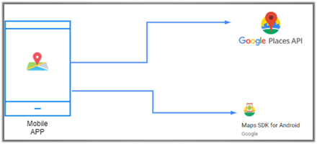**-Using Android Studio**

**SUBMITTED TO:**

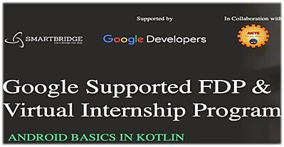

**SUBMITTED BY:**

**Ansh Rathore**

**Git Repo:- https://github.com/smartinternz02/SPSGP-77782-Virtual-Internship---Android-Application-Development-Using-Kotlin**

# INDEX

**1.1 Introduction**

**1.2 Object**

**1.3 Background**

**1.4 Visuals**

**1.5 Working**

**1.6 Conclusion and Future Scope**

**1.7 Acknowledgement**

**1.1 Introduction**

In today’s world everyone needs to have an shortcut for everything and to do so everyone uses there smartphones.

Therefore, to accomplish nearby business searching task I have developed an android application based on Kotlin Language.

This consists of an mapActivity that gives you a search bar through which you can search the desired business nearby.

On starting we have the splash screen followed by the main activity that is the map activity.

In the bottom the user has the option to either view all the business around his/her location at once. The marker is initially placed at the users current location and using that location as the center the google map api (application programming interface) shows the nearby places.

**1.2 Objective**

The main aim of this project is to help user find the places they want to find in an easier manner and let the user know the distance of that place.

**1.3 Background**

**The near by place application will allow the user to search for near by places it is done through the google map api.**

1. **Splash Screen**
2. **The Google Map Api**
3. **Fragments**
4. **Markers**
5. **Search Bar**
6. **Distance Calculator using google api**

**1.4 Visuals**

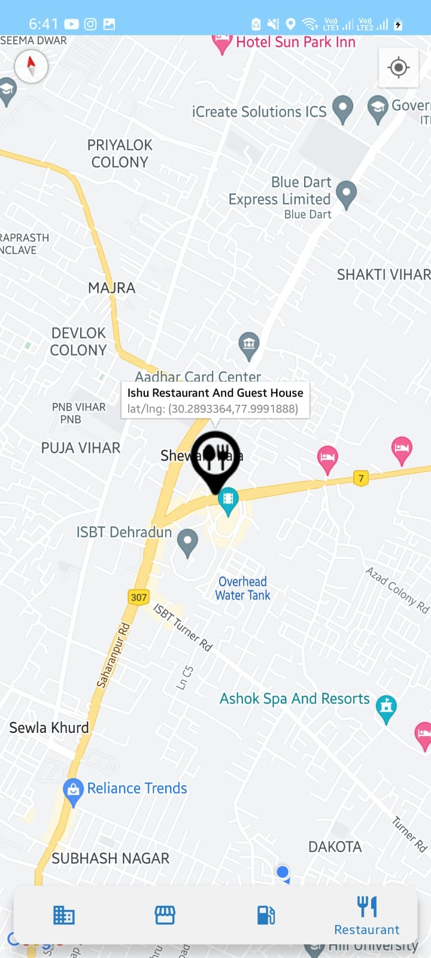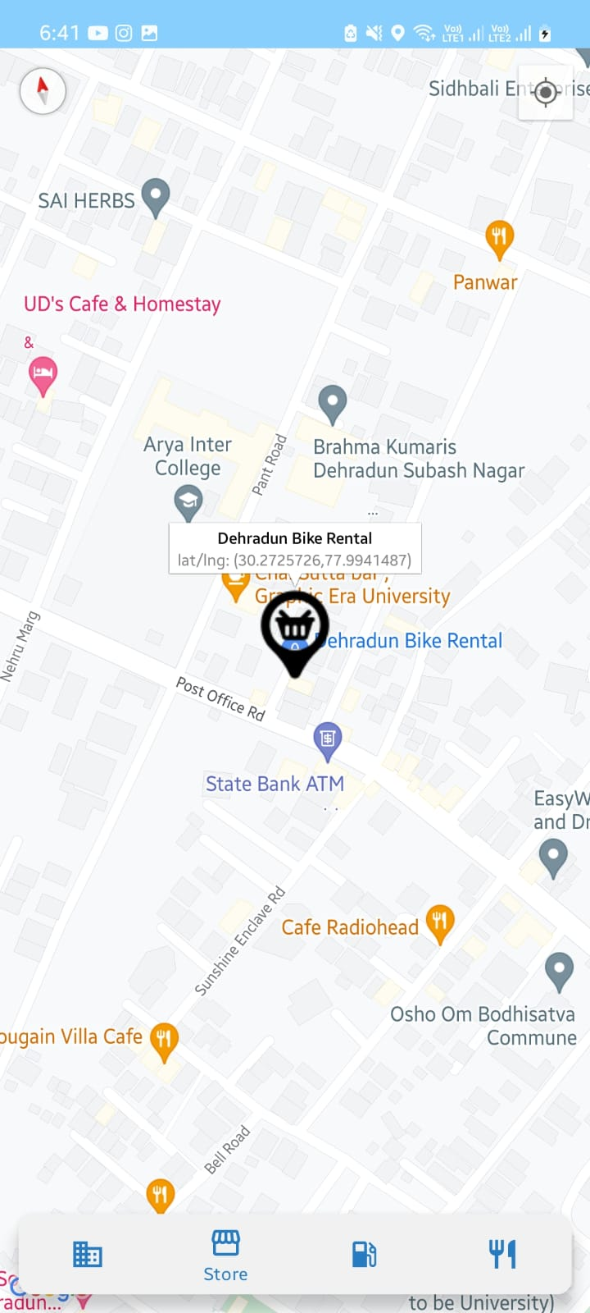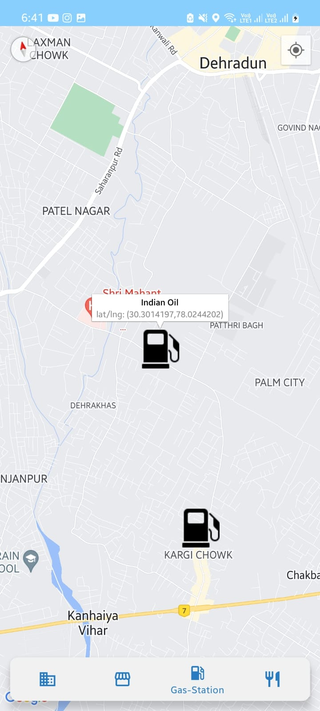



**1.5 Working**

**First, taking location permission from the user.**

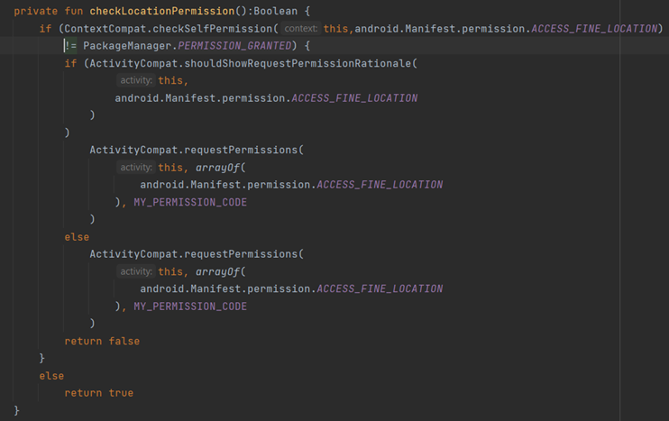

**Second, setting the user’s current location.**

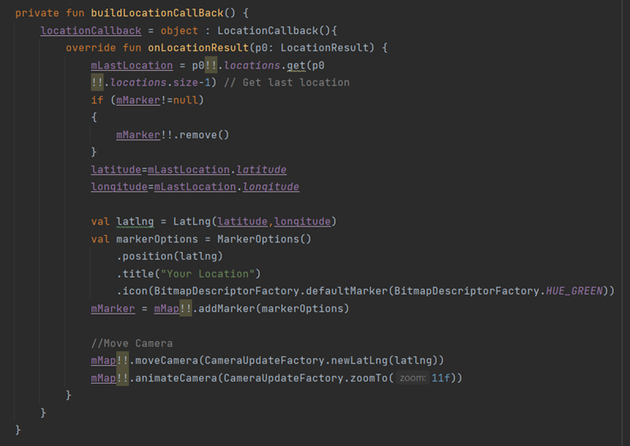

**Now, after knowing the selected menu option.**

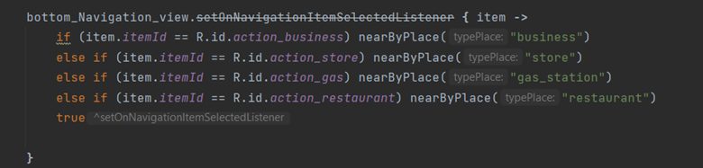

**We just have to fetch the location related to selected menu item and display it.**

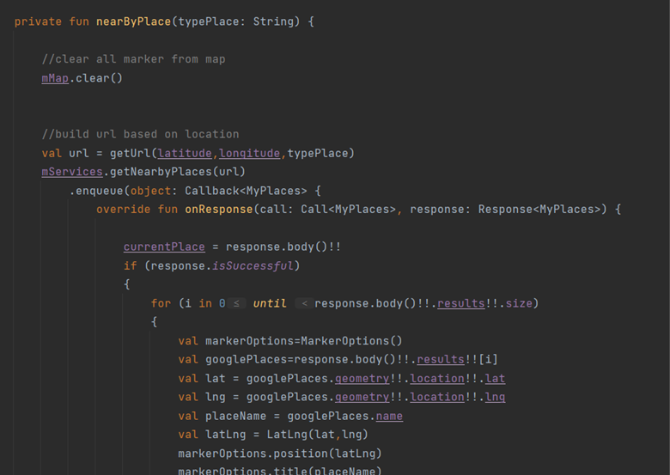

**Also, we have to display the needed info on the marker.**

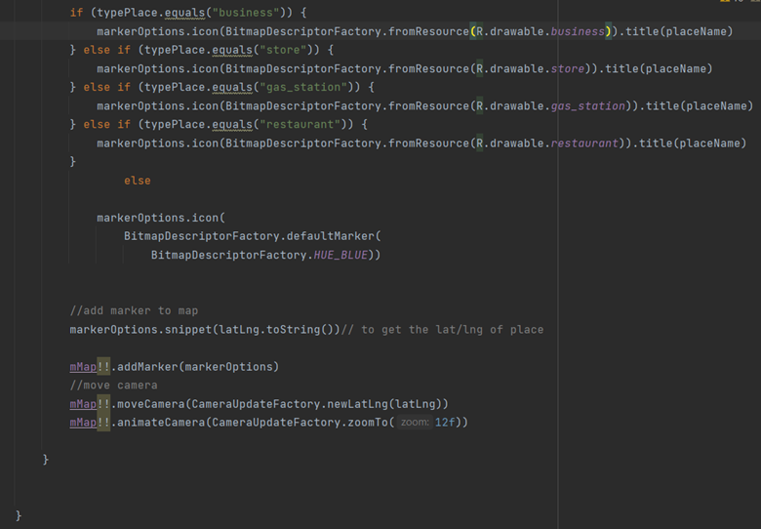

**Finally, we completed our aim.**

**1.6 Conclusion and Future Scope**

**This app could be useful for scanning the nearby areas and in future when we want to have more such feature full apps this could be helpful.**

**Future Scope: -**

1. **A dedicated feature to save the searched location for future reference**
2. **A reviewing feature for the business**
3. **Opening and closing time of store/business.**

**1.7 Acknowledgement**

**I have taken many efforts in this project. However, it would not have been possible without the kind support and help of many individuals and organizations. I would like to extend my sincere thanks to all of them.**

**I am highly indebted to SMARTINTERNZ (Experiential Learning & Remote Externship Platform to bring academia & industry very close for a common goal of talent creation) for their guidance and constant supervision as well as for providing necessary information regarding the**

**project & also for their support in completing the project. I would like to express my gratitude towards member of (Smart Internz) for their kind co-operation and encouragement which help me in completion of this project. I would like to express my special gratitude and thanks to industry persons for giving me such attention and time. My thanks and appreciations also go to people who have willingly helped me out with their abilities**

**------THE END------**