**INTERNSHIP PROJECT REPORT ON**

**INTERNET OF THINGS**

Completed

**Project Name**

SMART PLANT COMMUNICATOR SYSTEM USING WITH IBM CLOUD

**Submitted by**

Vikram Singh Chauhan

Mayank Yadav

Saurabh Pandey

Vedant Agarwal

**Project ID**

SPS_PRO_101

**Intern ID**

IISPS-INT-2322

i

**CHAPTER-01**

**INTRODUCTION**

**1.1 OVERVIEW**

Agriculture plays an important role in a country’s economy and provides large-scale employment to the people. However, agriculture is highly dependent upon weather and climate. For example, changes in temperature, soil moisture, carbon dioxide may result in low yield of crops. It is Significant to monitor environmental parameters in order to manage crop growth and increase the agricultural production yield. The sensed information is not only important for decision making but also for evaluating the impacts of agricultural practices on the environment.

Nowadays, it is more necessary than ever to increase the crop yields food grain production. Cloud-connected, wireless systems aid in this crop yield maximization, which automates day-to-day agricultural tasks and real-time monitoring for smart decision-making.

**1.2 PURPOSE**

∙ Need for technology to monitor important parameters like soil moisture, temperature, Humidity etc. to improve the cultivation process.

∙ Development of a feasible method to control the electrical equipment in the farm from any part of the world.

**CHAPTER-02**

**LITERATURE SURVEY**

**2.1 Smart Plant Communicator System With IBM Cloud**

Sukpal Singh Gill et al (2017) modeled a cloud-based autonomic information system for delivering Agriculture-as-a-service, through the use of clouds and big data technology. From the experimental results it was observed that the proposed system offers better service and the quality of service was also better in terms of Qos parameters.

Ravi Kishore Kodali et al(2016) proposed a low cost weather monitoring device to retrieve the weather condition of any location from cloud data base management system. Since it is not using any peripheral device monitoring the weather. It was observed that cost of the device can be reduced.

Ibrahim Mat et al (2018) developed a smart Agricultural system using Iot. It was concluded that above proposed system using IoT can play a important role in conventional and large farming area. And a comparison b/w IoT and Conventional Mushrom farming was conducted. It was observed that the farm monitored by IoT had better growth rate than the conventional method.

Prathibha et al (2017) modeled a smart farming using IoT. The important parameters like Temperature and Humidity in agricultural field was monitored by using CC3200 chip and camera was interfaced with CC3200 to capture image and the captured image was forwarded to the farmer using MMS. The proposed system can be used in green house and temperature dependent plants.

2

Yifan Bo et al (2011) conducted a study on integrating cloud computing and IoT in the field of agriculture. It was observed that cloud computing and IoT had high reliability, expansibility and high accuracy.

Tien Wo-Hoang et al (2017) proposed an IoT System architecture based on wireless Sensor Network. The various parameters like temperature, relative humidity, luminosity, air pressure etc were monitored from a web browser. A WIFI interface device was used to transfer this environmental data’s from sensor to the web browser. It was observed that yield of crops can be improved by this method.

M.K.Gayatri et al (2015) proposed a technology to hold the huge data’s coming from the agrarian output. ZigBee module was used to measure various parameters like temperature, humidity, and illumination. A Wireless communication was used to communicate between the sensor and the data centre.

Samudra et al (2019) developed an intelligent farming with wireless Networking and MQTT, to monitor the real time agricultural environment. The parameters like luminicense, Soil moisture and Temperature were monitored. By comparing these data’s the output like motor was controlled.

Qiulan Wu et al (2017) developed an smarter agricultural system based on technologies like GIS, Cloud computing, IoT, Big data and sensing technology. This method allows the user to get the information at faster rate. This method will reduce the cost and energy consumption.

3

**2.2 EXISTING PROBLEM**

1. Controlling the device from longer distance from web application. 2. Getting the weather data from weather station.

3. Transfer of node data to the gateway at faster rate.

**2.3 PROPOSED SOLUTION**

1. To control a device from a longer distance from web application.

2. To get the weather details like wind speed, temperature, humidity from the weather station through weather API.

3. To display the data in the web application

4

**CHAPTER-03**

**THEORETICAL ANALYSIS**

**3.1 BLOCK DIAGRAM**

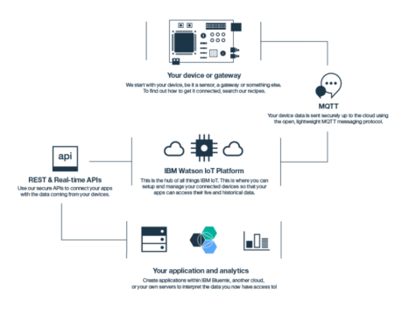

5

**3.2 SOFTWARE DESIGNING**

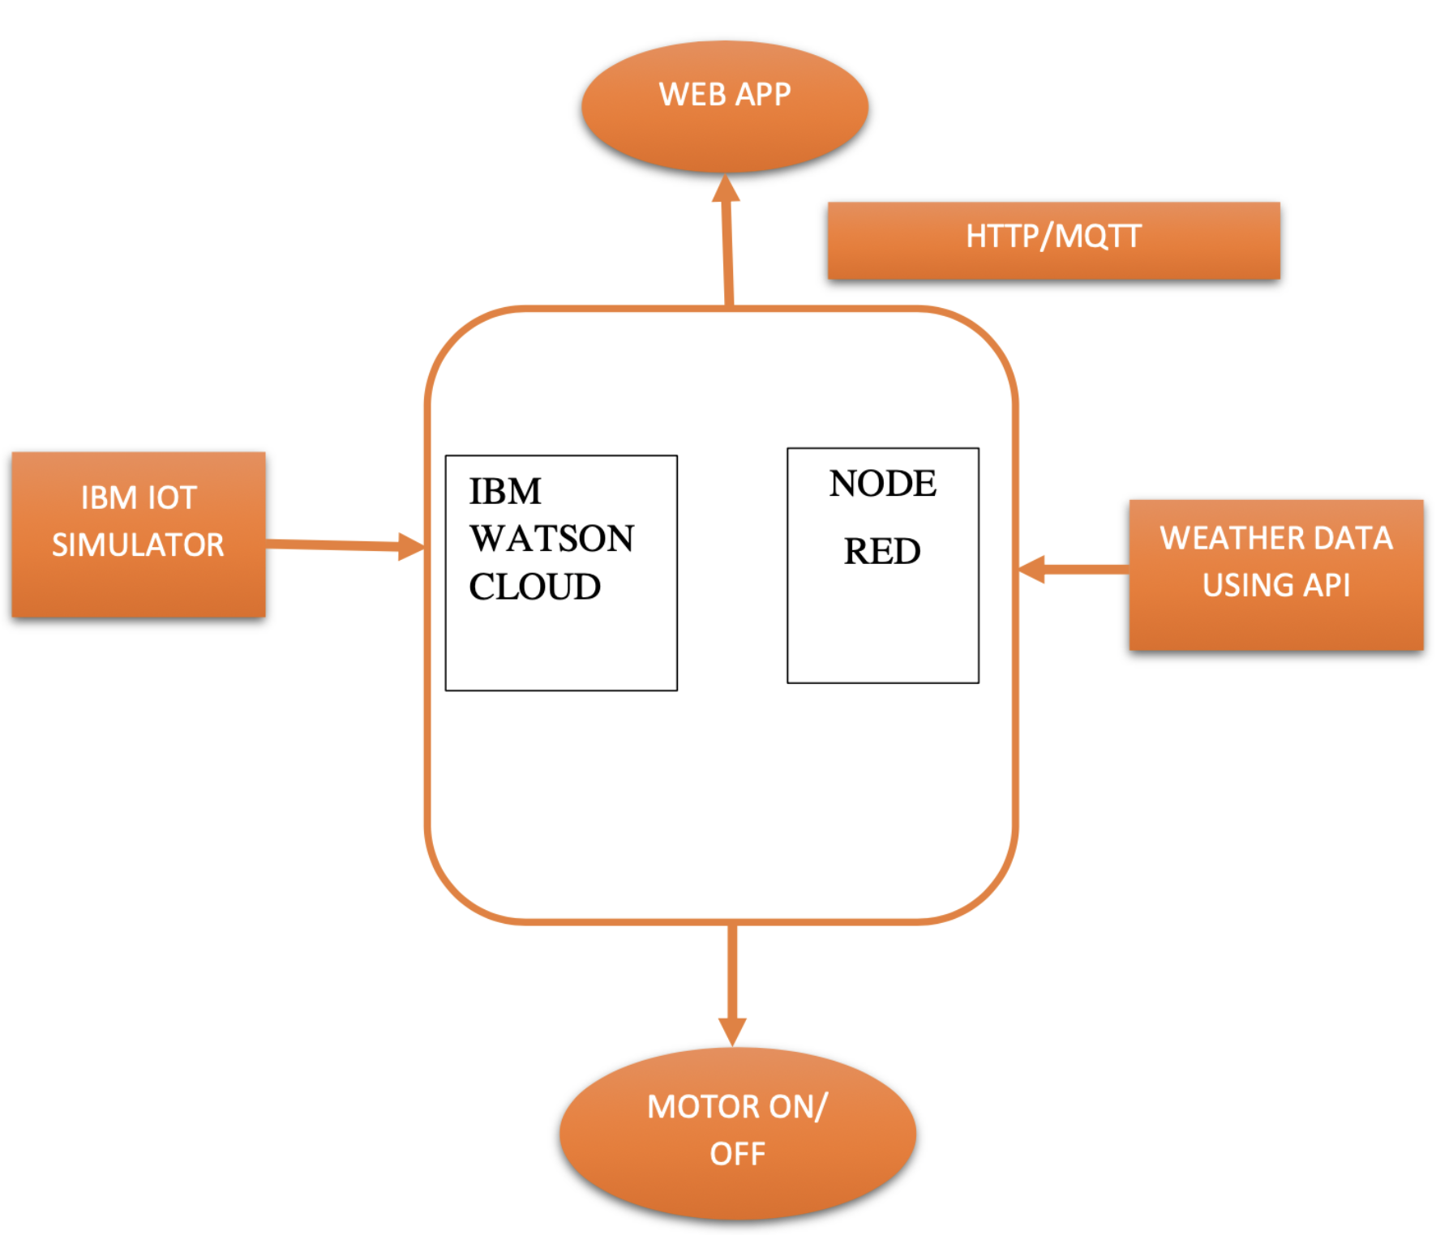

**CHAPTER-05**

**FLOW CHART**

**5.1 METHODOLOGY**

****START

CREATING IBM CLOUD AND 

INSTALLING THE IOT PLATFORM IN

THE CLOUD

CREATING DEVICE AND API KEY

SETTING IOT SENSOR SIMULATOR

CREATING THE NODE-RED FLOW 

FOR READING AND TO DISPLAY THE

SIMULATED VALUE

CREATING THE FLOW TO DISPLAY 

THE WEATHER API DATA

CREATING A PYTHON CODE TO 

READ THE DATA FROM CLOUD

STOP

**CHAPTER-06**

**RESULT**

**6.1 HOME PAGE**

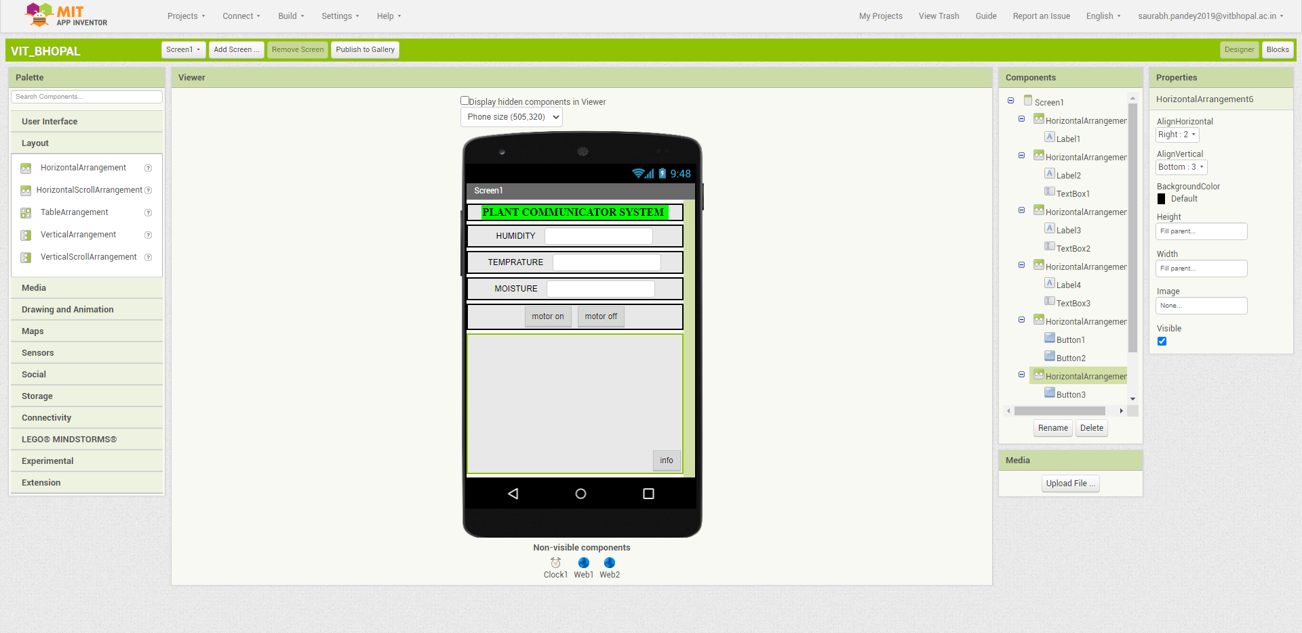**6.2 SENSOR SIMULATOR AND MOTOR CONTROL PAGE**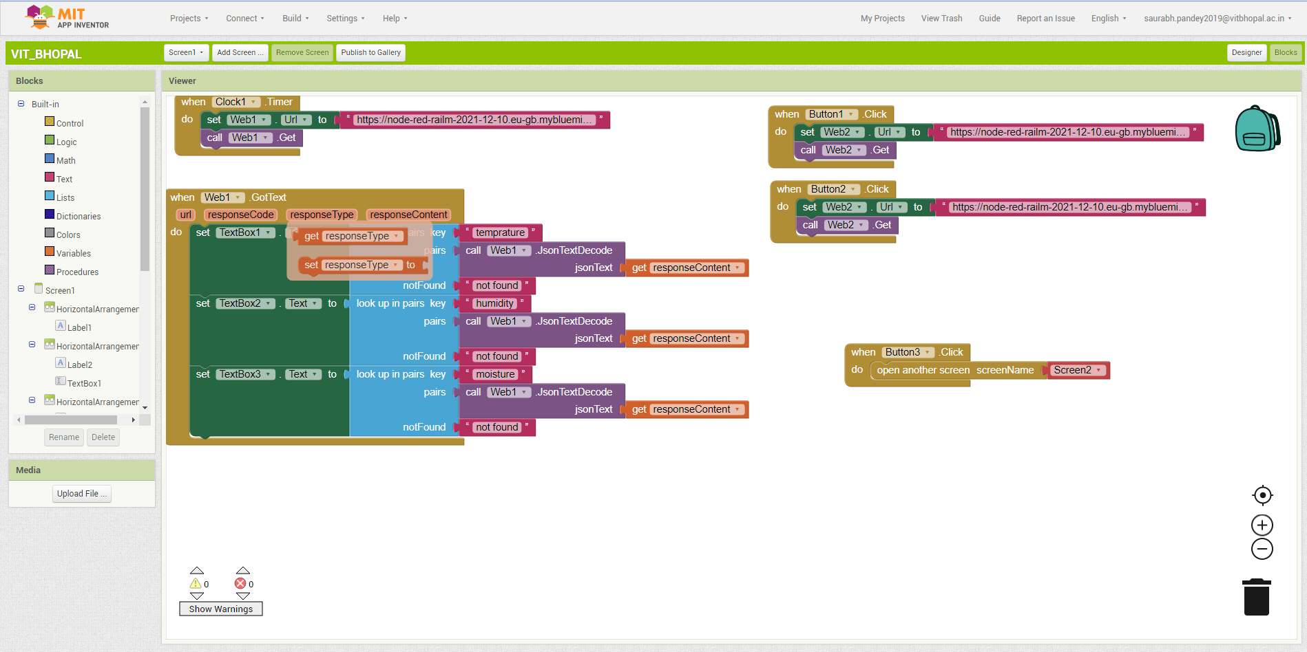

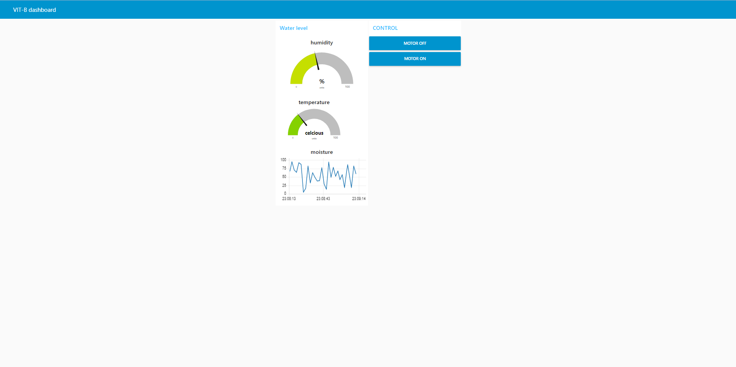

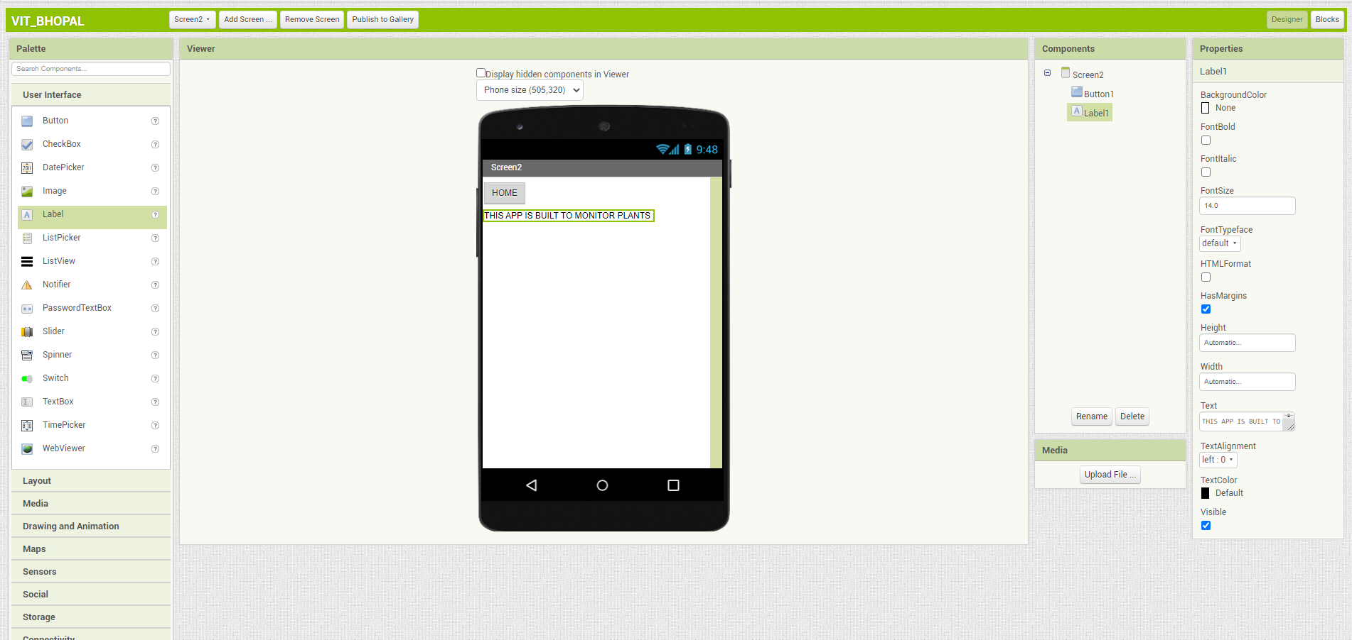

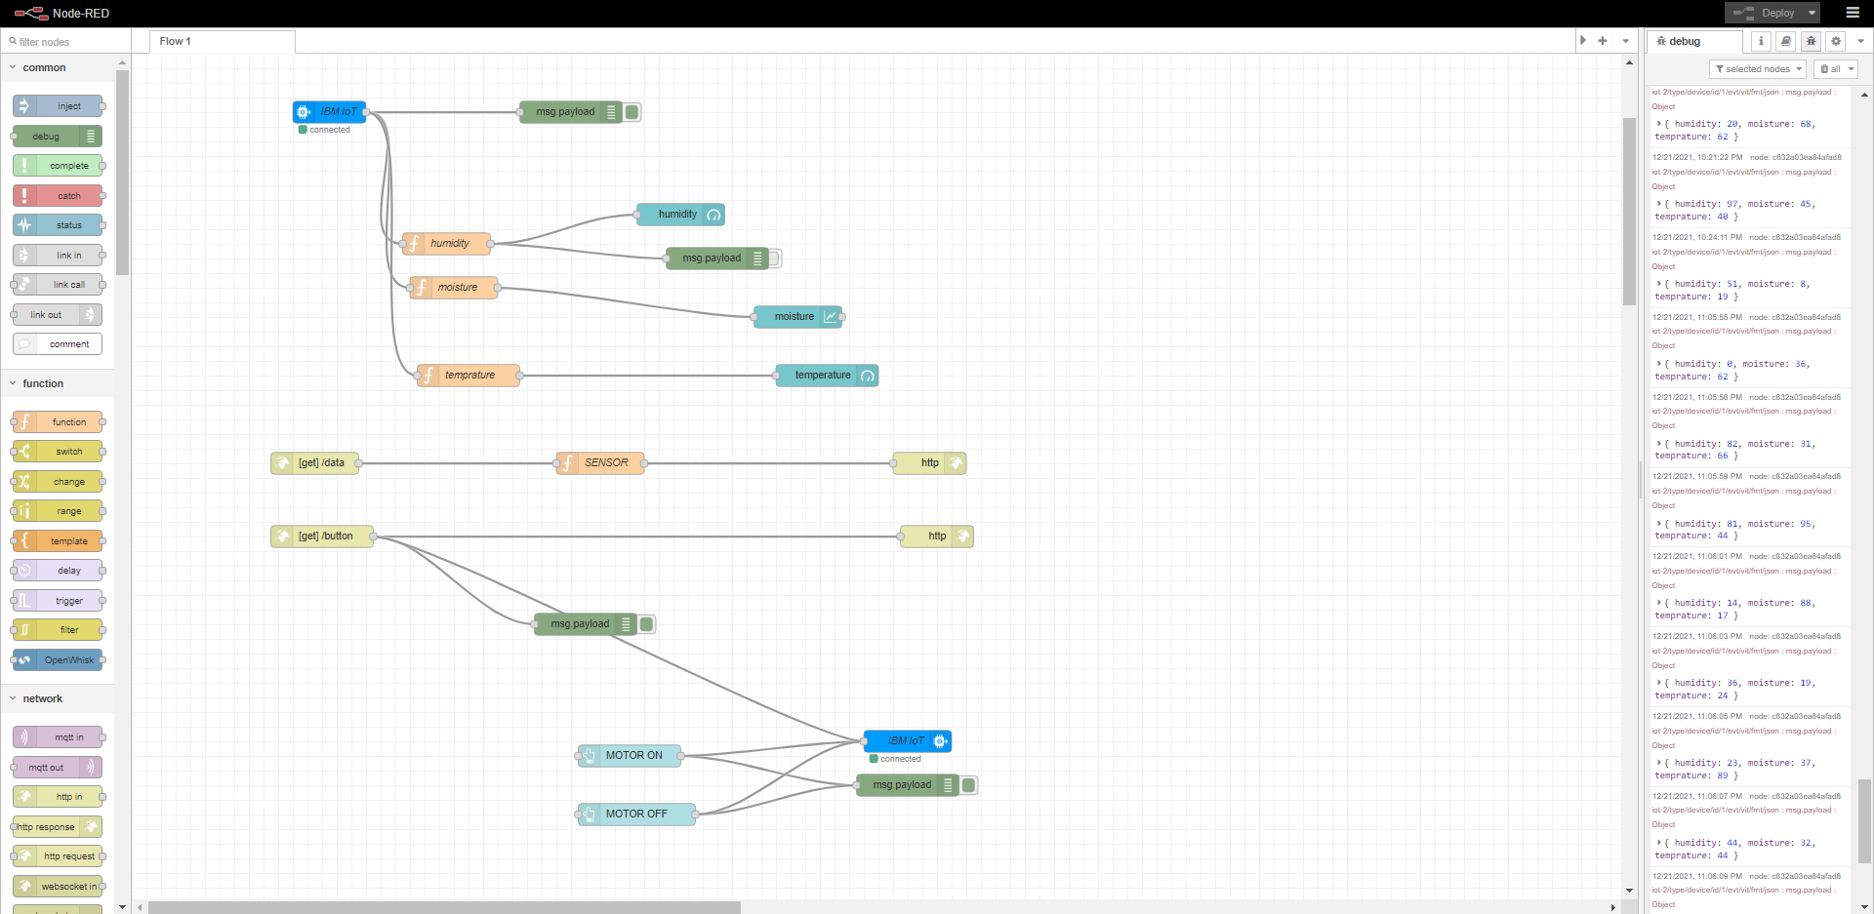



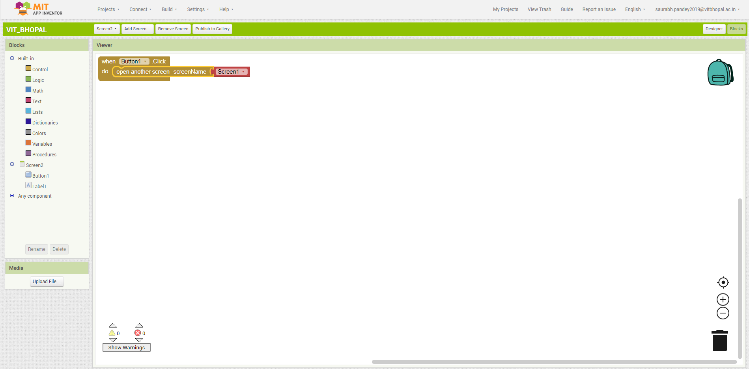

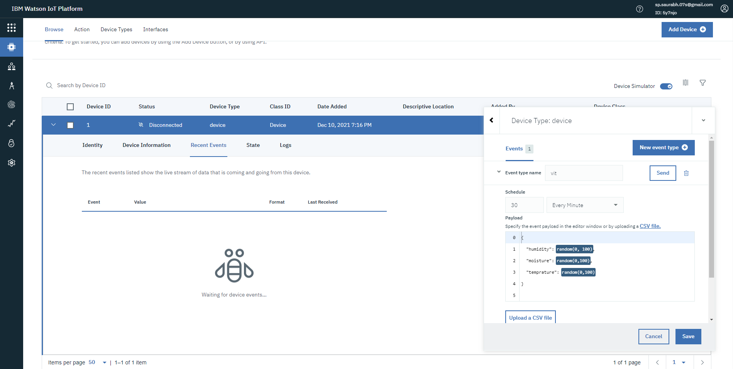

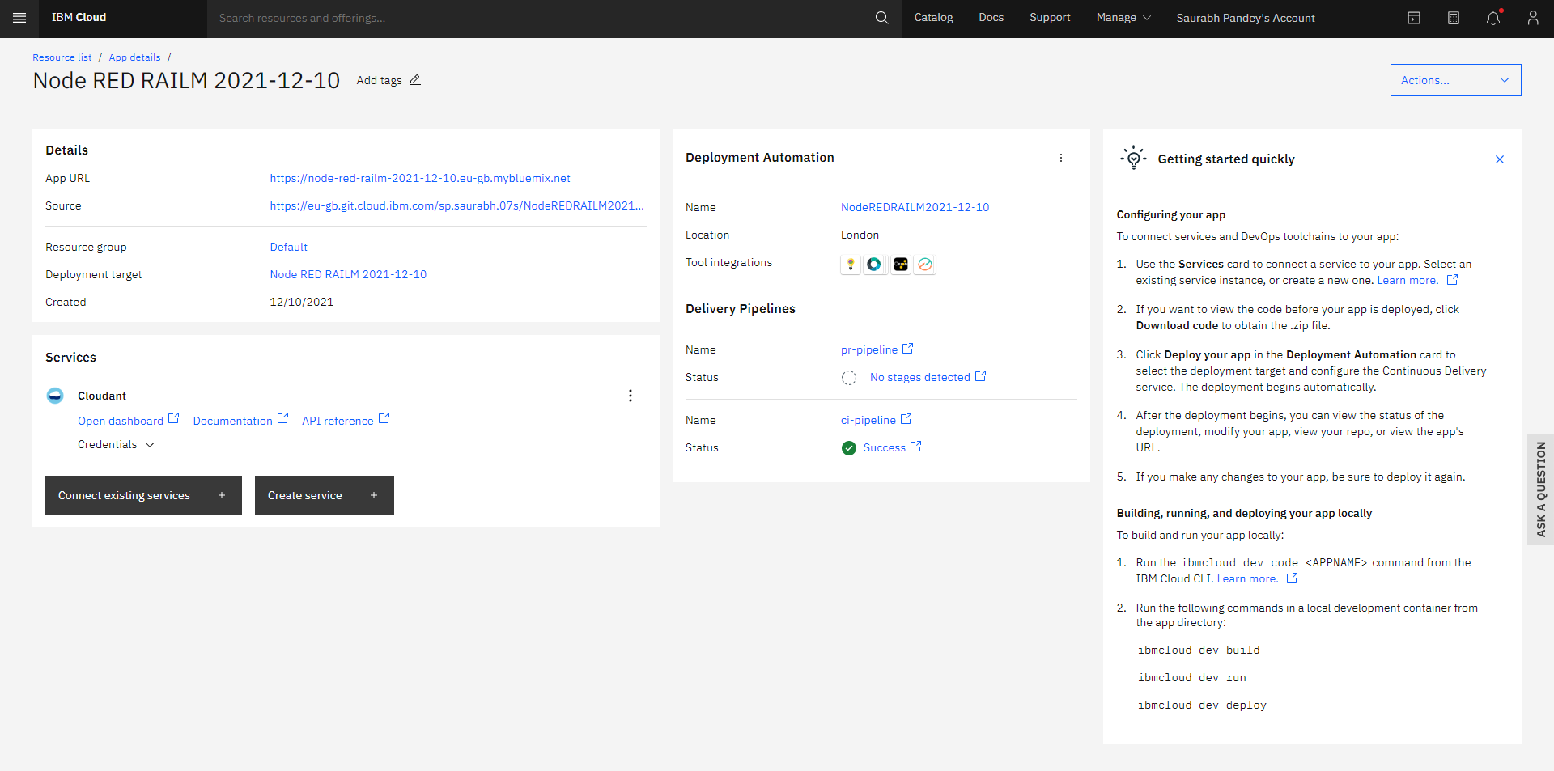

34

**CHAPTER-07**

**ADVANTAGE AND DISADVANTAGE**

**7.1 ADVANTAGE**

1. Communicating the device at larger distance through web application. It will play an important role in reducing the man power and travelling expenses of a farmer.

2. Monitoring the parameter like temperature, humidity etc will play an important role in improving the growth of the plant.

3. Integrating the weather station to the web browser will provide the details of status of the cloud, wind speed etc. It will allow the farmer to prevent their plants from natural calamities.

**7.2 DISADVANTAGE**

1. Since the real time sensor will be connected to the controller, the controller requires continuous supply of internet to transfer the data.

2. Non availability of weather prediction for long period of time. Since the long weather prediction require additional payment to open weather.

37

**CHAPTER-08**

**APPLICATIONS**

**8.1 APPLICATIONS**

1. This technique can be used in the field of home automation. 2. This method can also be used in the field of POKA YOKE verification in industry.

3. It can also be in the field where maintaining the process parameters are essential. 4. It can also be used in controlling the wheel chair for physically challenged people.

5. It can be used in hospitals to monitor the patient's temperature, heart rate etc. During this COVID- 19 situation, it will play a huge role.

6. It can also be used in material handling equipment in hospitals.

38

**CHAPTER-09**

**CONCLUSION**

The various parameters like temperature, humidity etc were monitored using web application. The data from weather station like wind speed, temperature, humidity etc were displayed in the web browser. The device like motor, light etc can also controlled by the web application.

39

**CHAPTER-10**

**FUTURE SCOPE**

∙ The various data’s of soil nutrients is not added in the web browser, that can be added to the web application.

∙ Long range forecast is not available in the web application, it can also be added to provide accurate information about weather.

∙ Controlling the device through mobile application and voice will play important role in enhancing this project.

∙ Providing the GPS and GIS information will also improve productivity of the farmer.

**CHAPTER-11**

**BIBLIOGRAPHY**

[1] S. S. Gill, I. Chana, C. Science, and R. Buyya, “IoT Based Agriculture as a Cloud and Big Data Service : The Beginning of Digital India,” vol. 29, no. 4, pp. 1–23, 2017.

[2] R. K. Kodali and A. Sahu, “An IoT based Weather Information Prototype Using WeMos,” no. 1, pp. 612–616, 2016.

[3] I. Mat, M. Rawidean, M. Kassim, A. N. Harun, I. M. Yusoff, and M. Berhad, “Smart Agriculture Using Internet of Things,” *2018 IEEE Conf. Open Syst.*, pp. 54–59, 2018.

[4] S. R. Prathibha, A. Hongal, and M. P. Jyothi, “IOT BASED MONITORING SYSTEM IN SMART AGRICULTURE,” pp. 5–8, 2017.

[5] Y. Bo and H. Wang, “The Application of Cloud Computing and The Internet of Things in Agriculture and Forestry,” pp. 168–172, 2011.

[6] Tien Cao Huang and Can Nugyen Duy, “Environment Monitoring for Agricultural Application Based on Wireless Sensor Network.”, *april16-17.*

-[7] M. K. Gayatri, “Providing Smart Agricultural Solutions to Farmers for better yielding using IoT,” no. Tiar, pp. 40–43, 2015.

[8] S. V. Mukherji, R. Sinha, S. Basak, and S. P. Kar, “Smart Agriculture using Internet of Things and MQTT Protocol,” *2019 Int. Conf. Mach. Learn. Big Data, Cloud Parallel Comput.*, pp. 14–16, 2019.

**APPENDIX**

| import wiotp.sdk.device  import time  import random  myConfig = {  "identity": {  "orgId": "5y7njo",  "typeId": "device",  "deviceId":"1"  },  "auth": {  "token": "saurabhPandey"  }  }  def myCommandCallback(cmd):  print("Message received from IBM IoT Platform: %s" % cmd.data)  m=cmd.data['command']  print (m)  if m=="mon":  print("motor is switched on")  elif m=="moff":  print("motor is switched off")  client = wiotp.sdk.device.DeviceClient(config=myConfig, logHandlers=None)  client.connect()  while True:  temperature=random.randint(-20,125)  humidity=random.randint(0,100)  moisture=random.randint(0,100)  myData={'temperature':temperature, 'humidity':humidity, 'moisture':moisture}  client.publishEvent(eventId="status", msgFormat="json", data=myData, qos=0, onPublish=None)  print("Published data Successfully: %s", myData)  client.commandCallback = myCommandCallback  time.sleep(2)  client.disconnect() |
| --- |

B. UI OUTPUT SCREENSHOT

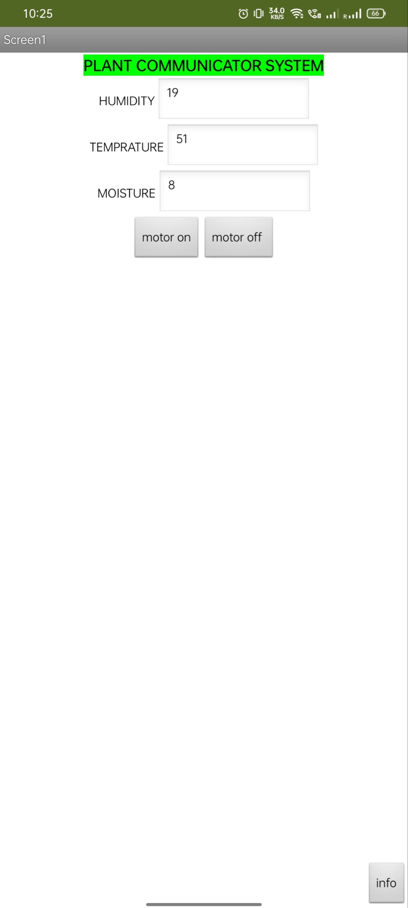

50