General Data
DevID | Base
Dev Description | Core Smart IS Library
Process | General Purpose
Release
Wave
Priority | High
Complexity | Medium
Status | Approved
Business Unit | All
Application | RedPrairie WMS
Type | New & Enhancement
Smart IS Bugzilla Ids | 12535, 12536

Change History
Date | Version | Name | Details
3/13/2021 | 1.0 | Saad Ahmad | Initial Draft

Approval
This document requires approval from the following individuals:
(Signed approval forms are filed in the quality section of the project files)
Name | Role | Date | Signature

Responsible Contact Persons
The following people had input into this document:
(Signed approval forms are filed in the quality section of the project files)
Role | Name | Contact Details
Customer Process Owner

Open Design Points
# | Rel/ Wave | Desc | Status of Resolution | Impact | Date | Responsible
1

Table of contents
Approval 1
Responsible Contact Persons 1
Open Design Points 1
1 Functional Description (Process view) 4
1.1 Environment Variables 4
1.2 Jobs 4
1.3 Policies 5
1.4 Scripts 6
1.5 Caching 6
1.6 General Purpose MOCA Functions 7
1.7 General Purpose Commands 10
1.8 LES Comamnd Capability 13
1.8.1 LES Comamnd Maintainence 14
1.9 Rules Engine 14
1.9.1 Rules Engine Context 15
1.9.2 Rules Engine Help 16
1.9.3 Rules Engine Maintenance 16
1.10 Data Surgery Functionality 18
1.11 EMAIL 18
1.12 Monitor 19
1.12.1 Execution 19
1.12.2 Maintainence 19
1.12.3 Functionality 20
1.13 Data Change History Tracking Capability 21
1.14 Job Logging Capability 22
1.14.1 Job Log Visibility 22
1.15 Job Manager 24
1.16 Asynchronous Execution 25
1.17 Deferred Execution via Asynchronous Execution 26
1.18 FTP Job 26
1.19 Document Store 27
1.20 LDAP Integration 27
1.21 Generating Documentation 28
1.22 Bugzilla Integration 30
1.23 Data Change Hook 30
1.24 Query Components 32
1.25 Integrator Objects 32
1.25.1 Algorithms 33
1.25.2 Communication Methods 33
1.26 Results Verification 33

Functional Description (Process view)
The objects in this design are general purpose toolkit functions. In order to see the implementation details of the components, refer to the generated documentation

Environment Variables
Following environment variables impact the functionality of certain features
Variable | Values | Comments
UC_INHIBIT_OSSI_CACHE | 1 or 0. Default 0 | If set then caching API will not cache results and call the underlying command every time.
UC_INHIBIT_INFINISPAN_CACHE | 1 or 0. Default 0 | If set, then we force the system to not use MOCA provided infispan cache and instead use legacy C structures.
UC_DEV_ENV | 1 or 0 | If 1 then this is a dev environment

Jobs
Certain capabilities require underlying jobs.
Job | Comments
UC_OSSI_APPMON | This provides the core monitor capability.
UC_%_JOBS | The job manager interface relies on these jobs to be setup for each node for this capability.
UC_G_DEFFERRED_PRINT_01 | If we are using the capability of [print ossi file] submitting the reports in background then this job needs to be configured. The run command of the job will be:  execute ossi deferred commands async  where exec_typ = 'DPRT'  and uc_thread_group_by_col = 'exec_kv3' and comflg = 1
UC_G_DOC_STORE_01 | If we are using the functionality where we can load in the reports that are put in a folder into the usr_ossi_doc_store table, then jobs of this type are needed. The command is:  load ossi inbound file contents to table  where uc_folder = @@UC_DOC_STORE_01_IN_DIRECTORY  and uc_filename_expr = @@UC_DOC_STORE_01_IN_FILENAME  and uc_processed_folder =@@UC_DOC_STORE_01_PRC_DIRECTORY  and uc_temp_folder= @@UC_DOC_STORE_01_TMP_DIRECTORY  and uc_filter_moca_expr = "@uc_file_age_secs>60"  and uc_expr_ordnum = "usr__parse_filename_for_doc_store(@uc_filename_only,'ordnum')"  and uc_expr_cponum = "usr__parse_filename_for_doc_store(@uc_filename_only,'cponum')"  and uc_expr_wh_id = "usr__parse_filename_for_doc_store(@uc_filename_only,'wh_id')"  and uc_expr_doc_typ_cd ="usr__parse_filename_for_doc_store(@uc_filename_only,'uc_doc_typ_cd')"  and uc_expr_doc_subtyp_cd ="usr__parse_filename_for_doc_store(@uc_filename_only,'uc_doc_subtyp_cd')"
UC_G_LDAP_SYNC | If we are using the capability of synchronizing the authentication tables from an LDAP store then this job needs to be configured. The job will be setup as follows:  process ossi ldap sync

Policies
Following policies impact certain functionality:
- Policy Code: USR-OSSI-SYSTEM-SETTINGS
- Policy Variable: EMAIL
Note that policy values listed below that end in “-EXPR” are MOCA Expressions. This implies that they can reference any MOCA variables or environment variables (@@ prefix). If a literal value is to be defined, then put it in quotes.
Policy Value | Setting | Example | Comments
ENABLED | Rtnum1 of 1 enables it | 1 | This is respected by “send ossi email” command. Setting it to 0 will bypass email in this API.
MAIL-SERVER-EXPR | Rtstr1 expression resolves to the mail server | 'itmanage-w-001.oracular.com'
MAIL-PORT-EXPR | Rtstr1 expression resolves to the port on the mail server | '25'
MAIL-TLS-EXPR | Rtstr1 resolves to 0 or 1 to indicate if TLS is used for emailing. | ‘0’
MAIL-USER-EXPR | Rtstr1 resolves to a user id for authenticating to the mail server | ‘’
MAIL-PASSWORD-EXPR | Rtstr1 resolves to the password for authenticating to the mail server | ‘’ | This password can be encrypted using the script $LESDIR/scripts/smartpasswd.bat
DEFAULT-MAIL-FROM-EXPR | Rtstr1 resolves to the from email address that can be used by default | 'saad.ahmad@smart-is.com' | If an alternate from address is passed to the API that will be used.

Scripts
Some scripts are provided to streamine some functionality. These scripts are in $LESDIR/scripts
Script | Comments
nmake.bat | Standard windows make is typically not available on production systems. The “REBUILD LES” tag in rollouts still calls it though. This script gracefully preempts those calls so that rollout does not fail.
smartpasswd.bat | This script provides a simple mechanism to encrypt passwords before storing them in the registry.

Caching
This library provides general purpose caching functionality. The general approach is that results of any command can be cached. The results are cached using underlying MOCA cache layer. For legacy versions it also has support for caching in C – but that is strictly for legacy versions and should not be used for versions 2011 and higher.
MOCA Command | Description
execute ossi moca and cache | This is the main API to execute a command cache its results. The idea is that we pass in the MOCA command and a caching key.  It calls “execute ossi moca and cache core” to perform the work. If infispan is disabled, it will call “execute ossi moca and cache core using c” to use C data structures.  It utilizes “CacheManager” APIL to cache the results. The results are cached per the provided cache key.
execute ossi moca and cache core | Wrapper for executing moca command and cache
execute ossi moca and cache core using c | Execute the MOCA but if it is the same as a previous run, just return those results
free ossi moca execute cache | Free the MOCA Execute cache
get ossi data from cache | We may need to save cached data in environment variables in some cases, e.g. mload files. This provides that capability. It should not be used for general purpose cache.
list ossi policy data and cache | get policy data and cache the results
save ossi data to cache | Save data to a cached variable

General Purpose MOCA Functions
This section includes some general purpose MOCA functions. These are MOCA functions so they can be invoked as expressions. Note that MOCA functions are invoked such that a space in the component name is replaced with two underscores “__”. Also note that the parameters are declared in the MOCA Comamnd using special naming convention moca_fargn, where n is an integre representing its ordinal position.
MOCA Function | Description
ossi get_fld_from_list | Given a delimited string, get nth value from it.
ossi polval | This function returns a specific policy value. The input is passed in as arguments – and any data for the specific policy can be retuned. This caches the data.
ossi polval_nc | Same as ossi polval, put does not rely on cache. Base table data is retuned on every call.
ossi replace | Given a string, replacres occurrences of a substring with another string.
ossi running_in_server_mode | Sometimes it is important for a command to see if it is running in the context of a normal MOCA client or as a server (e.g. from within msql -S or mload). This returns 1 if it is running in server mode.
o td | It can return data from any table as a MOCA function. Parameters to it allow for passing table and key column information. It can be useful in context of integrations as we can use it to specify alternate expressions.
ossi is_dev_env | In some contexts we need to differentiate between dev and non dev environments. Per our conventions, we declare that a development environment should have an environment variable UC_DEV_ENV set to 1. This function returns 1 if that variable is set and 0 otherwise.
ossi abs | Returns absolute value of an integer.
ossi add_business_days | Given a date, it adds business days to it and returns a new date.
ossi am_i_archive | Generally all rollouts should be installed on all instances – including archive. If a command needs to behave diffently on archive, then this function can be used. It uses our convention that environment variable UC_MY_ARCH_HOST should be set. If this environment variable is not set we return 0 (meaning not archive) and if set we return 1 (meaning we are on archive instance).
ossi build_sel_list | Given a delimited string, it constructs a select clause form it.
ossi cat_str | Given some input strings, it concatenates them together with a passed in delimiter between them.
ossi ceil | Get ceiling value of a number.
ossi_command_only | Given a MOCA call (with where), return just the command name portion. It is useful when logging the command name in some contexts.
ossi csv_to_yaml | Convert a CSV string to a YAML equivalent. It is used during rollout process to create yaml files for REFS while doing mloads.
ossi user_has_access_to_opt_nam | See if user has access to an option. if option does not exists or user does not exist - it means access is allowed.
ossi data_version_url | This function is used to get a URL to change log.
ossi date | Convert string to moca date, taking into account various inbound formats.
ossi db_to_yaml | Convert a resource_bundle db entry to yaml.
ossi device_context_value | This function can be used to easily get a value from device context.
ossi dscmst_text | This function can be used to easily fetch the dscmst data for a given value. Useful in rules engine.
ossi e | Get number for an error symbol.
ossi execute remote retrieve | Retrieve data from a remote data source. It provides abstraction for typical operations  like executing data in another commit context or using openquery (in SQLServer).
ossi expand vars in string | Analyze the passed in string and expand variables that are  specified with @ prefix based on MOCA stack.
ossi expr_for_mov_path_cri | Convert the move path to an expression.
ossi file_exclusively_available | Checks to see if a file is currently being written to and attempts to change the suffix.
ossi get_clean_string | Replace some special characters that typically give issues with nothing.
ossi get_csv_for_max_len | Given a coma separted list, get complete data till a length.
ossi get_field_help | Get help for a passed in field.
ossi get_file_path_base_on_list | Find a file in a list.
ossi get_fld_from_list | Get a field from list by ordinal position.
ossi get_hash_value | Get a value for hashing. e.g. ship_id last 2 characters can be used to get a number for whatever we need.
ossi get_part_replication_sess_var | Get session variable for part replication.
ossi get_policy_data_as_list | Gets policy data as a list.
ossi get_policy_data_as_var_list | Get policy data as a list of @+ moca variables.
ossi get_rollout_install_dt | Get date/time of when a rollout was installed.
ossi get_rowcount | Function to lookup number of rows in a table for passed Column Value.
ossi get_rp_version | This will return the RP version so that we can easily write code when we need to compare versions.
ossi get_sql_in_from_string | Given a string convet to a series of in clauses for SQL.
ossi get_url_decoded | Function to decode the URL.
ossi get_url_encoded | Function to encode the URL.
ossi get_wh_local_time | Gets a Warehouse TimeZone for passed in WH_ID.
ossi get_xml_attr_value | Parse XML old fashion way to get the value of an attribute. if a node just has attributes moca way does not work.
ossi group_column_in_res | Group data in a result set. Currently only support sum.
ossi has_column | Generate next number.
ossi html_data | Function to put value in HTML.
ossi html_data_row | Function to put value in HTML as a row.
ossi html_val | Function to put value in HTML.
ossi instr | This moca function is an extension of startdard instr and works like oracle instr function. it allows for nth occurrence search and also search from end.
ossi intnvl | NVL function that is sensitive to the integrator rules for absent characters.
ossi is_dev_env | Function to check if it’s this a dev environment?
ossi is_number | See if this is number.
ossi is_part_being_replicated | See if we are in middle of part being replicated.
ossi max | Returns the value that is higher. If instance of java.lang.Comparable, like dates, uses that comparison.
ossi mls_text | Function to get MLS text.
ossi multi_instr | MOCA Function to get a substring of a string but index can be a string value. The logic is to look up the substring and find the index.
ossi next_number | MOCA Function to get next number.
ossi normalize_flag | This function will normalize it to string '1' or '0'.
ossi ord_value_from_list | This function uses the "ossi parse name value list" command to return the value of a parameter from a name-value list.
ossi parse name value list | Parse a name value pair list. A list of name value pairs may be specified. This command will parse them out in a well-defined resultset.
ossi polval_cat | MOCA Function to get multiple rows of a policy as a string.
ossi pos_value | Given a list, return nth value indexed off 1.
ossi registry_value | This command may be used to get registry values.
ossi res_column_index | MOCA function to get resultset index column.
ossi res_has_val | MOCA Function to return 1 if a value exists in a res.
ossi return multiple lines from one line | This component breaks up the passed one line into multiple lines.
ossi round | MOCA function to round a value to appropriate decimal.
ossi rp_role_from_ldap_role | MOCA function to get RP role from LDAP role id.
ossi secs_as_display_time | MOCA Function to convert seconds to a string like hh:mm:ss.
ossi sequence_curr_val | Get the current value of a sequence. There is an issue in SQLServer where since the ident_current works across sessions that this may return wrong value.
ossi sess_var | This function abstracts the get session variable command so that it may be called as a function.
ossi str_right | MOCA function to get characters from right.
ossi table_columns_as_list | A function to get a column name as list.
ossi table_pk_as_join | This function will return a string like  x.pk1 = y.pk1 and x.pk2 = y.pk2.
ossi to_char | Passing in a single D in the string crashes normal to_char, so this fixes that.
ossi ts | Get current timestamp as milliseconds since midnight. Used to see sub second time difference.
ossi txt_substr | MOCA Function to get a substring of a string but index can be a string value. The logic is to look up the substring and find the index.
ossi val_in_poldat | Moca function to check that a value exists in poldat.
ossi val_or_env_var | FUNCTION: if passed in value is null get from environment variable.
Ossi value_from_list | This command uses the "ossi parse name value list" command to return the value of a parameter from a name-value list.
ossi value_in_base_mu | Function to convert value to DB unit of measure.
ossi value_in_other_mu | MOCA function to convert value to DB unit of measure.
ossi wh_in_list | For integration blocking algorithms, we have lists defined in policy USR-INTEGRATION / WH-LISTS. Here by passing in the ID of the list we can easily check that wh exists in that. Makes blocking algs easier to manager.
ossi replace_enclosed_tags | MOCA function that will convert substrings enclosed in tags with another prefix. EMS Lite functionality uses it to convert substrings enclosed in “^” to have a prefix of “@” instead and then replaced by MOCA stack values
ossi int_decrypt | Function to decrypt a value

General Purpose Commands
We also have some commands that are general purpose.
MOCA Command | Description
combine ossi columns from multiple results | This command can be used to concatenate results from upto 10 input MOCA results.
compare ossi result set rows | This command compares the rows from two resultsets
compress ossi files | This command compresses a set of input files into a zip archive.
convert ossi file characterset | This command converts the characterset of an input file.
convert ossi pointer | This command converts an input into a C pointer type.
convert ossi results to in clause | This command convets input resultset to an IN clause for SQL
convert ossi results to string | This command converts a resultset to a CSV equivalent
convert ossi results to xml | This command comvets a resultset to an XML equivalent
convert ossi xml to results | This command convets an XML string to a MOCA resultset.
create or replace sequence | This command can be used to maintain a sequence (MOCA sequence implemented using database specific constructs)
decode ossi from base64 | This command decodes a base64 string
execute ossi odbc select | This command allows for executing a select against any ODBC data source.
filter ossi rows with condition | Given a MOCA result and an expression representing a filter, it returns the rows that satisfy the condition.
find ossi file in path list | Find file given a path list
find ossi pattern in file | Find patterns in an input file.
flatten ossi res with rows as columns | Convert a resultset into a single row.
flatten ossi results | Convert rows to columns.
generate ossi filename | Get a unique file name by trying suffixes until we find one that does not exist.
generate ossi mload ctl file | Generate an mload ctl file for a table
get ossi database lock | Sometimes we need to get an arbitrary semaphore lock from the database (so that it is still by transaction)
get ossi default report printer | Get the default report printer
execute ossi dda action | Execute a DDA action
get ossi media in base64 | This command may be used to get media in base64.
get ossi mls text with args | Get mls text and replace place holder values
get ossi printer information | This command is used to get printer information.
get ossi text from xml node | Parse the XML looking for the given tag and return the contents
get ossi warehouse id | This command is used to get warehouse id.
increment ossi component version | This command is used to increment component version.
list ossi criteria | This command may be used to get criteria data.
list ossi label fields | It utilizes list ossi label fields core
list ossi policy data and cache | get policy data and cache the results
list ossi policy list values | This command is used to get policy list values.
list ossi policy lists | This command is used to get policy list.
list ossi policy logic domains | Returns a list of policy logic domains
list ossi reason codes for group | This command is used to get reason codes.
list ossi system files | This command is used to get system files
list ossi variables used | Return the variables used
load ossi language pack | Add a new locale
load ossi locale | Loaded with every rollout
load ossi mls cat to refs | Take all entries in les_mls_cat that are custom and load them into refs messages
load ossi refs resource via yaml | This will load the object via yaml. the refs mload scripts call it
modify ossi sequence base | Modify the base of the sequence
ossi expand vars in string | Analyze the passed in string and expand variables that are specified with @ prefix based on MOCA stack
ossi execute remote retrieve | Retrieve data from a remote data source. It provides abstraction for typical operations like executing data in another commit context or using openquery (in SQLServer)
ossi return multiple lines from one line | This component breaks up the passed one line into multiple lines.
parse ossi xml node values | Parse the given XML and return the contents of the given node name
print ossi file | Basic component to handle printing. OSSI Version as we have some extensions. If a site wants to use this instead of print file they could call this from print file
print ossi report for batch operations | This can be used from workflows and rules engines to print reports. It can habdle reports that are prinetd and also those that are sent to us.
publish ossi values as row on stack | Take a res where one column has field names and second has value and a 3rd tells if value is literal or expression. Then show as 1 row
purge ossi msg log for events | This command may be used to delete data from msg log.
replace ossi variables | Replace @var with the value from the stack
reseed ossi sequence | Set the new starting value for a sequence
reseed ossi sequence for base change | This component can be used to change a base 10 sequence to a base 36 sequence. It will see current value of the sequence (in base 10) and assume it is base 36 (i.e. very high number). It will reseed the sequence to that and then change sequence base 36 to 1.
qq | This command is used to quote a string properly
read usr csv file | Command to read and parse cvs files.
release ossi database lock | Release lock obtained by get ossi database lock
remove ossi duplicates from results | This command may be used to remove duplicate from results.
send ossi email | This command use the policy values to send an email
transpose ossi resultset | This command transposes a resultset
transpose ossi resultset c | This command transposes a resultset
unload ossi refs resource via yaml | This will unload the object via yaml. the refs mload scripts call it
validate ossi moca expression | This will be called from front-end screens where we allow the user to enter expressions.
validate ossi user and password | Validate the user and password for adhoc needs
write ossi aut daily transaction | Logs a daily transaction entry and commit
write ossi csv | This command writes csv
write ossi daily transaction aut | This command logs a daily transaction entry
write ossi daily transaction for print | Logs a daily transaction entry
process ossi moca context arguments | It takes the “where clause” for the call and converts it to a string. EMS Lite functionality uses it to convert the where clause to a string so that it can be included in the email message easily.
manage ossi encrypted values for integration | Integrations sometimes require that passwords are stored in the registry. This API allows us to encrypt those values and then decrypt it later.

LES Comamnd Capability
BY provides a general-purpose table called les_cmd. We provide a set of components to execute MOCA commands that are stored in this table. This can provide a useful place to allow for providing hooks where we can specify hooks. This provides the ability where the highest cust_lvl is executed.
MOCA Command | Description
execute ossi les_cmd | Execute a specific les command. It finds the highest customization level for a specific named command and executes it.
execute ossi les command for dda | This can be invoked from a DDA to execute les_cmd entry
get ossi les command | Find the les_cmd for a given name with highest customization level.

LES Comamnd Maintainence
This data can be maintained via “OSSI LES Command Maintenance” screen:
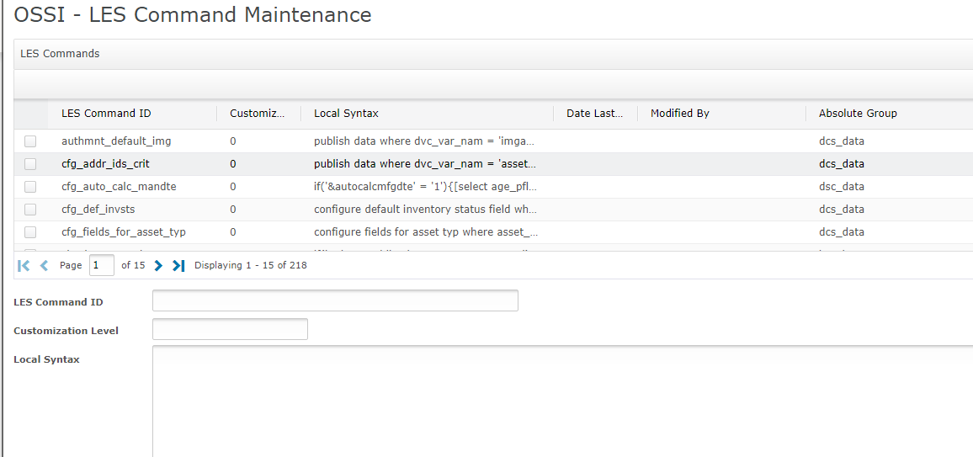

Rules Engine
We have general purpose capability to invoke rules engine for following situations:
- Based on context, detect a condition and then execute an action. These are deifned in usr_rule_engine_cond_expr table.
- Based on context, find a value when condition becomes true. These are defined in usr_rule_engine_expr table.
MOCA Command | Description
execute ossi all conditional rules | Evaluate rules and execute the actions based on the conditions that evaluate to true.  Please note that there are certain legacy components for this functionality. Those are not included in the documentation here as they are strictly for maintaining compatibility.
get ossi commands for condition | This command returns what actions we need to run
get ossi conditional rule expression command | The condition can be a MOCA expression or a SQL statement. This API parses the text of expression to see how to execute it. For providing a SQL statement expression is enclosed between []. It is also possible to provide a MOCA snippet – in that case it is enclosed in {}.
get ossi policy expression command | This command is used to get policy expression command.
get ossi row processing code | Given a row on stack, analyze rules to assign a code to it
get ossi rules for policy based rules engine | This command will return the rule expressions needed to run the rules engine. It supports the idea that we may need an alternate command to get the rules. That can come in handy if the ordering of the rules is based on some other data elements.
publish ossi data as projection using policy | Publish the data in one row with columns based on policy metadat
publish ossi default values | Publish data from default map for downstream components
publish ossi fields from rules engine | This component will execute the rules engine and publish out the data that we need to then pass on.
publish ossi polval as projection with evaluated expressions | For passed in polcod, polvar see all polval and publish them out such that all polvals are on single row and their values are based on concatenated expresison stored in rtstr1
resolve ossi rules engine return value | If the value returned is in a specific format we may need to resolve it further

Rules Engine Context
Every rules engine is defined by a uc_rule_grp_id and uc_rule_subgrp_id. The table is looked up with that and then we execute all actions that are enabled and where the condition indicats that it should run. The uc_rule_id provides a mechanism for creating groups based on certain data conditions. “XXXX” is used to define wild cards.
The context is defined by policy USR-CTXT-<uc_rule_grp_id>. Polvar is the uc_rule_subgrp_id value. Then we have two sets of policies:
- Rtnum1 =2 and sorted by srtseq. Polval is the stack variable.
These define the variables in order that will be used to determine the correct rule_id. For example:
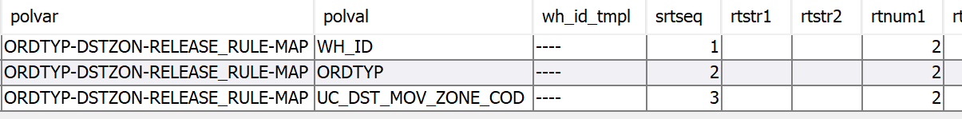
Says that this rule utilizes @wh_id, @ordtyp and @uc_dst_mov_zone_cod to get the proper rule id to use.
- Rtnum1 = 1, sorted by srtseq, polval is the rule_id
Then we define the actual rule id to use when defining the rules. Here polval needs to have specific values like:
  - UC_RULE_ID
  - UC_RULE_ID_WILD_CARD_01
  - UC_RULE_ID_WILD_CARD_02
  - UC_RULE_ID_WILD_CARD_03
  - UC_RULE_ID_WILD_CARD_04
Rtstr1 has the expression that will resolve to the specific value. “XXXX” implies wild card, for example:
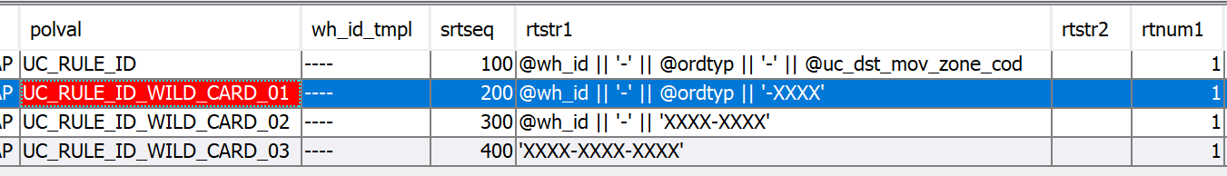
Says that we first look for rules where rule_id is exactly warehouse, order type, and destination move zone – then we also select more based on soft matches defined above.

Rules Engine Help
We can store rule engine help in usr_rule_engine_help table. The context is stored in usr_rule_engine_help_ctxt table. Data is added to these tables manually via “mload”. The data is then available on the smart rule screens.
MOCA Command | Description
list ossi command output information | This command returns the output field information for a command

Rules Engine Maintenance

To support data maintainaince, we have following commands:
MOCA Command | Description
create ossi rule based condition expression | Create record in usr_rule_engine_cond_expr table
create ossi rule engine expression | Create data in USR_RULE_ENGINE_EXPR
change ossi rule based condition expression | Change data in usr_rule_engine_cond_expr table
change ossi rule engine expression | Change data in USR_RULE_ENGINE_EXPR
execute ossi rules for data validation | Validate all the rules.
evaluate ossi rules for policy based rules engine | This command is used to evaluate rules for policy based rule engine.
evaluate ossi conditional rules | This command is used to evaluate conditional rules.
get ossi conditional rule expression command | This command is used to get conditional rule expression command.
get ossi policy logic help text | This command is used to get policy logic help text.
get ossi policy logic valid possiblity command | Get the valid possibilities that fill the combo box when you add a value in OSSI Policy Logic Maintenance
get ossi policy logic validation command | This command is used to get policy logic validation command.
list ossi conditional rule categories | Returns a list of distinct uc_rule_grp_id
list ossi conditional rule domains | Returns a list of policy logic domains
list ossi conditional rule groups | Returns a list of distinct uc_rule_subgrp_id
list ossi conditional rule headers | This command will list rule headers only
list ossi conditional rule names | This command will list rule names
list ossi conditional rule variables | List variables to be used for usr_rule_engine_cond_expr
list ossi conditional rules for display | Get the data for conditional rules
list ossi conditional rules | This command is used to get the conditional rules data
list ossi conditional values | This command is used to get conditional values
list ossi smart rule variables | This command is used to get smart rule variables.
list ossi smart rule values for display | Get the smart rule values for display.
list ossi smart rule values | Read data from usr_rule_engine_expr table
list ossi smart rule domains | This command will returns distinct rules group as domains
list ossi smart rule domain sub groups | This commands will list rule sub groups for a rule group
move ossi rule based condition expression | This command is used to move rule up or down by condition expression.
remove ossi rule based condition expression | remove data in usr_rule_engine_cond_expr table
resolve ossi rules engine return value | If the value returned is in a specific format we may need to resolve it further
renumber ossi condition based rules expression | This command may be used to renumber ossi condition based rules.
validate ossi moca expressions for rule | Validate the various moca expressions stored in the rule tables

Rules Engine Maintenance for Conditional Rules
This is used when certain event happens and we want to conditionally execute certain actions. This data is maintained in usr_rule_engine_cond_expr table.
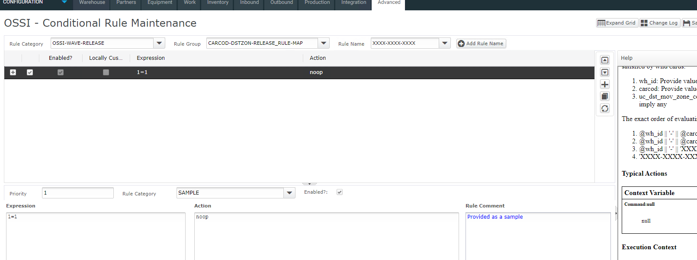

Rules Engine Maintenance for Determining Values
This is used when we want to determine a value (as opposed to executing an action).
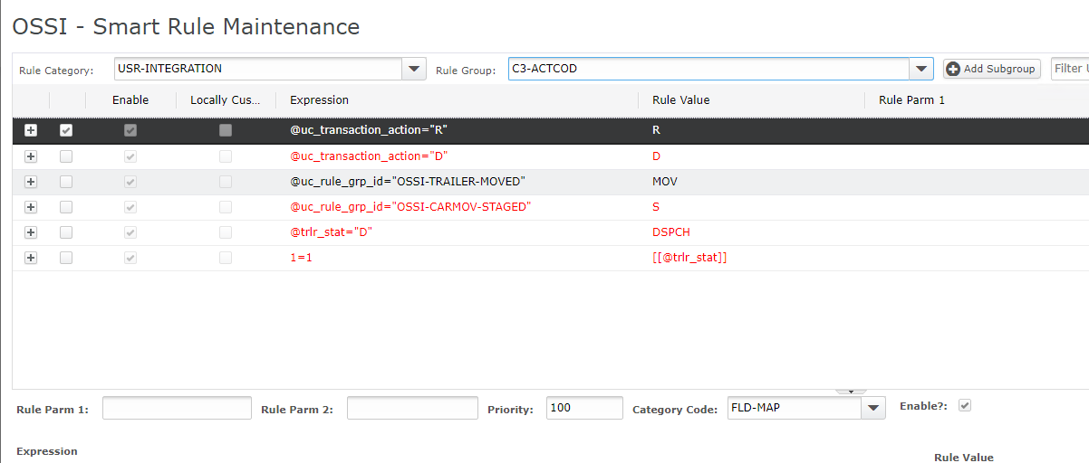
The logic stops when we find a record where expression resolves to true.

Data Surgery Functionality
While supporting the WMS, the support teams need to execute certain defined scripts in order to fix data conditions. This functionality is provided to create a front-end so that the scripts are not invoked directly rather they are invoked from a screen.

MOCA Command | Description
add ossi issue for surgery | This command can be used to add issues for surgery data
get ossi clause from adhoc filter file
get ossi issue filter for surgery | This command is used to get issue fiter for surgery
get ossi issue for surgery | This command is used to get issue for surgery
list ossi cases for surgery | Used in OSSI Surgery By Case
list ossi data clinic surgeries | List the surgery metadata defined for data clinic
list ossi data clinic surgery actions | List the surgery metadata defined for data clinic
list ossi data for surgery | This command is used to get data for surgery for load
list ossi shipments for surgery | This command is used to get shipment data for surgery.

EMAIL
MOCA provides basic email capability via “send email” command. We have some wrappers around it to simplify the process of using the functionality for certain use cases:
MOCA Command | Description
get ossi global email settings | Refer to the policies section at the beginning of this document. This API is used to get those values and push them to the MOCA stack as names that the “send email” API expects later.
send ossi email | This is the lowest level wrapper for “send email”. It gets the setup values via “get ossi global email settings” and then calls the “send email” command.
execute ossi report and email | A rpt_id can be passed to it along with email information. The repot data is generated as PDF and then attached to the email. Email is sent via “send ossi email” command.

Monitor
We often need to detect certain abnormal conditions and fix them. This capability is provided via table usr_ossi_mon. These are executed using job UC_OSSI_APPMON.

Execution
MOCA Command | Description
run ossi monintor | This command is executed in the job to provide the core capability.
get ossi app monitor email settings | Get email settings for an application monito
raise ossi ems alert for monitor failure | If monitor fails and we want to raise an EMS alert for it, do it
send ossi app monitor email | To send email from application monitor

Maintainence

This requires following CRUD components
MOCA Command | Description
[create or change or remove or list] ossi app monitoir | The CRUD components for the monitor data.
[create or change or remove or list] ossi app monitor parameter | The CRUD components for the monitor parameers.

These can be maintained via following DDA

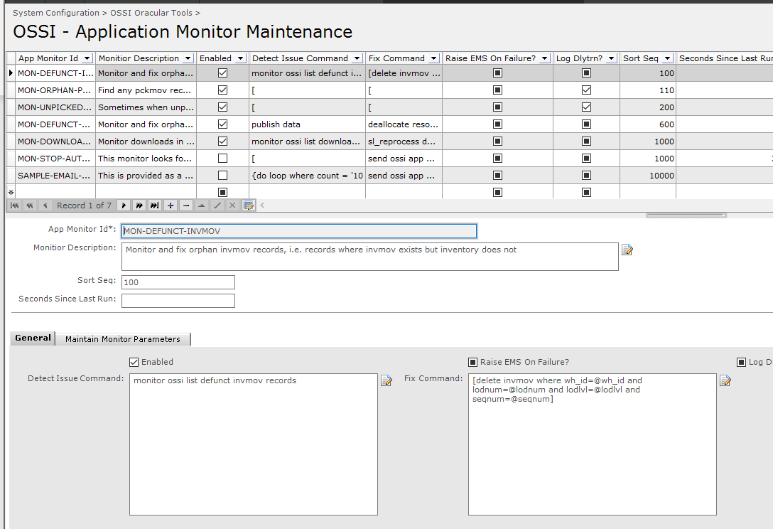
For every monitor we can define some additional parameters. These parameters are mainly used for defining email settings:
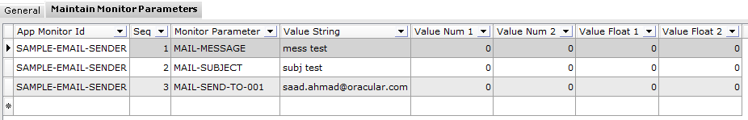

Functionality
Job UC_OSSI_APPMON is defined above which runs frequently. Whenever it runs:
- It will call the “detect” command. That is expected to return 0 or more rows. Every row implies an issue and pushes data on stack
- The “detect” command executes for each row. uc_mon_key_data may be published to provide consistent data for dlytrn.
- If “Log dlytrn” is checked, then a dlytrn is logged for every row.
- “Raise EMS on Failure” implies that if fix fails then an EMS is logged.
- There is no caching in play. When a change is made, it is activated for next run.
- “Sort Seq” implies the order in which the monitors run.
- “Seconds Since Last Run” is used to control how frequently a specific monitor runs. This indicates how much time must have passed since last run.
One of the use cases is to send an email. In order to use that:
- The “detect” command should publish the result set to include in email as “uc_mon_data_res”
- The “fix” command will have “send ossi app monitor email” In order to get the email settings it uses command “get ossi app monitor email settings”.
In addition to above common policies, we have additional policies per monitor. Policy variable is the monitor id and value is PARAMETERS. Rtstr1 has the setting identifier and rtstr2 has the value.
Rtstr1 | Rtstr2 | Comments
MAIL-SUBJECT | This is the subject of the email
MAIL-MESSAGE | This is the email message
MAIL-SEND-TO | Email address | Muliple records can be added with MAIL-SEND-TOsuffix

Data Change History Tracking Capability
These APIs provide the basic capability to track changes to data. The data changes are tracked to table USR_DATA_CHANGE_HIST_LOG. This table creates 1 or 2 rows to capture before and after view or data. Columns may be added to the table for various types of data elements that need to be captured.
MOCA Command | Description
capture ossi table data for history logging | This command should be called as a pre-trigger on the change command to create a resultset for the before image of the data.
capture ossi data change history log | Evetually this command is called to write data to the and also create a dlytrn entry
list ossi change log history | This command will list the history of data change. It is used by frontend screens to show the history
list ossi data change history log | List the data change history log
ossi get_part_replication_sess_var | MOCA function to get session variable for part replication
ossi is_part_being_replicated | MOCA function to see if we are in middle of part being replicated
This table can be extended as needed to provide additional columns. Idea is that for every change we record before and after view of the columns. So this table has all columns form all tables in this table plus some key audit columns:
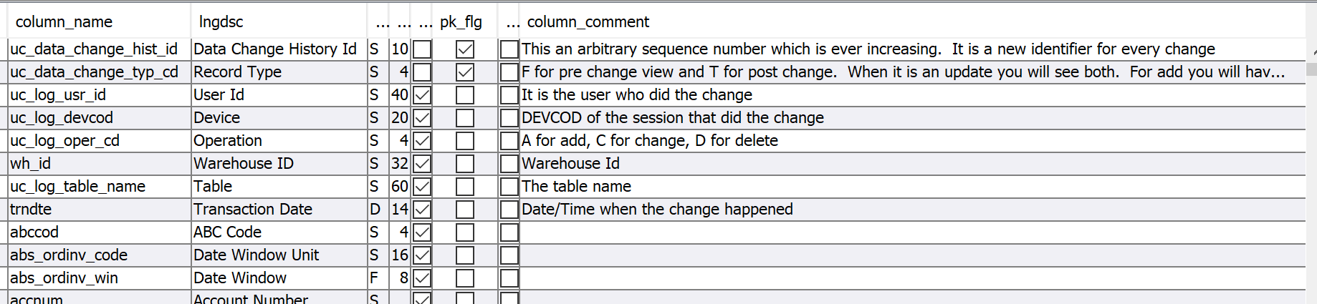
And every time records are added here a record is added to dlytrn table as well:
- Activity Code of UC_HISLOG
- trndtl_id is the keyt into this table
- trndtl_table is usr_data_change_hist_log
- var_nam is “table_name”
- to_value is name of the table that is updated
To use this functionality:
- We add tiggers on create, change, and remove components to call “capture ossi data change history log” component.
- The “change” and “remove” components call “capture ossi table data for history logging” as a pre-trigger. That captures old values and push to stack.

Job Logging Capability
We often have long running jobs like auto close jobs, aging jobs etc. This capability provides the ability to push information about the progress of these jobs to usr_ossi_job_log table.
MOCA Command | Description
ossi register_job | Indicate start of a job
register ossi job or module | If within a job start module. If not in job, start job and module
ossi register_action | Start an action
raise ossi job error | Raise an error and complete the job or log
complete ossi job or module | If within a job complete module only otherwise complete job and module
complete ossi job log | Complete a job logs
complete ossi job | Complete a job
purge usr job log | Scehdule this for purging the table.
list usr specific job log | list specific job log entry - to show stuff in a display
list usr job log | List the job logs
list ossi job repository | List the job repositories.
list ossi job executions | List the job executions
list ossi job execution detail | List the job execution detail.
execute ossi command as job action | Run the passed in command as an action within a job
check ossi time to run job | To support idea of looking here to decide if we should run a job again.
check ossi allowed to run job | Look at various parameters like time of day and time of job since last run to see if this job should run now

Job Log Visibility
Following screen is provided as a DDA to view this data. The screen is called “OSSI Job Log Display”
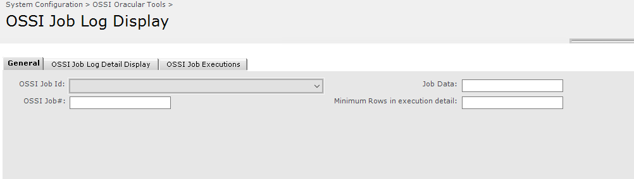
Note that “OSSI Job Id” dropdown is refreshed by doing a blind find on this screen first, then exiting and coming back to thi screen
The main grid shows job executions recorded in usr_ossi_job_log and also in standard job_definition_exec tables:
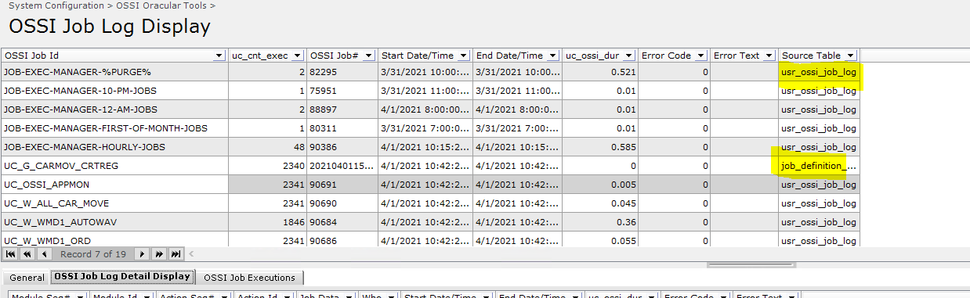
This grid shows latest execution data. Clicking on the “OSSI Job Log Detail Display” shows the details for that execution:
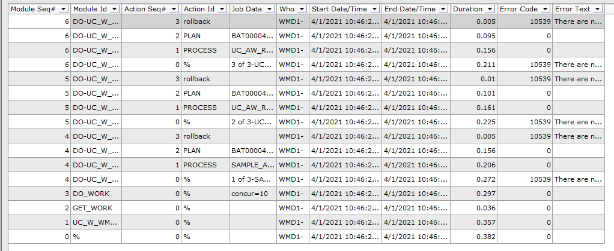
The “OSSI Job Executions” tab shows all executions of the selected job:
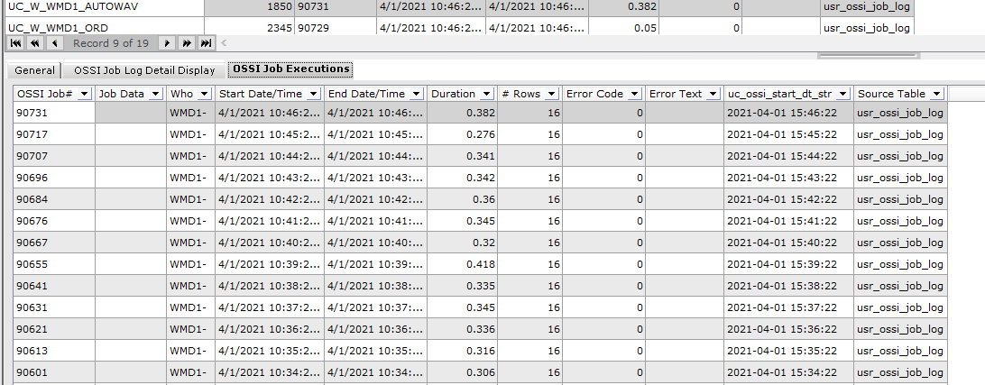
From here, after highlighting a record, click on “OSSI Job Log Detail Display” button:
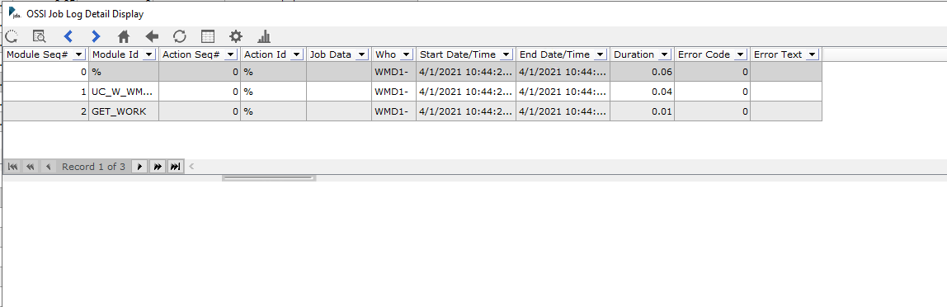

Job Manager
We often have several jobs in a typical implementation. While these can be scheduled directly in MOCA job manager, that can adversely impact the system since we may end up scheduling several competing commands at the same time.
This capabiulity allows for creating fewer jobs which then look at policy to provide the commands that are run. This allows for the jobs to run in sequence so that they do not compete. Moreever when these commands run, they publish their progress to the usr_ossi_job_log table as well.
MOCA Command | Description
execute ossi jobs using job manager | This is the command that is scheduled in MOCA job manager.
Refer to the section 1.2 above to see the jobs that are scheduled to run these jobs. These are stored under policy USR-JOB-MANAGER. Policy Variable is to group certain jobs and the scheduled jobs in BY job manager point to this entry. Our rollout provides following:
- 12-AM-JOBS
- 12AM-MON-TO-SAT-JOBS
- 2AM-DAILY-JOBS
- EVERY-15-MIN-JOBS
- EVERY-1-MINUTE
- EVERY-5-MINUTES
- HOURLY-JOBS
- SL-PURGE-01
- WM-PURGE-01
Per our standard rollout we provide following jobs:
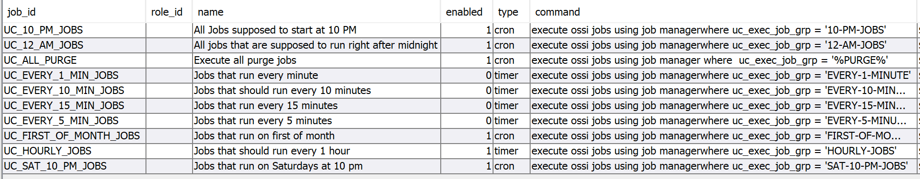
These can be adjusted as needed. As you can see the uc_exec_job_grp points to the policy variable. Within each policy variable we have following policy setup:
Value | Rtstr1 | Rtstr2 | Rtnum1 | Rtnum2 | Rtflt1
An identifier for the job | Command to execute. If it gets too long, refer to “execute ossi les_cmd” functionality. | For commenting | 1 to enable | If 1 then job is executed for every warehouse in the system. We will run command as:  [select wh_id form wh]  |  <command> | To sort

For a specific policy variable we can define parmeters as well. For that polval is _PARAMETERS and then we can have multiple policies added where rtstr1 is the name of a parameter and rtstr2 is the value (as an expression). For example:
Says:
- When running any job within SL-PURGE-01 group
  - Push on stack older_than_days and set to the value of environment variable and if not set to 5
- When running any job within WM-PURGE-01 group
  - Push daysold and uc_daysold_exec_log
When we run jobs using this functionality the information is pushed to usr_ossi_job_log table as well.
- Uc_ossi_job_id is JOB-EXEC-MANAGER. Uc_ossi_data on the row is the polvar value
  - Module is added for every job’s polval. Uc_ossi_data is the rtstr2 value
    - Then within that an action is created for the specific command.
When we read the policy, we read from database every time so there is no caching impact. If the data is changed, that is respected on the next run.

Asynchronous Execution
MOCA provides an elaborate framework for executing commands via asynchronous execution.
MOCA Command | Description
execute ossi work using async execution | This is the main API to execute anything via deferred execution. Refer to the command documentation to see how it can be utilized for specific needs. Deferred execution listed below serves as an example for its usage as well.
execute ossi one row for async execution | This is called from within the asynchronous execution framework to process a single record

“execute ossi deferred commands async” provides an example of how we can use this functionality. This requires two input parameters for defining the data it processes:
- uc_get_work_cmd parameter is used to define a command that returns the “work”. Each row should represent an autonomous task. Each task may then be processed in parallel.
- uc_do_work_cmd parameter proceses one of those rows.
- uc_num_concurrent_calls is used to define how many parallel tasks can be started for this.
This is typically part of a job which is processing data. This pushes job execution details to use_ossi_job_log table as well as follows:
- A record is added for the job (as it is typically launched from the job manager)
  - A header record is added for the job as a module
    - A module is created with module id of [GET_WORK].
    - Then a module is added with module id of [DO_WORK].
      - Below this, we launch concurrent asynchronous proceses for each piece of data returned by the “get work” command.

Deferred Execution via Asynchronous Execution
Using the provided asynchrononus execution framework, this provides the capability of executing certain dererred executions via asynchronous execution. This can also be used as reference for utilizing this framework for additional tasks.
MOCA Command | Description
list ossi deferred execution groups ready for execution | This command will list all the groups within deferred execution ready for execution
process ossi one deferred execution group | This command will process one execution grou
execute ossi deferred commands async | Look at deferred execution commands and run them in async mode. Each thread takes value of a certain filter

FTP Job
This library provides general purpose functionality to support the capability of sending data to an ftp server
MOCA Command | Description
find ossi files for ftp job | Find local files which will then be sent to the destination.
put ossi ftp | This command put a file to another host via ftp or sftp.
get ossi directory contents over ftp | Get data from an FTP destination.
get ossi directory contents over ftp and download | This also downloads the file.
get ossi ftp | Get a file over ftp.
put ossi ftp multi | Put files on a remote ftp server using sftp. Handle multiple files in one session
put ossi ftp multi using job | Put files on a remote ftp server using sftp. Handle multiple files in one session. Execute via job
Remove ossi ftp | This command is used to remove a file via ftp.
rename ossi ftp | This command is used to rename a file via ftp.

Document Store
We have a general capability to store documents in a database table. That may be used to cover the requirement where another system may be sending certain documents to WMS. These can then be saved in a table for later reirieval. This store is also used to save output in some cases. This table is USR_OSSI_DOC_STORE.

MOCA Command | Description
get ossi stored file from doc store | Read files in a foder.
load ossi inbound file contents to table | This will poll a folder and then load the contents of the file to a table

LDAP Integration
This library provides the capability of synchronizing the authentication data based on an LDAP source.
MOCA Command | Description
list ossi ldap attribute values | Get the LDAP attribute values
list ossi ldap data for sync | Get the LDAP users
ossi rp_role_from_ldap_role | Get RP role from LDAP role based on our env va
process ossi ldap sync* | Process LDAP Sync
process ossi ldap sync role | Process LDAP Sync for a user
process ossi ldap sync send user shutdown | Process LDAP Sync for a user - Send dhutdown to disabled users
process ossi ldap sync user | This component syncs up rp les_usr_ath to the result set passed in
process ossi ldap sync user role | Process LDAP Sync for a user to role
process ossi ldap sync user wh | Process LDAP Sync for a user to wh

Generating Documentation
We have extended the commands called by standard “mgendoc” to create improved integration documentation.
MOCA Command | Description
SL* | Standard commands have been extended to improve documentation
generate ossi algorithm documentation | Create algorithm documentation
generate ossi map documentation | Generate documentation about data maps
generate ossi retrieve method documentation | Retrieve Method documentation

Then events generated by SL_DOC have also been modified to provide richer data. We have following enhancemnets to this concept:
- Folder docs/uc_int_alg has algorithms
- Folder docs/uc_int_map has maps (usr_rule_engine_expr relating to integrations)
- Folder docs/uc_retr_mthd has retrieve methods
- Folder uc_rev_log/ is populated only if we have SVN and Bugzilla. In this case change log is populated as well.
Enhancements are as follows:
- Display Event Arguments:
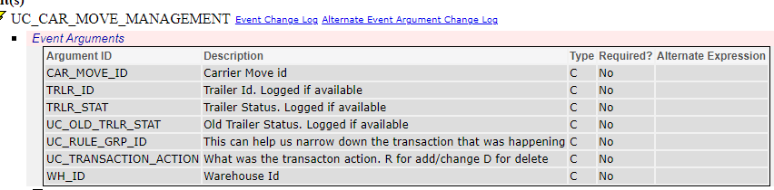
- Display Retrieve Method information (e.g, algorithm or SQL)
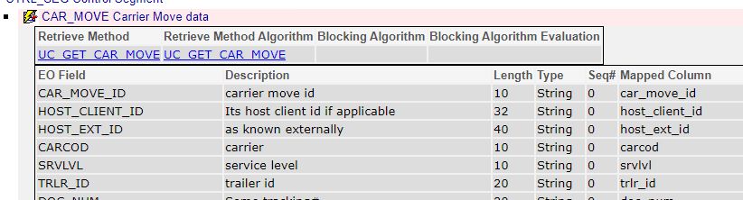
  - Clicking on retrieve method implementation will show its data:
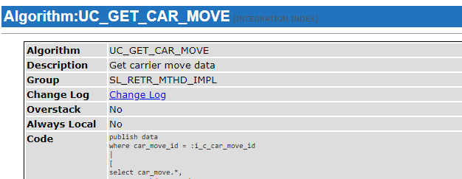
When it is not an algorithm, then we can click on retrieve method:
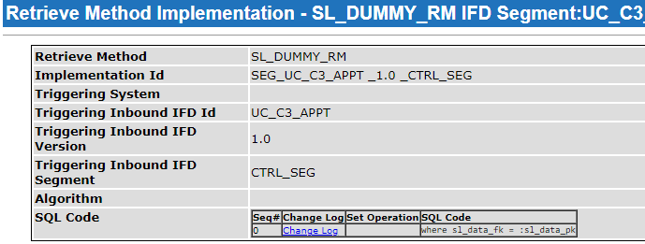
  - Blocking details and communication details are displayed:
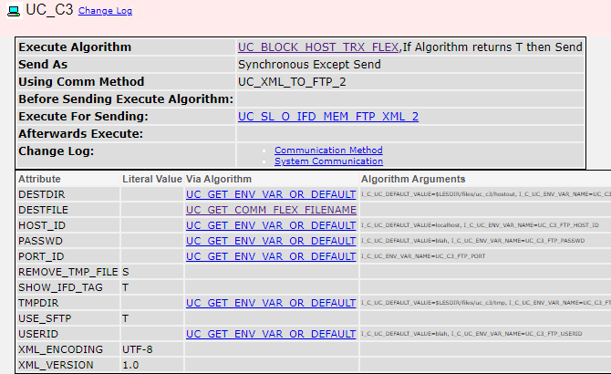

- When displaying result IFD data. If it calls an algorithm, that is a hyper link to the algorithm documentation.
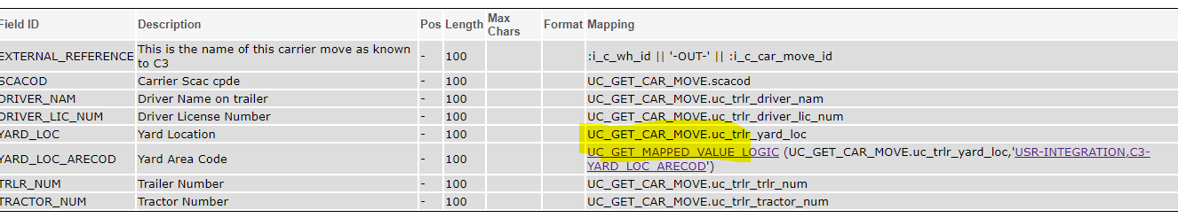
- For the algorithms that call into rules engine, i.e. UC_GET_MAPPED_VALUE, UC_BLOCK_HOST_TRX_FLEX, and UC_GET_COMM_FLEX_FILENAME either the algorithm itself will link to the map – or in case of UC_GET_MAPPED_VALUE, the paremeter is a hyper link to the map. The map is displayed as follows:
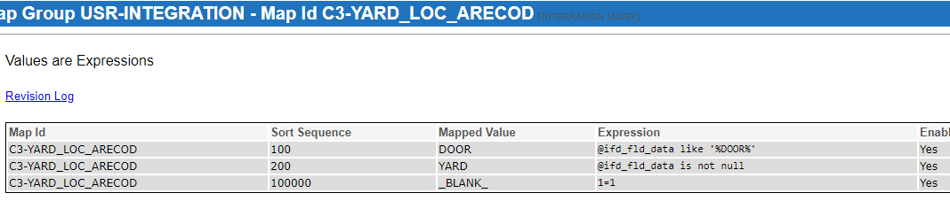
Following xslts have been modified as well:
- Xsl/docs/*.xsl have been enhanced to provide the functionality.

To generate the documentation, we simply run “mgendoc” as before. It will generate the needed documentation.

Bugzilla Integration
If Bugzilla is used for issue tracking, we have certain components available to view data in that database.
MOCA Command | Description
get ossi bugzilla connection information | Get the connection details for Bugzilla database.
execute ossi bugzilla dml | Any Bugzilla DML
execute ossi bugzilla select | A select against the Bugzilla DB
list ossi bugzilla bugs | List the buggs in bugzilla
list ossi bugzilla objects | List the objects in bugzilla
list ossi bugzilla rollout bug status | List the bugzilla statuses
list ossi bugzilla rollouts | List the rollouts in bugzilla
list ossi object changes since last rollout | Get all rollouts
list ossi object dependencies for rollout | If a rollout is to be created, given a bug# this will find if there are any dependency issues.
list ossi rollout installs | List the rollout installs
list ossi version control information for data core | Core component to extract the version control information for reporting purposes.
load ossi bugzilla environments | Load bugzilla environments table
load ossi svn log to table | Load SVN log to table usr_ossi_svn_hist_log for deeper analysis

Data Change Hook
We have the capability to track changes in certain tables and then have a job that executes rules and actions to perform certain actions. Idea is that when certain data changes directly or when its child data changes – we invoke rules engine actions. The components are provided in ossichghook component level. The functionality is enabled by adding following three columns to the table:
Column name | Specification | Comments
uc_reg_stat_cd | String(10) | It can have values of P or C. When P a job processes each row and performs actions against it and then updates to C
uc_reg_reacod | String(10) | The reason for changing uc_reg_stat_cd to P. If data row itself was manipulated it is set to A, C, or D. If a child record was updated then it is set to AD, CD, or DD.
uc_regdte | Date/Time | Date/time when the registration was done and row was changed to C
It is currently enabled for following tables.
Table | Child Tables | Rule
Car_move | Stop, trlr, shipment (assign/deassign) | OSSI-CARMOV-CREATED
Rcvtrk | Rcvinv, rcvlin, trlr | OSSI-RCVTRK-CREATED
ord | Ord_line | OSSI-ORDER-CREATED
In the above cases, remove of the main table always executes the rules as part of the triggering transaction. For other actions we have the option of invoking the rules inline or via separate job. When we are doing it via job – then the columns mentioned above are updated and the jobs take care of processing the actions. The policy in play is USR-OSSI-DATA-CHANGE-HOOK
Policy Variable | Policy Value | Comments
Table Name | ENABLED | If rtnum1 is 0 then functionality is disabled. 1 means it is processed via job and 2 means it is processed inline.
 | UC_RULE_GRP | Which rule group from usr_rule_engine_cond_expr is used?  Rtstr2 is the usr_rule_subgrp_id
Following is the default setup where we process data for the 3 tables via job:
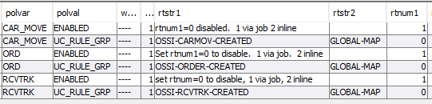
To register these as a job, schedule the following command:
register ossi object instances created
where uc_reg_table_name = 'CAR_MOVE'
and uc_rule_grp_id = 'OSSI-CARMOV-CREATED'
and uc_rule_subgrp_id = 'GLOBAL-MAP'
and uc_pk_col = 'car_move_id'
and uc_data_col = 'car_move_id'
and comflg = 1

Following tables execute conditional rules directly (i.e., these tables do not have the 3 columns)
Table | Actions | Rule
Appt | Create, change, remove | OSSI-APPT-CREATED
Trlr | Change | OSSI-TRAILER-STATUS-CHANGED
Trlr | move | OSSI-TRAILER-MOVED
Shipment | Staged | OSSI-SHIPMENT-STAGED
Car_move | Every shipment in carrier move staged | OSSI-CARMOV-CREATED

Query Components
We have a component level “ossiquery” with some common data access components. These components support smart rules that allow for adding additional columns. The concept is useful for reports and labels as they allow us to add additoional data to existing commands without changing the underlying commands;
MOCA Command | Description | Smart Rule
list ossi outer container pick header data | This provides data for an outer container that is handled during picking | OUTPUT-SET-LABEL-INV-CONTAINER
list ossi outer container pick detail dat | This provides contents of a an ounter container | OUTPUT-SET-LABEL-INV-CONTAINER-CONTENTS
list ossi lpn data | This provides data for an inventory load | OUTPUT-SET-LABEL-INVLOD
list ossi lpn data by part | This provides details on an inventory load by part | OUTPUT-SET-LABEL-INVLOD-BY-PART
list ossi pick with outer pick data
list ossi pick detail data
list ossi pick data
calculate ossi carton weight | Calculates the weight of a carton
The rules are defined using “Smart Rule Maintenance” screen.
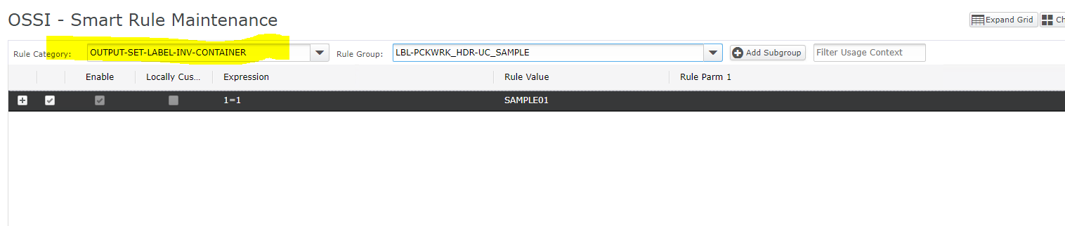
- The published value is the one in “Rule Group” from the last “-“ onwards, so UC_SAMPLE.
- Rule Value is the published value when condition deifned in expression is true.
- The rule value can be a MOCA command snippet as well.
This framework allows us to easily extend the output for specific requirements around labels and reports.

Integrator Objects
We provide some integrator utility components as part of the core library as well.

Algorithms
Algorithm | Usage Context | Description
UC_CONVERT_DATE_TIME_TIMEZONE | Field Level | The algorithm parameter is the time zone to convert the system time to. If not set UTC is assumed.
UC_GET_MAPPED_VALUE_LOGIC | Field Level | The rule group and subgroup in usr_rule_engine_expr are passed in as argument.
UC_CONVERT_DATE_TIME_TO_SYS | Field Level | Convert the date/time to system timezone. The input timezone is provided as algorithm parameter. If not passed UTC is assumed.
UC_CONVERT_MEASUREMENT | Field Level | Convert a measurement to a target unit. It uses policy USR-INT-MU. Policy variable is HOST-MU-DIM or HOST-MU-MASS. The polval is the system (or DEFAULT). Rtstr1 is the unit.  When applied to data, we can provide the context as argument. The value is then converted based on system we are sendimng data to.
UC_NUM_CEIL | Field Level | Get the ceiling vaue of a number
UC_GET_INB_FTP_FILES | Comm Method | Get files form an ftp source directory. It supports the idea where it will poll the folder for an expression per warehouse defined.
UC_SL_O_IFD_MEM_FTP_XML_2 | Comm Method | It converts a result IFD to XML and pushes to an FTP server.
UC_GET_ENV_VAR_OR_DEFAULT | Comm Arg | This is used when defining communication method argument values. It allows for passing in an environment variable and also a default value. The default value can reference environment variables as well.
UC_GET_COMM_FLEX_FILENAME | Comm Arg | It is used to generate file names using a rules engine. The rune group is USR-INTEGRATION-FLEX-FILENAME and the subgroup is the system id we are communicating with.  The file name can include special tags:  - <<NNNN>> is replaced with the value of sequence sl_gen_filename_seq  - <<WH_ID>> is replaced with the warehouse id
UC_BLOCK_HOST_TRX_FLEX | IFD Blocking | Block a result IFD based on rules engine. The rule group is USR-INTEGRATION-IFD-BLOCK and subgroup is ifd_id|ifd_version

Communication Methods
Following communication Methods are provided as well:
Communication Method | Description
UC_INB_FTP_XML_FILES | To get files from an FTP source
UC_XML_TO_FTP_2 | To send XML result IFDs to an FTP destination.

Results Verification
n/a

