General Data
DevID | Base
Dev Description | EMS Lite
Process | Exception Processing
Release
Wave
Priority | High
Complexity | Medium
Status | Approved
Business Unit | All
Application | RedPrairie WMS
Type | New & Enhancement
Smart IS Bugzilla Ids | 12567

Change History
Date | Version | Name | Details
11/4/2021 | 1.0 | Saad Ahmad | Initial Draft

Approval
This document requires approval from the following individuals:
(Signed approval forms are filed in the quality section of the project files)
Name | Role | Date | Signature

Responsible Contact Persons
The following people had input into this document:
(Signed approval forms are filed in the quality section of the project files)
Role | Name | Contact Details
Customer Process Owner

Open Design Points
# | Rel/ Wave | Desc | Status of Resolution | Impact | Date | Responsible
1

Table of contents
Approval 1
Responsible Contact Persons 1
Open Design Points 1
1 Functional Description (Process view) 3
1.1 Code Layout 4
1.2 Policies 4
1.3 Database 4
1.4 Log Ems Event 4
1.5 Get EMS Source System 5
1.6 Case Study – Simple override EMS scenario 5
1.6.1 Setup the general policies for sending email 5
1.6.2 Setup the command that is needed to enrich the context 6
1.6.3 Setup the conditional rule to perform the action we want 6
1.6.4 Setup the rules to determine email message components 6
1.6.5 The setup defined above will give us the desired functionality 8
1.7 Results Verification 8

Functional Description (Process view)
Standard BlueYonder systems provide “EMS” functionality. This provides the capability to send email alerts when certain exceptions occur. The code calls “log ems event” which sends a message to the EMS subsystem (a separate install of BlueYonder) which registers this alert. Users then subscribe to the events they are interested in and thus get notified.
Often the overhead of this separate subsystem does not justify its utilization. Many customers are only interested in getting the email alerts.
In that case, this functionality can be used. It intercepts the “log ems event” call and constructs email message using a rules engine. It also provides some added functionality:
- Logs a dlytrn in its own commit context
- Allows for executing some actions for the ems event.
- Allows for running a report and attaching it for an EMS event.
- Allows for enriching the context and using that data in the email message.
- Allows for simplifying email messages by providing a variable that has the full where clause as a string.
- By using rules engine the email subject and body can be shared easily for multiple events

Code Layout
The code is in following component levels:
- Ossiemslite contains all components for this functionality

Policies
- Polocod USR-EMSLITE
- Polvar SETUP
Polval | Setting | Comments
OVERRIDE-ENABLED | Rtnum1 = 1 enables override  Rtnum2 = 1 enables EMS logic within override | If rtnum1 is not 1 then it goes to standard functionality  If rtnum1 is 1 and then rtnum2 is 0 then EMS logic is bypassed
LOG-DLYTRN | Rtnum1 = 1 indicates that we log dlytrn | The dlytrm is logged in its own commit context. Actcod is UC_EMS
MAIL-SEND-FROM | Rtstr1 is from address | EMS alert emails are sent from this email address
The email settings are defined under policy USR-OSSI-SYSTEM-SETTINGS. Refer to ossiint base functionality for that information.

Database
n/a

Log Ems Event
This command is called for raising an EMS alert. It has been overridden in osisemslite component level. The command first uses the policy listed above to see if we have the override enabled. If we are going to do alternate logic then it works as follows;
- Default variables like mail_from (from policy), wh_id, usr_id, etc
- Look at the where clause of this call and construct a variable called all_args which is name=value list
- Execute an LES Command called uc_ems_ctxt_evt_nam (lower case). Its output will enrich the context for downstream logic.
- Execute conditional rules OSSI-EMSLITE / GLOBAL-MAP
- Using Rule engine OSSI-EMSLITE and subgroup of EMAIL-BODY, EMAIL-SUBJECT, EMAIL-TO, and RPT_ID determine the values so that email message can be constructed
- If we have a to address per rules
  - If we have a report id, then send email via API execute ossi report and email
  - If we have a variable uc_mon_data_res on stack and has more than 0 rows (this would have been published by les_cmd above), then send email via API send ossi app monitor email. This API attaches these results as a file to the emal.
  - Otherise send email via send ossi email API
- Log a dlytrn (in autonomous commit context) with actcod of UC_EMS if policy above allows us to do that
- If we had an error sending email, create a file in $LESDIR/log (one per day) with prefix of usr_ems_error_. File will have error details and also email details
- Optionally publish results.
The various conditional rules in this discussion have “Rule Name” with three possible values. When looking up the actions, we look up in following order:
- Exact Warhouse, Client, and Client Group.
- Each Warehouse, Client, and then any client group
- Any Warheouse, Exact Client, Any Client Group
- Any Warehouse, Any Client, Specific Client Group
- Completely wild card, i.e. XXXX-XXXX-XXXX
To determine the client group, we lookup the client_grp_client table for the client in context. For using client group in this way, the client should be in a single client group.

Get EMS Source System
This becomes a noop if we have override enabled

Case Study – Simple override EMS scenario
This case study provides an overview of a solution where we describe following:
- Event TESTRPTEMS should generate a report and attach it. Report is Std-AllEmployees
- Event TESTEMSCMD will utilize enriched context where uc_mon_data_res is published. The final email message will have this data attached.
- Event TESTEMSACTwill have some actions. Action will also then prevent email message later on.
- Event NORMALTEST is any other scenario

Setup the general policies for sending email
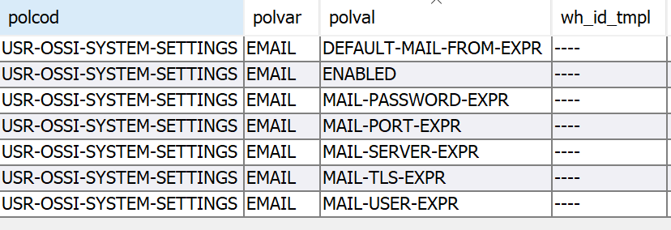

Setup the command that is needed to enrich the context
Setting up the command is completely optional and is needed only in case where we want to enrich the context. Command is named as uc_ems_ctxt_<ems event as lower case string>.
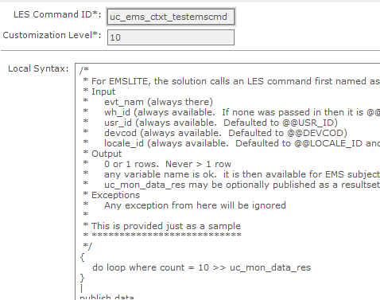

Setup the conditional rule to perform the action we want
The expression can filter based on the @evt_nam. The action can be anything. “Save session variable” allows us to influence the rules that will execute later.
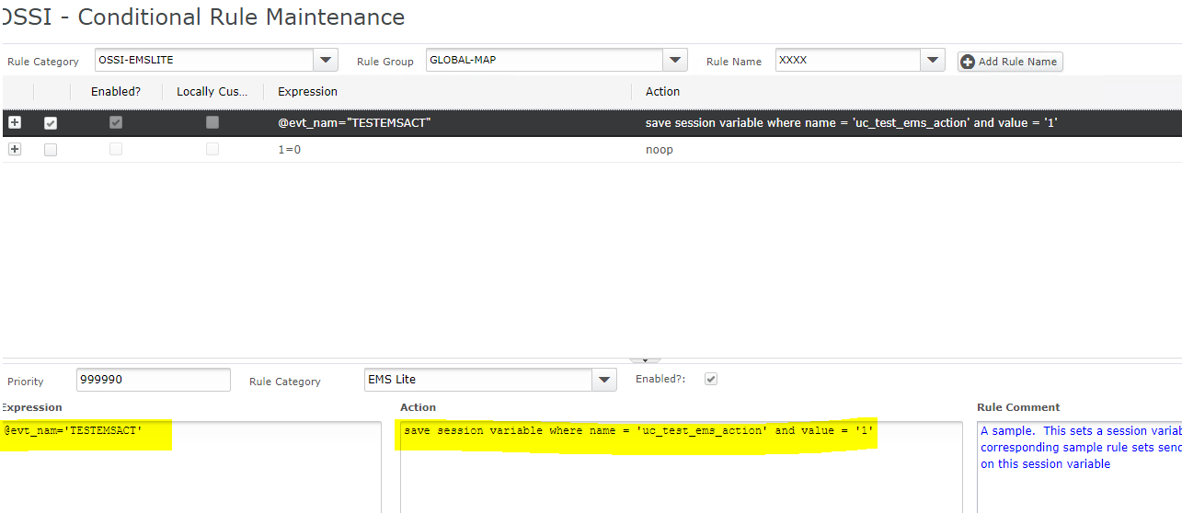

Setup the rules to determine email message components

EMAIL-BODY to define the email body
We can use this to define email body for specific events by using the “Expression”. “1=1” allows to create a default email message which will be sufficient for most cases sunce it can utilize special “all_args” which is replaced by all arguments passed in the where clause of “log ems event”
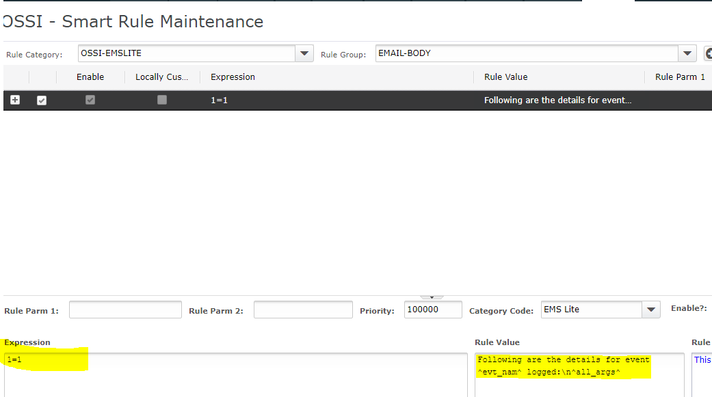

EMAIL-SUBJECT to define the email subject
We can use this to define email subject for specific events by using the “Expression”. “1=1” allows to create a default email message which will be sufficient for most cases sunce it includes event name, warehouse, user id, and the moca environment name
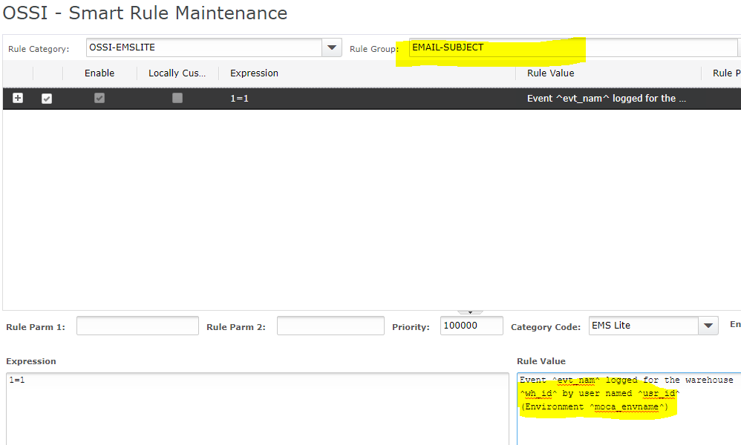

RPT_ID to define what report to execute
This rule does not have to return anything. We can use it to define the report we want to execute. If this rule retuns a value, then the specific report is executed with the data available on stack at the time and the output is attached as a PDF to the email message.
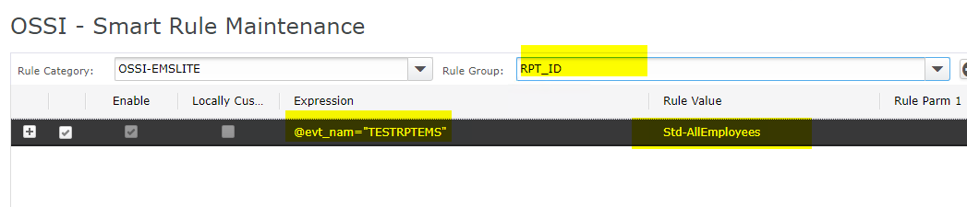

EMAIL-TO to define who the email is sent to
If this resolves to nothing, then email is not sent. This concept can be used to prevent email from getting sent in certain cases. In our case study the action earlier sets a session variable and here the “to address” resolves to NULL in that case and thus prevents email. In all other cases a default email address is used.
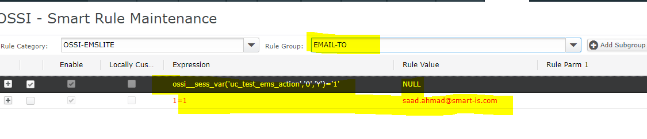

The setup defined above will give us the desired functionality
- TESTRPTEMS EMS event will determine a report id and thus send the output of the report
- TESTEMSCMD EMS event will first execute the command to enrich the context since it exists. And since the special variable uc_mon_data_res is in the context, final email will attach these results
- TESTEMSACT EMS event will perform an action which sets a session variable and in our test the email will not be sent out in that situation.
- NORMALTEST EMS event will send a normal email message.

Results Verification
n/a

