JOMO KENYATTA UNIVERSITY OF AGRICULTURE AND TECHNOLOGY
BACHELOR OF SCIENCE IN INFORMATION TECHNOLOGY
BIT 2319 ARTIFICIAL INTELLIGENCE
PRACTICAL LAB I: REVIEW OF DATA STRUCTURES

  - Explain the following terms and give examples of each
    - Algorithm
    - Data structure
    - Recursive algorithm
    - Analysis of algorithm
  - Distinguish between data abstraction and data structures with the aid of appropriate examples

    - Discuss the motivation behind the use of recursion in programming
    - Consider the following recursive definition:
n+1 if m=0
Acker (m, n) = Acker (m-1, 1) if n=0
Acker (m-1, Acker (m, n-1)) otherwise

This function, called Ackermann’s function, is of interest because it grows rapidly with respect to the sizes of m and n.
      - What is Acker (1, 2)? Show your working
      - Write a program in C/C++/Java to implement the function and test Acker (1,2). Compare the output with (I) above

  - Draw a binary Tree for the expression : A * B - (C + D) * (P / Q)
  - Traverse the tree in
    - Inorder
    - Preorder
    - Postorder traversals
  - Consider the following digraph G where the alphabetic order of node names defines the ordering of neighbors of each node.

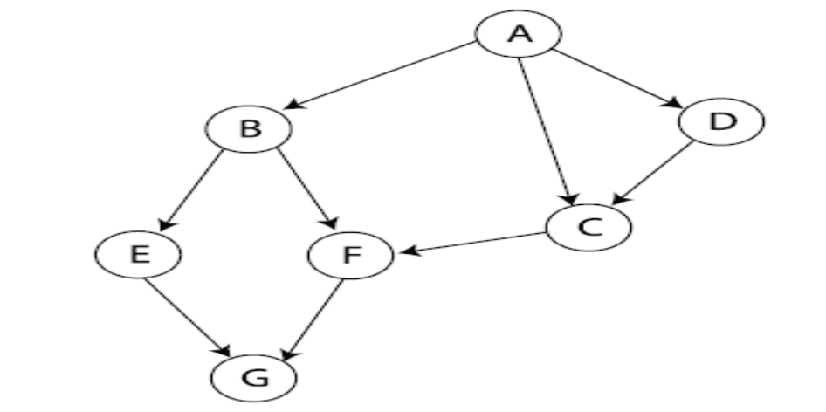

  - Show the order of visiting its nodes during the breadth-first search starting at A and using the neighbor ordering mentioned above.
  - Show the order of visiting its nodes during the depth-first search starting at A and using the same neighbor ordering. Draw the resulting depth-first search tree.

