Installation Desigo MP2024_03 = ABT V5.2 + XWP V6.3 SP2 (V6.30.440)
The Market Package MP2024_03 consists of 3 Tools (ABT, ABT Go and XWP).
The Desigo Tools can be installed as single standalone or together.
We propose, if all 3 are needed, to install them in the sequence described below.
All Desigo Engineering Tools including their libraries, FW and documentation are available under the following link (Partner Portal BP CEE access required):
Pos | Desciption | Last change (Date) | Last change (reason) | Download
1.1 | ABT Tool Base - Installation Set V5.2, Firmware Set V52_02  + Patches in folder .. \01_Tools\Patches,  Patches are generally available via SSU too- see section 10 | 29.3.2024 | Market Release | Link
1.2 | Patch 8 (Update for ABT V5.2) available also via SSU.  Workflow for patch installation via SSU see Chapter 10  Patches must be re-applied after each ABT reinstallation or ABT repair. | 4.12.2024 |  | Link
1.3 | New ABT_Firmware-Library_52_04 for PXC4/5/7, DCP, DRA | 4.12.2024 | Bug fixe | Link
1.4 | New ABT DRA Libset 08.1 HQ (CET) | 30.7.2024 | Bug fixe | Link
2.1 | XWP (Tool, Lib, Firmware V6.30.440, Firmware V6.30.298  + Patches in folder ..\01_XworksPlus_V6.30.440\_Updates\XWP  Note: patches are available via SSU - see section 10  (or current patch 02 download here) | 29.3.2024 | Market Release | Link
2.2 | New XWP_Firmware-Library_V6.30.298_inkl_ModbusUpdates (PXC001) | 2.10.2024 | Bug fixe | Link
3 | Desigo System Documentation Engineering Edition | 29.3.2024 | Market Release | Link
4 | Desigo System Documentation Customer Edition | 29.3.2024 | Market Release | Link
5 | Market Release Notes MR2024_03 with Update Juli 2024 | 30.7.2024 | Update | Link
6 | ValidVersionSet | 30.7.2024 | Update | Link
The respective zip files should be extracted to a local drive "D:", otherwise the drive letter "D:" specified in the installation workflow should be changed accordingly.
- Check of prerequisites

General:
Dual Core Computer minimum 32 GB RAM (recommended ≥64GB)
Do not install Desigo Tool’s (XWP or ABT) in concurrent of other S7 Simatic tools, propose VM Ware.
Microsoft .NET Framework 3.5 (activation via Windows features)
Microsoft .NET Framework 4.8 or higher (install or update)
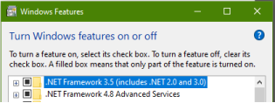

Desigo Control Point:

Google Chrome V122 or newer
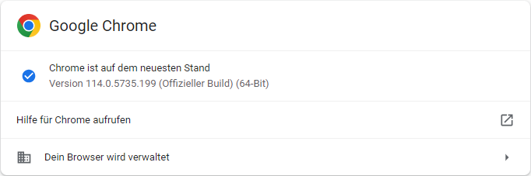
=> https://www.google.com/chrome/browser/desktop/index.html

Java JRE:
- It is not allowed to have more than one Java version installed on the device.

Open Command Prompt and enter „java -version“, to check whether JDK is already installed.
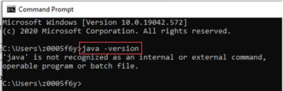
If „Azul Zulu“ Java is already installed, you can ignore the next steps.
If „Java Oracle“ is still installed on your PC, please uninstall it and install „Azul Zulu“.
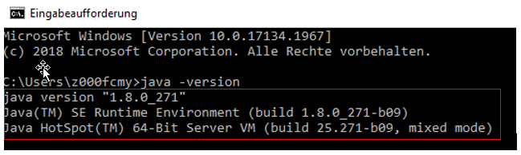
Uninstall
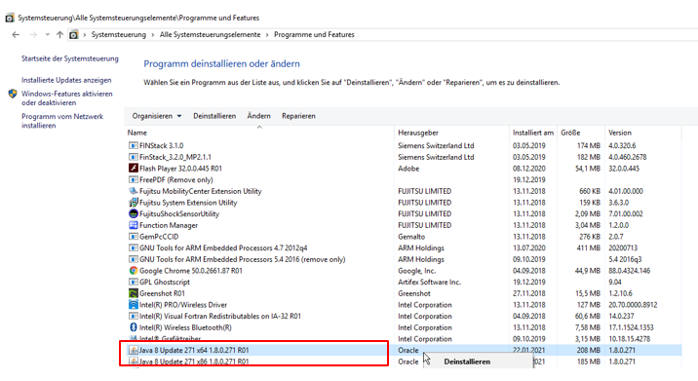

Siemens DWP clients: Azul Zulu is default OpenJDK component
(download from Siemens Software Center)
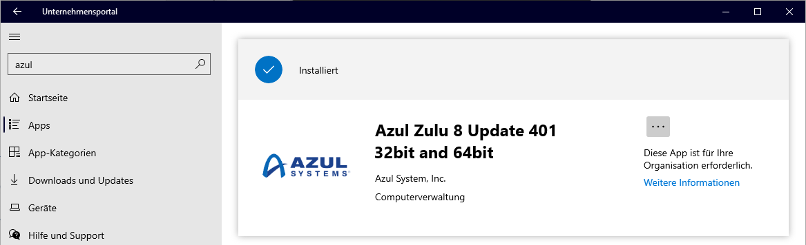

Continue/Finish the installation
Non-Siemens Computer: Please use Adopt OpenJDK 8 (LTS) as shown in the screenshot below
(download here https://adoptopenjdk.net/).
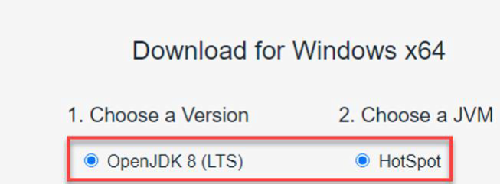
Start installation following the Setup process
Activate “Set JAVA_HOME variable” (as shown in screenshot)
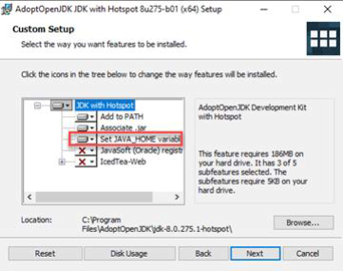
Continue/Finish the installation
- PC restart

- ABT: Update from ABT V5.x to ABT V5.2 (incl. ABT Libraries)
ATTENTION: Only carry out a new ABT installation if no ABT or an ABT version < V5.0 is installed! With the new installation, the ABTInstaller.exe must be started in the same way as with the update installation, but the screenshots are slightly different!

D:\MR2024_03\02_ABT\01_Tools\ABTInstaller.exe
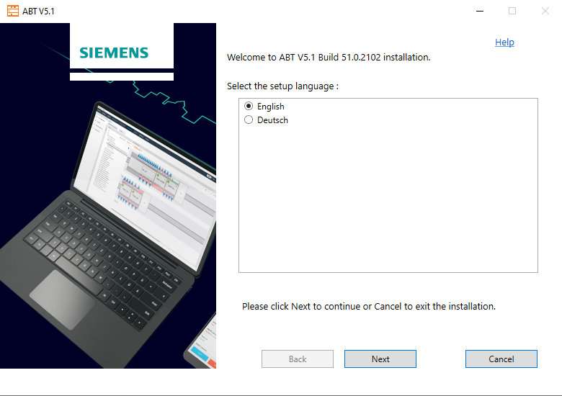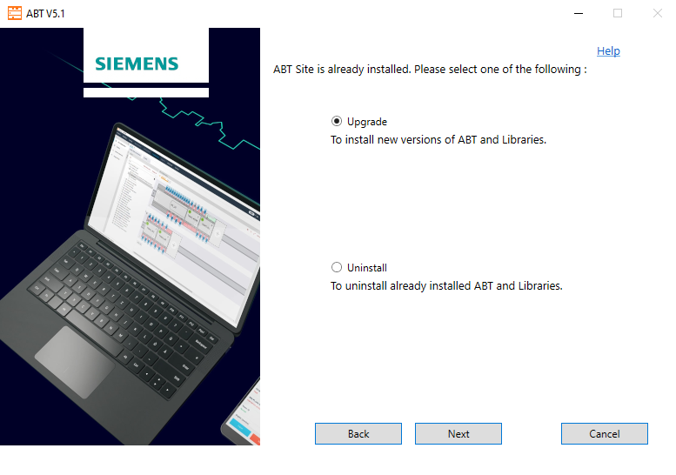
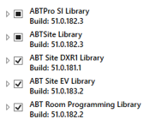
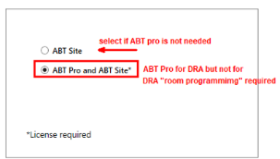
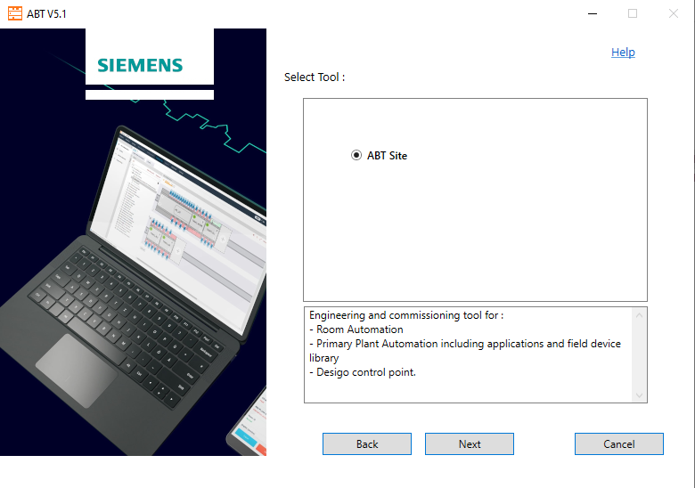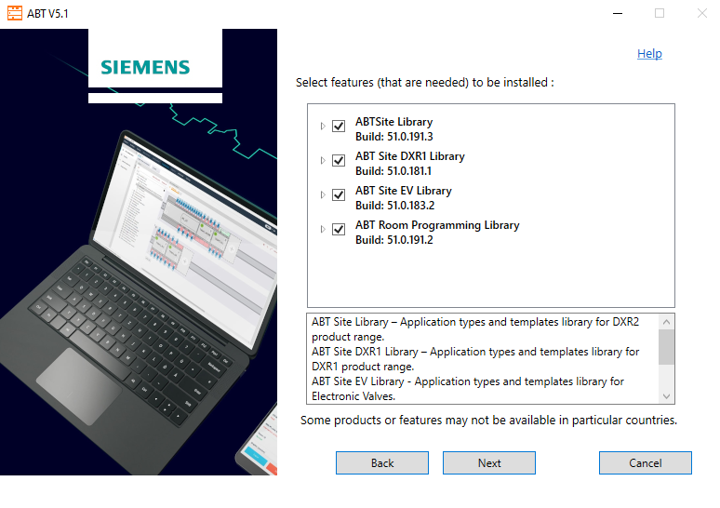

Note:
Older ABT Pro libraries (Previous Libraries) are preselected so that all libraries required for each controller migration are installed.

If necessary, the non-preselected libraries can be installed later by starting ABTInstaller.exe again.

ATTENTION: After running ABTInstaller.exe later, all current ABT patches must be installed again (see chapter 5) ABT-Updates/Patches

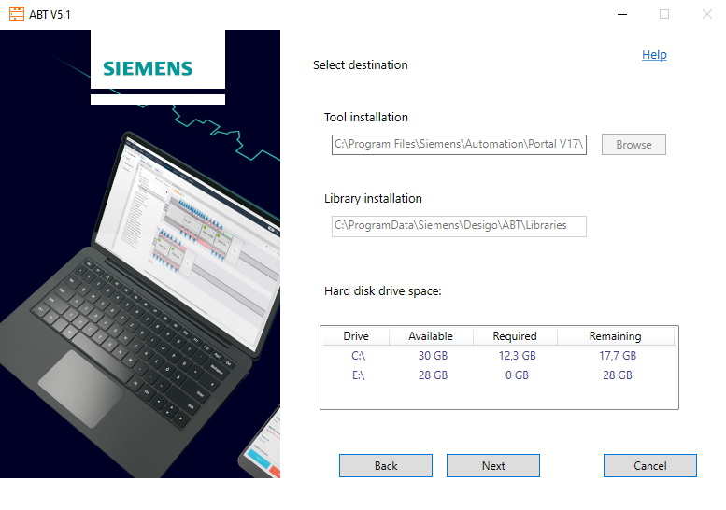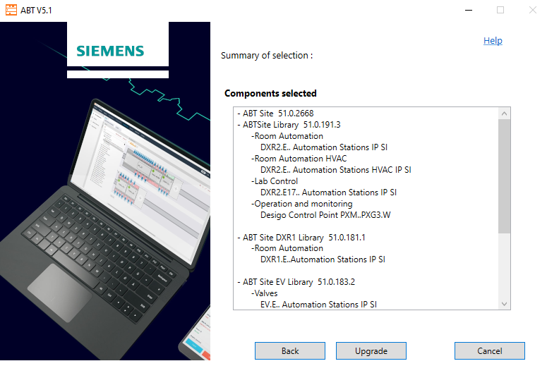
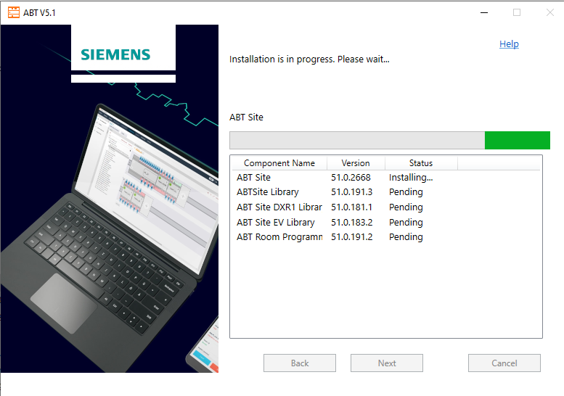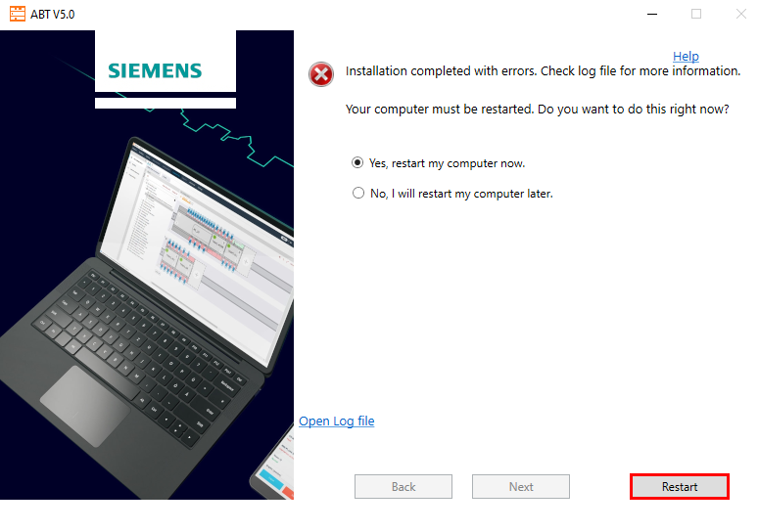

- PC-Restart (see last ScreenShot at pervious section)

- ABT Updates/Patches installation with SSU (Siemens Software Updates)
Run SSU, check and install offered patches.
Patch ABT_5.2_52.0.2771.6
Workflow:
- Click in Windows Start Icon and
- write “SSU” (Siemens Software Updates) utility
- select >Show hidden icons< on windows taskbar
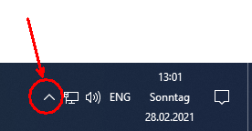
- Right on Icon >Windows Update Manager<
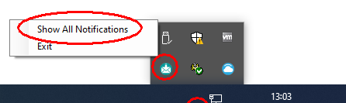
- select >Show All Notifications<

- Install all offered updates.

Tips:
- Open and periodically check SSU for update and patches (see SSU setting Auto - update daily/weekly).
- How do I check the installed ABT Site Version? start via ABT site > Help > Info …

- ABT: Libset-Upgrades installation for DRA)

ABT Site (Libset 08.1 HQ ABT Site 5.2) Installation:
D:\MR2024_03_AT-Release\02_ABT\02_Application\Libset 08.1 HQ ABT Site 5.2\Setup 08.1 HQ ABT Site 5.2.exe
ABT Site Room Programming (Libset 08.1 HQ ABT RP 5.2) Installation:
D:\MR2024_03_AT-Release\02_ABT\02_Application\Libset 08.1 HQ ABT RP 5.2\Setup 08.1 HQ ABT RP 5.2.exe
ABT Pro (Libset 08.1 HQ ABT Pro 5.2 SI) Installation:
D:\MR2024_03_AT-Release\02_ABT\02_Application\Libset 08.1 HQ ABT Pro 5.2 SI\Setup 08.1 HQ ABT Pro 5.2 SI.exe
- Firmware-Folder path adoption within ABT Site

start ABT Site (standalone) and at section „Settings“adopt the Firmware-path:
D:\MR2024_03\02_ABT\03_Firmware\ABT_Firmware-Library_52_03

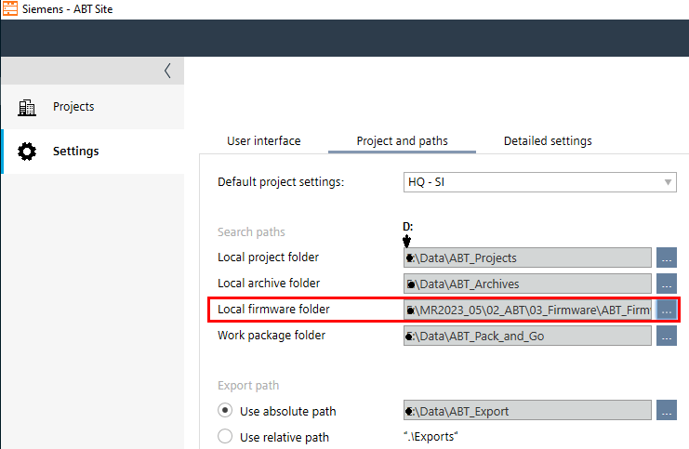

- ABT Go: ABT Go V5.2 installer.

ABT Go for Mobile Phone or Tablet is available via App Stores:
 | for Android-Devices, Download via Google Play Store
 | for iOS-devices, Download via Apple Store
 | for Windows Notebook  D:\MR2024_03\02_ABT\01_Tools\ABT-Go\ABTGo_52.0.2827.0.exe  PC neustart  Install ABT Go patch 01: D:\MR2024_03\02_ABT\01_Tools\Patches\ABTGo_5.2_Patch_01.exe

- PC-Neustart

- XWP: update or New Installation XWP V6.3 SP3 (V6.30.440)

  - Uninstall XWP (only necessary if an XWP older than V6.3SP2 (V6.30.290) is installed!)

Note: When uninstalling is needed than use the latest Uninstall Utility for uninstalling XWP version.

- Start the Uninstall utility from folder …\01_XWP_Framesetup\Uninstall\Uninstall.exe
If uninstall service do not start, run …\01_XWP_Framesetup\Vcredist10\vcredist_x86.exe and rerun Unistall.exe
- PC-Restart
- Continue with New Installation -> Setup.exe

  - XWP: Update New Installation

if XWP no or XWP V6.30.290 is already installed, then run
D:\MR2024_03\01_XWP\01_Tools\01_XworksPlus_V6.30.440\Setup.exe

  - PC restart

  - XWP: Installation LibSet

XWP: update- / new-installation LibSet LED28 (01_Libset_LED28-HQ-630440-10)
D:\MR2024_03\01_XWP\02_Application\01_Libset_LED28-HQ-630440-10\Autoplay.exe

    - PC restart

- XWP Updates/Patches installation
Run SSU (Siemens Software Updates) and install all offered patches
Workflow:
- Click in Windows Start Icon and
- write “SSU” (Siemens Software Updates) utility

- select >Show hidden icons< on windows taskbar

- Right on Icon >Windows Update Manager<

- select >Show All Notifications<

- Install all offered updates.

Tips:
- With the update/new installation, the XWP Patch02 is also supplied offline in the zip file and can be installed (after unzip) from here:
MR2024_03\01_XWP\01_Tools\01_XworksPlus_V6.30.440\_Updates\XWP\XWP630440Patch01.exe

2. run and periodically and check SSU for update patches (see SSU setting Auto - update daily/weekly).
3. How do I check the installed XWP Site Version? via XWP > Help > About...

PC restart

- XWP: Firmware-path Adoption within XWP
> XWP > Tools > Options > adopt the > Firmware-Library Path:
D:\MR2024_03\01_XWP\03_Firmware\XWP_Firmware-Library_V6.30.298
D:\Data\XWP_XWP_ABT_Export
D:\Data\XWP_Projekte
D:\Data\XWP_Archive
D:\MR2024_03\01_XWP\03_Firmware\XWP_Firmware-Library_V6.30.298
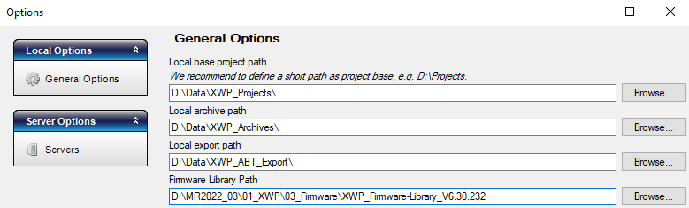

- error case, ABT connection to controller is not possible, repair "Siemens BT H7 CAL"
If the connection to the controller fails (online connection, download), it usually helps to repair the “Siemens BT H7 Communication Abstraction Layer” under “Programs and Features” 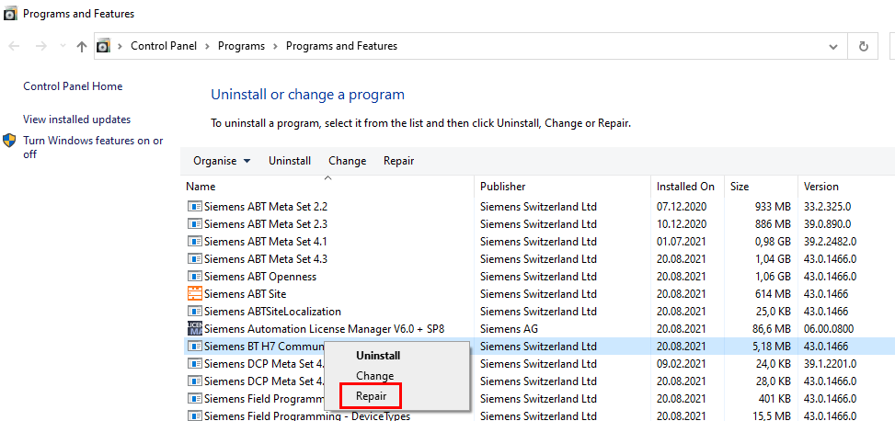

Versions
29. March 2024 | Dok V1.1 | G. Schmidt | Release ABT V5.2, XWP V6.30.440
3. July 2024 | Dok V1.2 | SGE/BRE | Update: patch 4 for ABT Site V5.2
30. July 2024 | Dok V1.3 | SGE/BRE | Update: patch 6 for ABT V5.2
2. Oct 2024 | Dok V1.4 | SGE/BRE | Update: patch 7 for ABT V5.2 and PXC00-U & PXC001 modbus FW update
11. Dec 2024 | DokV1.5 | SGE/BRE | Update: for ABT V5.2, patch 8 and ABT FW Lib V52_04

