Spinnaker is an open source, multi-cloud continuous delivery platform for releasing software changes with high velocity and confidence.

**Important feature:**

* Application Management
* Application Deployment

**Access Required:**

* Access to VM, from you can access kubernetes cluster.
* Required kube config file for access kubernetes cluster.

**Environment Setup:**

* Install helm on VM
* Install spinnaker using helm

**Helm installation:**

1. Download your desired version of helm binary

# wget <https://get.helm.sh/helm-v3.2.1-linux-arm64.tar.gz>

1. Unpack it

# tar -zxvf helm-v3.0.0-linux-amd64.tar.gz

1. Move helm binary to bin directory

# mv linux-amd64/helm /usr/local/bin/helm

1. Verify download

# helm version

**Install spinnaker:**

1. Add helm stable repo

# helm repo add stable <https://kubernetes-harts.storage.googleapis.com/>

1. Update repo

# helm repo update

1. Verify

# helm repo list

**Configuration for execution:**

1. Create namespace for spinnaker

# kubectl create namespace spinnaker

1. Customize spinnaker with values.yaml

Azure repo link of values.yaml

1. Install spinnaker

# helm install spinnaker stable/spinnaker -f values.yaml -n spinnaker

1. Verify

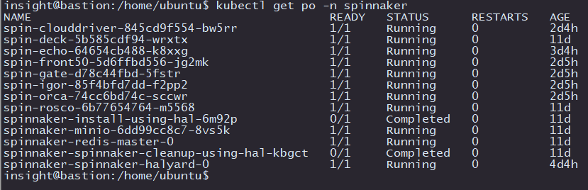# kubectl get po –n spinnaker

# kubectl get svc –n spinnaker

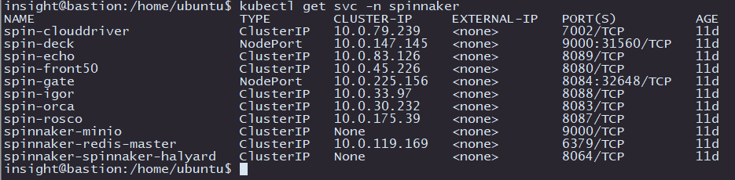

**Create spinnaker pipeline:**

**Access Required:**

* Spinnaker access

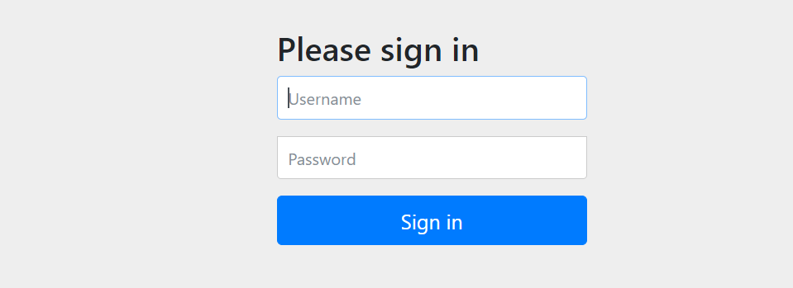Login to spinnaker in UI. (Use credential provided in values.yaml)

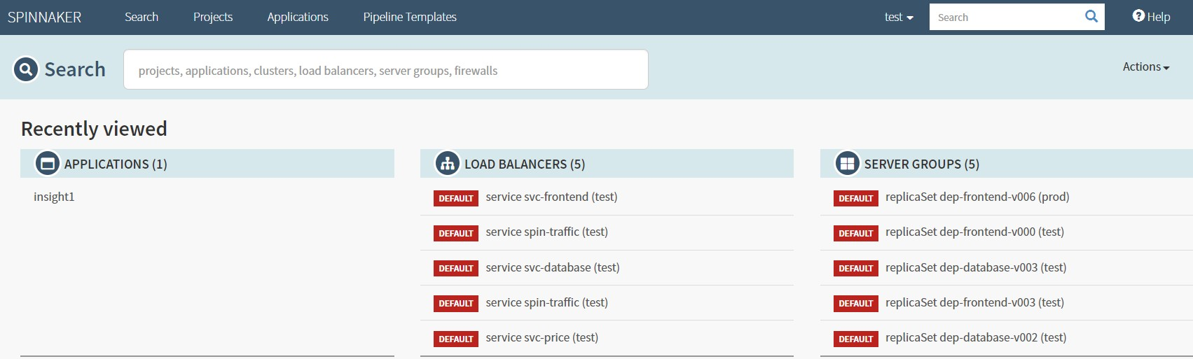Spinnaker homepage.

**Environment Set-up:**

Create application in spinnaker:

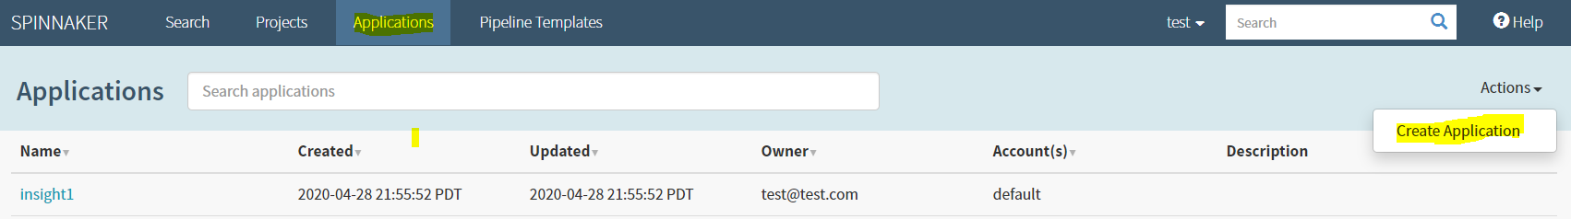Click on Application --> Action --> Give details --> Create

**Source Code:** Find pipeline template in azure repo.

**Link:**

**Pipeline creation:**

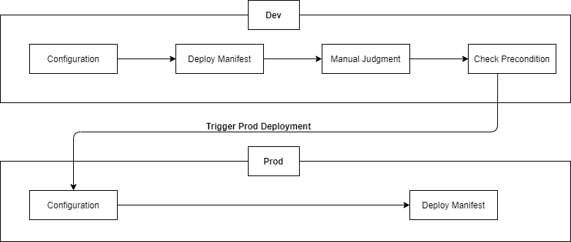**Workflow:**

Step by step guide for setup and execution:

Click on Applications -> click on application name

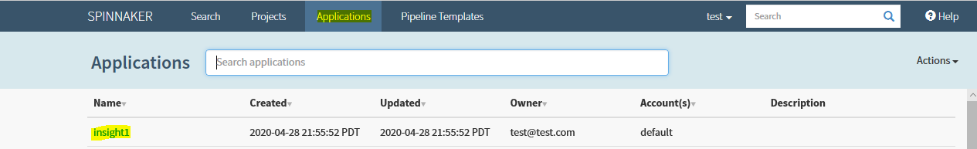

Click on Pipelines -> “ + ” -> Give pipeline name -> click on create

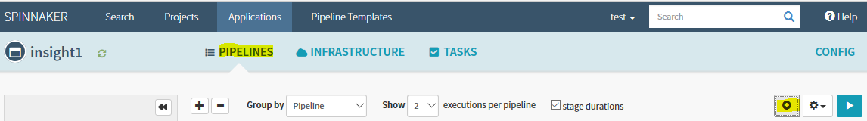

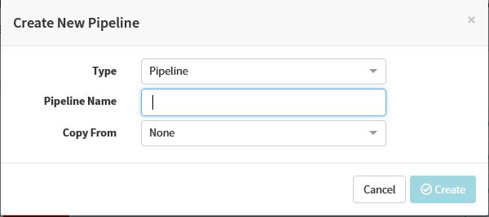

Go to pipeline action -> click on edit json -> give json template from azure repo

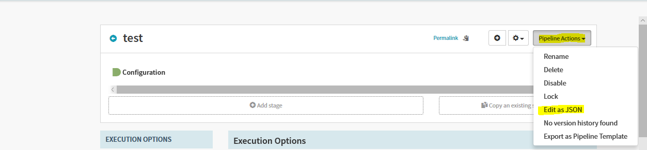

Spinnaker will create pipeline for you.

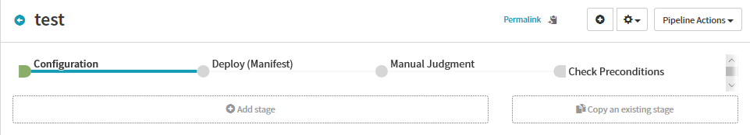

Update docker registry under Automated Triggers option in configuration stage.

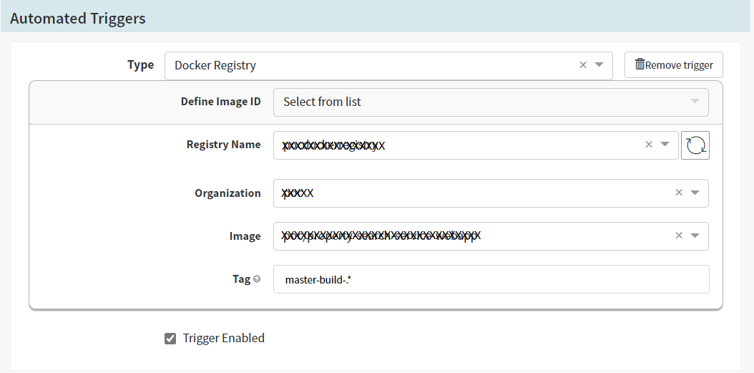

Change the namespace in deploy (Manifest) stage.

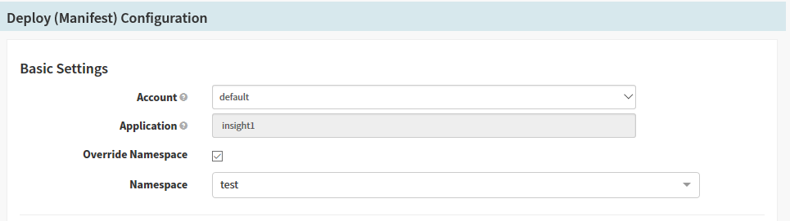

Then click on Start Manual Execution in pipeline homepage.



**Validation:**

Output:

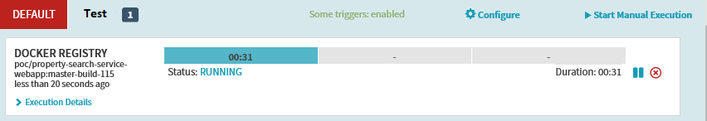

Click on Application 🡪 Application name 🡪 Infrastructure 🡪 Load Balancers 🡪

Frontend 🡪 your namespace 🡪 Load balancer IP

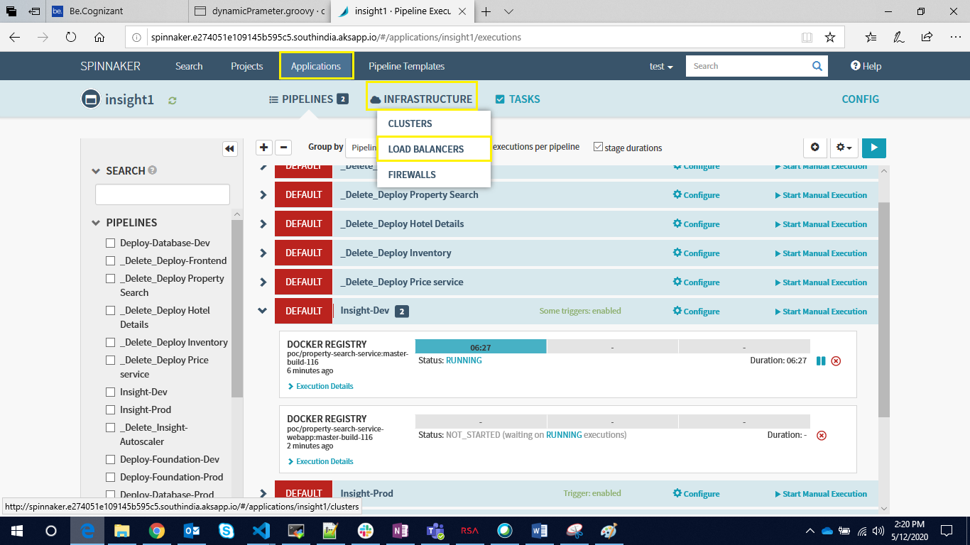

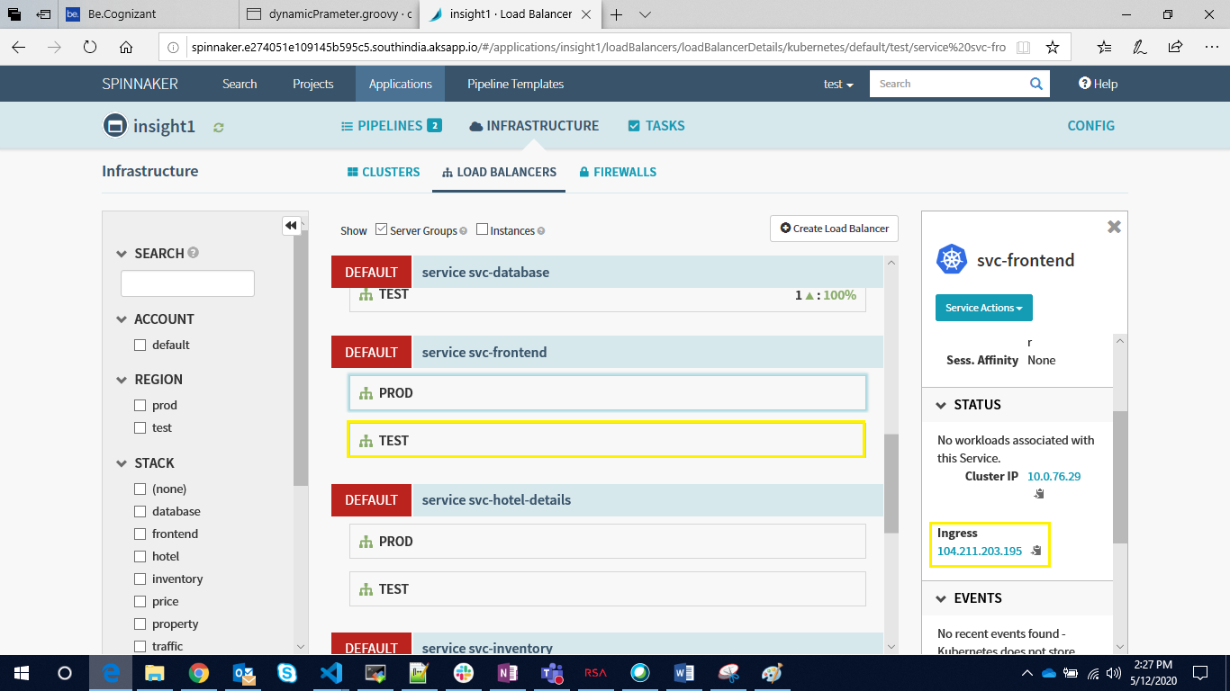

Access application:

