

**Healwire Android**

**HEALWIRE PRODUCT DOCUMENTATION**

***Version 1.0***

**27 August 2016**

***OVERVIEW***

***Healwire Android App***

After doing a fair share of good business, Healwire Online is proud to release its latest product Healwire Android.

Healwire Android, completely developed in the native android platform provides user the power to procure your medicine through an one-click process from your mobile app. It incorporates latest features provided by android market. With minimalistic and simplistic UI material design, it add more colors to pharmaceutical business model.

The store incorporates a user-friendly and visually pleasing layout with responsive navigation, making it very much workable and accessible even for the non tech – savvy people. The whole process of order placing and processing is simple and trouble free, increasing your conversions giving you more of what you want out of your mobile app. If you are unsure of your medicinal prescription simply upload the image or scanned copy of your prescription and your cart will be updated with prescribed medicines by the pharmacist admin. Or else you can browse for medicines by brand or trade name using the Search bar and add it to your cart. All relevant details regarding the drug like active ingredients, drug type, warnings, alternate medicines and directions of usage will be made available to you before the order placement.

Give the right drug, in the right dose, to the right person, at the right time and in the right way through Healwire Android.

***PRE-REQUISITES :***

* **Healwire Webapp :**

Working copy of the healwire webapp downloaded from Codecanyon hosted at any server.

**Purchase Link :**

<https://codecanyon.net/item/healwire-online-pharmacy/16423338>

***SYSTEM REQUIREMENTS***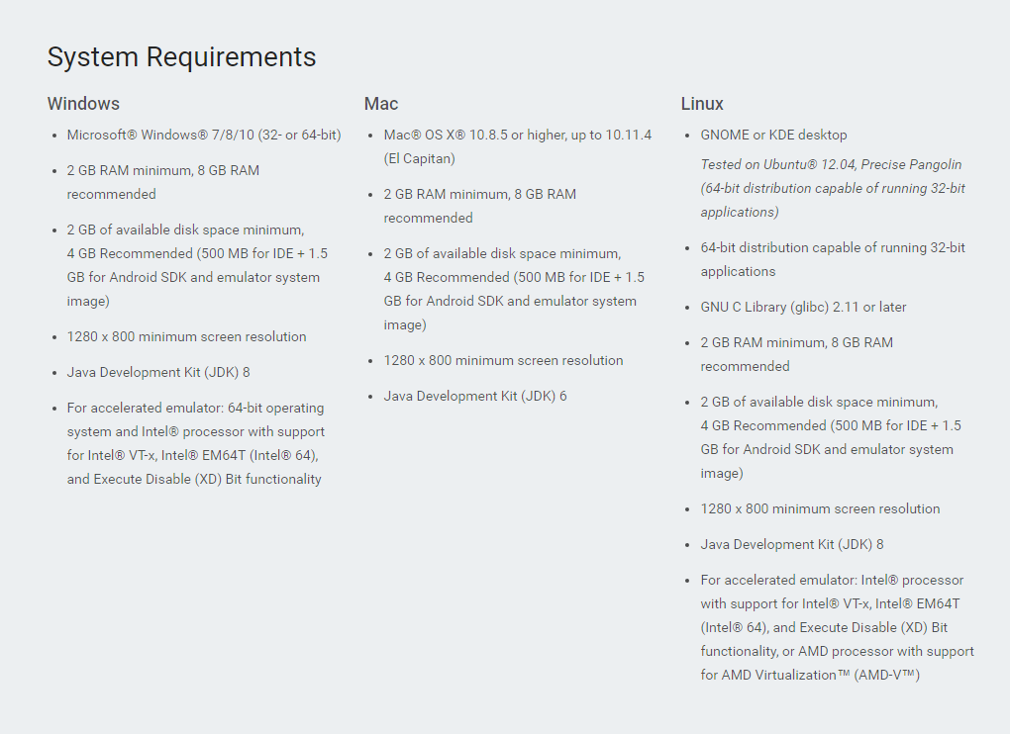

***INSTALLATION***

Healwire is an android application developed using Android Studio IDE and Android SDK tools. To build and run this project you have to install Android Studio latest version

installed on your PC. To install Android Studio go to the following link.

Step 1 :

Download Android Studio latest version from official android developer website.

<https://developer.android.com/studio/index.html>

Step 2 :

Install the android studio setup file you downloaded on your PC. Now the file will download the required components to build and run android studio projects.

For more visit :

<https://developer.android.com/studio/install.html>

Step 3 :

After installed Android Studio latest version. Now it's the time to build and run the Healwire project you got as compressed .zip file Healwire.zip

Step 4 :

Extract the Healwire.zip file and copied to a folder in your PC.

Step 5 :

Now it’s the time to import Healwire Android project to Android Studio.To run

Healwire project on Android Studio you have to import that project from your folder location to Android studio.

***Import Projects to Android Studio***

*Step 1* : Start Android Studio and close any open Android Studio projects

*Step 2* : From the Android Studio menu click **File > New > Import Project**

*Step 3* :

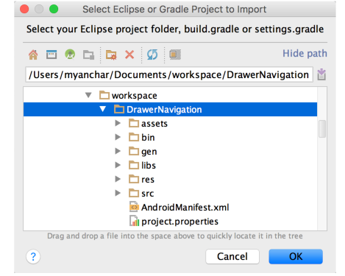

*Step 4* : Select the destination folder and click **Next**.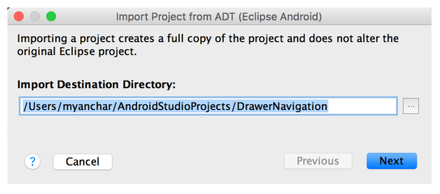

*Step 5* : Select the import options and click **Finish**

*Step 6* :

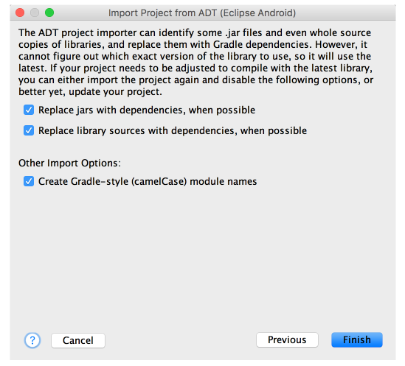

*Step 7* : Android Studio imports the app and displays the project import summary.

Review the summary for details about the project restructuring and the import process.

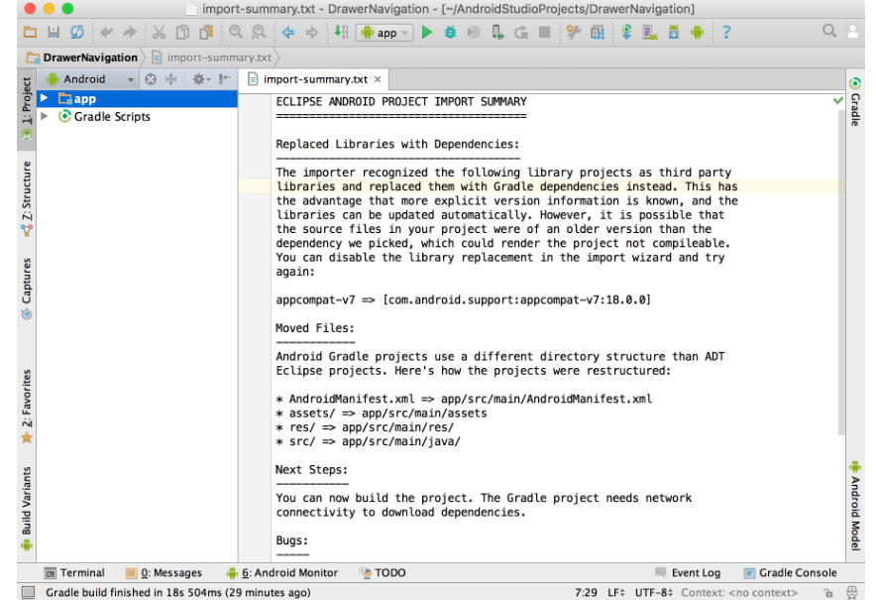

*Step 8*:

After importing the project from Eclipse ADT into Android Studio, each app module folder in Android Studio contains the complete source set for that module, including the src/main/ and src/androidTest/ directories, resources, build file, and Android manifest. Before starting app development, you should resolve any issues shown in the project import summary to make sure the project re-structuring and import process completed properly.

Step 6 : Build and Run your project.

Before that you can create your own virtual device or your android vice for build and run Healwire project.

If you want to run app using Android device Connect it with a USB cable and make sure USB Debugging is enabled on Android phone.

If you want to run on Device emulator,

**Tools > Android > AVD Manager** in android studio. Select a device and move forward.

To run click  **Run** 

It will build and run the Healwire project on android selected device.

***CUSTOMIZATION***

If you want to customize Healwire project with your own name and feature, you can change Product name , configurations files , App icon , Product Logo ,Splash screen ,

And some Information about your organization Contact details etc. using our the

following steps.

***Product name***

You can change this product name of your own name.In project window on left pane of Android Studio, on Android item

**app > res > values > strings.xml**

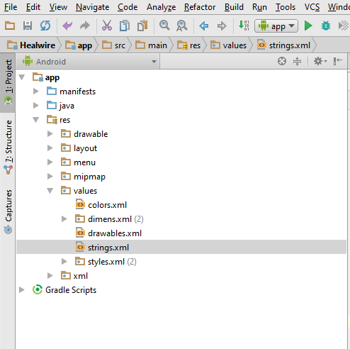

2 . in strings.xml file.Change the line from

<**string name="app_name"**>Healwire</**string**> to

<**string name="app_name"**>...your product name...</**string**>

3 . Save the project. **File > Save all .**

***App Logo***

You can also change the app logo of your own logo by the following steps

1 . In your computer, go to your project folder , This is our directory

**C:\Projects\Android\Healwire\app\src\main\res\drawable.**

2 . In the drawable folder, find and replace the file **logo.png** withsame name as

**logo.png**

3 . Save the project. **File > Save all .**

***App splash screen***

You can also change the splash screen of your own splash screen by the following steps

1 . In your computer, go to your project folder , This is our directory

**C:\Projects\Android\Healwire\app\src\main\res\drawable.**

2 . In the drawable folder, find and replace the file  **splash_screen.png** withsame name as

**splash_screen.png**

3 . Save the project. **File > Save all .**

***App icon( Launcher icon)***

You can also change the app icon of your own icon by the following steps

1 . In your computer, go to your project folder , This is our directory

**C:\Projects\Android\Healwire\app\src\main\res\drawable.**

2 . In the drawable folder, find and replace the file **icon.png**

same name as **icon.png**

3 .Copy **icon.png** to all mipmap folderssuch as mipmap-hdpi**,**mipmap-mdpi,mipmap-xhdpi,mipmap-xxhdpi and mipmap-xxxhdpi.

4 . Save the project. **File > Save all .**

***App details***

**About us**

1 . You can change the about us notes using the following steps.

In project window on left pane of Android Studio, on Android item

**app > res > values > strings.xml**

2 . in strings.xml file.Change the line from

<**string name="Aboutus"**>Healwire offer a wide selection of genuine medicines based on prescriptions placed by the customers.

Our prime motive is to be the first choice for wellness and health needs by customarily understanding and exceeding customers expectations</**string**>

to

<**string name="Aboutus"**>...your aboutus notes...</**string**>

3 . Save the project. **File > Save all .**

***Web Service URLs (Healwire web-app)***

You can change the URL path of the web services used in the Healwire project

by the following steps

1 . In project window on left pane of Android Studio, on Android item

**app > java> com.webandcrafts.healwire > AppController.java**

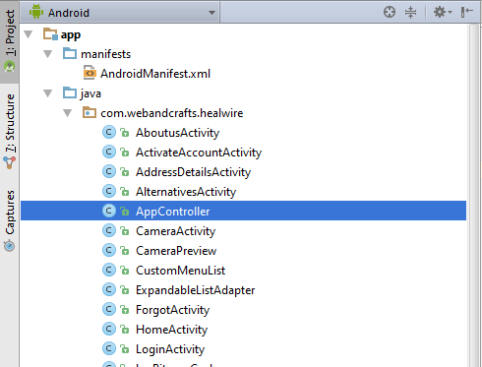

2 . in the **AppController.java** file change the line

***public static*** *String WEB_SERVICE_URL =* ***"HEALWIRE_WEB_APP_URL"****; //Change the web server URL of your product*

to

***public static*** *String WEB_SERVICE_URL =* ***"< ...your Webservice URL.. >"****; //Change the web server URL of your product*

Now you have completed the full customization of your project.

Finally, Save, Build and Run your customized project.

***Note : Make sure the resources you used for your own customized version includes only .png***

***files for App Logo, App icon and App splash screen with their corresponding name,size and dimensions of the Healwire project resource files.***