|  |
| --- |
| **Submitted in partial fulfilment of the requirements for the award of degree of**  **Bachelor of Technology**  **in**  **Computer Science & Engineering**  **Using Digital Twinning to enhance Human-Robot Collaboration with augmented reality**  **UE20CS390A – Capstone Project Phase – 1**  ***Submitted by:***  **Aakash Negi PES1UG20CS002**  **Aaryan M S PES1UG20EC007**  **Hari Ganesan PES1UG20CS158**  **Yuktha M PES1UG20CS237**    Under the guidance of  **Dr. Ashok Kumar Patil**  Associate Professor  PES University  **January-May 2023**  **DEPARTMENT OF COMPUTER SCIENCE AND ENGINEERING**  FACULTY OF ENGINEERING  **PES UNIVERSITY**  (Established under Karnataka Act No. 16 of 2013)    100ft Ring Road, Bengaluru – 560 085, Karnataka, India |

|  |
| --- |
| PES UNIVERSITY  (Established under Karnataka Act No. 16 of 2013)  100 Feet Ring Road, Bengaluru – 560 085, Karnataka, India  FACULTY OF ENGINEERING  **CERTIFICATE**  This is to certify that the dissertation entitled  **Using Digital Twinning to enhance Human-Robot Collaboration with augmented reality**    is a bonafide work carried out by    ***Submitted by:***    **Aakash Negi PES1UG20CS002**  **Aaryan M S PES1UG20EC007**  **Hari Ganesan PES1UG20CS158**  **Yuktha M PES1UG20CS237**    In partial fulfilment for the completion of sixth semester Capstone Project Phase-1 (UE20CS390A) in the Program of Study - Bachelor of Technology in Computer Science and Engineering under rules and regulations of PES University, Bengaluru during the period Jan.2023–May.2023. It is certified that all corrections/suggestions indicated for internal assessment have been incorporated in the report. The dissertation has been approved as it satisfies the 6th semester academic requirements in respect of project work.  Dr. Ashok Kumar Patil Dr. Shylaja S S Dr. B K Keshavan  Assoc. Professor Chairperson Dean of Faculty |

**DECLARATION**

We hereby declare that the Capstone Project Phase - 1 entitled “**Using Digital Twinning to enhance Human-Robot Collaboration with augmented reality**” has been carried out by us under the guidance of **Dr. Ashok Kumar Patil**, Associate Professor and submitted in partial fulfilment of the completion of sixth semester of Bachelor of Technology in Computer Science and Engineering of PES University, Bengaluru during the academic semester January – May 2023. The matter embodied in this report has not been submitted to any other university or institution for the award of any degree.

PES1UG20CS002 - Aakash Negi

PES1UG20EC007 - Aaryan M S

PES1UG20CS158 - Hari Ganesan

PES1UG20CS237 – Yuktha M

**ACKNOWLEDGEMENT**

We would like to express our gratitude to **Assoc. Prof. Dr. Ashok Kumar Patil**, Department of Computer Science and Engineering, PES University, for her/his continuous guidance, assistance, and encouragement throughout the development of this UE20CS390A - Capstone Project Phase – 1.

We are grateful to the project coordinator, **Dr. Priyanka H.**, all the panel members and the supporting staff for organizing, managing, and helping the entire process.

We take this opportunity to thank **Dr. Shylaja S S**, Chairperson, Department of Computer Science and Engineering, PES University, for all the knowledge and support we have received from her.

We are grateful to **Dr. M. R. Doreswamy, Chancellor**, PES University, **Prof. Jawahar Doreswamy**, Pro Chancellor – PES University, **Dr. Suryaprasad J**, Vice-Chancellor, **Dr. B.K. Keshavan**, Dean of Faculty, PES University for providing us various opportunities and enlightenment during every step of the way.

Finally, this project could not have been completed without the continual support and encouragement we have received from our family and friends.

**ABSTRACT**

The quick development of augmented reality (AR) and virtual reality (VR) technology in recent years has created new opportunities for improving the effectiveness and efficiency of industrial robotics. In this research, we present a revolutionary AR/VR tool created to enhance industrial robot performance and control by utilising digital twin technology. Each robot is given a digital twin, which is then mimicked using an AR/VR interface. The physical robot's behaviour and functions are replicated in its digital twin, enabling seamless integration and control via the AR/VR tool. The suggested method has the potential to increase overall system reliability, safety, and maintenance in addition to facilitating precise robot manipulation and monitoring. This discovery has ramifications for numerous industrial applications and has the potential to revolutionise the field of robotics and automation by offering a simple, engaging, and effective control mechanism for sophisticated robotic systems.

**TABLE OF CONTENTS**

1. Introduction

2. Problem Statement

3. Literature Survey

3.1 Introduction

3.2 Background

3.2.1 Digital Twin Concepts

3.2.2 Human Robot Collaboration

3.3 Digital Twin Data Modelling with Automation ML and a communication methodology for Data exchange

3.3.1 Key Contributions

3.4 Digital Twin : Realizing Cyber-Physical Production system for Industry 4.0

3.4.1 Key Contributions

3.5 Digital Twins for Human Robot Collaborations in a production setting

3.5.1 Key Contributions

3.6 A Machine Learning- Enhanced Digital Twin Approach for Human Robot Collaboration

3.6.1 Key Contributions

3.7 Conclusion and Future Research Directions

3.8 Challenges and opportunities in Digital Twin Technologies for HRC

3.8.1 Data Security and Privacy

3.8.2 Scalability and Interoperability

3.8.3 Human Factors

3.8.4 Realtime Performance and adaptability

3.9 Conclusion

4. Project Requirement Specification

4.1 Introduction

4.1.1 Project Scope

4.2 Functional Requirements

4.3 Non – Functional Requirements

4.3.1 Performance Requirements

4.3.2 Safety Requirements

4.3.3 Security Requirements

5. Software Requirement Specification

5.1 Introduction

5.1.1 Project Scope

5.2 Product Perspective

5.2.1 Product Features

5.2.2 Operating Environment

5.2.3 General Risks, Assumptions and Dependencies

5.3 Functional Requirements

5.4 External Interface Requirements

5.4.1 User Interfaces

5.4.2 Hardware Requirements

5.4.3 Software Requirements

5.4.4 Communication Interfaces

5.5 Non – Functional Requirements

5.5.1 Performance Requirements

5.5.2 Safety Requirements

5.5.3 Security Requirements

6. High Level Design

6.1 Introduction

6.2 Design Considerations

6.3 High Level System Design

6.4 Design Description

6.5 External Interfaces

6.6 Help

7. Implementation and Pseudocode

8. Conclusion of Phase -1

9. Plan of work for Phase - 2

10. References

## List of Figures

**Fig No. Title Page No.**

Fig.1 High Level System Design 25

Fig.2 Master Class Diagram 26

# Chapter 1

## INTRODUCTION

Automation, robots, and the Internet of Things (IoT) are becoming more widely used in a variety of industries as a result of Industry 4.0's rapid expansion. The need for creative ways to manage and control sophisticated robotic systems is constantly growing as companies look to increase production, efficiency, and safety. Virtual reality (VR) and augmented reality (AR) technologies have the ability to completely change how we interact with and operate these systems. Industrial robotics and AR/VR technologies combined provide a simple, engaging, and effective way to manage and maintain robotic systems. In this capstone project, we suggest creating an AR/VR solution that uses digital twin technology to improve the control and performance of industrial robots.

The design and implementation of an AR/VR interface that can naturally interact with a digital twin of an industrial robot is the main goal of this capstone project. The digital twin is a real-time simulation of the actual robot's behaviour and functioning that exists only in virtual form. We intend to develop an intuitive control system that enables users to manage and see the actual robot through its digital twin by utilising the possibilities of AR/VR technologies. The suggested solution will also make predictive maintenance easier, enhance safety precautions, and maximise overall system reliability.

The project will be broken down into many phases to accomplish these aims, including a thorough review of the literature, system design and architecture, development of the AR/VR interface and digital twin, integration with the real robot, and thorough testing and validation. We will follow best practices in software engineering, AR/VR development, and robotics throughout the project to ensure its success and the creation of a robust, dependable, and user-friendly solution.

In conclusion, the goal of this capstone project is to revolutionise the field of robotics and automation by creating a cutting-edge AR/VR tool that improves industrial robot performance and control by utilising digital twin technology. This project's successful conclusion is expected to make a substantial contribution to the development of Industry 4.0 and serve as a first step towards the creation of fully interconnected, intelligent, and effective industrial ecosystems.

# Chapter 2

## PROBLEM STATEMENT

The growing use of industrial robots across various sectors has led to an increased demand for efficient, reliable, and user-friendly methods to operate and manage these sophisticated robotic systems. Traditional control interfaces, such as teach pendants or computer-based systems, often require extensive training and expertise to function effectively, which may hinder the widespread adoption of robotic solutions. Additionally, these conventional control methods may not provide in-depth insights into the robot's performance and health status, potentially resulting in suboptimal performance and extended downtime for maintenance and repairs.

The goal of this project is to develop a state-of-the-art AR/VR control tool that leverages digital twin technology to address the limitations of traditional control approaches and enhance the performance and control of industrial robots. The AR/VR control tool aims to improve the usability, efficiency, and safety of industrial robotic systems by creating an immersive, intuitive, and real-time interface. Furthermore, by integrating advanced safety features and predictive maintenance capabilities, the tool will help reduce maintenance costs, minimize downtime, and generally enhance system reliability.

To accomplish these objectives, the project will involve designing, developing, and testing an AR/VR control tool that interacts with a digital replica of the industrial robot. The digital twin will accurately represent the physical robot's behavior and functionality, enabling users to control and monitor the robot through the AR/VR interface. The successful completion of this project will not only provide a groundbreaking approach to industrial robotics control and monitoring but also create new opportunities for advancements in AR/VR applications within the realm of robotics and automation.

# Chapter 3

## LITERATURE SURVEY

**Abstract**

In this survey paper, we examine current developments in digital twin technology with a focus on HRC within the context of Industry 4.0. We critically evaluate four essential works, highlighting their techniques, significant contributions, and potential research directions. In order to improve HRC's digital twin capabilities, our analysis emphasizes the significance of data modelling, communication, and machine learning methodologies.

**3.1. Introduction**

In the manufacturing sector, Industry 4.0 has resulted in substantial changes, with the integration of cyber-physical systems, digital twins, and human-robot cooperation playing a crucial part in this transformation. Modern manufacturing systems are now far more efficient, sustainable, and adaptable thanks to the adoption of digital twin technologies. In this article, we review four significant studies that cover various facets of HRC's use of digital twin technology.

**3.2. Background**

**3.2.1. Digital Twin Concepts**

A virtual depiction of a physical asset, procedure, or system known as a "digital twin" uses real-time data to build a dynamic model that closely resembles its physical counterpart. Many industries, including aerospace, automotive, and energy, have adopted the digital twin technology to streamline operations, cut costs, and boost overall effectiveness.

**3.2.2. Human-Robot Collaboration**

Human-robot cooperation (HRC) describes how humans and robots interact in a shared workspace where they both cooperate to complete tasks. Due to its ability to integrate human and robotic qualities (such as problem-solving and decision-making abilities), HRC has become an essential part of contemporary industrial systems.

**3.3. Digital Twin Data Modelling with AutomationML and a Communication Methodology for Data Exchange**

Utilising AutomationML (AML), an open, XML-based data format created for the exchange of plant engineering information, this paper presents a novel method for modelling digital twin data. To increase interoperability and simplify HRC systems, the authors provide a communication methodology for data transmission between digital twins and physical assets.

Methodology, the proposed methodology is based on a four-step process:

1. Data modelling: The authors develop an AML-based data model to represent the digital twin, including the structure and properties of the physical asset, as well as relevant environmental factors.
2. Data mapping: The AML data model is mapped to the actual data sources, such as sensors and control systems, to ensure accurate data representation.
3. Data exchange: The authors propose a communication protocol that allows for seamless data exchange between the digital twin and its physical counterpart, using standardized interfaces.
4. Data processing: The exchanged data is processed and analysed to generate actionable insights that can be used for decision-making and control purposes in HRC systems.

**3.3.1. Key Contributions**

Implementing AutomationML (AML), an open, XML-based data format created for the exchange of plant engineering information, this paper presents a novel method for modelling digital twin data. To increase interoperability and simplify HRC systems, the authors provide

a communication methodology for data transmission between digital twins and physical assets.

**3.4. The Digital Twin: Realizing the Cyber-Physical Production System for Industry 4.0**

In the framework of Industry 4.0's cyber-physical production systems (CPPS), the study investigates the idea of digital twins. The authors emphasise how the use of digital twins makes it possible to monitor, manage, and improve manufacturing processes in real-time.

The authors suggest a three-layer hierarchical digital twin design for CPPS that includes these layers:

1. Physical layer: This layer includes the actual production assets and the associated sensors and actuators.
2. Cyber layer: This layer consists of the digital twin and their interactions within the production system.
3. Cognitive layer: This layer is responsible for data analysis, decision-making, and control, using advanced algorithms and artificial intelligence techniques.

**3.4.1. Key Contributions**

The study highlights the significance of digital twins in increasing the effectiveness and adaptability of production systems while also lowering energy consumption and downtime. The physical and cyber layers of CPPS can be seamlessly integrated by the suggested digital twin architecture, enabling real-time monitoring and control of production operations. The writers also go through the benefits and difficulties of using digital twins in Industry 4.0.

**3.5. Digital Twins of Human-Robot Collaboration in a Production Setting**

This research investigates the use of digital twins to enhance human-robot collaboration in a production environment. The authors propose a framework that integrates digital twins with existing manufacturing systems to facilitate real-time monitoring and control of HRC.

This study examines how digital twins can improve human-robot collaboration in a production setting. The authors suggest a paradigm for real-time monitoring and management of HRC that combines digital twins with current manufacturing methods.

The following elements make up the methodology portion of the proposed framework:

1. Digital twin creation: The authors develop a digital twin model of the production environment, including the physical layout, machines, robots, and human operators.
2. Data acquisition and processing: Real-time data from sensors and control systems is collected and processed to update the digital twin model.
3. Simulation and visualization: The updated digital twin model is used to simulate and visualize the ongoing HRC processes, providing insights into potential issues and opportunities for optimization.
4. Decision-making and control: Based on the simulation results, decisions are made, and control actions are implemented to optimize HRC performance in the physical production environment.

**3.5.1. Key Contributions**

By providing accurate digital representations of the physical environment and facilitating better decision-making and increased collaboration between humans and robots, the article shows the potential of digital twins in increasing HRC in a manufacturing scenario. The suggested framework makes it easier to monitor and manage HRC activities in real-time, which boosts productivity and efficiency.

**3.6. A Machine Learning-Enhanced Digital Twin Approach for Human-Robot Collaboration**

The study outlines a digital twin strategy with machine learning enhancements for HRC optimisation in a production environment. The authors create a digital twin model that combines machine learning methods to forecast and improve real-time interactions between humans and robots.

The steps in the suggested methodology are as follows

1. Data collection: The authors collect historical data on HRC processes, including task completion times, human and robot positions, and interaction patterns.
2. Digital twin model: A digital twin model is created, representing the physical HRC system and incorporating the collected data.
3. Machine learning algorithms: The authors develop and train machine learning algorithms using the historical data to predict and optimize HRC performance.
4. Real-time prediction and optimization: The trained machine learning algorithms are integrated with the digital twin model, enabling real-time prediction and optimization of human-robot interactions.

**3.6.1. Key Contributions**

By anticipating and enhancing human-robot interactions in real-time, the article illustrates the potential of machine learning-enhanced digital twins in enhancing HRC performance. With this strategy, human-robot collaboration can be improved, task completion times can be shortened, and overall productivity can be increased.

**3.7. Conclusion and Future Research Directions**

In the context of Industry 4.0, the papers under review emphasise the value of digital twin technologies for developing HRC. Effective data modelling and communication strategies, the inclusion of digital twins with cyber-physical systems, and the use of machine learning to improve HRC performance are some of the key contributions. Future research directions should address data security and privacy issues, novel machine learning techniques, and the potential of digital twins in different industry fields. Future research must focus on developing standardised frameworks and procedures to make it easier to integrate digital twins into HRC systems and assess their effects on human variables like worker happiness and safety.

**3.8. Challenges and Opportunities in Digital Twin Technologies for HRC**

Despite the promising advancements in digital twin technologies for HRC, several challenges and opportunities remain to be addressed:

**3.8.1. Data Security and Privacy**

As digital twin technologies rely heavily on real-time data collection and processing, concerns about data security and privacy arise. Ensuring the protection of sensitive information and preventing unauthorized access to digital twin models is crucial. Future research should focus on developing robust security mechanisms and privacy-preserving techniques for digital twin-based HRC systems.

**3.8.2. Scalability and Interoperability**

The scalability and interoperability of digital twin technologies are essential for their widespread adoption in diverse industrial settings. The development of standardized data formats, protocols, and interfaces is necessary to ensure seamless integration of digital twin models with various production systems, sensors, and control platforms. Future studies should investigate methods for facilitating the integration and scalability of digital twin technologies across different industries and applications.

**3.8.3. Human Factors**

Worker satisfaction, safety, and workload are just a few examples of the human factors that are significantly impacted by the integration of digital twin technologies in HRC systems. For HRC systems based on digital twins to be implemented successfully, it is essential to recognise and address these concerns. Future studies should concentrate on assessing how digital twin technologies affect human variables and formulating plans for enhancing worker satisfaction, security, and productivity.

**3.8.4. Real-time Performance and Adaptability**

In complex and dynamic production contexts, real-time performance and adaptability of digital twin models are essential for efficient HRC. Real-time data processing, model update, and decision-making approaches must be developed in order to do this. Future studies should look into ways to enhance the responsiveness and adaptability of digital twin models in HRC systems.

**3.9 Conclusion**

This survey article examines four important studies and their key contributions to provide a thorough evaluation of digital twin technologies for HRC in the context of Industry 4.0. The report emphasises how crucial data modelling, communication, and machine learning approaches are for strengthening HRC's digital twin capabilities. To fully realise the potential of digital twin technologies in Industry 4.0 and beyond, future research should concentrate on tackling issues like data security and privacy, scalability and interoperability, human aspects, and real-time performance and adaptability.

# 

# Chapter 4

**PROJECT REQUIREMENT SPECIFICATION**

## 4.1. Introduction

Developing an AR/VR tool which can be used to enhance industrial robotics. A digital twin of the robot is made and simulated to run on an AR/VR interface.

#### 4.1.1. Project Scope

* Real-time monitoring and control of robotic systems
* Predictive Remote maintenance, optimization and programming of operations
* Virtual prototyping and training of robotic systems.

## 4.2. Functional Requirements

* Allow users to visualize and interact with the digital twin in real-time, reflecting the behavior and functionality of the physical robot.
* System should be accessible at all times over the internet.
* Enable users to control the digital twin's movements, which in turn control the physical robot's movements.
* Facilitate real-time monitoring of the robot's operational parameters, such as position, velocity, and torque.
* System should be able to accept data from a robot and reproduce movements on the digital twin.
* Should be able to seamlessly integrate with existing robot infrastructures.

## 

## 4.3. Non-Functional Requirements

#### 4.3.1. Performance Requirement

* Software must be robust against attacks from unauthorized users.
* Software must be available over the internet or Bluetooth based on access location.
* Difference between robot movement and digital twin simulations must be minimal

#### 4.3.2. Safety Requirements

* Robot must be handled with care- sensitive equipment.
* User must be wary of robot’s dimensions- industry standard devices.
* User must access robot only on a secure network (WPA or higher).

#### 4.3.3. Security Requirements

* Secure internet connection between robot and computer running simulations.
* Security on the robot device, to prevent open-source vulnerabilities.
* User must access the robot only on a secure network (WPA or higher).

# 

# Chapter 5

**SOFTWARE REQUIREMENT SPECIFICATION**

## 5.1. Introduction

Developing an AR/VR tool which can be used to enhance industrial robotics. A digital twin of the robot is made and simulated to run on an AR/VR interface.

#### 5.1.1. Project Scope

* Real-time monitoring and control of robotic systems
* Predictive Remote maintenance, optimization and programming of operations
* Virtual prototyping and training of robotic systems.

## 5.2. Product Perspective

AR/VR tools in the industry use cameras and other external devices to detect and control motion of robots. Our product tries to remove all the extra external and expensive devices by using the metadata from motor controllers and other methods.

### 5.2.1. Product Features

* Real time digital twin to robot connection.
* No external camera or detection device required.
* Seamless control of robot through digital twin

### 

### 5.2.2. Operating Environment

The product will run in a digital environment. The digital twin can be locally simulated on a computer on the same network as the robot or the digital twin can be accessed on the metaverse or other 3D supported environments. Data can also be transferred and transacted on a blockchain system.

### 

### 5.2.3. General Risks, Assumptions and Dependencies

**Dependency-**

* Resolution of movement
* Encoder accuracy
* Accuracy of model

**Assumptions-**

* Resolution of movement
* Encoder accuracy
* Accuracy of model

### Risks

* Data transfer failure
* Network failure
* Robot failure

## 5.3. Functional Requirements

* Allow users to visualize and interact with the digital twin in real-time, reflecting the behavior and functionality of the physical robot.
* System should be accessible at all times over the internet.
* Enable users to control the digital twin's movements, which in turn control the physical robot's movements.
* Facilitate real-time monitoring of the robot's operational parameters, such as position, velocity, and torque.
* System should be able to accept data from a robot and reproduce movements on the digital twin.
* Should be able to seamlessly integrate with existing robot infrastructures.

## 5.4. External Interface Requirements

### 5.4.1. User Interfaces

* Screen layout – 3D environment will be main part of the screen, other functions and tools will be available on the side panels (Similar to Blender’s UI)
* Inputs can be entered using the keyboard.
* Error messages will be displayed on both the robot’s screen and application.
* Other keys on the keyboard can be programmed and mapped to other functions, as required by the user.

#### 5.4.2. Hardware Requirements

* Hardware and software are connected through Bluetooth or over the internet based on access location.
* Robots with pid controllers and open-source code can be used.
* Computers with 4GB or more VRAM available can be used to render the 3D model and simulate the robot.

#### 5.4.3. Software Requirements

* 3D modelling - blender, Unity3D
* AR platform - Industrial AR tools
* Robotics- Raspberry pi, Arduino IDE, ROS
* Languages- C++, C#, python.

#### 5.4.4. Communication Interfaces

* Data exchange through the internet or local area network.
* Command exchange between digital twin and robots.

## 

## 5.5. Non-Functional Requirements

#### 5.5.1. Performance Requirement

* Software must be robust against attacks from unauthorized users.
* Software must be available over the internet or Bluetooth based on access location.
* Difference between robot movement and digital twin simulations must be minimal

#### 5.5.2. Safety Requirements

* Robot must be handled with care- sensitive equipment.
* User must be wary of robot’s dimensions- industry standard devices.
* User must access robot only on a secure network (WPA or higher).

#### 5.5.3. Security Requirements

* Secure internet connection between robot and computer running simulations.
* Security on the robot device, to prevent open-source vulnerabilities.
* User must access the robot only on a secure network (WPA or higher).

# 

# 

# 

# 

# 

# 

# 

# Chapter 6

# 

# High Level Design

# 6.1. Introduction

The project involves connecting to the robotic arm using a wireless internet connection and creating a virtual model of the robot that mimics the actions of the physical robot. The virtual model is then used to run machine learning models, which can be applied to the physical robot to optimize its performance. This process allows for the testing and refinement of machine learning algorithms in a simulated environment before applying them to the physical robot, ultimately resulting in more efficient and effective performance. According to the design of the solution, the security layer helps to establish an authorized wireless connection to the physical robot. The digital twin, physical twin and data layer work hand in hand, the physical twin sending a live stream of data which is processed in the data layer which is then processed and passed on to the digital twin. The service layer runs the algorithms and models to be implemented and the connectivity layer brings it all together function seamlessly.

**6.2. Design Considerations**

**6.2.1. Design Goals**

The objective of using this design pattern is to keep the project modular. We have each functionality implemented separately.

* The connectivity modules act separately to ensure a secure, private and encrypted connection with due authorization between the user and the physical robot.
* The middle layer has separate modules for performing different functions from collecting data from the physical model to streaming and processing it and finally using it to run simulations on the virtual model. Additionally the training models to be run are also implemented separately which can be applied on the virtual model when needed.
* All this is then accessed using the final user interface connectivity layer which calls the modules when needed.

**6.2.2 Architecture Choices**

This 3-tiered architecture enables us to keep separate functionalities independent from each other so that they do not interfere with each other and it enables ease of updates when required. Further it allows for simplified usage by the end user as they don’t have to deal with the low level issues.

# 6.2.3. Constraints, Assumptions and Dependencies

Constraints:

* Availability of data and information about the physical robot, including its specifications, component details, and performance data.
* Computing power and storage capacity required to run the simulation and store the data.
* Network bandwidth and latency requirements for real-time communication between the physical robot and its digital twin.

Assumptions:

* The accuracy and completeness of the data and information about the physical robot.
* The reliability and stability of the hardware and software components used to run the simulation.
* The consistency and accuracy of the mathematical models used to represent the physical robot and its behavior.

Dependencies:

* The availability of software tools and libraries for building and running simulations.
* The ability to integrate the digital twin with other systems and software, such as control systems, data analytics tools, and visualization software.

# 6.3. High Level System Design

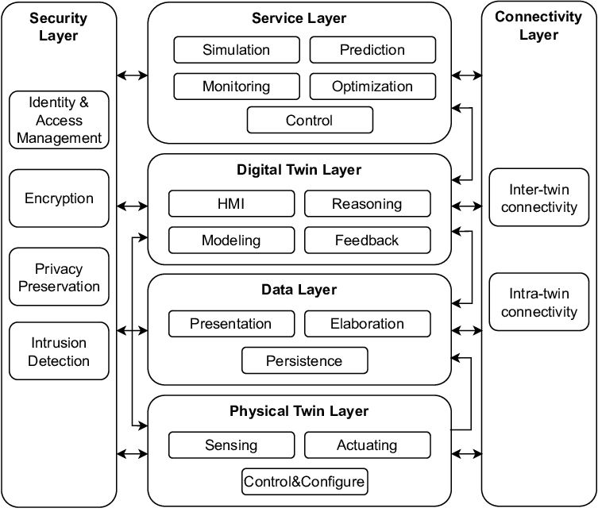

# 6.4. Design Description

**6.4.1. Master Class Diagram**

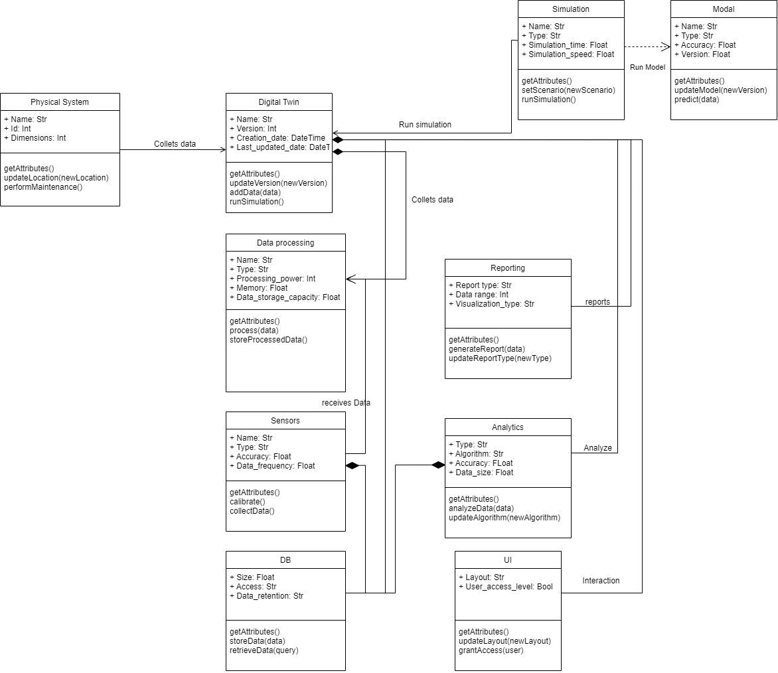

**6.4.2. Reusability Considerations**

Considering the modular nature of our design we will be able to reuse certain implementations in various segments of code as required, for example, implementing the ML models on the virtual system will be further reused on the physical system after its been trained.

However we are not using any existing reusable components because whatever modules there are to offer are very limited in functionality so we are developing our own components.

**6.5. External Interfaces**

The existing external interface available to us is the Niryo Studio application which allows for a direct connection to the robot in a localized area via ethernet cable. This however is very restrictive and further the functionalities offered by the application are very minimal.

To overcome these limitations we are implementing our own interface developed using the PyNiryo library which allows us a wireless ranged connection to the robot and much more customizable functionalities to generate and process data as required.

# 6.6. Help

The product that we are developing is designed to be extremely user friendly with the intent that anyone anywhere will be able to access the physical robot remotely regardless of their knowledge of working the system, so we will be creating a basic user manual that will give a thorough description of how to use the product. Further we will have a more technical manual to be used by professional experts to aid them in applying the product to their industrial setups.

# Chapter 7

# IMPLEMENTATION AND PSEUDOCODE

We are using the Niryo Python module to access and control the robot remotely.

## Connecting to the robot

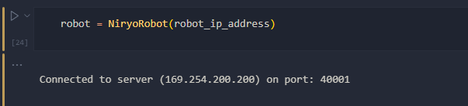

Fig.1

## Moving robot remotely

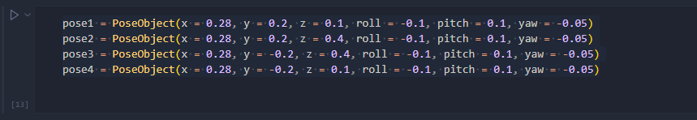

Fig.2

## Joint data in a list format

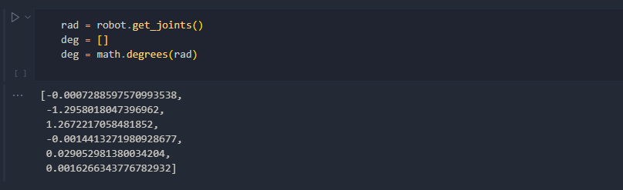

Fig.3

## Controlling Robot remotely using WASDQE<Space><Ctrl>

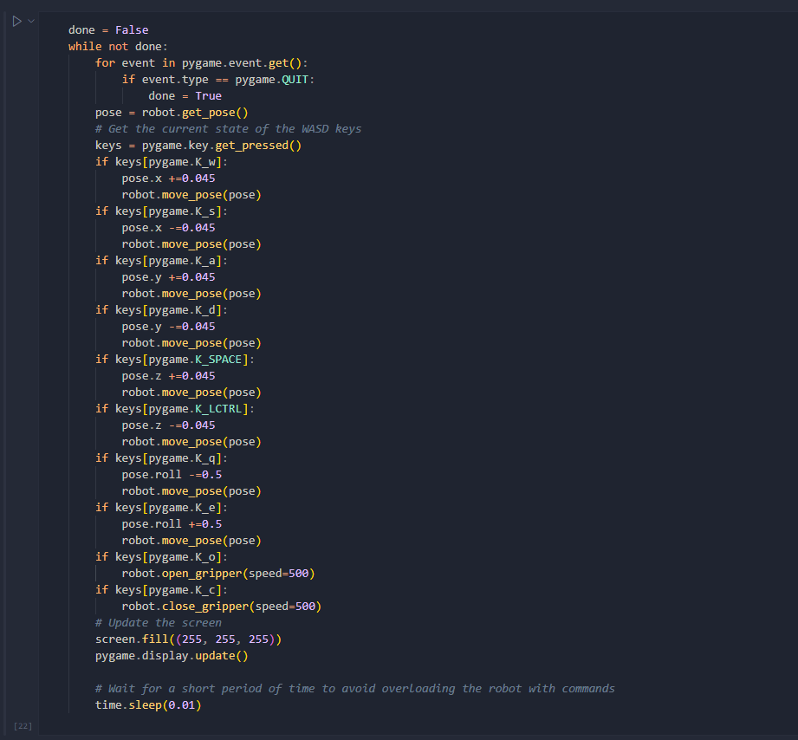

Fig.4

# Chapter 8

# Conclusion of Phase -1

In conclusion, the successful completion of Phase 1 of this project has laid a strong foundation for the development of an innovative AR/VR control tool that leverages digital twin technology to enhance the control and performance of industrial robots. The comprehensive literature survey conducted during this phase provided valuable insights into the latest technologies, methodologies, and best practices in the fields of AR/VR, digital twins, and industrial robotics.

Moreover, the design and development of the digital twin were accomplished, enabling the accurate representation of the physical robot's behavior and functionality. The ability to connect to the robot remotely, control its movements, and collect joint data demonstrates significant progress in achieving the project's overall objectives. This accomplishment not only validates the feasibility of the proposed AR/VR control tool but also highlights its potential to revolutionize the way industrial robots are operated and monitored.

# Chapter 9

# Plan of work for Capstone Phase-2

As the project moves into Phase 2, the focus will shift to refining the AR/VR interface, integrating advanced safety features, and incorporating predictive maintenance capabilities. The lessons learned and experiences gained from Phase 1 will inform the development and testing of these additional features, ensuring that the final AR/VR control tool will offer a user-friendly, efficient, and reliable solution for managing industrial robotic systems. Ultimately, the success of this project has the potential to drive further innovation in AR/VR applications within the field of robotics and automation, significantly contributing to the advancement of the industry.

# 