Class Diagram
- Description
A Class Diagram is a structural representation of the software objects and their static relationships that comprise the system being developed. This description is made using the following structuring concepts:
- Classes (including instances of classes)
- Attributes (representing the knowledge responsibilities or data)
- Methods (representing operational responsibilities or functions)
- Association relationships between classes
- Aggregation relationships between aggregate and component classes
- Inheritance relationships between superclasses and subclasses
- Formal or informal constraint descriptions (optional)
A Class Diagram should also include detailed descriptions of each of these components. Depending on the tool being used descriptions for each of these components will often be embedded in the model, otherwise detailed descriptions should be documented elsewhere. The descriptions should record volumetric information – the number of instances of each class, the average size of an instance in terms of secondary storage required, and association volumetrics.
It is important to note that a Class Diagram is typically developed iteratively over the lifecycle of the project. Though there may be many iterations of it depending on the overall complexity of the solution, it is often convenient to think in general terms of what are the typical elaboration points during development.
The initial or conceptual view focuses on what is traditionally thought of as analysis, i.e., “what” is needed for the solution. Analysis is concerned with defining the problem domain by understanding what aspects of a business model are to be included in the software system. At this point the design should remain technology neutral, although not technology ignorant, as the decisions about how the software system will be constructed are not the primary concern at this time.
Next, the logical design or specification view starts to answer the questions on “how” the system will be implemented and where the overall structure of the solution is defined. Factors such as concurrency and distribution, coordination and sharing, transactions and persistence, user interface capability, and system interfaces such as communication are also taken into account as well. At this stage in the design process, much of the design is dependent on the technology and architectural decisions also being made at this time. Likewise certain design decisions may influence technology and architecture as well.
The final iteration is the physical design or implementation view that details the constructs and mechanisms to be used based on the actual implementation language chosen. This may include the refactoring of existing classes and the introduction of new classes to handle implementation specific details.
- Purpose
The overall purpose of the Class Diagram is to interpret business, user and system requirements and develop an overall model of what is expected of the software. Creating a robust and complete Class Diagram further helps to accomplish the following goals:
- Refine the system boundary or context by deciding which objects are within the boundary of the software system
- Create a starting point for other architectural layers such as the user interface and the database model
- Help divide and organize work by partitioning the problem domain into separate “areas of concern” based on the relevant objects, this allows us to partition the application in the best way to support parallel development efforts
- Facilitate the verification and validation of the analysis and design by enabling a high-level representation of requirements in a detailed and concise manner
- Avoid rework in programming by considering changes and realizing the key abstractions, patterns, and mechanisms ahead of implementation
- Enhance the quality of the design by facilitating the building of design structures for commonality and malleability and encourage common approaches to the use of common design principles, architectural templates and design patterns
- Improve the understanding of the design and system intent by the development team and key customer personnel to allow the actual construction to be done both iteratively and incrementally.
Not developing interaction diagrams may result in:
- Poor extensibility, maintainability, and reusability of the system and its components
- No consistent understanding in the development team of which business data, functionality, and rules need to be incorporated into the system
- Difficulty partitioning work, for example, between a team of interface developers, a team of business functionality developers, and a team of database specialists
- Incomplete coverage of objects, relationships, and constraints in the design
- Inadequate attention may be paid to the data policy, data transaction, and persistence management needs
- Inconsistent use of design principles and design mechanisms
- Inconsistent reuse of design patterns
- Failure to discover opportunities for component and framework reuse
- Inadequate identification of tradeoffs between reusability, modifiability, and efficiency
- Failure to perform commonality and variability analysis resulting in missed opportunities for reuse and poor refactoring of the design for better resilience to change
- Incomplete and erroneous specification of the classes to be implemented
Reasons for not needing interaction diagrams may include the following:
- When structured analysis and design work products are being used there is seldom a reason to also create Class Diagram unless and class based development language is being selected for implementation.
- If the system being developed requires very little application development work it may not be necessary to develop the Class Diagram.
- Typically there are very few reasons why a Class Diagram should not be done to some level of precision. There are situations where the model need not be elaborated to all levels of detail.
- Notation
- A class is a description of a set of objects with common properties and common semantics. By common properties, we mean common methods, attributes, relationships, and constraints. By common semantics, we mean that it is not enough for two objects to have the same attribute names to belong to the same class. For instance, my dog and I both have a height attribute. However, no one would try to classify my dog as human, or me as canine. The set of objects described by a class is also called the instance set of the class.
- Attributes are used to model information that is associated with and maintained by an object. Attributes can be thought of as containers for pure data values. For instance, a person object may have an attribute BirthDate. This attribute can then, for example, contain the value 23 December 1968. Values always belong to certain domain. A domain determines the structure of a set of values and the operations that can be performed on these values. In our case, the value 23 December 1968 belongs to the domain Date.
- Methods are services that an object can provide to other objects and/or actors. For instance, ProvideAge is a service that is provided by a person object to other objects in the system. Methods can have an argument list. For instance, an argument of the ProvideAge method could be the unit of time that the age of the person object should be expressed in.
- Class methods are used to model services that are offered by the class itself, rather than the objects contained in the instance set of the class. An example is the $Create class method that creates and returns a new object belonging to the instance set of the class.
- Class attributes are used to model information that is the same for all objects in the instance set of the class. An example is the $NumberOfPersons class method of Person that contains the number of objects in the instance set of Person.
The following notation shall be used:
  - Classes
The simplest view of a class is a rectangle with its name at the center shows in (a). The Responsibility View of a class is represented as a three-pane box as shown in (b); only the attributes that are nonstructural, that is, the value-based properties of the class, are shown. The Detailed View shows all variables, both structural and value-based, and the methods that implement the responsibilities, as shown in (c).
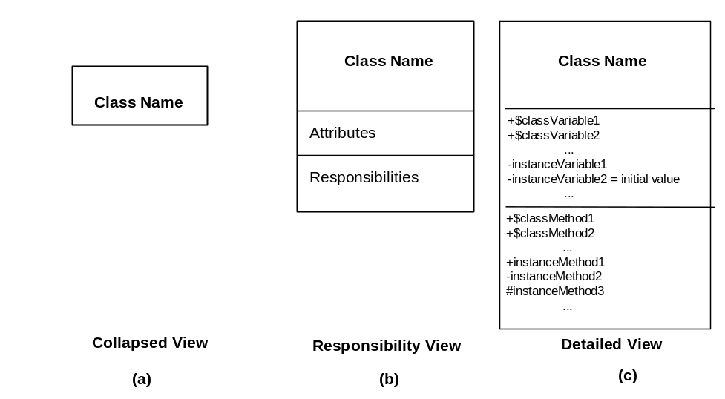

- Class Name–A class name is sometimes a single word but can also be a phrase. Each word of the name should have its first letter capitalized and all words are concatenated.
- Class Variables–Denoted by the prefix “$.” In Smalltalk, Class Variables can be subdivided into “Class (only) Variables” and “Class Instance Variables.” The latter are inherited by subclasses “$”. They can be tagged as private (‘-’), protected (‘#’), or public (‘+’).
- Instance Variables–The names of the value-based properties of the class and the structural-based properties that result from relationships with other classes. The latter can take their names from the role-names of the respective associations.
- Attributes–The information that is associated with, and maintained by, an object. As holders of pure data, they represent the value-based properties of an object. For example, a person object typically has an attribute name of type String.
- Responsibilities–A capability that the class is expected to supply to a client. Each responsibility relates to one or more methods of the class.
- Class and Instance Methods–Class Methods begin with the prefix “$”. They can be tagged as private (‘-’), protected (‘#’), or public (‘+’). In Smalltalk, all class methods are public, but design intent should still be indicated. Instance methods do not carry a prefix but can be tagged as public or private.
  - Association and Multiplicity
Just as a class is a description of a set of objects, an association is a description of a set of links with common properties and common semantics. A link is an instance of an association, much in the same way that an object is an instance of a class. An association is depicted as a line connecting the related classes. An optional association name can be specified with optional role names for the classes participating in the association. The role names convey the intent of each participant in the relationship: how one object is viewed by the other object. A role name indicates visibility of the near-end object by the far-end object.
Multiplicity specifies how many instances of one class may at the same time be related by means of a link to a single instance of an associated class. Multiplicity is often being described as being “one” or “many,” but more generally it is a (possibly infinite) subset of the non-negative integers. Generally the multiplicity value is a single interval, but it may be a set of disconnected intervals.
The following notation of associations and multiplicity is used. The instance sets (the ellipses) are merely shown for illustrative purposes. They are normally not included in a Class Diagram).
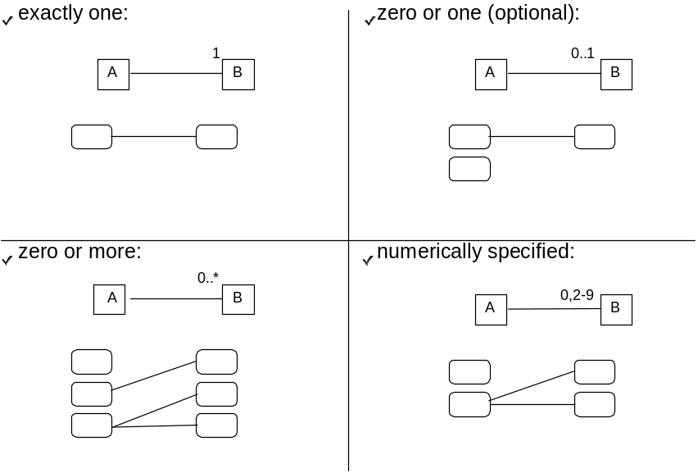
The Class Diagram indicates multiplicity with text at the ends of association lines. Multiplicity is specified with a number or set of intervals in the form lower-bound.upper-bound, such as “1” (exactly one), “0” (zero), “3.5” (three to five, inclusive), and “2, 4, 18” (two, four, or eighteen). An * represents an unlimited bound, such as “1.*” (one to infinity).
  - Aggregation
Aggregation is a special form of association. Two or more objects are involved; one of them is the container of the others. A simple test of whether or not an aggregation makes sense is to ask if the concept being represented is semantically complete only when considered along with its parts. Aggregation is commonly called a “part-of” relationship, or a “has-a” relationship. An aggregation can be denoted in the same way as an association except for the fact that a hollow diamond indicates the assembly end of the relationship.

  - Composition
A composition can be denoted in one of two ways, the most common being the same as an aggregation except that the diamond is filled in to denote a composition. An alternate notation would be to place the box representing the part class inside the assembly class. Composition is a stronger form of aggregation in which each part can only belong to one instance of an assembly class, and when that assembly class is destroyed, so are its parts.

  - Navigability
In UML, direction of visibility is indicated by an arrowhead on the link. Unadorned associations are, by default, bi-directional; to show a unidirectional association or aggregation, an open arrowhead is placed on the end of the line denoting the relationship in the pointing direction of visibility.
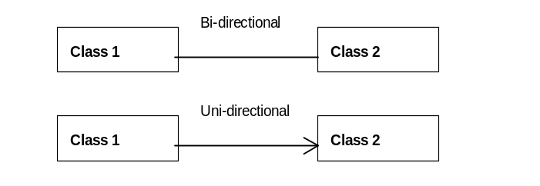
  - Dependency
The notation for dependencies is show below. A dependency is basically shown as a uni-directional association except that the association line is dashed rather than solid. This is a weaker form of association that states that changes in one class may result in changes to the dependent class.
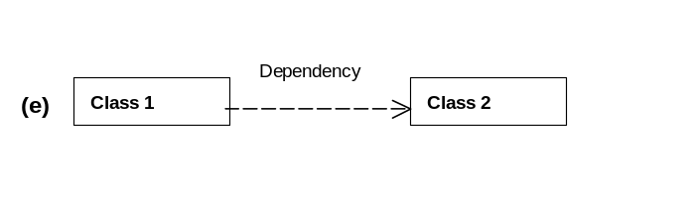
  - Inheritance
Inheritance is a concept that enables us to model real-world “is-a-kind-of” relationships. More specifically, by specifying an inheritance relationship between a class A (the superclass) and a class B (the subclass), we implicitly specify that class B has the same properties (attributes, methods, associations, and constraints) as class A. Synonyms for “superclass” are “generalization” and “parent class.” The term “ancestors” is a synonym for all direct and indirect superclasses. Synonyms for “subclass” are “specialization” and “child class.” The term “descendants” is a synonym for all direct and indirect subclasses.

  - Constraints
Constraints are restrictions on the values that objects, attributes, classes, links, and associations can assume. Constraints can be divided into implicit and explicit constraints. Implicit constraints are already captured through the class diagram structure itself. Multiplicity includes examples of implicit constraints. Explicit constraints, on the other hand, cannot be captured through the class diagram structure and hence have to be formulated separately. This formulation can be done using normal informal language or formally by means of UML’s Object Constraint Language.
It is left open for each project to decide how much effort to put into constraints and how formally to express them. A formal notation is described here because it is easier to make notation less formal than vice versa. In any case, the formal notation includes an informal comment so all the examples are also examples of informal notation.
Object Constraint Language (OCL) is a formal language used to express explicit constraints. You can only use structural properties (attributes and associations) of objects to formulate constraints (hence <object>.<method> is illegal).
  - Class Descriptions
The following is an outline for a Class Description. Specific projects may want to add or remove some items.
Class Name: | The class name
Class Description: | Definition of the class. Beware of recursive definitions: ‘a BankAccount is a bank account that…’ is a meaningless definition.
Superclass: | Superclass of this class
Subclasses: | List of the subclasses of this class
Constraints: | List of constraint definitions
Number of Instances: | Estimated number of instances of this class required in the operational system
Projected Growth Rate: | Estimated growth (or reduction) in number of instances in specified time period, e.g., per year
Average Instance Size: | Estimated size of stored data for an average instance (i.e., sum of attribute sizes, taking into account their multiplicity)
Notes: | Additionally it may prove useful to document items such as owner, creation date and change history

Attribute Name: | Attribute Description:
InstanceAttributeName: AttributeType = InitialValue | - Access (public or private)  - Brief description of the information that is maintained by the attribute  - Why was it assigned to this class?
$ClassAttributeName: AttributeType = InitialValue | - Access (public or private)  - Brief description of the information that is maintained by the attribute  - Why was it assigned to this class?
Method Signature: | Method Description: | Collaborating Classes:
InstanceMethodName (aFormalParameterName: aFormalParameterType): ReturnType | - Access (public or private)  - Brief description of what this method (service/responsibility) is supposed to accomplish  - Why was it assigned to this class | If this method is invoked on an object of this class, with which objects or classes does this object need to collaborate to be able to fulfill the service represented by this method?
$ClassMethodName (aFormalParameterName: aFormalParameterType): ReturnType | - Access (public or private)  - Brief description of what this method (service/responsibility) is supposed to accomplish  - Why was it assigned to this class | If this method is invoked on the class itself, with which object or classes does this object need to collaborate to be able to fulfill the service represented by this method?

Associated  To: | Via Association: | With  Role: | Multiplicity: | Description: | Average Instances:
ClassName | AssociationName | Association RoleName | Multiplicity | Description why this association is needed in the Class Diagram  Why does the association have this certain multiplicity? | Average number of associated instances
During analysis typically only a portion of the information listed will be filled out with the focus being on the responsibilities of the various classes. During design it is assumed that defined operations will specify concrete types for parameters and results. Depending on the development method, the division of the design, the implementation phases, and so on, it may be considered useful or necessary to provide pseudo-code for each operation. This can be done under “Notes,” which can also include any free-format notes, hints, or implementation instructions. This template can be further extended as required. For example, if invariants are used, they can be documented in an additional “Invariant” slot in the template.
- Example
The following is a Class Diagram for an automated warehouse, in which the following observations hold true:
- All loads in the warehouse are placed on pallets.
- Pallets in the warehouse can be moved around using automatic trucks. Trucks can be programmed by a technician to transport a pallet to another location. Trucks report back to the technician whether an attempt to move a pallet was successful or not.
- Operations management sets a policy that after every nth move of a pallet; the load has to be stabilized by a checking station. This n is the same for all pallets in the warehouse and can be changed at any time.
- If a truck wants to move a pallet for the (n+1)th time, and the destination is not a checking station, the pallet must not be moved.
- A pallet may be moved earlier than the (n+1)th time to a checking station. In that case, the load has to be stabilized anyway.
- If a pallet is currently located at a checking station, and a truck tries to move it to another location, the checking station must first release the pallet that is about to be transported.
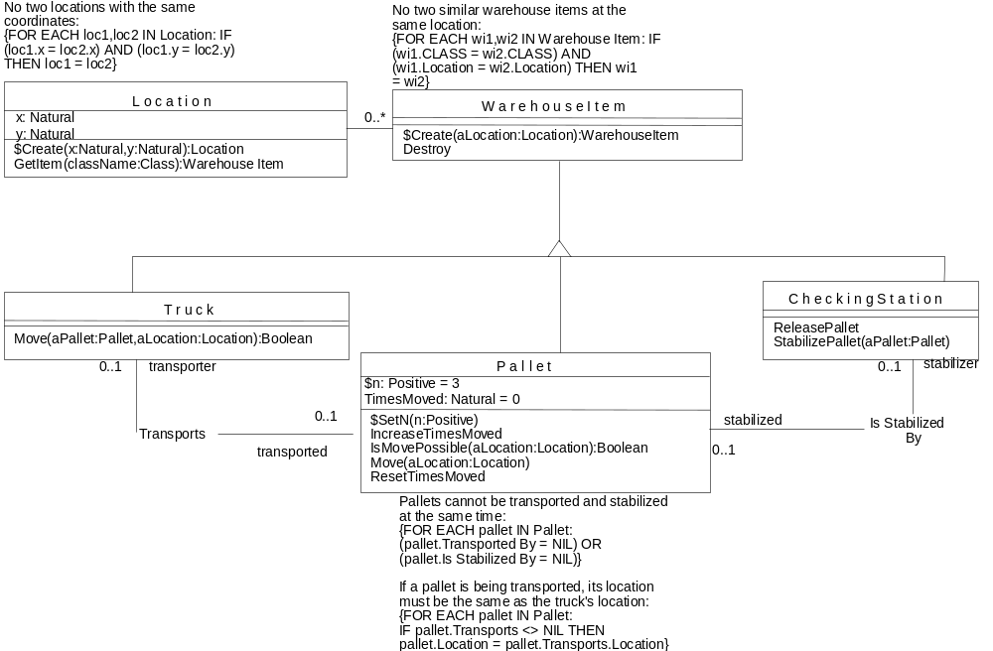
The class Pallet would be further documented as follows.
Class Name: | Pallet
Class Description: | A pallet is a means for storing and moving loads in the warehouse. Pallets may become unstable after having been moved a couple of times
Superclass: | WarehouseItem
Subclasses:
Constraints: | Pallets cannot be transported and stabilized at the same time: {FOR EACH pallet IN Pallet: (pallet.Transported By = NIL) OR (pallet.Is Stabilized By = NIL)}  If a pallet is being transported, its location must be the same as the truck’s location: {FOR EACH pallet IN Pallet: IF pallet.Transports <> NIL THEN pallet.Location = pallet.Transports.Location}
Number of Instances: | 10,000
Projected Growth Rate: | zero, unless warehouse extension is built
Average Instance Size: | 20 bytes

Attribute Name: | Attribute Description:
$n: Positive = 3 | Keeps track of the checking policy in the warehouse: it contains the number of times that a pallet can at most be moved before it must be stabilized at a checking station. This value might be changed at any moment.
TimesMoved: Natural = 0 | Keeps track of how many times this Pallet object has been moved already without having been stabilized yet

Method Signature: | Method Description: | Collaborating Classes:
$SetN (n: Positive) | Changes the checking policy in the warehouse to n
IsMovePossible (aLocation: Location): Boolean | Returns whether it is currently possible to move this Pallet object to aLocation | Location
Move (aLocation: Location) | Moves this Pallet object to aLocation and initiates the stabilization process if there is a CheckingStation object located at aLocation  Should only be invoked by the client object after it has received true from invoking IsMovePossible | Location  CheckingStation
IncreaseTimesMoved | Augments the TimesMoved attribute of this Pallet object by 1
ResetTimesMoved | Resets the TimesMoved attribute of this Pallet object to 0

AssociatedTo: | Via Association: | With Role: | Multiplicity: | Description: | Average Instances:
Truck | Transports | transport-ed | 0,1 (optional) | Represents the fact that this Pallet object is being transported by a Truck object. | 0.7  (70% of pallets are on trucks)
Checking Station | IsStabilizedBy | stabilized | 0,1 (optional) | Represents the fact that this Pallet object is being stabilized by a CheckingStation object. | 0.1 (10% of pallets are at CheckingStations)
- Development Approach
Developing a Class Diagram is a highly iterative activity. It is not expected that all possible classes, attributes, and methods that will eventually needed will be identified and defined on the first pass through.
- Study all reusable model frameworks, industry models and business object models to ensure plans for reuse are developed and followed.
- Find candidate objects using a brainstorming session, based on a sufficient number of use cases and scenarios. Class Responsibility and Collaboration (CRC) cards are a good technique to get started with this.
- Identify information that must be maintained and responsibilities that must be fulfilled and assign them to the objects you have identified. You may find that additional objects are needed to support all responsibilities.
- Identify other objects based on object stereotypes such as interface objects, which provide interface to actors, human users or interface to other systems or devices.
- Construct a Class Diagram, containing classes for all the objects you identified, and by assigning responsibilities to those classes in terms of needed attributes (for structural aspects), methods, or operations (for behavioral aspects).
- Determine any required associations to support the collaboration of objects in response to sets of interactions.
- Evaluate and specify classification association (inheritance) of objects (types) using generalization and specialization principles. Maintain natural classifications of real-world objects. Avoid classification from the design and coding point of view.
- Evaluate and specify assemblies (whole-part) association between objects. Explore capabilities to compose from smaller components and reuse from lower level components.
- Document the classes by in detail by describing its responsibilities and the business rules they support.
- Identify business constraints that should be fulfilled but that are not structurally captured in the model.
- Check that the Class Diagram supports the use cases by describing the use cases in Interaction Diagrams.
- For each design mechanism that is employed, introduce new classes from the solution analysis, such as utility classes (identified through interaction diagrams), where necessary.
- For every class and relationship in the model, consider the operations that can result in an instance being created or deleted. Determine ownership, who creates or initiates objects of a class, and who deletes them.
- For aggregations, consider those relationships that represent lifetime encapsulation. That is, the lifetime of the aggregate completely encloses the lifetime of the component. For other situations, consider asking if the identity of the contained object is used outside of the containing object and if the contained object has its own viability.
- For every association, specify the implementation of associations: directionality, name, visibility, and mutability of the attribute implementing the association. One-way associations require a reference only in one class. Two-way associations require references in both classes with code to maintain referential integrity. To support multiplicity, the reference will need to point to a set of references. How this is implemented is language dependent and should be expressed as a design translation rule. If the “many” end is ordered, then a list might be used instead of a set. A qualified association with multiplicity “one” can be implemented as a dictionary object. (A dictionary is a set of value pairs that maps selector values into target values). Qualified associations with multiplicity “many” are rare. They can be implemented as a dictionary of sets of objects.
- For every operation, consider accessibility. Public: any class has access, Protected: only subclasses have access, and Private: no other class can invoke the operation.
- Establish attribute kinds for implementing associations and aggregations. By reference: contains a pointer or a reference. By value: contains an object. Or by key: contains a key that can be converted into a reference by some means (such as a “name resolution mechanism”). In C++, attributes implementing superclass associations are either Protected or Private with Protected accessor operations.
- Determine the scope of operations reference. An interaction between two objects is established dynamically when object A gets a reference to object B through a method argument or a local variable of a method, and statically when the objects are defined within the class scope. In the latter case, the reference from object A to B persists between method calls.
- Consider mutability. The mutability of a reference indicates whether it can be reassigned after initialization. The label “Const” can be used to indicate immutability.
- Determine special or advanced properties of classes–for example, parameterized classes, deferred binding operations, friend class– and decide the types of all attributes.
- Perform a Commonality and Variability (CV) analysis across the initial class diagram, nominating new and existing abstractions that are reusable. Refactor on the basis of new abstractions, the reuse of design patterns, and the implementation of mechanisms.
- Elaborate the class diagram to handle constraints and semantic integrity, the incorporation of control for concurrency and exception handling, and data policy and persistence.
- Optimize the class diagram for performance and reuse. Introduce new associations or modify existing ones to optimize access. Consider making associations that were thought to be permanent features of the class into temporary links between objects that are either passed as arguments in methods or created as temporary objects within a method body. Consider converting inheritance to aggregation when appropriate to decouple elements of the design.
- Validation and Verification
  - Classes
- Check that the model is sufficiently resilient to the change. Check that the internal representations of classes may be changed independently of other classes, that is, knowledge of internal representations is localized as far as possible. Verify that attributes and operations are functionally coupled–there are no disjoint cut sets that could suggest the splitting of the class into new classes. Check how instances are created and destroyed.
- For each class, verify that names are unique and descriptive. Check that the definition of the class does not contradict the definition of the term that is used as a class name in other work products. Also make sure that each class is eventually defined adequately enough to serve as a basis for coding the class and that it’s description is consistent with the agreed coding guidelines.
- Check that all objects have a certain state (maintain information) and exhibit a certain behavior (offer services). The fact that objects can be allocated certain behaviors is one of the major distinguishing factors of an OO model with respect to an ER model. A Class Diagram that only contains objects with state and no behavior is simply an ER model in disguise. If you really cannot allocate any meaningful behavior to an object, it should probably be an attribute of another object.
- Check that all objects have a well-defined life cycle. Objects come into existence at some point in time and usually disappear at some point in time relevant to the business domain. For instance, in a bank, a bank account is opened at some point in time and can be closed later.
- Check that all objects have identity. Objects are uniquely identified by their mere existence; it is not because two objects have the same attribute value (e.g., ColorOfHair=black) that the two objects have the same identity. If you have “objects” in your model without identity (an example could be Date: the value of the date uniquely determines the date), it means that those “objects” should actually be values that should be contained in the attributes of another object.
- Check which object behavior stereotype category your objects fall into:
- Informational objects–Hold values that can be used by different kinds of objects; for example: Customer. These are valid Class Diagram objects.
- Service objects–Provide a common service to a variety of objects; for example: InterestCalculator. These are valid Class Diagram objects.
- Coordinating objects–Traffic cops or managers; for example: OrderManager. These are valid Class Diagram objects.
- Structuring objects–Manage complex relationships; for example: Order or Portfolio. These are valid Class Diagram objects.
- Controlling objects–Are responsible for controlling a cycle of action; for example: CustomerProfileAgent. These are valid Class Diagram objects.
- Interface objects–Support communication with users, other programs, or externally available services. For example, OrderEditWindow, DataManager, CommunicationManager, etc., are not valid Class Diagram objects and should only appear in the Class Diagram.
  - Methods
- Check that the classes provide the behavior required by all scenarios. Ensure that the model supports all of the information and behavior required by the rules, algorithms, and policies of the enterprise that will be required in the eventual system. The preferred way to “prove” this is to be able to express the use cases in terms of Interaction Diagrams using only objects that are contained in the Class Diagram and using only methods (services) that are defined in the Class Diagram.
- Check that behavior is evenly distributed over the classes in your model. Do not create a model in which one object does all the processing, and all the other objects merely supply data to the processing object.
- Verify that there is no redundant or duplicated behavior. Are there classes with the same behaviors? Are there behaviors that can be merged? Are there behaviors that could be removed either by moving the behavior to other methods or by its elimination altogether?
- Check that behavior is kept with related information. If an object is responsible for maintaining certain information, it is logical also to assign it the responsibility of performing any operations necessary upon that information. Conversely, if an object requires certain information to perform some operation for which it is responsible, it is logical (other things being equal) to assign it the responsibility of maintaining the information. This point speaks to the heart of encapsulation, which states that like things belong together. In this way, if the information changes, no update messages must be sent between objects. The object that needs to know if something changed will know it; other objects need not concern themselves.
- Verify that there are no intensive communications around one component. If one component dominates the communication pattern, it may have too many responsibilities and know too much about too many parts of the system. This could become a fragile part of the system. If any of the parts it knows about changes, it may have to change. If it is a large and complex component, then the chance of introducing an error or propagating changes is higher.
- Check that the number of classes with which another class collaborates is minimized. The more classes that Class A needs to know to fulfill its responsibilities, the more likely it is that Class A will have to be changed if one of its collaborators changes.
- Verify that there is no unnecessary intensive communications between components. Two components communicating with each other intensively evidently need to know a lot about each other. If Class A must collaborate with Class B by sending a number of messages, the number of messages and parameters that are being passed should be as small as possible.
- Check that all methods are defined in adequate detail. Validate the documentation of the model by checking that the class diagram documentation indicates where, how, and why design patterns have been used and that all traceability to the Class Diagram, design alternatives, and reused assets has been documented. For all operations, verify that:
- Operation names are descriptive and expressive of their purpose
- Operations that are conceptually the same across classes have the same names
- The types of all arguments and any return results are defined
- The constraints relating to referential integrity, attribute values, pre-conditions, and post-conditions of operations are implemented.

  - Attributes
- Check whether there are derivable attributes. There should be no derivable information in your initial Class Diagram. Introducing derivable information is a design decision. You can always model the fact that you need derivable information early on by providing a method that returns the derivable information.
- Check that all key attributes and relations have been identified and documented. For all attributes, check that their names are descriptive and that there are no attributes that represent the same thing. Ensure that the attribute represents a value-based property and is not an object reference that is implied by an association/aggregation or that represents a missing association/aggregation. Check that all attributes, parameters, and returns have types.
  - Associations
- Check the access paths. If an object of Class A needs to send a message to an object of Class B, the A object either needs a link to the B object to send it the message, or it needs to be passed the “address” of the B object by means of a parameter. In the former case, you need an association between A and B. In the latter case, you do not.
- For all relationships, verify that the relationship is named descriptively. Check that multiplicity and directionality of references have been specified, and that the relationship is always true. Check that associations do not reference too specific an object, that they do not warrant becoming classes in their own right, and that they should not be modeled as aggregations.
  - Aggregation/Composition
- Check that the composition relationship implies lifetime encapsulation of the component. The component should never be allowed to exist without being contained in an aggregate. If this is not the case, it is best to replace the composition relationship by an aggregation or association.
- Check that if the composite disappears, the components disappear as well (cascading destruction). If this is not the case, replace the composition by an aggregation or association
- For all aggregations, review visibility and ownership. Is the identity of the contained object used outside of the containing object? If so, then verify that existence constraints are properly observed outside of the containing object. Are there other containing objects that contain the same component? If so, are multiple owners responsible for controlling the existence of the contained object? Are these owners/members of the same class? If so, then indicate that the aggregation itself has a multiplicity of “many” by placing a “dot” next to the aggregation diamond. Should the contained object know its containing object? If so, then indicate that visibility is bi-directional.
  - Inheritance
- Check whether you have as much structural and especially behavioral compatibility as possible. A superclass protocol should be looked at as a contract that must be able to be fulfilled by the subclasses. While creating subclasses, you should strive for structural compatibility. (An inherited attribute in the subclass can never assume a value that would be invalid in the superclass.) You should also strive for behavioral compatibility. (An inherited method in the subclass should accept all parameter types that are accepted in the superclass and should return a result that is a subtype of the result type of the original method in the superclass.) You can usually “hide” structural incompatibility in the subclass by overriding the method that queries the structural property in the subclass. Behavioral compatibility is more important than structural compatibility since attributes should be encapsulated anyway.
- Check whether the subclass needs to “disable” any property it inherits from the superclass. A subclass should never “disable” any property it inherits from the superclass. This indicates poor use of inheritance. Consider removing the inheritance hierarchy and replacing it with an association.
- For all inheritance relationships, verify that public inheritance always implies substitutability. Objects of the subclass are substitutable for objects of the superclass; that superclass assertions are honored by redefined methods; and that deep inheritance hierarchies are designed correctly, particularly regarding flexibility and the advisability of avoiding down casts.
  - Constraints
- Check whether any explicit constraints can be expressed implicitly. Sometimes very difficult constraints on a Class Diagram can be described implicitly if the model is restructured.
- Check whether each formal constraint also has a brief informal explanation. Formal constraints can be difficult to understand quickly and intuitively. Therefore, if you formulate a constraint formally, also give a brief and intuitive description.
- Check whether there are any ambiguous informal constraints. Informal constraints may be ambiguous. Remove obvious ambiguities by introducing a more formal description.
- Advice and Guidance
The following guidance is recommended:
- Starting from the analysis, you should strive for seamless development. Seamless development means that every activity or phase that follows after producing the Class Diagram only adds more detail to what we already have. For example, in the design, we will introduce additional access methods for all attributes and additional derived attributes to improve processing speed. In the implementation, we will only add the actual method bodies of the methods that we have already identified during the design. Changes in the Class Diagram itself are only justified if they represent mistakes that are corrected. Seamless development is not an automatic by-product of object-oriented development. It must be carefully planned and monitored.
- Manage separate views of the Class Diagram. A Class Diagram can become complicated and difficult to understand. It is recommended that separate views of the model are organized so diagrams do not become cluttered. One set of views would be defined for “design scenarios.” Each view is to restrict a diagram to a single design scenario. Each view would depict only those features of each class that were relevant to the scenario. Another view should be a detailed inheritance view showing the immediate descendants and ancestors of a class. The full inheritance tree showing class names and kinds only is also a useful view.
- Clarify by example, not by abstraction. Whenever there seems to be a miscommunication about what is represented by a Class Diagram, it is usually very helpful to draw a couple of sample instance sets of the classes contained in the Class Diagram. Furthermore, this is also a practical way to make a Class Diagram understandable to non-IT personnel.
- Descriptions developed for the various classes should be uniform in their level of detail. The degree of detail to be documented for each class is dependent on the development process used. In general, however, the descriptions should define the various interfaces of the classes and provide enough information to allow the class to be coded autonomously. It may also be desirable to document method specifications or pseudo-code here for if appropriate.
- State responsibilities as generally as possible. If responsibilities are stated in general terms, common responsibilities can be shared between classes more easily, and a class described in this way can be more useful than initially specified.
- Split shared responsibilities. Occasionally, you may discover that a certain responsibility seems to be several responsibilities, or a compound responsibility that is best divided or shared among two or more objects. These kinds of high-level responsibilities should be split up into more specific responsibilities, which can then be assigned to the most appropriate class.
- Keep information about one thing in one place (confirm unique ownership). In general, the responsibility for maintaining specific information should not be shared. Sharing information implies a duplication that could lead to inconsistency. Part of making software easier to maintain is minimizing such duplication.
- The law of diminishing genericity returns. We said earlier that your Class Diagram should be as flexible as possible. In practice, flexibility is often achieved by limiting the number of classes in the model, rather than introducing classes in an unbounded fashion. (For example, a Customer in a bank can have many types of relations to other Customers, including Mother, Father, Brother, Sister, Legal Representative, Husband, Wife, etc. What will be the most flexible (generic) model–introducing a class per relationship type or introducing one class Relationship whose objects can represent any relationship type between Customers?) However, this would mean that the most generic model you can think of is Class, having a many-to-many association with itself. Obviously, such a model cannot accomplish much. Aim to strike an appropriate balance between flexibility and content in your Class Diagram.
Implementing Associations
- Aggregation is a special case of association. A lot of expensive analysis time tends to get eaten up by philosophical discussions on whether something is an association or an aggregation. The answer is usually that there is no point in discussing it. Deciding for or against an aggregation has little overall impact on the Class Diagram and on subsequent work products. In case of disagreement or doubt, use a simple association.
- Consider implementing an association as a distinct association class, independent of either class. An association class is a set of pairs of associated class stored in a single class. For efficiency, an association class can be implemented using two dictionary classes, one for the forward direction and one for the backward direction. Access is slower than with attribute pointers, but if hashing is used, then access is still in constant time. This approach is useful for extending predefined classes from a library that cannot be modified, because the association class can be added without adding any attributes to the original classes. Distinct association classes are also useful for sparse associations, in which most objects of the classes do not participate because space is used only for actual links. Do not overdo this.
- For prototype work, use bi-directional associations so new behavior can be readily added. For production work, optimize some associations. Hide the implementation using access operations to traverse and update the association allowing design changes with minimal effort.
Using Inheritance
Used properly, inheritance is a key means to achieve object-oriented designs that have well-formed abstractions and whose class structures are reusable and extensible. The misuse of inheritance, however, can lead to designs that are brittle and applications that are error-prone and difficult to understand and modify. When designing inheritance structures, a number of process guidelines should be considered:
- Verify the class hierarchy has structural and behavioral conformance. Type-safe use of inheritance considers the conformance of client-server object interactions. Structural conformance concerns the client’s expectations of the supplier’s properties and relationships with other classes. Behavioral conformance concerns the client’s expectation of the supplier’s behavior. When accessing properties or navigating relationships or invoking behavior, the client should not need to know if he/she is dealing with a supplier that is an instance of a superclass or one of its subclasses.
- Use abstract superclasses for interface-reuse—common interfaces across subclasses.
- Don’t overuse inheritance. Of all object-oriented structuring concepts, inheritance is probably the most overused. As a rule of thumb, inheritance should never be based on the value of one sole distinguishing attribute. You should only use inheritance if the subclasses that you construct really exhibit significantly different behavior. Use delegation instead of inheritance if the only reason for inheritance was “sharing” of code. Factor out classes into more atomic behaviors so large hierarchies become “forests” of trees.
- Limit the depth of inheritance hierarchies to a maximum of four to five levels. Deep inheritance hierarchies are a conceptual burden, cause maintenance problems, and can make it extremely difficult to reuse or extend a design. Furthermore, associations are often a much better modeling alternative than inheritance. Rather than using (n+1) levels of inheritance, you often can create more flexible models if you combine associations and n levels of inheritance.
- Consider replacing inheritance with aggregation and states when objects are expected to change types during their life cycle. (See Section 8, References, Design Patterns: Elements of Reusable Object-Oriented Software by E. Gamma, et al.).
- Avoid using multiple inheritance. This usually leads to inflexible models and an explosion of the number of classes in the class diagram. A model “needing” multiple inheritance can usually be represented more flexibly using a combination of single inheritance and associations.
- Design the inheritance hierarchy consistently with design patterns. Many design patterns exploit abstract superclasses and inheritance-based relationships, for example, Adapter, Bridge, Builder, Composite, Iterator, Mediator, Proxy, and Strategy. The underlying principles are often collaborations between superclass and subclass methods using so-called “template” and “hook” methods. (See Section 8, References, Design Patterns for Object-Oriented Software Development by W. Pree.).
- A class should be defined independently of its subclasses. The subclass relationships are, however, included in the descriptions to complete the picture of the class. Tool support should include the visualization of inheritance class structures.
- Document the intent of inheritance. If inheritance is used for code reuse—to “borrow” methods from superclasses—then class hierarchies quickly lose semantic cohesion. Document cases when inheritance is not behaviorally or structurally conformant. Document how the design would have to change to preserve conformance.
Refactoring Classes
Once the class diagram stabilizes and there is confidence in the completeness of the requirements, we should inspect the classes to look for opportunities to refactor the design.
- Remove redundant classes. If a class turns out to have no interactions with other classes, it should be discarded. Before you do so, however, it is wise to perform rigorous walkthroughs of your design to check and crosscheck the classes for collaborations. By “no interactions,” we mean that the class collaborates with no other class, and no other class collaborates with it.
- Consider removing classes that are leaves or orphans of the inheritance structure; that is, those that neither inherits from nor is inherited from. It can be the case that these classes are poor abstractions that should be reformed either by creating a more general concept, introducing a missing superclass, or reallocating their behavior.
- Consider merging classes that have related responsibilities. Small classes should be inspected as candidates for features that have a common generalization. By being combined, they might offer a more useful abstraction.
- Consider splitting those classes that have too many attributes or methods. Large classes often exhibit a bias towards a procedural rather than behavioral decomposition of the system. Factor out common behavior and attributes to a superclass. Look for disjoint subsets of coupling between attributes and methods as an obvious way to split the class. Refactor on the basis of behavioral consistency with other parts of the system. Inspect behavior within the class and consider design patterns that can re-structure the class.
- Consider de-normalizing parts of the class diagram to provide better performance from persistent storage systems such as relational databases, where avoiding joins is an important concern.
- References
Rumbaugh, J., Blaha, M., Premerlani, W., Eddy, F., and Lorenson, W. (1991). Object-Oriented Modeling and Design. Prentice Hall. ISBN 0-13-630054-5.
Wirfs-Brock, R., Wilkerson, B., and Wiener, L. (1990). Designing Object-Oriented Software. Prentice Hall ISBN 0-13-629825-7.
Riel, A. J. (1996). Object-Oriented Design Heuristics. Addison-Wesley. ISBN 0-201-63385-X. Very practical heuristics for improving the quality of your analysis and design models.
Gamma, E. Helm, R., Johnson, R., and Vlissides, J. (1995). Design Patterns - Elements of Reusable Object-Oriented Software. Addison-Wesley Publishing Company. ISBN 0-201-63361-2.
Khoshafian, S., and Abnous, R., (1995). Object Orientation - Concepts Languages Databases User Interfaces (2nd ed.) John Wiley and Sons. ISBN 0-471-07834-4.
Kurt, and Derr, W. (1995). Applying OMT - A Practical Step-by-Step Guide to Using the Object Modeling Technique. Prentice-Hall SIGS Books ISBN 0-13-231390-1.
Rumbaugh, J. (January, 1995). OMT: The Object Model - Journal of Object-Oriented Programming.
Fowler, M., and Scott, K. (1997). UML Distilled – Applying the Standard Object Modeling Language. Addison Wesley Longman, Inc.
UML Notation Guide, Version 1.1 (September 1 1997). Rational Software, Microsoft, Hewlett-Packard, Oracle, Sterling Software, MCI Systemhouse, Unisys, ICON Computing, IntelliCorp, i-Logic, IBM, ObjecTime, Platinum Technology, Ptech Taskon, Reich Technologies, Softeam.
Object Constraint Language Specification, Version 1.1 (September 1 1997). Rational Software, Microsoft, Hewlett-Packard, Oracle, Sterling Software, MCI Systemhouse, Unisys, ICON Computing, IntelliCorp, i-Logic, IBM, ObjecTime, Platinum Technology, Ptech Taskon, Reich Technologies, Softeam.
Booch, and J. Rumbaugh, J. (1995). Unified Method for Object-Oriented Development (Version 0.8). Rational Corporation.
Cook, S., and Daniels, J. (1993). Designing Object Systems - the Syntropy Approach. Prentice-Hall.
D’Souza, D., and Graff, P. (February 1995). Working with OMT: Model Integration. Journal of Object-Oriented Programming, 23-29.
Kilov, H., and Ross, J. (1994). Information Modeling - An Object-Oriented Approach. Upper Saddle River, NJ: Prentice-Hall. ISBN 0-13-083033-X.
Nerson. (September 1992). Applying Object-Oriented Analysis and Design. Communications of the ACM, 35(9), 63-67.
IBM (1995) MORE on Analysis Object Modeling, More on Design Object Structure Modeling, MORE on Converting Analysis Object Model into a Design Object Model
Pree, W. (1995). Design Patterns for Object-Oriented Software Development. Addison-Wesley.
Ian Graham (1998), Requirements Engineering and Rapid Approach, Addison-Wesley . ISBN 0-201-36047-0
IBM,. Business Language Analysis for Object-Oriented Information Systems. IBM Systems Journal, Vol. 35, No. 2, pp. 128-150.
Booch, G. (1994) Object-Oriented Analysis and Design with Applications. Benjamin/Cummings Publishing Company, Inc.
Odell, JamesJ. (1998) Advanced Object-Oriented Analysis & Design Using UML. Cambridge University Press. ISBN 0-521-64819-X
Taylor, David (1995) Business Engineering With Object Technology. John Wiley & Sons inc. ISBN 0-471-04521-7
- Up to 3 hrs to update each class that needs updating. Plan for updates to 20% of classes.
The following factors affect the effort required to produce a class diagram:
- Expected number of infrastructure support classes (e.g. persistence, communications)
- Expected number of user interface support classes
- Expected number of classes required to implement adopted architecture/design patterns
- Performance requirements
- Degree of programming language support for analysis concepts
If a Business Object Model has been created, typically plan for 2x as much analysis classes as business objects.
- Revision History

Date of this release: | Date of next revision:

Revision Number | Revision Date | Summary of Changes | Changes Marked?
4.1.1 | August 2002 | Edited to comply with intellectual property guidelines including R4 versioning scheme
3.0 | January 2000 | MIFP published version – no changes.
1.1 | December 1999 | Removed context information in Estimating Considerations.
1.0 | September 1999 | Base version

