Statechart Diagram
- Description
A Statechart Diagram represents the behavior or lifecycle of a single class; it is a projection of all Interaction Diagrams for a single class. It does this by describing:
- States that the may be attained
- How receipt of external stimuli (events, messages, responses) cause a change in state
A class state represents a subset of the possible attribute values and links the instances of a class can hold. Usually different behavior (gives a different response to the same event) is exhibited when in different states.
- Purpose
While working on the Statechart Diagram, if the class you want to talk about shows more than a trivial behavior in reacting to other classes, you could take this as a sign that building a Statechart Diagram of that class might prove useful. The level of detail of your Statechart Diagram should be compatible with the context of the surrounding classes with which the class you are describing interacts.
The Statechart Diagram can show the specific behavior related to each class. It provides a convenient, visual means of understanding how the threads of interaction among objects, as shown in Interaction Diagrams, can be projected onto each class participating in these interactions. You must keep in mind that only classes with strong state-dependent object behaviors need to have a Statechart Diagram. If the corresponding Interaction Diagrams are built at the right level of abstraction, each major interaction between two objects will be represented on the Statechart Diagrams. Each of the classes for those objects will have an action generating an event and possibly transitioning to another state on one side, and receiving that event will trigger a transition to another state on the other side.
A graphical representation helps improve the ease of reading and understanding. The event that triggers the interaction/transition, under which condition it is triggered, and what actions are accomplished. That is, processing done or events generated can find their way into the graphical representation. With the right type of tool, the efficiency of their capture can be improved, and customized documentation can be generated on-line.
While Statechart Diagrams created during Analysis are done for the purpose of discovery or understanding, Statechart Diagrams later revised or created as part of design can involve solving problems related to a class’s implementation.
The strength of Statechart Diagrams is their capability to describe the state-dependent behavior of objects concisely. If objects that exhibit complex changes in state are not modeled, unanticipated interaction between seemingly unrelated requirements could appear during application integration or, even worse, after deployment of the application. This is particularly important on larger projects with teams of more than two or three people.
A Statechart Diagram is not needed in the following cases:
- Statechart Diagrams are a powerful way of describing objects that have significant and complex state-dependent behavior. However, they are not useful for describing objects that have few meaningful states. Therefore, they should be developed very selectively. Statechart Diagrams can be very trivial for many classes since the majority of objects in most administrative systems (e.g., banks, insurance companies, etc.) have very uninteresting state behavior, and the effort of systematically producing Statechart Diagrams for all objects in the Class Diagram is not worthwhile. On the other hand, the majority of objects in most real-time systems (e.g., telephony, process control, etc.) do tend to have very interesting state behavior.
- The more models you produce, the more education you will need to give to the developers. Therefore, if there are only few objects with state-dependent behavior, it might be more cost-effective to express this behavior in terms of Interaction Diagrams.
- Developing Statechart Diagrams, together with Class Diagrams and Interaction Diagrams, implies certain consistency rules have to be respected. The more models the more consistency rules that must be checked. If such consistency rules are not enforced or supported by a CASE tool, they might take a lot of time to verify.
- Notation
Statecharts are a generalization of state-transition diagrams. State-transition diagrams have long been used to describe dynamic behavior. Each transition is triggered by an event, possibly under some condition, which causes an object to change its state. Each time an object of a given class gets instantiated, it will find itself in the initial state of the statechart of that class. Events have no duration. Boolean conditions are there to express happenings that have duration. The statechart will sit in the same state as long as no outgoing transition can be triggered, such as the event related to the transition happens while the guarding condition evaluates to true. Some actions can be accomplished during the transition or entering/exiting a state.
Statecharts introduce structuring concepts to state-transition diagrams. The first concept is aggregation by clustering together all related substates of a lower level inside a state. In this way, all the detail shown at that lower level will be hidden inside the higher-level state. Any transition applying to the higher-level state will also apply to its substates. Being in the higher-level (enclosing) state will mean being in one-and-only-one of its substates. For being able to choose among substates when entering the enclosing state, a default substate will be specified, so any incoming transition arriving at the boundary of the enclosing state will enter the default substate. Every statechart has top state which an aggregate of all of its substates although typically this is not depicted.
States

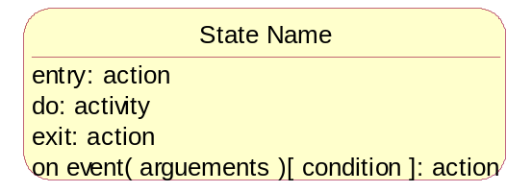

States are represented by a rounded rectangle, which contains the state name and a list of internal transitions.
Initial States, Final States and Events
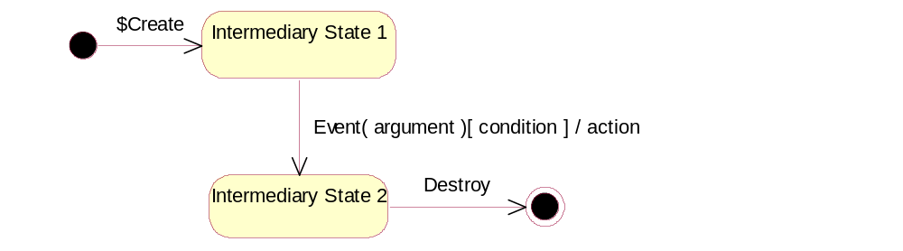

A Statechart Diagram always has an initial (corresponding, respectively, to the moment just before the object is created):
- The initial state is represented as a filled black bullet.
- The final state is represented as a filled black bullet surrounded by an open circle.
- An open arrow leading to the new state represents events. Events may be explicitly called from another object, triggered by the passage of a set period of time or the result of designated condition becoming true.
Sequential Substates
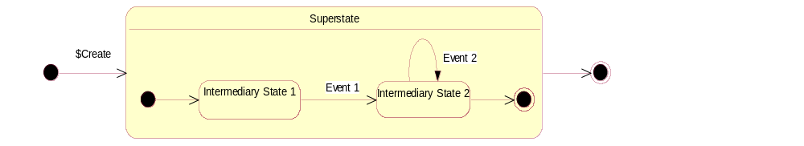

Concurrent Substates
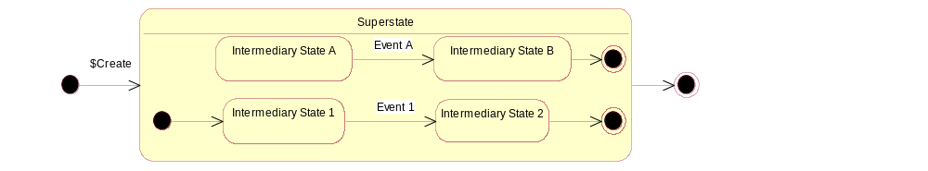



It is possible that sometimes there is independence and concurrency within the same object. We can use “aggregation” of states to describe such situations. On the diagram, there is one aggregate state Superstate. The state in which the object is that corresponds to this Statechart Diagram depends on the component states of Superstate.
- Example
We will use the Pedestrian Crossing example with classes such as PushButton, CarGrid, LightController, TrafficLights, and external actors such as Pedestrian and Car.
The behavior for CarGrid and PushButton will be detailed inside the state ON, giving way to the following statecharts for PushButton and CarGrid; pedestrianPushesButton and carHitsGrid are the events that bring PushButton and CarGrid to state Activated:

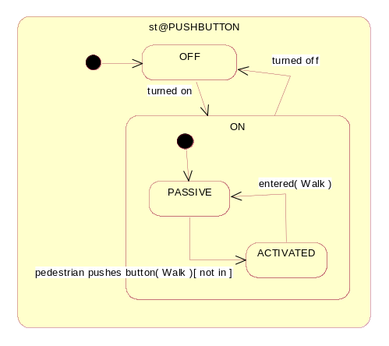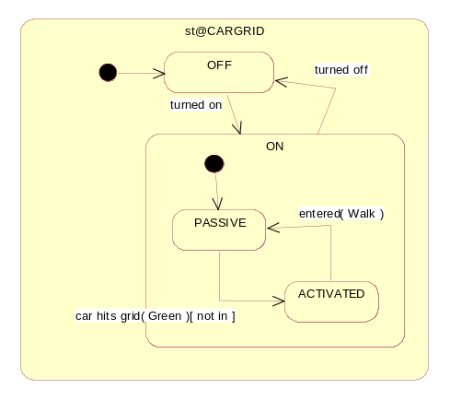

To describe the behavior of PushButton and CarGrid, we needed to know about the internal state of TrafficLights (that is Walk, Green) that will explicitly be made available to them.
We will first describe the behavior of TrafficLights as perceived by a Pedestrian and a Car respectively.
The following figure is the behavior of TrafficLights as seen by a Pedestrian:
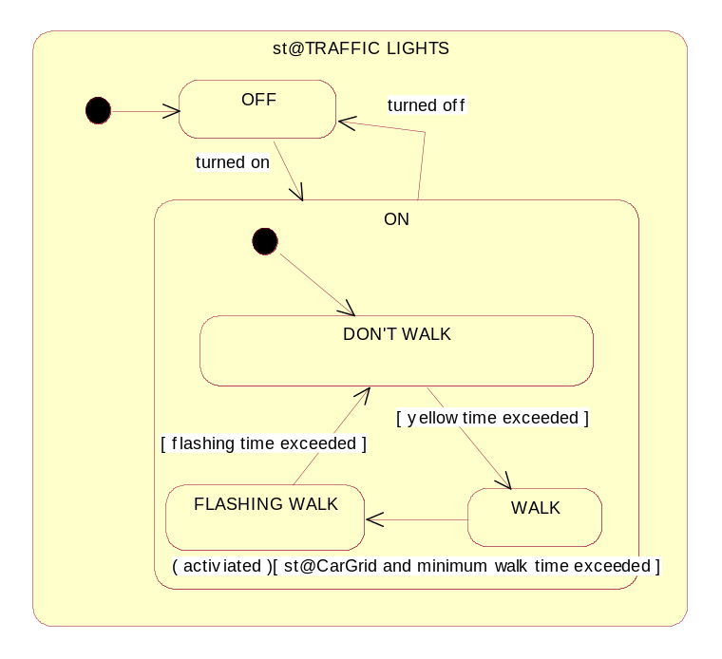

The conditions yellowTimeExceeded, minimumWalkTimeExceeded, and flashingTimeExceeded relate to the expiration of time periods (replace flashingTimeExceeded by using the following TIMEOUT event tm(en(FlashingWalk), FlashingDuration) which will mean that the TrafficLights will leave the state FlashingWalk as soon as the FlashingDuration expires after entering the state FlashingWalk.)
The following figure is the behavior of TrafficLights as seen by a Car:
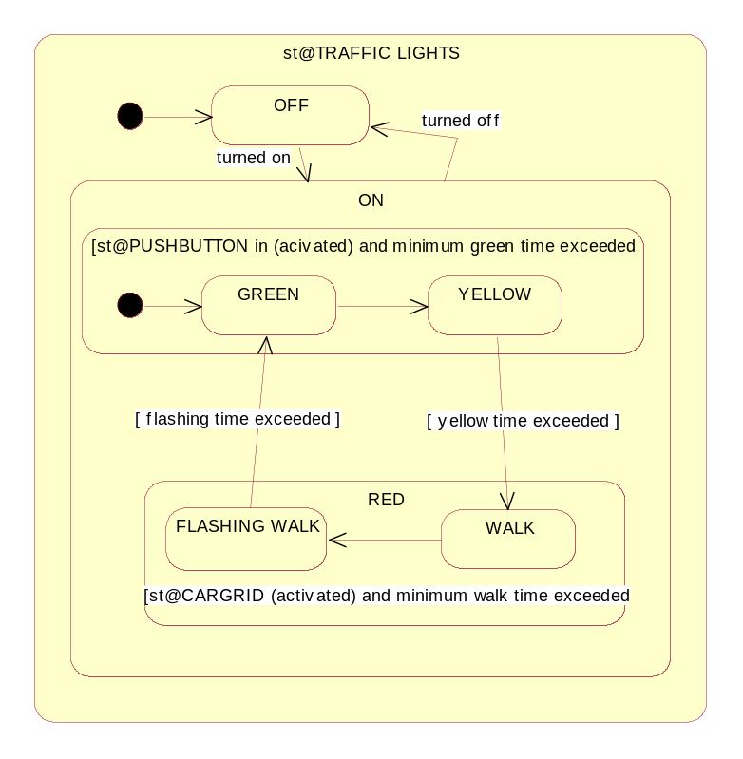

By merging these two views, we obtain the following statechart describing the overall behavior of TrafficLights at a PedestrianCrossing.
To complete TrafficLights dynamic model at a PedestrianCrossing, we need to add actions to display the necessary traffic signals, such as:
- On entered (Green) Do : DisplayGreen;
- On entered (Don’tWalk) Do : DisplayDon’tWalk;
- On entered (Yellow) Do : DisplayYellow;
- On entered (Red) Do : DisplayRed;
- On entered (FlashingWalk) Do : DisplayFlashingWalk;
- On entered (Walk) Do: DisplayWalk.
These actions will be attached to the corresponding states to execute them when entering a state. This will happen in the order Don’tWalk, Green, Yellow, Red, Walk, FlashingWalk, and then again, Don’tWalk.
- Development Approach
At the design level, architects and designers should define Statechart Diagrams. It is very important to have some key developers participate in this activity to ensure that the design can be efficiently implemented. Architects should help verify whether the later iterations of a Statechart Diagram meet the requirements described in the analysis. State Modeling is usually performed iteratively together with the development of a Class Diagram and Interaction Diagrams.
For each object that you can identify to have significant and complex state-dependent behavior, we suggest the following development approach:
- Identify the major information states during the life cycle of each such object. Question which subsets of the object’s attribute and association values result in a different response to the same message.
- At every state, stop and ask “What can possibly happen to me?” A good source for looking at what can happen to a certain object is in the set of Interaction Diagrams on which that object appears. Every incoming arrow for the object on the interaction diagram triggers a potentially relevant state transition. Ensure that all state transitions (and their respective states) are represented.
- From every state, ask if it is possible to visit every other state in the model. (Ask: “Can I possibly get from here to there?” where “there” is every other state in the model). It is not always true that each state should be reachable from every other state.
- Identify subsets of states that result in a transition to the same state if they receive a certain stimulus. Add a superstate that describes this transition once and for all.
- Do not show stimuli that always result in a transition to the same state. You may assume there is an “implicit” superstate for such stimuli (typical examples are “get” methods).
Statechart diagrams must reflect individual requirements on the application, which may be found in the form of Use Case List and scenarios. If each scenario is treated as a single “thread of usage” of the system and if the static Class Diagram is a foundation, the state modeling will weave these individual “threads of usage” into fabric whose texture will depend on classes made available in the static Class Diagram.
While accomplishing this, possible sequences will be determined, choices will be made on how to link different scenarios and inconsistencies or impossibilities on linking scenarios will be determined at the abstraction level of analysis scenarios.
In other words, out of static raw material a dynamic view will develop and will show the inconsistencies and the incomplete parts of original material. By analyzing and simulating the Statechart Diagram, an invaluable wealth of information may be derived before starting the construction.
A Use Case List with scenarios and a Class Diagram are assumed available for starting state modeling.
- Validation and Verification
Perform the following for validation and verification of Statechart Diagrams:
- Make sure that different conditions associated with the same incoming stimulus are exclusive.
- Check for black holes: a group of states that, once entered, cannot be exited (as a group). Note that not all black holes indicate modeling errors.
- Check the state transition table. Even if the table is not explicitly produced, check each possible combination of states for a possible transition.
- Check for the absence of race conditions using an appropriate tool.
- Check to see if any of the unwanted behaviors can happen, such as if there is a path of transitions taking you from a chosen state to an unwanted state, for example, TrafficLights showing Walk to Pedestrians and going from Red to Green for Cars.
- Check for initial and final states.
- Check that each state is reachable, i.e., there is at least one incoming transition to that state. Examine the statechart and ponder whether it is possible to get from one state to any other state. This sometimes uncovers behaviors or actions that otherwise might not be anticipated.
- Check that every nonfinal state has at least one outgoing transition.
- Check that every transition is labeled with the event that triggers it and any conditions that must prevail to enable the transition.
- Check the list of events on all outgoing transitions from a state for completeness. Can another transition be fired from that state?
- Check that every state is named.
- Check that the Statechart Diagram identifies the class whose behavior it is describing.
- Check the consistency between Interaction Diagrams and their related objects’ Statechart Diagrams. If there is a message received by an object in an Interaction Diagram, the message should show in the object’s statechart diagram as an event triggering a state change. In the same way, the object sending a message in an Interaction Diagram would have it in its Statechart Diagram as an action in a state or on a transition.
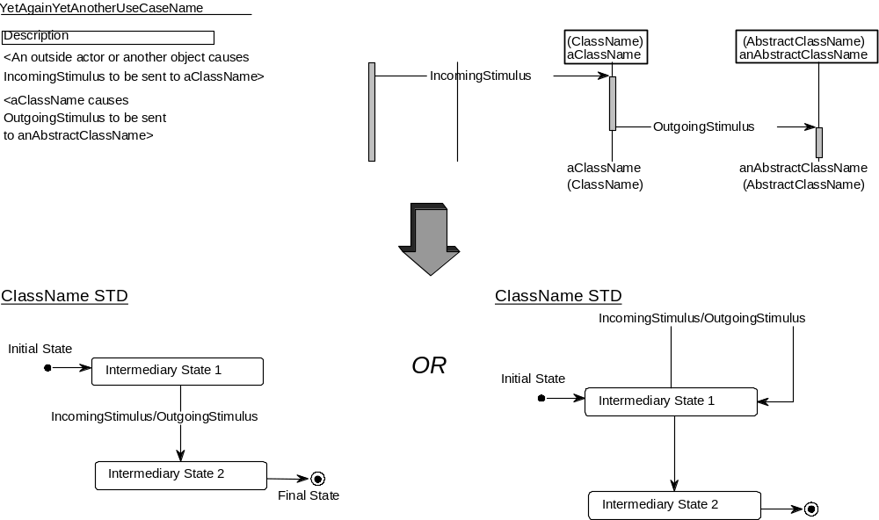
- Every incoming arrow IncomingStimulus on an object aClassName of ClassName on an Interaction Diagram results in a state transition in the ClassName Statechart Diagram. This transition may occur to the current state (Intermediary State 1) or to another state (Intermediary State 2).
- If an IncomingStimulus on aClassName results in aClassName sending OutgoingStimulus to anAbstractClassName (the fact that this is an “instance” of an abstract class is not relevant here), the IncomingStimulus in the ClassName Statechart Diagram must be followed by “/OutgoingStimulus”.
The validation of behavior descriptions by the application development team and by the client is instrumental in firming up your knowledge of the requirements and how you will meet them. It is through this validation that inconsistencies and incompleteness of the user requirements can be identified before the implementation starts. Otherwise, they will show up during different tests before rollout and/or even in a more costly way after the application has been put in use at several client sites.
Keep in mind that this is not a trivial task. The good news is that, if your behavior descriptions are done in a notation with clear executable semantics and if you have the right tool to understand and execute them, you can simulate, either in a step-by-step fashion or in an exhaustive way. The totality of your behavior descriptions or selected parts of them directly related to a specific domain of interest (such as security or high-level problem domain invariants).
- Advice and Guidance
The level of effort to produce the Statechart Diagram will obviously depend on the project type. You are more likely to spend more effort on it if you are developing a core enterprise-wide application to be installed on several sites than if you were to develop a proof-of-concept prototype. It is wise to present the Statechart Diagrams in such detail that the tough decisions can be easily discussed.
- Only develop Statechart Diagrams for objects with significant state dependent behavior. It makes no sense to develop Statechart Diagrams that contain only one intermediary state.
- Make sure that what you are trying to describe is not more easily understood by one or more interaction diagrams.
We suggest the following sequence of modeling and supporting task steps:
- Consider each class from the Class Diagram. Determine the event(s) triggering the creation of an instance of that class, and document the initial configuration in terms of its attribute values and relationships.
- Statechart Diagrams are built very selectively. In most domains, they are rarely done down to the design level. The exception to this is in real-time systems such as telephony, process control, or switch.
- One of the best ways of building a Statechart Diagram is to go through a role-playing exercise. This can be quite effective. Pretend that you are the thing being examined. Assume a state and ask “What can happen to me now?”
- Identify the major information states during the life cycle of each instance. Determine for each information state the attribute values, relationships, and services the instance will be capable of. Identify the event(s) triggering the destruction of an instance, if relevant. Document the object life cycle model of that class in terms of a simplified statechart. Repeat Steps 1 and 2 for all classes in the Static Class Diagram.
- Organize an inspection to make sure that nothing important is left out.
- Evaluate if all relevant information states have been completely described, without distortion or unwanted addition. If you had described information states in a notation with clear executable semantics under a tool that understands and, therefore, can simulate or execute them, make sure by an in-depth walkthrough that what you observe during simulation or execution of the Statechart Diagram corresponds to understanding of the domain.
- Document all inconsistencies discovered during the evaluation of information state descriptions. Document all distortions or unwanted additions. Return to the task that had produced the work product containing the defect(s) found during the evaluation, and make the necessary changes and evaluations before injecting these work products to their consuming tasks.
- Once you are confident about the stability and inter-coherence of the above-mentioned work products, organize a review to obtain the client’s acceptance of the revised version of these work products.
- Each object state represents a subset of all the possible values that the object’s attributes and associations can assume. Therefore, the state of an object is not necessarily dependent on the value of one single attribute or association of the object.
- Further refinements are made to the Statechart Diagrams as the focus of the engagement moves from Analysis to Design and optimization becomes much more of a concern.
- For classes rich in behavior, design state modeling is the place to identify whether the State design Pattern can be used (see Section 8, References, Design Patterns: Elements of Reusable Object-Oriented Software by E. Gamma).
- Check that the described information states naturally convey when a new instance is created; when the initial values of its attributes, initial instance configuration for aggregate objects, and the information state changes during object’s life cycle; and, finally, when an instance is destroyed.
- The necessary coherency checks inside the Statechart Diagram, as well as between the Statechart Diagram and the Class Diagram, can be automatically carried out with the right tool support. The results of these coherency checks and different simulations that can be carried out on an executable Statechart Diagram should be documented for each release of the work product.
- References
Harel, D. Statecharts: A Visual Formalism for Complex Systems. Sci. Comput. Prog., 8(3).
Cook, S., and Daniels, J. (1994). Designing Object Systems, Object-Oriented Modelling with Syntropy. Upper Saddle River, NJ: Prentice Hall.
Gamma, E., Helm, R., Johnson, R., and Vlissides, J. (1995). Design Patterns: Elements of Reusable Object-Oriented Software. Addison-Wesley.
Fowler, M., and Kendall Scott, S. (1997). UML Distilled – Applying the Standard Object Modeling Language. Addison Wesley Longman, Inc.
UML Notation Guide, Version 1.1. (September 1, 1997). Rational Software, Microsoft, Hewlett-Packard, Oracle, Sterling Software, MCI Systemhouse, Unisys, ICON Computing, IntelliCorp, i-Logic, IBM, ObjecTime, Platinum Technology, Ptech, Taskon, Reich Technologies, Softeam.
IBM. (1995). Practicing Object-Oriented Analysis and Design (pp. 2/200-2/216). Course Code AOAD. IBM Education and Training.
Harel, D. Statecharts: A Visual Formalism for Complex Systems. Sci. Comput. Prog. 8(3).
Rumbaugh, J. (1992) Modeling & Design: Derived Information. Journal of Object-Oriented Programming, 5(1), 57-61.
D’Souza, D. (1992). Education & Training: Teacher! Teacher! Journal of Object-Oriented Programming, 5(2), 12-17.

- Revision History

Date of this release: | Date of next revision:

Revision Number | Revision Date | Summary of Changes | Changes Marked?
4.1.1 | August 2002 | Edited to comply with intellectual property guidelines including R4 versioning scheme
3.0 | January 2000 | MIFP published version – no changes.
1.1 | December 1999 | Removed context information in Estimating Considerations. | No
1.0 | September 1999 | Base version

