Asset Workflow Specification

Name: Financial Services – Service Interface Review

Description: This workflow describes the participants and steps for reviewing service interface assets. This review workflow is decomposed into three reviews.

Conditions:
Community: Product Dev Division
Asset Type: Service Interface
Classification: Financial Services

Picture:
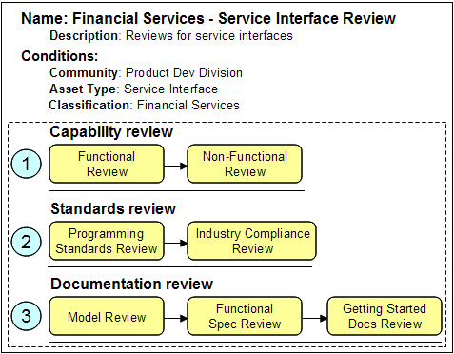

Participants:
- Business Analyst Team: provides functional capability review and model review
- System Test Team: provides non-functional capability review
- Asset Governance Board: provide governance and policies for asset-based development, provide enablement and training
- Documentation Team: though not formally on the chart, participate with Asset Governance board to enable teams

Capability Review: Functional Review
Business Analysts use service in the context of the business use case and the business process to verify the proper results [Step 1a, 3a].

Capability Review: Non-Functional Review
System Test Team uses testing lab to verify topology configurations support, load and performance testing [Step 1b].

Standards Reviews
Asset Governance Board evaluates [Steps 2a, 2b] the standards used and not used to determine compliance.

Documentation Review
Documentation Team reviews [Steps 3b, 3c] the supporting help material provided with the service interface asset.

Step 1a: Perform Capability Functional Review
Step 1b: Perform Capability Non-Functional Review
Step 2a: Perform Programming Standards Review
Step 2b: Perform Industry Compliance Review
Step 3a: Perform Model Review
Step 3b: Perform Functional Spec Review
Step 3c: Perform Getting Started Docs Review

Asset Workflow Specification

Name:

Description:

Conditions:

Picture:

Participants:

Step <n>:

