Interaction Diagram
Description
An Interaction Diagram a graphical representation of what depicts the internal behavior of the system. It shows how objects collaborate by sending messages and returning responses to each other. Typically the initial diagrams will only show the key interactions between the main business objects discovered during analysis. Later iterations will also include invented objects that provide the control, interface, communication, distribution and storage functionality of the system. The behavior initially represented will be functionality specified in use cases or more specifically the scenario of a use case while diagrams developed later may also show some internal design mechanism such as the standard way to instantiate a collection of objects.
An Interaction Diagram presents the dynamics of a scenario by representing related objects, messages, and interaction flows. It shows how objects can collaborate to perform a scenario. Interaction diagrams reflect the knowledge and viewpoint of clients who will use these objects. They also reflect how the system will manage interface, communication, control, and persistency based on the system requirements and the chosen architecture. Interaction Diagrams are instance level diagrams. They show how individual object instances react to a given input message with a particular set of values for its parameters. It is like the trace of the execution of a test case. It is meant to be a dynamic representation of the system. The diagram is a trace showing the sequence of method invocations that are executed by the objects in the system.
- Purpose
Interaction Diagrams form a direct link between the functionality specified in the use cases and the functionality that can be supported by a class diagram. This linkage between scenarios and the class diagram can be explored in either direction. The Interaction Diagram is the main vehicle for allocating behavior to objects, discovering problems, holding design discussions and considering alternatives to the current design. Interaction Diagrams can be used to help identify classes and their responsibilities by requiring the developer to decide:
- Which objects of which classes are participants in the Interaction Diagram and what are their ‘behaviors and responsibilities’
- An ordering of the operations relevant to carrying out the scenario
- An allocation of the responsibilities for these operations to specific classes
Interaction Diagrams may also be used in the reverse direction to validate that an existing Class Diagram does indeed support the required set of scenarios. Usually Interaction Diagrams and the Class Diagram are developed together in an iterative manner.
Interaction Diagrams provide an end-to-end understanding of how objects can carry out the scenario. This end-to-end view is difficult to achieve from the study of a Class Diagram alone.
Not producing Interaction Diagrams makes it difficult to identify typical patterns and to identify opportunities for component and framework reuse. It will also be more difficult to assess the overall viability of the system and to determine the necessary trade-offs between reusability, modifiability and efficiency.
Without an Interaction Diagram, there is a potential traceability gap; it will be harder to check that a Class Diagram can appropriately support the use cases. Arguing that very similar scenarios can be supported can fill this gap. Alternatively an analyst may perform a mental walkthrough to decide if there would be any problems constructing an Interaction Diagram. Finally, a Statechart Diagram can be used to express the assumptions and outcomes of the scenarios in terms of object states, ensuring that the Class Diagram has the necessary attributes, associations, and operations.
Writing Interaction Diagrams can be as time consuming and sometimes repetitive. Whether Interaction Diagrams are used in a forward thrust (to produce the Class Diagram) or backward (to validate a Class Diagram), a point of diminishing returns will be reached sooner or later. If writing Interaction Diagrams for more scenarios will not drive out any more responsibilities or related issues, there is no point continuing. It is important to know which Interaction Diagrams not to write. The key is to produce diagrams only for those scenarios that drive out the structuring mechanisms of the system. However, producing no Interaction Diagrams at all is hazardous, since this usually results in a poor understanding of the dynamic aspects of the system.
- Notation
There are two main ways in which an Interaction Diagram can be written: as a Sequence Diagram or as Collaboration. The former is better for displaying (and understanding) the trace of messages or communication patterns; the latter is better for displaying the relationships between the objects involved in the Interaction Diagram. If only a single notation has to be used, the Sequence Diagram is preferable as communications and not relationships are the primary concern of an Interaction Diagram. Both diagrams however contain the same information and either can be generated from the other. Both types of diagrams have a similar notation for representing the basic elements, which is defined by UML (Unified Modeling Language).
  - How to Represent Objects
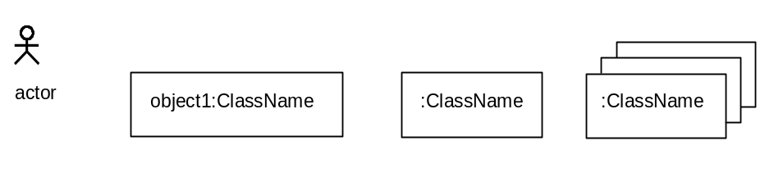
- Actors are represented by a stick figure.
- Objects are shown as a rectangle containing the name of the object and the class name separated by a colon. Where more than one object with the same name is drawn they are meant to represent the same object.
- A generic instance of a particular class may be identified by just its class name preceded by a colon.
- Multiple instances of an object may be shown by stacking.
- If stereotypes are used, then instead of the rectangle each object is represented by the appropriate shape for its type (i.e., Interface Object, Interaction Object, Dialogue Processor Object, Usage Object, Model Object or Persistence Access Object).
  - How to Represent the Sending of a Message and Returning a Response
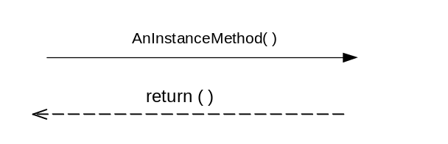
- A message being sent from an actor or an object is represented as a solid arrow, labeled with the name of the method AnInstanceMethod followed by a set of parenthesis that may included a list of the formal parameters to be supplied.
- A response being returned is represented as an open arrow, labeled with return( ), which would include the actual result being returned.
- For every message sent, there is eventually a return on the diagram, even if the method that was invoked doesn’t return a result. The return then could indicate that control is being transferred back to the object that originally invoked the message. It is however also possible not to show the return at all and to agree that an invocation automatically implies the return of a result.
  - How to Represent a Collaboration Diagram
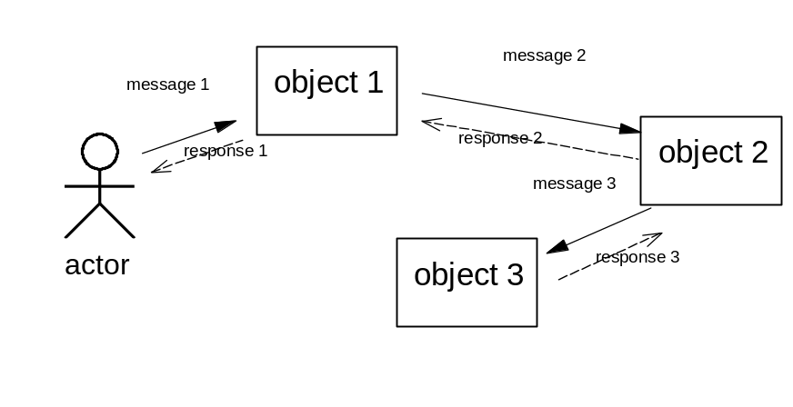
  - How to Represent a Sequence Diagram
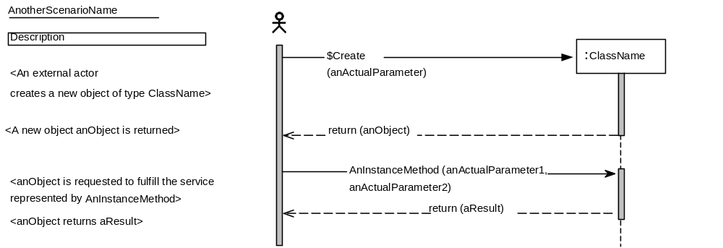
To show that two messages are sent in a certain sequence, we simply put the message being sent first above the message that is being sent later in the Interaction Diagram. The time axis is vertically down the diagram. Additional descriptions of the actual events may be included in the left-hand margin.
  - How to Represent the Object Lifecycle on a Sequence Diagram
Special conventions apply to show that an object is being created in a Sequence Diagram.
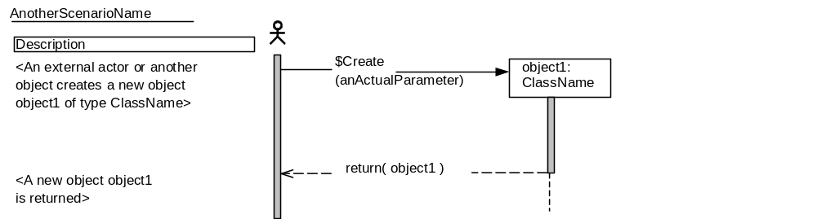
- To show that object1 comes into existence, we send the message $Create (anActualParameter) to the class ClassName. ClassName then instantiates a new object object1, by convention, object1 does not exist on the diagram and therefore cannot be used before we send it the $Create message.
- A dashed line extending from the bottom of an object is then used to represent the lifeline of that particular object, while a shaded rectangle shows the focus of control.
- Terminating the lifeline with an ‘X’ shows the destruction of an object (not shown).
- The return result of the $Create method is object1, the newly created object itself.
  - How to Represent Conditional Parts of a Sequence Diagram
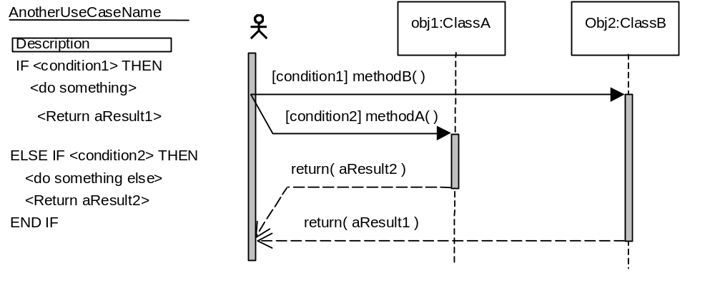
To show that a certain part of an Interaction Diagram is only executed under a certain condition, use the following syntax:
IF <condition> THEN
<statements>
END IF
  - How to Represent Iterative Parts of a Sequence Diagram
There are two alternative notations to describe iteration over a number of objects in an Analysis Interaction Diagram: the explicit notation and the iterator notation. The explicit notation is most understandable, while the iterator notation is the most practical. In general, the iterator notation is recommended. Each alternative is discussed below.
Explicit Notation
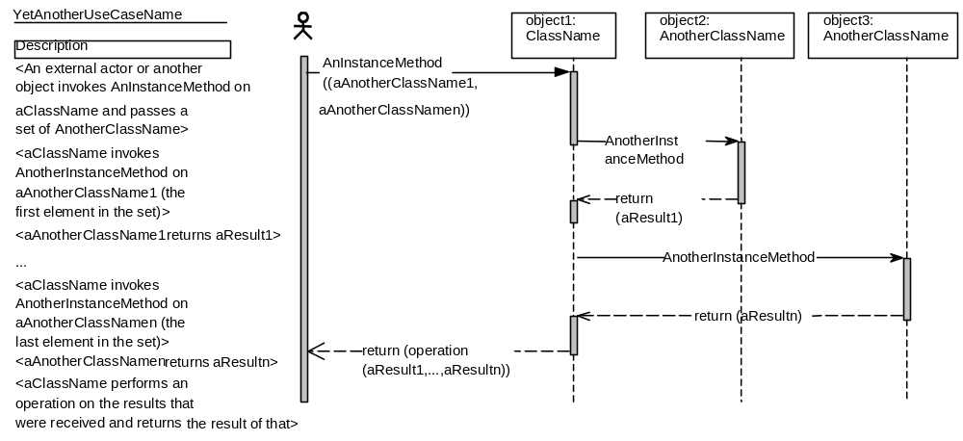
The first alternative is to explicitly show each of the objects of type AnotherClassName receiving the message. In this case object 2 and object 3, to each of which the message (AnotherInstanceMethod) will be repeated.
Iterator Notation
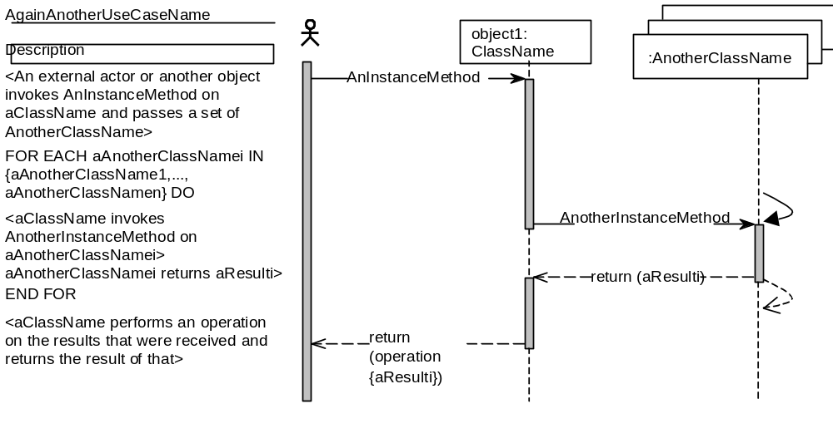
The second alternative is to show one set of iterator object of type AnotherClassName to which the repeated message is sent once. Curved lines show the begin and end of the iteration while the narrative description is enclosed in the following statement:
FOR EACH <iterator object name> IN <Set over which is iterated> DO
<message that is being sent to the iterator object name>
END FOR
- Example
The following is an Interaction Diagram for an automated warehouse, in which the following observations hold true:
- All loads in the warehouse are placed on pallets.
- Pallets in the warehouse can be moved around using automatic trucks. Trucks can be programmed by a technician to transport a pallet to another location. Trucks report back to the technician whether an attempt to move a pallet was successful or not.
- Operations management sets a policy that after every nth move of a pallet; the load has to be stabilized by a checking station. This n is the same for all pallets in the warehouse and can be changed at any moment.
- If a truck wants to move a pallet for the (n+1)th time, and the destination is not a checking station, the pallet must not be moved.
- A pallet may be moved earlier than the (n+1)th time to a checking station. In that case, the load has to be stabilized anyway.
- If a pallet is currently located at a checking station and a truck tries to move it to another location, the checking station must first release the pallet that is about to be transported.
The Interaction Diagram is a formal representation of the Use Case Moving Pallet:
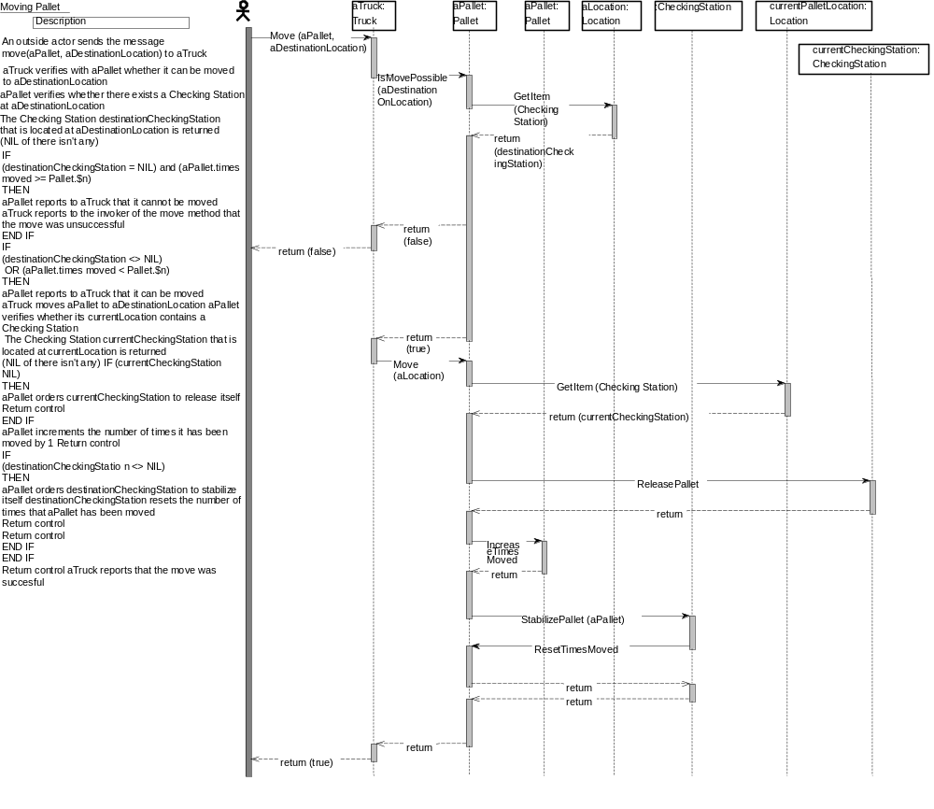
- Development Approach
Developing Interaction Diagrams usually takes place in the context of (at least) a draft Class Diagram. Although it is also possible to use the Interaction Diagrams to walk through a number of scenarios which will then drive the development of the corresponding classes and relationships.
- Start with a particular Use Case or better yet a scenario for the given Use Case. Identify what happens, who collaborates and to whom to delegate responsibilities. Determine what the parameter values will be for each of the various input stimuli required to execute the scenario.
- Decide which objects need to participate and insert these objects into the Interaction Diagram. Instance names should suggest the roles that the objects play in the scenario, for example, “sourceAccount” or “destinationAccount.”
- Decide the classes of each participating object based on the required responsibilities or methods needed to fulfill its role. Unless the Interaction Diagram breaks the Class Diagram, which frequently happens, the class will be one that has already been identified in the Class Diagram. If no class currently is capable of handling the required requests either add those responsibilities to an existing class or create a new class as appropriate.
- Use the responsibilities identified for the classes of the participating objects as menus from which to select methods. If no appropriate responsibility exists or it is assigned to an inappropriate class, then amend the object accordingly. For each method, it must be decided (or verified) which object is to send the message that invokes it, which object has the responsibility for executing the method, and which parameters are appropriate.
- Validation and Verification
Perform the following for validation and verification of an Interaction Diagram:
- Check for an even distribution of intelligence and control. Verify that there is no intensive communication around one component. If one component dominates the communication pattern, it may have too many responsibilities and knows too much about too many parts of the system. This could become a fragile part of the system. If any of the parts it knows about changes, it may have to change. If it is a large and complex component, then the chances of introducing an error or propagating changes is higher.
- Verify that there is no unnecessary intensive communications between components. Two components communicating with each other intensively evidently need to know a lot about each other. Perhaps they should be one component or there is a third abstraction waiting to be found.
- Verify that the responsibilities are well distributed. Avoid overly passive objects (pure data objects) and overly active objects (managing and controlling objects). Based on the frequency of object communication, identify any possible system bottleneck and find ways of improving performance. Also check for the absence of objects that primarily operate on other objects.
- Check consistency of with the Class Diagram.
- For each type of object used in an Interaction Diagram there must be a corresponding class in the Class Diagram.
- For each message sent to an object A, check that there is a corresponding method within in A’s class. Check the types of the actual parameters passed (par 1 and par2) conform to the types of the parameters that expected by the method (X and Y). Also check that the type of response that is returned conforms to the type of that is returned by the method (Return type).
- If object A sends a message to object B in an Interaction Diagram, either A’s class has an association (including aggregation) directed to B’s class, or there is a type dependency from A’s class to B’s class. The latter happens when B is passed to A through method parameters. Both cases should be reflected in the Class Diagram. Object collaboration graphs allow the nature of the reference to be explicitly represented.
- Verify the correctness of the Interaction Diagram. Check that every message is named and has needed parameters. Check that the scenario assumption/start state is used/needed and that the expected outcome occurs. Check that all navigations from object to object implied by an Interaction Diagram are in practice made possible by the appropriate attributes, parameters, and operations. Check that the frequency of inter-process communications is acceptable. Check the adequacy of all message parameter lists.
- Validate the Interaction Diagrams against requirements. Check that the objects provide the behavior required by all scenarios and that the expected outcomes do indeed occur. Also check that the design complies with the relevant rules, algorithms, and policies stipulated for the enterprise, and that the model is sufficiently resilient to the changes expressed in the Change Cases.
- Advice and Guidance
The following guidance is suggested:
- Include sufficient typical mechanisms to explain the general behavior of the model and special cases that illustrate behavior under exceptional situations. For a specific stimulus, a mechanism expresses what happens and how behavior is enacted when the recipient object receives a stimulus. By detailing the specific ordering of messages, a mechanism determines how objects are visible to each other. Mechanisms describe the intention of the design by illustrating key interactions that represent the essence of the design. The adoption of architecture templates and design patterns prescribes types of mechanisms that will determine the methods that the design classes have to provide.
- Develop interaction diagrams and class diagrams at the same time and iteratively. Interaction diagrams frequently “break” the class diagram that must then be modified.
- Focus on the major Interaction Diagrams that have an impact on either the system architecture or key functionality, or that explain how mechanisms in the design work. An Interaction Diagram can only specify the execution of a system for one scenario. A system can consist of hundreds of scenarios under different conditions and status. The amount of work can be too much to accomplish in a short period of time. Even if all Interaction Diagrams are written, their number tends to defeat their objective: a clear understanding of system dynamics. Avoid those Interaction Diagrams that do not contribute to the system understanding or design. Frequently, exception conditions are documented as notes at the bottom of each Interaction Diagram.
- Use and automated tool whenever possible. This entire process is greatly simplified through the use of an automated tool that will provide a list of existing classes and their methods as well as allow the creation of new classes and methods from the Interaction Diagram. Further aid can then be had by automatically generating the Collaboration Diagram for an existing Sequence Diagram or vice versa. Note that the notations may have to be amended to fit the notations supported by the chosen tool.
- Identification and dating of Interaction Diagrams are very important.
- Feel free to include very specific objects in an Interaction Diagram. For example, BillLarson and BillLarsonsComicBook, if this promotes clarity. The goal of an Interaction Diagram is not completeness but an end-to-end understanding.
- References
IBM. (1995). Practicing Object-Oriented Analysis and Design (pp. 2/189-2/198). Course Code OB15. IBM Education and Training.
Jacobson, I., Christerson, M., Jonsson, P., and Övergaard, G. (1992). Object-Oriented Software Engineering: A Use Case Driven Approach. Addison-Wesley Publishing Company. ISBN 0-201-54435-0. Jacobson et al. were the first to employ use cases and Analysis Interaction Diagrams in dynamic modeling. OMT and Booch also use similar work products in their method. OMT has a different kind of work product called “event trace diagrams”.
Rumbaugh, J. (February, 1995). OMT: The Dynamic Model. Journal of Object-oriented Programming.
Booch, G. (1994). Object-Oriented Analysis and Design with Applications. Benjamin/Cummings Publishing Company, Inc.
Fowler, M., and Scott, K. (1997). UML Distilled – Applying the Standard Object Modeling Language. Addison Wesley Longman, Inc.
UML Notation Guide, Version 1.1 (September 1, 1997). Rational Software, Microsoft, Hewlett-Packard, Oracle, Sterling Software, MCI Systemhouse, Unisys, ICON Computing, IntelliCorp, i-Logic, IBM, ObjecTime, Platinum Technology, Ptech, Taskon, Reich Technologies, Softeam.
Booch, and Rumbaugh, J. (1995). Unified Method for Object-Oriented Development (Version 0.8). Rational Corporation.
D'Souza, D., and Graff, P. (February 1995). Working with OMT: Model Integration. Journal of Object-Oriented Programming, 23-29.
Derr, K.W. (1995). Applying OMT. SIGS Books.
Gamma, E., Helm, R., Johnson, R., Vlissides, J. (1995). Design Patterns: Elements of Reusable Object-Oriented Software. Reading, MA: Addison-Wesley Publishing Co. ISBN 0-201-63361-2.
Technique Paper on Design Object Collaboration Modeling (1996). NA OTP.
The OOTC Workbook-Driven Approach to OO Software Development: A Reference Guide, Release 2.0. (March 28, 1996). REQUEST OOREF from OOTC at PKEDVM9
Pree, W. (1995) Design Patterns for Object-Oriented Software Development. Addison-Wesley.
Object-Oriented Application Development with VisualAge in a Client/Server Environment. (June 1994). Document Number GG24-4227-00. International Technical Support Organization, San Jose Center.
Negros, Pascal (1997) An Architectural Template <<The Sextet>>
- Revision History

Date of this release: | Date of next revision:

Revision Number | Revision Date | Summary of Changes | Changes Marked?
4.1.1 | August 2002 | Edited to comply with intellectual property guidelines including R4 versioning scheme
3.0 | January 2000 | MIFP published version –no changes.
1.1 | December 1999 | Removed context information in Estimating Considerations. | No
1.0 | September 1999 | Base version

