Asset Workflow Specification

Name: Enterprise Asset Governance and Development Workflow

Description: This high-level workflow describes the participants and steps for applying asset-based governance and development at corporation Z. This workflow is revised from the Asset-based governance “Enterprise Partial” template.

Picture:
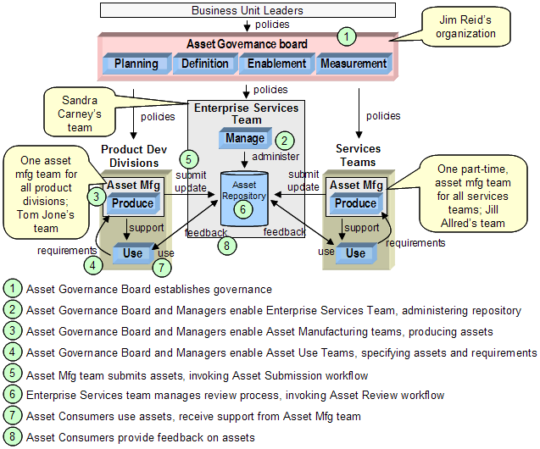

Participants:
- Business Unit Leaders: provide business direction to Asset Governance Board
- Asset Governance Board: provide governance and policies for asset-based development, provide enablement and training
- Managers: though not formally on the chart, participate with Asset Governance board to enable teams
- Enterprise Services Team: provide repository administration and asset review management
- Product Dev Division Asset Mfg Team: provide asset manufacturing for all product development divisions
- Services Asset Mfg Team: provide asset manufacturing for all services teams
- Asset Consumers: provide asset specifications, requirements, usage and feedback

Step <n>: The steps are outlined in the picture.

Asset Workflow Specification

Name:

Description:

Picture:

Participants:

Step <n>:

