# This is a heading 1

This is a heading 8

This **is *just*** *so∑∂®åπçme* text.

One empty line above, two below…

And *a bullet list:*

* *Item 1*
* *Not first, not last*
* *Not first, not last*
* *Item* 2 with a [link](http://smart.pr/)

And an image:[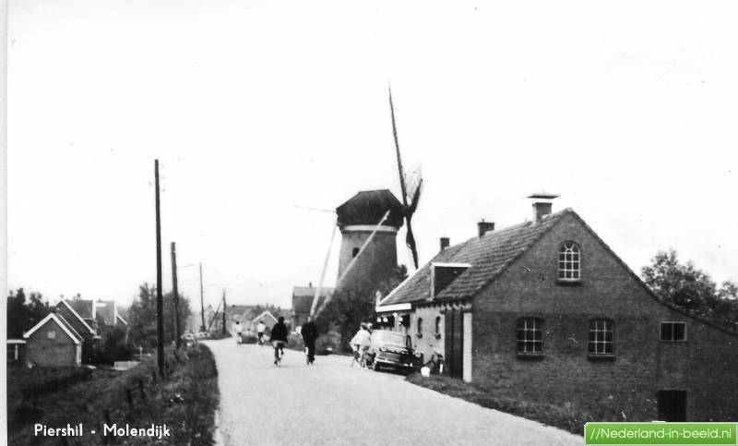](http://blog.smart.pr/)

Bullet list of one:

* The only item

Ordered list:

1. One
2. Two
   1. Nested hell
   2. Yes
      * This
      * Is
      * Gonna
      * hurt
3. Three
4. four