**Eloquent ORM**

Model blan ulab togirlab beruvchi funksiya koproq database da ishlatamiz where*from select orniga shu eloquent ni ishlatib kodni chiroyli yozib togirlase boladi

**Chunk**

Bu bir nechta chaqirib olib kese boladi

# $posts = Post::*where*('title'**,** 'title')->get()->orderby()->limit(**1**)**;**

**Retriving models**

Find – topish

# $post = Post::*find*(**3**)**; find(id) shu xolatda turibdi**

Database ga create qilish !

Database ga qoshish bu ishla postcontroller da bovoti

$newPost = new Post**;**$newPost->title = 'mohir'**;**$newPost->short_content = ' mohir short content'**;**$newPost->content = ' mohir content'**;**$newPost->photo = '/storage/mohir.png'**;**$newPost->save()**;**return 'success'**;**

Bundan soddaro yozish mumkin keyingisida qoyilgan

Fillable shundan boshqasi toldirish keremas manoni bildiradi

class Post extends Model  
{  
 use HasFactory**;** protected $fillable = ['title' **,**' short content' **,** 'content'**,** 'photo']**;**}

bu asosan modelni ichidi post.php da boladi va

class PostController extends Controller  
{  
  
 public function index()  
 {  
  
  
 $newPost = Post::*create*([  
 'title' => '4'**,** 'short_content' => 'short' **,** 'content' => 'content 123'**,** 'photo' => 'photo.jpg'  
  
  
  
 ])**;**

**return ‘success’;**

shu holatda yaratamiz buni postControllerda boladi proccess

UPDATE qilish

$post = Post::*find*(**6**)**;**$post->title = 'updating page'**;**$post->save()**;**

PostControllerda yoziladi

DELETE qilish

$post = Post::*where*('id'**, 7** )->first()**;**$post->delete()**;**return 'deleted'**;**

Id nomeri berib ochiramiz

Bundan qulay yoli

Post::*destroy*(**2**)**;**

**Phpmyadmin da ochirilgan lekn korzinaga oxhab turish uchun**

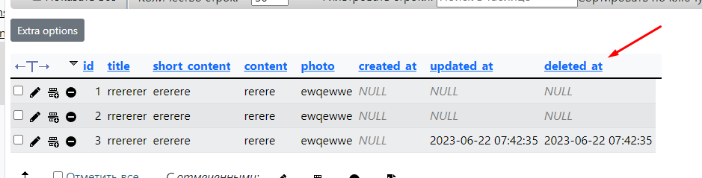

Shu holat boladi

Unaqa chqish uchun avvalambor shuni :

class PostController extends Controller  
{  
  
 public function index()  
 {  
  
  
 Post::*destroy*(**3**)**;** return 'deleted'**;**

shu joyga yozamiz

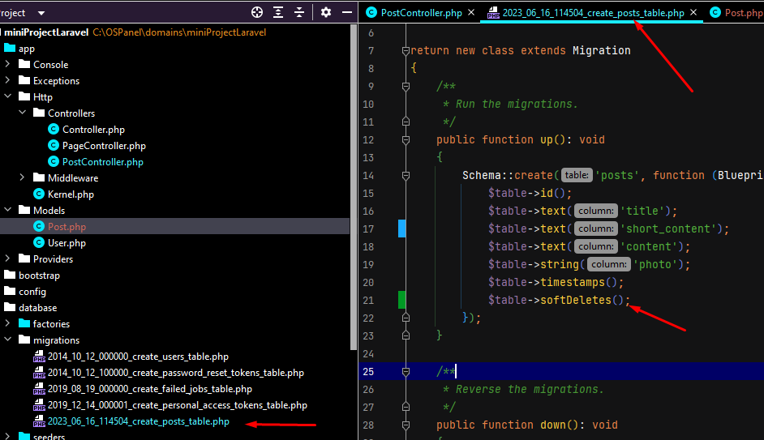

**Keyin mi**grate fresh qlamiz

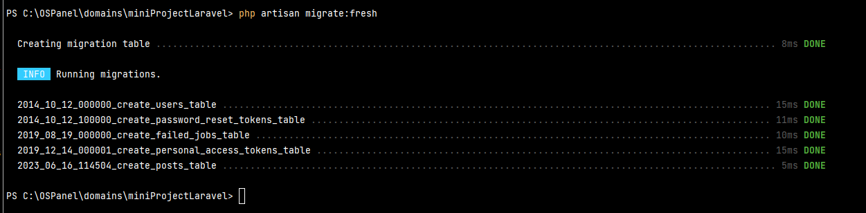

**Korzinadan olib chqish yolini qlamiz**

**Qaytarish yoli 1#**

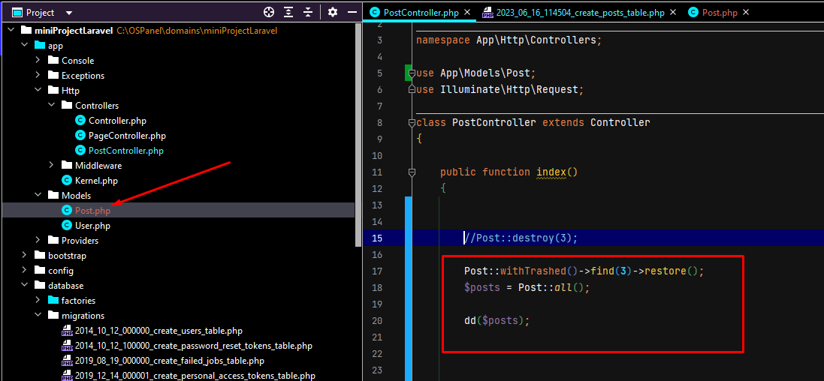

**2#**

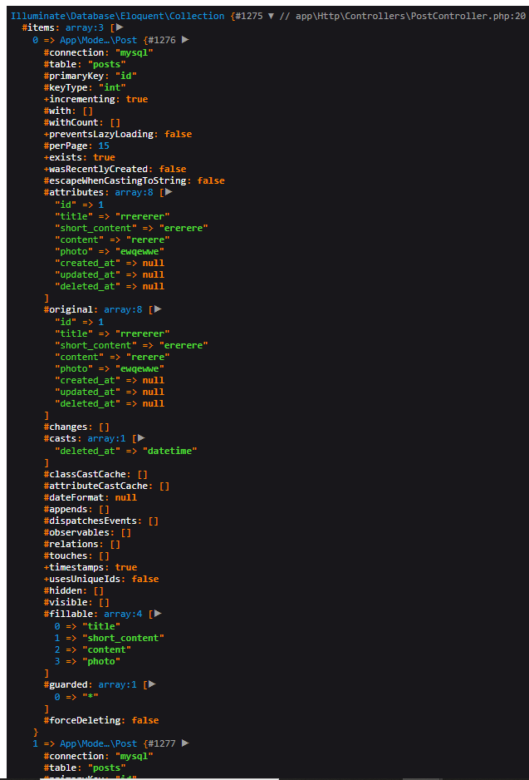

**Saytga shuni chqarib qaytib keganini korse boladi**

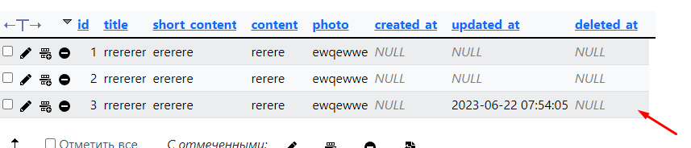

**Va natija**