SMART STEERING WHEEL

Arathy Francis
Arya Mohan
Fathimath Farzeena Shirin
Lekshmipriya BL

CONTENTS

1.Abstract
2.Introduction
3.Proposed System
3.1.Sensor Module
3.2.Speed Control Module
3.3.Bluetooth Module
3.4.Mobile App
3.5.Webpage
4.Conclusion
5.References

ABSTRACT

In recent years, driver drowsiness has been one of the major causes of road accidents and can lead to severe physical injuries, deaths and significant economic losses. Statistics indicate the need of a reliable driver drowsiness detection system which could alert the driver before a mishap happens. A method and steering wheel for determining and verifying a state of driver alertness includes receiving a response at a steering wheel. If the subject is in the state of drowsiness then an alert is generated from their mobile phone and a message is send to the selected contact list. Also they can view their drowsiness pattern.

INTRODUCTION

Smart Steering Wheel is an initiative to check whether a person falls asleep during the journey thereby ensuring safety. It measures drowsiness of the driver for preventing accidents, by measuring the pressure applied by the driver on the steering wheel. If the person is drowsy then an alarm is generated through the mobile app.The system registers the speed at which the vehicle is moving and location at which driver fell sleep and also sends notification to emergency contacts there by alerting them before accident occur.

PROPOSED SYSTEM
SENSOR MODULE
Flex sensor is a component that changes the resistance when bent. It measures the pressure applied on the steering wheel. As the sensor is flexed, the resisitence across the sensor increases.
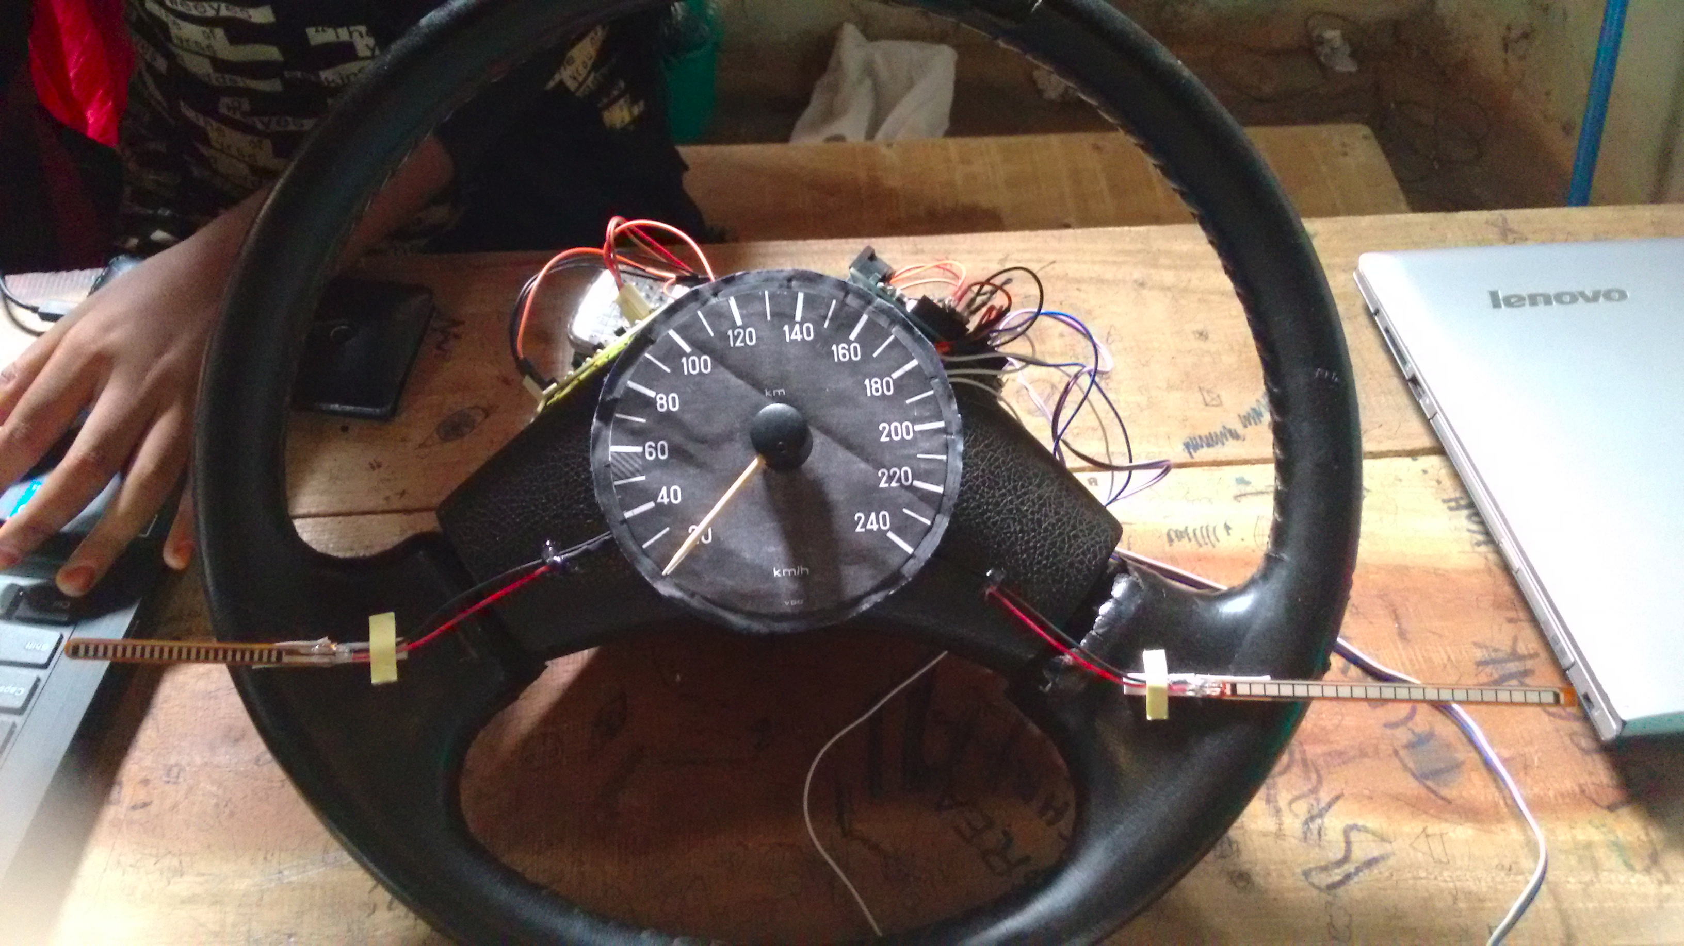

ULTRA SONIC SENSORS
Ultrasonic Sensors are self-contained solid-state devices designed for non contact sensing of solid objects. This measures the distance from nearby obstacles.
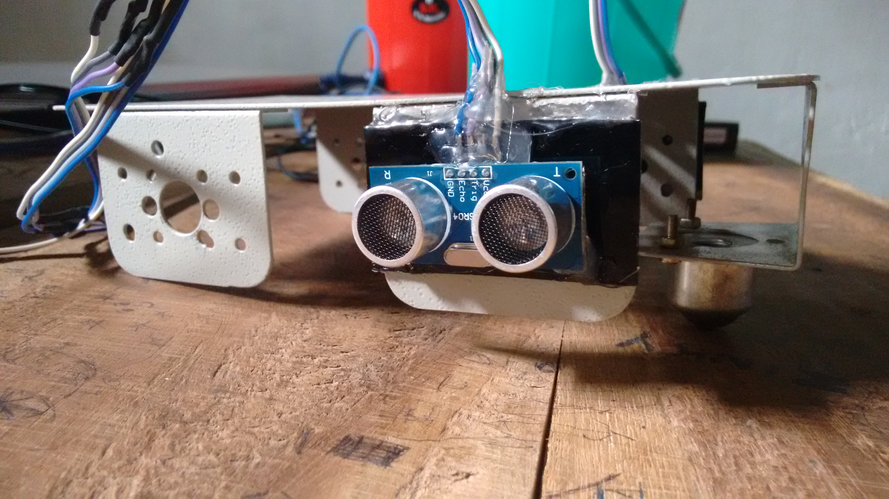

SPEED MODULE
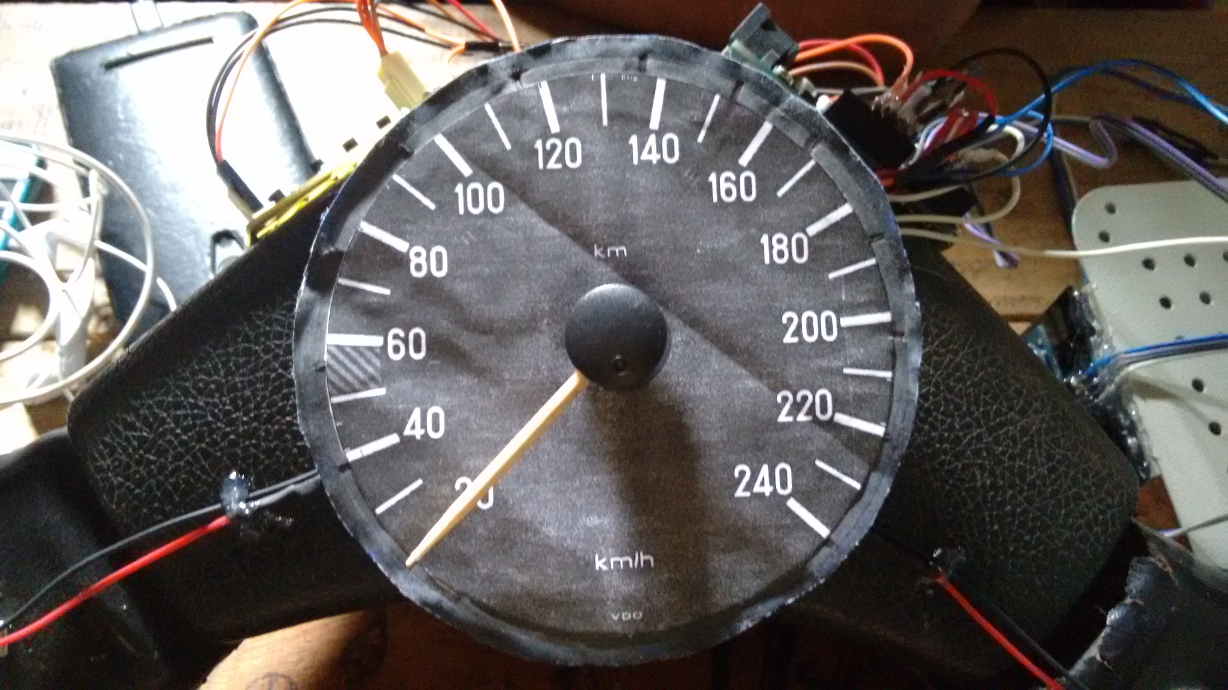
A potentiometer, informally a pot, is a three-terminal resistor with a sliding or rotating contact that forms an adjustable voltage divider. Here we used this to measure the speed variation.
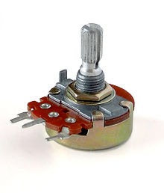

BLUTOOTH MODULE

HC-05 module is an easy to use Bluetooth SPP (Serial Port Protocol) module, designed for transparent wireless serial connection setup.
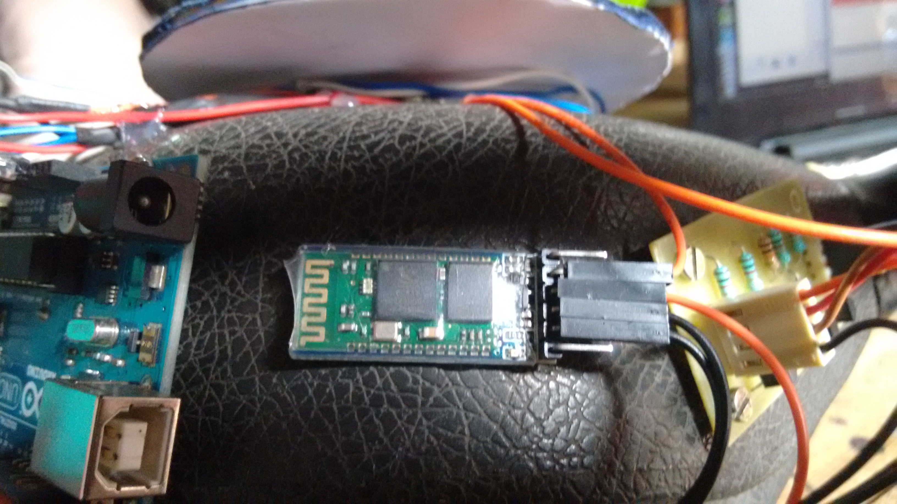

ANDROID APP

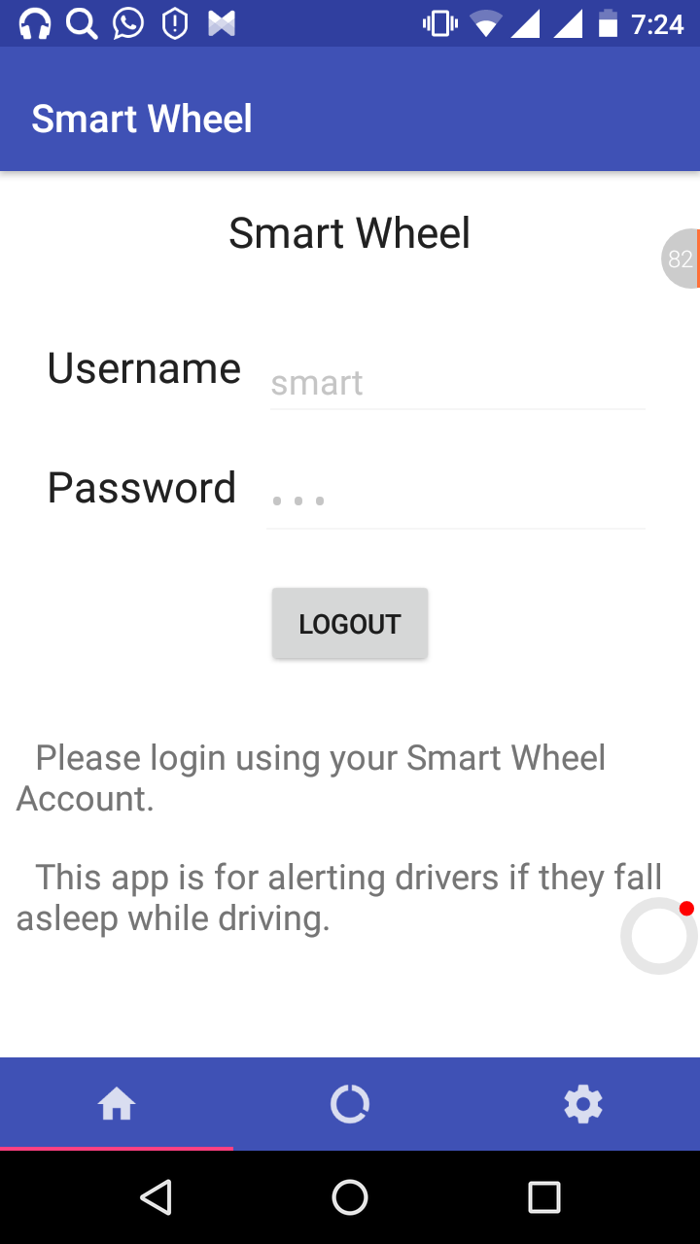
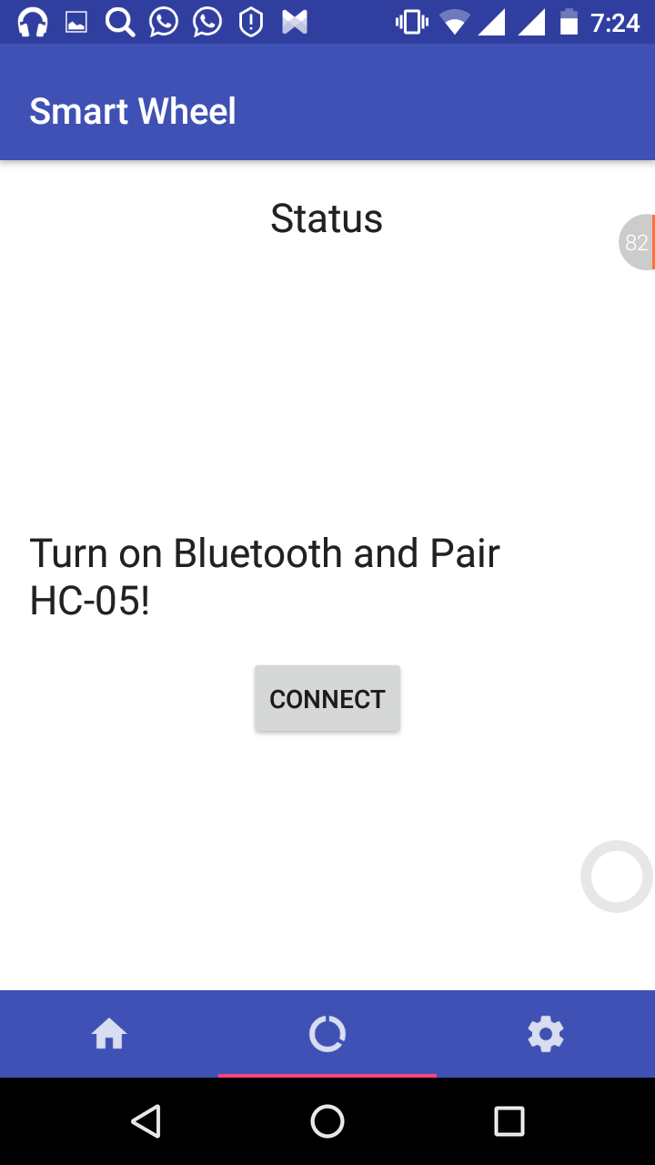

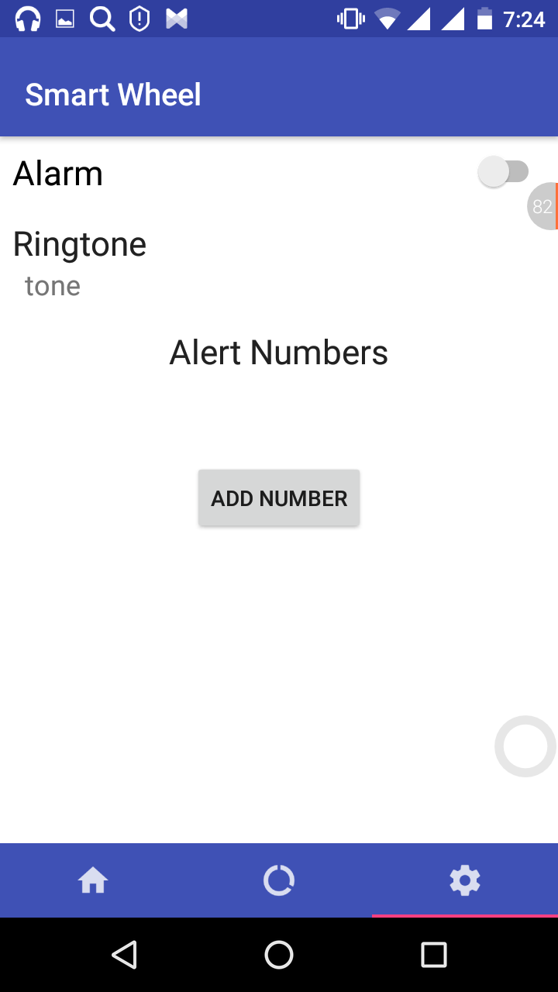

Our app shows the current status of the driver as per the data colleted from sensing unit and speed module. First we have a login page which directed to the status page where we have to connect mobile bluetooth with bluetooth module. We have a settings icon in which we can set alarm and can add emergency contacts.

WEB PAGE
Shows the login page ,where the user can login with the registered user name and password.
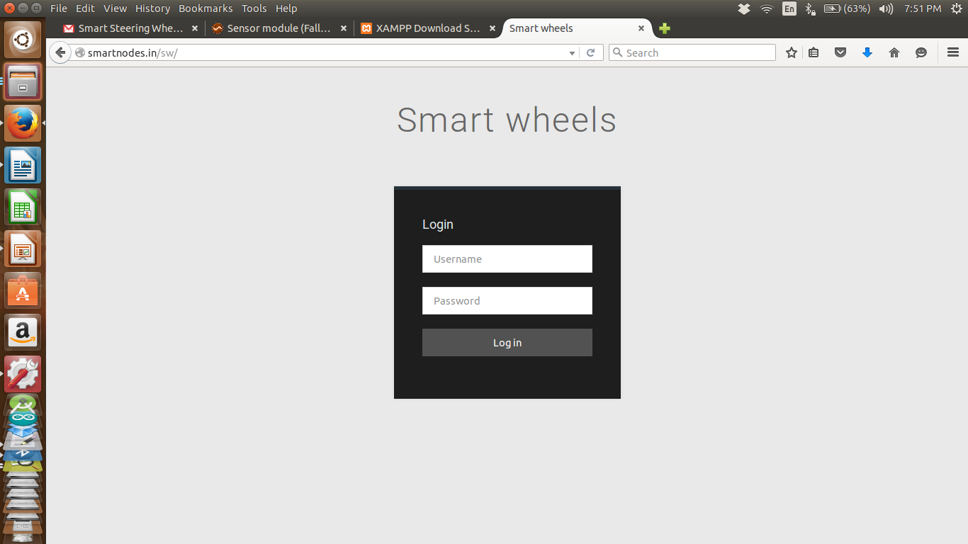

The login page directs to driver's login.Here we can see driver id,GPS,speed and date of the drive and on clicking the GPS coordinates the google map will be shown.

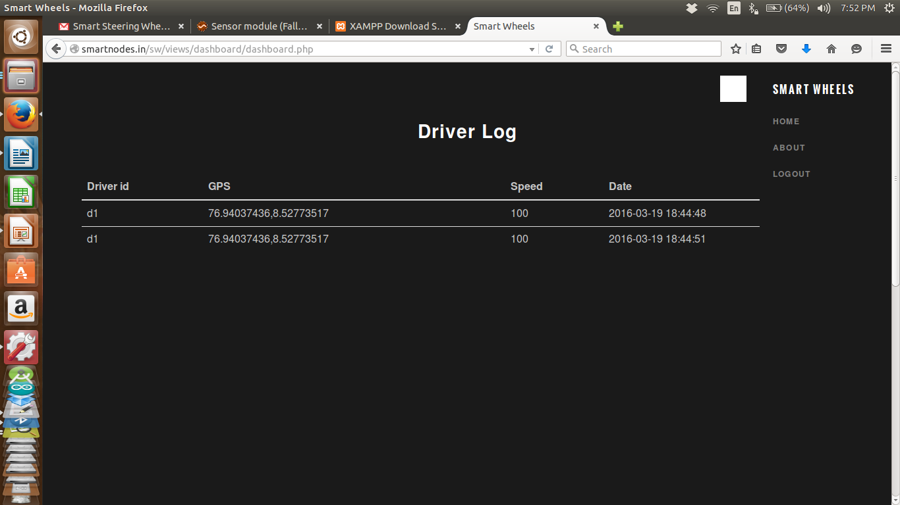

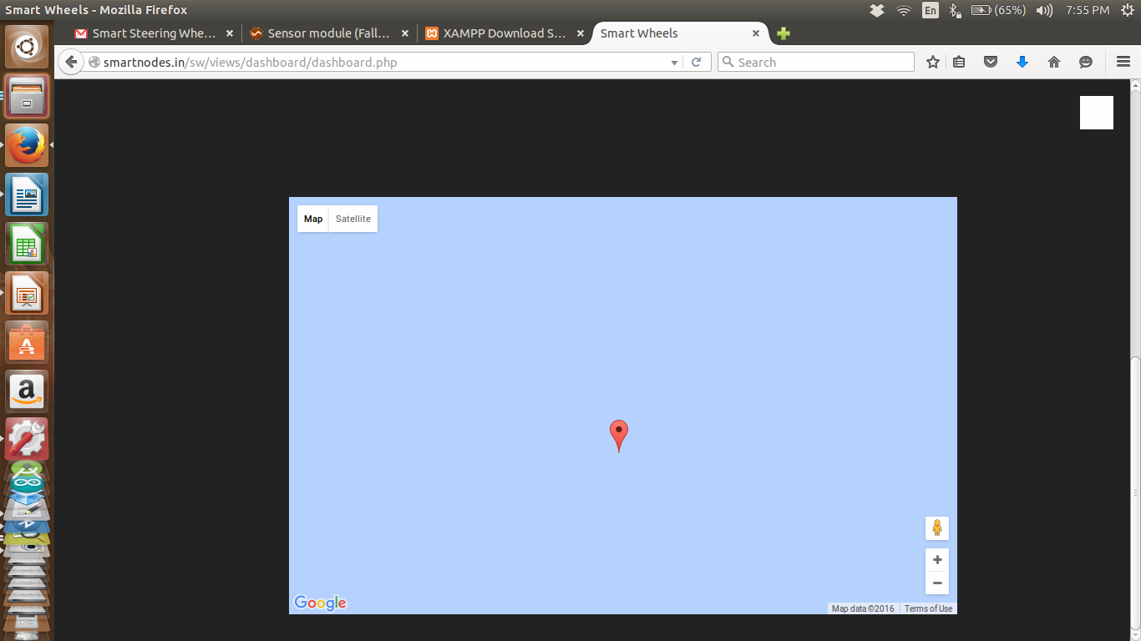

This page shows descriptions about the website.

CONCLUSION

Smart Steering wheel is an initiative for readucing the accidents due to drowsiness. The aim is to make the system available in low cost.

REFERENCE

- www.mdpi.com/journel/sensors – Detecting driver drowsiness based on sensors : A review.
- Intelligent car system to prevent accident due to exhaution.
- www.instructables.com/id/Simple-Arduino-and-HC-SR04-Example/
- http://www.engineersgarage.com/contribution/interfacing-flex-sensor-arduino
- http://www.instructables.com/id/Arduino-AND-Bluetooth-HC-05-Connecting-easily/

