Styling of Word files for Markdown conversion

The three fonts used are:

* Calibri(Heading) – used for headings
* Cambria(Body) – used for body text
* Consolas – used for code.

Headings - To create headings just select the segment you want to change and click heading 2 or heading 4 (depending of what is needed) in the style list. Make sure the font size is Calibri(Heading). 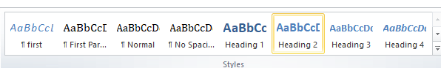

Bold - click the bolded **B** button under the font slider.  
*Italic* - click the ***I***button under the font slider.

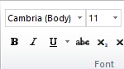

Links – To add links click Insert > Hyperlink. After you have set the address and text click **First** in the styles tab.

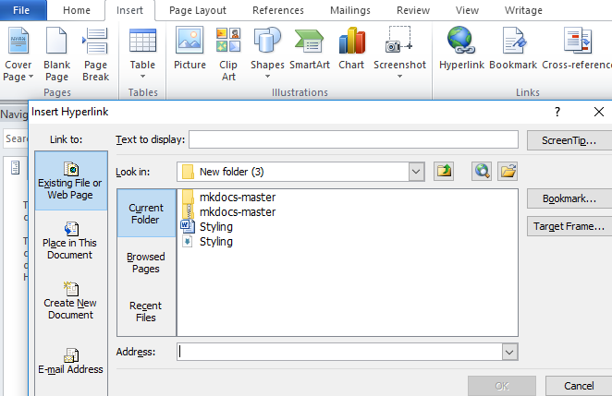

NOTES AND ATTENTION BLOCKS – they wont appear properly in markdown.

* Notes are blue
* Warning/attention blocks are orange
* Tips are green

In Word they could be written like this:

!!! note “Note title” If you would like manpages installed for MkDocs, the [click-man](https://github.com/click-contrib/click-man) tool can generate and install them for you. Simply run the following commands.

But in Markdown they need to be corrected to this:

!!! note "Custom Title:"

Custom note description....

!!! warning "Custom Title:"

Custom warning description....

!!!tip "Custom Title:"

Tip description....

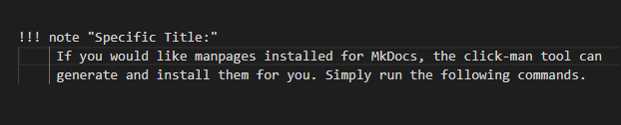

**And the final result should be this:**

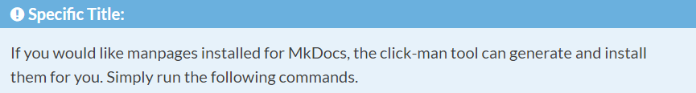

## Red highlighting words

This will have to be done in Markdown as well. Because it’s unreliable.

* `Content Items` - a single piece of content.

* `Content Types` - lists the different types of content that can be created.

* `Content Parts` - build a specific coherent behavior and that can be reused

Highlighting words in this specific way is done with the use of the back quotes “``”.

## Code Block

Again done in Markdown due to unreliability.

``There is a literal backtick (`) here.``

The code block is surrounded by “`` ``” back quotes.