**SmartWEB** visualizes HMI displays. These displays receive data via providers. Each provider is attached to a single gateway. The gateway represents the connection to a Smart OPC XML Server which delivers data from various sources like Experion PKS, Uniformance PHD etc.

## OPC DA

#### Preconditions

1. Administrator rights on the **SmartWEB** application.

## OPC DA Gateways

Sign in the **SmartWEB** site. Navigate to the admin's Dashboard.

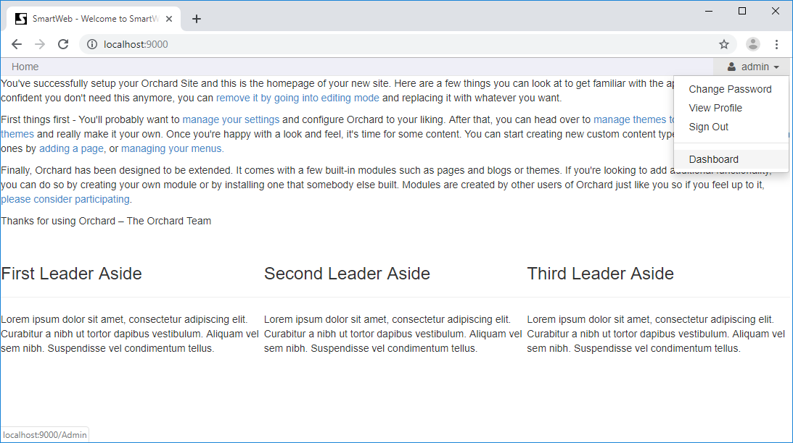

Click on the Smart Opc Xml Da link on the left side. The page for managing OPC XML DA Gateway Templates will be displayed. Press the Add New button to create a new one.

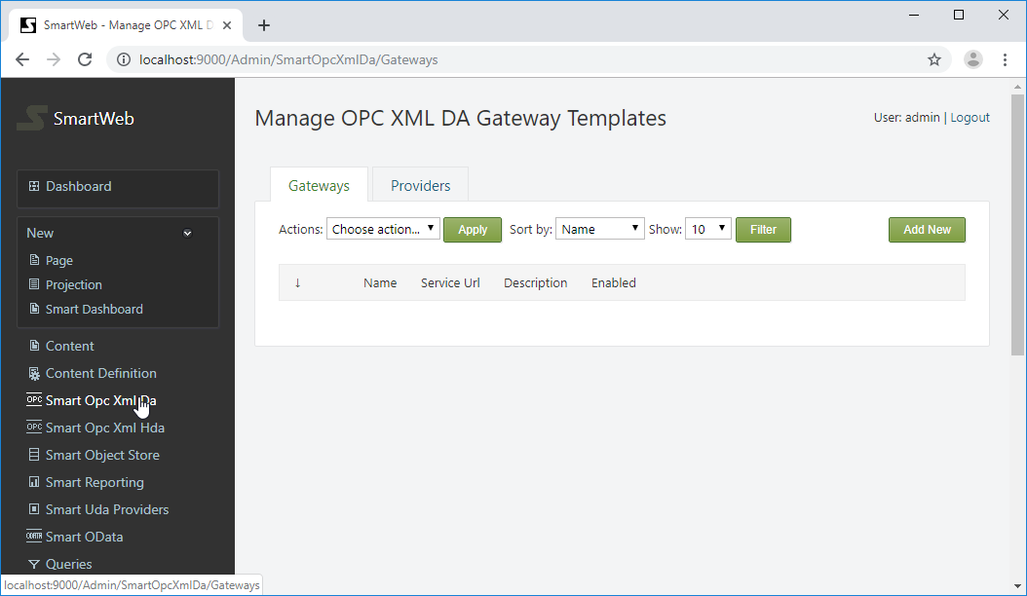

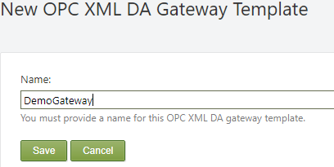

Provide a name for the gateway and press the Save button to create it.

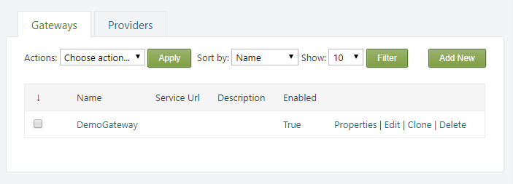

From the Properties link on the right side, the name of the gateway can be edited. It can also be deleted via the Delete link, and cloned via the Clone link.

!!! note "Note:" You cannot delete a gateway if there is an attached provider to it.

Press Edit link to configure the gateway.

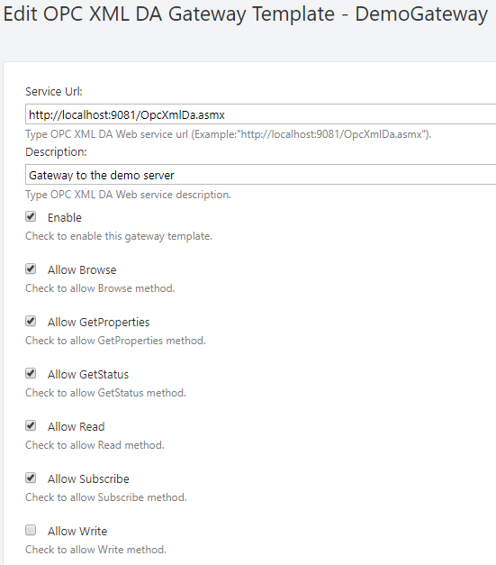

A service URL must be provided to the Smart OPC XML Server. Optionally, a description can be set. The Enable checkbox enables communication through this gateway. The next six checkboxes will toggle specific operations through this gateway.

The following settings are for configuring the authentication.

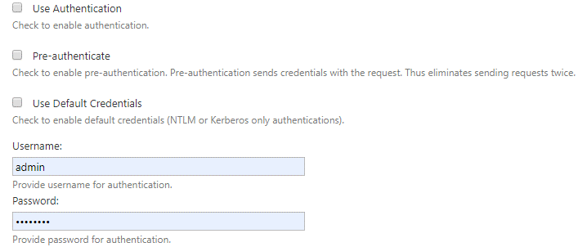

If Use Authentication is checked, a username and password must be provided in their respective fields. Alternatively, the Use Default Credentials must be checked. In this case, the running **SmartWEB** application credential will be used. Check the Pre-authenticate option to reduce client-server requests and fasten the communication. When this option is enabled, the client will send the credentials with request, instead of waiting for the server to ask for them.

The following settings are used for SSL communication with the Smart OPC XML Server.

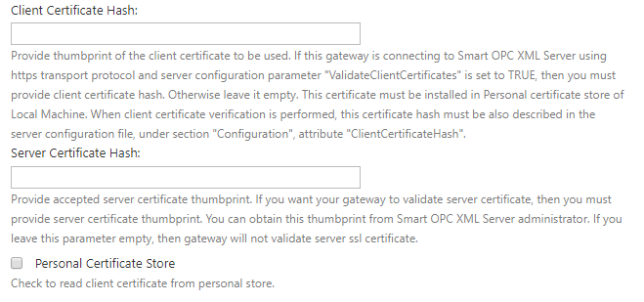

SSL can be used by setting the URL of the service to start with https:// (if the server supports SSL communication). The server's certificate thumbprint can be checked via the provider Server Certificate Hash field.

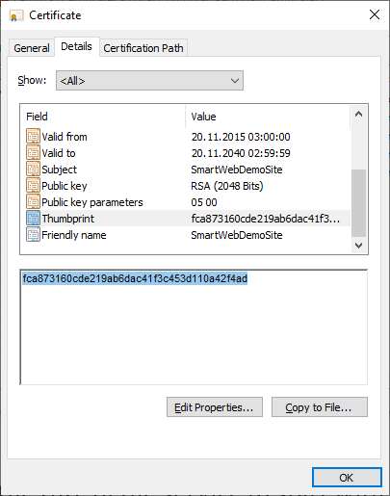

If а specific certificate has to be used to communicate with the OPC XML server (because the server also checks the thumbprint of the client), provide the client certificate's thumbprint in the Client Certificate Hash field. The used client certificate must be installed on the machine where the **SmartWEB** application is running. If the certificate is installed in the personal certificate store, the Personal Certificate Store option must also be checked.

!!! note "Note:" You will not be able to save the settings if the Client Certificate Hash is provided and the certificate is not found on the machine.

!!! note "Note:" When installing a client certificate, it is better to use Local Machine as a store location.

!!! warning "Warning:" The Certificate thumbprint displayed in the MMC certificate snap-in has an extra invisible unicode character. Do NOT copy the "extra space" that appears before the certificate thumbprint from the Richedit control. If you copy and paste the thumbprint with the extra (invisible) character, this will lead to errors like - unable to find client's certificate or unable to validate the server's certificate.

Three options are available for Compression Type - none, decompress, and gzip. If none is chosen, no compression algorithms are applied during conversation. The Decompress option means requests are not compressed, but the server response may be. The gzip option (available only when communicating with the Smart OPC XML Server) means that requests and responses must be compressed with the gzip algorithm.

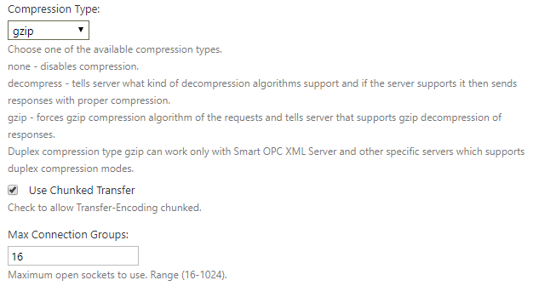

The Use Chunked Transfer option enables chunked transfer encoding. The data stream is divided into a series of non-overlapping chunks. This allows a server to maintain an HTTP persistent connection for dynamically generated content.

The Max Connection Groups option determines the maximum open sockets to use when communicating with the server. The range is between 16 and 1024.

The next option is Entry Point. In order to use this option, the configuration must first be saved. The server's address space can then be browsed.

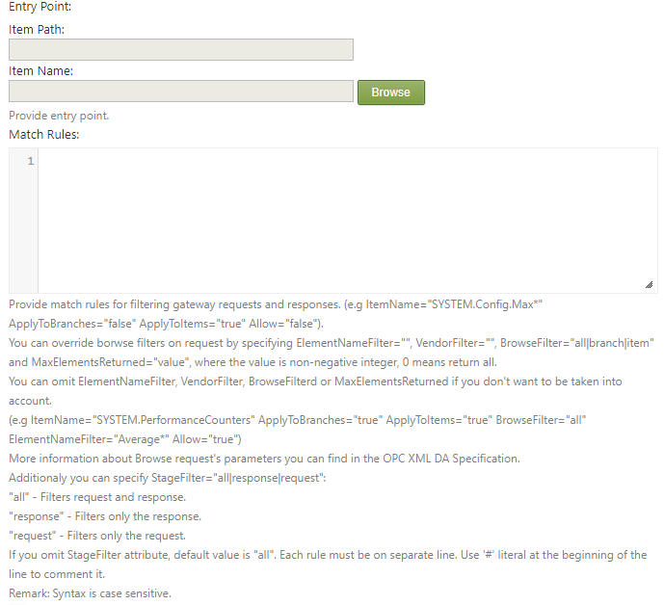

If the Entry Point is provided, browse requests will return this node as the root.

Match Rules are used to filter gateway browse requests and responses. Each rule must be on a separate line. Literal # in the beginning of the line is used to comment it. The available attributes are:

ItemPath - item path of the element to apply the rule.

ItemName - item name of the element to apply the rule.

!!! note "Note:" ItemPath and ItemName support wildcard expressions.

ApplyToBranches - if set to true, the rule is applied to branches.

ApplyToItems - if set to true, the rule is applied to items.

Allow - if true, the rule is to permit, false is to deny.

BrowseFilter - if set, overrides the browse filter for the specified rule. Available values are all, branch, and item. More information on browse filters can be found in the OPC XML DA specification.

ElementNameFilter - if set, overrides the element name filter of the browse request. Supports wildcard expressions. More information on element name filters can be found in the OPC XML DA specification.

MaxElementsReturned - a positive integer value, determining the maximum elements that the server will return at once. More information on MaxElementsReturned can be found in the OPC XML DA specification.

StageFilter - used to determine when a rule should be applied. The available options are - all, response, and request. These options are self-explanatory.

!!! note "Note:" If you omit the StageFilter, the default option will be - all, which means requests and responses are matched against the rule.

!!! note "Note:" The syntax is case sensitive.

The final section is Permissions.

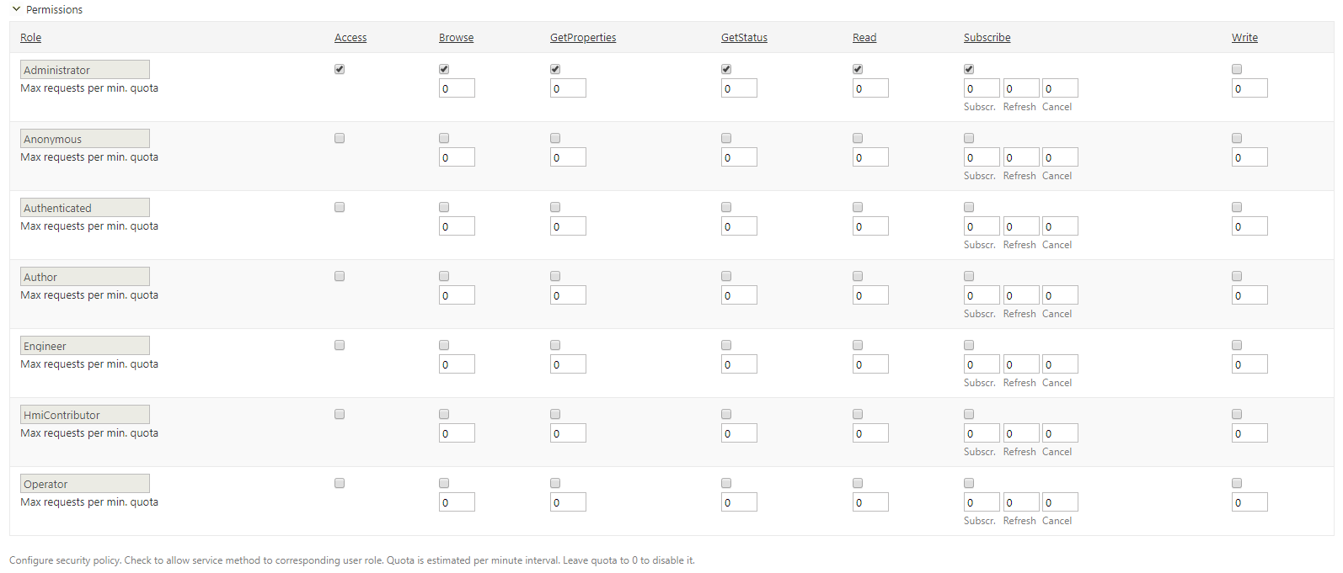

This section configures the security policy for the gateway. The roles are shown on the left-most column of the table. The available actions, according to the OPC XML DA specification, are placed in columns on the right side. If the Access column is not checked, the entire communication via this gateway is forbidden for that role. Below each action there is a checkbox that determines if the action is allowed or not. Below each checkbox, there is a box for setting a quota. The quota represent how many requests of a given type can be executed in a minute, after that the gateway will reject the requests. 0 means no limitation. Only the Subscribe column has 3 boxes for quotas - one for subscribe requests, on for pool refreshes, and one for the cancel requests. For more information about the subscribe mechanism, refer to the OPC XML DA specification.

Finally, save the last configuration. Press the Test connection button to check if the gateway connects to the OPC XML server.

If the connection succeeded, it will be indicated by green messages at the top of the page.



#### OPC XML DA Gateway Role Permissions

As well as the security policy for each gateway, there are role permissions for the entire module, and all gateways. Navigate to the Users section on the admin dashboard, and click on the Roles tab.

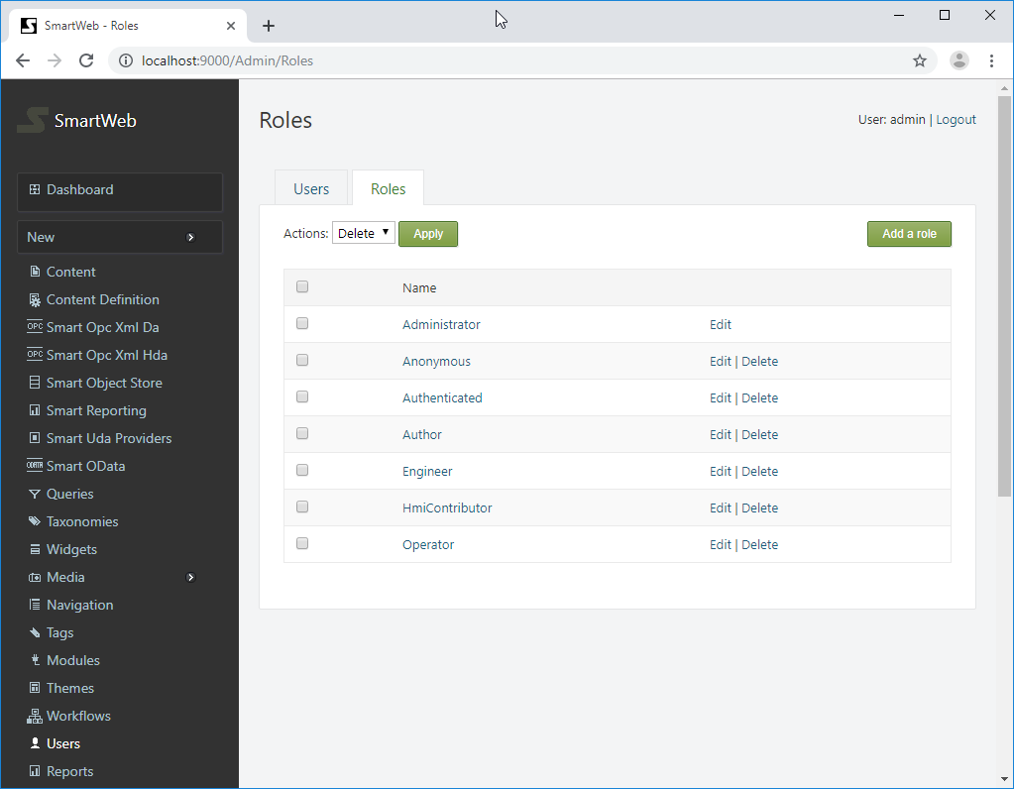

The available roles can be seen here. Click on the desired role and scroll down to the Smartsys.OpcXmlDa.Gateway permissions.

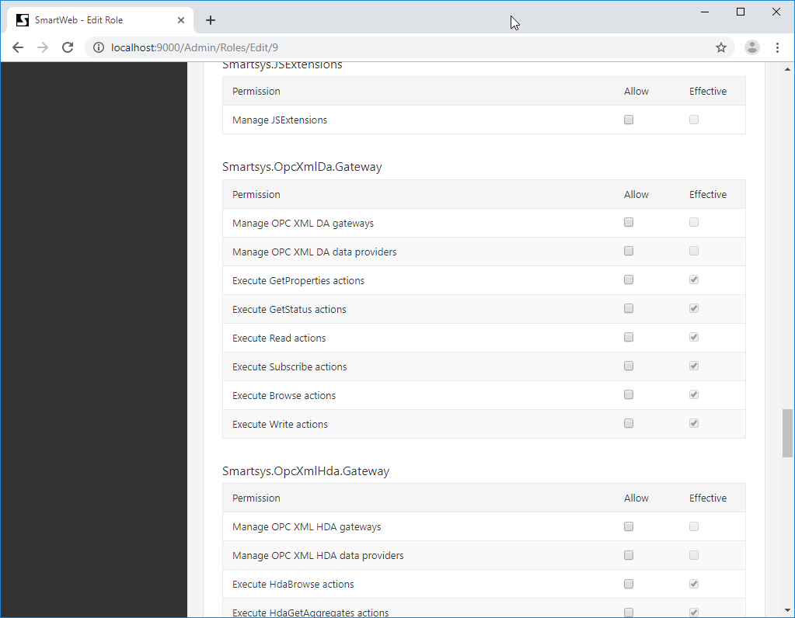

The available permissions are shown on the left side. There are two columns on the right side - Allow and Effective. The Effective column shows current estimated permissions for that role. In the Allow column, role permissions can be given if they are not set. If a given role does not have permission over a specified action, regardless of the security policy of the gateway, the user that has that role will not be able to execute such requests. **Manage permissions** must not be granted to regular users, they are only for administering OPC XML DA gateways. In order for a given role to be able to administer OPC XML DA gateways, **manage permission** must be granted to that role. The same rule applies for managing OPC XML DA providers.

## OPC DA Providers

HMI displays do not use OPC XML DA Gateways directly, instead they use OPC XML DA Providers. Each OPC XML DA Provider is connected to one OPC XML DA Gateway. Providers have additional settings for fine-graining conversation behavior with the OPC XML DA servers.

#### Creating OPC XML DA Provider Template

Click on the Providers tab (next to the Gateways tab).

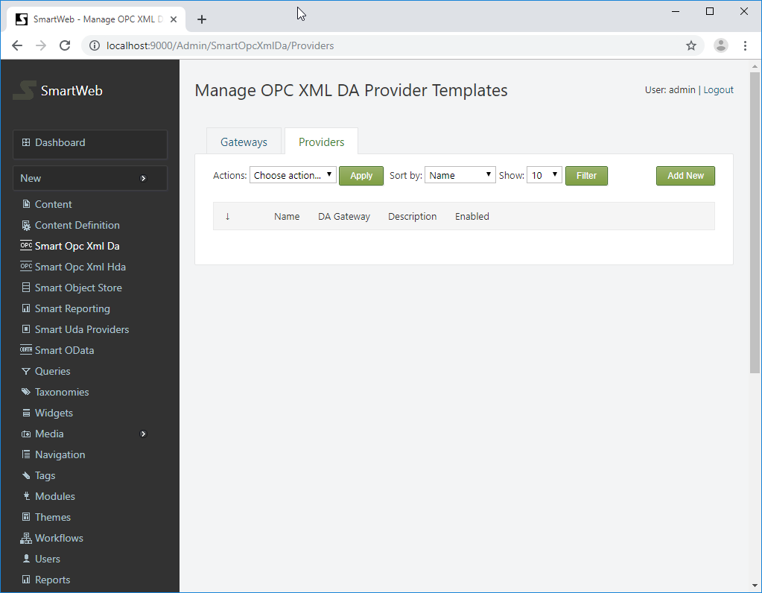

To add a new provider template, press the Add New button on the right side. Provide a name and press the Save button to create the new provider template.

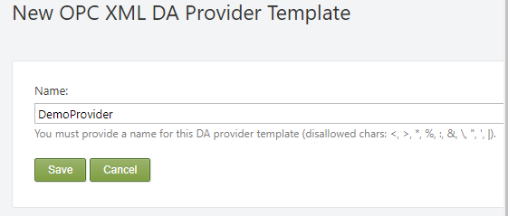

!!! note "Note:" There are disallowed chars for provider name: <, >, *, %, :, &, , ", ', |.

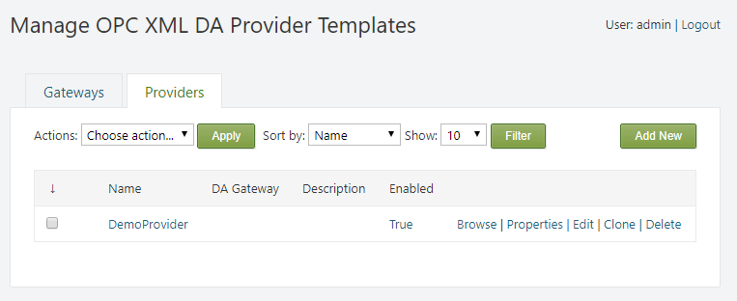

The name of the provider template can be edited from the Properties link on the right side. It can also be deleted via the Delete link, and cloned via the Clone link.

!!! note "Note:" The provider template can not be deleted if there are content types or items, which have providers that are using it.

Press Edit link to configure the provider template.

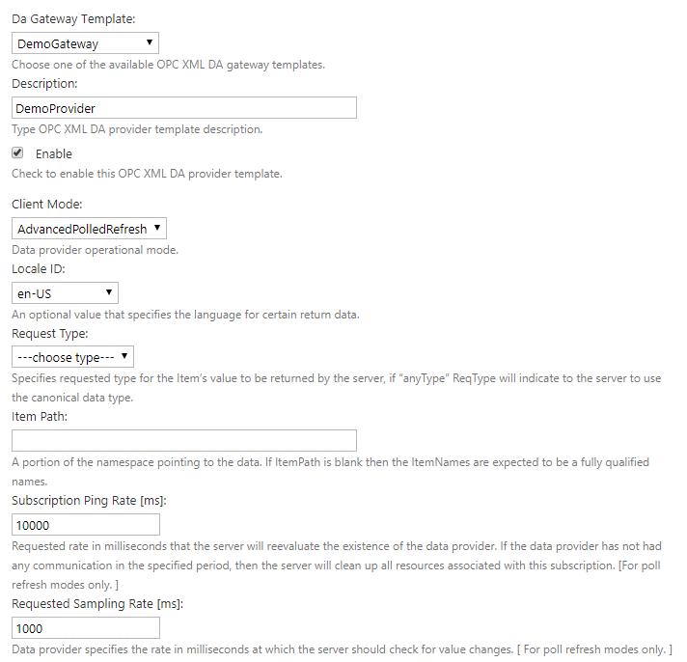

First, a gateway template must be attached to the OPC XML DA provider. Available gateways can be chosen from the Da Gateway Template drop down list. Optionally, a provider's description can be given. The Enable checkbox enables communication through this provider. The Client Mode determines how data is delivered to the client. There are three modes available - Read, Basic Polled Refresh and Advanced Polled Refresh. When Read is selected, the client sends Read requests to the server to get the data. When Basic Polled Refresh is selected, the client sends poll requests, and the server responds immediately - returning all value and/or quality changes since the previous poll. When Advanced Polled Refresh is selected, two additional parameters are used - Hold Time and Wait Time.

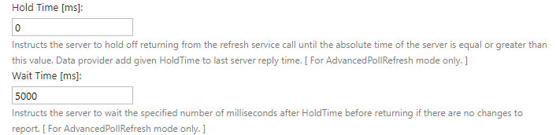

Both parameters are specified in milliseconds. Hold Time instructs the server to hold off response, until the specified absolute server time is reached. Wait Time instructs the server to wait a set amount of time after the Hold Time is reached, before responding if there are no changes to report. A change in one of the subscribed items, during this wait period, will result in the server responding immediately, rather than completing the wait time. More information on subscription architecture can be found in the OPC XML DA specification.

Locale ID - This option is used by the client to tell the server the preferred locale to be used. The server is not obligated to accept it. In that case, the server will respond respond with a revised locale.

Request Type - Specifies the requested type for the item value that will be returned by the server on Read requests.

!!! warning "Advice:" It is better to leave this option blank, and let the server return values as is.

Item Path - A portion of the namespace that is pointing to the data. If Item Path is blank, then the requested item names are expected to be a fully qualified names. For more information, refer to the OPC XML DA specification.

Subscription Ping Rate - The requested rate (in milliseconds) at which the server will reevaluate the existence of the client. If no communication between the server and the client has been established in the specified period, the server is free to clean up all resources associated for this subscription. This option is only applicable for basic or advanced polled refresh approaches. For more information, refer to the OPC XML DA specification.

Requested Sampling Rate - The client specifies the rate (in milliseconds) at which the server will check for value changes. This option is only applicable for basic or advanced polled refresh approaches.

Deadband - Specifies the percentage of the full engineering unit range of an item's value that must change prior to being returned in a response. This option is only applicable for basic or advanced polled refresh approaches.

Max Age - Indicates the requested age of the data in milliseconds. The data must be no older than this value. This option is only applicable when the Read client mode is used.

Request Deadline - Indicates the time (in milliseconds) which the provider will add to the last server reply time, in order to form the specific absolute time (in UTC) that the client wants to wait for the Server to process a response by, either returning whatever data it might have, or confirm that there was some error condition which prevents a successful response. This option is only applicable when Read client mode is used.

Delay Time - The period (in milliseconds) in which the provider will make data refresh requests to the server.

Max Elements Returned - The maximum amount of elements that will be returned at once from server on Browse request. 0 means no limitation.

Default Element Name Filter - An expression used to filter element names. This is applicable for Browse requests only. For more information, refer to the OPC XML DA specification.

Default Vendor Filter - A vendor specific expression that will be used to filter vendor specific information. This is applicable for Browse requests only. For more information, refer to the OPC XML DA specification.

Timeout - The maximum duration (in milliseconds) that the provider will wait for a server response, after that, the request will be canceled, and the provider will trigger a communication error. For the Advanced Polled Refresh mode, the configured Timeout will be taken into account after the Wait Time (total expire time = Hold Time + Wait Time + Timeout). If the value is set to 0 or empty, then the Timeout value will be set as the default value, calculated by one of the following equations: 2*Requested Sampling Rate for Advanced Polled Refresh mode, and 2*Delay Time for Read and Basic Polled Refresh modes (the lowest acceptable value is 1000 milliseconds).

Recovery Period - The period (in milliseconds) after which the data provider will try to recover the communication on error. If the Recovery Period is 0 or empty, the recovery is disabled.

Return Error Text - If checked, the server will return an error description.

Return Diagnostic Info - If checked, the server will return server specific diagnostic information that is relative to item specific errors. The server is required to return specific diagnostic information, or a blank string if the diagnostic information is not available.

Return Item Time - If checked, the server will return an item timestamp in the response. Use this option when the provider delivers data to a live updating trend component.

Return Item Name - If checked, the server will include the item name in the response.

Return Item ``Path- If checked, the server will include the item path in the response.

Return Values On Reply - If checked, the server will include item values in the reply of the subscribe request. This option is only applicable for basic or advanced polled refresh approaches.

Enable Buffering - If checked, the client will request that the server uses the Requested Sampling Rate to check for value changes, and save all changes in a buffer, to be returned to the client at the next subscription polled refresh request. This option is only applicable for basic or advanced polled refresh approach.

Return All Items - If not checked, the server will only return the changed items, since the last data refresh request. If checked, the server will wait the Hold Time, but then return with all current values (and any buffered values if Enable Buffering), ignoring the change status of the items. The Wait Time is not considered under this condition. This option is only applicable for basic or advanced polled refresh approaches.

Enable Statistics - If checked, the data provider will generate statistics information.

!!! note "Note:" If provider is attached to a Content Type or Content Item, the corresponding buttons for related content will be green, and the Delete button will become gray. The provider must be detached from any Content Types or Content Items, in order to be deleted.

#### Attaching OPC XML DA Provider to a Content Type

In order to be able to use an OPC XML DA provider, it must first be attached to a Content Type as a Content Part. Navigate to the Content Definition section in the admin panel. From the Content Types tab, find the appropriate Content Type and click Edit.

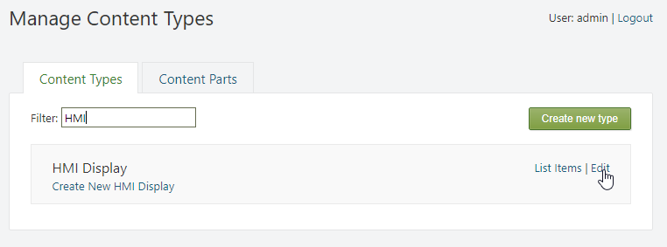

Press the Add Parts button. Find and select the Smartsys Opc Xml Da Data Providers part, and press the Save button at the bottom.

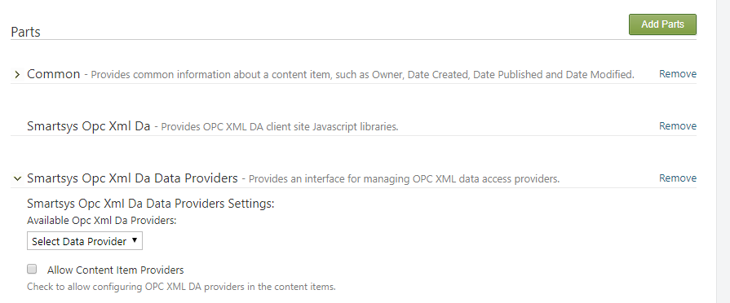

Expand the Smartsys Opc Xml Da Data Providers. Available provider templates can be selected via the dropdown list. Selected provider templates will be added to the Content Type immediately. You can add more than one provider.

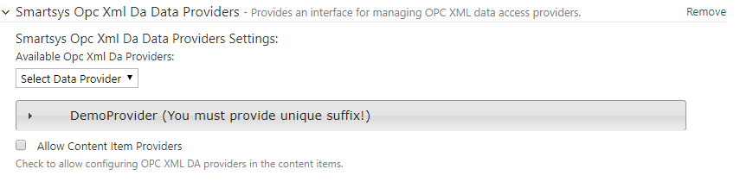

Expand the newly added provider to configure it.

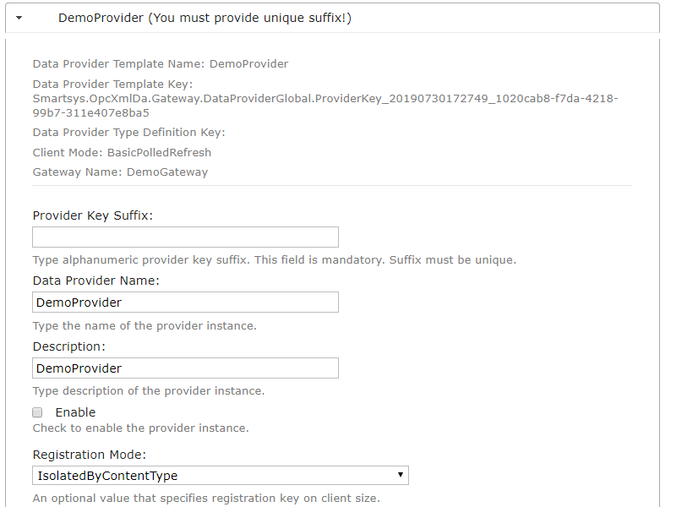

Provider Key Suffix - alphanumeric provider's key suffix. This field is mandatory, and must be unique.

Data Provider Name - name of the provider instance.

Description - description of the provider instance.

Enable - must be checked, otherwise it will be disabled and will not work on the page.

Registration Mode - defines how the provider is registered and how it is shared across the page. There are four available registration modes:

IsolatedByContentType - regardless of how many Content Items of the same type are visualized together on the same page, there will be only one registered data provider serving all of them.

IsolatedByContentTypeAndContentItemId - Content Items of the same type that are visualized together on the same page, will each have an individually registered data provider, serving only it's particular Content Item.

IsolatedByProviderTemplate - regardless of how many Content Items (regardless of type) are visualized together on the same page, there will be only one registered data provider of a given provider template.

IsolatedByProviderTemplateAndContentTypeProviderName - regardless of how many Content Items (regardless of type) are visualized together on the same page, there will be only one registered data provider of a given provider template, with the same Data Provider Name that is specified in the Content Type definition.

These provider registration modes are used to share and minimize the number of registered data providers on a page. Shared providers enlarge subscription lists with data points from different Content Items, and create one subscription for all of them. Thus, all items are refreshed with only one data refresh request, and client-server round-trips are considerably reduced.

The next available settings are the same as those that were described in the OPC XML DA Provider template creation segment. They are loaded from the used template and can be overridden.

Below the added data providers, there is an Allow Content Item Providers check box. If this option is checked, it will allow the addition of OPC XML DA data providers in a particular Content Item of this type.

!!! warning "Important:" Use this option carefully. If a data provider is created for each Content Item, and subsequent changes to the provider settings need to be made, the user has to go through all of the Content Items to make the necessary changes, so the recommendation is to stick to Content Type providers.

## OPC HDA

#### Preconditions

1. Administrator rights on the **SmartWEB** application.

## OPC HDA Gateways

Sign in the **SmartWEB** site. Navigate to the admin's Dashboard.



Click on the Smart Opc Xml Hda link on the left side. The page for managing OPC XML HDA Gateway Templates will be displayed. Press the Add New button to create a new one.

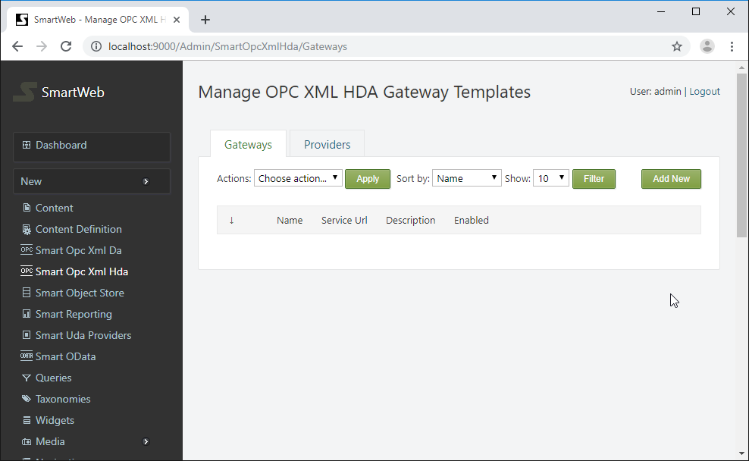

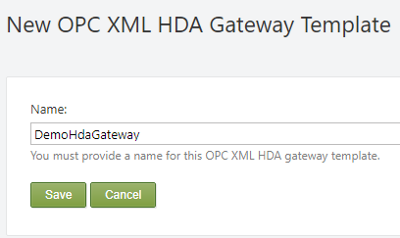

Provide a name of the gateway and press the Save button to create it..

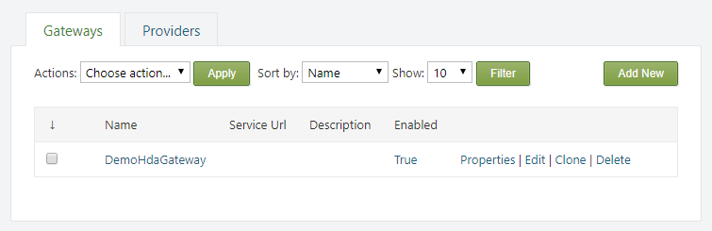

From the Properties link on the right side, the name of the gateway can be edited. It can also be deleted via the Delete link, and cloned via the Clone link.

!!! note "Note:" You cannot delete a gateway if there is an attached provider to it.

Press Edit link to configure the gateway.

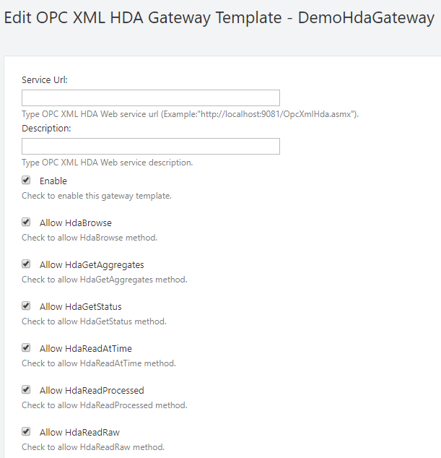

A service URL must be provided to the Smart OPC XML Server. Optionally, a description can be set. The Enable checkbox enables communication through this gateway. The next six checkboxes will toggle specific operations through this gateway.

The following settings are for configuring the authentication.



If Use Authentication is checked, a username and password must be provided in their respective fields. Alternatively, the Use Default Credentials must be checked. In this case, the running **SmartWEB** application credential will be used. Check the Pre-authenticate option to reduce client-server requests and fasten the communication. When this option is enabled, the client will send the credentials with request, instead of waiting for the server to ask for them.

The following settings are used for SSL communication with the Smart OPC XML Server.



SSL can be used by setting the URL of the service to start with https:// (if the server supports SSL communication). The server's certificate thumbprint can be checked via the provider Server Certificate Hash field.



If а specific certificate has to be used to communicate with the OPC XML server (because the server also checks the thumbprint of the client), provide the client certificate's thumbprint in the Client Certificate Hash field. The used client certificate must be installed on the machine where the **SmartWEB** application is running. If the certificate is installed in the personal certificate store, the Personal Certificate Store option must also be checked.

!!! note "Note:" You will not be able to save the settings if the Client Certificate Hash is provided and the certificate is not found on the machine.

!!! note "Note:" When installing a client certificate, it is better to use Local Machine as a store location.

Three options are available for Compression Type - none, decompress, and gzip. If none is chosen, no compression algorithms are applied during conversation. The Decompress option means requests are not compressed, but the server response may be. The gzip option (available only when communicating with Smart OPC XML Server) means that requests and responses must be compressed with the gzip algorithm.



The Use Chunked Transfer option enables chunked transfer encoding. The data stream is divided into a series of non-overlapping chunks. This allows a server to maintain an HTTP persistent connection for dynamically generated content.

The Max Connection Groups option determines the maximum open sockets to use when communicating with the server. The range is between 16 and 1024.

The final section is Permissions.

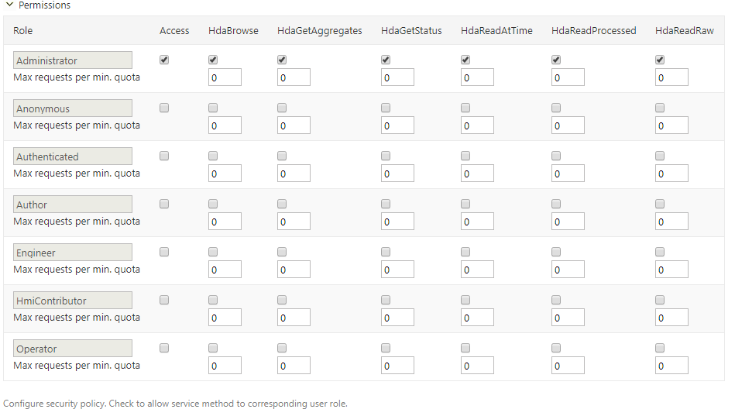

This section configures the security policy for the gateway. The roles are shown on the left-most column of the table. The available actions are placed in columns on the right side. If the Access column is not checked, the entire communication via this gateway is forbidden for that role. Below each action there is a checkbox that determines if the action is allowed or not. Below each checkbox, there is a box for setting a quota. The quota represent how many requests of a given type can be executed in a minute, after that the gateway will reject the requests. 0 means no limitation.

Finally, save the last configuration. Press the Test connection button to check if the gateway connects to the OPC XML server.

If the connection succeeded, it will be indicated by green messages at the top of the page.

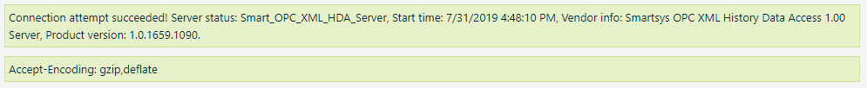

#### OPC XML HDA Gateway Role Permissions

As well as the security policy for each gateway, there are role permissions for the entire module, and all gateways. Navigate to the Users section on the admin dashboard, and click on the Roles tab.



The available roles can be seen here. Click on the desired role and scroll down to the Smartsys.OpcXmlHda.Gateway permissions.

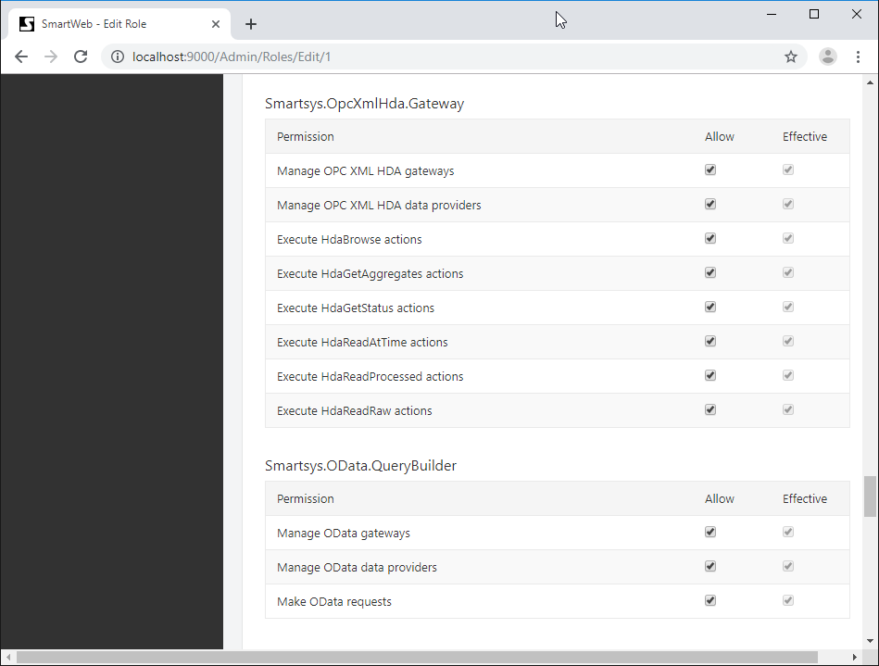

The available permissions are shown on the left side. There are two columns on the right side - Allow and Effective. The Effective column shows current estimated permissions for that role. In the Allow column, role permissions can be given if they are not set. If a given role does not have permission over a specified action, regardless of the security policy of the gateway, the user that has that role will not be able to execute such requests. **Manage permissions** must not be granted to regular users, they are only for administering OPC XML HDA gateways. In order for a given role to be able to administer OPC XML HDA gateways, **manage permission** must be granted to that role. The same rule applies for managing OPC XML HDA providers.

## OPC HDA Providers

HMI displays do not use OPC XML HDA Gateways directly, instead they use OPC XML HDA Providers. Each OPC XML HDA Provider is connected to one OPC XML HDA Gateway. Providers have additional settings for fine-graining conversation behavior with the OPC XML HDA servers.

#### Creating OPC XML HDA Provider Template

Click on the Providers tab (next to the Gateways tab).

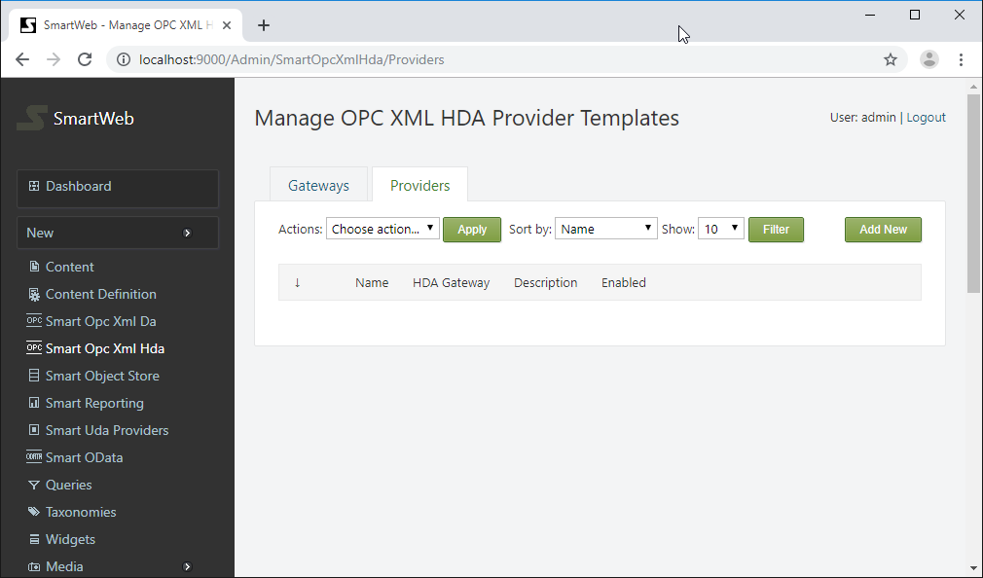

To add a new provider template, press the Add New button on the right side. Provide a name and press the Save button to create the new provider template.

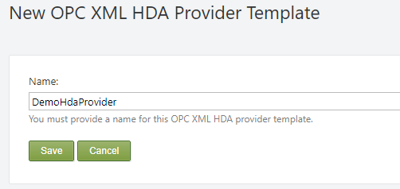

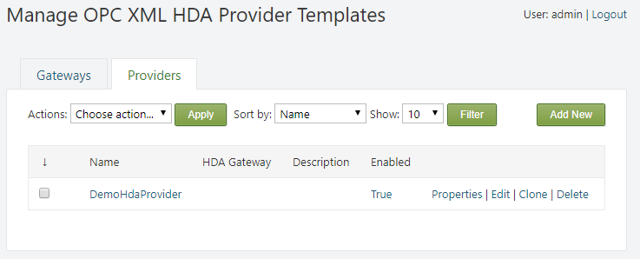

The name of the provider template can be edited from the Properties link on the right side. It can also be deleted via the Delete link, and cloned via the Clone link.

!!! note "Note:" The provider template can not be deleted if there are content types or items, which have providers that are using it.

Press the Edit link to configure the provider template.

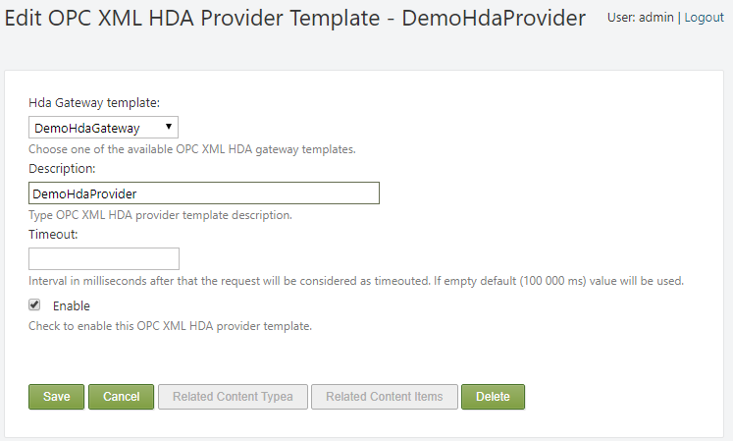

First, a gateway template must be attached to the OPC XML HDA provider. Available gateways can be chosen from the Hda Gateway Template drop down list. Optionally, a provider's description can be given. The Enable checkbox enables communication through this provider.

Timeout - the maximum duration (in milliseconds) that the provider will wait for a server response. After that, the request will be canceled, and provider will trigger a communication error. If the value is empty, the default value of 100 000 milliseconds will be used.

#### Attaching OPC XML HDA Provider to a Content Type

In order to be able to use an OPC XML HDA Provider, it must first be attached to a Content Type as a Content Part. Navigate to the Content Definition section in the admin panel. From the Content Types tab, find the appropriate Content Type and click Edit.



Press the Add Parts button. Select the Smartsys Opc Xml Hda Data Providers part, and press the Save button at the bottom.

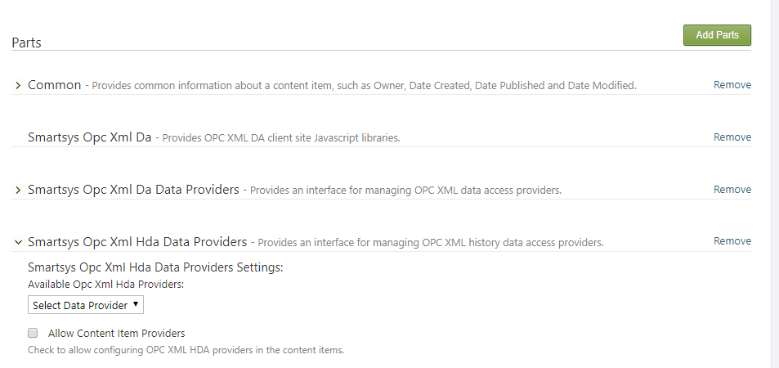

Expand the newly added Smartsys Opc Xml Hda Data Providers part. Available provider templates can be selected via the dropdown list. Selected provider templates will be added to the Content Type immediately. You can add more than one provider. If a given provider template is already added, it is not displayed in the drop down list.

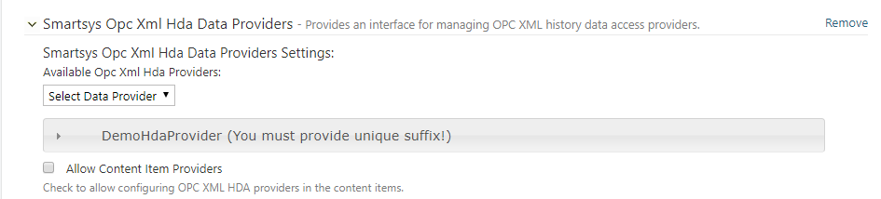

After adding a provider, it must be configured. Expand the newly added provider.

Provider Key Suffix - alphanumeric provider's key suffix. This field is mandatory, and must be unique.

Data Provider Name - name of the provider instance.

Description - description of the provider instance.

Enable - must be checked, otherwise it will be disabled, and will not work on the page.

Below added data providers there is Allow Content Item Providers check box. If this option is checked, it will allow to add OPC XML HDA data providers in a particular content item of this type. Be aware and use this option carefully, because if you create particular data provider for each content item and after that you need to change provider settings, you will have to go through all of the content items to make the necessary changes, so the recommendation is to stick to Content Type providers.

Below the added data providers, there is an Allow Content Item Providers check box. If this option is checked, it will allow the addition of OPC XML HDA data providers in a particular Content Item of this type.

!!! warning "Important:" Use this option carefully. If a data provider is created for each Content Item, and subsequent changes to the provider settings need to be made, the user has to go through all of the Content Items to make the necessary changes, so the recommendation is to stick to Content Type providers.

## OPC Configuration Examples