## OData

**SmartWEB** has the ability to visualize data from OData sources. Data is delivered to the displays by providers. Each provider is attached to a single gateway. The gateway represents the connection to an OData server which may deliver data from various sources.

#### Preconditions

1. Administrator rights on the **SmartWEB** application.
2. Enabled module Smartsys OData QueryBuilder.

## OData Gateways

Sign in the **SmartWEB** site. Navigate to the admin's Dashboard.

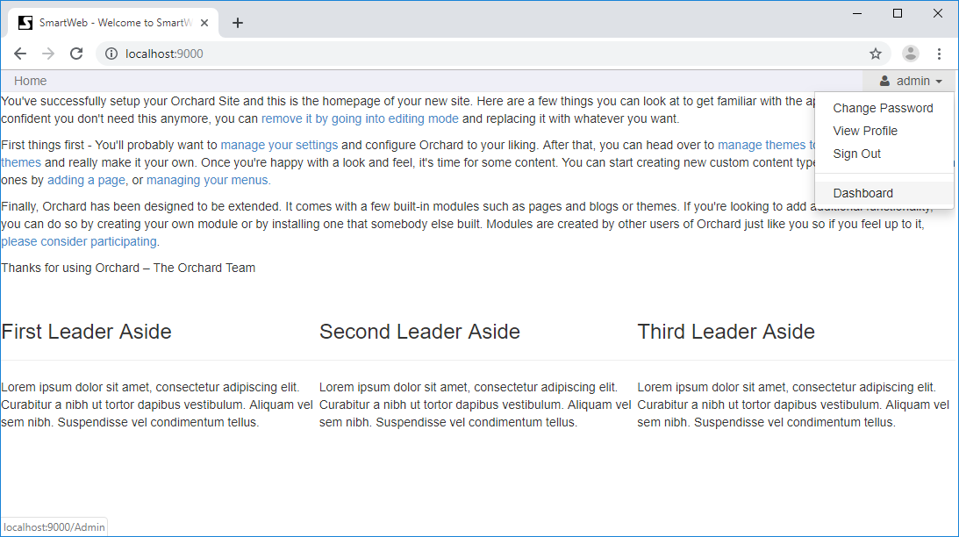

Click on the Smart OData link on the left side. The page for managing OData Gateway Templates will now be open. Press the Add New button to create a new one.

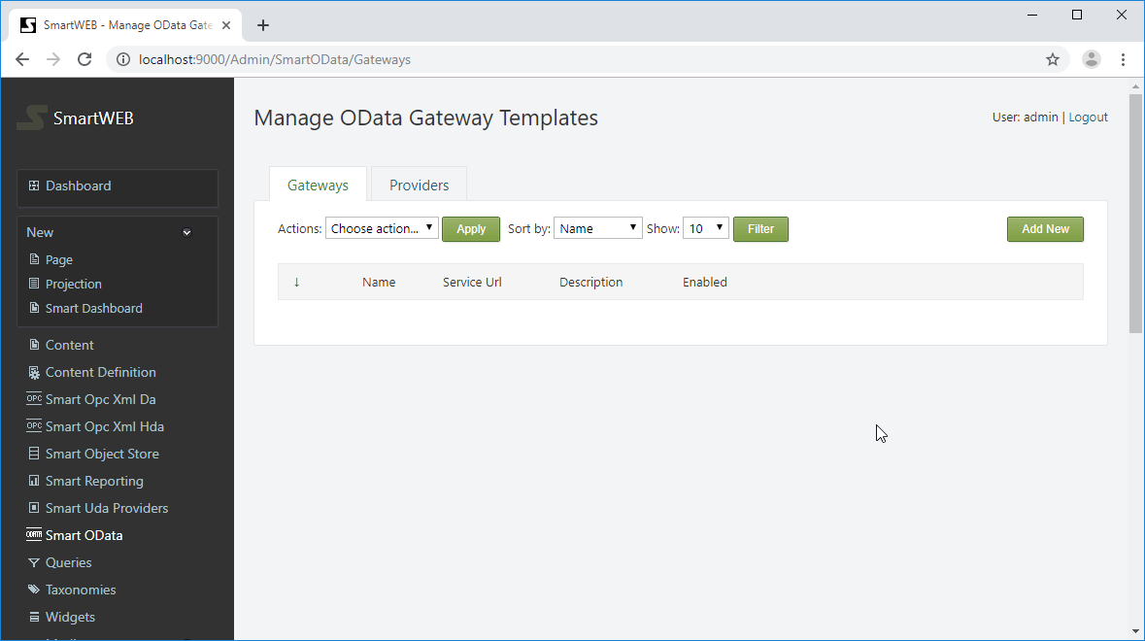

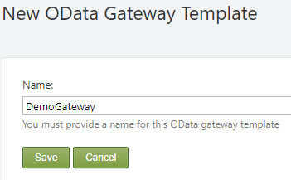

Provide name of the gateway and press the Save button to create the gateway.

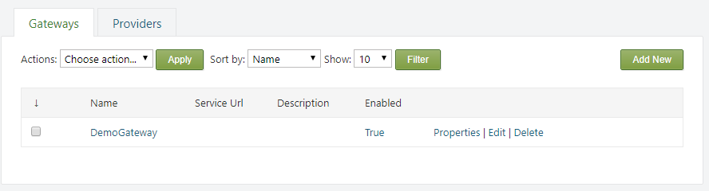

The name of the gateway can be edited from the properties link on the right side. It can also be deleted via the Delete link.

!!! warning "Important:" You cannot delete a gateway if there is a provider attached to it.

Press Edit link to configure the gateway.

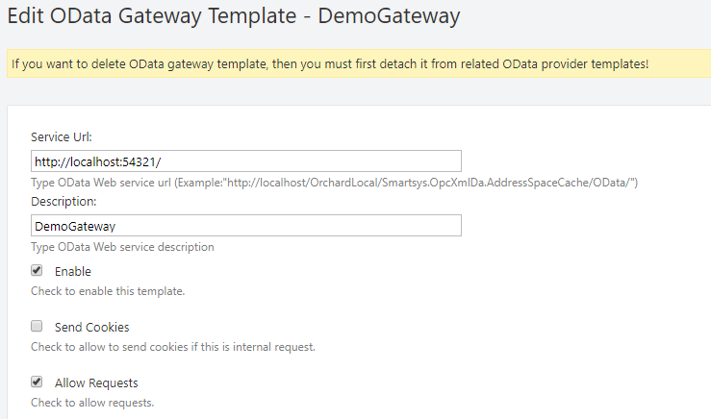

A service URL has to be provided to the OData Server. A description can be set. The Enable checkbox enables communication through the gateway.

Send Cookies - if checked, sends cookies with the request. (Used only for self-hosted OData service)

Allow Requests - if checked, allows operations through this gateway.

The following settings are for configuring authentication.

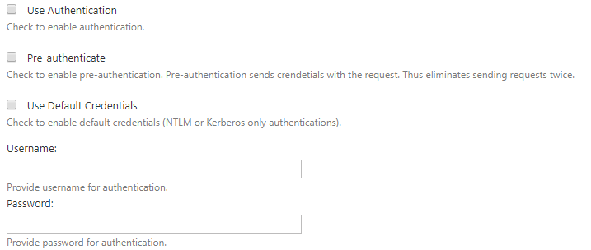

If the Use Authentication is checked, a username and password must be provided in their respective fields. The Use Default Credentials option may also be selected (the running **SmartWEB** application credentials will be used). Check the Pre-authenticate option to reduce client-server requests and fasten the communication. With the pre-authenticate option enabled, the client sends credentials with a request instead of waiting for the server to ask for them.

The following settings are used for SSL communication with the OData Server.

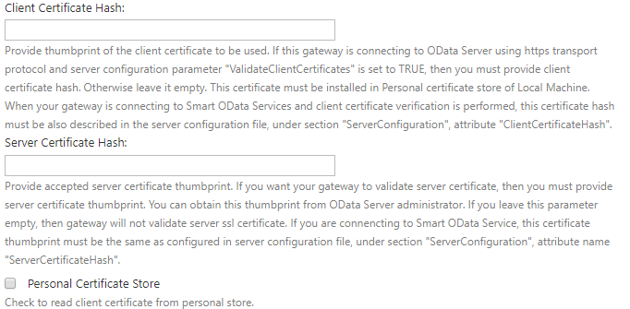

You can use SSL by just setting the beginning of the the URL of the service to https:// (if the server supports SSL communication). If you want to check the server's certificate thumbprint, navigate to the Server Certificate Hash field.

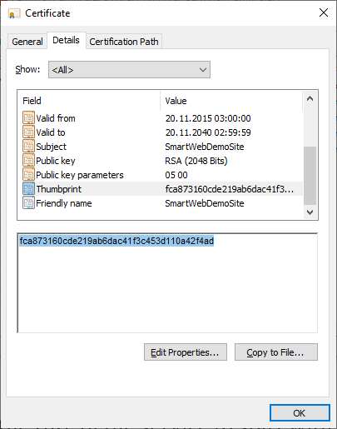

If you want а specific certificate to be used to communicate with the OData server (because the server also checks the thumbprint of the client), provide the client certificate's thumbprint in the Client Certificate Hash field. The used client certificate must be installed on the machine where the **SmartWEB** application is running. If the certificate is installed in the personal certificate store, the Personal Certificate Store option must also be checked.

!!! note "Note:" You will not be able to save the settings if the Client Certificate Hash is provided and the certificate is not found on the machine.

!!! note "Note:" When installing a client certificate, it is better to use Local Machine as a store location.

!!! warning "Warning:" The Certificate thumbprint displayed in the MMC certificate snap-in has an extra invisible unicode character. Do NOT copy the "extra space" that appears before the certificate thumbpint from the Richedit control. If you copy and paste the thumbprint with the extra (invisible) character, this will lead to errors like - unable to find client's certificate or unable to validate the server's certificate.

Two options are available for Compression Type - none and gzip. If none is chosen, no compression algorithms are applied during conversation. The gzip option (available only when communicating with Smart OData Server) means that requests and responses must be compressed with the gzip algorithm.

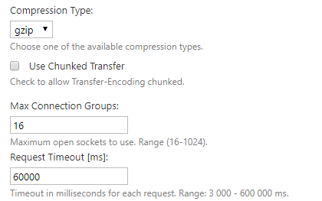

The Use Chunked Transfer option enables chunked transfer encoding. The data stream is divided into a series of non-overlapping chunks. This allows a server to maintain an HTTP persistent connection for dynamically generated content.

The Max Connection Groups option determines the maximum open sockets to use when communicating with the server. The range is between 16 and 1024.

The Request Timeoutoption determines the timeout in milliseconds for each request.

The final section is Permissions.

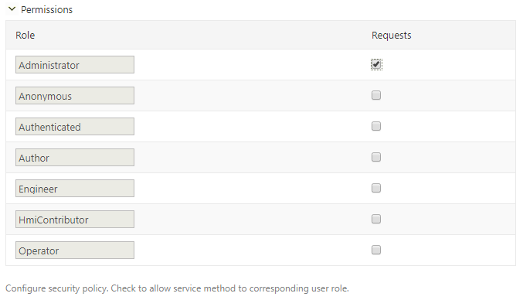

This section configures the security policy for the gateway. On the left-most column of the table, the roles are shown . If the Requests column is not checked, the communication via this gateway is forbidden for that role.

Finally, save the last configuration. After that, press the Test connection button to check if the gateway connects to the OData server.

If the connection succeeded, you'll see green messages at the top of the page.



#### OData Gateway Role Permissions

As well as the security policy for each gateway, there are role permissions for the entire module and all gateways. Navigate to the Users section via the navigation menu on the admin dashboard. Click on the Roles tab.

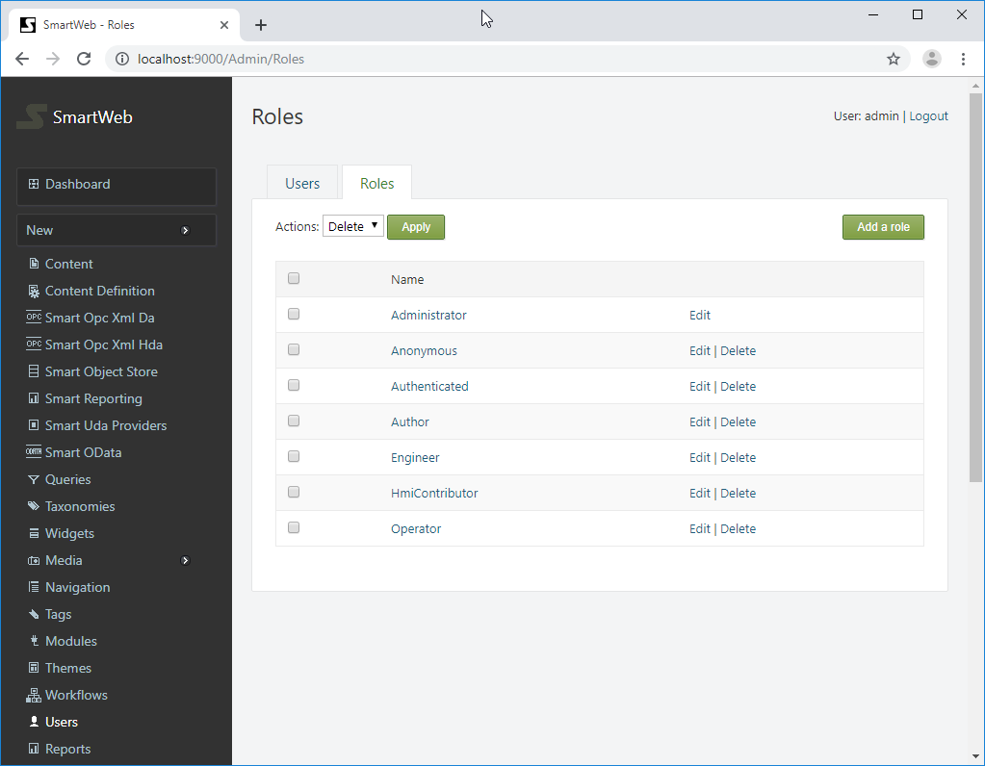

The available roles can be seen here. Click on the desired role and scroll down to the Smartsys.OData.QueryBuilder permissions.

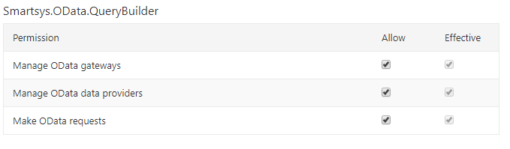

The available permissions are shown on the left side. There are two columns on the right side - Allow and Effective. The Effective column shows current estimated permissions for that role. In the Allow column, role permissions can be given if they are not set. If a given role does not have permission over a specified action, regardless of the security policy of the gateway, the user that has that role will not be able to execute such requests. **Manage permissions** must not be granted to regular users, they are only for administering OData gateways. In order for a given role to be able to administer OData gateways, **manage permission** must be granted to that role. The same rule applies for managing OData providers.

## OData Providers

The content does not directly use OData Gateways, it uses OData Providers. Each OData Provider is connected to one OData Gateway.

#### Creating OData Provider Template

Navigate to the Providers tab (next to the Gateways tab).

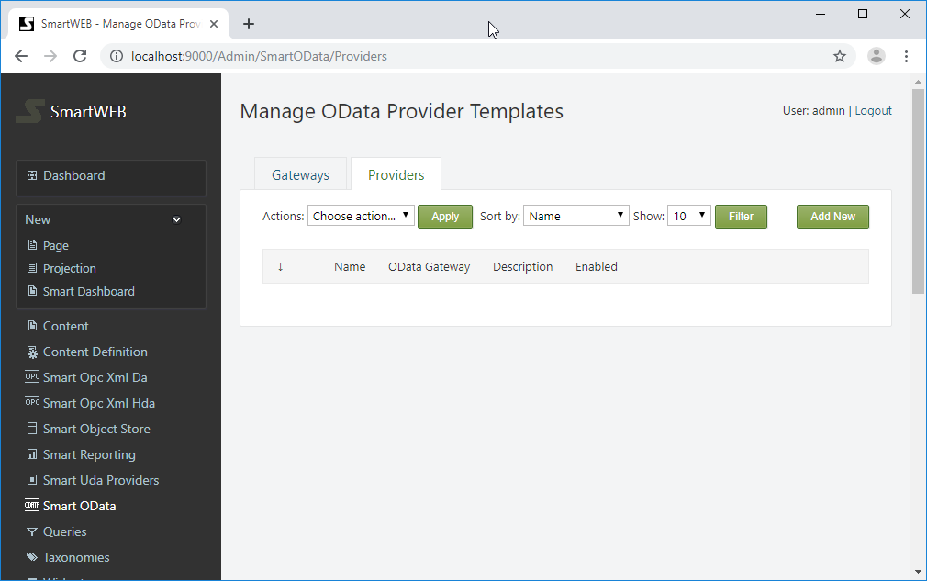

To add new provider template, press the Add New button on the right side. Provide the name and press the Save button to create the new provider template.

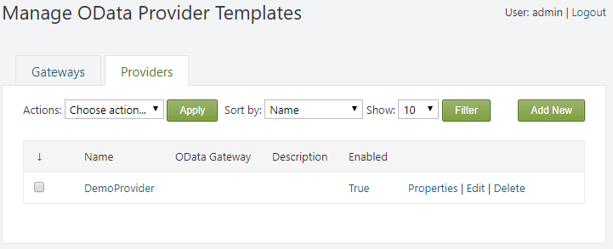

The name of the provider template can be edited from the properties link on the right side. It can also be deleted via the Delete link.

!!! note "Note:" The provider template can not be deleted if there are content types or items, which have providers that are using it.

Press Edit link to configure the provider template.

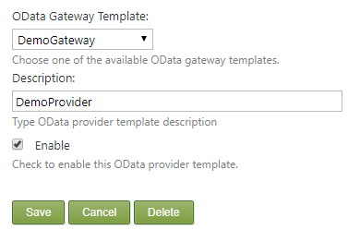

First, a gateway template has to be attached to an OData provider. A gateway can be chosen from the OData Gateway Template drop down list. A provider's description can be given, if it is necessary. The Enable checkbox enables communication through this provider.

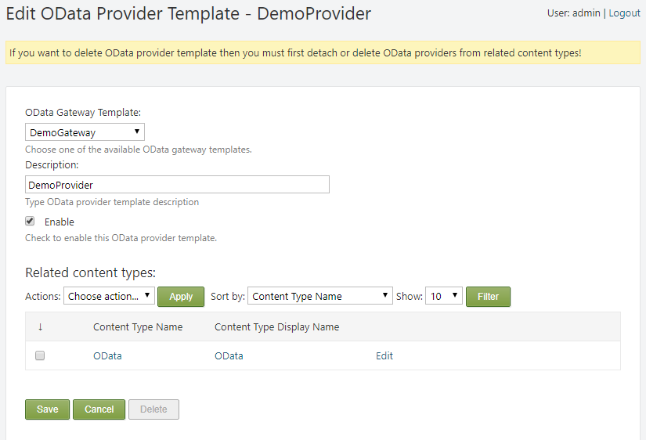

!!! note "Note:" If the provider is attached to a Content Type, a yellow warning message will be shown at the top, the corresponding Related content types section will be shown, and the Delete button will become gray. In order to delete the provider, it must first be detached from any content types.

#### Attaching OData Provider to a Content Type

In order to be able to use an OData provider, it must first be attached to a Content Type as a Content Part. Navigate to the Content Definition section in the admin panel. From the Content Types tab, find the appropriate Content Type and click Edit.

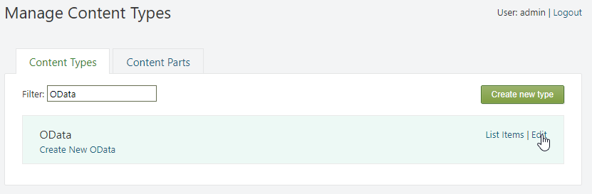

Press the Add Parts button. Select the Smartsys O Data Providers part, and press the Save button at the bottom.

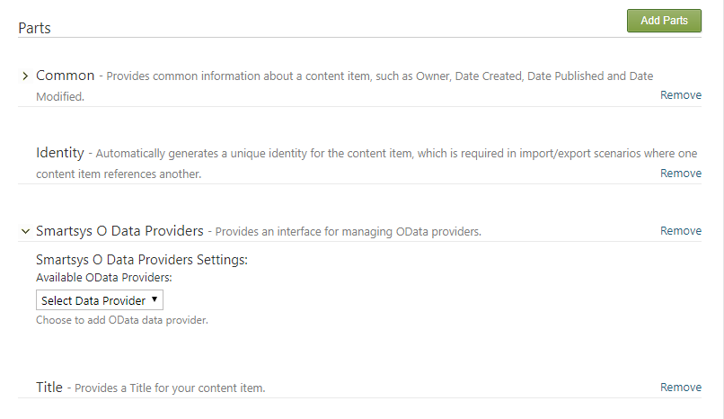

Expand the newly added Smartsys O Data Providers part. Available provider templates can be selected via the dropdown list. Selected provider templates will be added to the Content Type immediately. You can add more than one provider. If a given provider template is already added, it is not displayed in the drop down list.

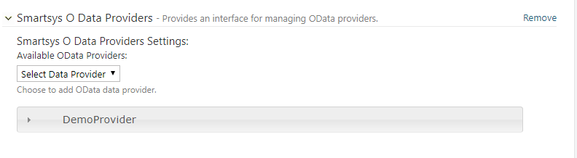

After adding a provider, it must be configured. Expand the newly added provider.

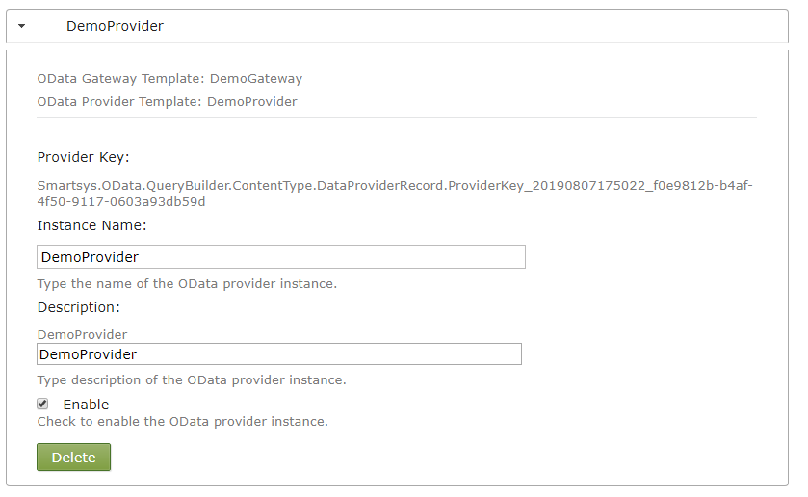

Instance Name - name of the provider instance.

Description - description of the provider instance.

Enable - must be checked, otherwise it will be disabled, and will not work on the page.

The Smart O Data Query Builder and Smartsys O Data Ng Grid parts can now be used to show OData results from the configured provider.

## EPKS Events

The **SmartWEB** application can collect **Experion PKS** alarms and events. Data is collected through the **ODATA** service (provided by the **Smart ODATA Server**) and stored in the application's database. A simple dataflow diagram is shown below.

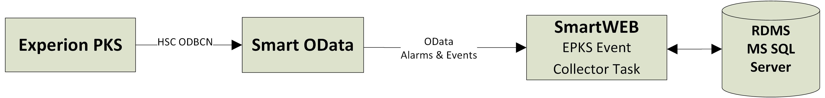

An EPKS Event Collector Task, reads and stores in RDBMS, Experion PKS events through the OData service provided by the Smart OData Server. The Smart OData Server maps Experion PKS events data as OData entities.

#### Preconditions

1. **SmartWEB** with a Microsoft SQL Server's database (due to database limitations and negative performance impact consider using MS SQL Server Standard or higher editions).
2. Administrator rights on the **SmartWEB** application.
3. Enabled module Smartsys OData QueryBuilder.
4. Enabled module Smartsys Experion PKS Event Collector.
5. Configured **ODATA** gateway to the **Smart ODATA Server**.

#### Creating EPKS Event Collector Task

To be able to collect Experion PKS events data, an Experion PKS Collector Task must be configured.

Sign in the **SmartWEB** site. Navigate to the admin's Dashboard.



Expand the Smart Events and click on the Experion PKS link on the left side. This will open the page for managing Experion PKS Event Collector Tasks. Press the Add New button to create a new one.

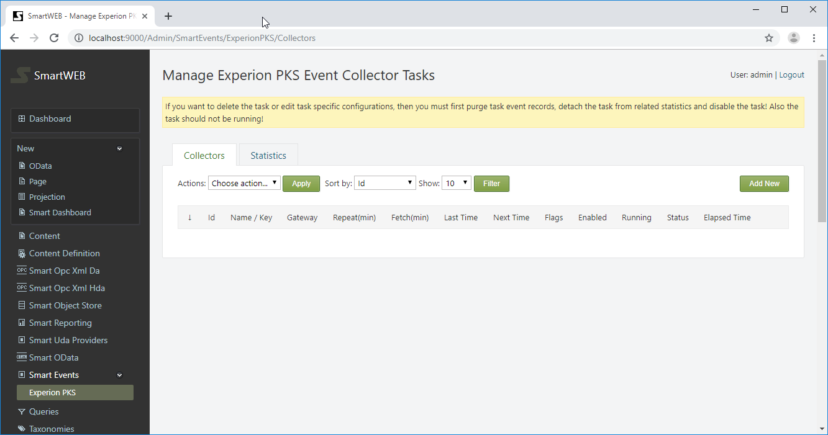

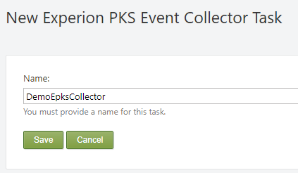

Provide the name of the task and press the Save button to create it.

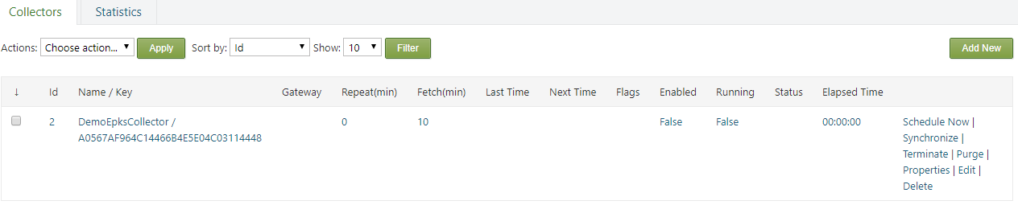

From the properties link on the right side, the name of the task can be edited. It can also be deleted via the Delete link.

With the Schedule Now link, you can schedule the next run of the task.

!!! warning "Important:" Do not schedule the task until it is entirely configured, otherwise you will not be able to edit some configuration options.

With the Synchronize link, the Synchronize flag of the task can be set, which means the scheduler will run the task to synchronize itself with the database, regardless if the task is scheduled or not.

With the Purge link, the Purge flag of the task can be set, which means the scheduler will run the task to purge events until the retention policies are satisfied, regardless if the task is scheduled or not.

With the Terminate link, the Terminateflag of the task can be set, which means the scheduler will interrupt the task if is running, or the task will not run at all if scheduled.

If a given flag is set, it can be unset by pressing the appropriate link again. The Purge and Synchronize flags are unset automatically when the operation completes, but the Terminate flag must be unset manually.

!!! note "Note:" Pressing Schedule Now link, schedules the task and clears all task flags!

!!! note "Note:" If you want to delete or edit a task with protected parameters, the task event records must be purged first. This will detach the task from related statistics. The task should be disabled and should not be running!

Press the Edit link to configure the task.

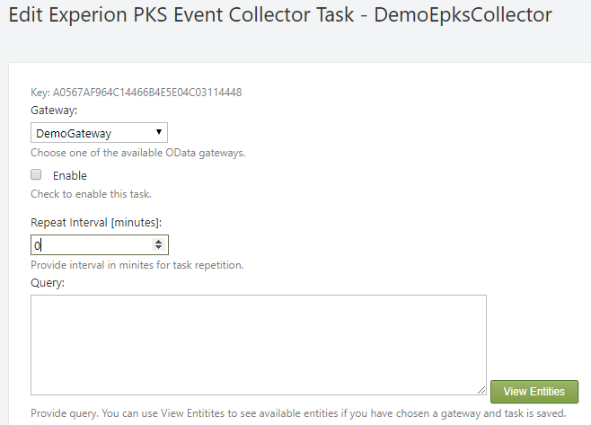

First, a gateway to the Smart OData Server must be provided. After setting the gateway, press the Save button, but don't enable the task. Press the Edit link again to continue configuring it.

Enable - Enables the task.

!!! note "Note:" Enable the task when everything else is configured.

Repeat Interval (minutes) - Specifies how often the task will get new data (5 minutes is a typical value). 0 means the task will run only once, no repetitions.

Query - Specifies an ODATA query to be executed and collect events. Different filters can be applied. Press the View Entities to see the available ones. Copy and paste the desired one into the Query box.

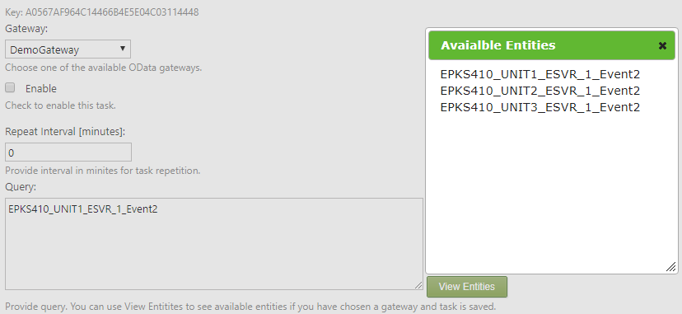

Event Categories - Expand this option to configure the event categories. Each event is dispatched by its category to a different table. Usually, the proposed default configuration is good enough, but it can be changed if needed.

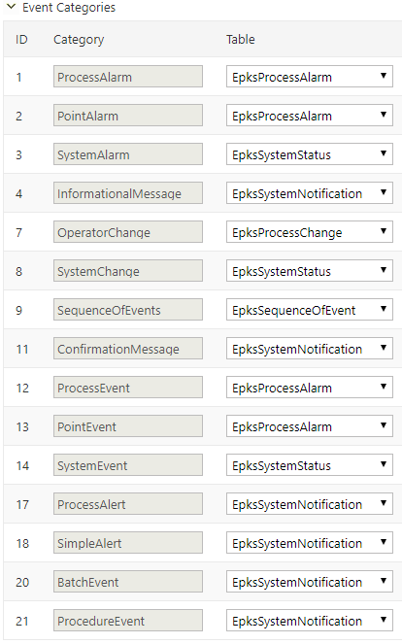

!!! note "Note:" You will not be able to edit the Query or Event Categories if the task has event records, related statistics, is enabled, or is running!

Fetch Interval [minutes] - The default is 10 minutes. Specifies at what time, portions of data will be fetched. If the interval is small there will be many requests and data will be gathered very slowly. If the interval is too big, requests will be much fewer, but large amounts of data will be transferred and timeouts may occur. The interval also depends on how fast the events occur. If the unit generates a huge amount of events for a small period of time, then a small fetch interval will be more suitable for use. Usually, the interval is between 60 and 1440 minutes, depending of the frequency of the events.

Request Timeout [ms] - Timeout (in milliseconds) for each data fetch request. The range is between (3000 and 600 000 ms). The default value is 60 000 ms (1 minute). Usually, it's enough. If you have a huge Fetch Interval, consider revising the timeout.

Sleep Between Requests [ms] - Sleep interval (in milliseconds) between two consecutive data fetch requests. 0 means no sleep. The default value is 0. Range is between 0 and 60 000 ms (1 minute). When the task sends too many requests in a short amount of time, it's good practice to provide time to "relax". In normal conditions it is not necessary.

Retention Period [days] - Amount of days that the events will be kept in the database. After that period, the events will be purged. The default value is 0, which means no limits, but it's good practice to provide it. If there are not many alarms on a daily basis, a long period (e.g. 365 days) can be set. If there are a lot of generated events, the period should be kept short (e.g 30 days or less).

!!! note "Note:" The speed of the queries will depend on the amount of events that are kept in the database.

Retention Records - How many records to keep in each table. If the number of records in a given event's table becomes more than specified, the oldest records will be purged until the amount of remaining records is less than the limit. 0 means no limit.

!!! note "Note:" An event is purged, regardless of which of the retention constraints is reached.

Maximum Rows - How many events to be fetched at once. The range is between 10 and 30 000. The default and recommended value is 5 000.

Collect Events After - If specified, after that date, events will be collected.

Next Time - Specifies when to run the task. After the task execution, the field is cleared or the next execution time is set, depending on if the task has a  
configured Repeat Interval.

Retry Attempts - How many times an attempt will be made to fetch data on fail. The range is from 0 to 10. The recommended value is 3.

Save Retry Attempts - How many times an attempt will be made to save data on fail. The range is from 0 to 10. The recommended value is 3.

Save Retry Attempts - Interval (in milliseconds) between attempts to save data on fail. The range is from 0 to 15000. The recommended value is 1000ms.

Debug - If checked, debug info will appear in the application log.

#### EPKS Event Collector Task Details

At the bottom of the collector task configuration page, there are some details.

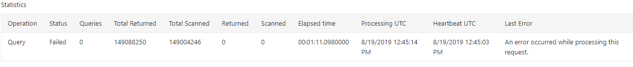

The Statistics table provides information about the current state of the task.

Operation - shows which operation is running at the moment (Query, Purge or Synchronize). When the task finishes, the last operation always remains. If the Status is empty, that means it was completed successfully.

The Query operation requests event data from the Smart OData server and processes it. The Purge operation deletes event data until the retention policies are satisfied. The Synchronize operation syncs the task state and counters, with the database.

Status - Available collector statuses are: Pending, Processing, Stuck, Failed, Terminated, Purging, Synchronizing. A missing status indicates a successfully finished task.

A status is Pending when the task is started from the scheduler, but is still not processing. The Processing state means the task is running. The Stuck status indicates a missing heartbeat from the task (the task is probably "dead" and can be re-ran). The Done status indicates that the current task run is successfully completed. The Failed status indicates the task run is interrupted/failed. The Terminated status indicates the task is terminated by a user request. The Purging status indicates that the task is purging event data until the retention policies are satisfied. The Synchronizing status indicates that the task is synchronizing it's counters and state with the database.

Queries - how many queries are ran in the current task run.

Total Returned - the total returned from query events.

Total Scanned - total evaluated events ever for this task.

Returned - returned events from the last query.

Scanned - evaluated events from the last query.

Elapsed time - how long the current task run has been running.

Processing UTC - UTC time of updated data.

Heartbeat UTC - last UTC time reported from the task's heartbeat. If there is no update for more than 5 minutes, the task is considered - stuck.

Last Error - last error seen during this task run. (If there is an error, you may check the application logs for details).

The Last Query table provides details for the last completed query.



Returned - how many events are returned from the query.

Scanned - how many events are evaluated.

Last Event UTC - timestamp of the latest returned event.

Last Event ID - ID of the latest returned event.

Begin Time - begin time of the period for which events are requested.

End Time- end time of the period for which the events are requested.

The Current Query table provides details for the currently processed query.



Returned - how many events are returned from the current query.

Scanned - how many events are evaluated.

Current Event UTC - timestamp of the currently processed event.

Current Event ID - ID of the currently processed event.

Begin Time - begin time of the period for which the events are requested.

End Time- end time of the period for which the events are requested.

The Event Table Statistics provides some statistic counters about events across the tables.

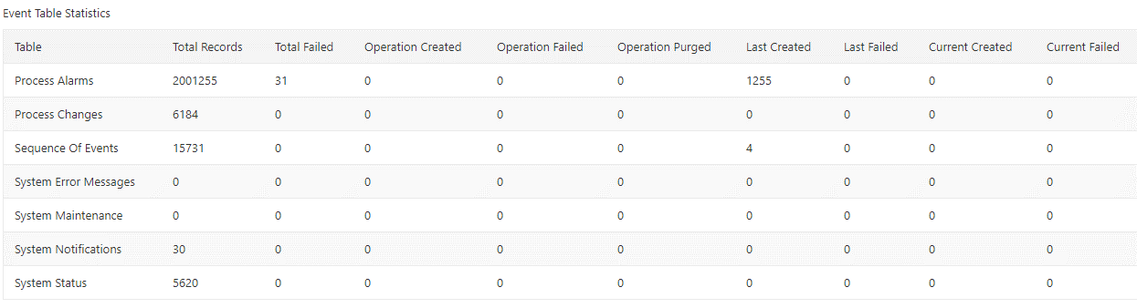

Table - the table for which the related data is provided.

Total Records - shows how many events there are.

Total Failed - total events of that type that have failed and are not saved.

Operation Created - how many events are created on the current task run.

Operation Failed - how many events are failed on the current task run.

Operation Purged - how many events are purged on the current task run.

Last Created - how many events are created on the last completed query.

Last Failed - how many events are failed on the last completed query.

Current Created - how many events are created on the current query.

Current Failed - how many events are failed on the current query.

If there is related statistic task a table like below will be shown.

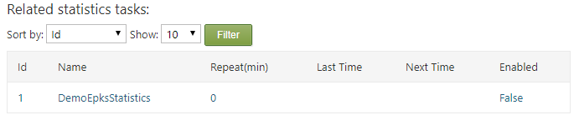

#### Creating EPKS Event Statistics Task

The EPKS Event Statistics Task provides simple statistics for the events collected by an EPKS Event Collector Task. It aggregates by event source, priority and specified aggregation interval, which may be 1, 2, 4, 6, 8, 12 or 24 hours. The result may be used later in reports (Smartsys Query Builder) and charts (Smartsys NVD3 Charting).

On the Manage Experion PKS Event Collector Tasks page, navigate to the Statistics tab. Press the Add New button to create a new statistics task.

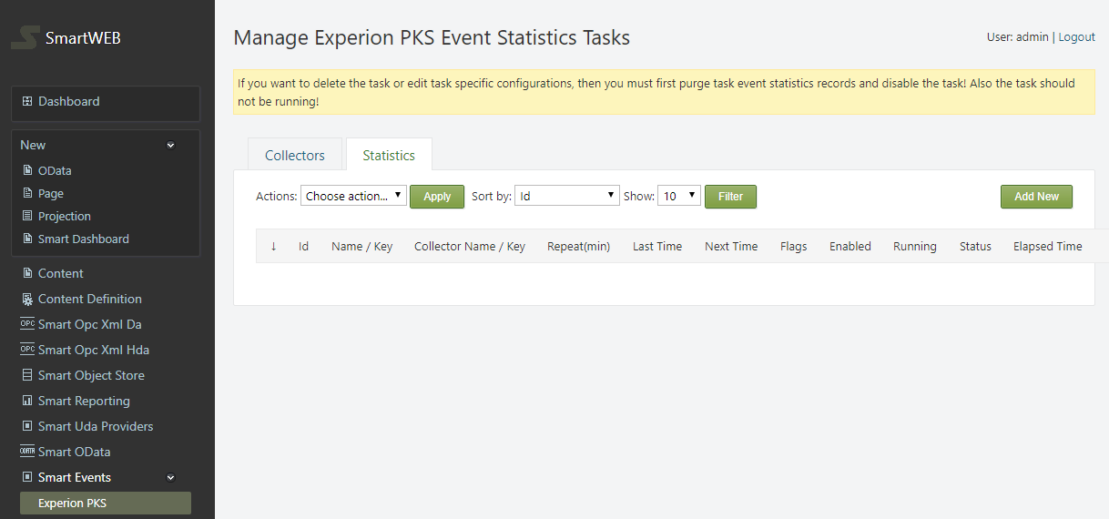

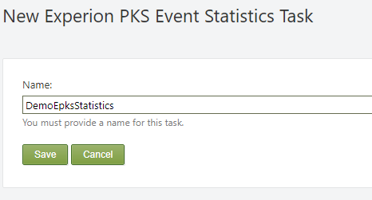

Provide a name for the task and press the Save button.

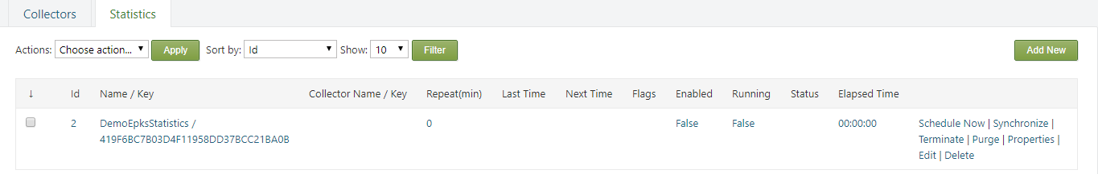

From the properties link on the right side, the name of the task can be edited. It can also be deleted via the Delete link.

Via the Schedule Now link, the next run of the task can be scheduled.

!!! note "Note:" Do not schedule a task until it is entirely configured, otherwise you will not be able to edit some configuration options.

Via the Synchronize link, the Synchronize flag of the task can be set. This means the scheduler will run the task to synchronize itself with the database, regardless if the task is scheduled or not.

Via the Purge link, the Purgeflag of the task can be set. Thich means the scheduler will run the task to purge events until retention policies are satisfied, regardless if the task is scheduled or not.

Via the Terminate link, the Terminate flag of the task can be set, This means the scheduler will interrupt the task if it is running, or the task will not run at all if it is scheduled.

If a given flag is set, it can be unset by pressing the appropriate link again. Purge and Synchronize flags are unset automatically when the operation is complete, but the Terminate flag must be unset manually.

!!! note "Note:" The Schedule Now link schedules the task and clears all task flags!

!!! warning "Important:" If you want to delete or edit a task with protected parameters (Event Collector Task, Event Table, Aggregation or Offset), you must first purge the task event records to disable it. It should not be running!

Press the Edit link to configure the task.

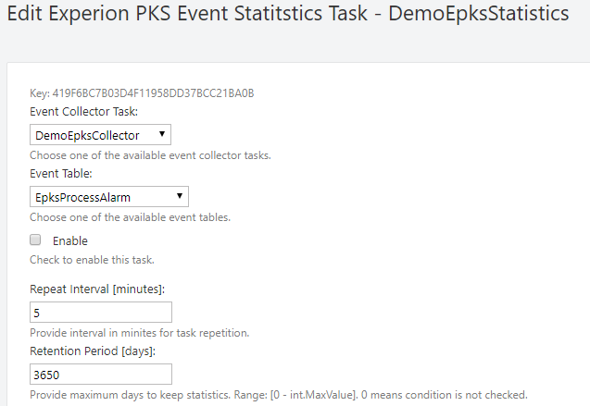

First, an event collector task must be chosen.

Event Table – provides the table from which the events will be processed.

Enable - The Enable checkbox enables the task.

!!! note "Note:" Enable the task when everything else is configured.

Repeat Interval (minutes) - Specifies how often the task will become active to get the new data (5 minutes is a standard value). 0 means the task will run only once, no repetitions.

Retention Period [days] - how many days the events will be kept in the database, before they are purged. The default value is 0. This means there is no limit, but it's good practice to provide one. The aggregated data is much less than the raw collected events. If there are not many events on a daily basis, a long period (e.g. 3650 days - 10 years) can be set for 24 hour aggregations, and a short one for 1 hour aggregations (e.g. 365 days - 1 year).

!!! note "Note:" The amount of records that are kept in the database will determine the speed of the queries.

Estimate After - If specified, after the set time, events will be estimated.

Next Time - Specifies when to run the task. After the task execution, the field is cleared. If the task has a configured Repeat Interval, the next execution time is set.

Aggregation - defines the aggregation interval. Events are aggregated by source, priority and aggregation interval, which may be 1, 2, 4, 6, 8, 12 or 24 hours.

Offset - By default, the accounting period is considered from midnight. You can shift the beginning of that period by setting an offset from midnight in minutes.

#### EPKS Event Statistics Task Details

At the bottom of the statistics task configuration page, there are some details.

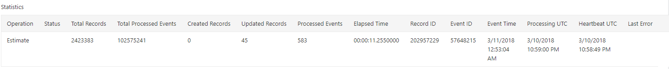

The Statistics table provides information about the current state of the task.

Operation - shows which operation is running at the moment (Query, Purge or Synchronize). When the task finishes, the last operation always remains. If the Status is empty, that means it was completed successfully.

The Estimate operation processes event data collected from the EPKS Event Collector Task. The Purge operation deletes data until the retention policies are satisfied. The Synchronize operation syncs the task state and counters, with the database.

Status - Available collector statuses are: Pending, Processing, Stuck, Failed, Terminated, Purging, Synchronizing.

A status is Pending when the task is started from the scheduler, but is still not processing. The Processing state means the task is running. The Stuck status indicates a missing heartbeat from the task (the task is probably "dead" and can be re-ran). The Done status indicates that the current task run is successfully completed. The Failed status indicates the task run is interrupted/failed. The Terminated status indicates the task is terminated by a user request. The Purging status indicates that the task is purging event data until the retention policies are satisfied. The Synchronizing status indicates that the task is synchronizing it's counters and state with the database.

Total Records - Total records in the database from this task.

Total Processed Events - Total evaluated events ever for this task.

Created Records - Created records since the last run.

Updated Records - Updated records since the last run.

Processed Events - Processed events since the last run.

Elapsed Time - The amount of time for which the current task has been running.

Record ID - Currently processed event record ID.

Event ID - Currently processed event EPKS ID.

Event Time - Currently processed event time.

Processing UTC - UTC time of updated data.

Heartbeat UTC - Last UTC time reported from the task's heartbeat. If there is no update for more than 5 minutes, the task is considered - stuck.

Last Error - The last error seen during this task run. (If there is an error, you may check the application logs for details).

If there is a related collector task, the following table will be visible.

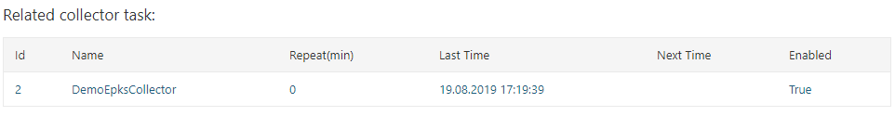

#### EPKS Event Collector Settings

Navigate to the admin's dashboard. Expand she Settings menu item, and click on EPKS Event Collector. The EPKS Event Collector Settings form will be displayed. The form below is filled with high throughput values for the MS SQL Server.

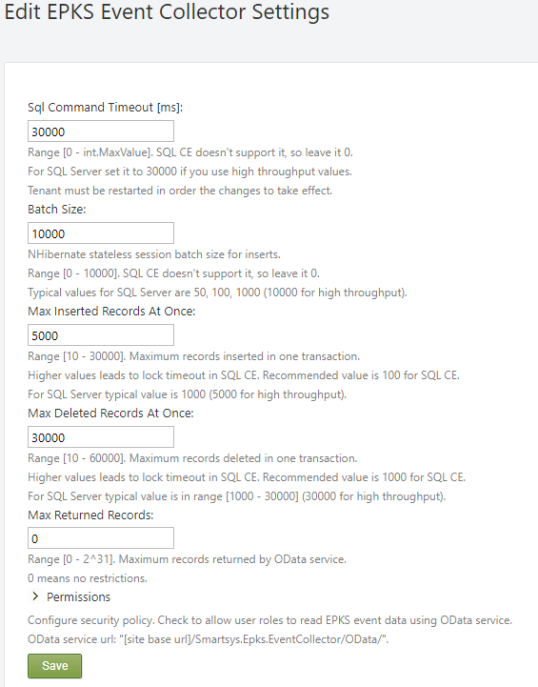

SQL Command Timeout [ms]- Timeout (in milliseconds) for a SQL command. Range [0 to 2^31]. Set it to 30000ms (30 sec) if high throughput values are used for other options. **Not supported for SQL CE, leave it 0**.

!!! note "Note:" The tenant must be restarted in order for changes to take effect. If the tenant is only one (Default), then the site application pool must be restarted.

Batch Size - How many records to be inserted with one batch. Range [0 to 10000]. If 0, no batches are used. Typical values are 50, 100, 1000 (10000 for high throughput). **Not supported for SQL CE, leave it 0**.

Max Inserted Records at Once - Maximum records inserted with one transaction. Range [10 to 30000]. The SQL Server typical value is 1000 (5000 for high throughput). **Recommended value for SQL CE is 100, higher values lead to lock timeout**.

Max Deleted Records at Once - Maximum records deleted with one transaction. Range [10 to 60000]. The SQL Server typical value is range [1000 to 30000] (30000 for high throughput). **Recommended value for SQL CE is 1000, higher values lead to lock timeout**.

!!! warning "Warning:" Due to database limitations, SQL CE is not supported for that module.

Max Returned Records - Maximum amount of records fetched by the OData service at once. 0 means no restrictions. Range [0 to 2^31].

The final section is Permissions. The EPKS Event Collector module allows collected and estimated events data to be queried via the OData service. These permissions specify which roles have **read** access.

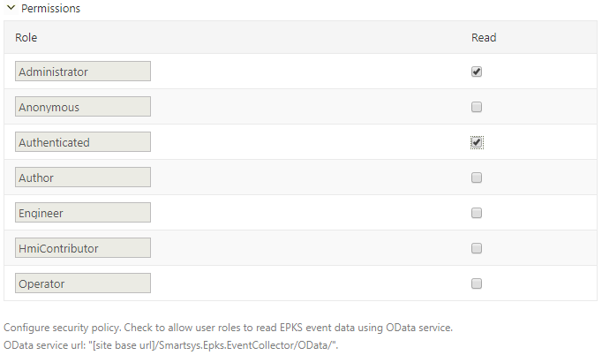

The roles are shown with their respective checkboxes. The checkbox determines if the **read** action is allowed for that role.

The OData service url is [site base url]/Smartsys.Epks.EventCollector/OData/.

#### Role Permissions

There are role permissions to enable management of the module. Navigate to the Users on the left side navigation menu of the admin dashboard. After that on the right side click on the Roles tab.



Here you see available roles. Click on the desired role and after that scroll down to the Smartsys.Epks.EventCollector``permissions.

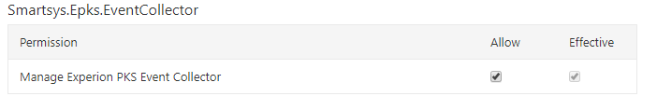

On the left side are shown available permissions. On the right side there are two columns Allow and Effective. Effective shows current estimated permissions for that role. In the Allow column you can give role permissions if not set. Manage permissions must not be granted to regular users, they are only for managing current module. To be able given role to administer Experion PKS Event Collector module, manage permission must be granted to that role.

## Safety Historian

The **SmartWEB** application can collect **Safety Historian** events. Data is collected through the **ODATA** service (provided by the **Smart ODATA Server**) and stored in the application's database. A simple dataflow diagram is shown below.

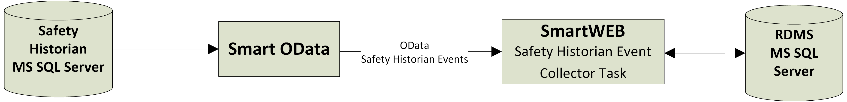

The Safety Historian Event Collector Task reads and stores Safety Historian events in RDBMS through the OData service that is provided by the Smart OData Server. The Smart OData Server maps Safety Historian events data as OData entities.

#### Preconditions

1. **SmartWEB** with Microsoft SQL Server's database (due to database limitations and negative performance impact, consider using MS SQL Server Standard or higher editions).
2. Administrator rights on the **SmartWEB** application.
3. Enabled module Smartsys OData QueryBuilder.
4. Enabled module Smartsys Experion PKS Event Collector.
5. Enabled module Safety Historian Event Collector.
6. Configured **ODATA** gateway to the **Smart ODATA Server**.

#### Creating Safety Historian Event Collector Task

To be able to collect Safety Historian events data, a Safety Historian Event Collector Task must be configured.

Sign in the **SmartWEB** site. Navigate to the admin's Dashboard.



Expand the Smart Events menu item and click on the Safety Historian link on the left side. This will open the screen for managing Safety Historian Event Collector Tasks. Press the Add New button to create a new one.

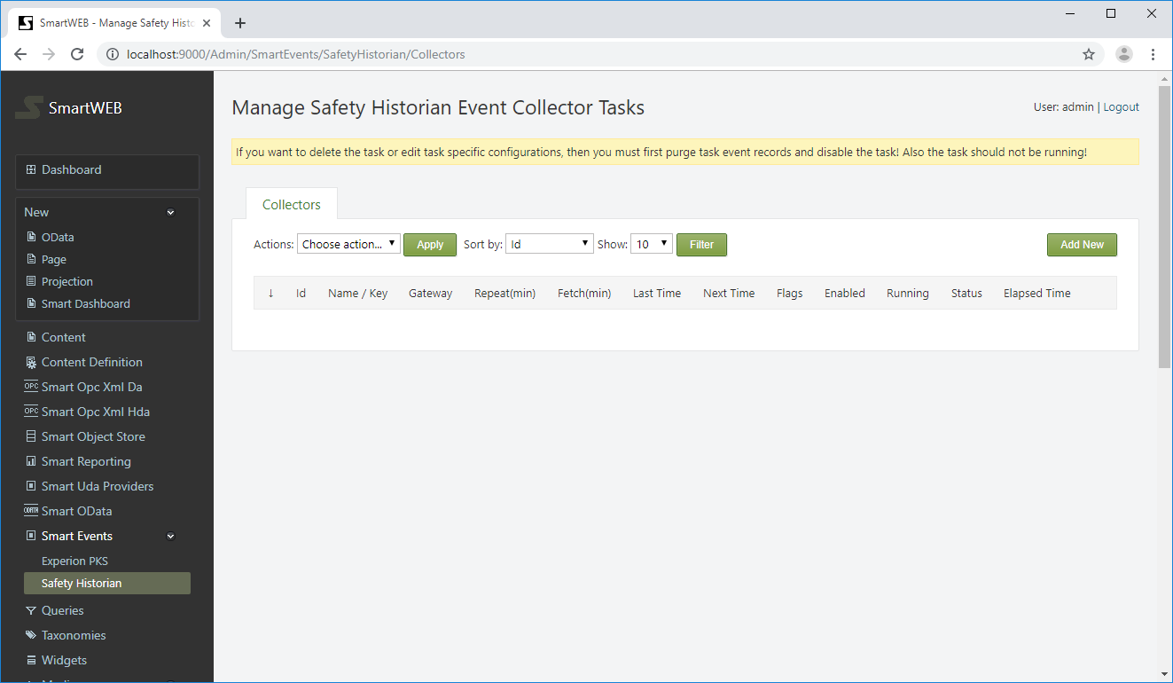

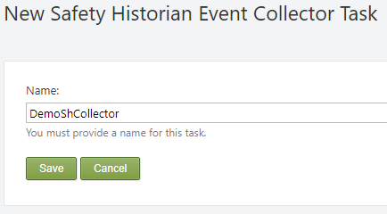

Provide a name for the task and press the Save button.

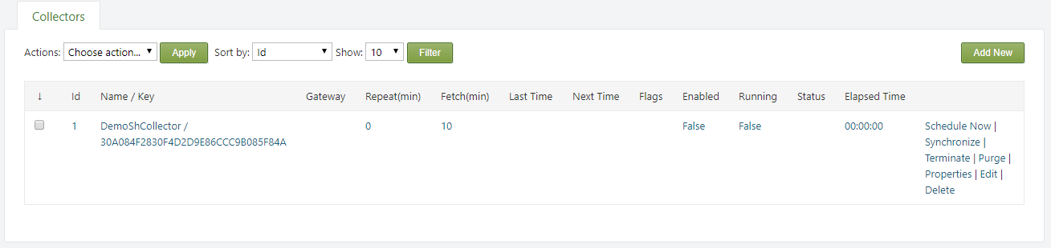

From the properties link on the right side, the name of the task can be edited. It can also be deleted via the Delete link.

Via the Schedule Now link, the next run of the task can be scheduled.

!!! note "Note:" Do not schedule a task until it is entirely configured, otherwise you will not be able to edit some configuration options.

Via the Synchronize link, the Synchronize flag of the task can be set. This means the scheduler will run the task to synchronize itself with the database, regardless if the task is scheduled or not.

Via the Purge link, the Purgeflag of the task can be set. Thich means the scheduler will run the task to purge events until retention policies are satisfied, regardless if the task is scheduled or not.

Via the Terminate link, the Terminate flag of the task can be set, This means the scheduler will interrupt the task if it is running, or the task will not run at all if it is scheduled.

If a given flag is set, it can be unset by pressing the appropriate link again. Purge and Synchronize flags are unset automatically when the operation is complete, but the Terminate flag must be unset manually.

!!! note "Note:" The Schedule Now link schedules the task and clears all task flags!

!!! warning "Important:" If you want to delete or edit a task with protected parameters, you must first purge the task event records to disable it. It should not be running!

Press the Edit link to configure the task.

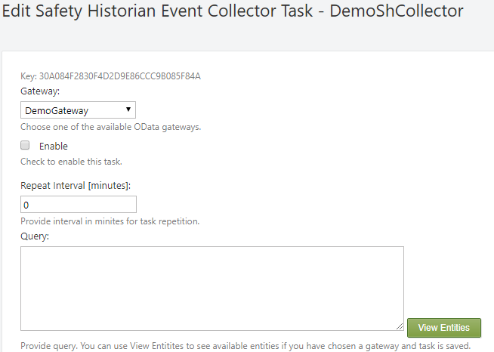

First, a gateway to the Smart OData Server must be provided. After setting the gateway press the Save button, but don't enable the task. Press the Edit link again to continue configuring it.

Enable - The Enable checkbox enables the task.

!!! note "Note:" Enable the task when everything else is configured.

Repeat Interval (minutes) - Specifies how often the task will become active to get the new data (2 minutes is a standard value). 0 means the task will run only once, no repetitions.

Query -- Specifies an ODATA query to be executed to collect events. Different filters can be applied. Press View Entities to see the available entities. Copy and paste the desired one into the Query box.

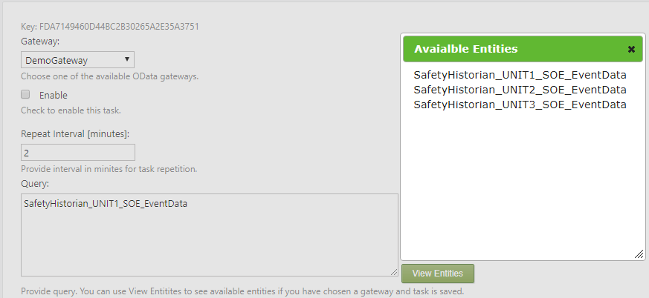

Fetch Interval [minutes] - 10 minutes by default. Specifies at what time portions of data will be fetched. If the interval is small there will be many requests and data will be gathered very slowly. If the interval is too big, requests will be much fewer, but large amounts of data will be transferred and timeouts may occur. The interval also depends on how fast the events occur. If the unit generates a huge amount of events for a small period of time, then a small fetch interval will be more suitable for use. Usually, the interval is between 60 and 1440 minutes (depending of the frequency of the events).

Request Timeout [ms] - Timeout in milliseconds for each data fetch request. The range is between (3000 and 600 000 ms). The default value is 60 000 ms (1 minute). Usually it's enough. If you have a huge Fetch Interval, consider revising the timeout.

Sleep Between Requests [ms] - The sleep interval in milliseconds between two consecutive data fetch requests. 0 means no sleep. The default value is 0. The range is between 0 and 60 000 ms (1 minute).

Retention Period [days] - how many days the events will be kept in the database, before they are purged. The default value is 0. This means there is no limit, but it's good practice to provide one. If there aren't many alarms on a daily basis, a long period can be set (e.g. 365 days), but if there are many generated events, keep the period short (e.g. 30 days or less).

!!! note "Note:" The amount of events that are kept in the database will determine the speed of the queries.

Retention Records - How many records are kept in each table. If the number of records in the event's table becomes more than number specified, the oldest records will be purged until the amount of records that remain are less than the specified number(limit). 0 means no limit.

!!! note "Note:"  
An event is purged, regardless of which of the retention constraints is reached.

Maximum Rows - How many events will be fetched at once. The range is between 10 and 30 000. The default and recommended value is 5 000. If the maximum of 30000 is set, revise the Save Retry Attempts to 5 or more, and the Save Retry Interval to 3000 or more.

Collect Events After - If specified, events will be collected after that date.

Next Time - Specifies when to run the task. After the task execution, the field is cleared. If the task has a configured Repeat Interval - the next execution time is set instead.

Retry Attempts - How many times an attempt will be made to fetch data on fail. The range is from 0 to 10. The recommended value is 3.

Save Retry Attempts - How many times an attempt will be made to save data on fail. The range is from 0 to 10. The recommended value is 3.

Save Retry Attempts - The interval (in milliseconds) between attempts to save data on fail. The range is from 0 to 15000. The recommended value is 1000ms.

Debug - If checked, debug info will appear in the application log.

#### Safety Historian Event Collector Task Details

At the bottom of the collector task configuration page, there are some details.

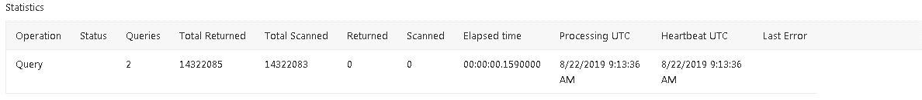

The Statistics table provides information about the current state of the task.

Operation - shows which operation is running at the moment (Query, Purge or Synchronize). When the task finishes, the last operation always remains. If the Status is empty, that means it was completed successfully.

The Query operation requests event data from the Smart OData server and processes it. The Purge operation deletes event data until the retention policies are satisfied. The Synchronize operation syncs the task state and counters, with the database.

Status - Available collector statuses are: Pending, Processing, Stuck, Failed, Terminated, Purging, Synchronizing. A missing status indicates a successfully finished task.

A status is Pending when the task is started from the scheduler, but is still not processing. The Processing state means the task is running. The Stuck status indicates a missing heartbeat from the task (the task is probably "dead" and can be re-ran). The Done status indicates that the current task run is successfully completed. The Failed status indicates the task run is interrupted/failed. The Terminated status indicates the task is terminated by a user request. The Purging status indicates that the task is purging event data until the retention policies are satisfied. The Synchronizing status indicates that the task is synchronizing it's counters and state with the database.

Queries - how many queries are ran in the current task run.

Total Returned - the total returned from query events.

Total Scanned - total evaluated events ever for this task.

Returned - returned events from the last query.

Scanned - evaluated events from the last query.

Elapsed time - how long the current task run has been running.

Processing UTC - UTC time of updated data.

Heartbeat UTC - last UTC time reported from the task's heartbeat. If there is no update for more than 5 minutes, the task is considered - stuck.

Last Error - last error seen during this task run. (If there is an error, you may check the application logs for details).

The Last Query table provides details for the last completed query.

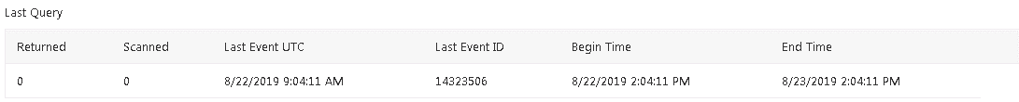

Returned - how many events are returned from the query.

Scanned - how many events are evaluated.

Last Event UTC - timestamp of the latest returned event.

Last Event ID - ID of the latest returned event.

Begin Time - begin time of the period for which events are requested.

End Time- end time of the period for which the events are requested.

The Current Query table provides details for the currently processed query.

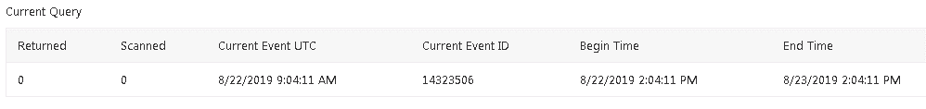

Returned - how many events are returned from the current query.

Scanned - how many events are evaluated.

Current Event UTC - timestamp of the currently processed event.

Current Event ID - ID of the currently processed event.

Begin Time - begin time of the period for which the events are requested.

End Time- end time of the period for which the events are requested.

The Event Table Statistics provides some statistic counters about events across the tables.

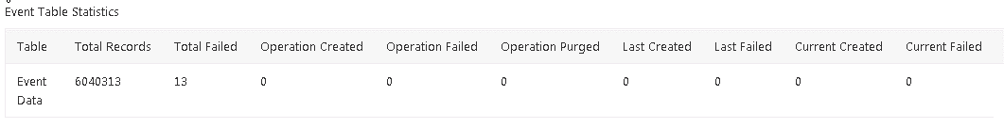

Table - the table for which the related data is provided.

Total Records - shows how many events there are.

Total Failed - total events of that type that have failed and are not saved.

Operation Created - how many events are created on the current task run.

Operation Failed - how many events are failed on the current task run.

Operation Purged - how many events are purged on the current task run.

Last Created - how many events are created on the last completed query.

Last Failed - how many events are failed on the last completed query.

Current Created - how many events are created on the current query.

Current Failed - how many events are failed on the current query.

#### Safety Historian Event Collector Settings

The Safety Historian Event Collector uses the EPKS Event Collector settings, described in the  
Smartsys EPKS Event Collector documentation.

#### Role Permissions

There are role permissions to enable management of the module. Navigate to the Users section on the left side of the navigation menu of the admin dashboard. Click on the Roles tab.



In this tab, the available roles can be seen. Click on the desired role and scroll down to the Smartsys.SafetyHistorian permissions.

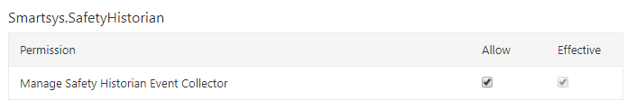

The available permissions are shown on the left side. On the right side, there are two columns - Allow and Effective. The Effective column represents the current estimated permissions for that role. Role permissions can be given via the Allow column, if they are not set. **Manage permissions** must not be granted to regular users, they are only for managing the current module. In order for a given role to be able to administer the Safety Historian Event Collector module, a **manage permission** must be granted to that role.

## Universal Data Access

**SmartWEB** UDA (Universal Data Access) is a model for unified data delivery. The main parts of the model are - providers and interceptors. Providers are responsible for delivering data. Interceptors are responsible for accepting and displaying the data to the front end. Both interact through a common UDA framework, provided by the Smartsys UDA Core module. Smartsys UDA OPC XML DA Providers and Smartsys UDA SQL Providers modules act as providers. They deliver data from OPC XML DA sources and various SQL databases. Smartsys UDA Simple Interceptor and Smartsys NVD3 Charting modules act as interceptors and display data from providers on the front end.

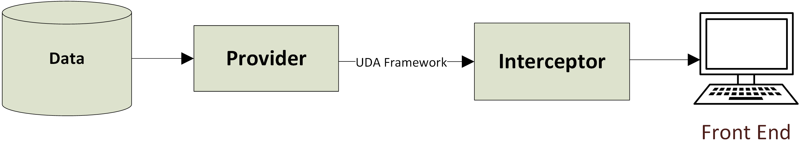

Each provider delivers data in a different format. Interceptors make the necessary data transformations, in order to visualize it on the front end in a meaningful manner.

#### Preconditions

1. Administrator rights on the **SmartWEB** application.

#### Creating Uda OPC XML DA Provider Template

Sign in the **SmartWEB** site. Navigate to Dashboard>Modules, and enable the Smartsys UDA OPC XML DA Provider. This module depends on the Smartsys UDA Core module, so it will also be enabled. Click on the Smart Uda Providers link on the left side. This will open the page for managing UDA OPC XML DA Provider Templates. A preconfigured provider from the **SmartWEB** setup recipe may already exist. Press the Add New button to create a new one.

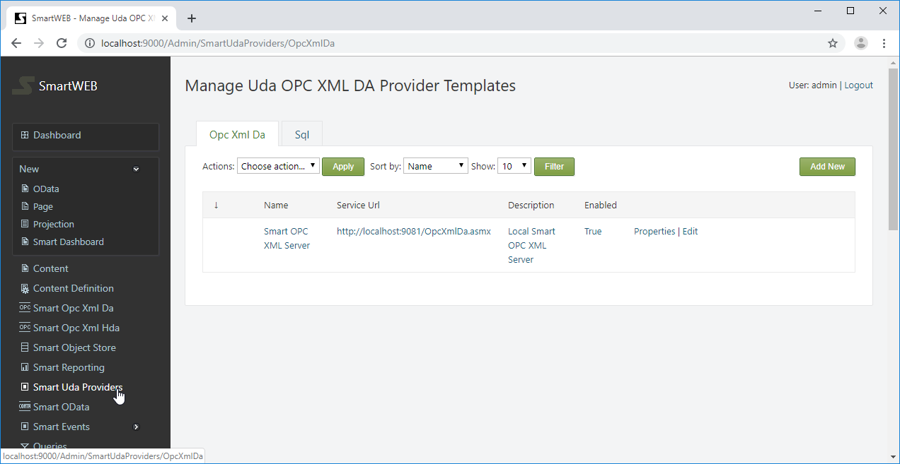

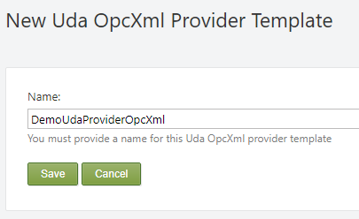

Provide a name for the provider and press the Save button to create it.

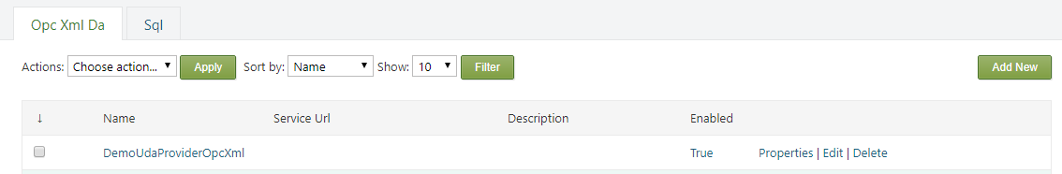

From the properties link on the right side you can edit the name of the provider. With Delete link you can delete it.

!!! note "Note:" You cannot delete provider if there is a content item that uses it.

Press Edit link to configure the provider.

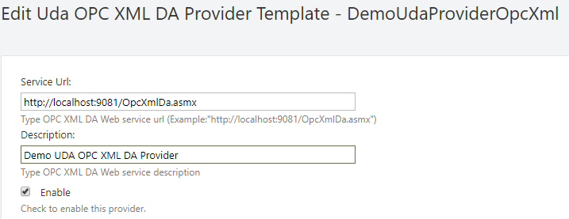

A service URL must be provided to the Smart OPC XML Server. Optionally, a description can be set. The Enable checkbox enables the provider.

The following settings are for configuring the authentication.

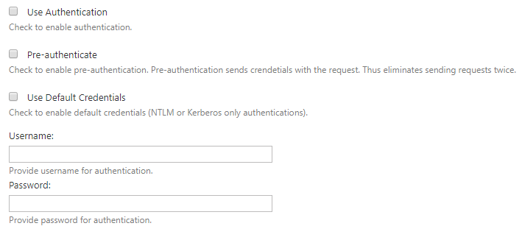

If Use Authentication is checked, a username and password must be provided in their respective fields. Alternatively, the Use Default Credentials must be checked. In this case, the running **SmartWEB** application credential will be used. Check the Pre-authenticate option to reduce client-server requests and fasten the communication. When this option is enabled, the client will send the credentials with request, instead of waiting for the server to ask for them.

The next settings are used for SSL communication with the Smart OPC XML Server.

The following settings are used for SSL communication with the Smart OPC XML Server.

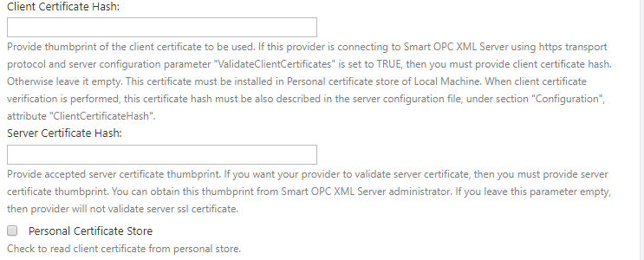

SSL can be used by setting the URL of the service to start with https:// (if the server supports SSL communication). The server's certificate thumbprint can be checked via the provider Server Certificate Hash field.



If а specific certificate has to be used to communicate with the OPC XML server (because the server also checks the thumbprint of the client), provide the client certificate's thumbprint in the Client Certificate Hash field. The used client certificate must be installed on the machine where the **SmartWEB** application is running. If the certificate is installed in the personal certificate store, the Personal Certificate Store option must also be checked.

!!! note "Note:" You will not be able to save the settings if the Client Certificate Hash is provided and the certificate is not found on the machine.

!!! note "Note:" When installing a client certificate, it is better to use Local Machine as a store location.

!!! warning "Warning:" The Certificate thumbprint displayed in the MMC certificate snap-in has an extra invisible unicode character. Do NOT copy the "extra space" that appears before the certificate thumbprint from the Richedit control. If you copy and paste the thumbprint with the extra (invisible) character, this will lead to errors like - unable to find client's certificate or unable to validate the server's certificate.

Three options are available for Compression Type - none, decompress, and gzip. If none is chosen, no compression algorithms are applied during conversation. The Decompress option means requests are not compressed, but the server response may be. The gzip option (available only when communicating with the Smart OPC XML Server) means that requests and responses must be compressed with the gzip algorithm.

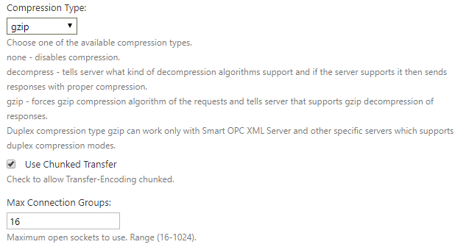

The Use Chunked Transfer option enables chunked transfer encoding. The data stream is divided into a series of non-overlapping chunks. This allows a server to maintain an HTTP persistent connection for dynamically generated content.

The Max Connection Groups option determines the maximum open sockets to use when communicating with the server. The range is between 16 and 1024.

Finally, save the last configuration. Press the Test connection button to check if the provider connects to the OPC XML server.

If the connection succeeded, it will be indicated by green messages at the top of the page.



Related Content Items, that use this provider, can be seen at the bottom of the screen.

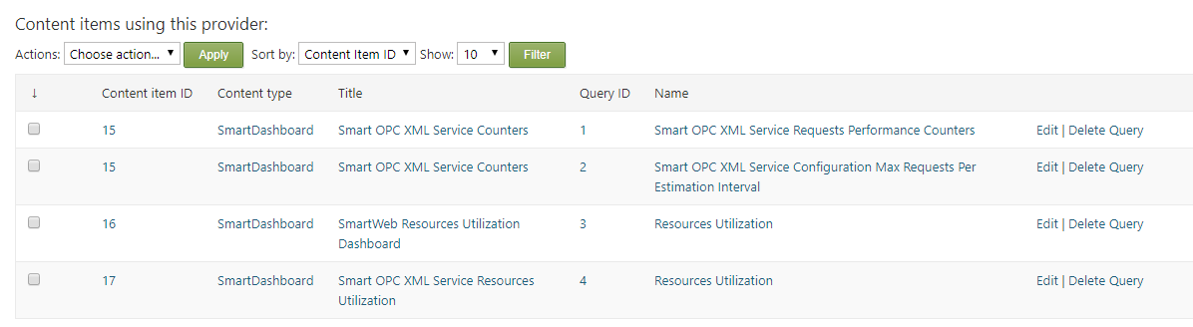

!!! note "Note:" A provider can not be deleted if it is related to a Content Item. If you want to delete the provider, you have to delete the queries that uses this provider in content items.

#### A Demo with UDA OPC XML DA Provider

The following demo requires a running Smart OPC XML Server with enabled Simulation OPC XML DA module, and configured Uda OPC XML DA Provider Template pointing to that server.

For the demo, prepare a simple Content Type named Demo Uda, which consists of the following parts: Common, Autoroute, Identity, and Title. Leave the Creatable and Draftable boxes as set.

To be able to deliver data, the Smartsys Uda Opc Xml Da Provider must be attached as a part to the Content Type.

Navigate to Dashboard > Content Definition. From the Content Types tab, find the appropriate Content Type and click Edit.

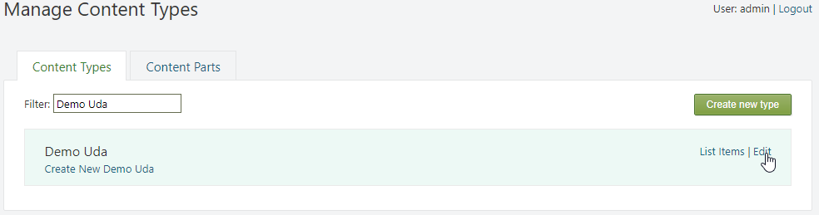

Press the Add Parts button. Select the Smartsys Uda Core, Smartsys Uda Opc Xml Da Provider parts, and press the Save button.

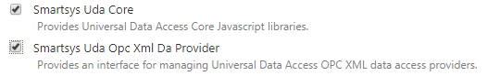

Each UDA module is dependent on Smartsys Uda Core, that is why it must be added first.

To be able to visualize data to the front end, an interceptor is required. The Smartsys Uda Simple Interceptor module will be used for this demo. It provides a part, as well as two fields that can be added to a Content Type.

Press the Add Field button, and add the Simple Interceptor Grid Field named - Display Data. Press the Save button.

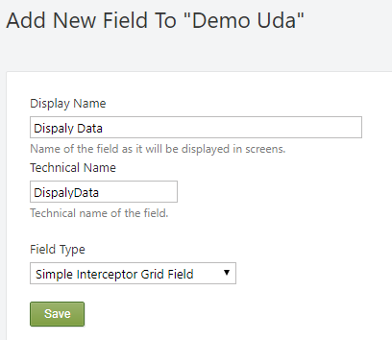

On the left menu of the admin dashboard, expand New, and click on Demo Uda to create a new Content Item. Provide a meaningful title (it will be used to create a permalink), and press the Save button. Expand the Smartsys Universal Data Access OPC XML DA Provider node, and press the Create Query button.

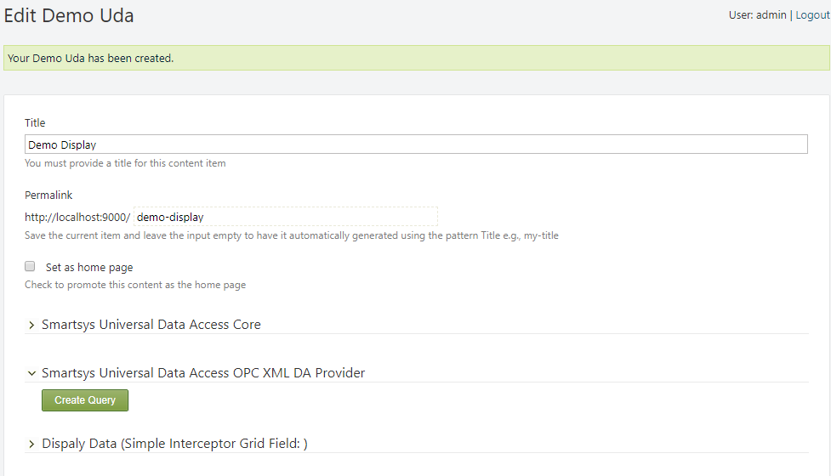

Re-expand the node to configure the new provider.

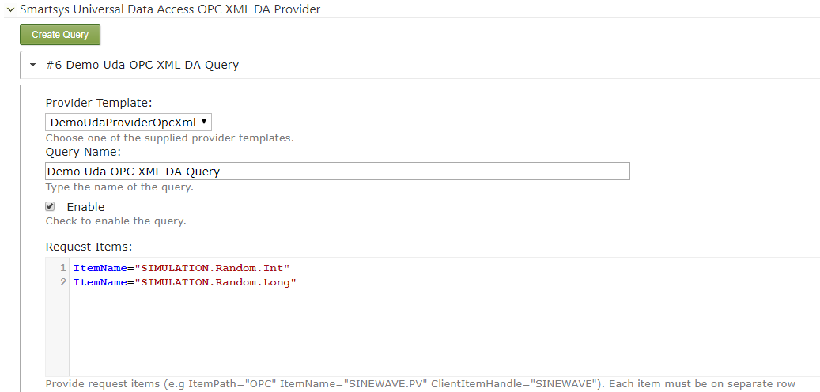

Choose the provider template from the dropdown list. Place a meaningful name for the query, and set the request items as shown above. Don't forget to enable the query.

The following options are according to the OPC XML DA specification. Refer to it for more details. For the demo, check Return Error Text, Return Diagnostic Info, Return Item Time, Return Item Nameand Return Item Path.

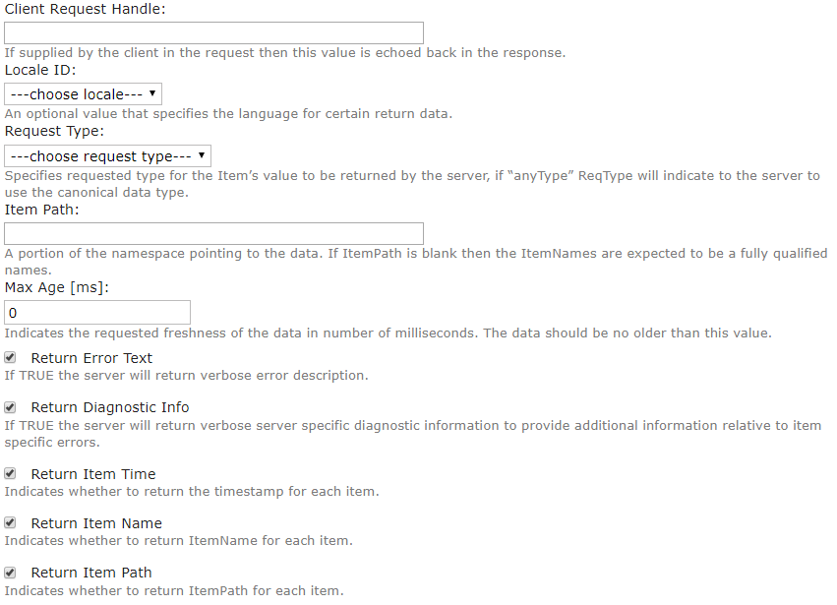

Set the refresh interval to 1000ms. It means that provider will try to update the data each second. Set Return Replied Items Only and Return Only Quality Field. These options reduce the amount of returned data. For the fetch method - choose Key-Value Pairs, and set Serializer to Newtonsoft.

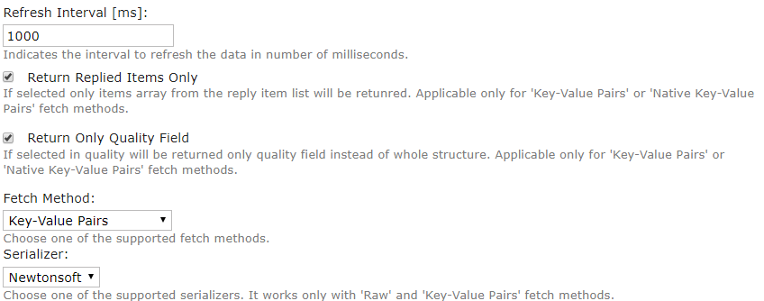

Press the Save button. Expand the Smartsys Universal Data Access Core. In the Provider, choose the configured Demo Uda OPC XML Da Query, and press the Test button.

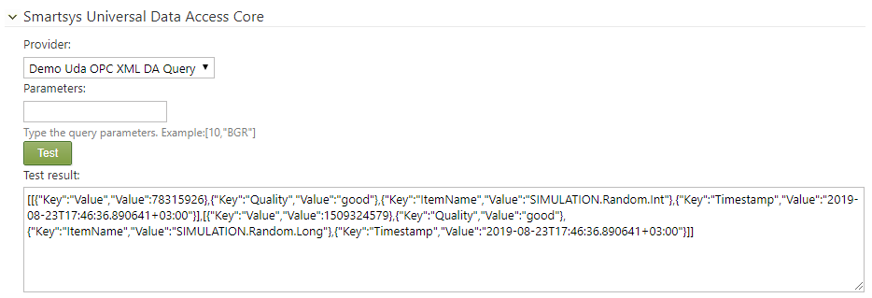

The Test result will show the returned data and its format.

Expand the Display Data field to configure it.

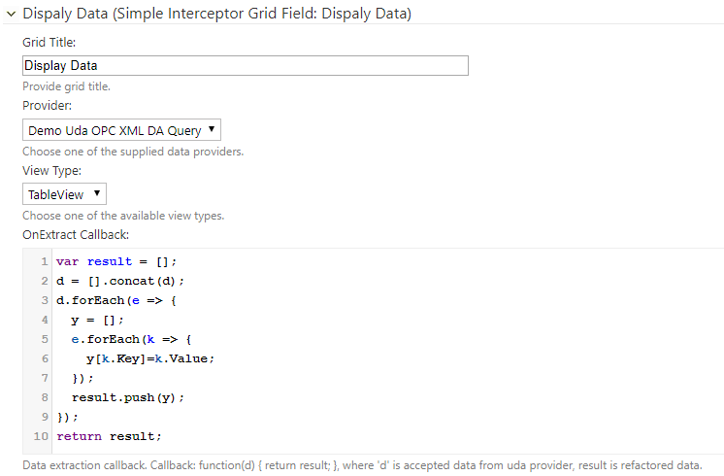

Set the grid title, and set the provider to Demo Uda OPC XML DA Query. Set the View Type to Table View. Interceptors are responsible for appropriate data transformations, and data visualization. OnExtract Callback makes some data transformations, in order to make it understandable for Table View.

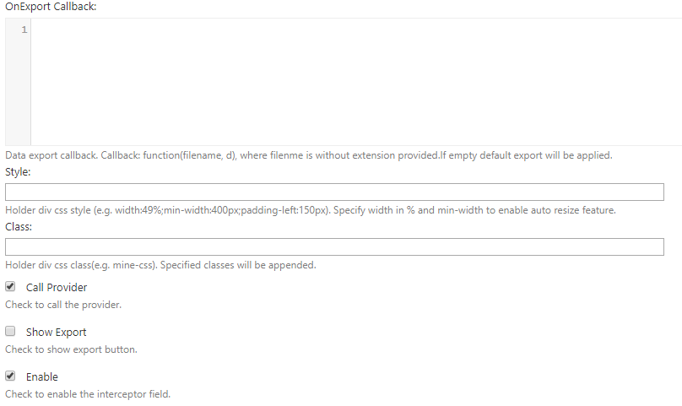

Finally, check Call Provider and Enable. Press the Save button, navigate to the Manage Content page, and press the Preview button of the Demo Display.

If Call Provider is checked, the interceptors trigger the provider to start updating its data. If the provider's Refresh Time is set, after triggering, it continuously updates the data.

!!! note "Note:" It is possible to have more than one interceptor connected to a provider, but make sure that only one of them will call it, otherwise the provider will be triggered multiple times.

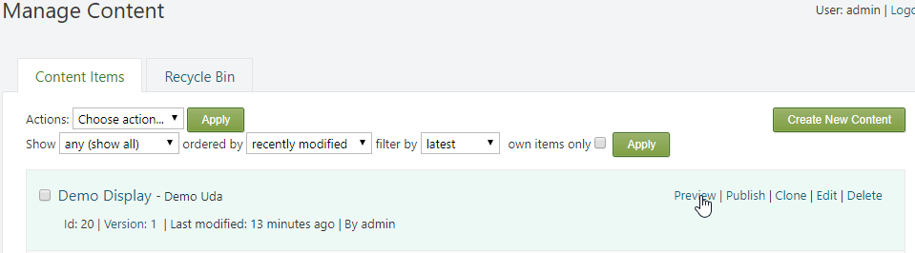

The following content will now be visible, and will be updated each second.

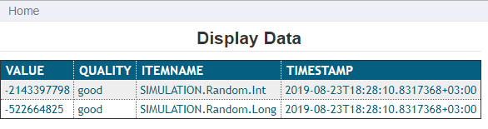

#### UDA OPC XML DA Provider Query Options

Provider Template- The provider template that is used by the query.

Query Name- Name of the query.

Enable- If set, enables the query.

Request Items- The UDA OPC XML DA Provider makes Read operations to get the requested data from the OPC XML DA Servers. This list specifies the requested item in the following format:

ItemPath="OPC" ItemName="SINEWAVE.PV" ClientItemHandle="SINEWAVE"

Each item must be placed on a new row.

Client Request Handle- According to the OPC XML DA specification, if supplied by the client in the Read request, this value is echoed back in the response.

Locale ID- An optional value that specifies the language for certain return data. See OPC XML DA specification for details.

Request Type - Specifies the requested type for the item's value that will be returned by the server. If it is set to anyType, this will tell the server to use the canonical data type (see the OPC XML DA specification for details).

Item Path- A portion of the namespace pointing to the data. According to the OPC XML DA specification, all requested items with omitted item paths will be considered to have this path. If ItemPath is blank, then the ItemName is expected to be a fully qualified name.

Max Age- Indicates the requested age of the data in milliseconds. The data should be no older than this value.

Return Error Text - If set, the server will return an error description.

Return Diagnostic Info - If set, the server will return server specific diagnostic information that is relative to item specific errors.

Return Item Time - If set, the server will include a value timestamp in the response.

Return Item Name - If set, the server will include the item name in the response.

Return Item Path - If set, the server will include the item path in the response.

Refresh Interval- The interval in milliseconds that the provider will use to continuously refresh the data. If the refresh interval is 0, the data will only be refreshed when the provider is triggered.

Return Replied Items Only- Reduces the amount of returned data by returning an array of the replied items. Applicable only for Key-Value Pairs or Native Key-Value Pairs fetch methods.

Return Only Quality Field- Reduces the amount of returned data by returning the quality field, instead of whole quality structure. Applicable only for Key-Value Pairs or Native Key-Value Pairs fetch methods.

Fetch Method- Four methods are available- Raw, Key-Value Pairs, Native Raw, and Native Key-Pairs.

Raw- Returns serialized data, using a specified JSON Serializer.

Key-Value Pairs- Transforms data objects to key-value pairs, and serializes the result, using a specified JSON Serializer.

Native Raw- Returns a serialized result, using a native JSON Serializer.

Native Key-Value Pairs- Transforms data objects to key-value pairs, and returns the result, using a native JSON Serializer.

Serialzier- A set of supported JSON Serializers. Applicable only for Key-Value Pairs and Native Key-Value Pairs fetch methods.

#### Creating Uda SQL Provider Template

The Smartsys UDA SQL Provider module, in conjunction with NHibernate (an object-relation mapper), enables the **SmartWEB** application to connect to various SQL databases.

Sign in the **SmartWEB** site. Navigate to Dashboard>Modules, and enable the Smartsys UDA SQL Provider. This module depends on the Smartsys UDA Core module, so it will also be enabled. Click on the Smart Uda Providers link on the left side. Navigate to the Sql tab. In this tab, the UDA Sql Provider Templates can be managed. Press the Add New button to create a new one.

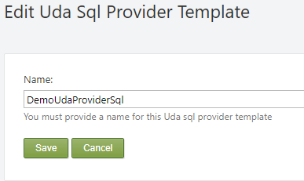

Provide a name for the provider and press the Save button to create it.

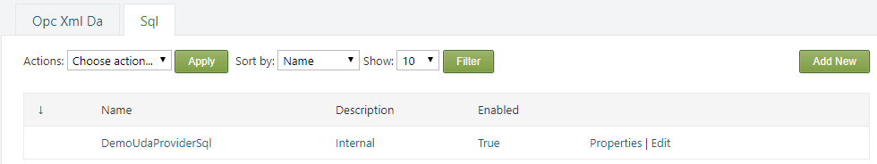

The name of the provider can be edited from the Properties link on the right side. It can also be deleted via the Delete link.

!!! note "Note:" You cannot delete a provider if there is a Content Item that is using it.

Press the Edit link to configure the provider.

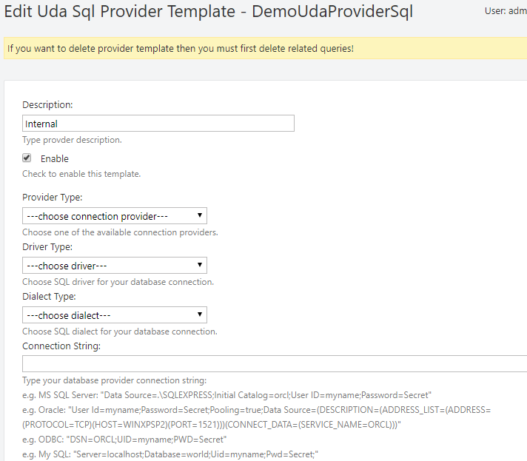

Description - An optional description of the provider.

Authentication- If set, enables the provider.

The next four fields configure the connection to the SQL source.

Provider Type - A list of available connection providers.

Driver Type - A list of available database drivers.

Dialect Type - A list of supported SQL dialects.

Connection String - A database provider's connection string.

!!! note "Note:" If the last four fields are empty, the provider will use the database connection of the **SmartWEB** application!

Related content items, that use this provider, can be seen at the bottom of the screen.

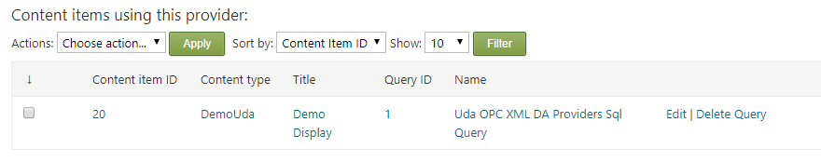

!!! note "Note:" The provider cannot be deleted if there are any related Content Items. In order to delete it, the queries that use this provider in Content Items must be deleted beforehand.

#### UDA SQL Provider Demo

The following demo requires the  
Smartsys UDA OPC XML DA Provider demo to be done first. Create a new Uda Sql Provider Template with the name DemoUdaProviderSql, and do not set the connection fields. This will cause the provider to use **SmartWEB**'s connection to the database. Open the Demo Uda content definition and add the Smartsys Uda Sql Provider part. Add a second Simple Interceptor Grid Field with the name Display Data 2.

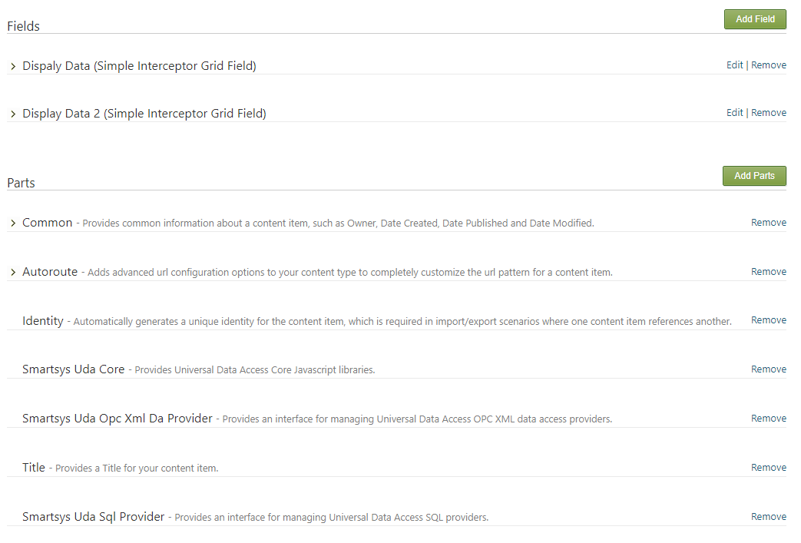

Open the existing Demo Uda content item. Expand the Smartsys Universal Data Access Sql Provider, and press the Create Query button.

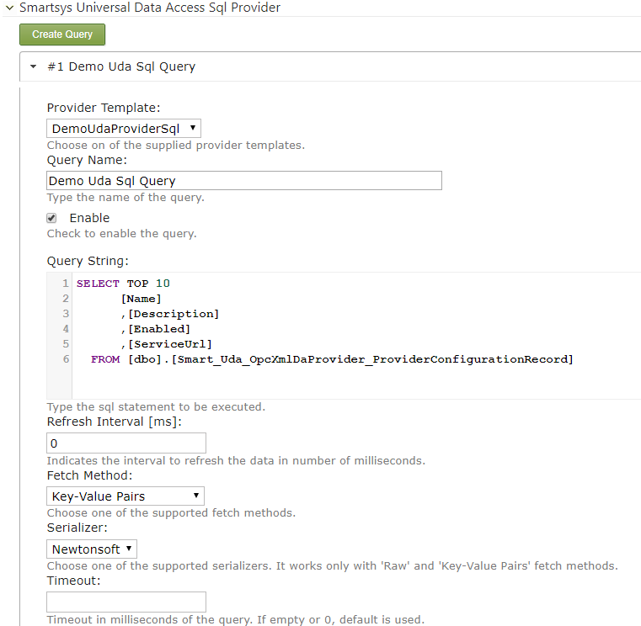

Follow the configuration that is shown above. Expand the Display Data 2 field, and follow the configuration that is shown below.

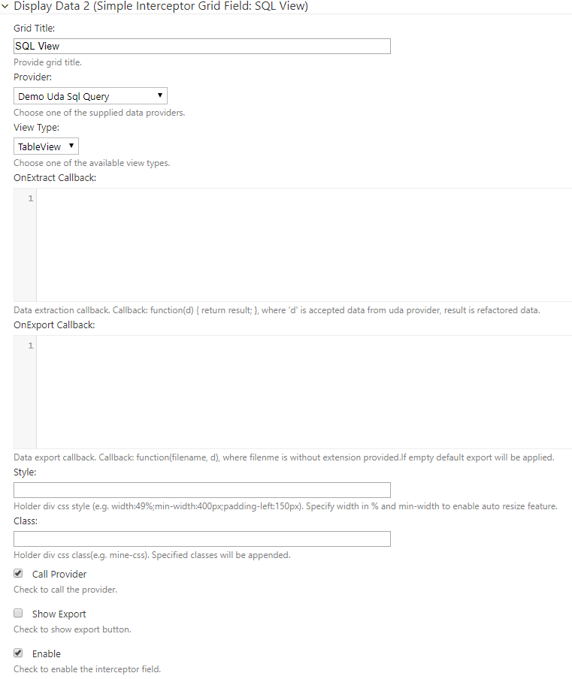

Save the content item and preview it. The following result is expected:

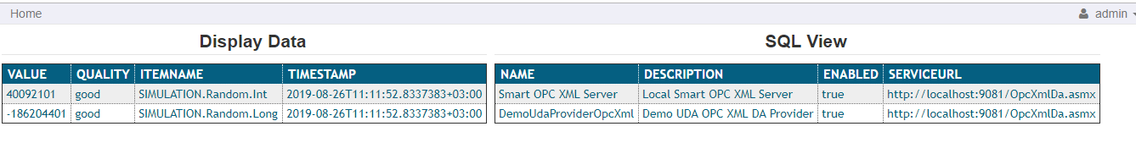

#### UDA SQL Provider Query Options

Provider Template - The SQL provider template that the query uses.

Query Name - Name of the query.

Query String- The SQL statement to be executed.

Enable - If set, enables the query.

Fetch Method - Four methods are available - Raw, Key-Value Pairs, Native Raw, and Native Key-Pairs.

Raw - Returns serialized data, using a specified JSON Serializer.

Key-Value Pairs - Transforms data objects to key-value pairs, and serializes the result, using a specified JSON Serializer.

Native Raw - Returns a serialized result, using a native JSON Serializer.

Native Key-Value Pairs - Transforms data objects to key-value pairs, and returns a result, using a native JSON Serializer.

Serialzier - A set of supported JSON Serializers. Applicable only for Key-Value Pairs and Native Key-Value Pairs fetch methods.

Timeout - Query execution timeout in milliseconds. If empty or 0, the default value is used.

#### NVD3 Chart Demo

The Smartsys NVD3 Charting **SmartWEB** module delivers a part and a field that act as a UDA interceptor. The following demo requires the Smartsys UDA OPC XML DA Provider demo to be done first. Enable the Smartsys NVD3 Charting module. Go to the Demo Uda content definition, and add a Smartsys NVD3 Chart Field with the name Chart.

Open the previous Demo Uda content item. Expand the Smartsys Universal Data Access OPC XML DA Provider, and press the Create Query button.

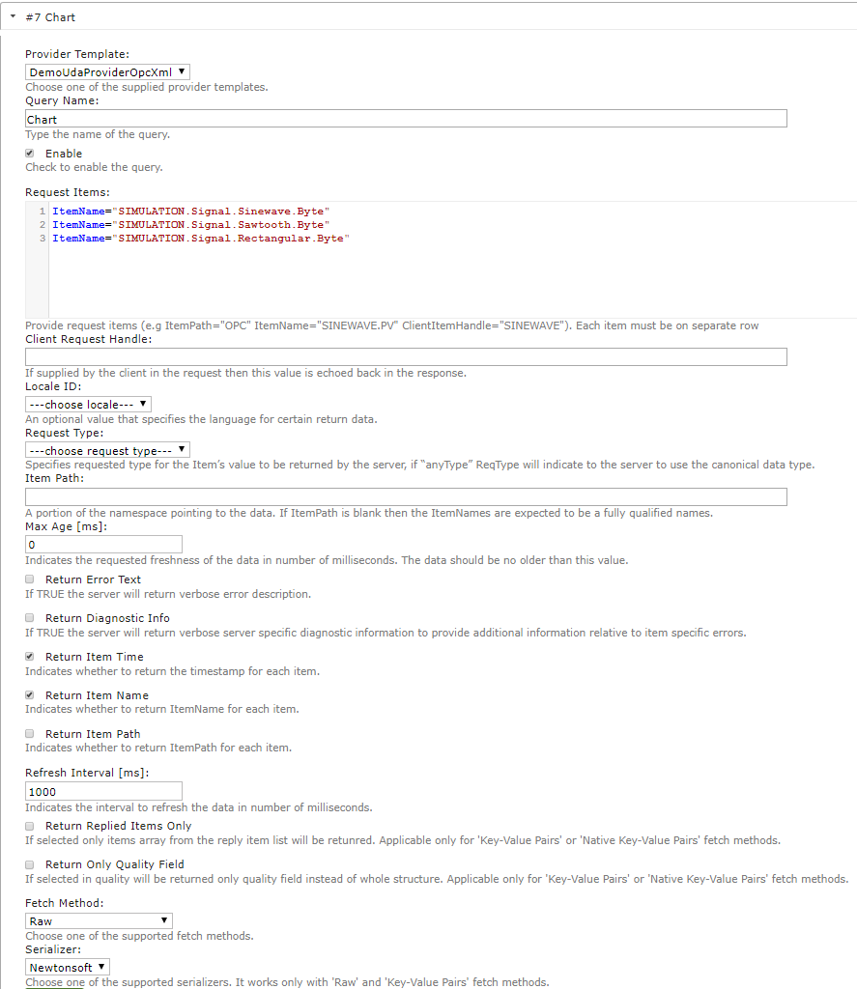

Expand the new query and configure it as shown above (set the provider template to DemoUdaProvidetOpcXml, set the query name to Chart, enable the query, configure the request items as shown on the picture above, set the return item time and item name options, set the refresh interval of data to 1000ms (1sec), chose the Raw fetch method, and Newtonsoft serializer). Press the Save button.

Expand the Chart (Smartsys NVD3 Chart) field. Navigate to the Line Chart tab, and check the Use Demo Data and Load Demo Settings options. These options will load preconfigured line chart demo settings. Press the Save button and preview the Content Item.

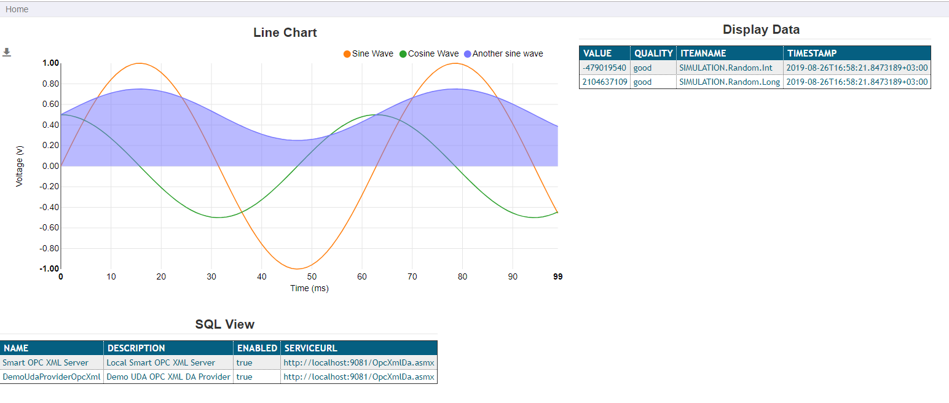

Go back to the edit page for the Content Item. To set data from a real provider, expand the Chart field in the Common Settings tab. Enter the following in X-axis Data Extraction Callback:

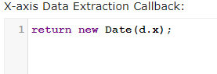

Press the Line Chart tab. Set the X-Axis label to Time and Y-Axis label to Value. Change the X-Axis Tick Format as shown below. Remove the check from Use Demo Data.

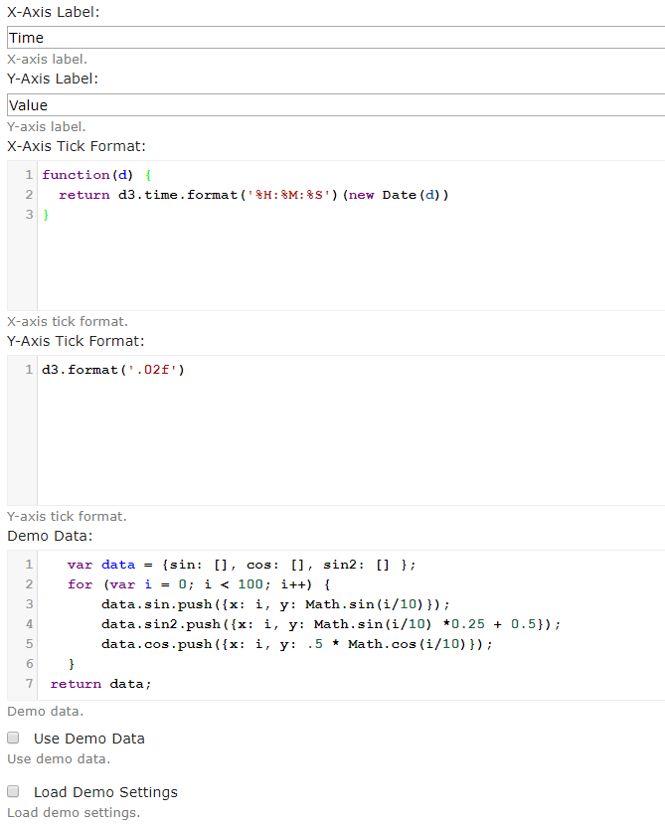

Navigate to the Series tab. Set the first series name to Sinewave. Set the Uda Provider to Chart. Check the Call Provider. Set Max Points to 100. Enter the following in  
Data Extraction Callback:

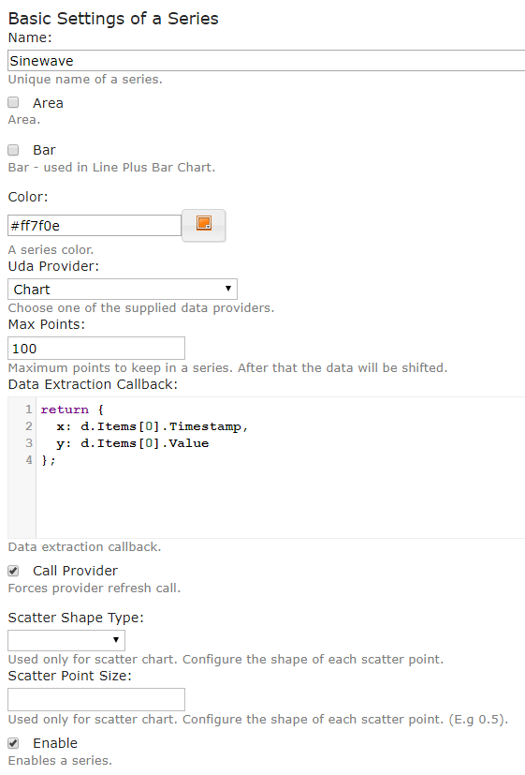

Open the second series. Set the name to Sawtooth. Choose the Chart UDA provider. Set Max Points to 100. Enter the following in Data Extraction Callback:

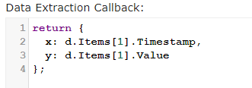

Open the third series. Set the name to Rectangular. Uncheck Area. Choose the Chart UDA provider. Set Max Points to 100. Enter the following in Data Extraction Callback:

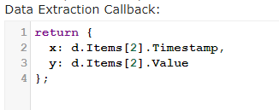

Press the Save button. Preview the Content Item.

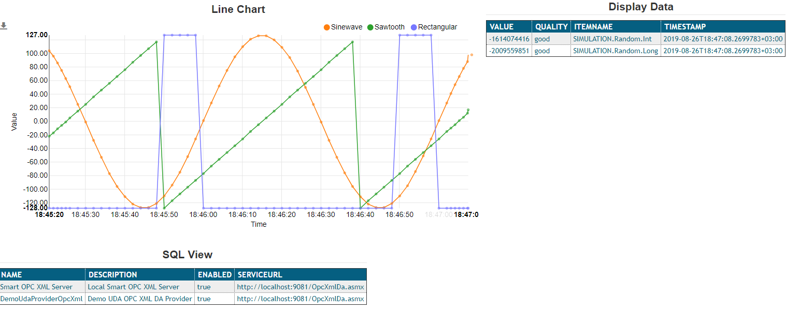

!!! note "Note:" The series here are created by the demo. If you disable a series, it will disappear. In order to have a permanent number of series, which you can configure, navigate to the Content Type. Expand the Chart field, and go to the Series tab. Create the required number of series that you want to be able to configure.

## OData Configuration Examples