The “Content Anatomy” of SmartWeb consists of the following components:

* Content Items - a single piece of content.
* Content Types - lists the different types of content that can be created.
* Content Parts - build a specific coherent behavior and that can be reused across content types.
* Content Fields - pieces of information that can be added to a content type.

These components come together to form a dynamic and flexable way of managing content at runtime.

## Content Item

A content item is a single piece of content, often associated with a single URL (address) on the site.  
Content Items are instances of Content Types. They store all the data you need to handle and display.

An item is a concept that is close to an entity but more centered around the idea of contents (as in contents management). An item can appear in a list but will also typically have its own page in the site.

To create a content item, navigate to the “Content” tab on the admin menu and click the “Create New Content” button in the top-right corner.  
You'll be taken to the “Create New Content” page where a content type can be selected for the content item. Afterwards the option to “Save” will become available.

!!! attention  
It's important to note that the “Save” button will allow you to save your work without having it appear on the site as opposed to the “Publish Now” which will display your changes on the client side.

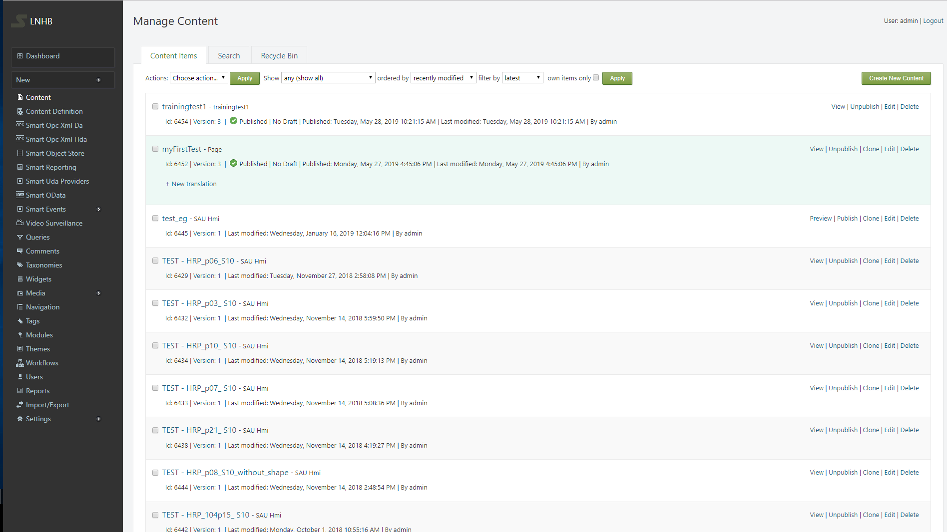

## Content Type

“Content Types” lists the different types of content that can be created. Content types are structures for content items.

Contents are managed under an actual type system that is rich and more dynamic. In order to provide the flexibility that is necessary in a Web CMS: types must be composed on the fly at runtime and reflect the concerns of content management.

A content type can be seen as a category of contents; it represents what a content item is. For example, it's easy to understand that a content item is a HMI Web Page or a PHD Report. The core of the notion here are in the words "is a": if you can say that a given content item is a "something", that "something" probably is the content type of the content item.

## Content Type Example

Creating new content types is done by navigating to the the “Content Definition” tab  
on the admin menu. From there you'll be taken to the “Manage Content Types” page. To add a new content type click the “Create new type” button.

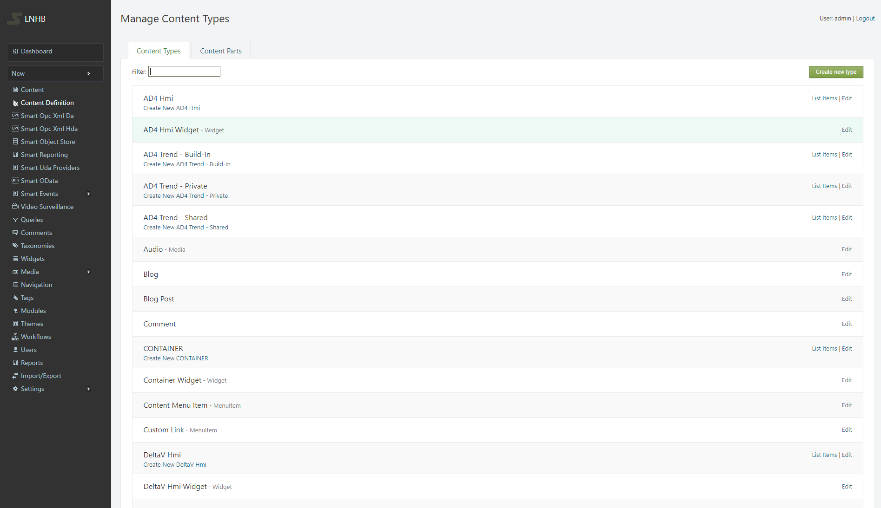

This will take you to the “New Content Type” page, where the display and technical names can be set and click “Create”.

!!! attention The technical name of the content type is better left in the state generated by default.

To customize the newly created content type head to the “Manage Content Types” page and click the “Edit” button on the new content type. From the following “Edit Content Types” page the content type can be altered and saved.

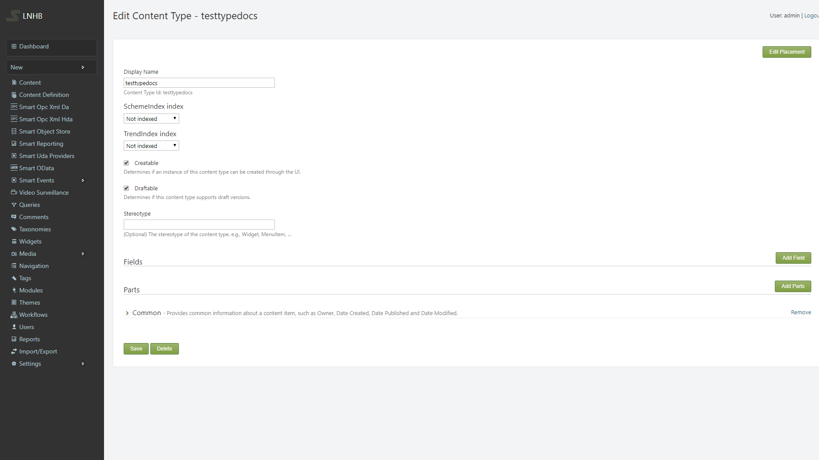

The “Edit Content Item” page's structure can be edited and changed to have a different appearance. By clicking on the “Edit Placement” button in the top-right corner,  
you'll be taken to the “Edit Placement” page where each page element can be seen. The elements are structured on top of eachother and their placement corresponds to how they will be shown on the “Edit Content Item” page. Changing the position of an element can be done  
by simply holding down the left mouse button on an element and draging it over or under the elements its supposed to be adjacent to.

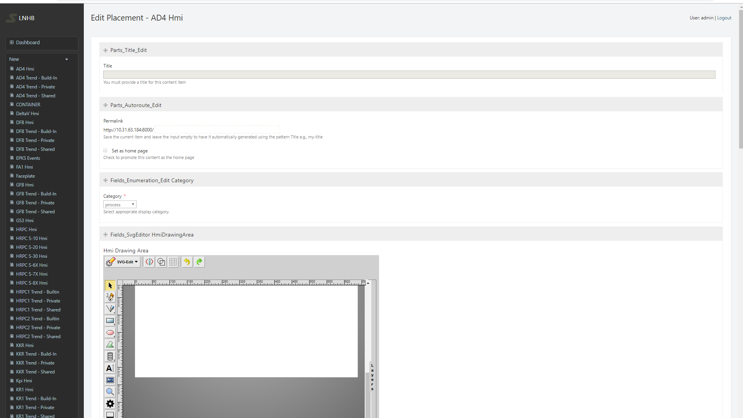

## Content Parts

A content part is a feature that can enrich any existing content-types without prior knowledge of the content part by the content-type or by the content-type from the content part. Content types are built from smaller parts, that are conveniently called content parts. Content parts are atoms of content that are enough to build a specific coherent behavior and that can be reused across content types.

Clicking the “Edit” option on a content type opens up the “Edit Content Type” page. From there the option to add content parts is available.

By adding content parts, the content items will automatically gain behavior and attributes.  
Add the content parts to the content type by checking the appropriate boxes and clicking “Save.”

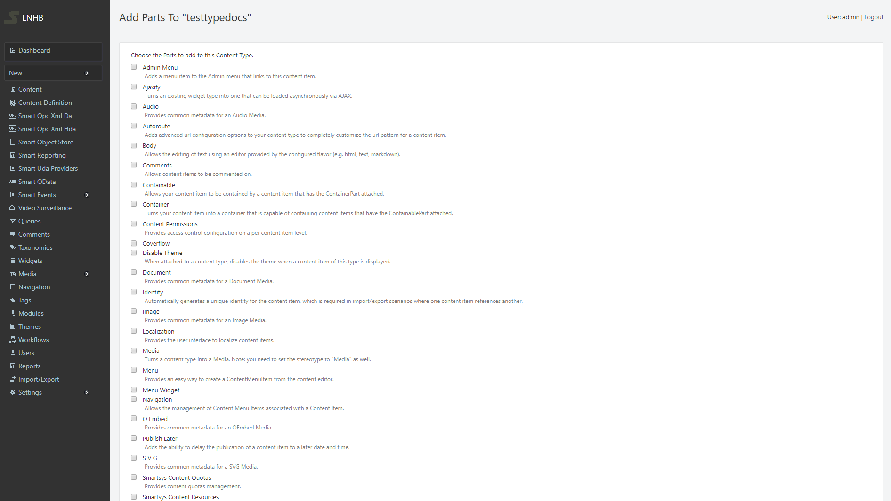

After saving parts to the content type, you’ll be taken to a page where you can choose to add fields or additional parts or click “Save”.

## Content Fields

Content fields are pieces of information that can be added to a content type. Content fields have a name and a type and are specific to a content type.

!!!attention There can be several of each field type on any given content type!

Content types initially lack fields for capturing information such as pictures and characteristics. To add a field navigate to the “Content Definition” menu option and click the “Edit” button on a content type.  
That will open up the “Edit Content Type” page.

Clicking “Add Field” will open a form for creating a new field for the template. Several types of fields are available by default. Set the “Display Name”(used for labels). Let the “Technical Name”(used in code) default to the display name and click “Save”. New fields are available for existing content items.

