The Honeywell EPKS (Experion® Process Knowledge System) is integrated in SmartWEB via the OPC (Open Platform Communications) specifications for process data. The HMI2SmartWebConvertor tool helps with the HMI (Human-Machine Interface). It converts HMI displays in a suitable format for the Svg-Editor module and support configurations.

## Prerequisites

* HMI2SmartWebConvertor is a portable application (doesn't have installer).
* Operating system: Windows 7 / Windows 2008 Server or newer.
* .NET Framework 4.5.1 - [download and installation](https://www.microsoft.com/en-us/download/details.aspx?id=40779) / [web installer](https://www.microsoft.com/en-us/download/details.aspx?id=40773).
* Pre-installed HMI Display Builder - used for processing HMI displays.
* HMIWeb Display Builder version 5 or newer.

## Select HMI displays

When the HMI2SmartWebConvertoris open, the following window should be available:

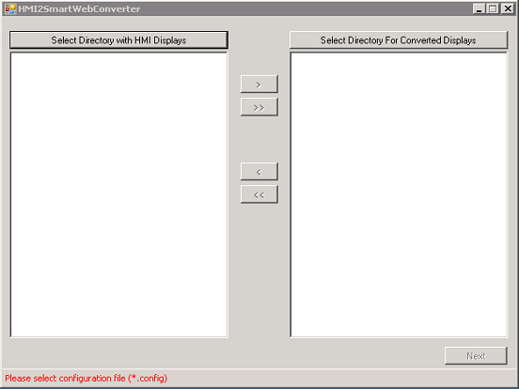

Select Directory with HMI Displays - opens a dialog box that will allow the user to select a folder that contains HMI displays (with the htm extension). All displays in the selected folder will appear in the white area under the button.

Select Directory For Converted Displays - opens a dialog box that will allow the user to select the folder where the converted displays will be stored. If a folder is not selected, a ConvertedDisplays folder will be created automatically within a folder with HMI displays. The converted displays will then be stored in the ConvertedDisplays folder.

Button > - this button will become active when a display is selected from the left side (HMI display). When the button is clicked, the selected display will be moved to the right side.

Button >> - this button will become active when a folder with HMI displays is selected. When it is clicked - all displays from the left panel will move to the right panel, which means they are selected for converting.

Button < - this button will become active when selecting a display from the right side (list of displays for converting). When clicking on it selected display will be removed from the list of displays for converting.

Button << - this button will become active when there is at least one display on the right side (list of displays for converting). When it is clicked, it will remove all displays from the list of displays for converting.

Next - this button will become active if there is at least one selected display for converting. When this button is clicked, the user can proceed to the compatible shapes configuration.

The image below shows an example with a selected folder with HMI displays (6 displays and 3 of them are added for converting).

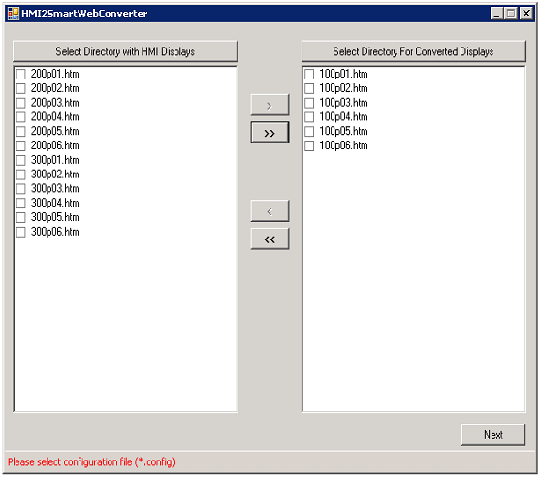

## Analyzing Shapes

Compatible shapes are shapes that are developed in SmartWEB to have the same behavior and view as EPKS shapes. Visit the Dynamic Shapes Development chapter for more information on shapes.

When the desired HMI displays are selected, the next stage is to configure the shapes. By clicking on Next the following window will appear.

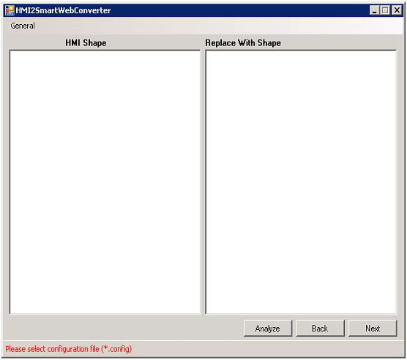

On the Compatible Shapes screen the following buttons are available:

Analyze - this button will analyze displays. It will look for new shapes and their custom parameters.

Back - this button will return the previous screen.

Next - this button leads to the the next screen.

After clicking on the Analyze button, a new dialog window with a progress bar will appear (see the image below).

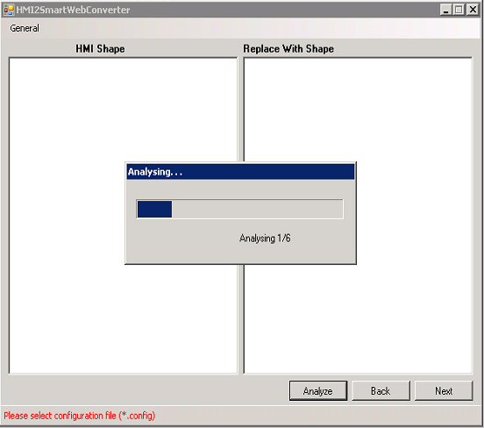

When the analyzing process has finished, this new window will close automatically. The result of the process is shown below.

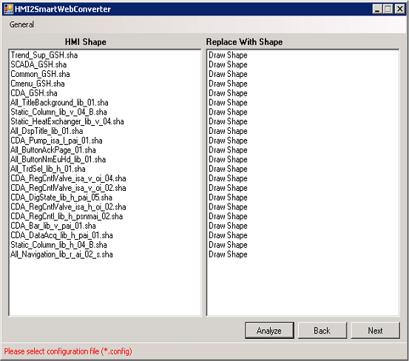

The EPKS HMI shapes from selected displays are located on the left side of the window - in the  
HMI Shape panel. The Replace With Shape panel is located on the right side of the panel, and there are three possible options on each line.

* Draw Shape - this shape will be drawn static.
* Skip Shape - this shape won't be drawn.
* Compatible Shape Name - the name of the shape which is configured to replace an EPKS HMI shape.

Before selecting a configuration file all EPKS HMI shapes will be drawn statically. In the upper left side of the panel, there is a menu General with three options:

* Open Config - this option will open a dialog box that will allow the selection of a configuration file (file with extension config).
* Save Config - this option will save the current state in the configuration file. If a configuration file is not provided it may create a new one.
* Open Shapes - this option will open a dialog box that will allow the selection of a folder with SmartWeb shapes. In most cases, this is necessary when creating a new configuration file. After saving, this information is stored in the configuration file.

After a configuration file is loaded, some of EPKS HMI shapes will have alternatives in SmartWEB, and the bottom tooltip bar label will be replaced with a config name.

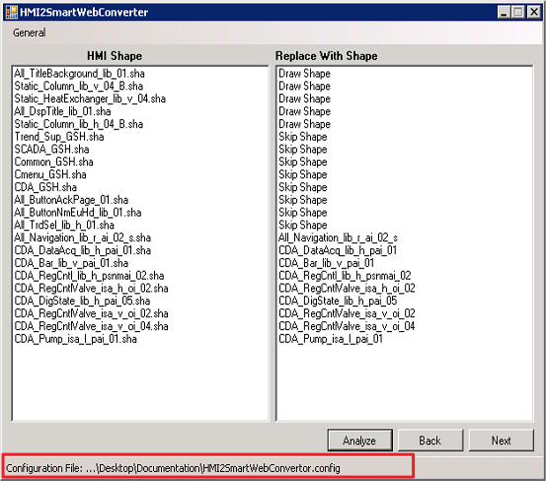

## Compatible shapes configuration

When displays are being converted, the SmartWEB Converter replaces each EPKS HMI shape with an explicitly defined SmartWeb shape. A dynamic configuration like TagName, Parameter, States etc. is replaced by the rules described below.

To edit a row consisting of an EPKS shape and its equivalent SmartWEB shape - click on the row itself. A Compatible Shapes window will appear with the configuration options.

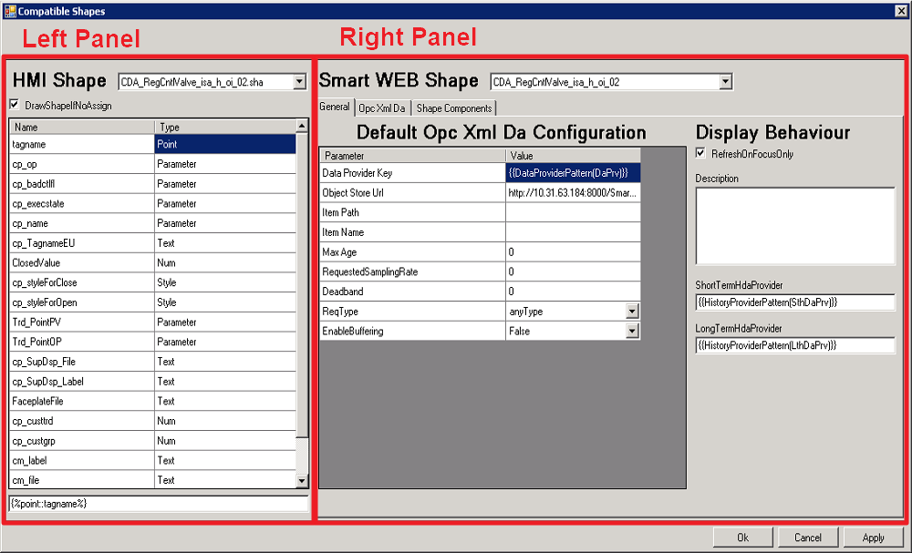

The left panel shows the selected EPKS HMI Shape and its available properties. If the checkbox DrawShapeIfNoAsign is not checked, and a SmartWeb Shape is not selected, this shape will be skipped in the conversion process. This functionality is often used for shapes that only provide scripts or functionalities that are not supported in SmartWEB (Script holders).

In the list with available properties, for each property, there are two columns. The first is the exact property name, and the second is its type (Point, Parameter, Text, Style, Num). Below the list, there is a field with an automatically generated pattern. The pattern will be generated for each property when the user clicks on it in the list.

Pattern:

{%param_type::param_name%}

Where param_type is the parameter type for EPKS HMI Shapes - Point, Parameter, Text, Style, Num, and param_name is the unique parameter name.

Example:

{%point::tagname%}

This pattern is automatically generated if the user clicks on the first line in the list.

The idea behind the property pattern is that it can be put where it is required by the user to get the respective value. For example, if it is put somewhere in the SmartWeb Shape pattern - {%point::tagname%}, it will be replaced with its value (for example "FIC153") in the conversion phase.

The right panel shows SmartWEB Shape information. The selected SmartWEB shape is shown in the dropdown list at the top. Below the selected shape, there are three configuration tabs.

#### General Tab

The General Tab provides common configuration for the entire display (not for individual shapes). There are two main sections - Opc Xml Da and Display.

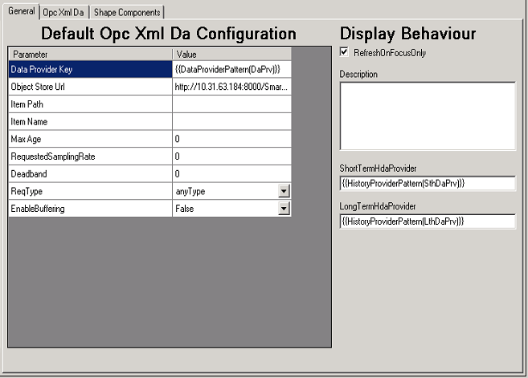

The available fields in the Default Opc Xml Da Configuration section are:

* Data Provider Key - explicitly defined DataProvider key. Also used to attach the shape to the first available DataProvider on the page by a pattern:

{{DataProviderPattern(DaPrv)}}

Where DaPrv must be part of the DataProvider key.

* Object Store Url - service URL to the Persistent Object Store. Permissions for Anonymous users must be added In SmartWEB (Deprecated).
* Properties according to the Opc Xml Da Specification.

In the Display Behaviour section, the shown configuration consists of:

* RefreshOnFocusOnly - if this checkbox is checked, the display in SmartWEB will be updated only when the user is on the current tab. This functionality uses a new browser feature called  
  Page Visibility API. If the browser doesn't support this functionality, it will be skipped.
* Description - display description.
* ShortTermHdaProvider - explicitly defined STH key. Also used to attach the display to the first available STH provider on the page via a pattern:

{{HistoryDataProviderPattern(SthDaPrv)}}

Where SthDaPrv must be part of the SthDataProvider key.

* LongTermHdaProvider - behavior is the same as ShortTermHdaProvider.

#### OpcXmlDa Tab

Properties for the selected shape are shown in this tab. If you leave empty fields, they will use values defined in the General tab.

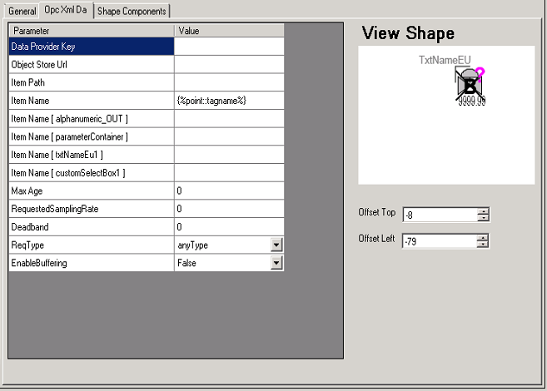

The available properties on the left side are the same as in the General tab, but here they are related to the current shape only. The shape view is shown in the View Shape area. The user may specify a horizontal and a vertical offset in the fields that follow.

#### Shape Components Tab

In this tab, the user will be able to see all of the information provided by directives and base elements (Svg Editor).

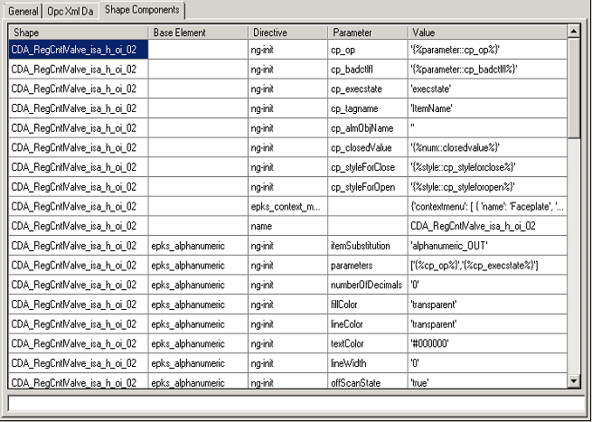

The first column contains the shape name. The Base Element column is second and it contains the component name. The cells are empty for directives which are applied directly to the shape. The third column contains the directive name. Some directives have additional parameters and they are shown in the fourth column. The first four columns are read-only. The users can manipulate only the last column.

To edit a row from the last column, the user can click on it once. The cell text will be displayed in the wide field at the bottom. The idea behind this is to have more space for editing because some of the directive values are long. For values, the user can provide - String, Numeric, Boolean, JSON and so on, it depends on what the directives expect as a value. In addition to the primitive types, patterns formed from EPKS HMI Shapes are also allowed (example: {%point::tagname%}). In this case, directives will receive their values in the conversion phrase. In this column, only single quotes are allowed.

## Converting

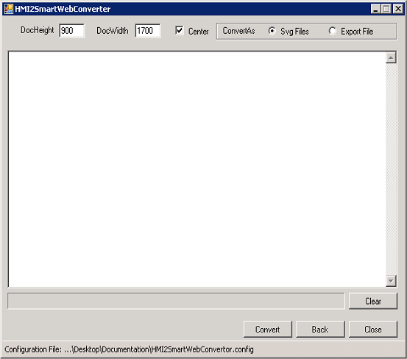

There are a few final properties to tune before converting:

* DocHeight - document/display height in pixels.
* DocWidth - document/display width in pixels.
* Center - if this checkbox is checked all display elements will be centralized.

Example: If DocWidth is 1700 and the display width is 1500, all elements on the page will be redrawn with an offset of 100 (pixels) from the left and the right side

* ConvertAs - provide two options. The Svg Files option will save each display in a separated file(recommended). The Export File option will combine all converted displays in one export file(deprecated).
* Button Back - navigate to the previous panel.
* Button Close - close the program.
* Button Convert - start converting.

When the conversion process has started, it will write information in the highlighted log zone shown below. It will log each processed element, how many elements are left, and converting time for each display. If there are multiple(more than one) selected displays for converting, the convertor will process them in parallel.

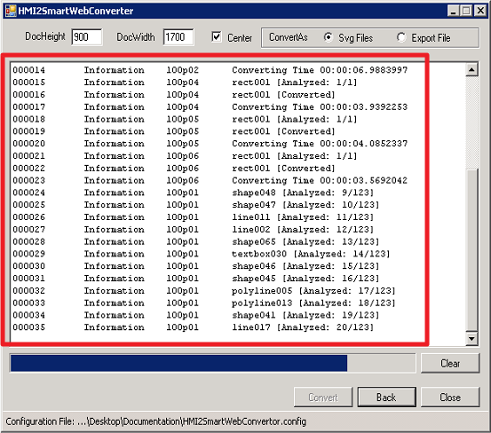

There is a progress bar which shows how many displays are left for conversion. If the progress bar is full, the conversion process has finished. This will be indicated by the last log:

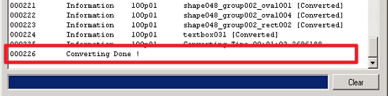

The result will be a set of SVG files for each display. These files are compatible with the Svg Editor, and can be used after they are imported.