This chapter describes the admin interface related to content management. The **SmartWEB** admin interface, also known as the Back-End or Admin Panel, is essentially the control panel for the entire website. The Admin Panel is the interface where administrators and other site officials with appropriate privileges can create and manage content, add functionality, change styling, etc. The Admin Interface Overview chapter provides an overview of other admin tasks and links to chapters with in-depth task descriptions.

## Content Management

Navigate to the Dashboard via the user options in the top-right of the page.

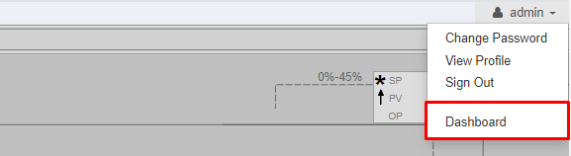

All of the Content Types that the user can use to create content are on the left side of the page, located under the NEW dropdown list.

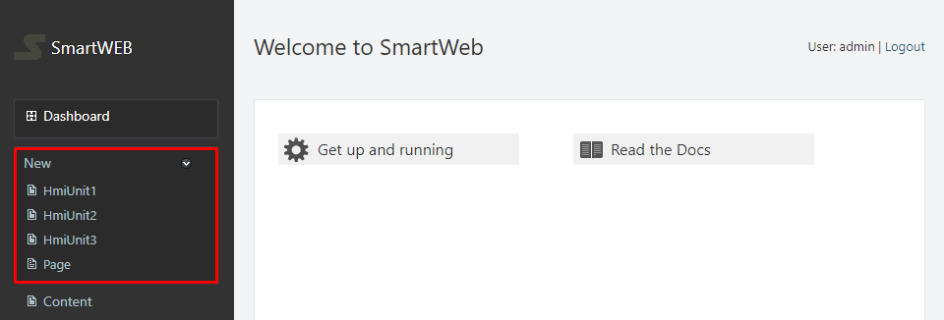

Under these Content Types, there is a link - Content. This link leads to the Manage Content section, where content can be reviewed, searched, created, and edited. In this section, all of the available Content Items (pages) can be seen. On the right side of each Content Item, there is a selection of actions allowed for that Content Item.

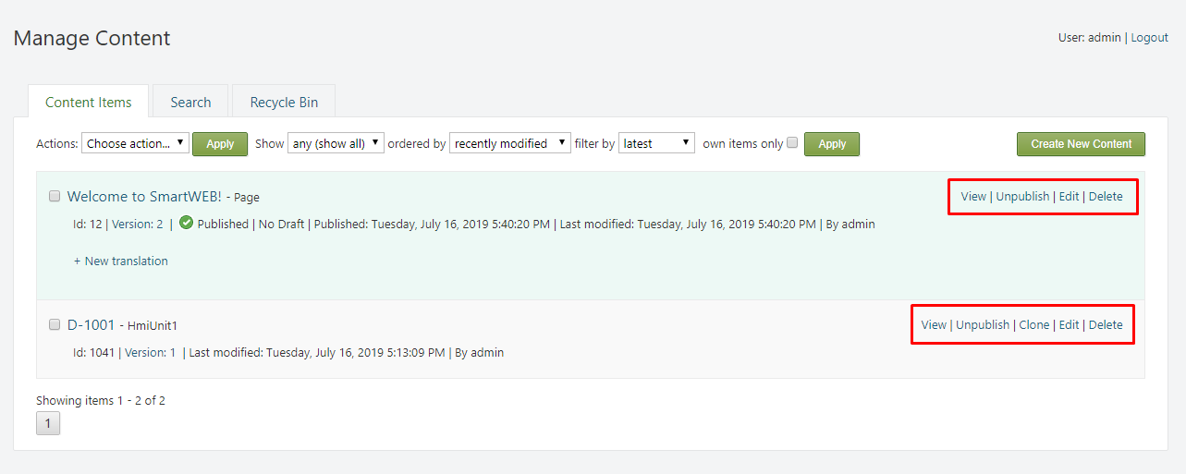

The actions which users can perform on Content Items (pages) will depend on the permissions their role has (Users and Roles). The administrator has unlimited access to every Content item and can perform every action. These actions include:

* Preview – preview an unpublished version of the Content Item.
* View – view a published version of the Content Item.
* Save - save the current version of the Content Item without publishing it.
* Publish – save the current version of the Content Item and publish it.
* Publish Later - schedule the publication of Content Item for a future time by setting a date and time
* Publish Draft – publish a draft.
* Unpublish – convert a published Content Item into a draft.
* Clone – clone the Content Item.
* Edit – edit the Content Item.
* Delete – delete the Content Item.

Users will only have access to only two actions on Content Items that are not created by them - View and Clone.

The following image represents the flow of content and the overall structure that is responsible for its management:

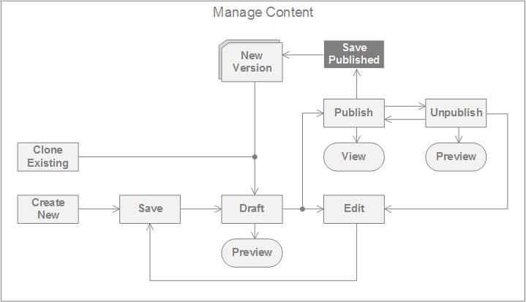

!!! attention "Attention:" When a page is published, the Edit option will not be available **to users**. If a user has to edit a published page, the page must, first, be converted to a draft via the Unpublish action. The user will then be able to edit the page. The **administrators** have the ability to Edit, Save and Publish content without having to Unpublish it first. This is represented in the image above via the Save Published element.

Content Items to which the user has no access will not have any actions displayed. If a short description can be seen, but there are no available actions, this means that the author of the Content Item does not have a published version, just a draft. When the draft is published, the user will be able to view the page and clone it. When a page is cloned, the user will receive a copy, which he is the author of. The user can then edit this copy and publish it under his own name.

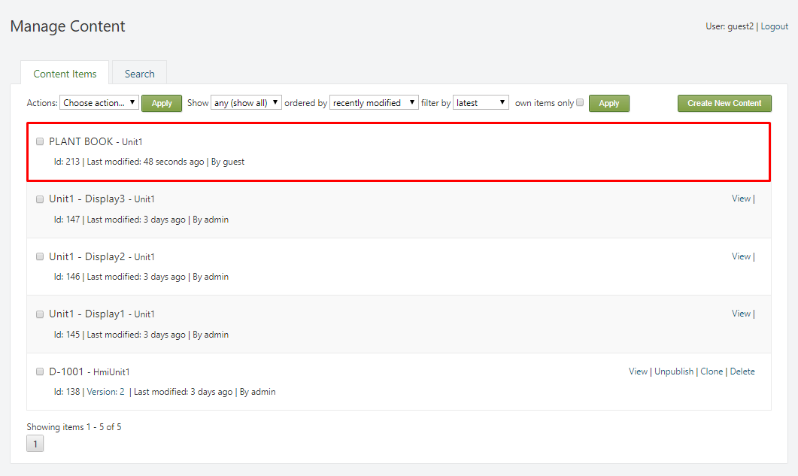

In the case where only the View action is available, the content author has a published version of the page, but has started editing a new draft, which is not published yet. In this case, the user can only view the last published version. When the author publishes the draft, the user will be able to clone the latest version.

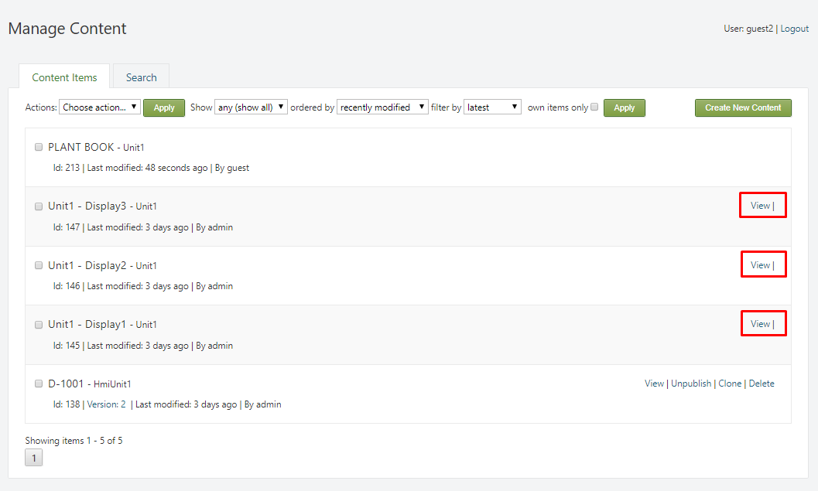

At the top of the Manage Content section, there is toolbar that is used to filter search results. The search results will strictly depend on the user's role. If the role is not authorized to create pages from a specific Content Type, results from that Content Type will not be returned.



The options that are provided by the toolbar consist of:

* Show – filter the pages by Content Type.
* ordered by – select the order in which the search results are returned:
  + recently created – show the most-recently created pages first.
  + recently modified – show the most-recently edited pages first.
  + recently published – show the most-recently published pages first.
* filter by – filter the results by:
  + latest – returns the latest version for each of the pages.
  + published – return only the published versions of the pages.
* own items only – (if checked) return only the pages created by the user.

## Searching

The system has built-in functionality that provides the ability to index and search Content Items (pages) in the application. In the admin panel, navigate to Content and select the Search Tab.

!!! note "Note:" The indexing functionality is provided by enabling the Indexing feature, along with a specific implementation of indexing (Lucene-based is included by default). In addition to the Indexing, the Search feature provides the ability to query the index (by keyword or using Lucene query syntax) to return a list of content items. Visit the Site Settings chapter for more information on indexing.

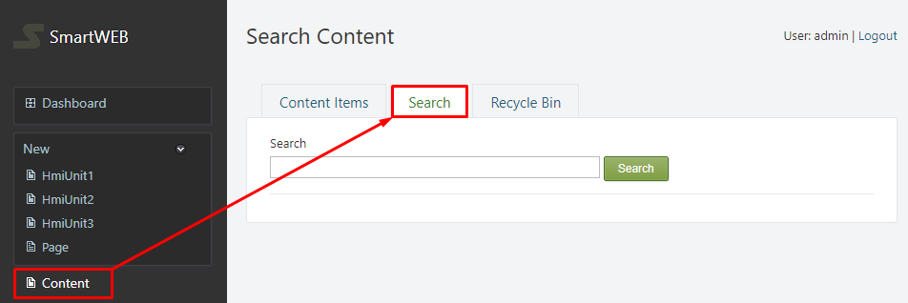

There is a selection of ways to search for a Content Item (page). The specific fields which represent the search criteria are configured within an index (Site Settings). For demonstration purposes, some of the ways to search for content will be shown:

!!!note "Note:" Due to the nature of indexing, it's good practice to use lowercase when searching for an item.

To look for a Content Item page by its title, simply enter the title in the search box and press the Search button. This will return all items that have a title that corresponds to the search criteria.

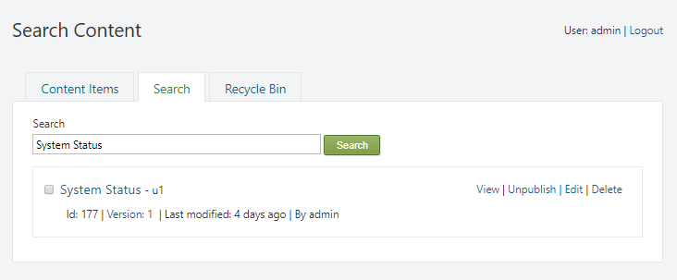

Additionally, specific words or phrases, found within a Content Item (page), can also be used to locate the specific item. In the example, all of the returned pages contain the word "**report**".

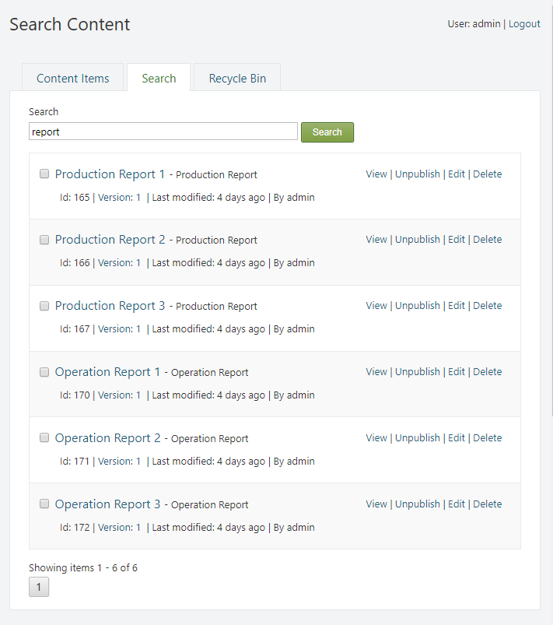

Searching for Content Items (pages) can also be done by using the technical name of their Content Type. This will return every available item from that **specific** Content Type. Example: **unit3**.

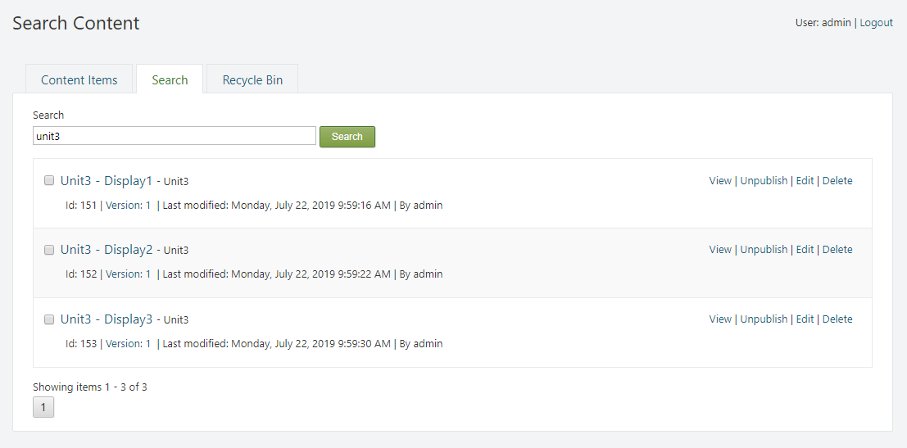

Using the authors name as the search criteria is also an option. This will return all available Content Items (pages) that are owned by the author, whos name was used in the search. Example: **admin**.

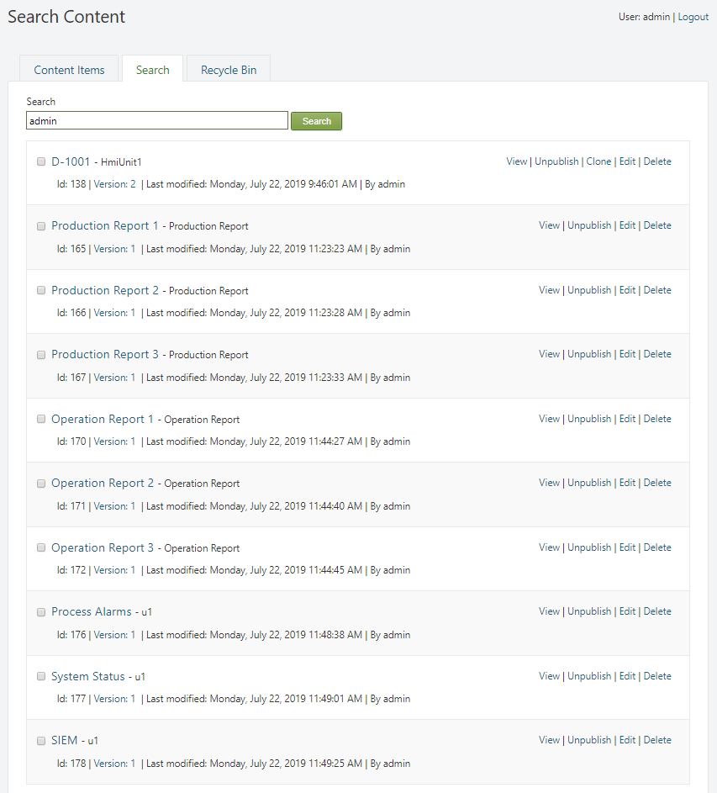

The [lucene query syntax](https://lucene.apache.org/core/2_9_4/queryparsersyntax.html) can be used to specify the index field that is being used as a search criteria. This will ensure that a specific criteria will be used in the search. In the example, we will search for pages that belong to the Content Type with the technical name - unit2. Example: **ltype:unit2**.

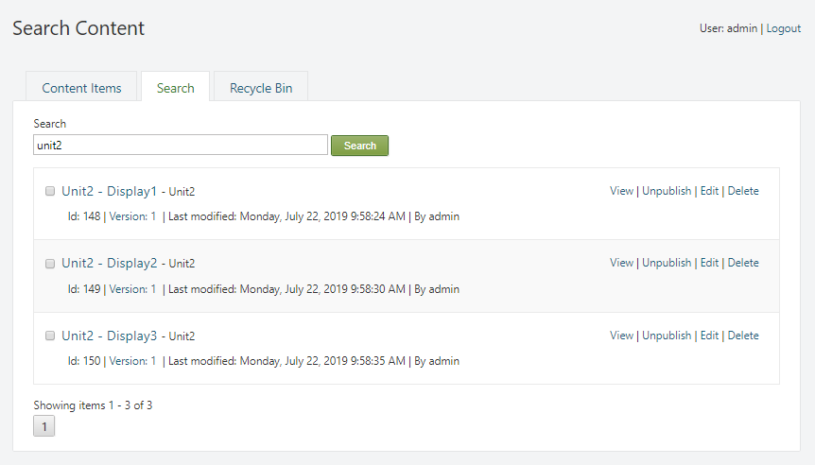

!!! attention "Important:"  
In order for the [lucene query syntax](https://lucene.apache.org/core/2_9_4/queryparsersyntax.html) to be used in the search, the Do Not Escape Query option must be checked (Site Settings).

## Recycle Bin

The Recycle Bin tab is an administrator feature that displays the items that are marked for deletion. When a Content Item (page) is deleted via the Delete action, it is not immediately destroyed, rather, it is moved to the Recycle Bin tab, where it can be viewed and restored later. In the admin panel, navigate to Content. Then select the Recycle Bin tab.

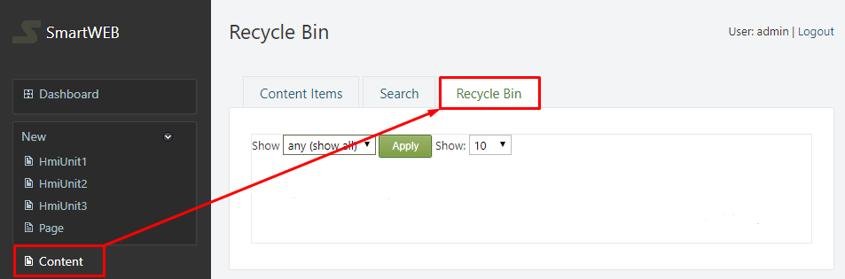

At the top of the tab, there is toolbar that is used to filter search results by Content Type. Additionally, the number of items returned can also be selected.

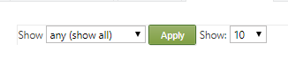

The pages are presented with a brief description, consisting of:

* Id - represents the position of the page in the database.
* route - the route of the page (used in urls).
* owner - the owner of the page.
* date deleted - the date and time when the page was deleted.

Only two actions are available for the deleted pages:

* Undelete - undelete the page.
* View - view the deleted page.

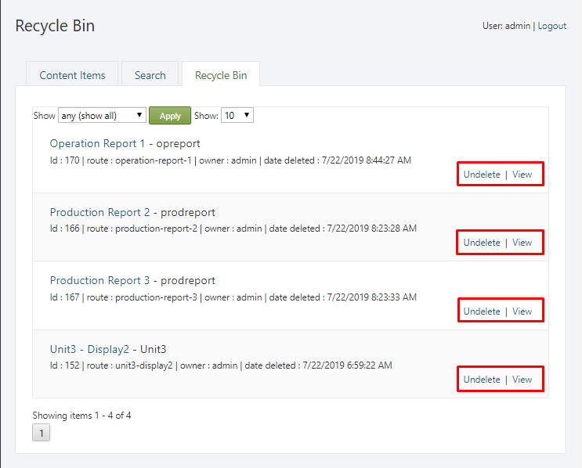

!!!warning "Important" When a Content Item is undeleted, the system will automatically generate a new Id for that item. This will cause changes in indexing, and in the database.