The Media module, in **SmartWEB**, provides a UI to upload and organize binary files that can be used while creating content. It is used to upload a resource that can be accessed anywhere in the system.

## Media Library

The Media Library can be accessed via Dashboard > Media. Here the user is be able to see and utilize media files, which are stored in specific folders in a tree-like structure.

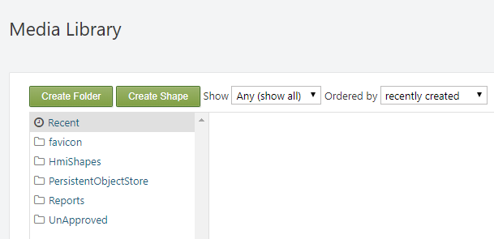

!!!warning "Important:" In order for a user to be able to manage media in the Media Library - his assigned role must have the respective permission checked. For more information on users and roles visit the  
Users and Roles chapter.

!!!warning "Important:" Note that a file that is not imported via the Media Library does not have a content item created for it, and is not visible.

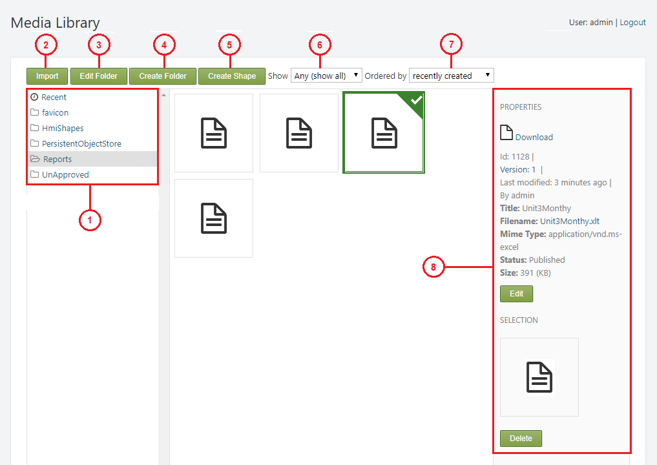

!!!note "Note:" The Import and Edit Folder options will be displayed after the user has selected a folder.

* The files are stored in folders in a tree-like structure.
* Recent - displays the most recent files.
* favicon - web icon.
* Hmi Shapes - stores the shapes that are in use (HMI Editor in-depth).
* PersistentObjectStore - contains Excel (.xlsx) files regarding - DISPLAYS, PARAMETERS, POINTS, SERVERS.
* Reports - stores the server reports in .xlt format.
* UnApproved - stores shapes that are in development (therefor are not accessible in the editor). It is not advisable to import anything into this folder, because it is a system folder, and newly created shapes are automatically stored in it.
* Import - the user can import files from an external source. There are three import options available:

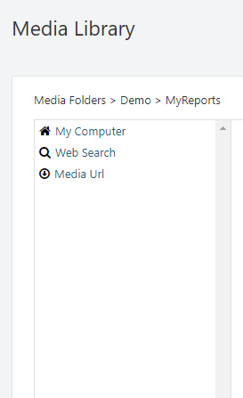

* My Computer - import a files from the computer on which the system is running.
* Web Search - import files via web search.
* Media Url - import files via a media url.
* Edit Folder - edit the selected folder.

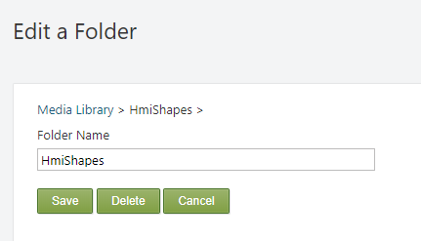

* The text field in which a new name for the folder can be provided if necessary.
* Save - save the new changes.
* Delete - delete the folder and all sub-folders that it contains.
* Cancel - cancel editing.
* Create Folder- create a new folder. In order to create a folder within another folder, you must first select the folder in which you want to create the new sub-folder by clicking on it.
* Create Shape - this option is used for creating shapes. Visit the Dynamic Shapes Development chapter for more information on shapes.
* Show - this dropdown list allows the user to filter the files by their type: Any, Audio, Document, External Media, Image, SVG, Video.

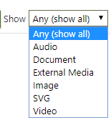

* Order by - this dropdown list allows the user to sort the files by: recently created, recently published, recently modified.

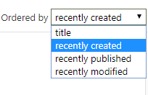

* This panel displays the property data of the selected file.
* id - The id of the file in the database.
* Version - The version of the file (content item that is created for it).
* Last modified - The time at which the file was last modified.
* By - The owner of the file.
* Title - The title of the file.
* Filename - The file name/extension.
* Mime Type - The mime type of the file.
* Status - The current status of the file.
* Size - The size of the file.
* Edit - allows the user to edit the Title of the file and provide a caption and/or alternate text.
* Delete - delete the file.

#### Example

The following example in intended to show the user how to create and structure files in the Media Library.

The first step is to create a folder, which for the purposes of this example will be named Demo, so it it can then be used to store files. This is done via the Create Folder button **4)**, as explained above.

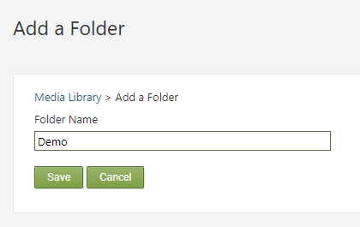

Enter the specific name in the Folder name field and click Save.

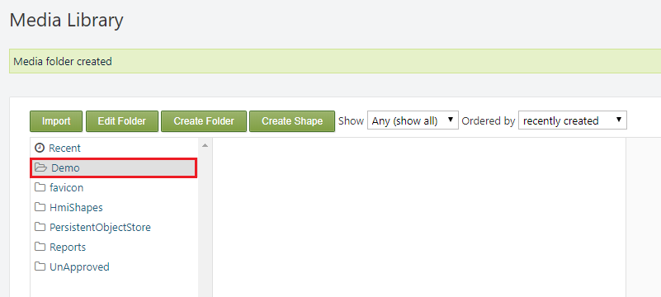

A *Media folder created* message can then be seen at the top of the page, and the recently created folder will be visible in the tree-like folder structure of the Media Library. We will then repeat the same process to create a sub-folder named - MyReports. Select the Demo folder with a left click to target that specific directory, and create the new sub-folder.

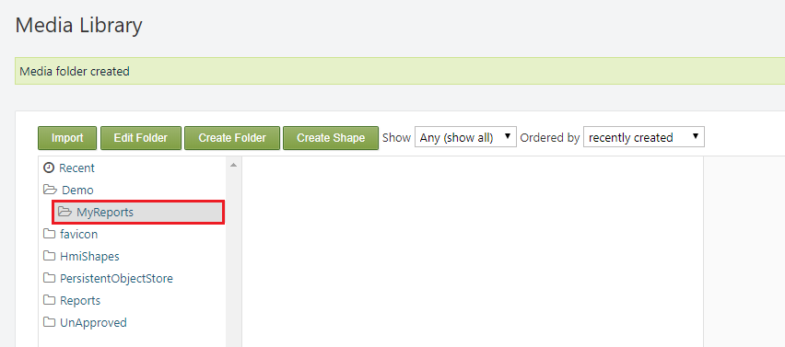

If the process was completed successfully there should be a *Media folder created* message at the top of the page, and the new sub-folder will be visible inside the Demo parent folder.

The folders are now created, but they are empty. To import files simply use the Import button **2)** as shown above. For the purpose of this example we will import a report file from the local machine.

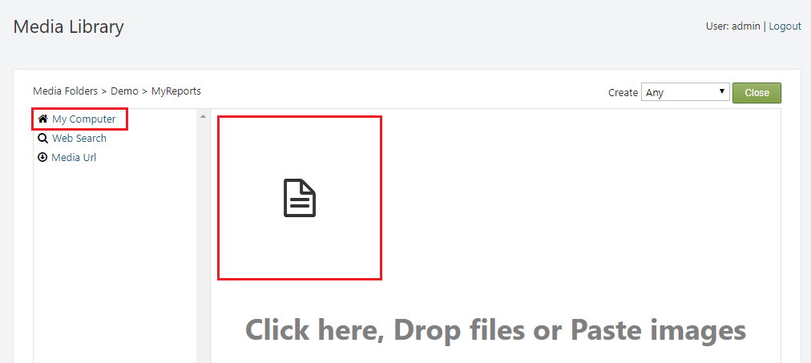

If the process was successful the file will be visible in the respective folder in the Media Library.

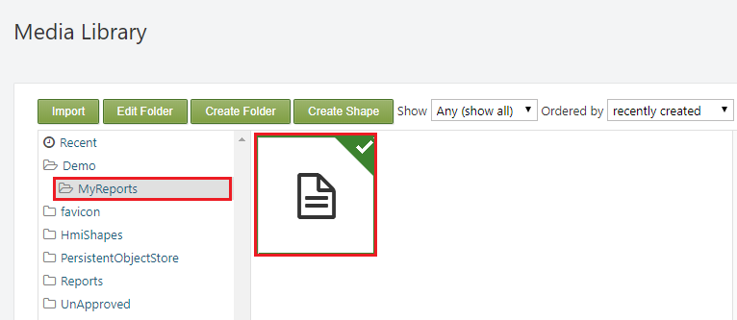

## Media Storage

The Media Storage is used to browse the physical files of the items that are present in the Media Library. The main purpose of the Media Storage in **SmartWEB** is to provide the url of a resource.

In order to be able to get the url of a resource, the user needs to navigate to its directory via the Media Storage section. For the purpose of this tutorial we will use the example that was given above - *MyReport*.

Navigate to Demo>MyReports>MyReport.xlt.

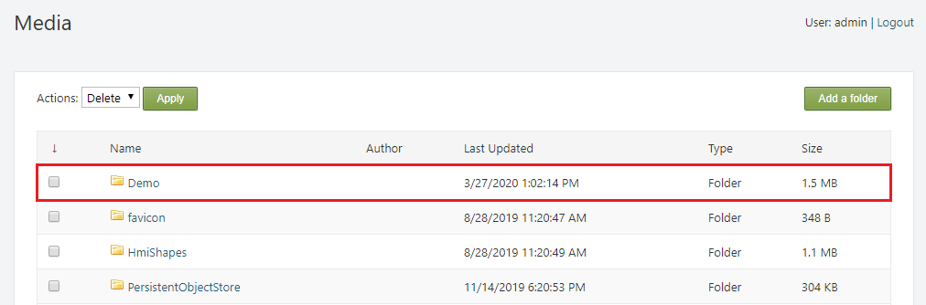

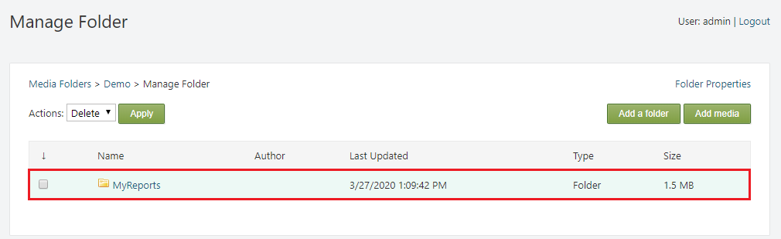

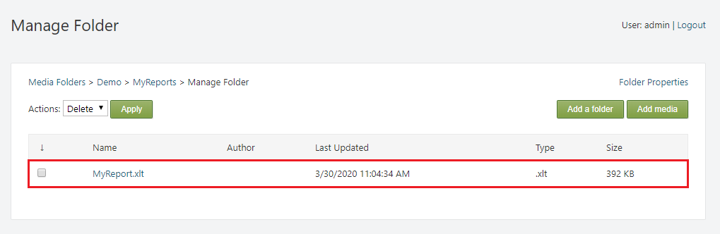

On this page the user will be provided with a link to the respective resource - in this case MyReport.xlt via the Embed field. The link can then be copied and placed where necessary in order to be utilized.

