Installing Micropython Firmware on ESP8266

This guide will provide instructions on how to flash an ESP8266 with Micropython firmware. If you encounter any issues or wish to learn more about Micropython, visit [Micropython ESP8266 Installation](http://docs.micropython.org/en/v1.15/esp8266/tutorial/intro.html#getting-the-firmware).

This guide assumes you have correctly wired and setup a serial UART communication line from your ESP8266 to your computer. If you have not done so, follow the “ESP8266_ProgrammerAndSerialUART_Wiring” guide.

Before you begin this guide you will need to download the following:

* Stable download of Micropython firmware, in this guide we will use v1.11
* Python installed on your computer, we will use v3.7
* “PIP” functionally in your command prompt (should come with Python)

1. Open your command prompt and run: pip install esptool

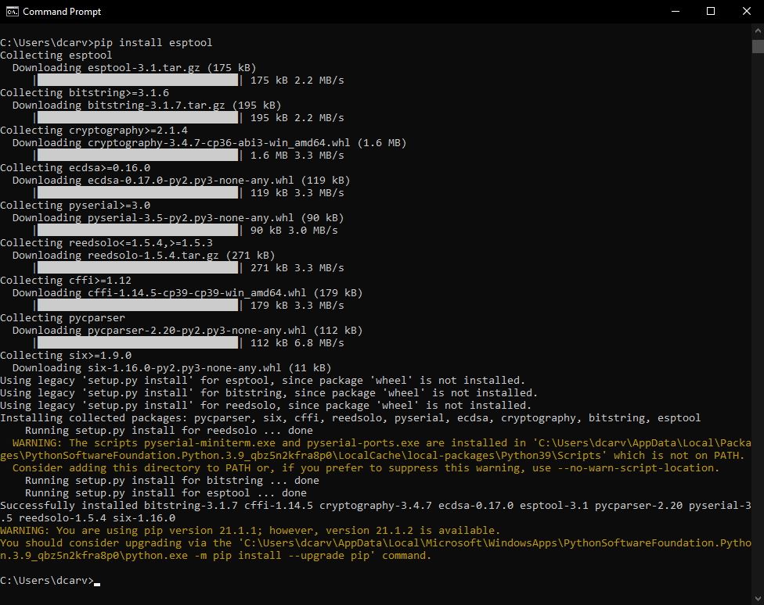

You should see a similar output. You can ignore the warnings, but you are free to run the suggested command to update your pip.

2. We will use the esptool to erase the current flashed firmware, run: esptool --port X erase_flash

Replace the ‘X’ with the port number that your ESP8266 is connected serially to. In this example, port COM5 is used.

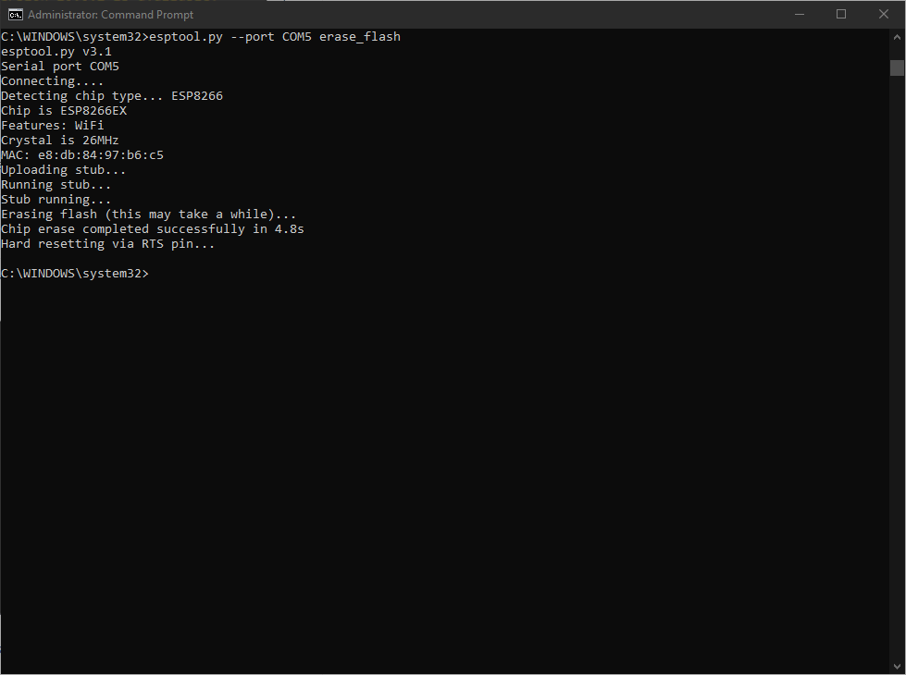

Successful clearing of flash will output something similar to the above

Error Notes: If ‘esptool’ is not recognized as an internal or external command, try using ‘esptool.py’. If neither work, you can try deleting and reinstalling Python. If the prompt gets stuck at ‘Connecting........_____.....’ , take the RST & EN wires out of the programmer and connect them to the same power as VCC, and take GPIO-0 and connect that to ground. The programmer can sometimes be unreliable.

3. Next, change to the directory you have the downloaded firmware in and run: esptool --port COM5 --baud 115200 write_flash --flash_size=detect 0 esp8266-20190529-v1.11.bin

You can replace “esp8266-20190529-v1.11.bin” with the name of the firmware bin you downloaded.

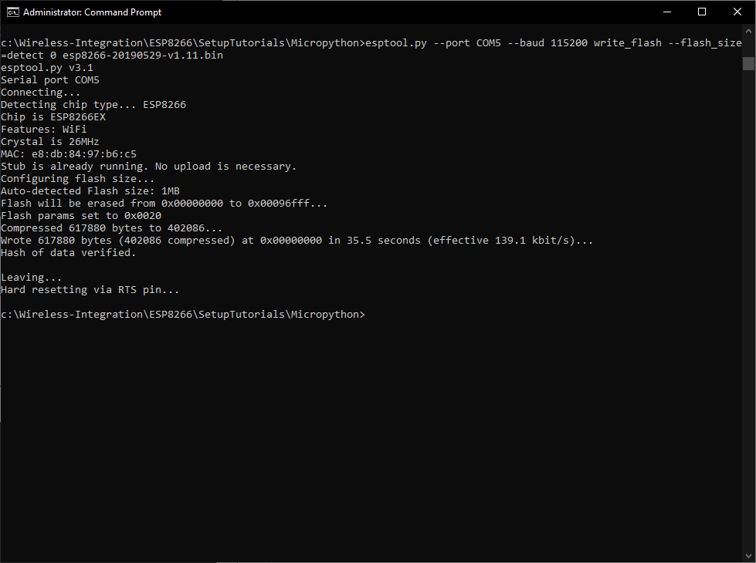

A successful Micropython installation should be similar to the above.

4. If the above lines run successfully, a clean Micropython install will be on your ESP8266