**Form Designer**

# Function

One objective of the data management system is to implement paper-based forms used during the test with the electronic ones, for example, test order forms, the test data record form, equipment maintenance forms, so that the data is stored in a structured manner in the database of the system, it become easy to query and use. Quantity of Forms is usually very large and types of forms are different, for example, each of the different test items has different data recording forms. A laboratory generally has dozens of different test items, each form usually has to be customized. One can imagine that the workload of implementing electronic forms is very large.

By using a Form Designer, one can implement business forms quickly and flexibly without programming, which greatly improves the efficiency of the implementation of the form, and the form can be modified at any time.

Form designer uses a Bootstrap instead of HTML Table to create "responsive" layout form, such a form can automatically adjust the width of the field, and the number of lines per page according to the screen size.

# Operations Guide

Form Designer interface is shown below, there is a toolbar and design region. The toolbar provides a variety of forms design elements and operations.

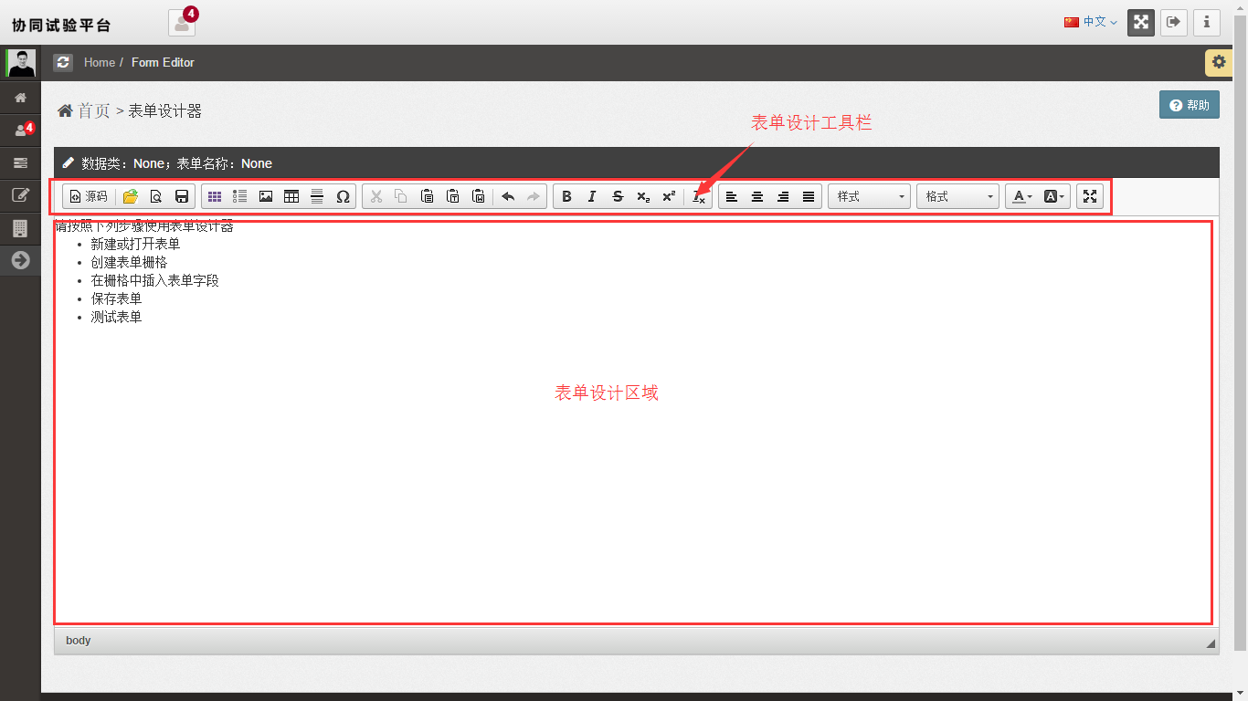

## Creating form

Here are the steps of creating a new form:

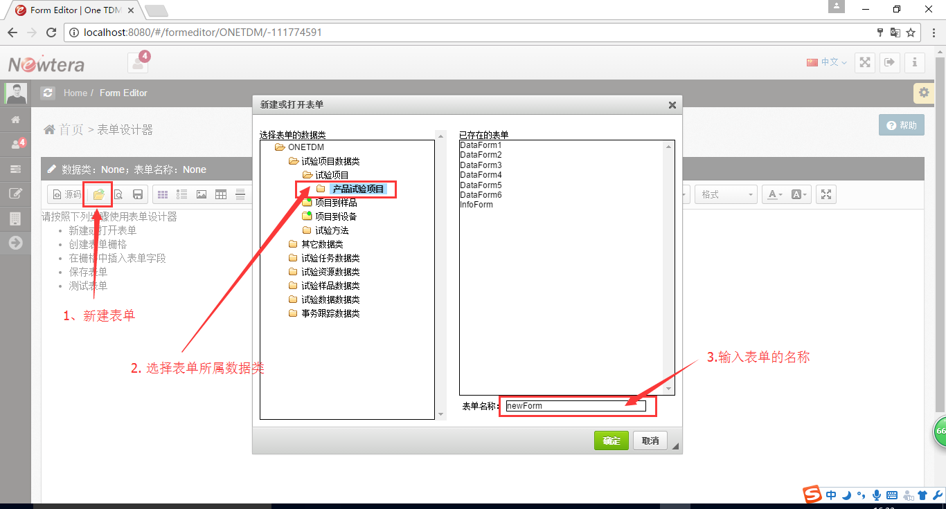

The process to create a blank form. First with the elements of the toolbar at the top of the form fill out the form title, will be able to design a grid layout of the form, the steps below:

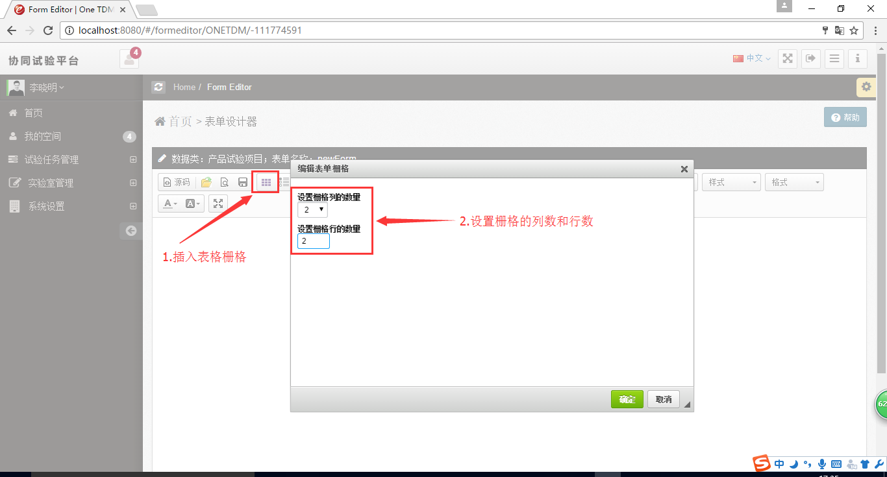

Next step is to insert a form design grid field following the steps below:

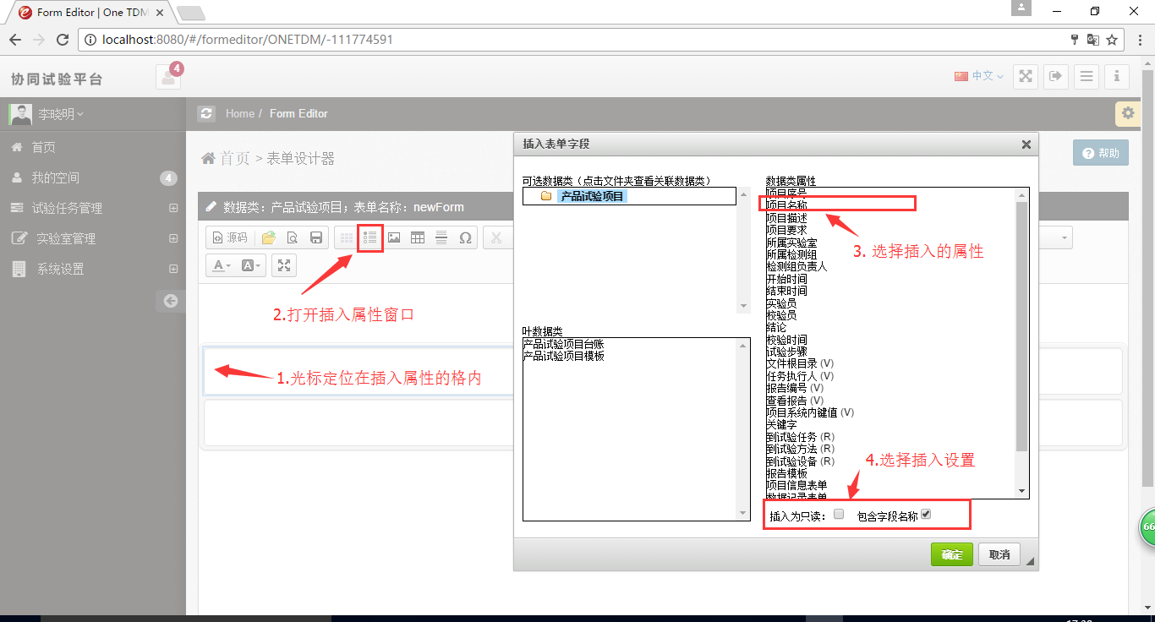

According to the above steps into a different field in all blank grid.

If you want to insert the associated data class fields, click on the top left of the folder appears with the form data binding class associated with the data type (one to many, many to one, one to one, or many-associated data type) . Selecting an associated data class. If the association data class is an abstract data type, then beneath leafy associated data type will appear. Select a leafy, leafy appears on the right of property, select a property, click on the "OK" button to insert property.

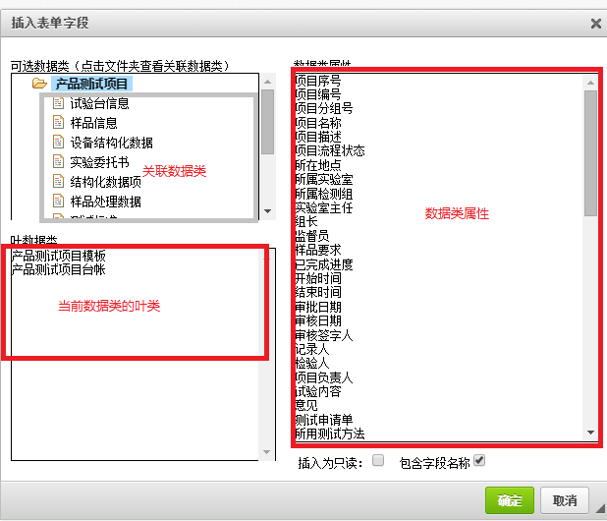

After the design is complete form, following the steps in FIG preservation and test the form.

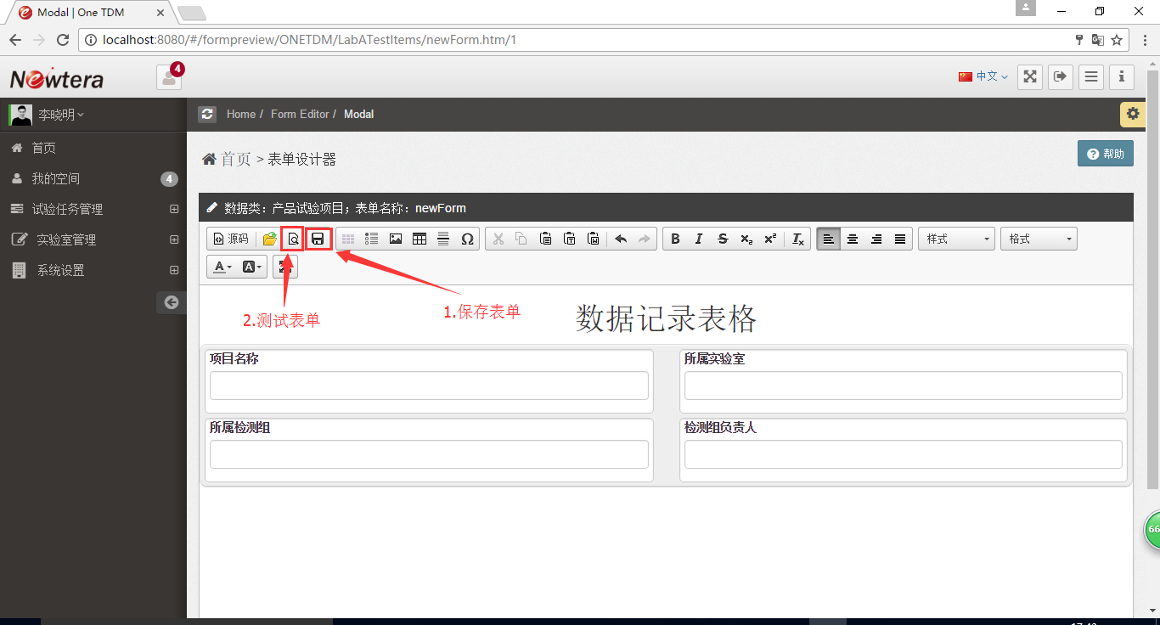

Test form is used to view the form of the final display. Form under test based on the definition of the field, shows the corresponding controls, such as drop-down menus, multi-line display, read-only, date and the like. See below:

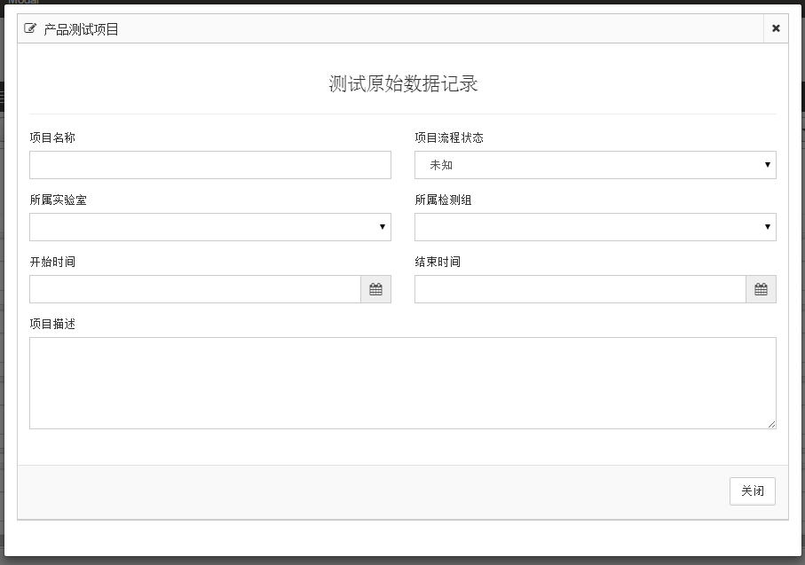

## Modify the form

To change the form, for example, increasing the field in the form, following the steps in FIG operation:

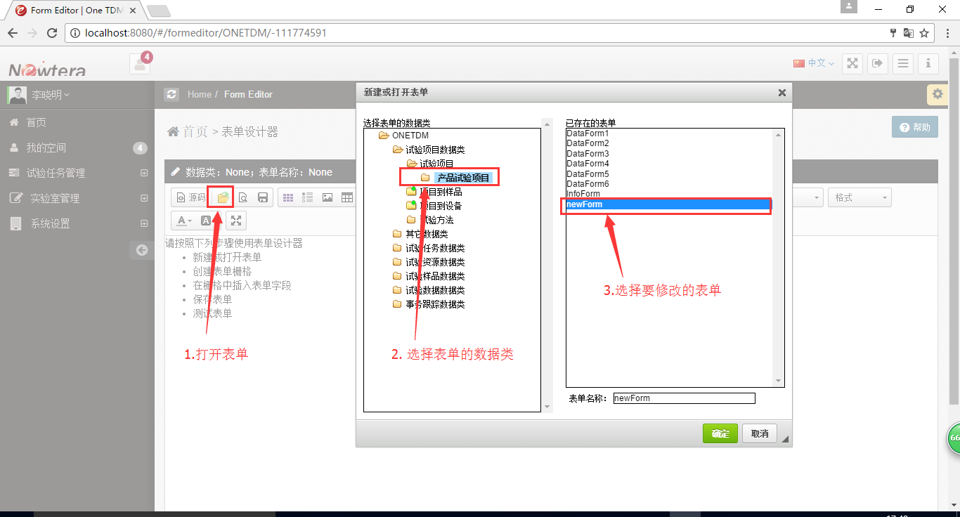

Next, the grid is inserted in the open form, as shown below:

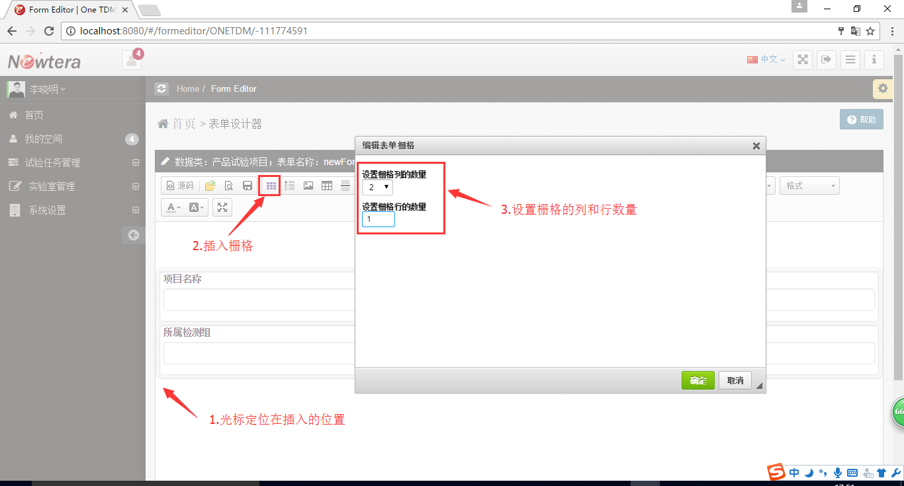

Then insert the inserted grid field, as shown below:

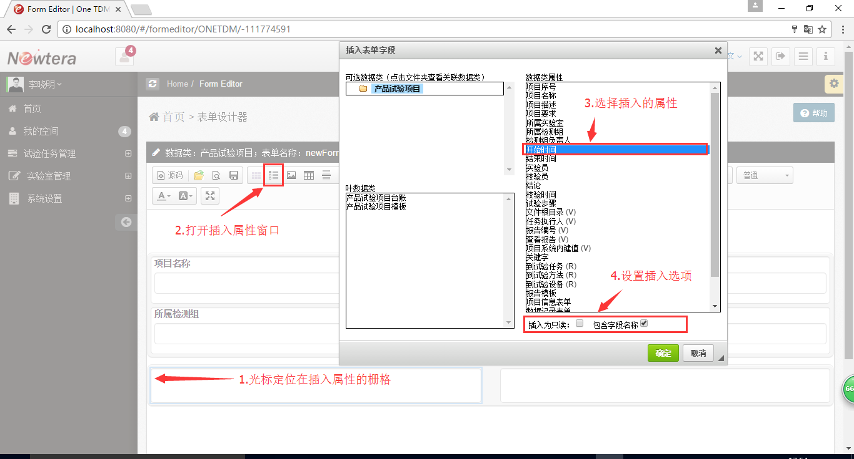

Finally, save and see the form of the final results, you can.

