AIoT Bedroom Environment

Au Ka Long

Sha Tin Methodist College, Hong Kong

Contact: [stmctommyau@gmail.com](mailto:First.Author@email.com)

Abstract— AI and IoT technology are used to improve the bedroom environment, making it easier to relax. Thermal cameras monitor objects and temperatures, while object detection models and algorithms analyse data and automate IoT devices. This environment can enhance living quality and working efficiency.

1. Introduction

Bedroom is a place to relax and recover from a tiring day. But there are multiple issues that make it difficult to rest. This project aims to use AI and IoT to solve these problems and create the most restful bedroom for your most exhausted moments.

1. Problems
2. Lights are on while ready to sleep and in bed

The issue is when we are in bed and ready to sleep, but the lights are still on. It is really exhausting and irritating for us to get up to turn off the lights when we are already in bed and ready to sleep.

1. *Lights are off while using phone*

Looking at a phone in a dark environment can strain our eyes [1].

1. *Air conditioning can't always provide the ideal temperature for sleeping*

* *Why temperature is important for sleeping?*

Temperature is essential for a good night's sleep. Research has shown that human body temperature has a direct

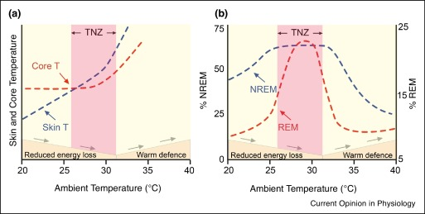 correlation with the percentage of REM(Rapid eye movement) sleep and NREM(Non-rapid eye movement) sleep.[2] The charts show that there is a clear relationship between body temperature and sleep quality. from fig.1 , where NREM has a high percentage on the TNZ(Thermal Neutral Zone).

fig. 1 Relation between temperature and NREM percentage [2]

* *Why cannot air conditioner provide the ideal temperature?*

The air conditioner cannot automatically adjust to the ideal temperature for human sleep. It keeps the same temperature, while body temperature and bed temperature fluctuate throughout the night. To guarantee a good sleep, the air conditioner needs to adjust its temperature accordingly.

1. *Danger inside bedroom*

Around 30% of domestic accidents happen in bedrooms.[3] Moreover, in the US, 450 people die each year from falling off beds.[4] This makes it dangerous for people to sleep alone without taking precautions.

1. Solution

We can use a thermal camera to monitor objects and their temperatures. An object detection model can then be used to recognize the objects. Various algorithms can be employed to detect different patterns and conditions from the data. The analysis results can then be used to automate IoT devices to solve the above problems.

Problem faced

The lack of thermal image datasets is a problem. This is because there are no standards for rendering them, making it hard to find enough data online to create a sufficient dataset. Moreover, I don't have enough items to collect the necessary amount of data.

Therefore, I use visual images for object detection while preserving the temperature data from the thermal camera as a temporary bypass.

1. Object detection model

Yolov5 is a widely used object detection model, known for its high speed and accuracy. The model used in the project has been pre-trained on the Coco datasets, with only the Person, Bed, Cell Phone, and Laptop classes enabled.

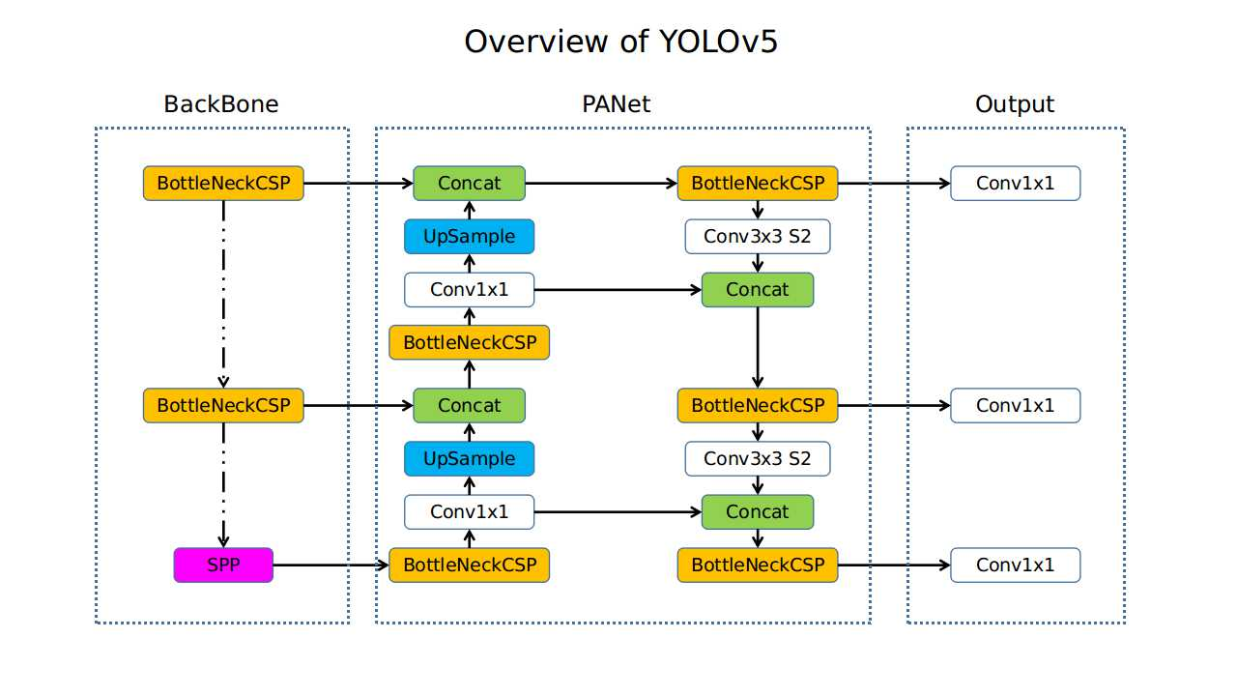Fig. 2 Yolov5 Efficiency toa accuracy [5]

Fig. 3 Yolov5 model structure [6]

1. Algorithms
   1. *Human Lying Detection*

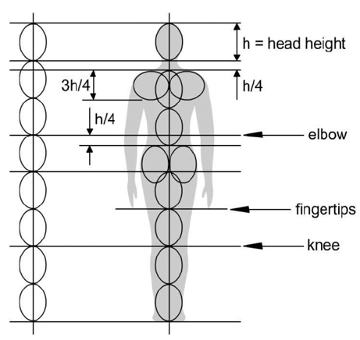The human shoulder-to-height ratio is typically 1:4[7], with a tolerance of 1:3 to 1:5. If a person matches this ratio, they are likely lying. If not, they are likely standing or sitting.

fig. 4 Proportions of the Human Body with Respect to the Height of the Head [7]

* 1. *Touching/On Another Object Detection*

To determine if an object is touching another, we can calculate the percentage of the first object's bounding box that is inside the second object's bounding box. For example, if a cell phone's bounding box is mostly inside a person's bounding box, we can conclude that the person is touching the phone, or vice versa.

* 1. Movement Detection

We detect whether an object is moving or not by setting the first frame coordinate as Ci. If the new frame of the object's bounding box is within a tolerance to Ci, the object is considered not moving. Otherwise, we reset Ci to the current coordinates. This can be used to detect if a human has fainted after a fall.

* 1. Calculation of the Temperature of an Object Inside a Bounding Box

We can calculate the temperature by taking the average inside the object's bounding box, while excluding other objects. However, since the bounding boxes are rectangles, there are unrelated parts inside the box. We need to filter them out to exclude extreme values. For example, for humans, we can exclude some ultra-cold or hot temperatures that are impossible for a human to have.

1. Networking

This project used socket networking to connect the thermal camera to the main processor (the PC). The current thermal camera is a mobile phone equipped with a thermal camera, so Java code was written on the thermal camera side, while Python was used on the main processor. However, since socket is a unified protocol, they can be connected seamlessly.

1. Actual use

We receive visual and thermal images from the thermal camera via intranet. We then use YOLOv5 to detect objects in the visual image. We then run algorithms on both the visual and thermal images. This allows us to do IoT automation with the results. For example, if a person is lying in bed and not touching their phone, we can consider them ready for sleep and turn off the lights. Or, if a person is using their phone, we can turn the lights on, etc. We can also set up other automations with other constraints.

1. Conclusions

In conclusion, this project seeks to leverage AI and IoT technology to improve the bedroom experience and make it easier for people to relax. I present a novel solution to the problems of the lights being on while in bed, the lights being off while using the phone, and the air conditioning not providing the ideal temperature for sleeping. I also discuss the danger of sleeping alone in a bedroom and propose a solution to monitor and detect objects and their temperatures. Finally, I implemented a networking system and discussed actual use cases for IoT automation.

This project enhances the bedroom environment better than ever before. There has not been much attention on specifically improving the bedroom environment, yet this is one of the places where we spend most of our time. With my project, we can achieve a cozy and safe bedroom for everyone to enjoy and recover. Moreover, this can improve the efficiency of people at work, as better rest and sleep quality have been proven to have a correlation with presenteeism.[8]

I hope this project can bring a new change to people's lives and offer an opportunity for technology to become part of their daily lives.

References

1. Afshan Yasmen, thehindu.com, Staring at your mobile in the dark could harm your eyes, <https://www.thehindu.com/news/national/karnataka/staring-at-your-mobile-in-the-dark-could-harm-your-eyes/article7721603.ece>
2. Edward C Harding, Nicholas P Franks,and William Wisden*, Sleep and thermoregulation*, *Current Opinion in Physiology*, vol. 15,pp. 7-13, Jun. 2020
3. 10-year average, Underlying Cause of Death: 2014,CDC,http://wonder.cdc.gov/
4. *SLIP, TRIP AND FALL ACCIDENTS: LIST OF SURPRISING STATISTICS*: https://callsam.com/blog/slip-trip-and-fall-accidents-list-of-surprising-statistics/, data from CDC, OSHA, etc. ﻿
5. Yolov5 GitHub repo: <https://github.com/ultralytics/yolov5>
6. seekFire, Yolov5 GitHub repo, issue 280, *Overview of model structure about YOLOv5,* [*https://github.com/ultralytics/yolov5/issues/280*](https://github.com/ultralytics/yolov5/issues/280)
7. Liyanage C De Silva, Audiovisual Sensing of Human Movements for Home-Care and Security in a Smart Environment, Proportions of the Human Body with Respect to the Height of the Head, *International Journal on Smart Sensing and Intelligent Systems,* Jan. 2008
8. Yoshiki Ishibashi MD, Akiyoshi Shimura MD, PhD, *Association between work productivity and sleep health: A cross-sectional study in Japan*, 4 Aug.2020