NAMI

In partnership with

THE UNIVERSITY OF NORTHAMPTON

BSc Computing

CSY1018 Web Development – I

Assignment 1

**Table of Content**

1. Introduction ------------------------------------------------------------------------------- 3
2. Getting Started ----------------------------------------------------------------------------- 3
3. Design -------------------------------------------------------------------------------------- 3
   1. Wireframes ---------------------------------------------------------------------------- 3
      1. Desktop view ----------------------------------------------------------------- 3
         1. Wireframe of homepage -------------------------------------------- 3
         2. Wireframe of CV ---------------------------------------------------- 4
         3. Wireframe of Bio ---------------------------------------------------- 5
         4. Wireframe of Contact ----------------------------------------------- 5
      2. Wireframes (Responsive) --------------------------------------------------- 6
         1. Homepage ------------------------------------------------------------- 6
         2. CV --------------------------------------------------------------------- 7
         3. Bio --------------------------------------------------------------------- 7
         4. Contact ---------------------------------------------------------------- 8
   2. Logo sketch ------------------------------------------------------------------------- 8
4. Good Practice ----------------------------------------------------------------------------- 9
   1. Header and Footer ------------------------------------------------------------------- 9
   2. Navigation ---------------------------------------------------------------------------- 10
5. Final Design ------------------------------------------------------------------------------- 11
   1. Desktop view ------------------------------------------------------------------------- 11
      1. Homepage --------------------------------------------------------------------- 11
      2. CV ------------------------------------------------------------------------------ 12
      3. Bio ------------------------------------------------------------------------------ 13
      4. Contact ------------------------------------------------------------------------ 14
   2. Responsive --------------------------------------------------------------------------- 15
      1. Homepage --------------------------------------------------------------------- 15
      2. CV ------------------------------------------------------------------------------ 16
      3. Bio ------------------------------------------------------------------------------ 17
      4. Contact ------------------------------------------------------------------------- 18
6. Validation ---------------------------------------------------------------------------------- 18
   1. W3C markup Validation ------------------------------------------------------------ 18
   2. W3C validator Validation ----------------------------------------------------------- 19
7. Progression of webpage over 12 week ------------------------------------------------- 20
8. Collaboration ------------------------------------------------------------------------------ 23
9. Conclusion --------------------------------------------------------------------------------- 23
10. **Introduction:**

This is the report based on the assignment of designing own portfolio site. And this report is also a brief description about the things I have done during the development. I have changed the design throughout the development of my portfolio. I have tried to match the color combination and gave my cent percent effort to make the better design using HTML5, CSS and CSS3 properties. In order to make my page responsive I have used media queries.

1. **Getting Started**

Before started my assignment, I looked the personal site that the university provided in our NILE and got enough idea to create my own portfolio site. Soon, I commenced creating layout and logo. Also, I have got some of the idea from my own college’s webpage about the animation and transition that I have included in my site either. Furthermore, I got some other ideas for creating my site when my friends asked me for help to make them understand how to use CSS properties properly and started showing few personal website. I haven’t used any bootstraps for developing my site. All I did is creating on my own just by the idea I got. The websites from which inspired me is listed below:

1. <https://joel.sh/>
2. **Designs**
   1. ***Wireframes***

Before starting the development of any webpage there is a practice of drawing wireframe for the effective and efficient way to create the page. Thus, at first, I begun to draw the wireframe for my homepage directly in paint without drawing any rough sketches and after that other pages. Now-a-days, people access websites not only through Computers but also through mobile phones. Thus, keeping this in mind, I have drawn the wireframe for both desktop view and mobile view.

* + 1. ***Desktop view***
       1. ***Wireframe of Homepage***

Here is the wireframe for my homepage. At the top-left I am planning to put logo and address at top-right side. Just below these, I am planning to keep navigation to the other pages. These will be in header and at the bottom, there will be three equal sized division and the left one will contain about me content while the second and third division will contain Social media links linked through the icons and copyright information respectively and these will be arranged in row. And in the section part I am planning to write few quotation at the left side and another side will contain image.

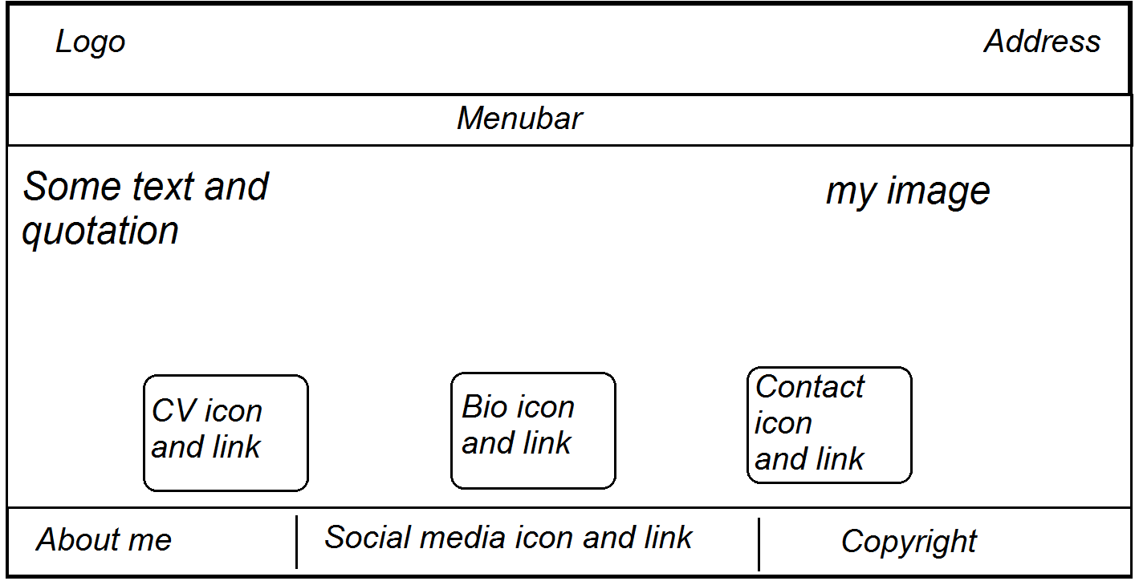

* + - 1. ***Wireframe of CV***

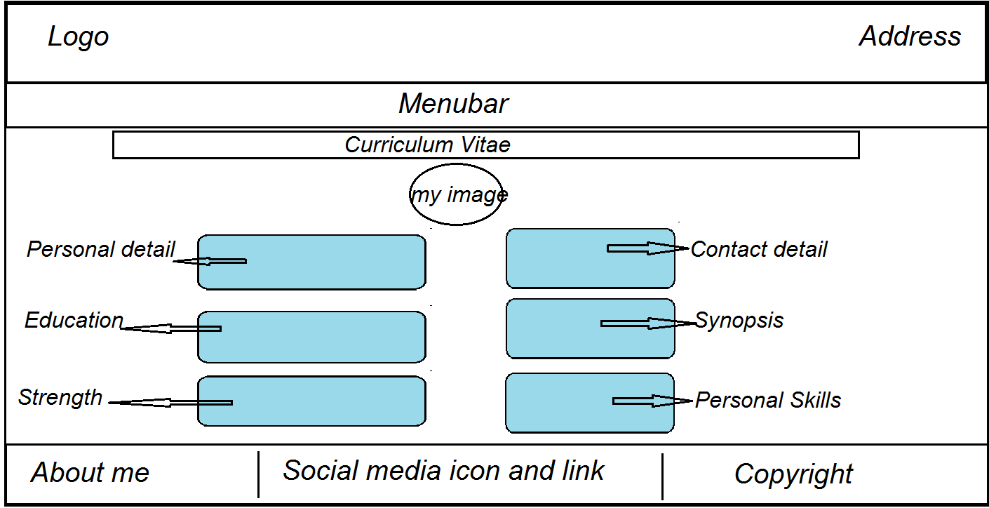

In the above wireframe, I am planning to keep the header and footer as in homepage and in the section part I will keep a heading of the CV and just below the heading, there will be an image and below the image there will be my brief detail. And also I am thinking of keeping some transitional effect in every content of section of this page.

* + - 1. ***Wireframe of Bio***

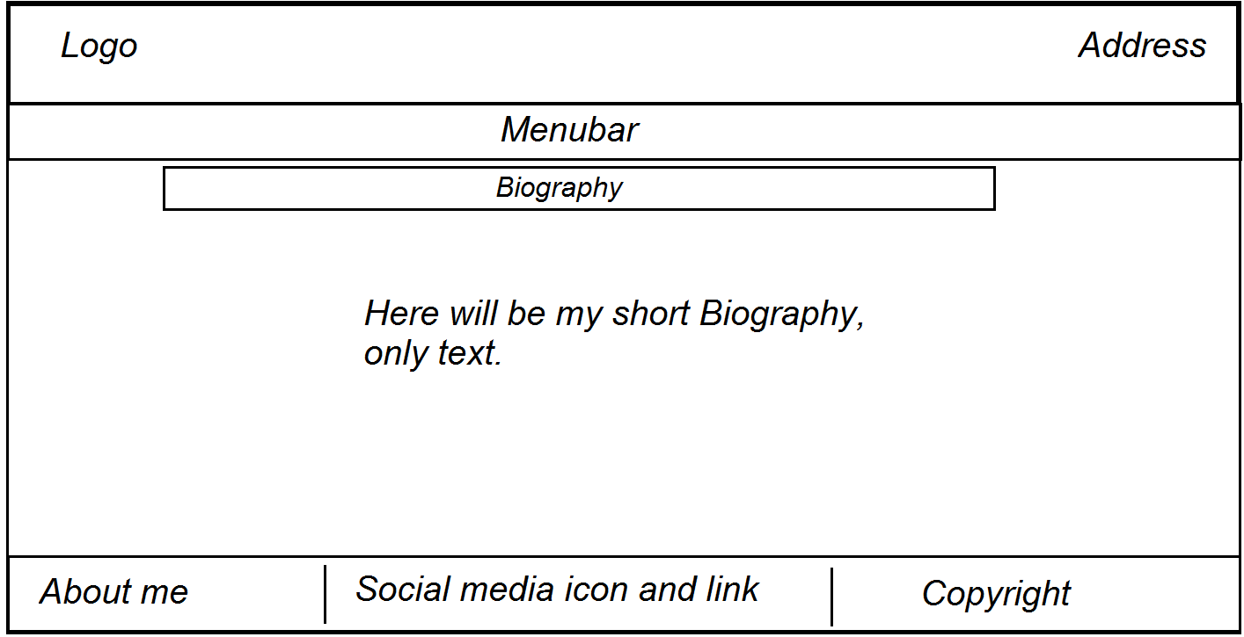

This is the wireframe for my biography and I am thinking of writing a brief detail about me and this section will contain only textual information.

* + - 1. ***Wireframe of Contact***

The presented wireframe is of my Contact page and in the section part of this page, I am planning to keep form through which people may contact me at left side and at right side there be my phone numbers and email address.

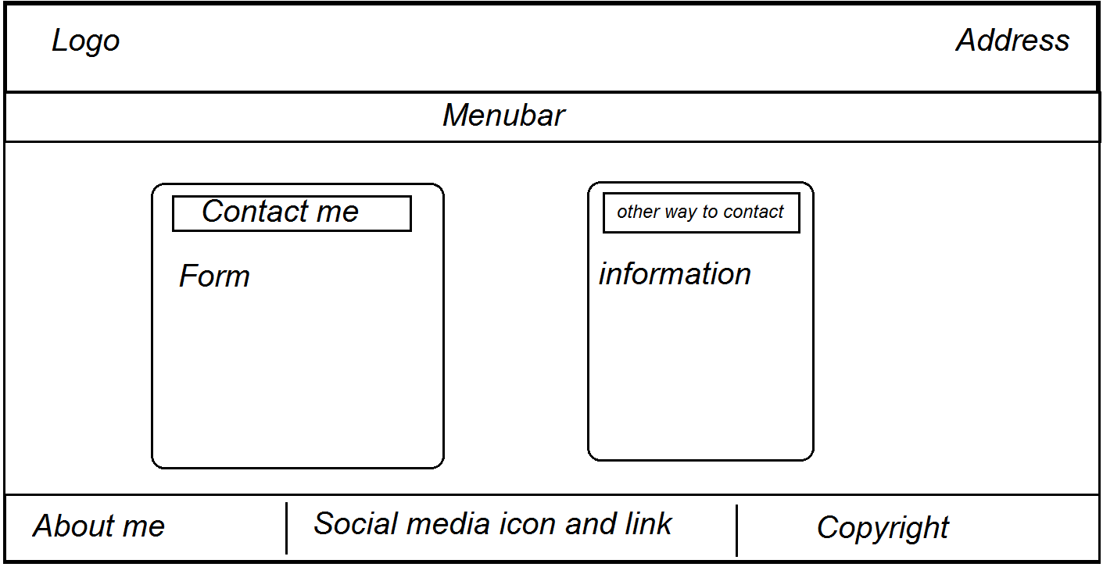

* + 1. ***Responsive***

When someone access this page in mobile then they find that all the content of the section part are shown in column whereas in desktop there would be content in row as the large screen of computers.

* + - 1. ***Wireframe of Homepage***

In the responsive view I will keep the logo same as it is in desktop view and the footer will be changed. The content of the footer will be kept in column and these header and footer will be same for all other pages. There will be modification of the content in section part of this page. The left side quotation will be same but the image of right side and the lower division will be disabled and instead of these I will put background image. The wireframe of the homepage is shown below:

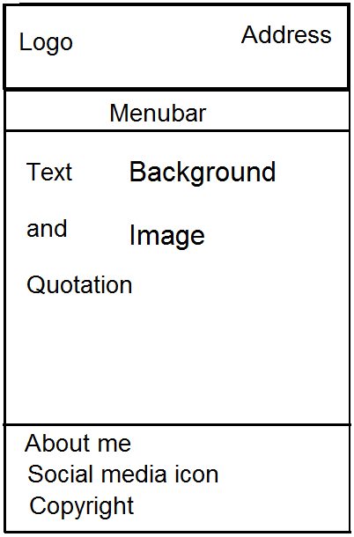

* + - 1. ***Wireframe of CV***

The header and footer of this page will be same for responsive and the design of the section will be changed. The transitional effect will no longer exist and all the content will be shown in column.

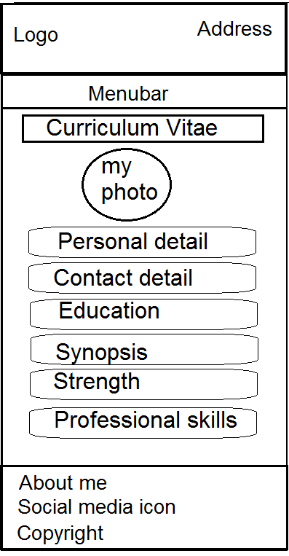

* + - 1. ***Wireframe of Bio***

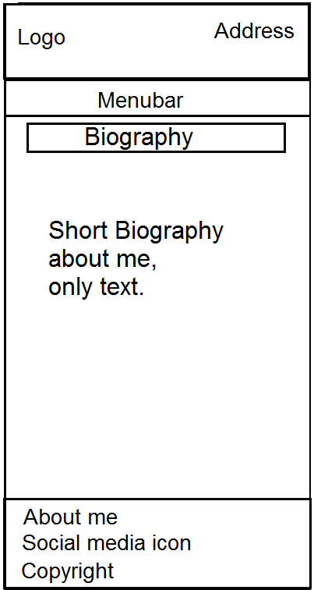

The above presented wireframe is of my biography and there will be no any changes in the section. It will be same as that was for desktop.

* + - 1. ***Wireframe of Contact***

In this page the header and footer will be same as in homepage and the content will be displayed in column. Any information inside the section will not be changed.

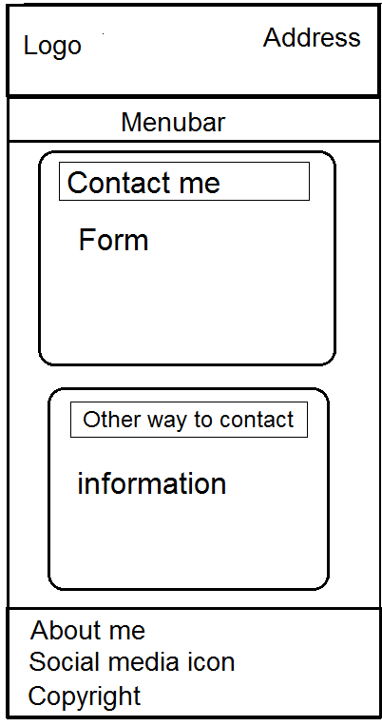

* 1. ***Logo Sketch***

Logo plays the vital role in identifying one’s identity. Thus, I have decided to make logo myself for my website. For this, I tried drawing many logos and at last I came up with the one. All the sketches that I tried are shown below:

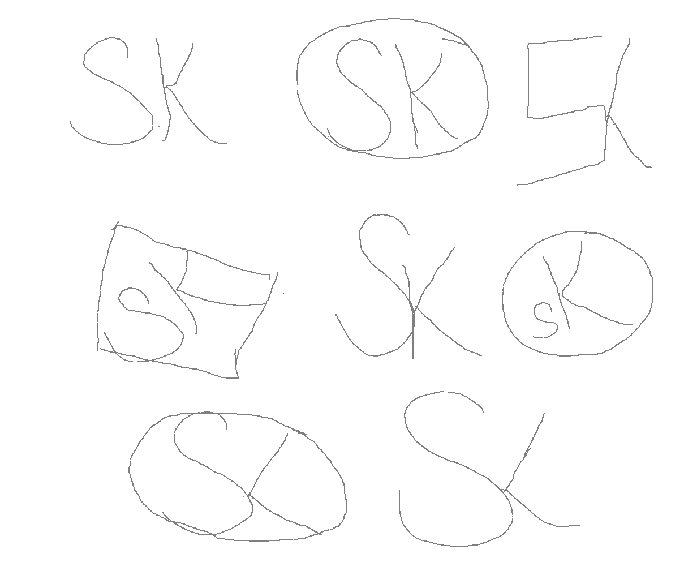

And then I begin creating logo and tried all of the sketched drawn above. Finally I choose one of all those I created whose sketch and actual logo is shown below.



1. **Good Practice**
   1. ***Header and Footer***

Among all the webpages, I surfed to collect idea, all of them contained header and footer in some different and attractive way. It is important to make the page attractive so that the visitors of the page would be infatuated. Thus I have also tried to make beautiful header and footer as it is static or same in all of the pages that I have created. The mock-up of header and footer is presented here.

1. ***Desktop view***

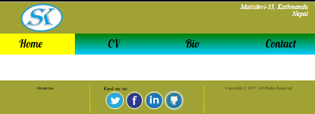

1. ***Responsive***

Here, in the responsive view, layout of the header and navigation is not changed. I have reduced the font size and other content whereas the footer is changed. The content of the footer were displayed in row in desktop view while in responsive, the content is shown in column using flex-direction property.

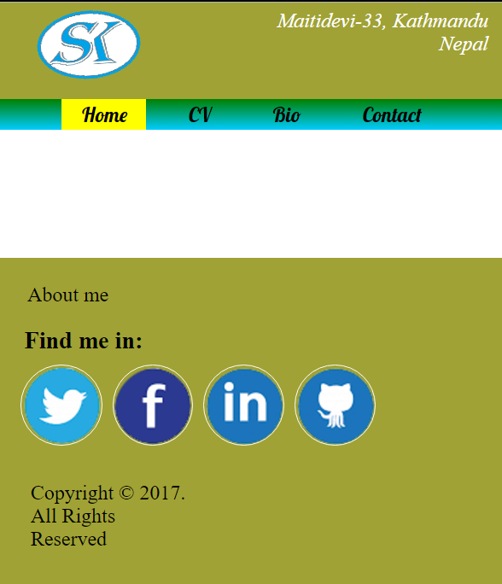

* 1. ***Navigation***

It is good practice to keep the navigation in every page such that it helps the user to navigate from one page to another and it must be available in each page for surfing pages efficiently and without wasting the time in searching the navigation here and there. Thus, I have kept the navigation or menu bar just below the header and it is visible from every page as it is set in each page. Furthermore, background color is set in the anchor of navigation to show in which page the user are at the instant. I have tried to fix the navigation bar at the top of the page so that while scrolling down the page it would always be seen at the top so, user do not need to scroll up to surf another page. Unfortunately, for some reason, I could not be able to create like that. The mock-up of the navigation is shown below:



1. **Final Design**

Here, I am going to represent the mock-ups or can say the final design that I have been working at. With the combination of different colors and different CSS property, I have created a beautiful and attractive page. As I had created the wireframe for both desktop and mobile, the pages are also created for both which are described and given below.

* 1. ***Desktop view***

As I have mentioned in my wireframe, at the top part of the body there is a header and inside header, at the left side there is a logo to enhance my page and at the right side there is address. Just below the header there is a menu bar or navigation and the navigation links homepage, CV, Bio and Contact. This navigation is kept in all pages that I have designed. And at the bottom of the page there is a footer and it contains about me, links to the social media along with respective icons and copyright information. These three content in the footer are shown in row using flex-direction property. The social media icon are rotated 360 degree when hovered. And these content will be the common part for all page. And the section part of each page are different. The mock-ups for the desktop view are represented below:

* + 1. ***Homepage***

This is the homepage for my portfolio. Section part of the homepage includes two divisions that are kept in column and the upper division is further divided into two equal division and shown in row. The left division of the upper one contain quotation and the right one contains my photo. The lower division is further resolved into three divisions. The left-most division of the lower division contains an image of a paper that links to the CV and the middle division contains an image of diary that links to the Bio and the right-most contains an image of contact book that links to the contact page of my portfolio. This images of lower division when hovered, overlay is displayed as a transition that arises from the right side.

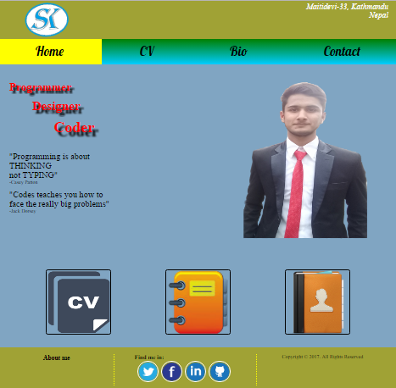

* + 1. ***CV***

The picture mentioned below is CV page of my portfolio. The section part of this contains heading, image and information of my experience and personal details. I have used transitional effect in all of the content of this page. When cursor is moved near to the image and other content, these will be magnified. And in every heading I have used text-shadow which on hover changes to another color text-shadow.

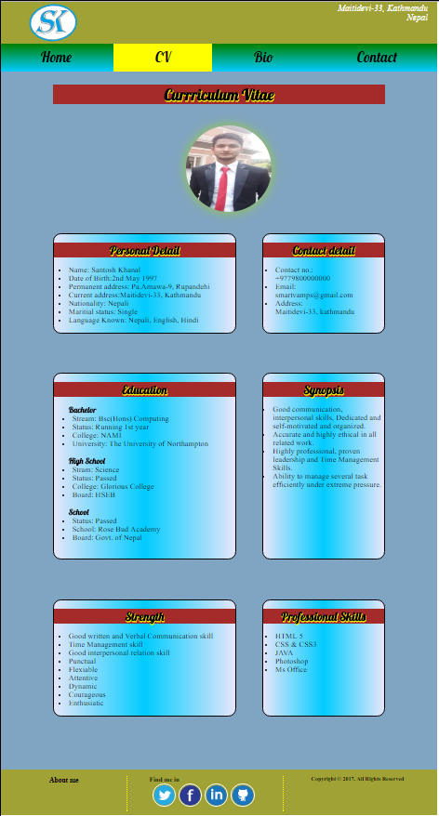

* + 1. ***Bio***

The picture of my biography page is mentioned below and the section of this page contains heading and biography. I have not kept any pictures in the section of this page, it includes only textual information.

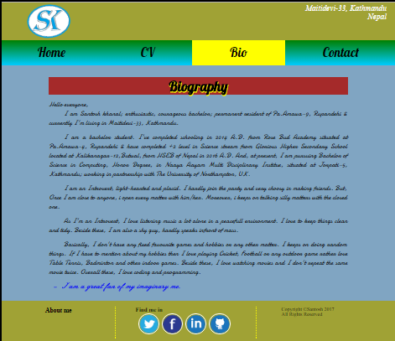

* + 1. ***Contact***

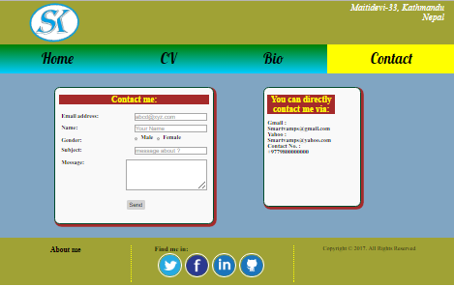

This is the final design of the contact page. One can contact me either by filling the form or directly via email and phone number. The section part has two divisions. Left division contains the form to contact me and the right one contains the email address and phone number. Both of them are enclosed using border.

* 1. ***Responsive***

I have designed my page for mobile view either because user may access the page from any device. For responsive, I have made a slight changes in the designation. The header and the navigation are same as in the desktop view. I have reduced the font-size, image size and padding. The footer is changed in responsive. Three content of the footer i.e. about me, links to the social media and copyright information; in the desktop view were in row but in the responsive view these are shown in column. The header and footer are too same for all pages in the responsive view as that were in desktop, only the section part is changed in all pages. The screen-shot of the responsive are presented below:

* + 1. ***Homepage***

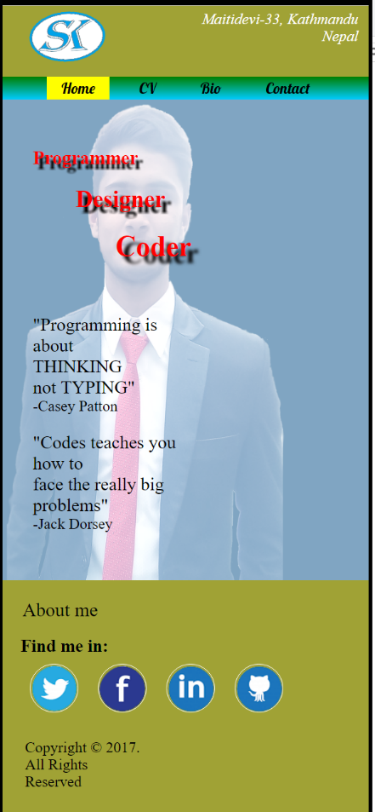

All the content of the section that were arranged in row in desktop view are changed to column in responsive. And the image in the right division of the upper division is hidden and instead of that image, background image has been kept. The transition in the images of lower div are also hidden in responsive view.

* + 1. ***CV***

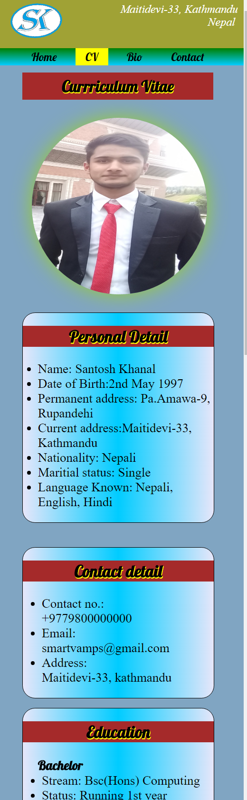

Any content of this page are not changed but all the transition that are in desktop view are disabled in responsive view. All the divisions are kept in column.

* + 1. ***Bio***

This is the bio page and the content of the section of this page are not changed. It is kept same as it is in desktop view.

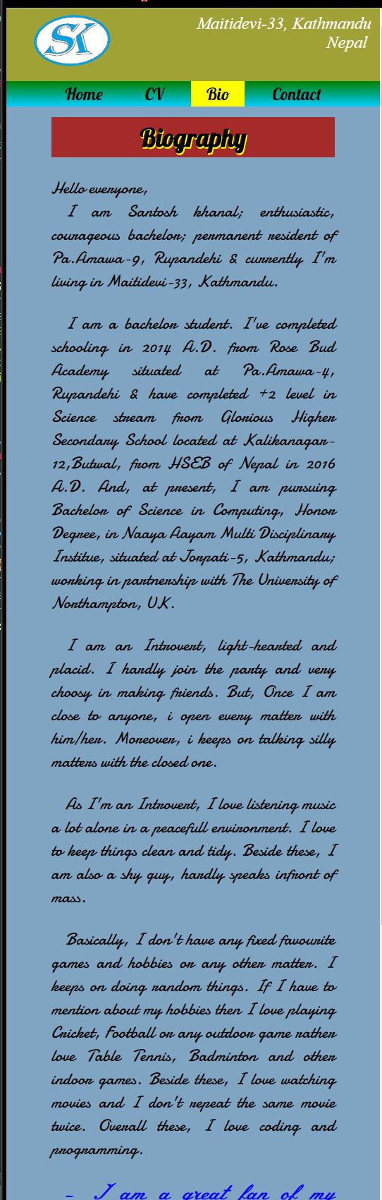

* + 1. ***Contact***

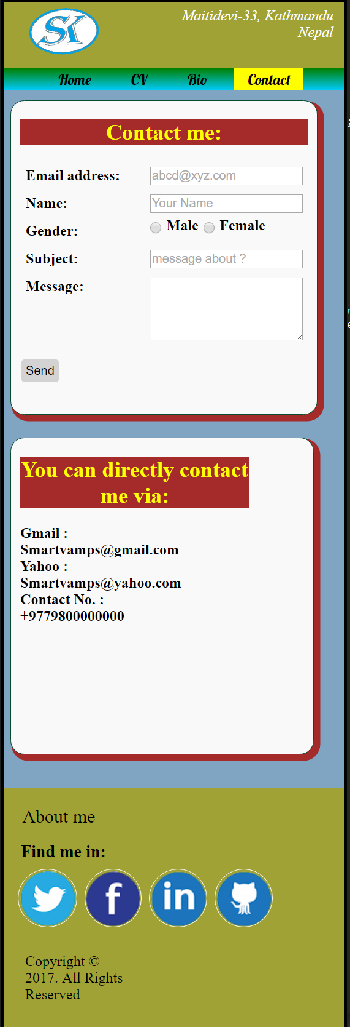

Contact page is shown above and I have kept the division of this page in column.

1. **Validation**

To ensure the use of tags and properties of HTML and CSS correctly, I have validated it online through the site that the university provided. The results of the validation are shown below:

* 1. ***W3C Markup Validation***

1. ***Homepage***

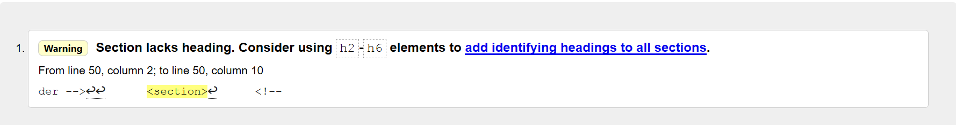

When validating homepage, the result I got is only warning.

1. ***CV***



There was no errors or warning in CV page.

1. ***Bio***

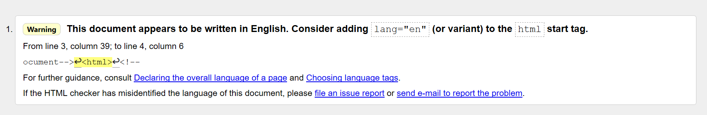

In the bio, the result was warning for not assigning language. But I have used meta charset tag here.

1. ***Contact***



The result of the validation was good as there was no any errors or warning in this html document.

* 1. ***W3C CSS Validation***

The results of the validation of the CSS property are good. There is no any error in the CSS properties in any of the CSS stylesheet document. The result is shown below:



This is the result that the validator generated when checked.

1. **Progression of webpage over 12 week**
2. ***Week 1-4***

In the first month from the starting of the course, I learned the most of the element of the HTML5 and also learned to use few CSS3 properties. In this period of time, I learned to design layout, give background color, link sites and other html page and a few about using flex-box. Here, I present the layout of my portfolio that I was able to create in first month.

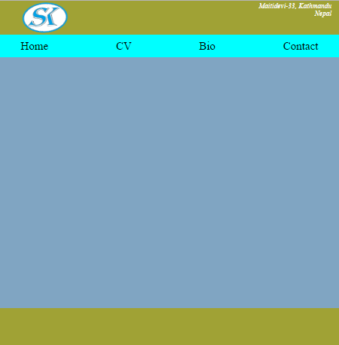

1. ***Week 4-8***

Between the weeks 4 to 8, I learned most of the CSS3 properties and was well known to use flex-box, import google fonts, add images, give border, and add blocks, hover text and images, and many more. I was able to create an attractive static webpage between these weeks and was also able to make a bit responsive design. The progress I made in these weeks is shown below by presenting the design a simple homepage of my portfolio.

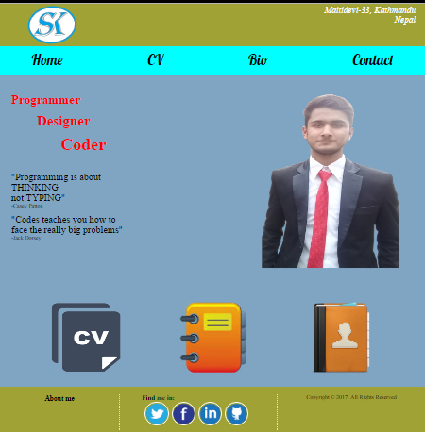

1. ***Week 8-12***

In the last 4 week, I was able to create a full web page using HTML5 and CSS3 element. And between these weeks I learned to use transitions, gradient, make responsive design. In the homepage, just above the footer, I have kept images and the linked them to my other pages and there I have used overlay and transition to hide and show text when hovered. But in responsive view, I have disabled those image and added background image by hiding the right side’s image seen in desktop view. Here, I represent the glimpse of my webpage through my final web page in desktop view as well as in mobile view which I made by the end of 12th week.

1. ***Desktop view***

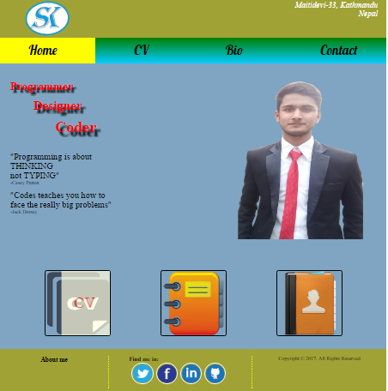

1. ***Responsive***

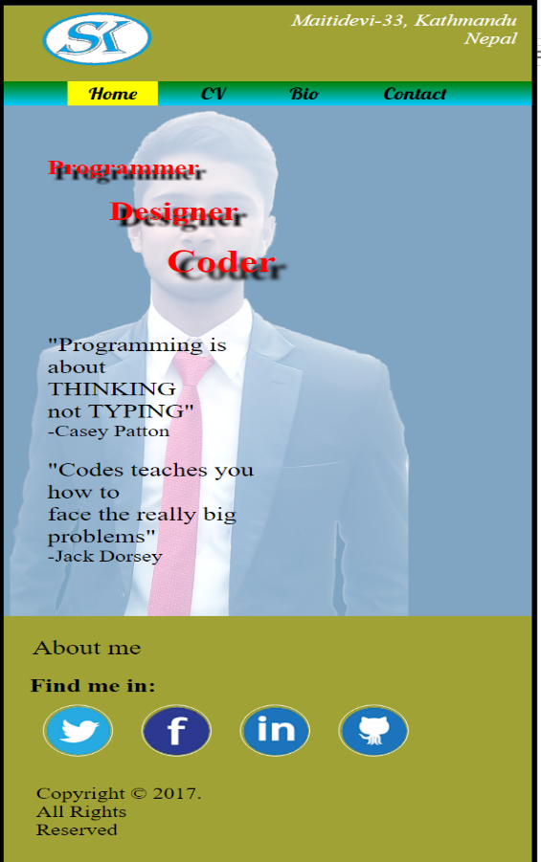

1. **Collaboration**

Throughout the designation of the pages, I had consulted with my tutor, Ganesh Khatri and in some extent with my friend, Rupak Shrestha. And we have just consulted about the project but we haven’t copied the code. Codes in our project is our own creation.

I spent roughly 80 hours for the completion of this project; roughly 5 hours a day.

1. **Conclusion**

As presented above, the header, footer and menu bar are same in all pages and just the section part is changed in every pages. I have been changing the color scheme frequently while developing the page for the better color combination. Also, I have regularly updated all the file into GitHub after modifying the tag and properties. I have tried my best to make it attractive and also responsive so that everyone could access it using any devices.

**Links:**

* <https://github.com/smartvampsk/csy1018-assign1>
* <https://smartvampsk.github.io/csy1018-assign1>

# References

W3schools.com. (2016). *CSS linear-gradient() function.* [Online] Available from: https://www.w3schools.com/cssref/func_linear-gradient.asp shadow3 [Accessed on 24 Mar 2017].

W3schools.com. (2016). *Tryit Editor v3.3.* [Online] Available from: https://www.w3schools.com/css/tryit.asp?filename=trycss3_box-shadow3 [Accessed on 24 Mar 2017].

W3schools.com. (2016). *Tryit Editor v3.3.* [Online] Available from: https://www.w3schools.com/css/tryit.asp?filename=trycss3_transition_transform [Accessed on 24 Mar 2017].

Google.com. (2017). *Diary logo – google search.* [Online] Available from: https://www.google.com/search?sa=G&hl=en&q=diary+logo&tbm=isch&tbs=simg:CAQSlAEJSdq2YMyxvRwaiAELEKjU2AQaAggFDAsQsIynCBphCl8IAxInvgKBCdESgwmACZEBxhSiFJoKLN021za7J9w2-jb1NvA2-zbWNvomGjCHqv-Fr6RqxjaxMPwEJ1vXGfW7epz2riTF5MXzEK7vTx5cbjO0v40pKf6zp9qp7HQgBAwLEI6u_1ggaCgoICAESBNCe1wUM&ved=0ahUKEwiD_qmSq4jTAhVJK48KHYNOBGMQwg4IGCgA&biw=1280&bih=611#imgrc=71ZVUVEqqflD1M: [Accessed on 29 Mar 2017].