# 1 部署环境

## 1.1 软件版本

OS: rhel7.3[1]

Mysql: mysql-cluster-community-7.5.7[2]

Hypervisor: virtualbox 5.1.28 r117968

## 1.2 部署架构

|  |  |  |  |  |  |
| --- | --- | --- | --- | --- | --- |
| 宿主机 | 虚拟机 | 管理节点 | SQL节点 | 数据节点 | MySQL Cluster Installer |
| 10.19.240.33 | 10.19.240.41 (rhel73-dbinstaller) | - | - | - | 1 |
| 10.19.240.35 (rhel73-srv1) | 1 | 1 | 1 | - |
| 10.19.240.36 (rhel73-srv2) | - | 2 | 2 | - |
| 10.19.240.34 | 10.19.240.37 (rhel73-srv3) | 2 | 3 | 3 | - |
| 10.19.240.38 (rhel73-srv4) | - | 4 | 4 | - |

# 2 安装步骤

## 2.1 dbinstaller环境准备

# 加载rhel iso镜像，其他节点同

mkdir /mnt/dvd

mount -o /dev/sr0 /mnt/dvd

# 配置yum本地源，其他节点同

yum-config-manager --add-repo=file:///mnt/dvd

echo "gpgcheck=0" >> /etc/yum.repos.d/mnt_dvd.repo

yum clean all

yum update

# 移除老版本的mariadb组件，其他节点同

yum erase mariadb-libs

# 安装必备的依赖组件，其他节点同

yum install perl-JSON.noarch

rpm -ivh python-paramiko-2.1.1-2.el7.noarch.rpm

rpm -ivh python2-crypto-2.6.1-15.el7.x86_64.rpm

rpm -ivh libtomcrypt-1.17-26.el7.x86_64.rpm

rpm -ivh libtommath-0.42.0-6.el7.x86_64.rpm

# 安装必备的mysql rpm

mysql-cluster-community-common-7.5.7-1.el7.x86_64

mysql-cluster-community-server-7.5.7-1.el7.x86_64

mysql-cluster-community-client-7.5.7-1.el7.x86_64

mysql-cluster-community-libs-7.5.7-1.el7.x86_64

mysql-cluster-community-auto-installer-7.5.7-1.el7.x86_64

# 关闭防火墙，其他节点同

systemctl stop firewalld

systemctl status firewalld

## 2.2 数据库节点环境准备

# 安装必备的依赖组件

yum install perl-JSON.noarch

rpm -ivh python-paramiko-2.1.1-2.el7.noarch.rpm

rpm -ivh python2-crypto-2.6.1-15.el7.x86_64.rpm

rpm -ivh libtomcrypt-1.17-26.el7.x86_64.rpm

rpm -ivh libtommath-0.42.0-6.el7.x86_64.rpm

# 安装必备的mysql rpm，缺少的组件可从rpm中检索，rpm --whatprovides *

for r in `ls *.rpm`; do echo $r; rpm -qpl $r | grep mysqladmin; done

mysql-cluster-community-devel-7.5.7-1.el7.x86_64

mysql-cluster-community-libs-7.5.7-1.el7.x86_64

mysql-cluster-community-client-7.5.7-1.el7.x86_64

mysql-cluster-community-server-7.5.7-1.el7.x86_64

mysql-cluster-community-data-node-7.5.7-1.el7.x86_64

mysql-cluster-community-management-server-7.5.7-1.el7.x86_64

mysql-cluster-community-common-7.5.7-1.el7.x86_64

mysql-cluster-community-java-7.5.7-1.el7.x86_64

# 配置程序链接

ln -s /usr/sbin/ndb_mgmd /usr/local/bin/ndb_mgmd

ln -s /usr/bin/ndb_mgm /usr/local/bin/ndb_mgm

ln -s /usr/bin/mysqladmin /usr/local/bin/mysqladmin

ln -s /usr/sbin/ndbmtd /usr/local/bin/ndbmtd

ln -s /usr/sbin/mysqld /usr/local/bin/mysqld

# 关闭防火墙

systemctl stop firewalld

systemctl status firewalld

## 2.3 安装集群

**# 启动对应的虚拟机**

vboxmanage list vms

"rhel73" {0041d6ac-3c8c-4599-aee1-280d83495685}

"rhel73-srv1" {fac763cd-0c01-4761-9d60-297af2d7320c}

"rhel73-srv2" {87da1097-c9da-42ae-a4f1-51910ccf0901}

"rhel73-dbinstaller" {8ac499ac-8be8-48ab-aab6-d9e9489e4ec1}

vboxmanage startvm rhel73-dbinstaller -type headless

# 彻底关闭防火墙

systemctl status firewalld

systemctl stop firewalld

systemctl is-enabled firewalld

systemctl disable firewalld

setenforce 0

getenforce

perl -p -i -e 's/SELINUX=enforcing/SELINUX=permissive/g' /etc/selinux/config

# 关闭默认的mysqld服务

systemctl stop mysqld

systemctl disable mysqld

**# 启动mysql安装控制台**

ndb_setup.py

*Running out of install dir: /usr/bin*

*Starting web server on port 8081*

*deathkey=428267*

*Press CTRL+C to stop web server.*

*The application should now be running in your browser.*

*(Alternatively you can navigate to http://localhost:8081/welcome.html to start it)*

**# 访问MySQL Cluster Installer，在Host List中填写服务器节点、shell登录名称和口令**

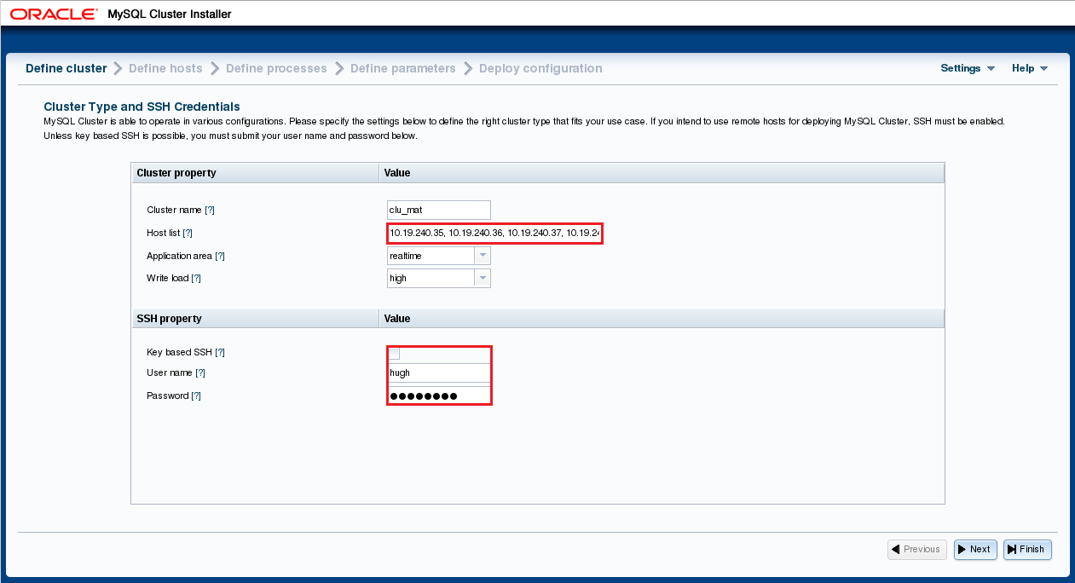

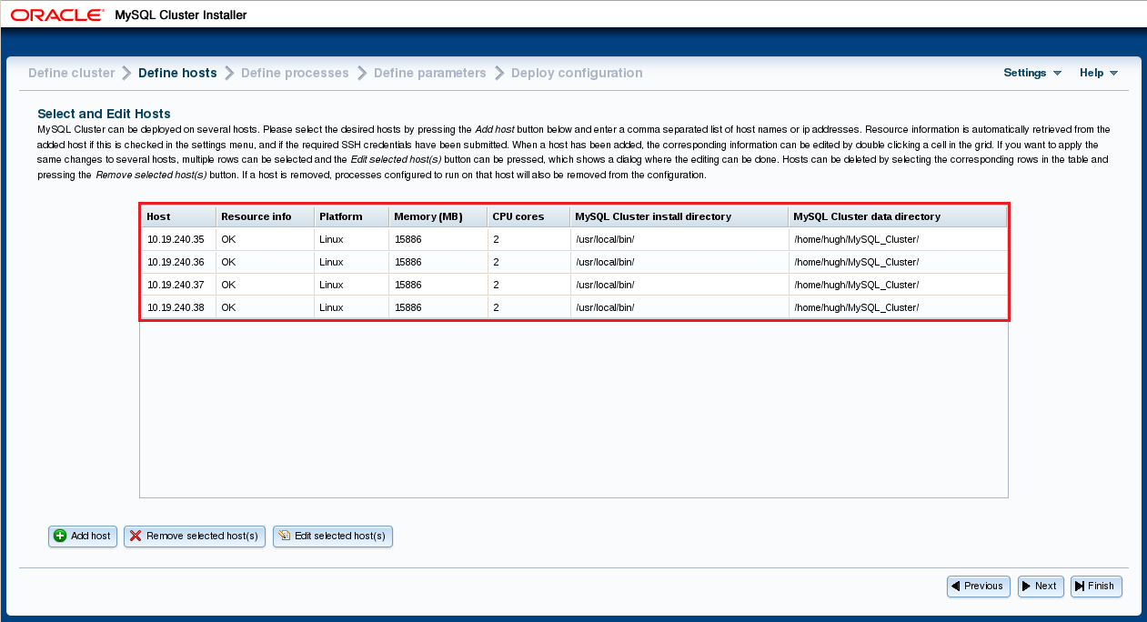

# 整体组网结构图

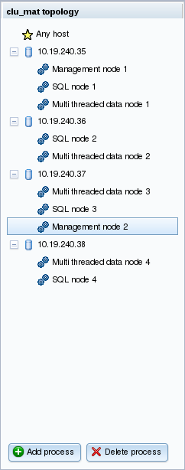

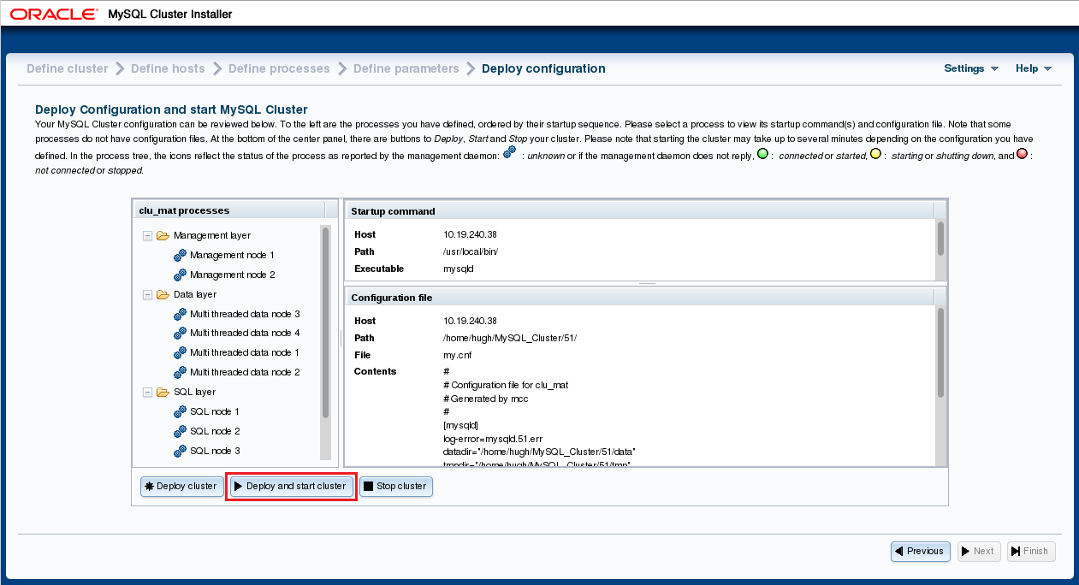

## 2.4 安装mysql workbench

# 查询vm的storage控制器

vboxmanage showvminfo rhel73-dbinstaller

# 加载一个iso镜像

vboxmanage storageattach rhel73-dbinstaller --storagectl "IDE" --port 1 --device 0 --type dvddrive --medium /home/rhel-server-7.3-x86_64-dvd.iso

# 安装依赖组件

rpm -ivh proj-4.8.0-2.rhel7.x86_64.rpm

# 安装程序

mwget --proxy="http://10.19.240.114:8801" http://download.myeclipsecn.com/myeclipse-2017-ci-8-offline-installer-linux.zip --count=50

rpm -ivh mysql-workbench-community-6.3.9-1.el7.x86_64.rpm

# 3 MySQL Cluster使用

## 3.1 MySQL Cluster用户权限共享

MySQL Server的用户权限表在数据库中是采用MYISAM存储引擎保存的，这就意味着在一个mysql节点创建的用户只能访问那一个节点，如果要访问mysql cluster中的其他的sql节点，就需要在其他sql节点都重复的创建，这就使mysql cluster中的权限管理变得非常的痛苦。自MySQL Cluster 7.2版本开始就提供了对分布式MySQL数据库用户的支持，实现了在整个MySQL Cluster中共享用户权限，使我们的权限管理变得简单、高效。

# 在Cluster的任意一节点上以root身份登录

shell> mysql --socket=/home/hugh/MySQL_Cluster/55/mysql.socket -u root

# 执行ndb_dist_priv.sql脚本，创建存储过程

mysql> SOURCE /usr/share/mysql/ndb_dist_priv.sql

# 检查已经创建的存储过程

mysql> SELECT ROUTINE_NAME, ROUTINE_SCHEMA, ROUTINE_TYPE FROM INFORMATION_SCHEMA.ROUTINES WHERE ROUTINE_NAME LIKE 'mysql_cluster%' ORDER BY ROUTINE_TYPE;

# 更改用户权限表的存储引擎

mysql> CALL mysql.mysql_cluster_move_privileges();

# 检查更改是否已成功

mysql> SELECT CONCAT( 'Conversion ', IF(mysql_cluster_privileges_are_distributed(), 'succeeded', 'failed'), '.') AS Result;

# 检查表定义，看表存储引擎是否已变化

mysql> show create table mysql.user;

## 3.2 创建数据库、用户、授权

# 创建数据库

CREATE DATABASE IF NOT EXISTS jeeplus_schema;

# 创建用户，允许远程登录

CREATE USER jeeplus@'%' IDENTIFIED BY '[C02bpCfh';

# 授权用户访问数据库

GRANT ALL PRIVILEGES ON jeeplus_schema.* TO jeeplus;

1. rhel-server-7.3-x86_64-dvd.iso
2. https://dev.mysql.com/get/Downloads/MySQL-Cluster-7.5/mysql-cluster-community-7.5.7-1.el7.x86_64.rpm-bundle.tar