# 1 依赖组件

**yum install -y binutils.x86_64**

**yum install -y compat-libstdc++-33.x86_64**

**yum install -y compat-libstdc++-33.i686**

**yum install -y gcc.x86_64**

**yum install -y gcc-c++.x86_64**

**yum install -y glibc.x86_64**

**yum install -y glibc.i686**

**yum install -y glibc-devel.x86_64**

**yum install -y glibc-devel.i686**

**yum install -y ksh.x86_64**

**yum install -y libaio.x86_64**

**yum install -y libaio.i686**

**yum install -y libaio-devel.x86_64**

**yum install -y libaio-devel.i686**

**yum install -y libgcc.x86_64**

**yum install -y libgcc.i686**

**yum install -y libstdc++.x86_64**

**yum install -y libstdc++.i686**

**yum install -y libstdc++-devel.x86_64**

**yum install -y libXext.x86_64**

**yum install -y libXext.i686**

**yum install -y libXtst.x86_64**

**yum install -y libXtst.i686**

**yum install -y libX11.x86_64**

**yum install -y libX11.i686**

**yum install -y libXau.x86_64**

**yum install -y libXau.i686**

**yum install -y libXi.x86_64**

**yum install -y libXi.i686**

**yum install -y make.x86_64**

**yum install -y sysstat.x86_64**

# 2 系统配置

groupadd oinstall

groupadd dba

useradd -g oinstall -G dba oracle

passwd oracle

dd if=/dev/zero of=ora12c.img bs=1M count=20480

losetup /dev/loop1 /home/ora12c.img

mkfs.ext4 /dev/loop1

mount /dev/loop1 /oracle

chown -R oracle:oinstall /oracle/

chmod -R 775 /oracle/

cat >> /etc/security/limits.conf <<!

oracle soft nproc 2047

oracle hard nproc 16384

oracle soft nofile 1024

oracle hard nofile 65536

oracle soft stack 10240

oracle hard stack 10240

!

cat >> .bash_profile <<!

export ORACLE_BASE=/oracle/12c

export ORACLE_HOME=$ORACLE_BASE/db1

export ORACLE_SID=orcl12c

export PATH=$ORACLE_HOME/bin:$PATH:$HOME/bin

export EDITOR=/bin/vi

!

# 使.bash_profile配置生效

source ~/.bash_profile

# 使用建立的raid阵列存放数据

mount /dev/md0 /oracle/12c/oradata

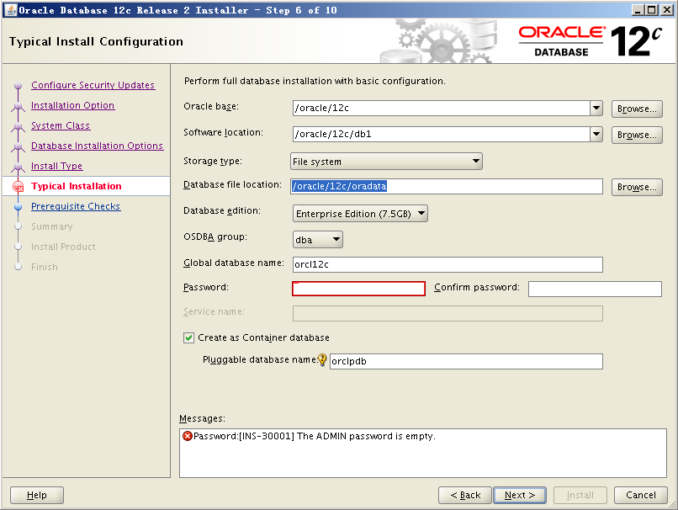

# 密码自动生成

yum -y install expect.x86_64

# 不妨设置如下

4ayX_fY4p

# 3 创建表空间、账户

*-- 当使用sqlplus、plsql连接到数据库时，默认进入的是cdb$root容器*

*-- 将当前的session指向pdb (Pluggable DB)*

ALTER SESSION SET container=pdborcl12c;

*-- 查看当前的容器只能看到pdborcl12c容器*

SELECT * FROM v$containers;

*-- 查看当前pdb的数据文件*

SELECT * FROM dba_data_files;

SELECT * FROM dba_tablespaces;

SELECT * FROM v$pdbs;

*-- 初始化表空间*

DROP TABLESPACE tmall DROP QUOTA INCLUDING CONTENTS AND DATAFILES CASCADE CONSTRAINTS;

CREATE TABLESPACE tmall DATAFILE '/oracle/12c/oradata/orcl12c/pdborcl12c/tmall.dbf' SIZE 1g AUTOEXTEND ON NEXT 1g;

*-- 创建用户，只能在pdb下创建，在cdb中会提示无法创建本地用户错误*

CREATE USER tmall IDENTIFIED BY tmall DEFAULT TABLESPACE tmall TEMPORARY TABLESPACE temp;

*-- 授权*

SELECT * FROM dba_sys_privs t WHERE t.grantee = 'TMALL';

GRANT CREATE SESSION TO tmall;

GRANT CONNECT TO tmall;

GRANT RESOURCE TO tmall;

*-- 在tnsnames.ora文件中增加pdb的配置*

orcl =

(DESCRIPTION =

(ADDRESS_LIST =

(ADDRESS = (PROTOCOL = TCP)(HOST = 10.19.245.190)(PORT = 1521))

)

(CONNECT_DATA =

(SERVER = DEDICATED)

(SERVICE_NAME = orcl12c)

)

)

orclpdb =

(DESCRIPTION =

(ADDRESS_LIST =

(ADDRESS = (PROTOCOL = TCP)(HOST = 10.19.245.190)(PORT = 1521))

)

(CONNECT_DATA =

(SERVER = DEDICATED)

(SERVICE_NAME = pdborcl12c)

)

)

*-- 可以使用sqlplus连接pdb了*

sqlplus tmall/tmall@orclpdb;