在Centos7虚拟机中安装ELK
===========================================================
原始doc文件：在Centos7虚拟机中安装ELK.docx
ELK的介绍PPT： ELK介绍.ppt

资源：
由于文件较大，所以全部放到百度网盘，信息如下：
链接：https://pan.baidu.com/s/1PSvwPC0lwseoY6HFSo48Zw
提取码：lizn
===========================================================
在Centos7虚拟机中安装ELK

目录
一、 文档目的... 1
二、 环境准备... 1
1、 虚拟机准备... 1
2、 需要的资源信息... 3
三、 安装ELK. 4
1、 上传资源文件... 4
2、 Yum安装gcc gcc=c++. 5
3、 安装JDK8. 5
4、 安装ELK.. 7
5、 修改系统配置... 9
(1) 修改/etc/security/limit.conf 9
(2) 修改vm.max_map_count大小... 10
6、 运行ELK.. 10
(1) Elasticsearch. 10
(2) Logstash. 12
(3) Kibana. 15
四、 配置ELK获取SRX流量和URL日志进行展示... 22
1、 实验目的... 22
2、 实验前提... 22
3、 LogStash配置... 23
（1） 在logstash中创建模板目录... 23
（2） 创建模板，对应srx发出来的流量日志... 23
（3） 创建模板，对应srx发出来的url访问日志... 26
（4） 在logstash中编写启动配置文件，如下所示：... 29
4、 启动ELK.. 39
5、 在Kibana中配置显示界面... 39
五、 Kibana中测试正则表达式... 51
1、 RFC5242 syslog提取正则表达式... 51
2、 F5提取正则表达式... 52

文档目的
在VMWare Centos7中安装ELK 6.4.2，并进行实际使用。

环境准备

虚拟机准备
在VMWare中安装一个虚拟机，配置如下：

MEM：8G
Disk：2T
系统：centos 7
网络：桥接 192.168.1.71
2T硬盘系统分区如下所示：

主要是把/分区分配最大限度1.7T
软件选择，我们选择最小安装
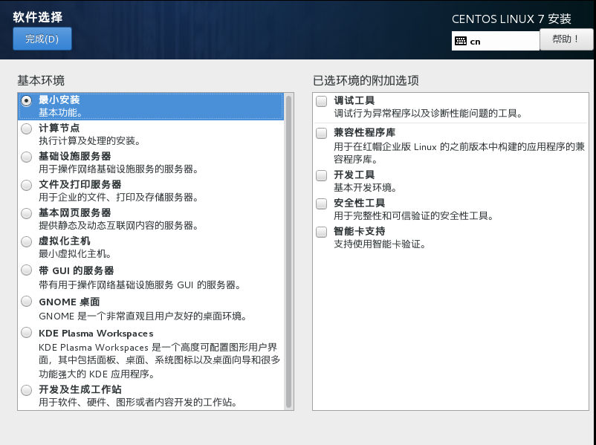
安装过程中，我们创建用户ELK，因为ELK中ElasticSearch不能使用root用户启动。
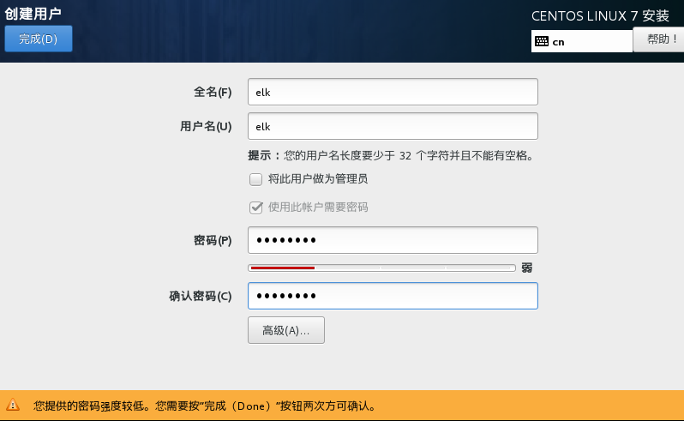
网卡配置为自动自动，
IP：192.168.1.71
netmask：255.255.255.0
gateway:192.168.1.1
dns:114.114.114.114

需要的资源信息
ElasticSearch 6.4.2
LogStash 6.4.2
Kibana 6.4.2
JDK 1.8
国家地图：
城市地图：

安装ELK

上传资源文件
我们先将所有的资源文件上传到/home/lgh/tools目录下
ELK
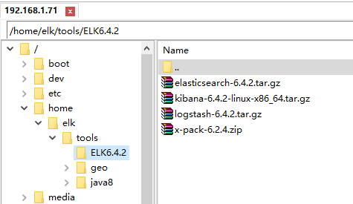
GEO
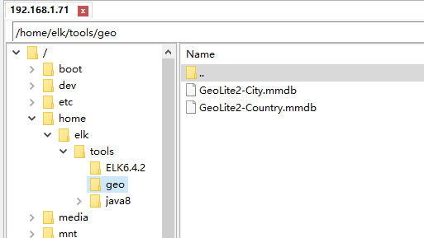
Java8
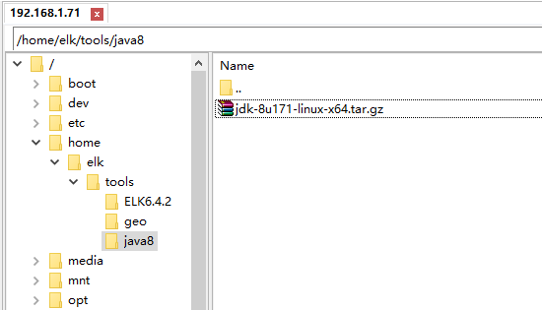

Yum安装gcc gcc=c++
[root@localhost ~]# yum -y install gcc gcc-c++

安装JDK8
- 将jdk原始文件拷贝到/usr/local
[root@localhost ~]# cp /home/elk/tools/java8/jdk-8u171-linux-x64.tar.gz /usr/local/
- 解压缩jdk8文件
[root@localhost ~]# cd /usr/local/
[root@localhost local]# tar zxf jdk-8u171-linux-x64.tar.gz
[root@localhost local]# ll
总用量 186420
drwxr-xr-x. 2 root root 6 11月 5 2016 bin
drwxr-xr-x. 2 root root 6 11月 5 2016 etc
drwxr-xr-x. 2 root root 6 11月 5 2016 games
drwxr-xr-x. 2 root root 6 11月 5 2016 include
drwxr-xr-x. 8 10 143 255 3月 29 2018 jdk1.8.0_171
rw-rr-. 1 root root 190890122 10月 23 14:50 jdk-8u171-linux-x64.tar.gz
drwxr-xr-x. 2 root root 6 11月 5 2016 lib
drwxr-xr-x. 2 root root 6 11月 5 2016 lib64
drwxr-xr-x. 2 root root 6 11月 5 2016 libexec
drwxr-xr-x. 2 root root 6 11月 5 2016 sbin
drwxr-xr-x. 5 root root 49 10月 23 2018 share
drwxr-xr-x. 2 root root 6 11月 5 2016 src
[root@localhost local]# rm -f jdk-8u171-linux-x64.tar.gz
- 配置系统变量
[root@localhost local]# vi /etc/profile
在文件最后添加如下内容:
export JAVA_HOME=/usr/local/jdk1.8.0_171
export JRE_HOME=${JAVA_HOME}/jre
export CLASSPATH=.:${JAVA_HOME}/lib:/${JAVA_HOME}/lib/tools.jar:${JRE_HOME}/lib
export PATH=${PATH}:${JAVA_HOME}/bin:${JRE_HOME}/bin
使更改生效
[root@localhost local]# source /etc/profile
- 验证安装
[root@localhost local]# java -version
java version "1.8.0_171"
Java(TM) SE Runtime Environment (build 1.8.0_171-b11)
Java HotSpot(TM) 64-Bit Server VM (build 25.171-b11, mixed mode)
[root@localhost local]#

安装ELK
ELK的安装基本都为拷贝解压即可。
[root@localhost local]# cd /opt/
[root@localhost opt]# cp /home/elk/tools/ELK6.4.2/* .
[root@localhost opt]# tar zxf elasticsearch-6.4.2.tar.gz
[root@localhost opt]# tar zxf logstash-6.4.2.tar.gz
[root@localhost opt]# tar zxf kibana-6.4.2-linux-x86_64.tar.gz
[root@localhost opt]# chown -R elk:elk elasticsearch-6.4.2
[root@localhost opt]# cp /home/elk/tools/geo/* .
[root@localhost opt]# ll
总用量 791488
drwxr-xr-x. 8 elk elk 143 9月 26 21:38 elasticsearch-6.4.2
rw-rr-. 1 root root 97914519 10月 23 14:57 elasticsearch-6.4.2.tar.gz
rw-rr-. 1 root root 57658870 10月 23 14:59 GeoLite2-City.mmdb
rw-rr-. 1 root root 3480069 10月 23 14:59 GeoLite2-Country.mmdb
drwxrwxr-x. 11 elk elk 229 9月 26 22:01 kibana-6.4.2-linux-x86_64
rw-rr-. 1 root root 188077286 10月 23 14:57 kibana-6.4.2-linux-x86_64.tar.gz
drwxr-xr-x. 12 root root 255 10月 23 14:57 logstash-6.4.2
rw-rr-. 1 root root 153924169 10月 23 14:57 logstash-6.4.2.tar.gz
rw-rr-. 1 root root 309419696 10月 23 14:57 x-pack-6.2.4.zip
[root@localhost opt]#

修改系统配置

修改/etc/security/limit.conf
修改文件/etc/security/limits.conf，更改默认打开句柄数
[root@localhost ~]# vi /etc/security/limits.conf
在最后添加如下内容：
* soft nofile 65536
* hard nofile 65536
重新登陆用户后，查看更改是否生效
[root@localhost ~]# ulimit -Hn
4096
[root@localhost ~]# su - elk
上一次登录：二 10月 23 15:04:47 CST 2018pts/0 上
[elk@localhost ~]$ ulimit -Hn
65536
[elk@localhost ~]$

修改vm.max_map_count大小
[root@localhost ~]# vi /etc/sysctl.conf
在最后添加如下内容:
vm.max_map_count=262144
查看更改是否生效
[root@localhost ~]# sysctl -p
vm.max_map_count = 262144
[root@localhost ~]#

运行ELK

Elasticsearch
Elasticsearch为ELK的核心部件，默认配置既可以运行，我们先启动elasticsearch。
- 切换到elk用户，
[root@localhost opt]# su - elk
上一次登录：二 10月 23 15:09:47 CST 2018pts/0 上
[elk@localhost ~]$ cd /opt/elasticsearch-6.4.2
[elk@localhost elasticsearch-6.4.2]$
- 更改配置文件：
[elk@localhost elasticsearch-6.4.2]$ vi config/elasticsearch.yml
#path.data: /path/to/data
path.data: /opt/elasticsearch-6.4.2/data
#
# Path to log files:
#
#path.logs: /path/to/logs
path.logs: /opt/elasticsearch-6.4.2/logs
#
#bootstrap.memory_lock: true
bootstrap.memory_lock: false
- 启动elasticsearch
[elk@localhost elasticsearch-6.4.2]$ pwd
/opt/elasticsearch-6.4.2
[elk@localhost elasticsearch-6.4.2]$ bin/elasticsearch

Logstash
LogStash为日志采集和整理部件，负责接收外部日志，整理后，按照系统规划将数据写入elasticsearch中进行保存。
[root@localhost logstash-6.4.2]# pwd
/opt/logstash-6.4.2
[root@localhost logstash-6.4.2]# vi t1.conf
input{
stdin{}
}
output{
stdout{}
}
[root@localhost logstash-6.4.2]# bin/logstash -f t1.conf
Sending Logstash logs to /opt/logstash-6.4.2/logs which is now configured via log4j2.properties
[2018-10-23T15:48:09,585][INFO ][logstash.setting.writabledirectory] Creating directory {:setting=>"path.queue", :path=>"/opt/logstash-6.4.2/data/queue"}
[2018-10-23T15:48:09,593][INFO ][logstash.setting.writabledirectory] Creating directory {:setting=>"path.dead_letter_queue", :path=>"/opt/logstash-6.4.2/data/dead_letter_queue"}
[2018-10-23T15:48:10,112][WARN ][logstash.config.source.multilocal] Ignoring the 'pipelines.yml' file because modules or command line options are specified
[2018-10-23T15:48:10,139][INFO ][logstash.agent ] No persistent UUID file found. Generating new UUID {:uuid=>"3e39cfd0-e935-48b1-86f1-d21f6de94056", :path=>"/opt/logstash-6.4.2/data/uuid"}
[2018-10-23T15:48:10,561][INFO ][logstash.runner ] Starting Logstash {"logstash.version"=>"6.4.2"}
[2018-10-23T15:48:12,596][INFO ][logstash.pipeline ] Starting pipeline {:pipeline_id=>"main", "pipeline.workers"=>4, "pipeline.batch.size"=>125, "pipeline.batch.delay"=>50}
[2018-10-23T15:48:12,735][INFO ][logstash.pipeline ] Pipeline started successfully {:pipeline_id=>"main", :thread=>"#<Thread:0x5904686d run>"}
The stdin plugin is now waiting for input:
[2018-10-23T15:48:12,825][INFO ][logstash.agent ] Pipelines running {:count=>1, :running_pipelines=>[:main], :non_running_pipelines=>[]}
[2018-10-23T15:48:13,013][INFO ][logstash.agent ] Successfully started Logstash API endpoint {:port=>9600}
abcd1234
{
"message" => "abcd1234",
"@timestamp" => 2018-10-23T07:48:34.943Z,
"@version" => "1",
"host" => "localhost.localdomain"
}
abcabc
{
"message" => "abcabc",
"@timestamp" => 2018-10-23T07:48:43.138Z,
"@version" => "1",
"host" => "localhost.localdomain"
}

Kibana
- 防火墙开启5601端口
5601端口使Kibana使用端口，需要在防火墙放通该端口的数据访问
[root@localhost elasticsearch-6.4.2]# firewall-cmd --zone=public --add-port=5601/tcp --permanent
success
[root@localhost elasticsearch-6.4.2]# firewall-cmd --list-ports
[root@localhost elasticsearch-6.4.2]#
[root@localhost ~]# firewall-cmd --reload
success
[root@localhost ~]# firewall-cmd --list
usage: see firewall-cmd man page
firewall-cmd: error: ambiguous option: --list could match --list-lockdown-whitelist-contexts, --list-all, --list-lockdown-whitelist-uids, --list-ports, --list-source-ports, --list-lockdown-whitelist-users, --list-forward-ports, --list-icmp-blocks, --list-interfaces, --list-rich-rules, --list-services, --list-lockdown-whitelist-commands, --list-all-zones, --list-sources, --list-protocols
[root@localhost ~]# firewall-cmd --list-all
public (active)
target: default
icmp-block-inversion: no
interfaces: ens33
sources:
services: dhcpv6-client ssh
ports: 5601/tcp
protocols:
masquerade: no
forward-ports:
sourceports:
icmp-blocks:
rich rules:
或者重新启动防火墙：
#重启firewall
firewall-cmd --reload
#停止firewall
systemctl stop firewalld.service
#禁止firewall开机启动
systemctl disable firewalld.service
systemctl start firewalld.service
systemctl restart firewalld.service
- 配置Kibana允许外部地址访问
[root@localhost kibana-6.4.2-linux-x86_64]# pwd
/opt/kibana-6.4.2-linux-x86_64
[root@localhost kibana-6.4.2-linux-x86_64]# vi config/kibana.yml
# Specifies the address to which the Kibana server will bind. IP addresses and host names are both valid values.
# The default is 'localhost', which usually means remote machines will not be able to connect.
# To allow connections from remote users, set this parameter to a non-loopback address.
#server.host: "localhost"
server.host: "0.0.0.0"
- 启动Kibana
[root@localhost kibana-6.4.2-linux-x86_64]# pwd
/opt/kibana-6.4.2-linux-x86_64
[root@localhost kibana-6.4.2-linux-x86_64]# bin/kibana
log [07:38:42.934] [info][status][plugin:kibana@6.4.2] Status changed from uninitialized to green - Ready
log [07:38:42.961] [info][status][plugin:elasticsearch@6.4.2] Status changed from uninitialized to yellow - Waiting for Elasticsearch
log [07:38:42.963] [info][status][plugin:xpack_main@6.4.2] Status changed from uninitialized to yellow - Waiting for Elasticsearch
log [07:38:42.966] [info][status][plugin:searchprofiler@6.4.2] Status changed from uninitialized to yellow - Waiting for Elasticsearch
log [07:38:42.969] [info][status][plugin:ml@6.4.2] Status changed from uninitialized to yellow - Waiting for Elasticsearch
log [07:38:43.000] [info][status][plugin:tilemap@6.4.2] Status changed from uninitialized to yellow - Waiting for Elasticsearch
log [07:38:43.001] [info][status][plugin:watcher@6.4.2] Status changed from uninitialized to yellow - Waiting for Elasticsearch
log [07:38:43.010] [info][status][plugin:license_management@6.4.2] Status changed from uninitialized to green - Ready
log [07:38:43.011] [info][status][plugin:index_management@6.4.2] Status changed from uninitialized to yellow - Waiting for Elasticsearch
log [07:38:43.097] [info][status][plugin:timelion@6.4.2] Status changed from uninitialized to green - Ready
log [07:38:43.099] [info][status][plugin:graph@6.4.2] Status changed from uninitialized to yellow - Waiting for Elasticsearch
log [07:38:43.105] [info][status][plugin:monitoring@6.4.2] Status changed from uninitialized to green - Ready
log [07:38:43.107] [warning][security] Generating a random key for xpack.security.encryptionKey. To prevent sessions from being invalidated on restart, please set xpack.security.encryptionKey in kibana.yml
log [07:38:43.110] [warning][security] Session cookies will be transmitted over insecure connections. This is not recommended.
log [07:38:43.115] [info][status][plugin:security@6.4.2] Status changed from uninitialized to yellow - Waiting for Elasticsearch
log [07:38:43.131] [info][status][plugin:grokdebugger@6.4.2] Status changed from uninitialized to yellow - Waiting for Elasticsearch
log [07:38:43.134] [info][status][plugin:dashboard_mode@6.4.2] Status changed from uninitialized to green - Ready
log [07:38:43.136] [info][status][plugin:logstash@6.4.2] Status changed from uninitialized to yellow - Waiting for Elasticsearch
log [07:38:43.149] [info][status][plugin:apm@6.4.2] Status changed from uninitialized to green - Ready
log [07:38:43.152] [info][status][plugin:console@6.4.2] Status changed from uninitialized to green - Ready
log [07:38:43.154] [info][status][plugin:console_extensions@6.4.2] Status changed from uninitialized to green - Ready
log [07:38:43.156] [info][status][plugin:notifications@6.4.2] Status changed from uninitialized to green - Ready
log [07:38:43.158] [info][status][plugin:metrics@6.4.2] Status changed from uninitialized to green - Ready
log [07:38:43.633] [warning][reporting] Generating a random key for xpack.reporting.encryptionKey. To prevent pending reports from failing on restart, please set xpack.reporting.encryptionKey in kibana.yml
log [07:38:43.634] [info][status][plugin:reporting@6.4.2] Status changed from uninitialized to yellow - Waiting for Elasticsearch
log [07:38:43.992] [info][status][plugin:elasticsearch@6.4.2] Status changed from yellow to green - Ready
log [07:38:44.195] [info][license][xpack] Imported license information from Elasticsearch for the [data] cluster: mode: basic | status: active
log [07:38:44.197] [info][status][plugin:xpack_main@6.4.2] Status changed from yellow to green - Ready
log [07:38:44.197] [info][status][plugin:searchprofiler@6.4.2] Status changed from yellow to green - Ready
log [07:38:44.198] [info][status][plugin:ml@6.4.2] Status changed from yellow to green - Ready
log [07:38:44.198] [info][status][plugin:tilemap@6.4.2] Status changed from yellow to green - Ready
log [07:38:44.198] [info][status][plugin:watcher@6.4.2] Status changed from yellow to green - Ready
log [07:38:44.198] [info][status][plugin:index_management@6.4.2] Status changed from yellow to green - Ready
log [07:38:44.199] [info][status][plugin:graph@6.4.2] Status changed from yellow to green - Ready
log [07:38:44.199] [info][status][plugin:grokdebugger@6.4.2] Status changed from yellow to green - Ready
log [07:38:44.200] [info][status][plugin:logstash@6.4.2] Status changed from yellow to green - Ready
log [07:38:44.200] [info][status][plugin:reporting@6.4.2] Status changed from yellow to green - Ready
log [07:38:44.200] [info][kibana-monitoring][monitoring-ui] Starting monitoring stats collection
log [07:38:44.202] [info][status][plugin:security@6.4.2] Status changed from yellow to green - Ready
log [07:38:44.436] [info][license][xpack] Imported license information from Elasticsearch for the [monitoring] cluster: mode: basic | status: active
- 验证
访问:192.168.1.71:5601，如果出现下面界面，说明Kibana运行成功。
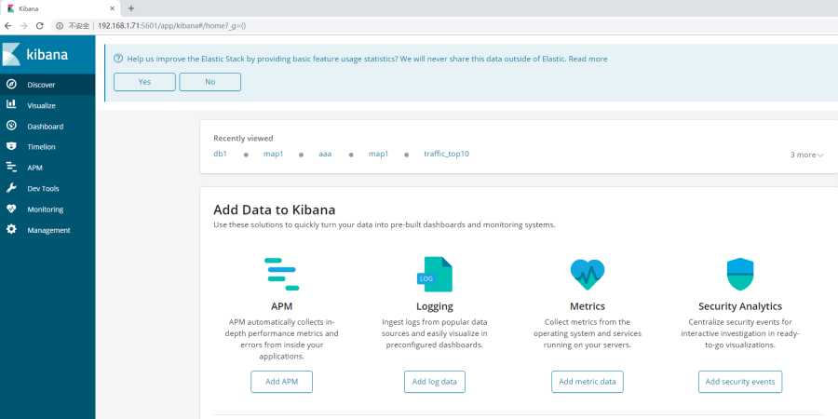

配置ELK获取SRX流量和URL日志进行展示

实验目的
接收SRX的流量日志和URL日志，写入ES中进行保存，然后在Kibana中提取当日流量TOP10用户，以及URL访问IP地理分布图。

实验前提
SRX中指定了日志发送到192.168.1.71的514端口。日志格式为标准syslog日志，格式符合rfc5242。
ELK安装完毕。

LogStash配置

在logstash中创建模板目录
[root@elk logstash-6.4.2]# pwd
/opt/logstash-6.4.2
[root@elk logstash-6.4.2]# mkdir template

创建模板，对应srx发出来的流量日志
[root@elk template]# vi srx_traffic.json
{
"template": "srx_traffic_*",
"order":0,
"settings": {
"index.number_of_replicas": "1",
"index.number_of_shards": "5",
"index.refresh_interval" : "10s"
},
"mappings": {
"doc": {
"properties": {
"@timestamp": {
"format": "strict_date_optional_time||epoch_millis",
"type": "date"
},
"host": { "type": "keyword" },
"hostname": { "type": "keyword" },
"program": { "type": "keyword" },
"message_id": { "type": "keyword" },
"source-address": { "type": "keyword" },
"source-port": { "type": "integer" },
"destination-address": { "type": "keyword" },
"destination-port": { "type": "integer" },
"connection-tag": { "type": "keyword" },
"service-name": { "type": "keyword" },
"nat-source-address": { "type": "keyword" },
"nat-source-port": { "type": "integer" },
"nat-destination-address":{ "type": "keyword" },
"nat-destination-port": { "type": "integer" },
"nat-connection-tag": { "type": "keyword" },
"src-nat-rule-type":{ "type": "keyword" },
"src-nat-rule-name": { "type": "keyword" },
"dst-nat-rule-type": { "type": "keyword" },
"dst-nat-rule-name": { "type": "keyword" },
"protocol-id": { "type": "keyword" },
"policy-name": { "type": "keyword" },
"source-zone-name": { "type": "keyword" },
"destination-zone-name":{ "type": "keyword" },
"session-id-32":{ "type": "keyword" },
"packets-from-client": { "type": "integer" },
"bytes-from-client": { "type": "integer" },
"packets-from-server": { "type": "integer" },
"bytes-from-server": { "type": "integer" },
"elapsed-time": { "type": "integer" },
"application": { "type": "keyword" },
"nested-application": { "type": "keyword" },
"username": { "type": "keyword" },
"roles": { "type": "keyword" },
"packet-incoming-interface": { "type": "keyword" },
"encrypted": { "type": "keyword" },
"geoip": {
"dynamic": true,
"type": "object",
"properties": {
"location": {
"type": "geo_point"
}
}
}
}
}
}
}

创建模板，对应srx发出来的url访问日志
[root@elk template]# vi srx_url.json
{
"template": "srx_url_*",
"order":0,
"settings": {
"index.number_of_replicas": "1",
"index.number_of_shards": "5",
"index.refresh_interval" : "10s"
},
"mappings": {
"doc": {
"properties": {
"@timestamp": {
"format": "strict_date_optional_time||epoch_millis",
"type": "date"
},
"host": { "type": "keyword" },
"hostname": { "type": "keyword" },
"program": { "type": "keyword" },
"message_id": { "type": "keyword" },
"source-address":{ "type": "keyword" },
"source-port": { "type": "integer" },
"destination-address": { "type": "keyword" },
"destination-port": { "type": "integer" },
"session-id":{ "type": "keyword" },
"category": { "type": "keyword" },
"reason": { "type": "keyword" },
"profile": { "type": "keyword" },
"url": { "type": "text" },
"obj": { "type": "keyword" },
"username": { "type": "keyword" },
"roles": { "type": "keyword" },
"geoip": {
"dynamic": true,
"type": "object",
"properties": {
"location": {
"type": "geo_point"
}
}
}
}
}
}
}

在logstash中编写启动配置文件，如下所示：
[root@elk logstash-6.4.2]# vi srx.conf
input {
syslog {
type => "syslog"
port => "514"
}
}
filter {
grok {
match => {
"message" => "<%{NONNEGINT:syslog_pri}>%{NONNEGINT:version}%{SPACE}(?:|%{TIMESTAMP_ISO8601:syslog_timestamp})%{SPACE}(?:|%{IPORHOST:hostname})%{SPACE}(?:%{SYSLOG5424PRINTASCII:program}|)%{SPACE}(?:|%{SYSLOG5424PRINTASCII:process_id})%{SPACE}(?:|%{SYSLOG5424PRINTASCII:message_id})%{SPACE}(?:|(?<structured_data>(\\[.*?[^\\\]
])+))(?:%{SPACE}%{GREEDYDATA:syslog_message}|)"
}
add_tag => [ "match" ]
remove_field => "message"
}
if [message_id] {
syslog_pri {
remove_field => "syslog_pri"
}
date {
#match => ["syslog_timestamp", "yyyy-MM-dd HH:mm:ss,SSS", "UNIX"]
#target => "@timestamp"
#locale => "cn"
#remove_field => "syslog_timestamp"
match => [ "syslog_timestamp", "ISO8601", "MMM dd HH:mm:ss", "yyyy-MM-dd HH:mm:ss.SSS" ]
remove_field => "syslog_timestamp"
locale => "cn"
}
if [structured_data] {
ruby {
code => '
# https://github.com/logstash-plugins/logstash-input-syslog/issues/15#issuecomment-270367033
def extract_syslog5424_sd(event,syslog5424_sd)
syslog5424_sd.scan(/\\[(?<element>.*?[^\\\])
]/) do |element|
data = element[0].match(/(?<sd_id>[^\ ]+)(?<sd_params> .*)?/)
sd_id = data[:sd_id].split("@", 2)[0]
event.set("[sd_id]",sd_id )
next if data.nil? || data[:sd_params].nil?
data[:sd_params].scan(/ (.?[=](?:""|".?[^\\\]"))/) do |set|
set = set[0].match(/(?<param_name>.?)[=]\"(?<param_value>.)\"/)
event.set(set[:param_name], set[:param_value])
end
end
end
extract_syslog5424_sd(event,event.get("[structured_data]"))
'
remove_field => "structured_data"
}
if [source-port] {
mutate {
convert => ["source-port", "integer"]
}
}
if [destination-port] {
mutate {
convert => ["destination-port", "integer"]
}
}
if [nat-source-port] {
mutate {
convert => ["nat-source-port", "integer"]
}
}
if [nat-destination-port] {
mutate {
convert => ["nat-destination-port", "integer"]
}
}
if [packets-from-client] {
mutate {
convert => ["packets-from-client", "integer"]
}
}
if [bytes-from-client] {
mutate {
convert => ["bytes-from-client", "integer"]
}
}
if [packets-from-server] {
mutate {
convert => ["packets-from-server", "integer"]
}
}
if [bytes-from-server] {
mutate {
convert => ["bytes-from-server", "integer"]
}
}
if [elapsed-time] {
mutate {
convert => ["elapsed-time", "integer"]
}
}
if [destination-address] {
geoip {
source => "destination-address"
target => "geoip"
database => "/opt/GeoLite2-City.mmdb"
add_field => [ "[geoip][coordinates]", "%{[geoip][longitude]}" ]
add_field => [ "[geoip][coordinates]", "%{[geoip][latitude]}" ]
}
mutate {
convert => [ "[geoip][coordinates]", "float"]
}
}
}
}
}
output{
if [host] == "192.168.0.1" {
if [message_id] {
if [message_id] == "RT_FLOW_SESSION_CLOSE" {
elasticsearch {
hosts => ["http://127.0.0.1:9200"]
index => "srx_traffic_%{+YYYY.MM.dd}"
template => "/opt/logstash-6.4.2/template/srx_traffic.json"
template_name => "srx_traffic"
template_overwrite => true
#workers => 1
#flush_size => 20000
#idle_flush_time => 10
}
stdout{}
}else if [message_id] == "WEBFILTER_URL_PERMITTED"{
elasticsearch {
hosts => ["http://127.0.0.1:9200"]
index => "srx_url_%{+YYYY.MM.dd}"
template => "/opt/logstash-6.4.2/template/srx_url.json"
template_name => "srx_url"
template_overwrite => true
#workers => 1
#flush_size => 20000
#idle_flush_time => 10
}
stdout{}
}
}
elasticsearch {
hosts => ["http://127.0.0.1:9200"]
index => "srxlog_%{+YYYY.MM.dd}"
}
}
}

启动ELK
分别开启三个终端，分别启动ELK
[root@elk ~]# su – lgh
[lgh@elk ~]$ cd /opt/elasticsearch-6.4.2/
[lgh@elk elasticsearch-6.4.2]$ bin/elasticsearch
[root@elk logstash-6.4.2]# pwd
/opt/logstash-6.4.2
[root@elk logstash-6.4.2]# bin/logstash -f srx.conf
[root@elk ~]# cd /opt/kibana-6.4.2-linux-x86_64/
[root@elk kibana-6.4.2-linux-x86_64]# pwd
/opt/kibana-6.4.2-linux-x86_64
[root@elk kibana-6.4.2-linux-x86_64]# bin/kibana

在Kibana中配置Top10流量用户
使用浏览器访问：192.168.1.71:5601

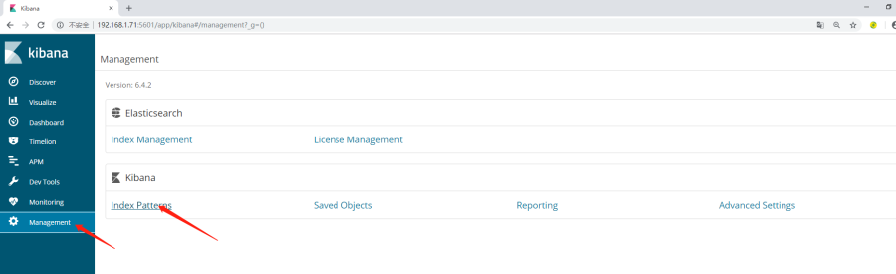
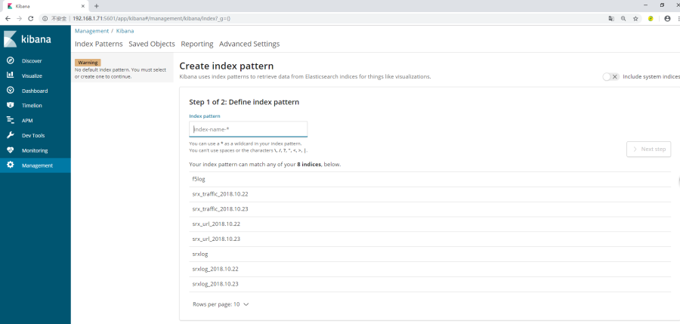
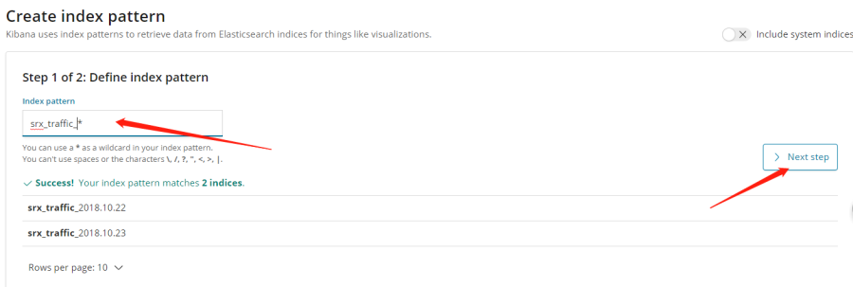
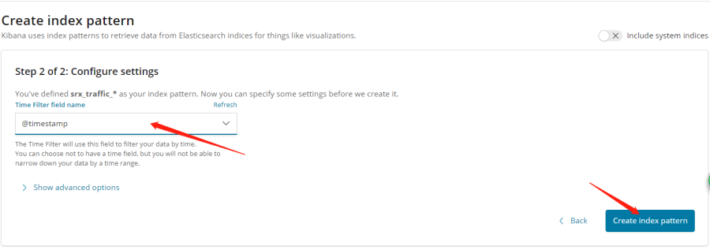
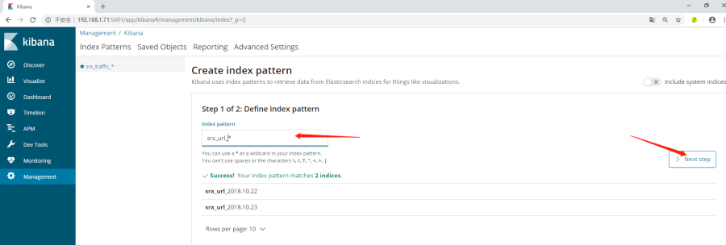
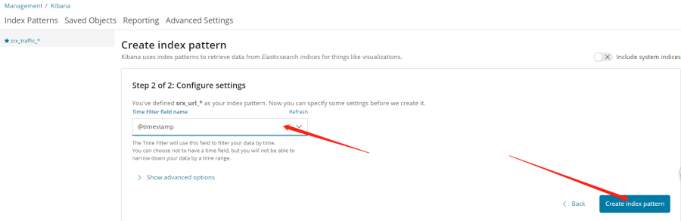
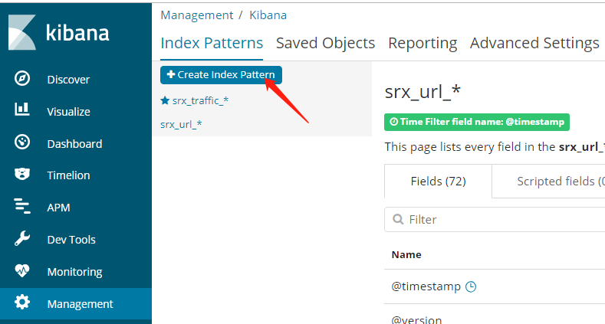
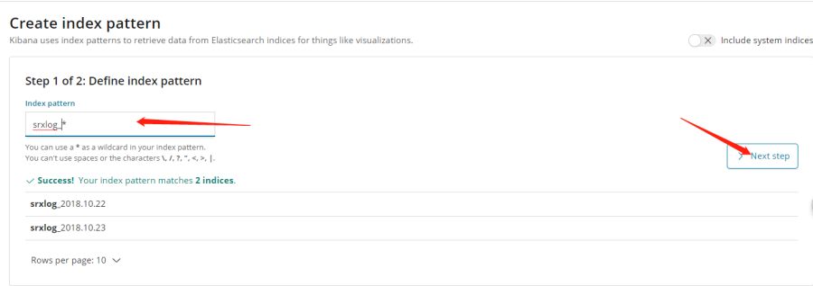
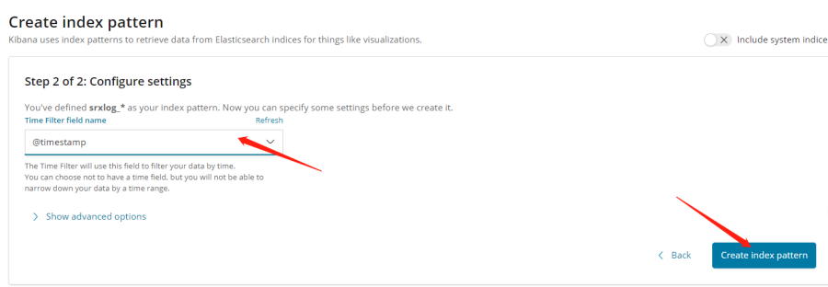
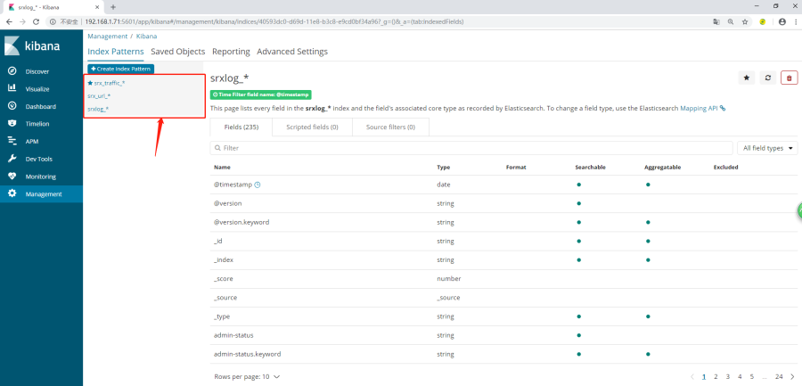
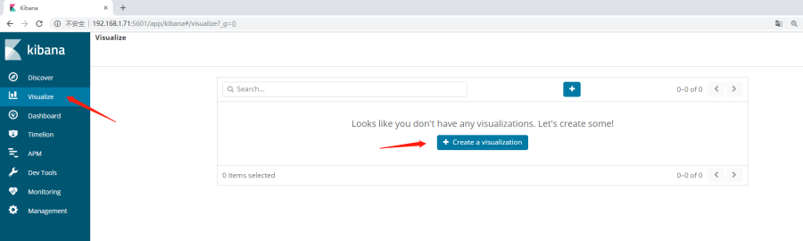

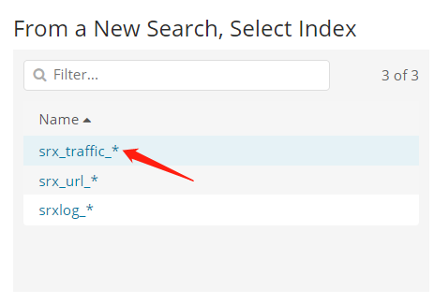
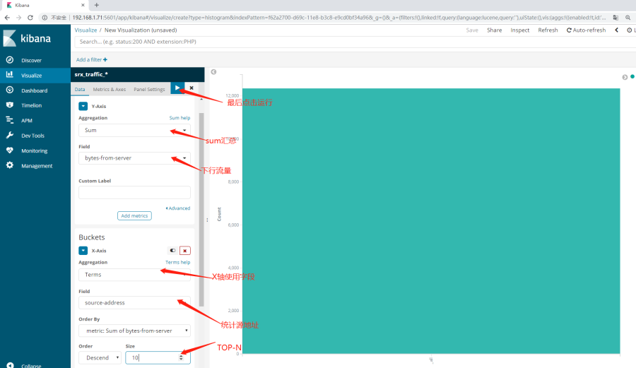
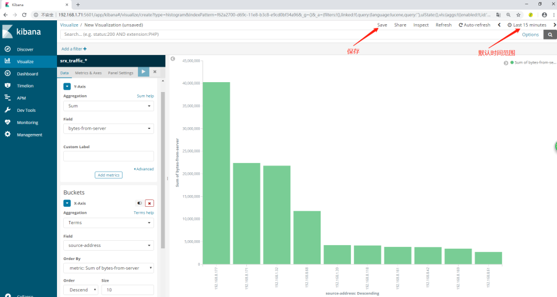

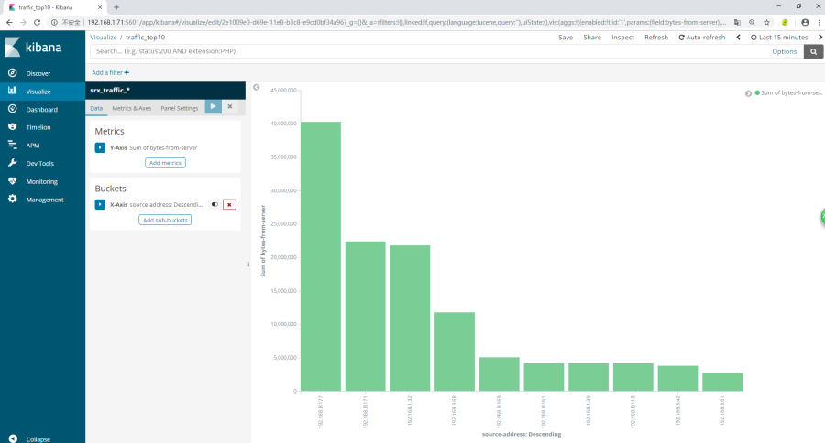
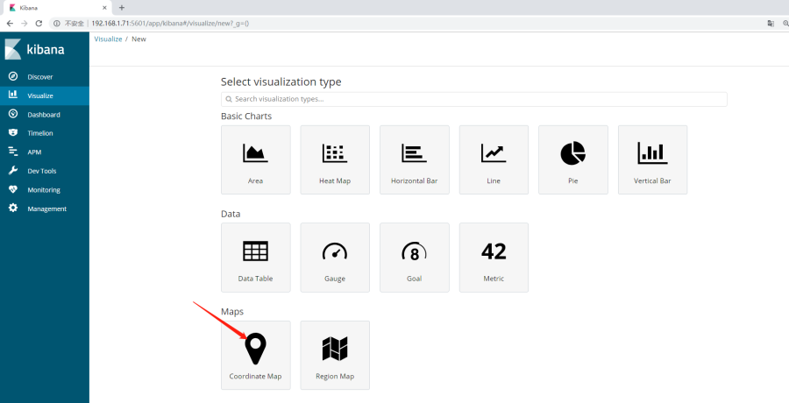
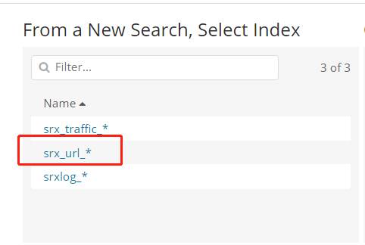
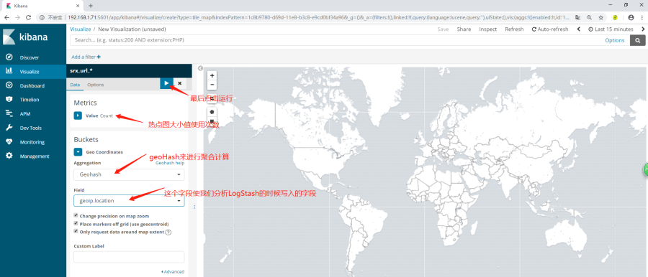
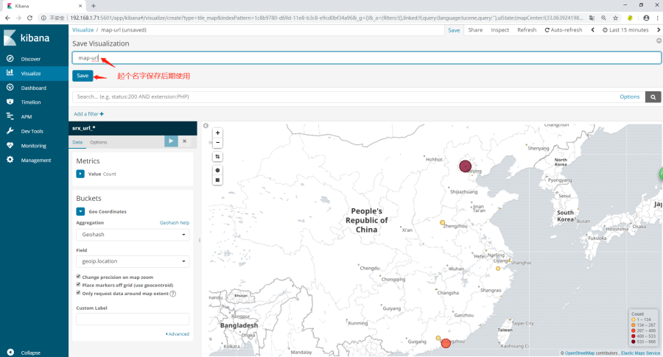
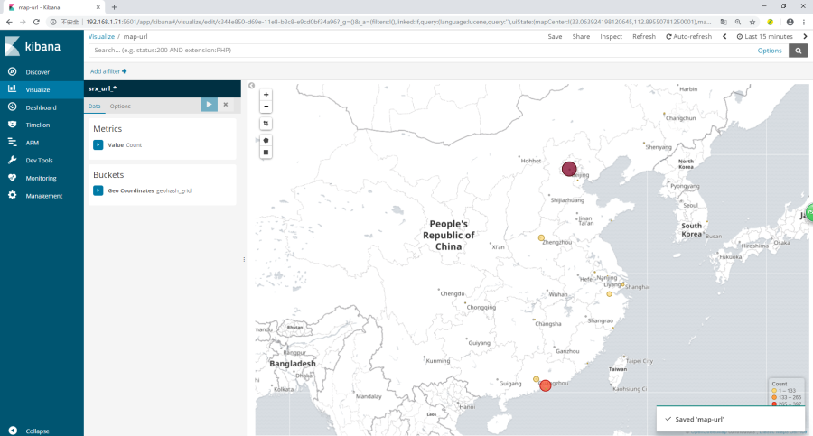
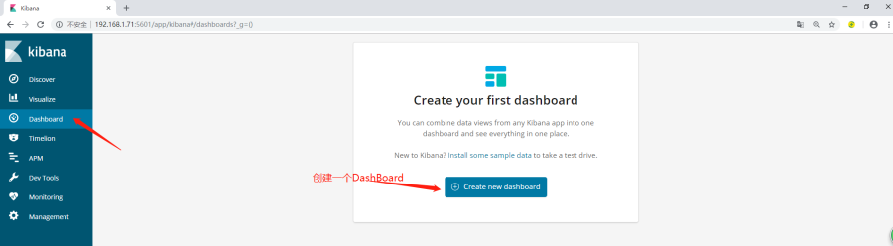
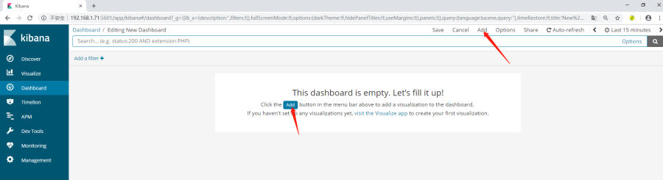
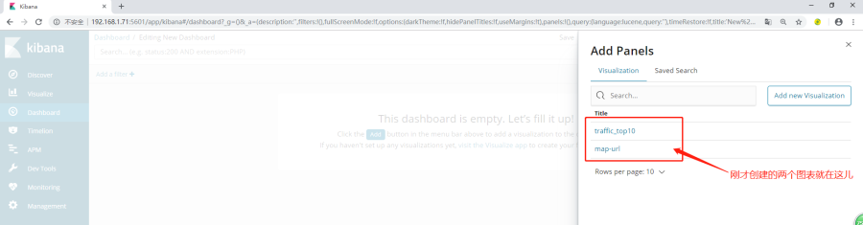
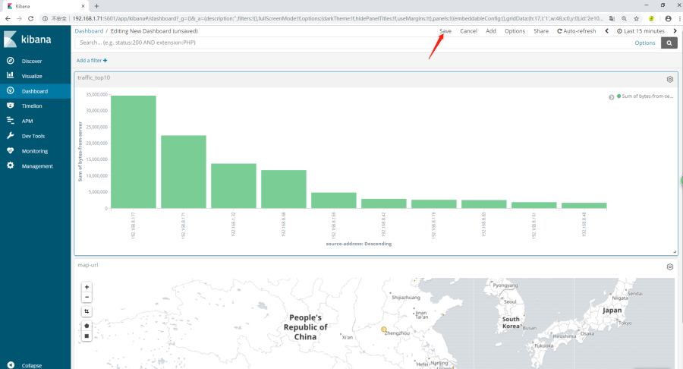
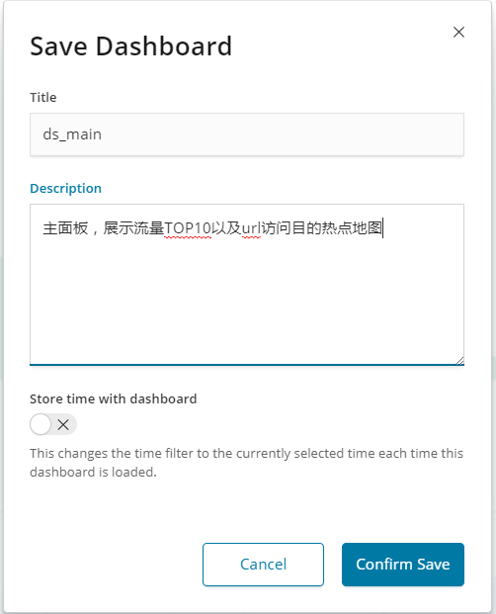
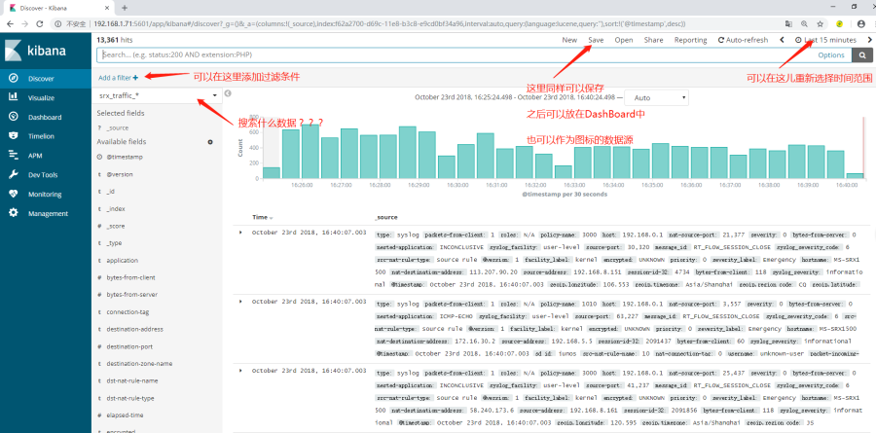

Kibana中测试正则表达式
Kibana中提供了正则表达式的测试界面，可以在这里测试之后，应用到LogStash中，进行日志字段提取操作。
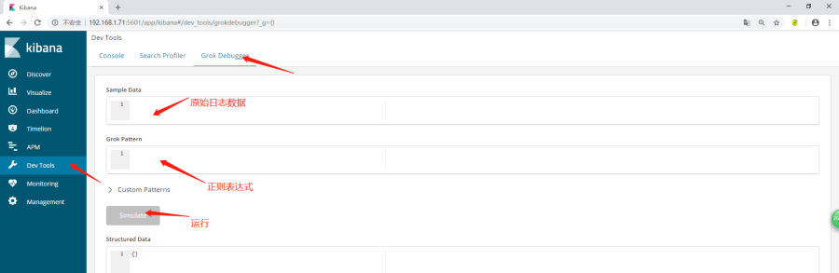

RFC5242 syslog提取正则表达式
如，标准Syslog日志格式如下：
<14>1 2018-10-19T09:05:59.016+08:00 MS-SRX1500 RT_FLOW - APPTRACK_SESSION_CREATE [junos@2636.1.1.1.2.137 source-address="192.168.1.72" source-port="59753" destination-address="74.125.204.139" destination-port="443" service-name="junos-https" application="UNKNOWN" nested-application="UNKNOWN" nat-source-address="121.69.46.102" nat-source-port="12003" nat-destination-address="74.125.204.139" nat-destination-port="443" src-nat-rule-name="20" dst-nat-rule-name="N/A" protocol-id="6" policy-name="3000" source-zone-name="trust" destination-zone-name="untrust" session-id-32="449073" username="N/A" roles="N/A" encrypted="UNKNOWN" destination-interface-name="ge-0/0/1.0"]
对应正则为：
<%{NONNEGINT:syslog_pri}>%{NONNEGINT:version}%{SPACE}(?:|%{TIMESTAMP_ISO8601:syslog_timestamp})%{SPACE}(?:|%{IPORHOST:hostname})%{SPACE}(?:%{SYSLOG5424PRINTASCII:program}|)%{SPACE}(?:|%{SYSLOG5424PRINTASCII:process_id})%{SPACE}(?:|%{SYSLOG5424PRINTASCII:message_id})%{SPACE}(?:|(?<structured_data>(\\[.*?[^\\\]
])+))(?:%{SPACE}%{GREEDYDATA:syslog_message}|)
运行如下：
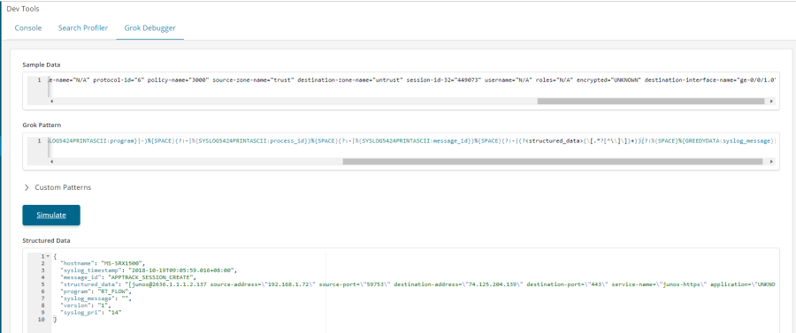

F5提取正则表达式
数据如下：
192.168.1.71 [18/Oct/2018:23:22:53 -0700] 192.168.5.237 /Common/wiki-vs /Common/wiki-pool 192.168.5.151 8090 "/rest/helptips/1.0/tips" GET /rest/helptips/1.0/tips HTTP/1.1 200 44 3 "http://192.168.5.237/display/chat/Comparing+the+Broadcom+Silicons+used+in+Datacenter+switches?src=contextnavpagetreemode" "Mozilla/5.0 (X11; Linux x86_64; rv:45.0) Gecko/20100101 Firefox/45.0"
对应正则如下：
%{IP:clientip} \\[%{HTTPDATE:[@metadata][timestamp]}
] %{IP:virtual_ip} %{DATA:virtual_name} %{DATA:virtual_pool_name} %{DATA:server} %{NUMBER:server_port} %{DATA:path} (?:%{WORD:verb} %{NOTSPACE:request}(?: HTTP/%{NUMBER:httpversion})?|%{DATA:rawrequest}) %{NUMBER:response:int} %{NUMBER:bytes:int} %{NUMBER:response_ms:int} %{QS:referrer} %{QS:agent}
