# New Way of City Goverance, One Stop Service On Smart Parking

## Introduction of Smartway Soultions Inc.

### One stop service on parking management

Smartway Solution Inc. provides comprehensive service from facility building, parking service for car drivers, till parking management for operators of on/off street parking and public authorities. Through apps and management platforms to fulfill the smart parking for car users, operators of on/off street parking and authorities. Meanwhile we have eco-friendly smart lighting products.

### Promoting service procurement to replace equipment procurement

Smartway Solution Inc. dedicated promoting service procurement to replace equipment procurement. Integrate system integration into our service, promote cross-space and cross-sector integration, and accelerate information integration services in Taiwan. Minimize the service gap between systems and the pressure of authorities on system building and

maintenance.

### Strong cooperation with Feng Chia University

Currently Smartway Solution Inc. utilities the campus of Feng Chia University as the test field to implement our parking management service. Introduce high discriminant accuracy smart parking detectors to provide real time parking space information. Meanwhile develop apps and service platform for the parking management, including apps for car drivers and patrolman, service platforms for parking operators, authorities and backend control panel. Integrate information in order to provide service for different stakeholder.

Besides using campus as test field, moreover to cooperate with the Innovation Center for Intelligent Transportation & Logistics. With their adequate researching capabilities to match the state of art technologies and possible applications. Then test the service quality and business model of those applications. It would be easier to convince clients with the on site experiment. Once the application works well, we could efficiently integrate the service platform and provide comprehensive one stop service.

### From planning to service applicaition

As transportation planning consultant, we seek to integrate every possible technologies to solve problems. Meanwhile to think about innovate applications. We take ourselves as the platform for the industry to match their technologies, as well as the stage for them to demonstrate their innovate products.

## Service area

* Parking spaces searching: find out available parking space around your destination.
* Parking spaces guildance：guiding you to the available parking space with google map in the App
* Parking spaces reservation：reserve the parking space online though the App
* Guild to your car on the way back：on your way back click one bottom in the App, it would guild you to your parked car.
* Online payment：pay your parking fee online throuth the App.
* Unauthorized parking detection：dectecting unauthorized parking on specific locations such as bus bay, loading zones, fire hydrant and parking spaces for disable.
* Emgerancy vehicle notification：with our mid-distance transmission platform and smart tags, the emgerancy vehicles could have prority traffice signal when they are on duty.
* Smart parking lot operation：Planning, implementing and operating of samrt parking lot.
* Eco-friendly lighting：automatic lighting system、long life cycle (12 years)，no electromagnetic waves, radiation and electric shock light tubes.
* Software and hardware for license plate and face recognition
* Software and hardware for vehicle and violation detection

## Technical advantages

### Discriminant accuracy higher than conventional geomagnetic sensor

Beside the geomagnetic sensing device, we combine the infrared sensing device into our smart parking sensor. Through long term experiment and data collection, we develop an unique algorithm to integrate these two sensing devices. With these two sensing devices, our smart parking sensor could avoid most mis-detecting circumstances and reach 99.5% of discriminant accuracy.

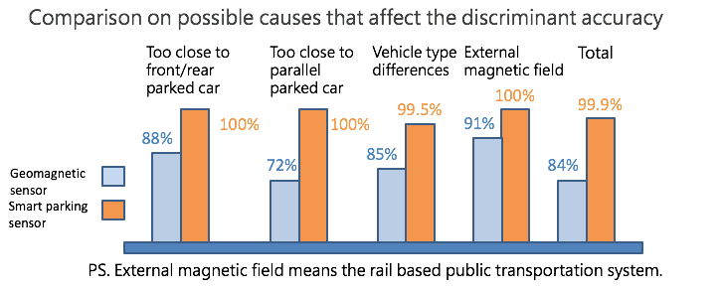

### Easy installation

The 3rd generation smart parking sensor had minify its size which is easier to install, meanwhile enhances the protection capability.

### Solar power supply energy saving and easy to install

### Both our gateway and data repeater could use solar power, no need to excavate roads to connect to supply mains which could save cost on engineering and electricity.

### Realible transmission platform

* Our gateway, data repeater and smart parking sensor cummuncate each other throuth wireless ISM band.
* The smart parking sensor could fit with multi-transmission platform, including NB-IoT, Sigfox ...etc.

## 

## Product datasheet

|  |  |  |
| --- | --- | --- |
| Specification &model | Smart parking detector  (ES-T31(sticky type) & ES-T51(buried type)) | |
| IMG_0132.JPG |  |
| Performance  parameters | * In a clearance area, communication distance:>1000m * Reliable wireless transmission distance * Outdoor parking -sticky type: >200m * Outdoor parking -buried type: >180m * Indoor or underground parking: >80m * Discriminant accuracy >99.5% * Transmit power <18dBm * Transmit current<330mA * Receive current<30mA * Power supply：3V disposable batteries, the battery life of 5 to 6 years (depending on the use of occasions and methods). * Power consumption：Standby power consumption <20uA * Geomagnetic detection sensitivity :1uT * Range of geomagnetic detection sensitivity: 0~2000uT * Infrared detection sensitivity <1cm * Range of infrared detection:10~50cm * Response time of vehicle detection <20s * Alarmed when foreign body block the sensor (dirt that covering the sensor) * Waterproof level：IP68 * Operating temperature：-30℃～ +80℃ * weight：< 210g * Compressive capacity:> 25 tons * Dimensions of sticky type： * diameter-138mm, height-36mm * Dimensions of buried type： * diameter-100mm, height-36mm * Installation of sticky type ：paste by spike glue, or fix by 6mm diameter expansion screw * Installation of buried type ：punching （diameter:120~130mm，hole deep:36-50mm） | |

### 

|  |  |
| --- | --- |
| Specification  & Model | Smart Parking Detector  （ES-T51\_NB） |
| Performance  Parameters | * NB-IoT: Quectel * Communication distance: > 180m * Indoor or underground parking: > 80m * Discriminant accuracy: > 99.5% * Transmit power: < 18dBm * Transmit current: < 330mA * Receive current: < 30mA * Power Supply: 3V disposable batteries have a battery life of 3 years (depending on the use of occasions and methods). * Power Consumption: Standby power consumption < 20uA * Geomagnetic detection sensitivity:1uT * Range of geomagnetic detection sensitivity: 0~2000uT * Range of infrared detection: 10~50cm * Response time of vehicle detection: 10~20s * Alarmed when foreign body block the sensor（dirt covering the sensor） * Waterproof level: IP68 * Operating temperature: -30℃ – +80℃ * Weight: < 510g * Compressive capacity: > 25 tons * Dimensions:Diameter-110mm, Height- 86mm |

|  |  |
| --- | --- |
| Specification  & Model | General Type Parking Information  Gateway （ES-C04/062） |
| Performance  Parameters | * In a clearance area, communication distance: >1000m * Reliable wireless transmission distance Outdoor parking- Sticky type: > 200m Buried type: > 180m * Indoor or Underground Parking: > 80m * Transmit power: < 20dBm * Transmit current: < 500mA * Receive current: < 30mA * Power supply: AC110-AC220V * Power consumption- Average power consumption: < 3W * Maximum power consumption: < 5W * Spare battery capacity: 10AH * Operating time of spare battery: > 24 hours * Data interface: RJ45（optional） * Communication interface: Wireless * Data storage: When saving the data and the corresponding time to the internal flash memory, it will not lose data when the network connection is interrupted. * Maximum amount of data stored: > 500000 * Instant time error: < 60s/month * Read speed: Approximately 25 per second(related to network) * Waterproof level: IP66 * Operating temperature: -30℃~+80℃ * Dimensions: 200x150x100 mm * Weight: < 800g * No special installation requirements |

### 

|  |  |
| --- | --- |
| Specification  & Model | Smart Tag （ES-T41） |
| Performance  Parameters  机车车载标签-近距离.jpg | * Operating frequency : 2.400Ghz~2.481Ghz * Power supply: Rechargeable battery with USB charging interface * Charging voltage: 4.7~5.5V * Charging current: 500mA * Battery voltage: 3.7V * Battery capacity: 1000mAH * Operating temperature: -20°~+70° * Standby current: 200uA * Operating current: 40mA * Transmit power: -20~4dBm（customizable） * Read/Write distant: 10-100m（customizable） * Communication interface: wireless（Built-in） * Antenna type: PCB(Built-in) * Transmission rate: 250kbps * Send frequency: 0.1~1Hz（customizable） * GPS position accuracy: 5m（outdoor） * GPS capture sensitivity: -148dBm * GPS cold boot Positioning time: 32s（outdoor） * GPS hot boot Positioning time: 3s（outdoor） * GPS sleep time: 1~10 min（customizable）—response time from motion to stop of scooter * GPS battery operating time: Continuous work for 24 hours（scooter in motion） * Shell material: ABS Engineering plastics * Protection level: Ip44 * Dimensions: 96×62×12mm |

Software and hardware for license plate and face recognition

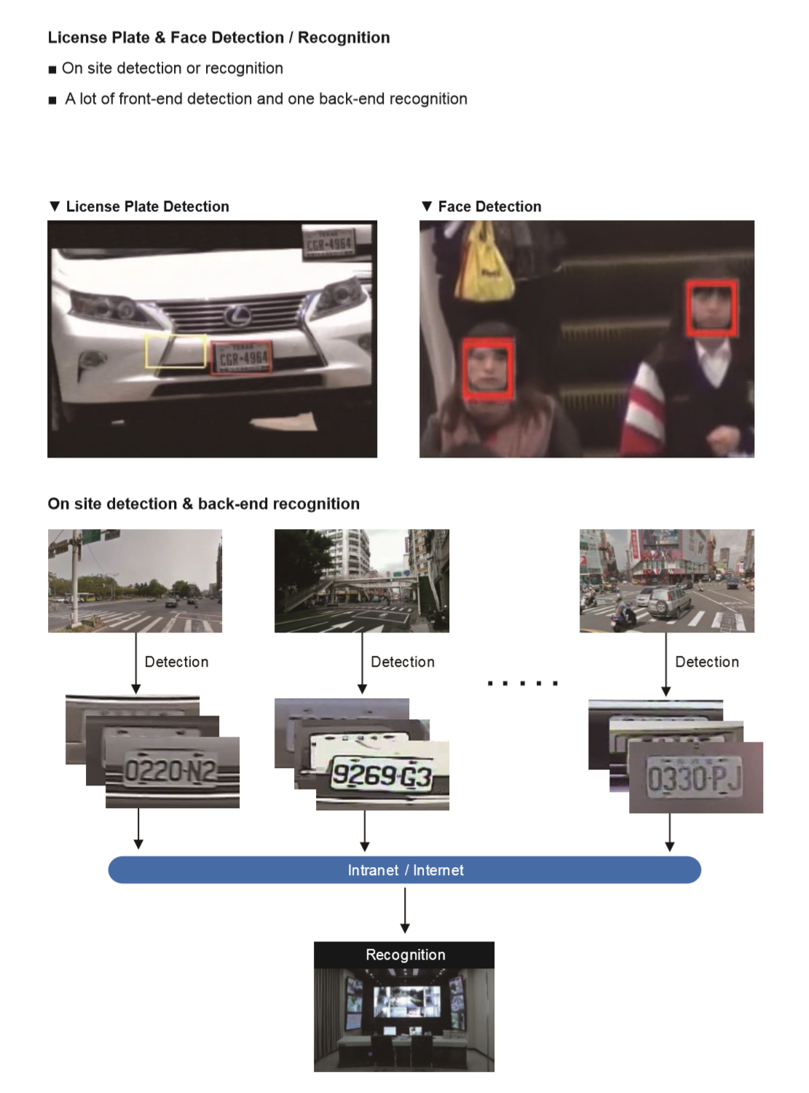

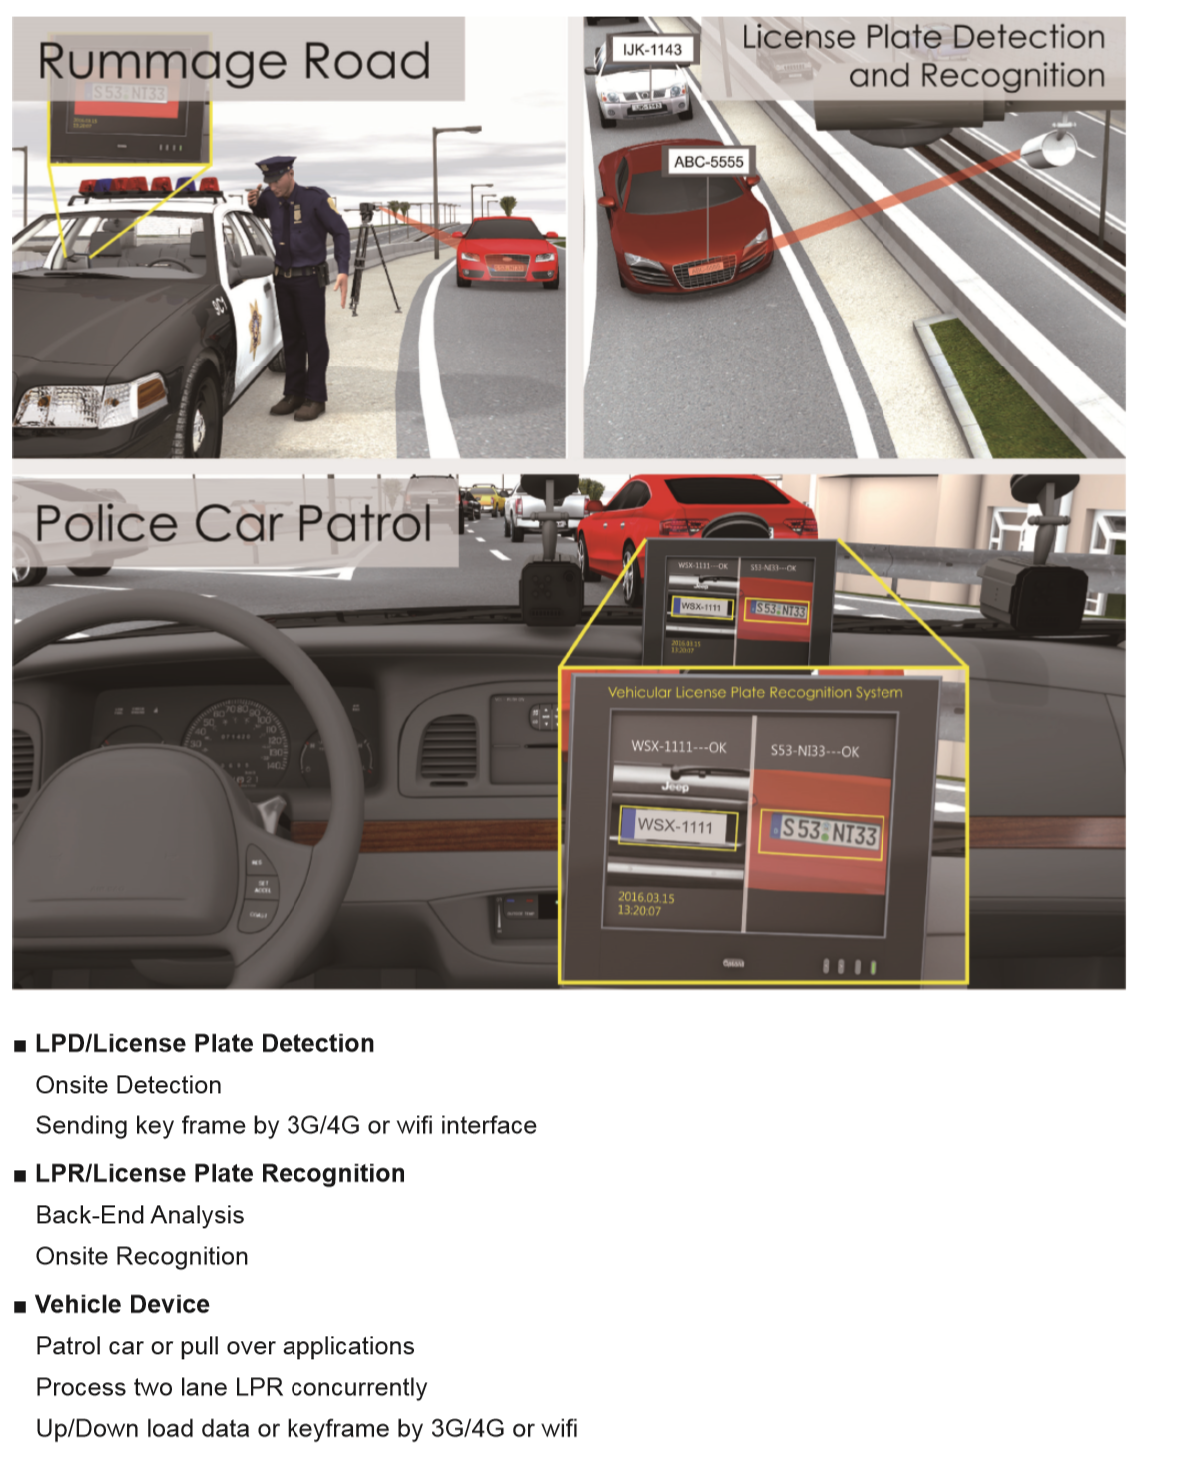

Software and hardware for vehicle and violation detection

