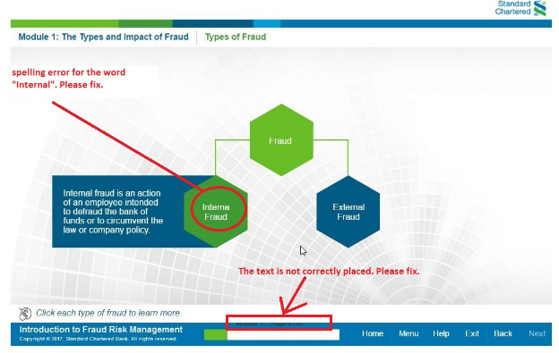

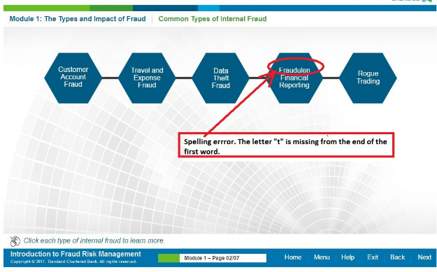

**Global Error: Submit spelling incorrect in Assessment and in CYU pages also. Like Mod3 Page 5.**

