Hi Hitesh,

Even we were able to complete the training at our end. Also we have received screenshots from you already. However, for some users it is not getting completed. Please see the highlighted text from one of the stakeholders in the mail below.

Please debug the course thoroughly and see what must be going wrong, while trying different scenarios. This is very critical and on high priority, since course is on live already and people are not able to complete the course, even though they reached the ‘Thank you’ page.

Regards,

Kamalesh

**From:** Hitesh Rawat [<mailto:hiteshr@gc-solutions.net>]   
**Sent:** Thursday, April 20, 2017 5:58 PM  
**To:** Singh, Neelam <[neelam.singh@philips.com](mailto:neelam.singh@philips.com)>  
**Cc:** 'Mridusmita Bordoloi' <[mridusmitab@gc-solutions.net](mailto:mridusmitab@gc-solutions.net)>; Bhamare, Kamalesh <[kamalesh.bhamare@philips.com](mailto:kamalesh.bhamare@philips.com)>  
**Subject:** RE: V60: 2.30 Software Updates | Unable to mark completion on CSoD LMS

Hi Neelam,

I was able to complete the training assigned in the trail below. Following is the screenshot of completion:

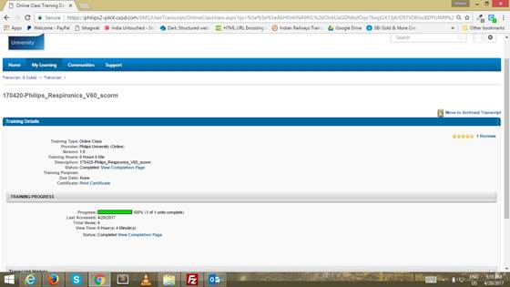

Regards,

Hitesh Rawat

**From:** TechSupport, PU [<mailto:pu.techsupport@philips.com>]   
**Sent:** Thursday, April 20, 2017 5:37 PM  
**To:** Hitesh Rawat <[hiteshr@gc-solutions.net](mailto:hiteshr@gc-solutions.net)>  
**Cc:** Singh, Neelam <[neelam.singh@philips.com](mailto:neelam.singh@philips.com)>; 'Mridusmita Bordoloi' <[mridusmitab@gc-solutions.net](mailto:mridusmitab@gc-solutions.net)>; Bhamare, Kamalesh <[kamalesh.bhamare@philips.com](mailto:kamalesh.bhamare@philips.com)>  
**Subject:** RE: V60: 2.30 Software Updates | Unable to mark completion on CSoD LMS

Hi Hitesh,

Below course is uploaded on CSOD

Search Text- 170420-Philips_Respironics_V60_scorm

Thanks,

Amol Suryavanshi

**From:** Hitesh Rawat [<mailto:hiteshr@gc-solutions.net>]   
**Sent:** Thursday, April 20, 2017 5:09 PM  
**To:** Bhamare, Kamalesh <[kamalesh.bhamare@philips.com](mailto:kamalesh.bhamare@philips.com)>  
**Cc:** Singh, Neelam <[neelam.singh@philips.com](mailto:neelam.singh@philips.com)>; 'Mridusmita Bordoloi' <[mridusmitab@gc-solutions.net](mailto:mridusmitab@gc-solutions.net)>; TechSupport, PU <[pu.techsupport@philips.com](mailto:pu.techsupport@philips.com)>  
**Subject:** RE: V60: 2.30 Software Updates | Unable to mark completion on CSoD LMS

Hi,

Following is the download link for latest package:

<https://ftp2.gc-solutions.net/ftp/Philips_University/Philips/20042017/Philips_Respironics_V60_scorm.zip>

Regards,

Hitesh Rawat

**From:** Bhamare, Kamalesh [<mailto:kamalesh.bhamare@philips.com>]   
**Sent:** Thursday, April 20, 2017 4:48 PM  
**To:** 'Mridusmita Bordoloi' <[mridusmitab@gc-solutions.net](mailto:mridusmitab@gc-solutions.net)>; Hitesh Rawat <[hiteshr@gc-solutions.net](mailto:hiteshr@gc-solutions.net)>; TechSupport, PU <[pu.techsupport@philips.com](mailto:pu.techsupport@philips.com)>  
**Cc:** Singh, Neelam <[neelam.singh@philips.com](mailto:neelam.singh@philips.com)>  
**Subject:** RE: V60: 2.30 Software Updates | Unable to mark completion on CSoD LMS

Hi Hitesh and Mridusmita,

Could you please share the latest package?

@Amol, After receiving the download link from Hitesh, please upload it on CSoD and share the search text.

Regards,

Kamalesh

**From:** Singh, Neelam   
**Sent:** Thursday, April 20, 2017 2:24 PM  
**To:** Hitesh Rawat <[hiteshr@gc-solutions.net](mailto:hiteshr@gc-solutions.net)>; Bhamare, Kamalesh <[kamalesh.bhamare@philips.com](mailto:kamalesh.bhamare@philips.com)>  
**Cc:** 'Mridusmita Bordoloi' <[mridusmitab@gc-solutions.net](mailto:mridusmitab@gc-solutions.net)>  
**Subject:** RE: V60: 2.30 Software Updates | Unable to mark completion on CSoD LMS

Hi Hitesh,

Thanks for confirming.

Hi Kamalesh,

Can we provide access for debugging the issue?

Regards,

Neelam Singh

**From:** Hitesh Rawat [<mailto:hiteshr@gc-solutions.net>]   
**Sent:** Thursday, April 20, 2017 2:18 PM  
**To:** Singh, Neelam <[neelam.singh@philips.com](mailto:neelam.singh@philips.com)>  
**Cc:** Bhamare, Kamalesh <[kamalesh.bhamare@philips.com](mailto:kamalesh.bhamare@philips.com)>; 'Mridusmita Bordoloi' <[mridusmitab@gc-solutions.net](mailto:mridusmitab@gc-solutions.net)>  
**Subject:** RE: V60: 2.30 Software Updates | Unable to mark completion on CSoD LMS

Hi Neelam,

I downloaded the package you shared and tested it successfully for completion on scorm cloud. If, you are facing the an issue regarding the completion of the training, then, we would need to debug the issue for which we would require the course to be uploaded on CSOD.

Regards,

Hitesh Rawat

**From:** Singh, Neelam [<mailto:neelam.singh@philips.com>]   
**Sent:** Thursday, April 20, 2017 1:05 PM  
**To:** Mridusmita Bordoloi <[mridusmitab@gc-solutions.net](mailto:mridusmitab@gc-solutions.net)>  
**Cc:** Bhamare, Kamalesh <[kamalesh.bhamare@philips.com](mailto:kamalesh.bhamare@philips.com)>; 'Hitesh Rawat' <[hiteshr@gc-solutions.net](mailto:hiteshr@gc-solutions.net)>  
**Subject:** RE: V60: 2.30 Software Updates | Unable to mark completion on CSoD LMS

We have used the attached package to replace the previous training. Please check if it’s working at your end and is the same version (shared in the mail).

Regards,

Neelam Singh

**From:** Mridusmita Bordoloi [<mailto:mridusmitab@gc-solutions.net>]   
**Sent:** Thursday, April 20, 2017 12:41 PM  
**To:** Singh, Neelam <[neelam.singh@philips.com](mailto:neelam.singh@philips.com)>  
**Cc:** Bhamare, Kamalesh <[kamalesh.bhamare@philips.com](mailto:kamalesh.bhamare@philips.com)>; 'Hitesh Rawat' <[hiteshr@gc-solutions.net](mailto:hiteshr@gc-solutions.net)>  
**Subject:** RE: V60: 2.30 Software Updates | Unable to mark completion on CSoD LMS

Hi Neelam,

We have successfully tested the **V60: 2.30 Software Updates** course for completion on scorm cloud.

Request you to get the last version of the scorm package we had shared, uploaded on CSoD, so that the same can be tested on CSOD as well.

**Thanks and Regards**

**Mridusmita Bordoloi**

**Desk:** +91.120.4000.363 **||Mobile:** +91-9810359882 **|| Skype:** Mridusmita.bordol

**From:** Singh, Neelam [<mailto:neelam.singh@philips.com>]   
**Sent:** Thursday, April 20, 2017 10:13 AM  
**To:** 'Mridusmita Bordoloi' <[mridusmitab@gc-solutions.net](mailto:mridusmitab@gc-solutions.net)>  
**Cc:** Bhamare, Kamalesh <[kamalesh.bhamare@philips.com](mailto:kamalesh.bhamare@philips.com)>  
**Subject:** V60: 2.30 Software Updates | Unable to mark completion on CSoD LMS  
**Importance:** High

Hi Mridusmita,

Can you please check the **V60: 2.30 Software Updates** SCORM package for CSoD is working correctly as the training is not marked as “completed” even after going through the whole course?

Regards,

Neelam Singh

+++++++++++++++++++++++++++++++++++++++++++++++++++++++++++++++++++

I checked the course, completed the assessment and have the same problem as this user. This is a showstopper as the NPI users cannot proceed with completing the curriculum due to the sequencing.

Could you undertake the appropriate actions?

See my screen below as “proof” that I completed the course.

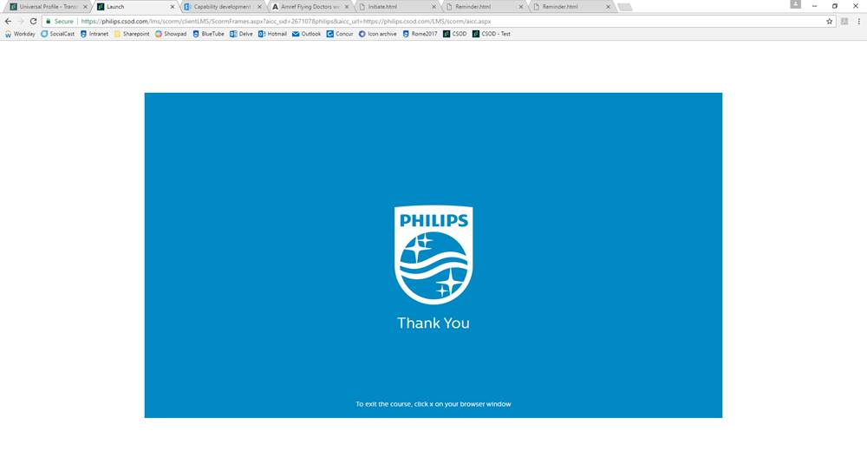

The information contained in this message may be confidential and legally protected under applicable law. The message is intended solely for the addressee(s). If you are not the intended recipient, you are hereby notified that any use, forwarding, dissemination, or reproduction of this message is strictly prohibited and may be unlawful. If you are not the intended recipient, please contact the sender by return e-mail and destroy all copies of the original message.