Question 1:

**What is the correct extension for a Java bytecode compiled file?**

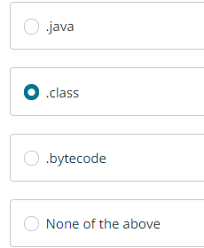

Question 2:

**Consider the given situation:**

**X and Z are two classes, A and B are two interfaces, E is an abstract class.**

**Which one of the following is a correct declaration? (Select two)**

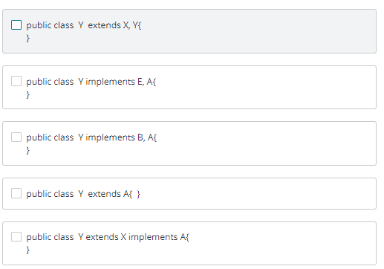

Question 3:

**What is the output of this code-block, if user input is 49?**

**int message = sc.nextInt();  
        switch (message) {  
            case 11:  
                System.out.println("hi");  
                break;**

**case 21:  
                System.out.println("bye");  
                break;**

**default:  
                System.out.println("what?");  
                break;  
        }**

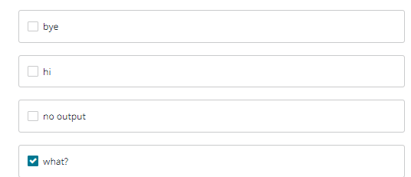

Question 4:

**Which of the following is not true about Java object-oriented programming?**

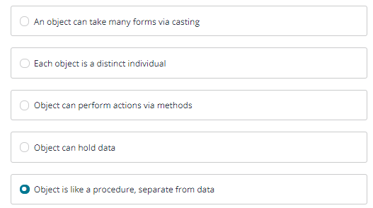

Question 5:

**What is the output of the following code?**

1. **public static void main(String[] args) {**
3. **int []x = {0, 1, 2, 3, 4};**
4. **int i = x.length - 1;**
6. **while(i >=0 ){**
7. **System.out.print(x[i]);**
8. **i -= 1;**
9. **}**
10. **}**

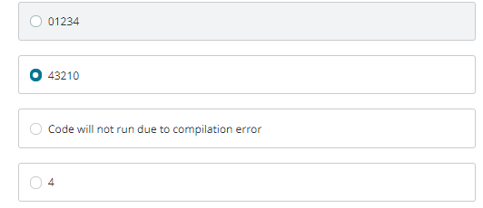

Question 6:

**Which one of the following has no syntax error?**

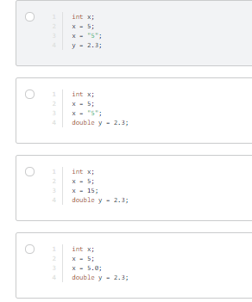

Question 7:

**What does this code output?**

1. **public static void main(String[] args) {**
2. **System.out.println("x\tx^2\t\n1\t2");**
3. **}**

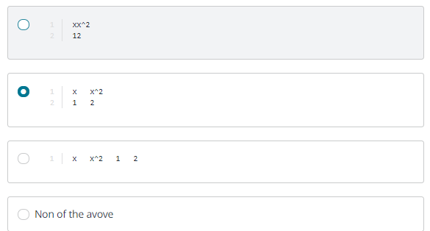

Question 8:

**What is the result of the following Java class?**

1. **public class Village {**
2. **int house = 10;**
3. **public static void main(String[] data) {**
4. **int building = 5;**
5. **System.out.print(building + house);**
6. **}**
7. **}**

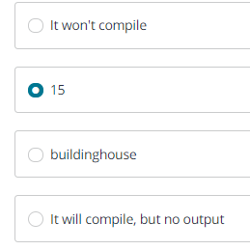

Question 9:

**Identify the error in this code-block. What is the correct code for that line?**

1. **Scanner input = new Scanner(System.in);**
2. **int x;**
3. **System.out.print("x: ");**
4. **x = input.nextLine();**
5. **System.out.println(x);**

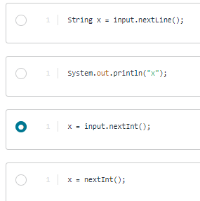

Question 10:

**What is the difference between x++ and ++x?**

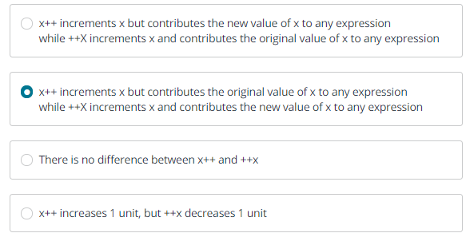Question 11:

**Which of the following *statements* will output “Hello Dolly” if a string variable named s contains the exact contents “I’m Dolly”?**

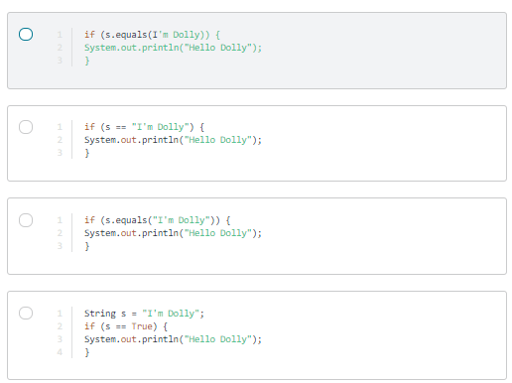

Question 12:

**Which one of the following statements is correct? (Select two)**

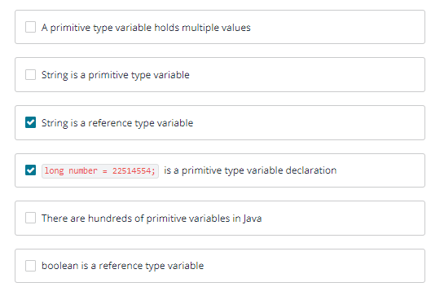

Question 13:

**Which of the following Java declarations will not compile?**

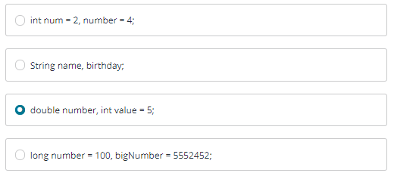

Question 14:

**Which of the following is not a valid name for declaring variable? (select two)**

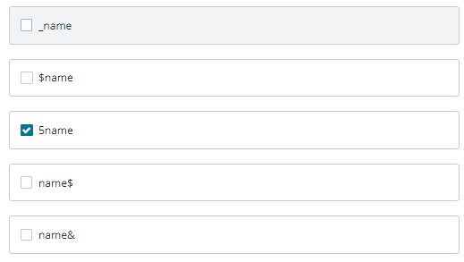

Question 15:

**What is the result while running this code?**

1. **public class Values {**
2. **integer x = Integer.valueOf("7");**
4. **public static void main(String[] args) {**
5. **integer x = Integer.valueOf("5");**
6. **integer y = Integer.valueOf("2");**
7. **System.out.println(x*y);**
8. **}**
9. **}**
10. 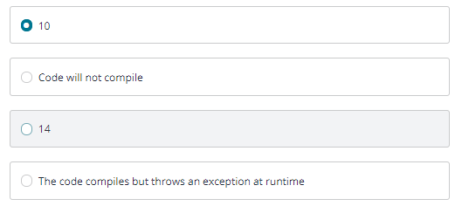

Question 16:

**Which one is a valid statement? (Select two)**

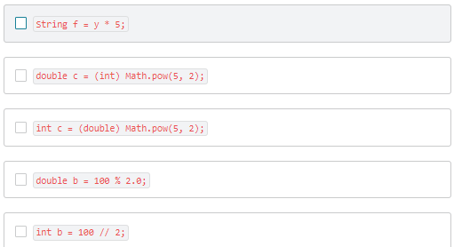

Question 17:

**What is the output of  this code?**

1. **public static void main(String[] args) {**
2. **double i = 2012.2654;**
3. **System.out.printf("%.2f", i);**
4. **}**

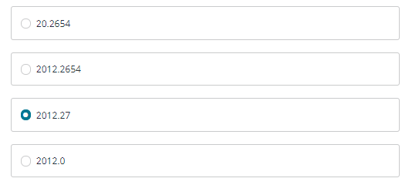

Question 18:

**Which one of the following lists presents from smallest to largest data type?**

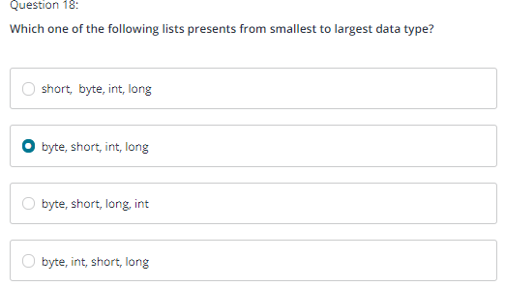

uestion 19:

**What  does the code output?**

1. **public static void main(String args[]) {**
2. **String s = "Hi, there java";**
3. **System.out.print(s.indexOf('i')+" "+s.lastIndexOf('e')+" "+s.lastIndexOf('v'));**
4. **}**

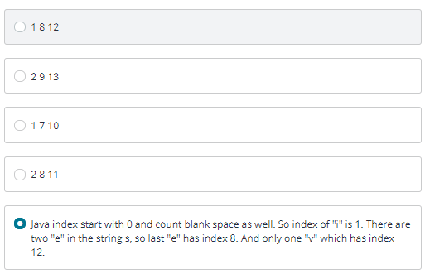

Question 20:

**What is the first line in the following code to not compiling?**

1. **public static void main(String[] args) {**
2. **int Integer = 0; //line 1**
3. **Integer int = 0; //line 2**
4. **Integer ++; //line 3**
5. **int++; //line 4**
6. **}**

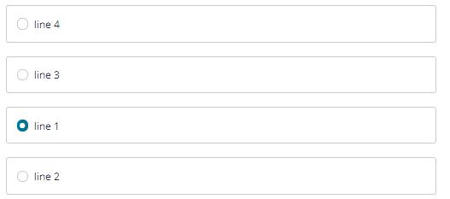

Question 21:

**What is the output if following loop run in the main method?**

1. **int age = 3;**
2. **do {**
3. **System.out.print(age + " ");**
4. **age -= 1;**
5. **} while (age != 0);**

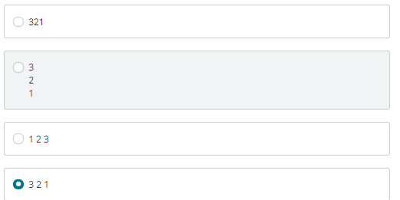

Question 22:

**Which statement immediately exits a switch statement, skipping all remaining case or default branches?**

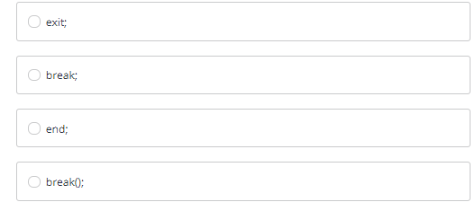

Question 23:

**What is the output of the following application?**

1. **public class Bird {**
2. **public final static void main(String... arguments) {**
3. **int peter = 16;**
4. **long tom = 5;**
5. **if(peter % 4 >= 1)**
6. **tom++;**
7. **tom--;**
8. **System.out.print(tom);**
9. **}**
10. **}**

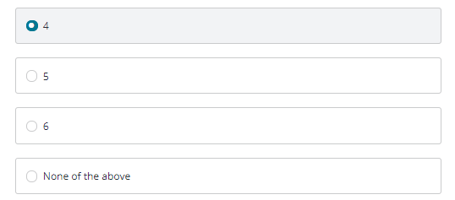

Question 24:

**Given the following truth table, which Java operator for the boolean expressions x and y corresponds to this relationship?**

**y =  True                     y = False**

**---------------------------------------------------------------------------**

**x = False            True                            False**

**y= True               True                            True**

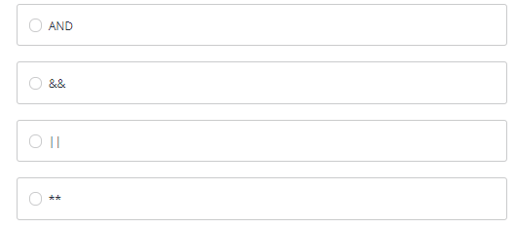

Question 25:

**Which Java statement will output the contents of the variables x and y to the screen separated by a space? The variable x is an int and y is a double type. The variable y should be printed  with exactly 3 decimal place.**

