Research on the System Composition of Comprehensive Display Using Improved Web Page Editors
Master’s thesis research draft
Three chapter manuscript
Prepared in English on 2 October 2026
The subject of this study is a web page editor that generates reusable display components and updates their contents when underlying statistical data change. The proposed system combines production information, management records, financial indicators, documents, photographs, and statistical graphics within a configurable web page.
This manuscript develops a reference architecture, mathematical models, implementation structures, and an evidence based evaluation method. It includes an executed synthetic experiment and an executable JavaScript reference core. The author’s existing editor, source code, deployment, screenshots, and operational measurements were not available during preparation.
Research status Design and analytical draft with synthetic evaluation. Institutional details, author identity, supervisor approval, actual implementation mapping, and editor specific empirical results must be supplied before submission.

Abstract
Organizations often maintain production, management, financial, and documentary information in separate systems. A web page can present these sources together, but the usefulness of that page depends on whether its components remain correct, timely, understandable, and maintainable as the sources change. This study investigates the composition of a web service and editing environment for such displays.
The proposed design represents a page as a versioned specification containing layout, component types, data bindings, transformations, access policies, and freshness requirements. An adapter layer converts source changes into typed events. A materialization layer derives operational indicators. A dependency index identifies the components affected by each change, and a stream gateway delivers authorized updates to viewers. Mathematical models describe visual mappings, dependency propagation, freshness, workload, update costs, layout constraints, and publication state.
An executable JavaScript reference core demonstrates dependency registration, monotonic state updates, exact integer currency arithmetic, and production metric validation. A discrete event simulation compares four update policies using identical synthetic traces at three event rates and thirty seeds. At moderate load, selective push delivery substantially reduces modelled payload traffic and acknowledgement delay relative to one second full polling. At high load, it increases total update work and traffic while preserving fresher state. These findings expose a workload dependent trade off rather than universal superiority.
The thesis contributes an integrated design and a reproducible evaluation approach. It does not establish that the author’s existing editor outperforms commercial or open source editors, because those products and the actual editor were not benchmarked. A matched implementation study, browser measurements, recovery tests, and authoring study are specified to complete that empirical claim.
Keywords information visualization, web page editor, component binding, event processing, Node.js, incremental rendering, freshness, working capital.

Research evidence and contribution boundaries
Three kinds of evidence are distinguished throughout the manuscript. Literature and documentation support descriptions of established ideas and publicly documented capabilities. Mathematical analysis supports conclusions that follow from stated assumptions. Executed synthetic results support conclusions about the supplied simulator. These evidence classes must not be substituted for measurements of the author’s existing application.
The proposed contribution is the integration of typed operational data, explicit temporal semantics, reusable visual components, a dependency index, and version aware delivery into a page editing workflow. Components, data binding, declarative visualization, incremental computation, and server push are established techniques. Their use does not independently constitute a new scientific invention. The potential research contribution lies in the system composition, the consistency and freshness contracts it enforces, and the evidence that a particular implementation improves a defined workload.
The reference core is intentionally smaller than the full architecture. It verifies several important algorithmic rules, but it does not implement a complete editor, persistent event log, browser chart renderer, access control service, or production deployment. Diagrams present proposed structures. The interface figure is a design mockup rather than a screenshot of an existing product.
The empirical claim remains conditional: an editor using the proposed composition may improve freshness and reduce unnecessary work when change activity is sparse relative to the page’s dependencies. The synthetic experiment tests this mechanism and also identifies circumstances in which its cost increases. A complete thesis submission should replace provisional implementation descriptions with verified facts and append measurements obtained from the actual editor under matched conditions.
The document uses numbered references and a targeted narrative literature review. It does not report a systematic review, a completed user study, or an industrial deployment.

Contents
Abstract 2
Research evidence and contribution boundaries 3
List of figures 5
List of tables 6
Abbreviations and notation 7
Introduction and research questions 8
Chapter 1 Foundations and existing editing tools 9
1.1 Information visualization concepts and flexible models 9
1.2 Visualization authoring and web page editing tools 24
Chapter 2 Mathematical composition and editor design 38
2.1 Web service architecture and performance model 38
2.2 Component models and proposed editing interface 54
Chapter 3 Implementation structures and evaluation 70
3.1 Logical and physical architecture in Node.js 70
3.2 Comparative evaluation and synthetic evidence 86
Conclusions 101
Completion requirements for an implementation specific thesis 102
References 103
Reproducibility and accompanying research files 106
The contents refer to this draft’s fixed manuscript layout. Further editing, institutional formatting, or replacing mockups with actual screenshots may change pagination. The six main sections follow the requested three chapter structure; their numbered subsections develop the detailed arguments.

List of figures
Figure 1 Classification of visual display tasks 13
Figure 2 Flexible visualization pipeline 18
Figure 3 General editor framework 27
Figure 4 Revision and publication lifecycle 32
Figure 5 Proposed web service composition 39
Figure 6 Queue utilization sensitivity 46
Figure 7 Batching and delay model 47
Figure 8 Component dependency example 49
Figure 9 Operational and financial metric relationships 56
Figure 10 Proposed editing interface mockup 61
Figure 11 Editing and binding flow 64
Figure 12 Logical deployment architecture 71
Figure 13 Physical deployment architecture 72
Figure 14 Persistent entity relationships 73
Figure 15 Source ingestion flow 76
Figure 16 Browser update flow 78
Figure 17 Publication flow 80
Figure 18 Reconnection and recovery flow 81
Figure 19 Synthetic payload comparison 91
Figure 20 Synthetic component update comparison 92
Figure 21 Synthetic acknowledgement latency comparison 93
Figure 22 Synthetic intermediate state visibility comparison 94
Figure 23 Dependency density sensitivity 95
All diagrams, the interface mockup, and analytical plots were created for this manuscript. Benchmark figures use results generated by the accompanying simulator. None represents a captured screen or measured performance of a third party editor.

List of tables
Table 1 Research questions and evidence 8
Table 2 Data and task classifications 12
Table 3 Visual representation comparison 15
Table 4 Temporal semantics of displayed information 17
Table 5 Constraints on flexible visualization 20
Table 6 Families of visualization authoring tools 25
Table 7 Web page editor categories 28
Table 8 Documented editor capabilities 31
Table 9 Proposed language and runtime choices 34
Table 10 Architecture responsibilities 40
Table 11 Source event contract 41
Table 12 Update transport comparison 44
Table 13 Workload variables 45
Table 14 Proposed quality and freshness policies 51
Table 15 Component contracts 55
Table 16 Operational metric definitions 57
Table 17 Financial interpretation rules 58
Table 18 Interface areas and behavior 62
Table 19 Editing commands and invariants 63
Table 20 Data structures and complexity 65
Table 21 Proposed deployment responsibilities 74
Table 22 API and stream contracts 75
Table 23 Failure handling cases 82
Table 24 Comparative evaluation indicators 87
Table 25 Functional evidence matrix 88
Table 26 Synthetic experiment parameters 89
Table 27 Synthetic mean outcomes 90
Table 28 Paired synthetic policy differences 96
Table 29 Evidence required for product comparison 97
Table 30 Hypothesis assessment and limitations 98
Table 31 Proposed functional acceptance tasks 99
Table 32 Evidence required by comparative claim 100
Tables describing the proposed editor are specifications. Capability tables for existing products are documentation based observations, not results from executed acceptance tests.

Abbreviations and notation
API Application programming interface. CDC Change data capture. CDN Content delivery network. CMS Content management system. DAG Directed acyclic graph. DOM Document object model. ERP Enterprise resource planning. MES Manufacturing execution system. KPI Key performance indicator. OEE Overall equipment effectiveness. SSE Server sent events. TLS Transport layer security. WCAG Web Content Accessibility Guidelines. WYSIWYG What you see is what you get.
Node.js is a JavaScript runtime, not a programming language. JavaScript is the implementation language of the supplied reference core and simulator. TypeScript is an optional language for a larger implementation. HTML describes document structure, CSS describes presentation, SQL expresses database queries, and JSON represents interchange documents.
The main mathematical symbols are defined locally when introduced. In general, S denotes a set of information sources, C a set of components, D a dataset, G a dependency graph, B a binding relation, and R a rendering function. The symbol λ denotes event arrival rate, μ denotes service rate, ρ denotes utilization, τ denotes a polling interval, and b denotes a batching interval. A denotes information age when used in a temporal expression; availability is written as Av to avoid confusion.
Time quantities are expressed in milliseconds in the simulator and in explicitly stated units in other equations. Currency amounts are expressed in integer minor units together with a currency code. Ratios are dimensionless unless a denominator introduces a rate unit. Counts of component updates measure computational work in the synthetic model; they are not browser frame counts, processor utilization, or elapsed execution time.
The expression real time is used operationally to mean that a defined freshness requirement is met. The design makes no hard real time guarantee under arbitrary overload, network loss, or unavailable source systems.

Introduction and research questions
A comprehensive display is a page that lets a user examine related operational facts and their context without manually assembling a report from several applications. For example, a production manager may need current output, planned output, maintenance status, a photograph of equipment, an approved instruction, and a financial constraint. The page editor determines how these elements are arranged; the runtime determines when they change and whether the resulting view remains meaningful.
The research problem is therefore broader than drawing a chart. A useful system must express which source fields determine a component, preserve their meaning across transformations, detect changes, propagate authorized updates, and explain missing or stale information. The central design question is whether these responsibilities can be made explicit in the editor’s page specification and executed efficiently by a web service.
Table 1 Research questions and evidence
Question | Required evidence
RQ1 How should a flexible display be represented | Literature synthesis and mathematical specification
RQ2 How should changes propagate across components | Dependency model and algorithm validation
RQ3 Under which workloads does selective delivery help | Paired synthetic experiment and sensitivity analysis
RQ4 Does the actual editor improve existing tools | Matched product tests and authoring study still required

H1 predicts that selective updates reduce component work relative to full updates at equal delivery frequency when dependency coverage is incomplete. H2 predicts that shorter batching intervals improve acknowledgement freshness while potentially increasing total traffic. H3 predicts that typed bindings and explicit quality state reduce invalid configurations; testing H3 requires an authoring study that has not yet been performed.

Chapter 1 Foundations and existing editing tools

1.1 Information visualization concepts and flexible models

1.1.1 The role of visualization in a comprehensive display
Information visualization is the deliberate mapping of abstract data to visible structures that support interpretation and action. In this thesis, the mapping includes not only marks such as bars and lines but also the surrounding labels, interaction controls, provenance information, and temporal state that make those marks interpretable. A production total without a reporting period, unit, or source may be visually prominent while remaining analytically ambiguous.
The distinction between visualization and presentation is useful. A photograph presents visual evidence about an object or situation. A bar chart encodes a quantitative relationship. A document viewer presents an authoritative record. A comprehensive page coordinates these different representations around a task; it does not turn every item into statistical graphics. The editor must consequently support both visual encodings and contextual media.
Shneiderman’s taxonomy connects data types and user tasks, while Munzner’s nested model separates domain characterization, data and task abstraction, visual encoding, and algorithmic implementation [1,2]. These works motivate two questions for the proposed editor: what decision does the page support, and what evidence is needed to show that the page supports it correctly? Improving rendering speed answers only part of the second question.
The chapter first classifies information and representations, then develops a formal notion of flexibility. It subsequently examines visualization authoring tools and web page editors. The purpose is to identify established capabilities, expose integration requirements, and define a bounded research gap. It is not to infer that all older editors are static or incapable of extension.

1.1.2 Literature selection and analytical method
The review is a targeted narrative analysis of primary research, standards, and official tool documentation. Foundational visualization papers were selected for their direct relevance to task abstraction, declarative encodings, and data driven documents. Stream processing research was selected for its treatment of changing and out of order data. Editor documentation was selected to verify concrete capabilities relevant to reusable components, dynamic bindings, publication, and extensibility.
Searches and documentation checks were performed on 2 October 2026. The source set is purposive rather than exhaustive. No screening count, inter reviewer agreement, or comprehensive database search is claimed. The method can support a conceptual synthesis and documented feature comparison, but it cannot establish market prevalence or statistically representative technology trends.
Each source is examined through four questions. First, which data and tasks does it address? Second, how does it represent a visualization or page? Third, how are changes and interactions expressed? Fourth, what form of evaluation supports its claims? This method separates an editor’s authoring model from the delivery policy of a deployed application built with it.
The review also distinguishes absence of documentation from absence of capability. A feature may be provided through a plugin, custom code, a managed service, or an integration that was not examined. The comparison therefore uses categories such as documented, extension required, design specified, and unmeasured instead of assigning unsupported numerical scores.
The synthesis that follows is the thesis author’s analysis. Where a mathematical model is introduced, it is a proposed model for this application domain unless explicitly attributed to prior work. This distinction prevents established frameworks and newly proposed engineering choices from being presented as the same type of contribution.

1.1.3 Data meaning and visualization boundaries
Data meaning determines which operations and visual mappings are valid. Nominal values identify categories without numerical ordering. Ordinal values express an order but do not establish equal distances. Quantitative values support arithmetic subject to their unit and scale. Temporal values identify points, durations, or intervals. These distinctions should be stored as metadata rather than guessed repeatedly by chart components.
The same field may require different treatment in different contexts. A department code consisting of digits remains a category. A production timestamp identifies an event time, while a reporting month identifies a period. A currency amount combines a number with a currency and valuation date. An image URL identifies an asset; it does not reveal whether the image is current, approved, or relevant to the selected equipment.
The editor should also distinguish facts, derived values, and annotations. Facts originate from a source contract. Derived values result from transformations whose definitions are inspectable. Annotations are authored explanations that may reference a fact but should not silently overwrite it. A manager’s comment that output is expected to improve must remain visibly different from a measured production count.
The comprehensive display boundary is therefore semantic as well as technical. It includes enough metadata to make a value interpretable and enough interaction to inspect supporting evidence. It excludes unsupported inferences, such as attributing a financial improvement to a production change merely because both appear on the same page.
For implementation, each bound field receives an identifier, type, unit, entity grain, period definition, quality state, and provenance reference. These properties are carried into component validation and used to reject invalid combinations before publication. This design requirement is developed formally in Chapter 2.

1.1.4 Data and task classifications
Shneiderman identifies several broad data structures and a set of information seeking tasks [1]. Brehmer and Munzner subsequently distinguish why a task is performed, how it is performed, and what its inputs and outputs are [3]. The following application oriented matrix uses these ideas to connect page content with concrete tasks; it is a synthesis for the proposed editor rather than a reproduction of either taxonomy.
Table 2 Data and task classifications
Structure | Typical information | Display task | Candidate representation
Tabular | Orders and management records | Find compare filter | Table and ranked bars
Temporal | Production observations | Inspect trend and change | Line chart and timeline
Multivariate | Output cost quality | Compare related measures | Small multiples and scatterplot
Hierarchical | Organization and accounts | Locate parent and children | Tree and grouped table
Network | Workflow and dependency | Trace relationships | Node link view and matrix
Spatial | Equipment and facilities | Locate a relevant object | Map and annotated plan
Documentary | Instructions and evidence | Read verify inspect | Document viewer and image

A task may cross several rows. Investigating a missed production target may begin with a temporal chart, proceed to a table of affected orders, and end with a maintenance document. The editor should support these transitions through common filters and stable entity identifiers. Treating every component as an isolated widget would preserve layout flexibility while losing analytical continuity.
The classification also guides testing. A chart can be tested for numerical correctness, while a document component must be tested for version identity and access control. A network diagram requires relationship validation that a simple quantitative KPI does not.

1.1.5 Classification by visual purpose
Representations can be classified by the relationship they make visible. Comparison displays support judgments among values. Temporal displays support judgments about change. Distribution displays expose spread and concentration. Relationship displays expose associations or connections. Hierarchical displays organize containment. Context displays provide documentary or photographic evidence.
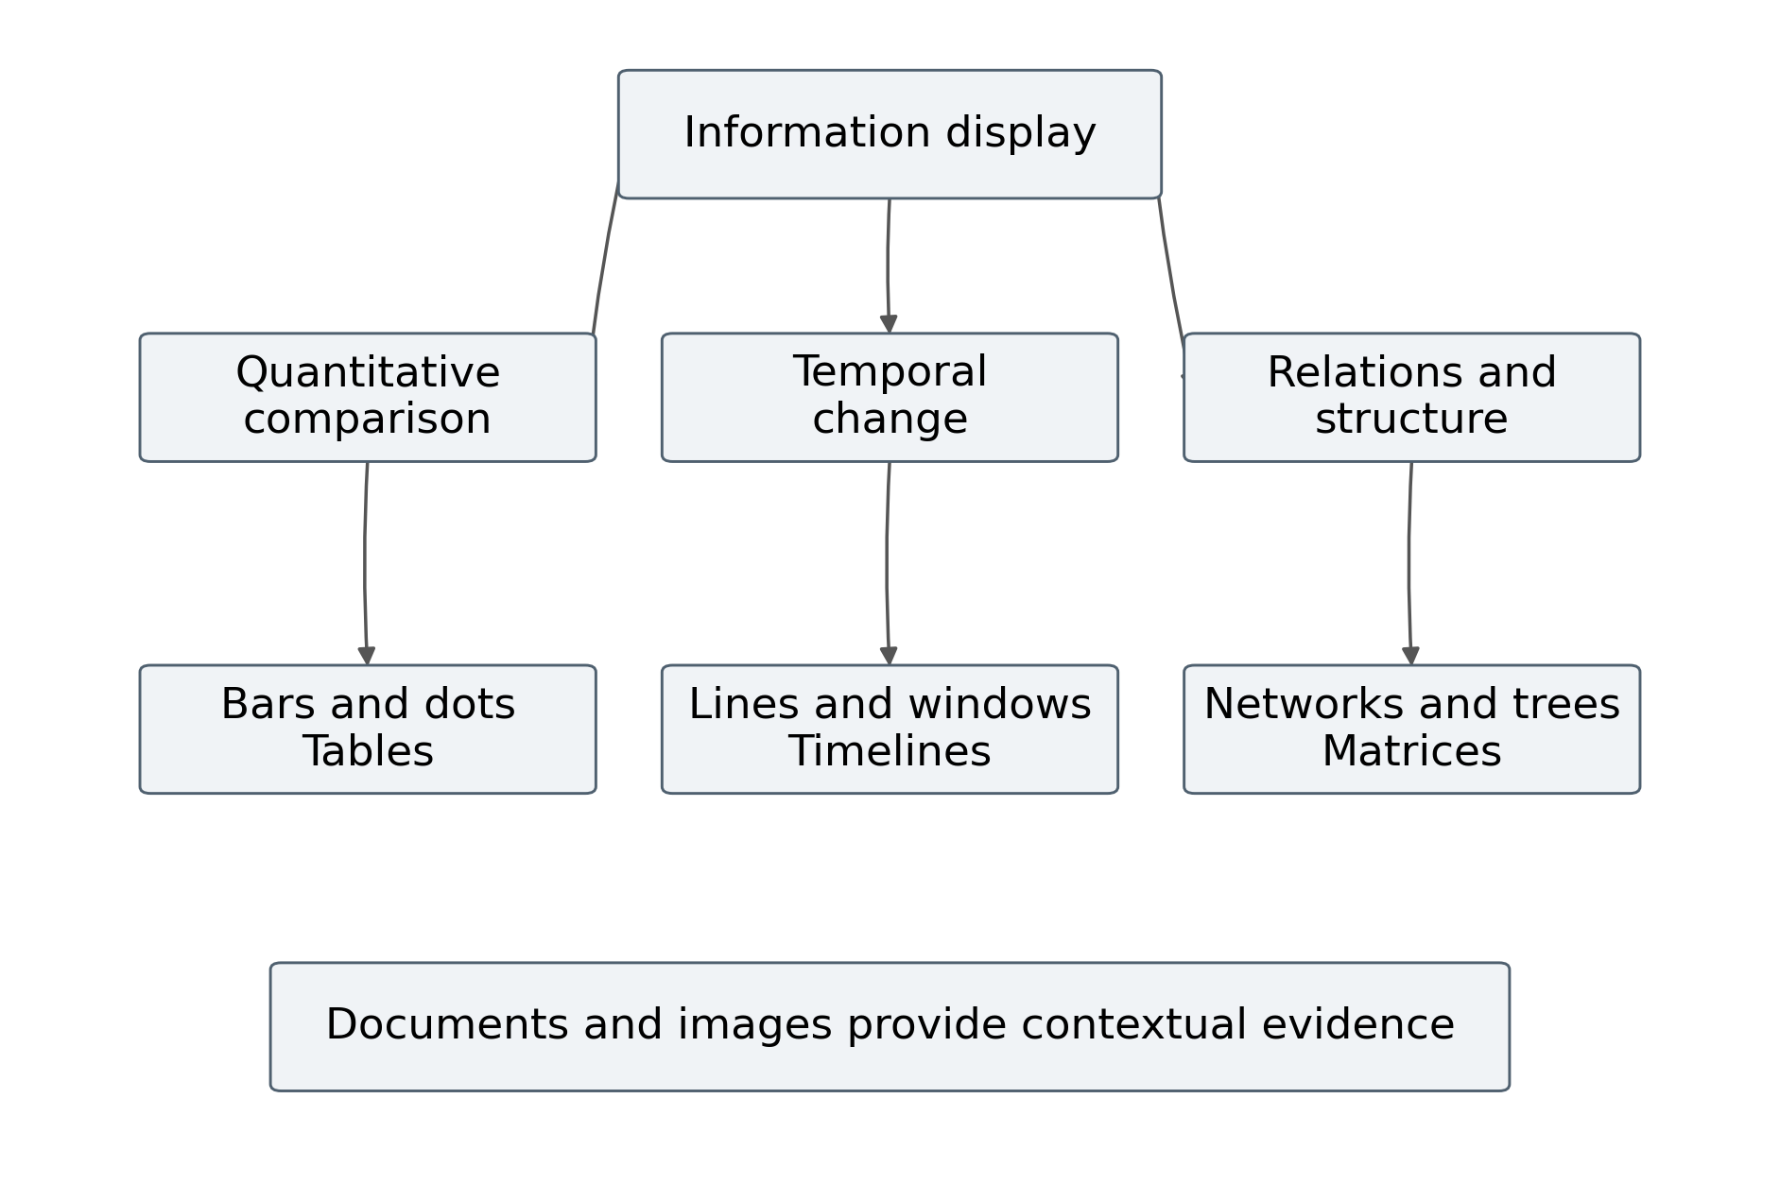
Figure 1 Classification of visual display tasks
The figure groups common tasks for this thesis without claiming an exhaustive taxonomy. Several representations can satisfy one purpose, and one representation can serve several purposes. A table supports exact lookup and comparison; a line chart supports both temporal change and threshold inspection. Classification should guide a choice rather than impose a rigid component catalog.
A useful editor lets the author begin with a task and then select a compatible representation. For example, a task to compare good output across production lines should expose bars, dots, and tables before presenting a network layout. A task to inspect an approved operating procedure should expose document controls and revision metadata. Compatibility can narrow the choices while still allowing an expert to override a recommendation with an explicit reason.
The chosen purpose should remain in the page specification. When a binding changes, validation can check whether the original visual task is still supported. Replacing a quantitative field with a category code should not silently preserve a numeric axis.

1.1.6 Visual encoding and perceptual accuracy
A visual encoding maps a data property to a visible channel such as position, length, area, color, or shape. The effectiveness of that mapping depends on the task and the differences a user must detect. A precise production comparison generally benefits from a common numerical scale and aligned positions. A status distinction may use shape or color, but color alone is insufficient when users cannot perceive that difference reliably.
Heer and Bostock’s graphical perception study illustrates how visualization design can be assessed through controlled estimation tasks [4]. The thesis draws a methodological lesson from that work: the proposed editor’s chart choices should be evaluated for users’ ability to answer operational questions, not only for whether the charts render successfully. It does not import a universal numerical ranking of all encodings into the component registry.
The registry should nevertheless enforce basic presentation rules. Bars representing nonnegative magnitudes normally use a zero baseline to preserve length comparisons. Lines should not connect unrelated categories as if they formed a continuous ordered process. Quantitative color scales need a documented domain, and diverging scales need a meaningful center. Units and reporting periods must appear where users can find them without opening a configuration panel.
An axis change is itself a visible change. If a component automatically rescales after each update, stable values may appear to move because the scale changed. The proposed design therefore supports fixed scales, explicit autoscale policies, and annotations when a domain changes. The policy is stored with the component and can be reviewed during authoring.
Perceptual correctness and data correctness are complementary. A component can encode incorrect data clearly, or encode correct data in a misleading way. Both must be tested.

1.1.7 Comparison of visualization kinds
The representation should be chosen by the intended question, data structure, and practical constraints. The following comparison states design trade offs rather than measured superiority. Its limitations are especially relevant when the page changes frequently: transitions, sorting, and rescaling can disturb the user’s ongoing inspection.
Table 3 Visual representation comparison
Kind | Useful question | Strength | Main limitation
Bar or dot chart | Which category is larger | Aligned magnitude comparison | Crowding with many categories
Line chart | How has a value changed | Ordered temporal pattern | Gaps and irregular time need care
Scatterplot | Are two measures associated | Shows joint distribution | Overlap and confounding
Heatmap | Where are high and low values | Compact dense comparison | Color gives limited precision
Table | What is the exact value | Lookup and auditability | Patterns take effort to detect
Tree or network | How are objects related | Exposes structure and paths | Layout instability and clutter
Photo or document | What evidence explains the state | Context and provenance | Cannot replace quantitative analysis

The editor should not force every component to update identically. A KPI may replace its value immediately, while a table may preserve row position during an active selection. A document viewer may notify the user of a new revision rather than replacing the page currently being read. Such behavior is part of the component contract.
Selection is therefore multi criteria. Accuracy, available space, user familiarity, accessible alternatives, update frequency, and interaction requirements all matter. Chapter 2 models this choice as a constrained configuration problem instead of a single chart ranking.

1.1.8 Interaction and coordinated views
Interaction changes the questions a page can answer. Filtering restricts the records shown. Selection identifies entities of interest. Zoom changes the temporal or numerical range inspected. Details on demand reveal supporting observations without placing every field in the initial view. These actions should be expressed in the page model rather than implemented as unrelated event handlers inside individual components.
A coordinated display needs a shared interaction state. If a user selects one production line in a chart, an adjacent management table should apply the same entity constraint when its contract permits that relationship. If a financial component has a different organizational grain, the editor should explain the mismatch instead of treating similar labels as a reliable join key.
The interaction state must also coexist with live updates. A newly arriving record can enter the selected range, leave it, or change the aggregate for that range. The runtime should preserve the user’s selection and recompute affected views according to an explicit policy. It should not reset every filter whenever an update arrives.
A useful design records filters as typed predicates. A temporal interval predicate differs from a category membership predicate. Predicates are validated against the field catalog and serialized with an allowed operator set. This approach makes them inspectable and avoids evaluating arbitrary author supplied JavaScript in the viewer.
Interaction requires clear feedback. The page should show active filters, the selected reporting period, and whether an incoming update was incorporated or held. The authoring preview can simulate these conditions. Such preview tests are needed because a page that works with a static sample may behave poorly when the underlying records change.

1.1.9 Temporal classifications and information age
Changing information has several clocks. Event time records when a fact occurred in the source domain. Ingestion time records when the integration layer received it. Processing time records when the service handled it. Display time records when a browser applied the resulting state. Treating these timestamps as interchangeable hides delays and complicates recovery.
Table 4 Temporal semantics of displayed information
Time or state | Meaning | Operational use
Event time | When the source fact occurred | Period assignment and history
Ingestion time | When integration received the fact | Source transport delay
Processing time | When materialization completed | Service processing delay
Display time | When browser applied state | Viewer freshness measurement
Period end | Boundary of a reporting interval | Comparable closed reports
Watermark | Declared event time progress estimate | Window completeness policy
Revision time | When content was approved or published | Document and layout history

Akidau and colleagues emphasize the trade offs among correctness, latency, and cost in unbounded, out of order processing [7]. The proposed editor adopts that distinction at a smaller application scale: a quickly updated component may still contain an incomplete period. A watermark is a progress estimate under a source policy, not proof that no future correction can arrive.
For each component, the interface should distinguish freshness from completeness. A production indicator may be current to within two seconds but remain provisional for an open shift. A financial summary may be complete for yesterday but unsuitable for a decision requiring today’s state. Both are valid displays when their status is explicit.

1.1.10 Mathematical model of flexible visualization
Flexible visualization is defined here as the ability to change data bindings, transformations, encodings, layout, and interaction while preserving specified semantic and operational constraints. Let D(t) be the authorized source state at time t, Q a query and transformation specification, E a visual encoding, L a layout, U the current interaction state, and P a quality and freshness policy. The displayed view is represented by Equation 1.
$V(t) = R(E, L, Q(D(t), U), P)$ (1)
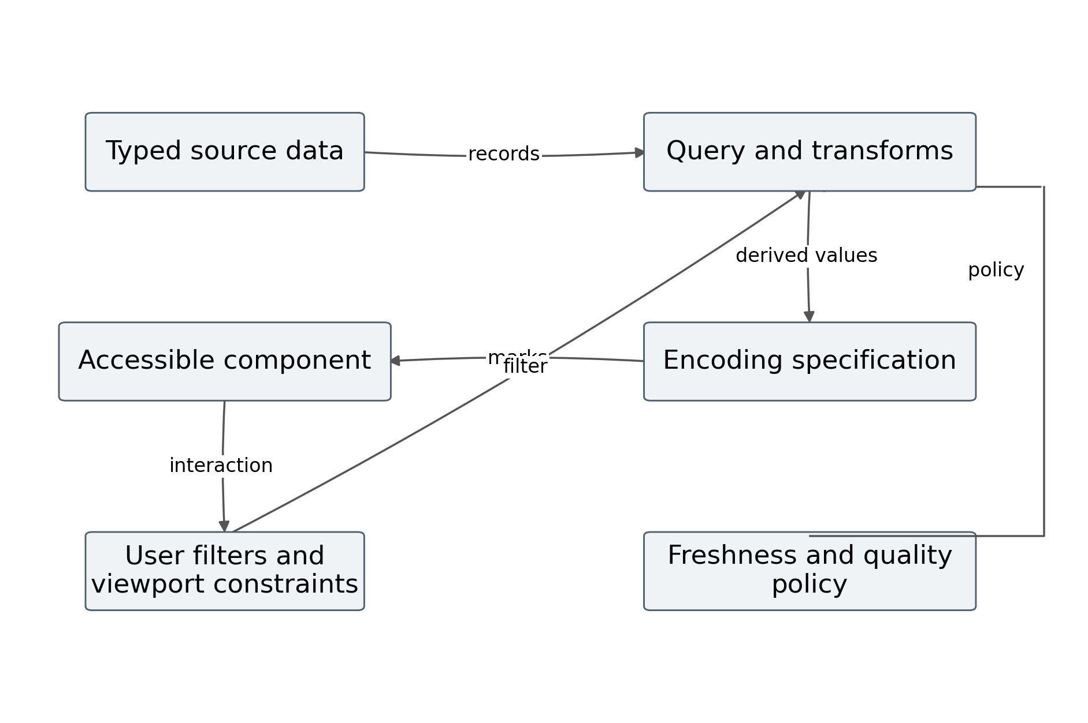
Figure 2 Flexible visualization pipeline
R is a rendering function that can produce a chart, table, document region, photograph region, or composite view. The model separates data transformation from visual mapping so that changing a color does not require redefining an aggregate. The policy argument determines how the component treats missing, stale, unauthorized, or provisional data.
The model is proposed for this thesis. It does not assert that rendering alone guarantees correct interpretation. Its value is to make configuration dependencies explicit and testable. A change to Q may invalidate E; a change to L may require a more compact accessible alternative; a change to P may alter whether a value appears at all.

1.1.11 Flexibility as a constrained configuration space
Let Θ be the set of configurations that the editor can express. A configuration contains the page’s queries, transformations, encodings, layouts, interaction rules, and policies. The valid subset consists of configurations satisfying constraints on type, unit, access, space, and freshness. Equation 2 defines this subset without assuming that all combinations are safe.
$Θ_{valid} = \{θ ∈ Θ : g_{k}(θ) ≤ 0 for every k\}$ (2)
For example, a layout constraint can prohibit overlap, a type constraint can prohibit aggregating document identifiers, and an access constraint can prohibit combining data that a viewer is not allowed to see. A period constraint can require all inputs to a ratio to describe the same entity and time window. These constraints should be evaluated before publishing a revision.
Flexibility can be estimated by the number of valid tasks and configurations reachable through the interface, but a larger count is not automatically better. An editor that exposes thousands of unsafe combinations may create more work than a smaller editor with reliable defaults. Consequently, flexibility should be assessed with task completion, error frequency, and extension effort as well as configuration expressiveness.
A configuration can also be adapted at runtime. A smaller viewport may trigger a compact chart or a table alternative. Such adaptation must preserve the meaning of the selected measure. Replacing a chart with a text summary that omits the reporting period would violate the semantic contract even if the summary fits the screen.
The practical objective is controlled flexibility: authors can compose useful pages quickly, while the system makes the consequences of changing a binding or representation visible.

1.1.12 Constraints and a multi objective selection model
Selecting a visualization can be treated as a constrained multi objective problem. Let a(θ) denote task accuracy, f(θ) freshness compliance, e(θ) authoring effort, c(θ) runtime cost, and r(θ) representation risk. Equation 3 expresses one possible scalar objective for exploring trade offs; weights must be chosen for a stated task rather than treated as universal constants.
$max J(θ) = w_{a} a(θ) + w_{f} f(θ) − w_{e} e(θ) − w_{c} c(θ) − w_{r} r(θ)$ (3)
Table 5 Constraints on flexible visualization
Constraint | Example validation rule
Type | Quantitative axis accepts quantitative fields
Unit | Addition combines compatible units
Grain | A ratio uses aligned entity and period keys
Layout | Components remain inside page boundaries
Access | Every referenced metric is authorized
Freshness | Display policy specifies a stale threshold
Accessibility | Nontext content has an appropriate alternative

The objective is meaningful only after its terms are normalized or expressed in compatible units. A weighted score can obscure a serious violation if excellent appearance compensates numerically for incorrect data. The proposed editor therefore treats correctness and authorization as hard constraints. Cost and convenience can be optimized only within the valid set.
For thesis evaluation, the preferable result is often a Pareto comparison: one design may offer lower delay at higher update cost. Section 3.2 reports that relationship directly instead of collapsing every outcome into one favorable score.

1.1.13 Declarative and imperative visualization models
A declarative visualization specification states the data transformation, mark types, encodings, and interactions to be produced. An imperative implementation states the operations that create and modify those elements. These styles can coexist. The proposed editor should store an inspectable specification while allowing its renderer to use efficient imperative operations internally.
Vega Lite demonstrates a high level grammar that combines visual composition with interaction specifications [6]. D3 exposes a data driven relationship to the browser’s native document representation [5]. Together they establish that reusable and changing web visualizations do not require a new rendering paradigm. The thesis instead asks how such visualization mechanisms can be integrated with page editing, operational source contracts, and delivery policies.
The component registry can therefore offer different renderer adapters. A declarative chart adapter compiles a chart specification. A DOM adapter updates accessible text and tables. A media adapter handles image identity and document revisions. The editor’s component contract should remain stable across these adapters so that authors do not need to understand each library’s internal event system.
Imperative escape hatches require boundaries. Arbitrary code can undermine reproducibility, authorization, and migration. An extension should declare the fields it reads, its output type, lifecycle methods, and error behavior. If it reads undeclared global data, the dependency index cannot determine which changes should invalidate it.
The stored page specification is consequently the source of configuration truth, while runtime state remains transient and versioned. This separation allows a published page to receive new data without being mistaken for a new authored revision.

1.1.14 Trends relevant to changing web displays
The selected literature and documentation show several directions relevant to this design. Declarative grammars make visual specifications inspectable. Component based editors separate reusable blocks from page instances. Documented binding APIs connect structured values to those blocks. Event delivery and incremental computation reduce the need to reconstruct every display for every change. These observations describe the selected source set and are not a quantitative forecast of adoption.
Another direction is the inclusion of temporal and quality semantics in the user experience. For an operational page, the age of a value and the completeness of a reporting period are often as important as the value itself. The proposed editor treats these as visible component properties. That choice addresses a design requirement of this thesis; it should not be presented as a claim that existing tools never expose similar information.
Accessibility and responsive presentation also affect system composition. A chart may need a table alternative, keyboard controls, and a textual explanation of change. The rendering pipeline must provide these outputs alongside visual marks. Adding them after deployment can require redesigning component contracts and interaction state.
Recent systems can also assist authors in choosing or generating visualizations. This thesis does not rely on automated generation for correctness. Any recommended component still needs type, unit, period, and authorization validation. A convincing preview cannot substitute for a valid data contract.
The most useful trend for this research is the movement toward explicit specifications and integration contracts. Such contracts make the proposed editor easier to test, migrate, and compare with extensions to established editors.

1.1.15 Synthesis of visualization requirements
The analysis leads to five design requirements. First, the page must represent analytical intent and data meaning in addition to visual appearance. Second, it must coordinate multiple representations through shared entities, periods, and interactions. Third, it must preserve explicit temporal and quality state. Fourth, it must make transformations inspectable. Fifth, it must support efficient changes without disrupting the user’s current task.
These requirements are related but not interchangeable. A fast stream can carry semantically incompatible values. A correct aggregate can be displayed with an unstable scale. A flexible layout can conceal the age of a document. The evaluation must consequently inspect the complete path from source fact to user interpretation instead of treating one benchmark as evidence for every quality dimension.
The mathematical models introduced in this section provide a vocabulary for that inspection. The view function separates queries, encodings, layout, interaction, and policy. The valid configuration space distinguishes expressive possibilities from safe combinations. The multi objective model exposes the need to report trade offs. Chapter 2 extends these ideas to event propagation, performance, and editor commands.
The remaining research gap is specific: how can an editing environment expose these contracts in a usable form and compile them into a runtime that updates only the relevant authorized components? The gap concerns composition and operational behavior. It does not depend on claiming that existing editors lack dynamic content.
Section 1.2 therefore examines the editor landscape with an emphasis on what can already be reused, what requires application specific integration, and what evidence would be needed to compare the resulting systems fairly.

1.2 Visualization authoring and web page editing tools

1.2.1 The nature of an information visualization editing tool
A visualization editing tool translates author intent into a persistent specification and a visible result. Its input may be a dataset, a schema, an interaction, a direct manipulation of marks, or a template. Its output may be a chart specification, a rendered graphic, an embedded component, or a complete dashboard. The tool’s quality depends on how accurately it preserves intent through that translation.
Authoring has several stages. The author discovers available fields, selects a task, chooses a representation, binds fields to channels, defines transformations, adjusts appearance, previews interaction, and publishes or exports the result. A tool may combine these stages, but the underlying responsibilities remain. Separating them analytically helps locate errors and identify which features the proposed page editor must add.
General visualization editors often assume that a dataset is already available in a usable form. The present application cannot make that assumption. Its sources include operational records, financial amounts, documents, and images, each with different update and access rules. The proposed editing tool therefore needs a field catalog and adapter contracts as well as visual authoring controls.
The distinction between authoring time and viewing time is essential. An author may configure a component using a sample dataset, while a viewer receives new values continuously. A successful authoring preview does not demonstrate that the runtime handles late events or a disconnected source correctly. Both environments must use compatible contracts and communicate their different temporal roles.
The following pages classify tools by their principal output and control model, then examine web page editing as a broader composition problem.

1.2.2 Families of general visualization tools
Visualization tools range from code libraries to visual authoring environments. The main difference is not simply whether coding is required; it is where the specification lives, how the user changes it, and which responsibilities the tool assumes. The following matrix classifies representative families rather than presenting a complete product inventory.
Table 6 Families of visualization authoring tools
Family | Primary control | Strength | Integration burden
Code library | Programmatic operations | Custom behavior and rendering | Developer maintains contracts
Declarative grammar | Structured specification | Inspectable repeatable charts | Application supplies data lifecycle
Visual chart editor | Field and channel controls | Fast chart composition | Limited custom behavior may need extension
BI authoring platform | Semantic model and reports | Business analysis workflow | Hosting and model integration
Dashboard editor | Queries and panels | Monitoring and operational views | Page layout and media may need customization
Web page editor | Components and layout | Mixed content composition | Metric semantics need explicit integration

Grafana documents a model built around data sources, queries, transformations, and panels [17,18]. That model is relevant because it shows that query based operational displays are already an established tool family. A comparison limited to static page editors would omit a strong alternative for the intended workload.
The proposed editor occupies the intersection of the last two families. Its aim is to combine page layout and contextual media with explicit metric bindings and change propagation. The thesis must test whether this combination improves the selected tasks enough to justify its implementation and maintenance cost.

1.2.3 Strengths and limitations of general authoring tools
Code libraries provide control over rendering and interaction, but they transfer configuration, validation, and maintenance responsibilities to developers. A small custom chart can be efficient to build, while a large collection of operational components requires a consistent registry, shared interaction state, migration procedures, and test coverage. The cost lies in the surrounding system as much as in the drawing code.
Declarative tools make configurations easier to inspect and reproduce. Their limitations arise when the application requires behavior outside the grammar or when the data delivery lifecycle is not part of the specification. A chart grammar can express an aggregate without deciding how a finance system’s corrected record should invalidate that aggregate across viewers.
Visual authoring tools reduce the need to write specifications directly. However, they can obscure transformations if the interface emphasizes appearance over data meaning. A user may select a field and obtain an attractive chart without noticing that the field contains mixed units or that the source records have different grains. The proposed editor should expose those properties in its binding inspector.
BI and dashboard platforms often provide substantial data and governance capabilities. Their suitability for a custom homepage depends on layout control, media handling, embedding, extension APIs, deployment constraints, and the organization’s existing environment. These criteria need task specific assessment rather than assumptions about which family is more advanced.
The synthesis suggests a design principle: reuse established rendering and authoring mechanisms where possible, while concentrating original work on operational contracts and their integration into page editing. This narrows the implementation burden and makes the claimed contribution more precise.

1.2.4 Framework of a general editing tool
A general editor can be decomposed into an authoring interface, a document model, a command layer, validation services, a component registry, a compiler, preview rendering, and versioned storage. The relationships among these parts determine whether a page can be edited safely and reproduced after publication.
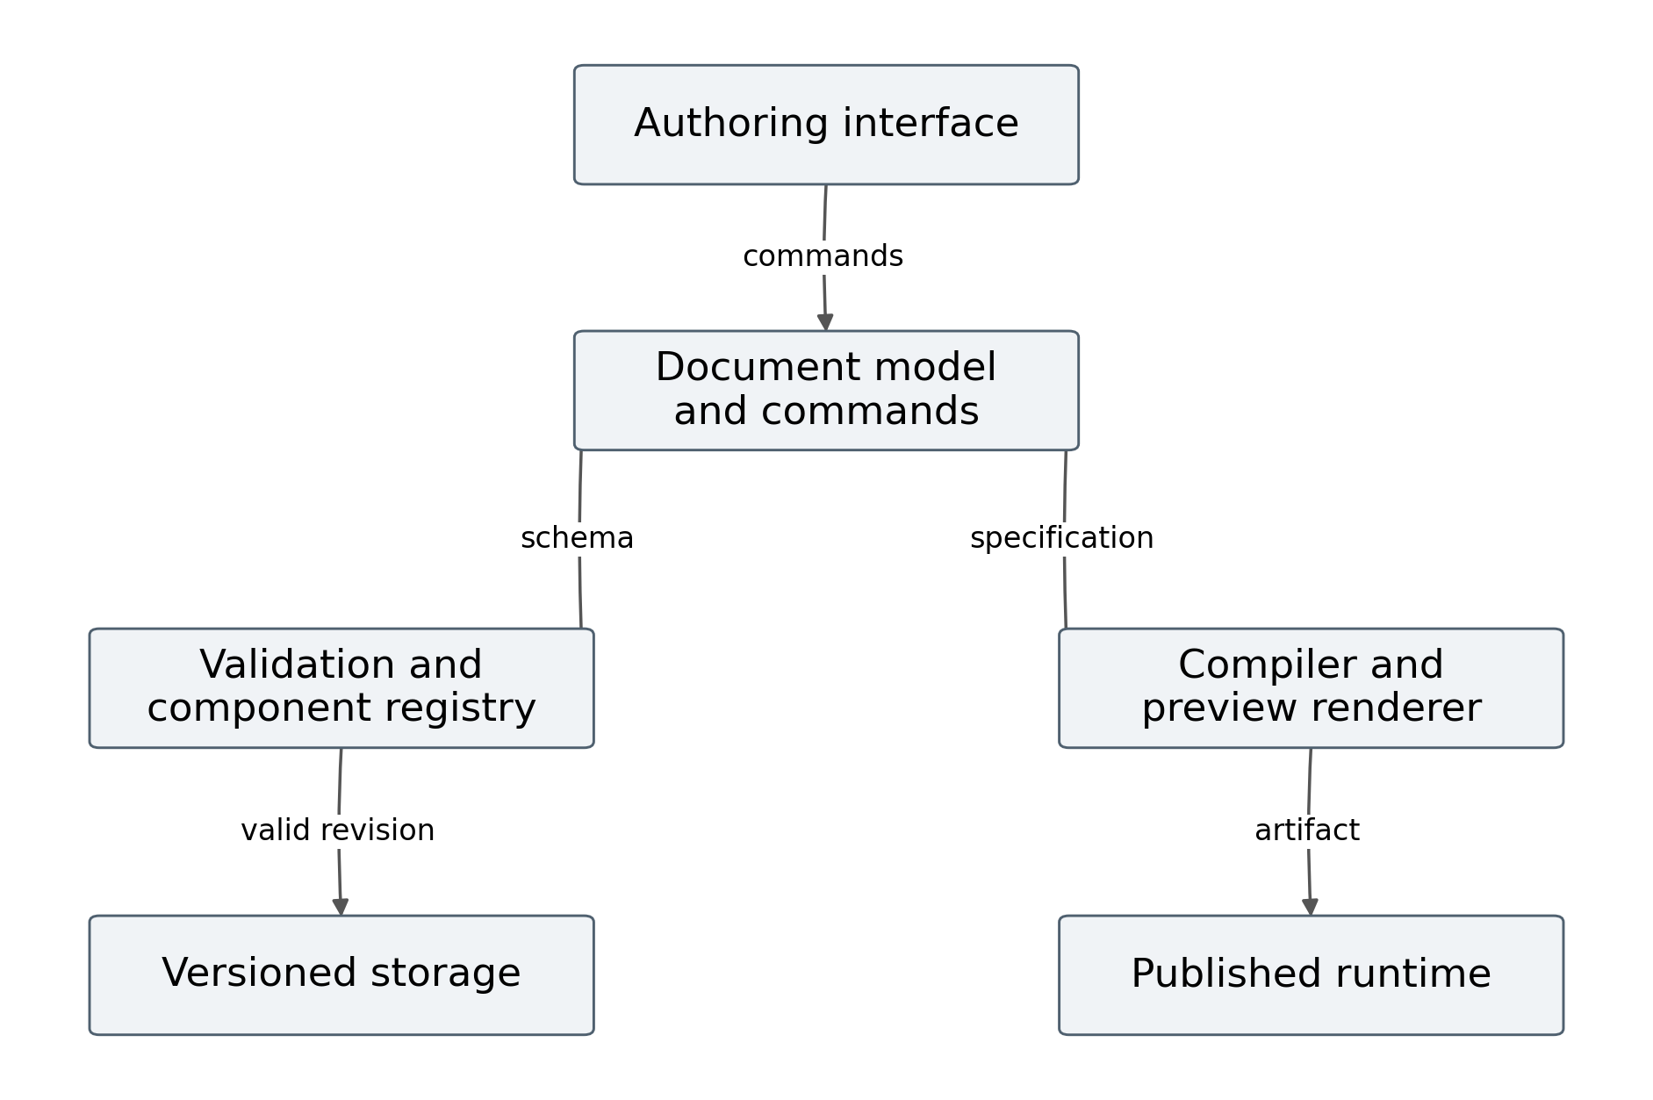
Figure 3 General editor framework
The document model stores authored intent. Commands modify the model through controlled operations. Validation rejects invalid changes or marks them as draft errors. The component registry supplies schemas, defaults, renderer adapters, and lifecycle rules. The compiler produces a runtime manifest; the preview uses the same semantic contracts to reduce differences between the authored and published page.
The interface should not become the only place where validation occurs. A configuration may be loaded from storage, modified through an API, or migrated from an earlier version. Each path must pass the same server side validation before publication. Client validation improves feedback but does not establish the validity of the stored revision.
This framework is a proposed abstraction common to many editor designs. It supports a clear extension boundary: metric and event services can be added without turning every component into its own integration application. Section 2.2 specifies the document and command models for the present system.

1.2.5 Concepts and kinds of web page editors
A web page editor creates or modifies the structure, content, and behavior of a web page. Some editors expose source code, some expose visual layout, and some constrain authors to templates or blocks. A page editor is distinct from a chart editor because it composes navigation, typography, media, data displays, and responsive regions into a complete document.
Table 7 Web page editor categories
Category | Persistent representation | Advantages | Disadvantages
Source editor | HTML CSS JavaScript files | Maximum implementation control | High coding and maintenance effort
WYSIWYG editor | Document or component model | Direct visual feedback | Generated structure may need review
Block based CMS editor | Blocks and content records | Reusable content workflow | Advanced runtime needs extensions
Hosted visual builder | Managed page and CMS model | Integrated design and publishing | Service and export constraints
Framework based custom editor | Application page schema | Domain specific validation | Engineering burden and migration work
Hybrid editor | Visual model plus code extensions | Flexible composition | Two models must remain consistent

These categories overlap. A hosted builder can offer code extensions, and a block editor can render dynamic data. Classification concerns their principal authoring and persistence model. It does not imply that one category is inherently faster in the browser.
For this thesis, the proposed tool is a custom component based editor with a declarative page schema and controlled extensions. That choice gives the author access to binding, freshness, and dependency rules, but it also creates obligations to maintain a registry, migrations, deployment, and usability.

1.2.6 GrapesJS and component based editing
GrapesJS documents a component model responsible for the stored and exported representation of a template, together with view behavior used by the editing canvas [9]. Its current API also includes data source management, and the Studio SDK documents variable binding and repeatable content [10,11]. These capabilities make it an important baseline rather than a static editor to dismiss.
For the present task, GrapesJS could provide an editing canvas, component hierarchy, and extension points. An application could add metric aware components and connect them to a data service. The relevant research question is how much additional work is required to enforce the proposed temporal, unit, and authorization contracts, and how the resulting runtime performs.
The distinction between the open source framework and the Studio SDK must remain explicit. They are not interchangeable evidence for every capability. A benchmark should pin the precise package, version, plugins, and any commercial SDK configuration used. It should record which features were supplied by the product and which were implemented by the researcher.
A fair comparison would construct the same page schema and component set in the proposed editor and a GrapesJS based application. Both should receive the same events and use equivalent chart renderers when the objective is to isolate the update architecture. Otherwise, a difference may arise from an unrelated chart library or styling implementation.
No GrapesJS application was installed or benchmarked for this draft. This page reports documented capabilities and an evaluation design. It does not assign latency, memory, or authoring time to the product.

1.2.7 WordPress block editing and dynamic content
The WordPress Block Editor composes content from discrete blocks [12]. Its Block Bindings API connects supported block attributes to dynamic data sources, and dynamic blocks can generate their output when rendered [13,14]. The supported binding attributes and extension mechanisms are version dependent, so a thesis experiment must pin the exact WordPress configuration.
WordPress provides a content and publication workflow that may be useful for documents, images, and explanatory material in a comprehensive page. The proposed workload additionally requires source event ingestion, metric definitions, viewer subscriptions, and temporal state. These can be implemented through custom blocks, plugins, or an external service; their need is an integration requirement, not proof that the platform cannot support the task.
The distinction between dynamic server rendering and continuous browser updating is important. A block may obtain current information when a page is requested without updating an already open browser when the source changes. A benchmark must state the delivery mechanism used after page load. Comparing a continuously subscribed proposed page with a baseline that is deliberately never refreshed would offer little insight.
An implementation comparison should therefore include a WordPress extension configured for the same freshness target where feasible. It should record plugin effort, content portability, access behavior, cache interactions, and browser performance. WordPress’s editorial workflow should also be evaluated as a possible advantage for document heavy tasks.
No completed product test is claimed here. The proposed editor’s domain controls remain design specifications until they are implemented and compared with a configured WordPress alternative.

1.2.8 Hosted builders and dashboard alternatives
Webflow’s CMS documentation describes structured collections and dynamic content references [15]. Its code export documentation states that the exported site does not include CMS content and functionality in the same form as the hosted service [16]. These facts matter when comparing deployment portability, but they do not establish the hosted runtime’s performance on the present workload.
A hosted builder can reduce design and publication effort for mixed content pages. Its suitability for operational integration depends on supported APIs, extension behavior, data access, and the available hosting model. The comparison should consider the total configured system, including any external metric service and embedded charts, rather than judging only the visual canvas.
Table 8 Documented editor capabilities
Tool or family | Documented core capability | Application specific addition to assess
GrapesJS framework | Component model and data source API | Metric contracts and live delivery
GrapesJS Studio SDK | Visual data binding and repeatable content | Operational source and freshness policy
WordPress Block Editor | Blocks bindings and dynamic rendering | Continuous viewer update integration
Webflow | Visual pages and structured CMS content | Operational streaming and portability
Grafana | Data source query transformation panels | Homepage layout and documentary composition
Proposed editor | Specified typed bindings and dependency updates | Complete implementation and validation

Grafana should be treated as a contextual dashboard comparator, not classified as a conventional homepage editor. A study may find that it better serves monitoring tasks while a page editor better serves mixed documentary composition. The final choice depends on the task distribution and integration constraints.

1.2.9 Publication and revision management
Editing produces an authored revision; live updates produce changing runtime state. Conflating them creates a common management problem: every source change appears to modify the page document, making it difficult to identify which changes an author approved. The proposed design maintains separate revision history and event history.
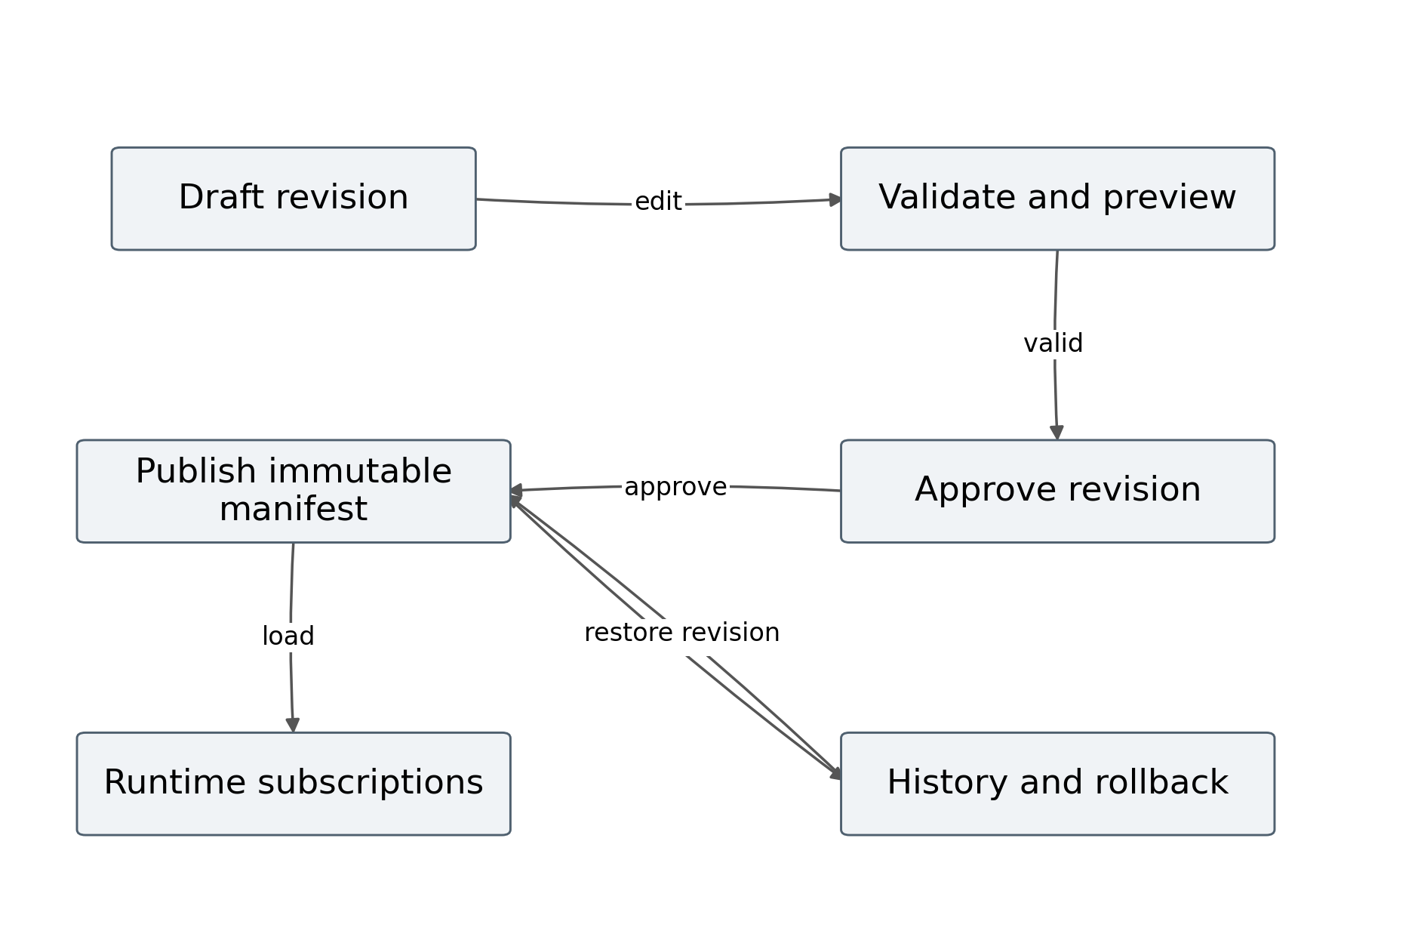
Figure 4 Revision and publication lifecycle
A draft contains layout, component definitions, bindings, and policies. Validation checks that the revision can be executed. Publication produces an immutable manifest and advances a published revision pointer. The runtime loads that manifest and receives data changes under its contracts. A rollback changes the pointer to a previous valid manifest; it does not rewind source business transactions.
Previewing a draft should allow the author to inspect current data without exposing unapproved layout changes to ordinary viewers. The preview must visibly identify its draft status and should be authorized independently of the published page. A sample dataset can support layout work when live data are unavailable, but its synthetic status should remain visible.
Revision control also supports reproducibility. An experiment must record the exact manifest used, because a small binding or layout change can affect dependency coverage and rendering work. A screenshot alone cannot recover that configuration.

1.2.10 Mathematical model of a web page editor
Let the editor state consist of a page document P, selection U, command history H, validation state Z, and registry version K. An editing command a transforms this state through a transition function T. The model separates persistent document changes from transient selection and preview state.
$X_{editor} = (P, U, H, Z, K)$ (4)
$X_{next} = T(X_{editor}, a)$ (5)
A valid command must preserve document invariants or produce a clearly marked invalid draft that cannot be published. Moving a component preserves its identity and bindings. Rebinding a component changes its dependencies and may invalidate the selected chart. Deleting a component removes its index entries and references. Undo restores the authored state but does not undo incoming production events.
The published page is a compilation of a validated revision. Let $C_{compile}$ map a document and registry version to a manifest M. Equation 6 identifies this dependency explicitly.
$M = C_{compile}(P_{revision}, K)$ (6)
Pinning K prevents a later plugin change from silently altering an old manifest’s meaning. A migration may create a new revision under a new registry, but it should preserve a record of the original configuration and any changed behavior.
The model provides concrete test properties. Applying a command and its inverse should restore the authored document where an inverse is defined. Compiling the same canonical document with the same registry should produce the same manifest hash. Invalid bindings should block publication. Section 2.2 develops these properties into data structures and interface behavior.

1.2.11 Programming languages and runtime choices
The user specified Node.js for development analysis. The supplied reference implementation uses JavaScript modules executed by Node.js 24.19.0 in the preparation environment. This identifies the runtime actually used for the accompanying experiment; it does not establish the technology stack of the author’s existing editor. That stack must be verified from the real project.
Table 9 Proposed language and runtime choices
Technology | Role in the proposed implementation | Reason
JavaScript | Reference algorithms and runtime logic | Executable in Node.js and browser environments
TypeScript optional | Larger service and editor codebase | Static checking of contracts and component types
Node.js | Server execution runtime | Asynchronous event and I O handling
HTML | Accessible page structure | Native document semantics
CSS | Layout responsive rules and presentation | Separation of structure and style
JSON | Page manifests and event payloads | Structured inspectable interchange
SQL | Metadata and transactional queries | Persistence and revision integrity

The proposed browser editor can use a component framework or established editing canvas, but no such framework is required by the mathematical model. Its choice should follow actual project constraints and measured behavior. A JavaScript backend does not imply that all browser rendering occurs on the server.
Financial arithmetic requires particular care. JavaScript floating point values are suitable for many plotted ratios but should not be used indiscriminately for exact currency accounting. The reference core uses BigInt minor units for a working capital difference. Serialization represents these amounts as strings with currency metadata.

1.2.12 Node.js framework and performance implications
Node.js supports nonblocking I O through its event loop and associated system mechanisms [19]. Its official guidance cautions that long running callbacks can prevent other work from progressing [20]. Worker threads can execute CPU intensive JavaScript in parallel, while ordinary asynchronous I O generally does not benefit from being moved into workers [21]. These are runtime properties, not automatic guarantees of application throughput.
The proposed service assigns short validation, routing, and subscription operations to the main event loop. Expensive transformations, image processing, or large chart export jobs can use bounded worker pools or separate services. A worker pool should be reused rather than creating a new thread for each event. Queue length and task duration must be observable.
Framework choice should be evaluated by the responsibilities it simplifies. An HTTP framework may provide routing and middleware; it does not define production metric semantics or safe event ordering. A websocket library may provide transport; it does not define replay, authorization, or snapshot consistency. The thesis therefore describes service contracts independently of a particular framework.
The data path should also avoid repeated parsing and transformation. Canonical event validation occurs once at the integration boundary, while authorization remains enforced for every access context. Shared metric materialization can reduce duplicate work across viewers, provided cache keys include the relevant tenant, permission scope, entity, and period.
Performance must be assessed end to end. A fast callback can coexist with slow source extraction, network congestion, heavy browser layouts, or large media downloads. Section 2.1 models those stages separately so that bottlenecks can be located rather than attributed generically to Node.js.

1.2.13 Comparative criteria and chapter synthesis
The tool analysis identifies several criteria for the eventual comparison: supported content, binding expressiveness, semantic validation, coordinated interaction, source integration, freshness controls, publication history, extension effort, accessible output, portability, and runtime cost. A useful editor should satisfy the required tasks with acceptable effort and predictable behavior; a long feature list is insufficient.
Existing tools provide substantial foundations. Component editors can support reusable layout, CMS tools can support content workflow, declarative grammars can support charts, and dashboards can support operational queries. The proposed system should be compared with reasonable configurations of these alternatives rather than intentionally weak versions.
The claimed improvement is consequently an architectural hypothesis. Making dependencies and temporal contracts explicit may reduce unnecessary component work and improve the traceability of changing information. It may also increase implementation complexity and generate more updates when the source is busy. Both outcomes belong in the assessment.
Chapter 2 develops the proposed composition mathematically. It specifies the source contract, transformation graph, delivery model, freshness constraints, component representation, and editor transitions. Chapter 3 then maps those structures to a logical and physical Node.js design and evaluates the update mechanism using an executed synthetic study.
The boundary established by this chapter is important: documentation supports the existence of features; proposed mathematics supports conditional predictions; configured product experiments are still required for a performance ranking. The final thesis should preserve that boundary even if later measurements strongly favor the author’s editor.

1.2.14 A bounded research gap and comparison strategy
The bounded gap is the integration of operational source contracts and dependency aware runtime behavior into a mixed content page editor. The system should let an author configure a production chart, financial summary, document, and photograph while making their source, unit, period, access, and freshness rules visible. The contribution is assessed at the system level because a component registry alone cannot enforce all these relationships.
Two comparison strategies are needed. An architecture experiment holds the component set, event trace, renderer assumptions, and delivery parameters constant while changing the update policy. This approach isolates mechanisms such as dependency pruning and batching. A product experiment asks how complete configured tools perform the same authoring and viewing tasks. It includes the consequences of their interfaces, storage models, plugins, and hosting arrangements.
These strategies answer different questions. A favorable architecture experiment can justify implementing a mechanism in several products. It cannot show that the proposed editor’s interface is easier to use. A favorable product experiment can show lower authoring time without proving that the runtime’s change propagation algorithm is better. Reporting both avoids attributing every improvement to one design decision.
The thesis adopts the architecture experiment as the executed study because the actual editor and baseline applications were not supplied. It specifies the product experiment in sufficient detail for later completion. The reference code, raw results, assumptions, and diagrams are provided with the manuscript so that a supervisor or reviewer can inspect the executed part independently.
This research strategy supports a credible draft now and a clear route to an implementation specific master’s thesis later.

Chapter 2 Mathematical composition and editor design

2.1 Web service architecture and performance model

2.1.1 System boundary and design objectives
The proposed web service connects heterogeneous information systems to a versioned page runtime. Its boundary begins at authorized source extraction and ends when a viewer applies an update to an authorized component. Authored layout, metric definitions, media metadata, event state, and operational telemetry are included. The source systems’ internal business transactions remain outside the service’s control.
Let S be the set of sources, A the adapter layer, L the event log, M the metric materialization layer, I the dependency index, G the delivery gateway, and W the viewer runtime. The composition is represented as a directed service graph. Edges carry typed events, versioned metric values, manifests, or control commands rather than unstructured screen content.
$G_{service} = (N_{service}, E_{service}), N_{service} = \{S, A, L, M, I, G, W\}$ (7)
The objectives are correct interpretation, explicit freshness, efficient change propagation, recoverable state, controlled publication, and acceptable authoring effort. Performance improvement means improvement on specified indicators under a specified workload. It does not mean that every component must refresh after every event or that all source systems can supply events immediately.
A deployed service should meet a freshness target when source availability, workload, and network conditions remain within an agreed operating envelope. When those conditions fail, the page should expose its degraded state. Hiding an old value behind a successful browser connection would defeat the purpose of a comprehensive display.
The architecture is proposed; Section 3.1 maps it to deployment units, while Section 3.2 tests selected mechanisms using the supplied simulator.

2.1.2 Composition of the proposed web service
The service graph separates source integration, durable processing, metric derivation, dependency lookup, and viewer delivery. This decomposition allows each stage to expose its own checkpoint and delay, which makes both correctness testing and performance diagnosis more precise.
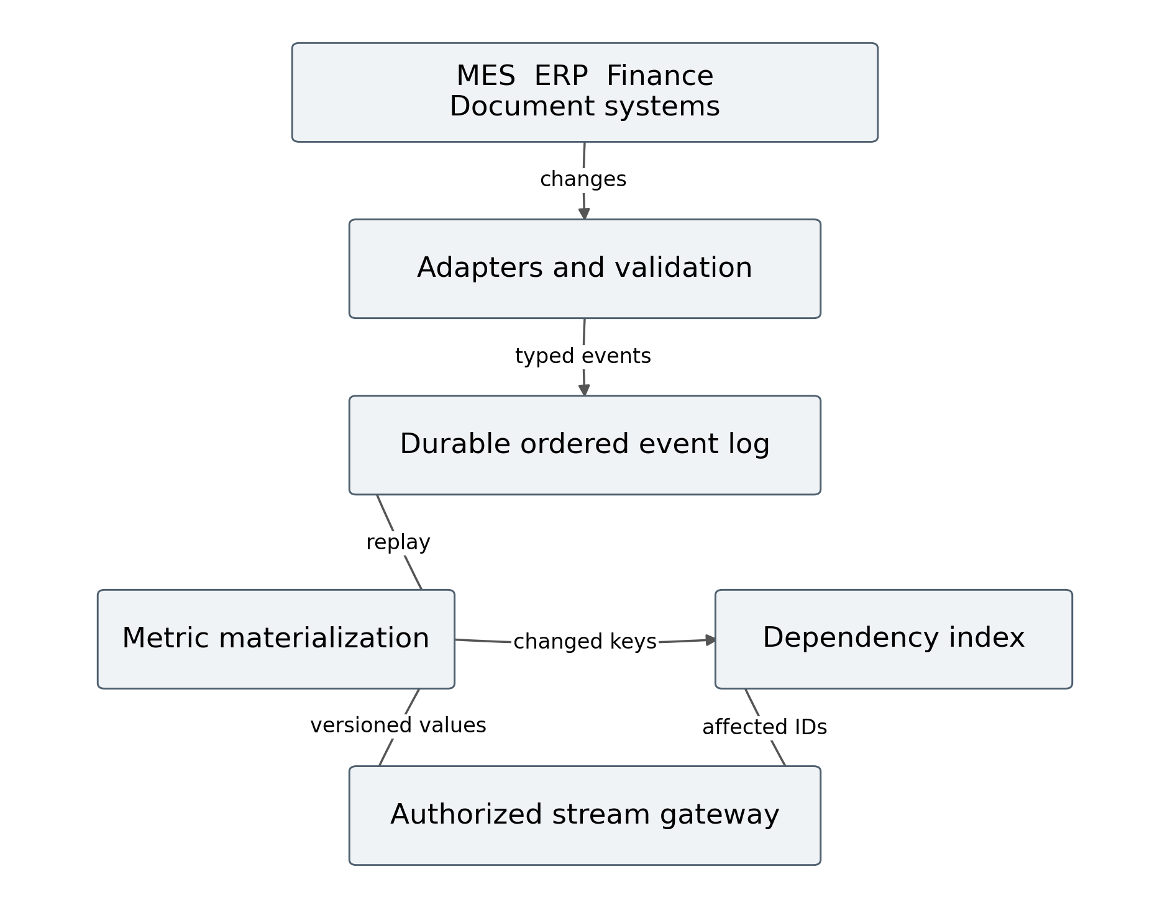
Figure 5 Proposed web service composition
Adapters translate source changes into a canonical contract without deciding how every viewer should display them. The event log preserves accepted changes for processing and replay. Materialization computes reusable metric state. The dependency index links changed metric keys to page components. The gateway checks access and delivers updates for the published revision a viewer has loaded.
Media follow a related but distinct path. A document or photograph is stored as an asset with content identity, approval metadata, and access policy. Its change event carries a reference to that asset, not necessarily the file bytes. The component can then retrieve the authorized asset separately and manage its loading state.
This architecture permits shared computation across viewers while preserving viewer specific authorization. Shared materialization must not imply that every viewer can receive every metric. Access filtering occurs before snapshot and delta delivery, and revocation must affect an already open stream. These responsibilities are part of the service contract rather than optional interface checks.

2.1.3 Components and their relationships
The following responsibility matrix assigns each function a primary owner. Ownership clarifies which component should reject an invalid input and which telemetry can explain a failure. A production implementation may combine several owners in one process while preserving the logical boundaries.
Table 10 Architecture responsibilities
Component | Input | Output | Main invariant
Adapter | Source records or change feed | Canonical event | Valid identity type and provenance
Event log | Accepted canonical events | Ordered partition records | Durable accepted change history
Materializer | Events and metric definitions | Versioned metric state | Deterministic transformation
Dependency index | Bindings and change keys | Affected component identifiers | No missing declared dependency
Gateway | Manifest access and state | Snapshot delta or recovery response | Authorized consistent delivery
Viewer | Manifest and versioned values | Visible component state | No older overwrite
Control API | Editing and publication commands | Validated immutable revision | Revision and registry compatibility

The relationship between the materializer and the index is especially important. A raw source update may change several derived metrics. The materializer first determines which metric keys have changed, then the index identifies their consumers. Indexing only raw fields can miss derived dependencies unless the transformation graph is included.
The control API updates bindings when an authored revision changes. The viewer does not rewrite the published page model merely because a metric value changes. This separation prevents live data from contaminating revision history and supports reproducible page configurations.
The matrix describes the proposed system, not an observed implementation of the user’s editor. Mapping each responsibility to actual project modules is a completion requirement.

2.1.4 Canonical source events and typed contracts
A canonical event must identify the source fact, entity, version, time, and meaning. Without these properties, a receiving service cannot distinguish a duplicate from a correction or decide which reporting period the value belongs to. The event contract should also include the operation, such as upsert or delete, and a schema version.
Table 11 Source event contract
Field | Meaning | Validation requirement
eventId | Identity for duplicate detection | Stable within source contract
sourceId and tenantId | Provenance and isolation | Authorized configured source
entityKey and metricKey | Business grain and measure | Known catalog identifiers
sourceVersion | Order within an entity stream | Monotonic source sequence or defined conflict rule
eventTime and ingestionTime | Occurrence and reception | Valid timestamps and clock policy
value unit and currency | Typed measurement | Compatible type and unit
operation and schemaVersion | Change meaning and contract version | Allowed operation and supported schema
quality and provenance | Interpretation status | Defined state and traceable reference

Source versions are not automatically comparable across systems. Two independent sources may each emit version 17 for different entities. The canonical contract scopes the version to its source and entity, while the internal event log supplies its own partition cursor. A distributed deployment needs a cursor vector or an equivalent consistent checkpoint when several partitions contribute to a snapshot.
Delete events require explicit handling. Removing a record may change an aggregate, invalidate a document reference, or remove a table row. Treating deletion as a missing update would leave stale visible information indefinitely.

2.1.5 Normalization and transformation graph
The materialization model is a directed graph whose leaf nodes are canonical source fields and whose internal nodes are transformations. A node can filter records, align periods, convert an approved unit, aggregate a group, or derive a ratio. The final nodes expose metrics that components can bind to. Cycles are prohibited in the ordinary transformation graph unless a separately specified iterative algorithm is used.
$x_{v}(t) = f_{v}(\{x_{u}(t) : u ∈ Pred(v)\}, p_{v})$ (8)
Here Pred(v) denotes the predecessors of transformation v, $f_{v}$ its deterministic function, and $p_{v}$ its configured parameters. Determinism means that the same accepted inputs and definition version produce the same result. External lookup data, such as an exchange rate, must therefore be versioned input rather than an invisible global dependency.
The transformation graph is evaluated in topological order. A change begins at a source node and marks reachable descendants as candidates for recomputation. A node can avoid propagating further when its output value and relevant quality state remain unchanged. A display timestamp policy may still require an update even when the numerical value is equal.
Aggregation must preserve grain. Summing daily totals with individual transaction records can double count unless the source contract distinguishes them. Joining production records to management records requires stable entity keys and an explicit temporal relation. Similar labels or row positions do not establish a valid join.
Incremental computation is established prior work; differential dataflow extends this idea to more general computation [8]. The proposed service uses a simpler acyclic materialization model suitable for the defined metrics and does not claim to reproduce that broader system.

2.1.6 Event ordering and consistent snapshots
The viewer needs an initial state and subsequent changes that form a coherent sequence. A common failure occurs when the initial snapshot is read and the subscription is opened separately: an event arriving between those operations may be lost. The proposed service therefore attaches a checkpoint to the snapshot and begins replay strictly after that checkpoint.
${State}_{after} = Apply(Snapshot(c), {{{{{Events}_{with}}_{cursor}}_{greater}}_{than}}_{c})$ (9)
For one ordered partition, c is a cursor. For multiple partitions, c is a vector whose entries identify the checkpoint used for each contributing partition. The snapshot must actually represent that checkpoint under the materializer’s storage contract. A timestamp attached after an ordinary database read is not sufficient.
Within one transactional database, an appropriate transaction isolation level can provide a stable read view [25]. That local property does not create a globally atomic snapshot across unrelated source systems. Cross source metrics must specify whether they use aligned closed periods, tolerated skew, or an explicit synchronization barrier.
Monotonic versions prevent older events from overwriting newer state, but they do not by themselves prove a cross source ratio is consistent. A numerator at one version and denominator at another may require a provisional label or a grouped update. The gateway can deliver a metric bundle with one materialization version when its inputs were evaluated together.
Recovery follows the same rule. A reconnecting viewer sends its last applied cursor. If retained history covers that cursor, the gateway replays newer events. If not, it sends a new snapshot and checkpoint. The page should indicate resynchronization while this occurs.

2.1.7 Transport policy and delivery mechanisms
The transport should fit the communication pattern. Server sent events provide a browser event stream with event identifiers and reconnection semantics [22]. WebSocket provides bidirectional communication over a framed connection [23]. HTTP polling remains useful when sources or infrastructure do not support a persistent stream. None of these transports determines metric correctness by itself.
Table 12 Update transport comparison
Policy | Direction | Operational advantage | Cost or limitation
Periodic polling | Client request and response | Simple refresh and caching integration | Interval delay and unchanged transfers
Long polling | Held request and response | Event driven response without permanent stream API | Repeated request lifecycle
SSE | Server to client events | Fits metric notifications and replay cursor | Commands need a separate request path
WebSocket | Bidirectional messages | Fits collaborative or interactive exchange | Application manages message and recovery protocol
Hybrid | Stream with snapshot requests | Separates continuous deltas from recovery | More protocol paths to validate

The reference architecture selects SSE for viewer metric delivery and HTTP commands for editing. This is a design choice for predominantly one way display updates. A collaborative editing implementation may reasonably use WebSocket while preserving the same page, metric, and version contracts.
A persistent connection must be configured through reverse proxies and gateways that can handle its lifecycle. Buffering, idle timeouts, authentication renewal, and disconnection behavior affect freshness. Those effects are excluded from the synthetic experiment and must be measured in a deployed comparison.
Fallback polling should disclose its interval and freshness effect rather than silently claiming the same service level as the streaming path.

2.1.8 Workload and end to end latency model
End to end delay is the sum of source extraction, queueing, transformation, delivery, and browser application stages. The mathematical model is useful because each term can be instrumented independently. It also prevents a low gateway response time from being mistaken for low source to display delay.
$L_{total} = L_{source} + L_{queue} + L_{transform} + L_{delivery} + L_{apply}$ (10)
Table 13 Workload variables
Variable | Meaning | Unit
λ | Accepted event arrival rate | Events per second
μ | Service rate for the modelled stage | Events per second
N | Number of components on a page | Components
m | Number of source or metric topics | Topics
d | Dependencies declared by a component | Topics per component
τ and b | Polling and batching intervals | Milliseconds
B_s and B_d | Snapshot and delta payload size | Bytes
n_viewers | Concurrent authorized viewers | Connections

The operational envelope also depends on burst size, payload distribution, query complexity, dependency density, history length, and media size. Average event rate alone cannot characterize a production workload. A short burst can fill a bounded queue even when the long run average is modest.
The synthetic study varies event rate and dependency density while holding other parameters fixed. It models network transit and component application through explicit constants, not measured hardware timings. Its conclusions therefore concern the interaction of policy and workload under those assumptions. The deployed study must replace the constants with measurements and include source, server, browser, and media effects.

2.1.9 Queueing model and overload behavior
A simple queueing approximation shows why spare capacity matters. Under an M/M/1 model with Poisson arrivals, exponential service times, one server, and a stable arrival rate, utilization is λ divided by μ and mean system time is the reciprocal of μ minus λ. These assumptions are analytical approximations and have not been verified for the proposed service.
$ρ = \frac{λ}{μ}, E[T] = \frac{1}{μ − λ}, λ < μ$ (11)
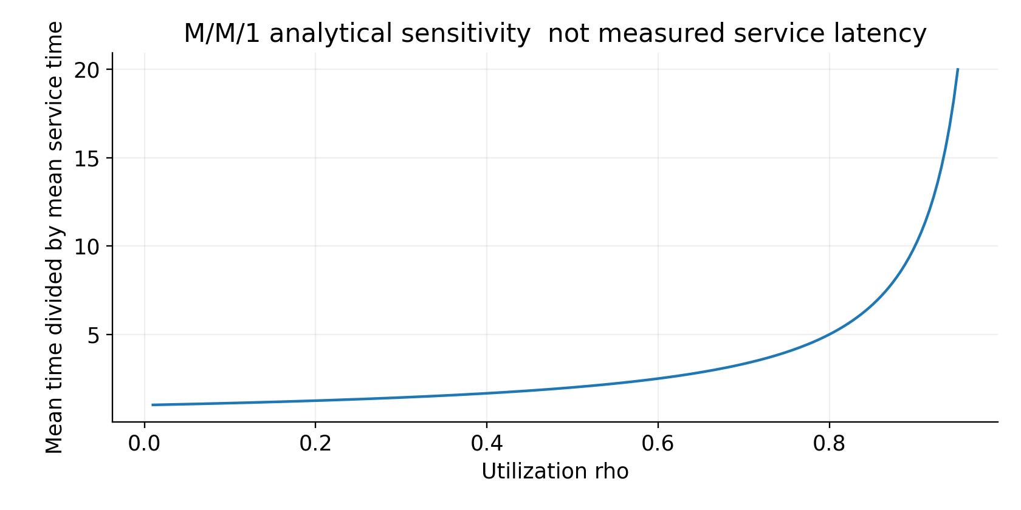
Figure 6 Queue utilization sensitivity
The plot expresses mean time relative to mean service time as utilization rises. It is an analytical sensitivity figure, not a measured latency curve. Real Node.js workloads can have heavy tailed service times, shared resources, batching, and several processing stages, so the simple model should guide capacity questions rather than predict exact percentiles.
The design must define behavior beyond stable capacity. Options include limiting accepted input, adding workers, slowing viewer delivery, coalescing latest state, or entering a degraded freshness mode. Each option changes a different part of the system. Coalescing display updates can reduce viewer work while the durable event log still preserves every accepted business event.
Overload must not silently discard critical events or label stale values current. Queue occupancy, rejected input, processing lag, and viewer information age should be observable and included in the deployment experiment.

2.1.10 Batching and freshness trade offs
Batching combines several changes into one delivery opportunity. Let b be the batch interval and suppose event phases are approximately uniform within that interval. The expected waiting time is b divided by two. A one second polling interval has the same waiting form under the corresponding phase assumption, although payload and processing work can differ substantially.
$E[W_{batch}] = \frac{b}{2}, E[W_{poll}] = \frac{τ}{2}$ (12)
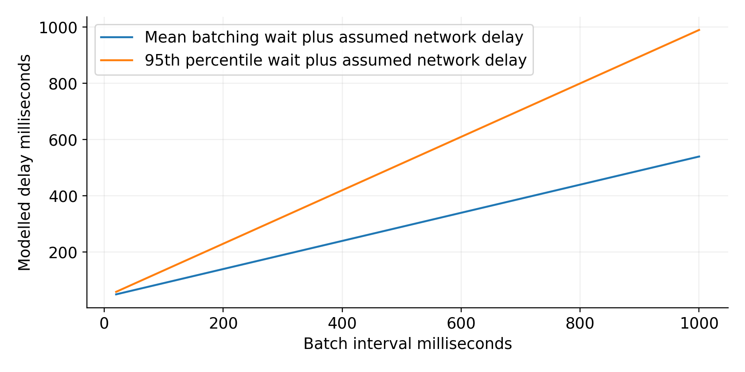
Figure 7 Batching and delay model
The analytical plot adds an assumed forty millisecond network delay to the waiting terms. It excludes source extraction, queues, serialization, browser contention, and media downloads. The figure makes a limited point: reducing b lowers a policy induced delay component while creating more opportunities to send messages and render changes.
A batch may preserve only the latest state for each key. That is appropriate for a current value display when all accepted events remain stored elsewhere. It is inappropriate for an event history component that must show every observation. The component contract therefore declares whether its semantics are latest state, a time series, an event list, or an approved content revision.
An adaptive policy may increase b during heavy load, but its allowed range must respect the freshness target. The thesis does not claim to have implemented an adaptive controller; Section 2.2 specifies how such a controller could be constrained and evaluated.

2.1.11 Full updates and incremental update cost
Let N be the number of components and $K_{t}$ the set affected by changes in delivery batch t. Let $c_{j}$ denote the cost of updating component j, and let $c_{I}$ denote dependency lookup and bookkeeping cost. A full update invokes every component, while a selective update invokes only affected components plus the index overhead.
$C_{full}(t) = {Σ_{j=1}}^{N} c_{j}$ (13)
$C_{selective}(t) = c_{I}(t) + Σ_{j∈K_{t}} c_{j}$ (14)
Selective updating improves component work at equal delivery opportunities when its avoided work exceeds its index overhead. If every component depends on every changed topic, the advantage disappears. If the selective policy sends changes much more frequently than the full policy, total work over a period may increase even when each batch is smaller.
Network cost must be modelled separately. A full snapshot can contain every component’s output, while a delta can contain only changed values or component payloads. Compression, shared metric references, headers, and grouping affect byte counts. The simulator deliberately states its snapshot and delta encoding sizes so that an apparent bandwidth gain is not falsely attributed entirely to dependency pruning.
JSON Patch defines a standard set of document change operations [24]. The proposed design can use patches for authored documents or runtime state, but a patch still requires a base revision and authorization rules. The existence of a compact patch does not establish that the receiver can safely apply it to any state.
The experiment in Section 3.2 uses a factorial policy comparison to separate delivery frequency from selective component updating.

2.1.12 Dependency graph and affected component selection
Let B be a binary binding matrix with one row per component and one column per metric topic. An entry is one when the component declares that topic as an input. For changed topic set $Δ_{t}$, the affected set contains components with at least one corresponding entry. Derived metrics are expanded through the transformation graph before this lookup.
$K_{t} = \{j : Σ_{i∈Δ_{t}} B_{ji} > 0\}$ (15)
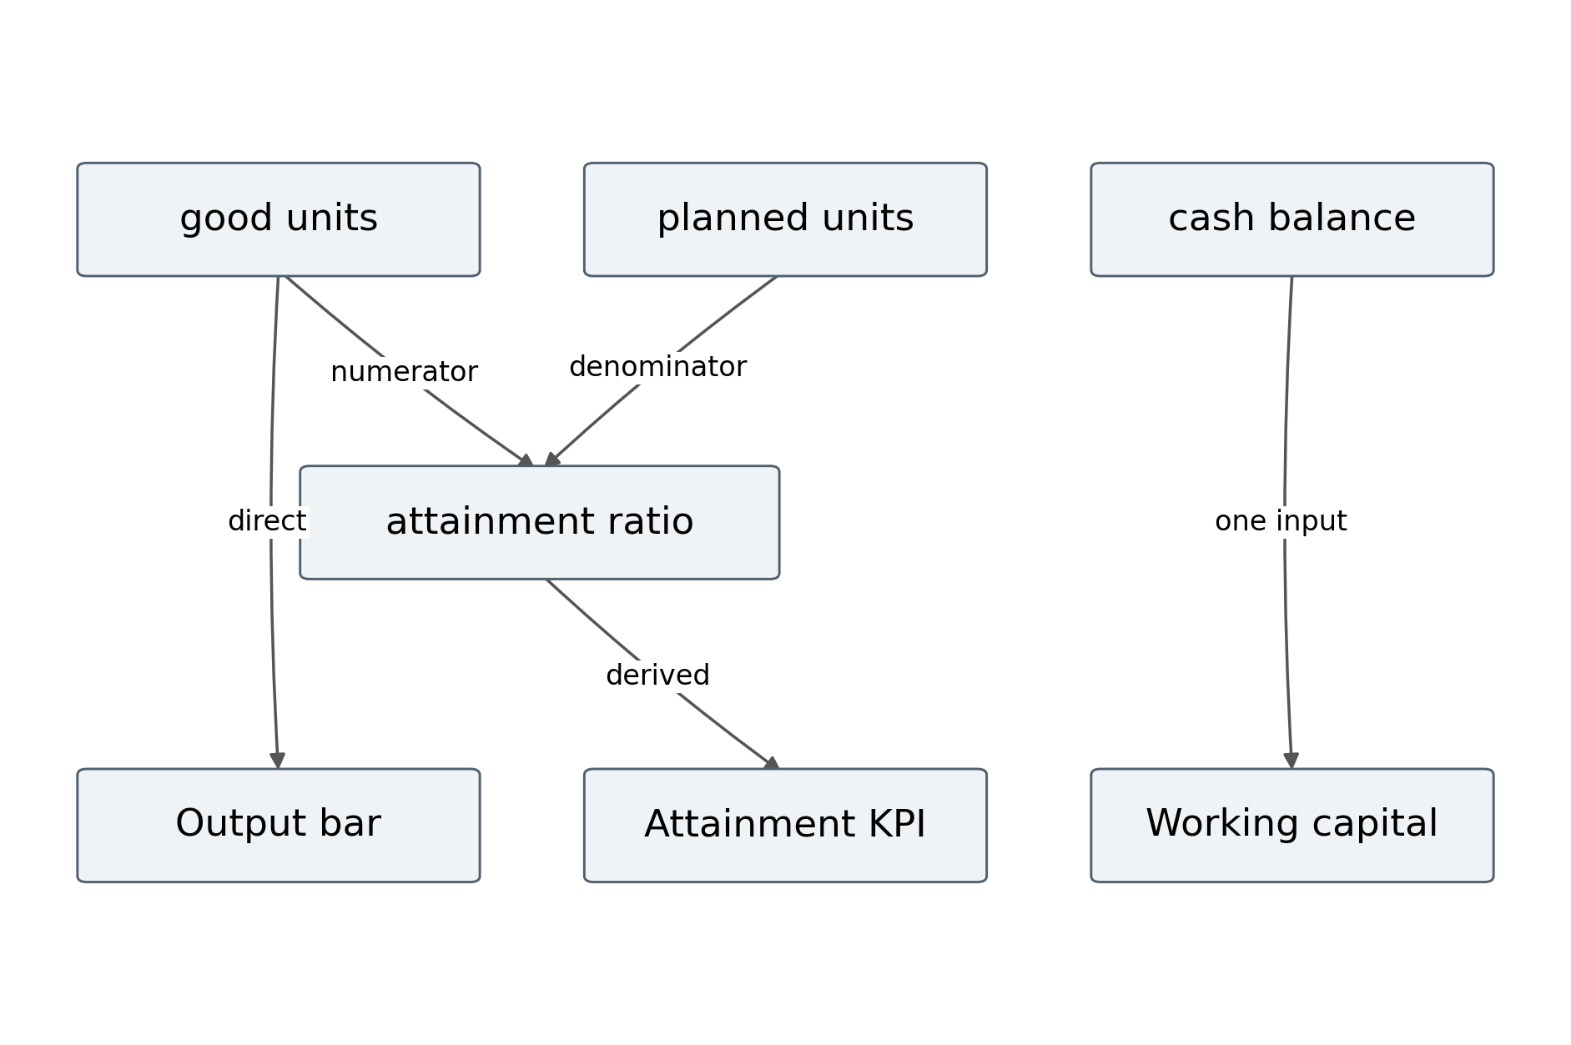
Figure 8 Component dependency example
The example shows that good output affects both a direct bar chart and an attainment ratio, while cash affects a separate financial view. A change in planned output affects the ratio without necessarily changing the direct output bar. The index should find these relationships from declared bindings rather than scanning the visible DOM.
The implementation maintains an inverse map from topic to component identifiers and a forward map from component to its topics. Rebinding first removes old entries and then registers the new set. Without removal, a deleted dependency would continue triggering unnecessary updates. Without the forward map, cleanup would require scanning every topic.
The index is correct only if all dependencies are declared. Custom components and transforms must therefore expose their inputs, including lookup tables and policy dependencies that influence output.

2.1.13 Shared computation and cache boundaries
Many viewers may use the same metric definition, entity, and reporting period. Materializing that metric once can avoid repeating the same transformation for every connection. The cache key must capture all inputs that affect the result, including definition version, tenant, entity filter, period, unit conversion policy, and any relevant permission scope.
${Key}_{cache} = Hash(tenant, metricVersion, entity, period, filter, policy)$ (16)
The hash is an identity mechanism, not an authorization decision. A gateway must still verify that a viewer is allowed to receive the cached value. If different roles can see different subsets of records, a shared aggregate must not reveal excluded information through a poorly chosen cache scope.
Cache invalidation follows the dependency graph. A changed source fact invalidates the materialized nodes it can affect. The gateway can avoid sending a numerical delta when the recomputed result is unchanged, but quality, completeness, provenance, or age state may still have changed. Equality must therefore be defined over the relevant output contract, not only the numeric value.
Media caching uses content identity and access policy. An immutable image hash can support reuse, while a changing document approval state requires separate metadata. A signed asset URL can expire without the asset’s content changing. Components should treat retrieval authorization and content version as different states.
The deployed evaluation should measure cache hit rate, materialization work, memory growth, and revocation behavior. The supplied simulator excludes caching and multiple viewers, so its traffic results cannot establish those properties. This omission narrows its conclusion but does not reduce the importance of the cache design.

2.1.14 Quality policy and service objectives
The proposed architecture exposes quality and freshness as explicit state. Each component has a freshness threshold, an allowed provisional state, a missing value rule, and a recovery behavior. These rules allow the page to remain informative when the service cannot meet its preferred timing.
Table 14 Proposed quality and freshness policies
Condition | Proposed behavior | Evidence to inspect
Fresh valid value | Display normally with period and unit | Metric version and source time
Stale source | Keep last valid value with stale indicator | Information age and source health
Missing denominator | Show undefined ratio with explanation | Input quality and denominator state
Provisional window | Display labelled provisional result | Window boundary and progress estimate
Unauthorized metric | Do not deliver or reveal cached data | Access decision and revocation test
Schema mismatch | Block affected binding and request migration | Schema and registry versions
Replay gap | Resynchronize from a new snapshot | Cursor retention and state equality

For a component j, information age is display time minus the event time of the represented latest fact, subject to the clock policy. A derived value may need several input ages and a completeness timestamp. The interface should not reduce these to one misleading connection status.
$A_{j}(t) = t_{display} − t_{event},j$ (17)
A service objective can require that a stated fraction of eligible observations meet $A_{j}$ below a threshold. Eligibility must exclude neither difficult cases nor failed updates without explanation. The denominator, outage treatment, and measurement method should be fixed before testing.

2.1.15 Architecture synthesis and falsifiable predictions
The architecture connects a typed source contract, deterministic materialization, dependency indexing, authorized delivery, and version aware rendering. Its main prediction is conditional: when changes affect only part of a page, selective updating should reduce component work at equal delivery frequency. A second prediction is that smaller batches should reduce policy induced delay while increasing delivery opportunities.
These predictions can fail or lose practical value. A dense dependency graph can make every change affect most components. Large changes can make delta encoding more expensive than a compressed snapshot. An expensive dependency index can offset saved rendering work. A slow source can dominate freshness regardless of the browser delivery policy. A rapid stream can create more total updates than a slower polling baseline.
The proposed evaluation therefore needs both mechanism tests and system tests. Mechanism tests verify the binding matrix, update ordering, and cost relationships under controlled inputs. System tests measure actual source to display delay, browser rendering, network transfer, memory, recovery, and authoring behavior. The supplied synthetic study addresses only a subset of the first group.
The architecture also yields correctness conditions. Snapshots and streams must share a checkpoint contract. Component bindings must declare all relevant inputs. Cross source measures must align grain and period. Publication must pin the registry and schema versions. Access must be enforced before delivery. These conditions are stronger than a demonstration that changing a number makes a chart redraw.
Section 2.2 now specifies the component and editor models that make these responsibilities configurable. It also defines the proposed interface and the important data structures required for a Node.js implementation.

2.1.16 Worked integration example across independent systems
Consider a proposed operations page containing a production chart, a management table, a working capital indicator, a document panel, and a current photograph. The production system records one row per line and shift. The management system records one row per work order. The finance system reports balances by legal entity and accounting period. Combining these records requires an explicit mapping of entity, time, metric definition, and authorization. A shared label such as Plant A is insufficient when two systems use different identifiers.
The adapter resolves each local identifier through a versioned mapping before producing a canonical event. For example, line L7 maps to plant P2, while a finance account maps to legal entity E1. A plant page may show production for P2 and finance for E1, but the caption must disclose that the finance scope covers the whole entity. The editor must not imply that an entity balance is attributable to one production line unless an allocation rule has been approved.
An illustrative production correction changes good units from 120 to 126 while planned units remain 150. Attainment changes from 80 to 84 percent. If current assets are 240000 and current liabilities are 175000 in the same currency and reporting period, net working capital is 65000 currency units. These numbers demonstrate the model and are not operational records. The financial display must retain its period label even when production updates every few seconds.
$V_{page}(t) = \{R_{j}(Q_{j}(D(t)), U_{j}, P_{j}) : j ∈ C_{authorized}\}$ (18)
Equation 18 describes a composite page as a set of authorized component views. Each component has its own query, interaction state, and quality policy. A production correction invalidates the production chart and its attainment indicator through their shared dependencies. It does not invalidate a photograph whose asset identifier is unchanged. A new document revision invalidates the document panel and any component that explicitly depends on its extracted content.
The model therefore supports a coherent page without pretending that every source has the same temporal resolution. A page level status summarizes the oldest required component and reports partial availability. Each component still exposes its own source time and quality state. This treatment prevents a freshly received production event from concealing a stale finance balance and provides a concrete interpretation of comprehensive display.

2.2 Component models and proposed editing interface

2.2.1 Formal representation of the improved page editor
The proposed editor improves the system composition by making data dependencies and operational policies part of the authored document. Each page contains components, layout rules, bindings, transformations, interaction state definitions, access references, and version metadata. The document does not store a copied current value as if it were permanent authored content unless the author explicitly creates a fixed report snapshot.
$P = (id, revision, C, L, B, Q, U, Policy, K)$ (19)
Each component c has an identity, kind, properties, binding specification, renderer reference, accessibility description, and temporal behavior. Its runtime state is separate: current value, quality, data version, loading status, and last applied cursor. This separation makes a production update a state transition rather than an edit to the page’s approved layout.
$c = ({id}_{c}, {kind}_{c}, {props}_{c}, {bind}_{c}, {renderer}_{c}, a11y_{c}, {timePolicy}_{c})$ (20)
The improvement is architectural rather than a claim of a universally new editor category. Established tools can be extended to express similar information. The thesis asks whether representing these contracts directly in the editor reduces invalid configurations and makes change propagation more efficient for the selected domain.
The model supports extensibility through a registry. A new component kind declares an input schema, permissible transformations, render and disposal methods, and error behavior. Registry versions are pinned in a published revision. An extension that changes these contracts requires validation or migration rather than silently altering an old page.
The following pages describe the component kinds, operational metrics, financial interpretation, layout constraints, editor commands, and implementation structures needed to realize this representation.

2.2.2 Contracts for documents photos charts and tables
Different display kinds require different change semantics. A chart usually consumes structured observations, while a photograph consumes an asset reference and context. A document consumes a revision and approval state. The registry should validate each kind against its own input contract.
Table 15 Component contracts
Kind | Required input | Update behavior | Accessible alternative
Text or KPI | Typed scalar unit and period | Replace accepted value and status | Readable label value and explanation
Bar chart | Category and quantitative measure | Update affected categories under sort policy | Data table and chart description
Line chart | Time and quantitative measure | Append correct or replace points by key | Ordered data table and summary
Table | Rows with stable identifiers | Keyed update preserving selection | Semantic table with headers
Photo | Asset identity entity time and alt text | Load new reference before replacement | Alternative text and context
Document | Asset revision approval and title | Notify or switch under reading policy | Accessible document or text equivalent
Diagram | Typed nodes and relationships | Update graph under layout policy | Relationship list and description

A component must not show a new value under an old unit or period label. The runtime applies value and metadata as one versioned output. For media, it can preserve the previous valid image while the new asset loads, but should identify the pending change if that distinction affects the task.
The contracts also define error behavior. A chart may show a labelled empty state, while a document may show an unavailable revision message. Neither should invent a zero value to fill missing data. These states must be available in the authoring preview.

2.2.3 Operational and financial data relationships
The requested application includes production performance, management information, and floating capital from different systems. The manuscript interprets floating capital provisionally as working capital. The author must confirm the intended accounting definition before applying financial formulas to real records. A translation or organization specific term may refer to a different measure.
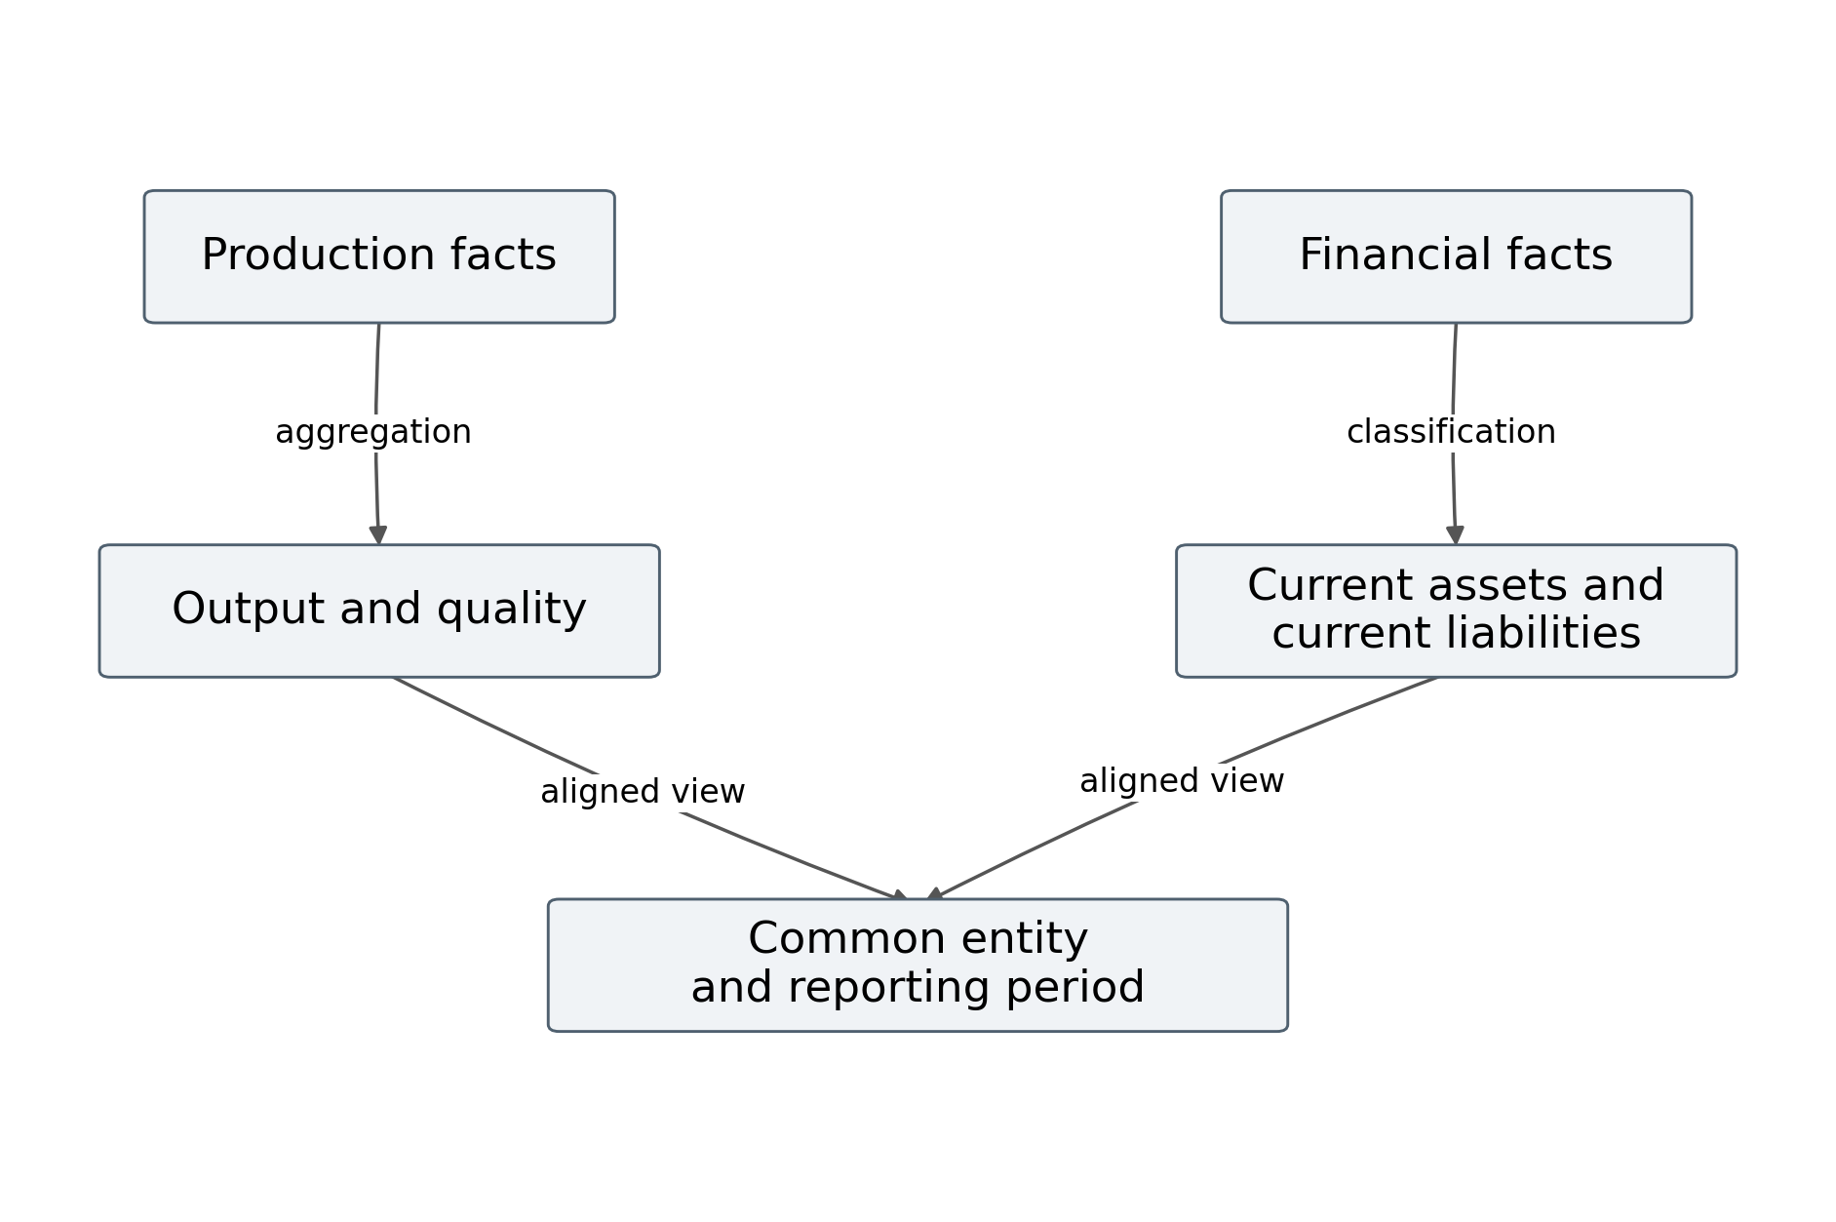
Figure 9 Operational and financial metric relationships
Production facts may originate in an MES, while plans and organizational records originate in an ERP. Financial balances may originate in an accounting system. They can appear together only after their entities, periods, units, and access rules are made explicit. A shared page does not create a valid numerical join by itself.
The relationship layer stores an entity catalog with stable keys and mapping versions. A production line can belong to a facility, and a facility can belong to a legal entity, but the financial balance may be available only at the legal entity grain. The editor should expose that difference rather than suggesting an unsupported per line financial figure.
Management data can provide explanation and action status. A maintenance ticket, responsible person, or approved plan may be linked to the selected production entity. These relationships support interpretation, but they should not be treated as causal proof that a particular intervention changed output. A separate analytical study would be required for such a claim.

2.2.4 Production performance models
Production indicators require explicit counting rules and denominators. The following definitions are proposed for the reference domain; an actual organization must confirm whether they match its operational definitions. Good units, total units, planned units, run time, and scheduled available time must refer to the same reporting period and compatible equipment scope.
Table 16 Operational metric definitions
Metric | Definition | Important qualification
Output attainment | Good units divided by planned units | Undefined when planned units are zero
Quality ratio | Good units divided by total units | Undefined when total units are zero
Availability Av | Run time divided by available time | Define planned and excluded downtime
Performance Pf | Ideal cycle time times total units divided by run time | Ideal cycle definition must be valid
OEE | Availability times performance times quality | Compatible scope and denominators required
Backlog | Accepted incomplete work at checkpoint | Do not mix order counts with unit counts

$Attainment = \frac{GoodUnits}{PlannedUnits}, Quality = \frac{GoodUnits}{TotalUnits}$ (21)
$Av = \frac{RunTime}{AvailableTime}, Pf = \frac{IdealCycleTime × TotalUnits}{RunTime}$ (22)
$OEE = Av × Pf × Quality$ (23)
Zero denominators yield an undefined value with an explanation, not an automatic zero or one. A performance value above one may reveal an incorrect ideal cycle time or a counting mismatch; the editor should flag it for review rather than silently clamp it. The supplied reference function validates nonnegative inputs and basic consistency, but a full implementation requires these additional domain checks.

2.2.5 Working capital and exact monetary state
For this draft, net working capital is modelled as current assets minus current liabilities at a stated reporting date. An operating working capital measure may use selected receivables, inventory, and payables instead. The two definitions must not be used interchangeably. The author should choose the organization’s intended definition and identify the authoritative accounts.
$NWC(t) = CurrentAssets(t) − CurrentLiabilities(t)$ (24)
$OWC(t) = Receivables(t) + Inventory(t) − TradePayables(t)$ (25)
Table 17 Financial interpretation rules
Property | Required rule
Definition | Select net or operating working capital explicitly
Reporting date | Align every balance to the same checkpoint or closed period
Currency | Use one currency or a versioned approved conversion
Precision | Preserve exact minor units or an approved decimal representation
Scope | Identify legal entity and consolidation treatment
Quality | Distinguish provisional posted and reconciled balances
Source | Trace displayed amounts to approved accounts

The reference core accepts BigInt minor units and subtracts them exactly. A payload serializes those integers as strings because ordinary JSON does not directly serialize BigInt. The renderer formats the number according to its currency without changing its underlying amount.
The mathematical subtraction is simple; selecting compatible balances is the harder task. A current assets total at yesterday’s close should not be combined silently with a liabilities total from an open current period. If the source cannot provide aligned state, the financial component should display a qualification or block the derived measure according to policy.

2.2.6 Management data and aggregation grain
Management information includes planned production, task ownership, maintenance status, order state, approval records, and organizational structure. It can be categorical, temporal, or quantitative. The editor should not treat every management field as a number to aggregate. A status code and a responsible person identifier require categorical or documentary presentation.
Let a record carry an entity key e, reporting interval w, measure m, and value v. A grouping operator produces an aggregate for a defined set of entities and a defined interval. The grouping key is part of the metric contract, so that a chart cannot accidentally combine incompatible levels.
${Aggregate}_{g,w,m} = Σ_{r : key(r)=(g,w,m)} value(r)$ (26)
The summation is valid only for an additive measure. A percentage should generally be recomputed from its numerator and denominator rather than summed. An average duration may require weighting by record count. A balance is a point in time value and should not be summed across dates as if it were a flow.
The interface therefore shows aggregation compatibility. A count field can allow sum, while a ratio field can require its declared aggregation function. A document field can allow latest approved revision or an ordered list rather than arithmetic. Custom aggregation functions must declare their state and deletion behavior.
Join rules also need explicit cardinality. Joining one order to several maintenance notes can multiply its production quantity unless the notes are kept in a separate relation or aggregated first. The proposed validator inspects grain and cardinality metadata; it does not attempt to infer business meaning solely from column names.
These controls support H3, but a completed authoring study is required to demonstrate that users make fewer errors with them.

2.2.7 Layout and responsive composition model
The layout model assigns a rectangular region to each component. Let $x_{j}$ and $y_{j}$ be its position, $w_{j}$ and $h_{j}$ its dimensions, and W and H the page or grid bounds. A valid layout keeps each region within bounds and prevents overlap where overlap is not an intentional layout feature.
$0 ≤ x_{j}, 0 ≤ y_{j}, x_{j} + w_{j} ≤ W, y_{j} + h_{j} ≤ H$ (27)
$Area({Rect}_{j} ∩ {Rect}_{k}) = 0 for nonoverlapping component pairs$ (28)
Responsive rules define alternative layouts for viewport ranges. They can change placement and dimensions while preserving component identities, bindings, and interaction state. A small screen may show a compact chart and offer its data table through a control. It should not silently omit critical freshness or quality information.
Layout evaluation also considers minimum useful size. A technically valid twenty pixel chart is unlikely to support a production comparison. Each component kind declares a preferred and minimum size, together with an allowed compact representation. The validator can warn when a layout falls below those constraints.
The optimization objective can minimize unused space and authoring effort while penalizing overlaps, unreadable labels, and excessive scrolling. Such an objective should remain subordinate to hard semantic and accessibility constraints. The proposed editor provides interactive grid placement and responsive preview; it does not claim a completed automatic layout optimizer.
A layout change can affect rendering cost through label wrapping, chart resolution, and the number of visible components. The product benchmark must therefore hold the layout constant where possible and record viewport dimensions. Comparing different visible content would confound the update architecture with display workload.

2.2.8 Proposed editing interface
The interface has five main regions: a command bar, a component library, a responsive canvas, a binding inspector, and a data status area. The design emphasizes the relationship between appearance and data meaning. The author can see where a component will appear while inspecting the metric, unit, period, and freshness rules that determine its contents.
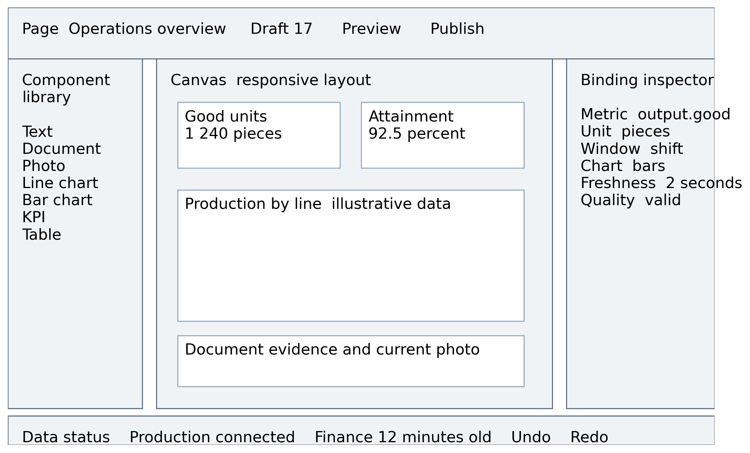
Figure 10 Proposed editing interface mockup
This is a design mockup with illustrative values. It is not a screenshot of the user’s existing editor. The displayed numbers serve only to show the placement of KPI and chart regions; they are not operational records or experimental outcomes.
The component library offers text, documents, photographs, charts, tables, KPIs, and diagrams. Dropping an item creates an instance with a stable identity and registry defaults. The binding inspector then restricts selectable fields to those compatible with the component contract while allowing the author to inspect why another field is unsuitable.
The data status area distinguishes source connection, metric age, and period completeness. The command bar distinguishes draft preview from publication. Together these controls make it harder to confuse a current preview value with an approved authored revision. The usability of this arrangement remains a hypothesis to test with representative authors.

2.2.9 Interface components and validation feedback
The interface should give feedback at the point of configuration. A binding error belongs beside the field selection, a layout error belongs on the canvas, and a publication error belongs in the command workflow. A general warning panel alone can force users to search for the cause.
Table 18 Interface areas and behavior
Area | Main action | Required feedback
Command bar | Save preview publish undo redo | Revision status and publication validity
Component library | Insert registered component | Type purpose and minimum size
Canvas | Select move resize and arrange | Bounds selection and responsive preview
Binding inspector | Choose metric transform period and unit | Compatibility source and dependency trace
Style controls | Set scale color labels and format | Readable defaults and encoding warnings
Data status area | Inspect source and component state | Age completeness connection and errors
History view | Review and restore authored revisions | Manifest registry and change record

The binding inspector can show a compact dependency explanation: a KPI depends on good units and planned units, both at facility and shift grain. If the author changes planned units to a monthly company total, the interface identifies the grain mismatch before the chart is published.
Validation has three levels. Hard errors block publication, warnings require attention but may permit publication under policy, and informational messages explain behavior. A warning must not be used for unauthorized access or a known incompatible arithmetic operation. The same classification is enforced on the server so that bypassing the interface does not bypass the contract.
The authoring study should measure whether these messages help users correct errors, not simply whether the messages exist.

2.2.10 Editing commands and model invariants
Commands make document changes explicit and reversible where appropriate. The command layer can record the operation, target identifier, previous state, new state, and expected revision. It updates the document and its dependency index as one logical operation.
Table 19 Editing commands and invariants
Command | State change | Invariant to preserve
InsertComponent | Add registered instance | Unique identity and valid defaults
MoveComponent | Change layout position | Bounds and responsive rules
ResizeComponent | Change dimensions | Minimum size and valid placement
BindMetric | Replace input dependencies | Compatible type unit grain and period
SetTransform | Change computation specification | Declared inputs and deterministic definition
DeleteComponent | Remove instance and references | No orphaned index entries
PublishRevision | Commit validated manifest | Expected revision and registry pinned
UndoCommand | Restore authored state | Runtime event history remains independent

Concurrent edits require a conflict policy. The simplest reference design uses optimistic revision checking: a command states the revision it expects, and the service rejects it when the document has changed. The client then reloads and lets the author resolve the difference. Collaborative merging is a separate feature requiring additional semantics.
A command log improves diagnostics because it explains how the current document was formed. It does not replace immutable published revisions. The published manifest is the executable configuration for viewers and experiments, while the command history is an authoring record.
The reference core does not implement the complete command service. It implements the dependency registration behavior needed by BindMetric and DeleteComponent, and its tests verify that old dependencies are removed correctly.

2.2.11 Flow of binding and component creation
Component creation begins with a registered kind and defaults. Binding then selects typed source or metric fields, validates compatibility, updates the authored model, and registers dependencies. Preview compiles the valid draft and renders it against live or explicitly synthetic state.
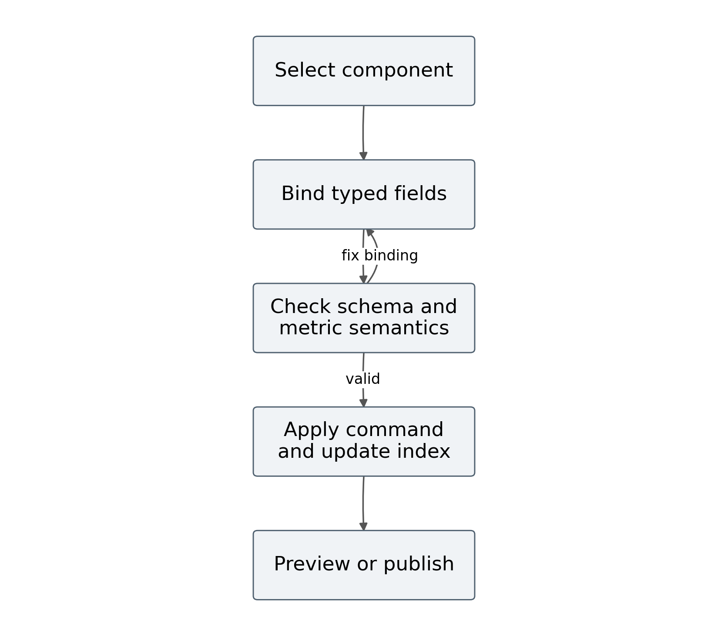
Figure 11 Editing and binding flow
The flow’s validation stage checks more than field existence. It checks the component’s accepted input schema, the metric’s unit, entity grain, reporting period, transformation dependencies, and access reference. A valid binding becomes part of the page model and the inverse dependency index. An invalid binding remains an editable draft error and cannot be published.
When a component is rebound, the old topic memberships must be removed before the new memberships are installed. The reference BindingIndex class stores the forward set precisely for this purpose. Deletion uses the same cleanup operation. The affected method unions consumer sets, ensuring that a component depending on several changed topics is returned only once.
The flow is implemented as ordinary JavaScript data operations in the reference core. In a complete editor, persistence and command revision checking surround those operations. A server transaction or equivalent atomic document update should prevent the stored binding and stored index metadata from disagreeing after a failure.

2.2.12 Data structures and computational complexity
The proposed data structures make the important relationships explicit. In memory, maps provide keyed lookup and sets prevent duplicate dependencies. Persistent storage uses page, revision, component, binding, metric, asset, and event checkpoint records. Exact database indexes should be selected after measuring the actual query workload.
Table 20 Data structures and complexity
Structure | Purpose | Typical operation cost
Map of component IDs | Find instance and renderer state | Expected constant keyed lookup
Map topic to Set of component IDs | Find consumers of changed topics | Proportional to visited memberships
Map component to Set of topics | Remove or replace dependencies | Proportional to declared dependencies
Map key to latest versioned value | Reject old or duplicate state | Expected constant keyed lookup
DAG adjacency lists | Propagate derived metric changes | Proportional to reachable graph
Dirty component Set | Deduplicate a delivery batch | Expected constant insert
Versioned page manifest | Reproduce published configuration | Validation proportional to document size

Expected constant time describes ordinary hash map behavior, not an absolute worst case guarantee. The affected lookup cost is proportional to the topic memberships it visits and the number of returned component identifiers. Dense dependencies can make that cost approach a full scan.
The in memory reference uses topic identifiers only. A production tenant aware index must scope them to avoid collisions across organizations and revisions. Index entries should also be released when subscriptions end or manifests change. Memory growth under repeated editing and reconnecting is therefore an important deployment test.
The registry stores schema and renderer metadata rather than mutable business values. This keeps component type definitions separate from instances and runtime state.

2.2.13 Important Node.js reference functions
The executable reference core contains four primary functions or classes. BindingIndex maintains topic memberships. LatestState rejects invalid or older values for one scoped key. netWorkingCapital performs exact subtraction of integer minor units. productionMetrics validates inputs and derives several ratios while preserving undefined denominators.
const index = new BindingIndex();
index.bind('attainment', ['production.good', 'production.plan']);
index.bind('output-bars', ['production.good']);
const dirty = index.affected(['production.good']);
// dirty contains each dependent component once
const state = new LatestState();
state.apply({ key: 'production.good', version: 12, value: 1240 });
state.apply({ key: 'production.good', version: 11, value: 1200 });
// version 11 is rejected; version 12 remains current
The snippet illustrates reference behavior and uses invented values. LatestState accepts only finite numerical values and a nonnegative safe integer version. Its key must already represent the intended source and entity scope. It is not a full canonical event validator, and it does not establish cross source snapshot consistency.
The complete functions are provided in core.mjs. Tests exercise rebinding cleanup, duplicate and out of order rejection, exact currency arithmetic, undefined ratios, deterministic traces, and the loss of dependency pruning benefit at full coverage. Five tests pass in the recorded environment.
These checks support limited algorithmic claims. They do not test the interface, durable event processing, browser chart rendering, authentication, or deployment. A complete implementation must add those layers and map each proposed contract to an actual module before the thesis can describe it as built.

2.2.14 Constrained adaptive update policy
The synthetic findings suggest an adaptive delivery policy as future implementation work. A controller could choose a batching interval and delta or snapshot representation according to observed event rate, dependency coverage, payload size, and viewer lag. The chosen policy must remain within the component’s allowed freshness and history semantics.
Let b be a candidate interval, L(b) the predicted delay, B(b) transmitted bytes, and C(b) component work. One proposed selection objective minimizes a weighted resource cost subject to a freshness bound and correctness constraints. Its weights and prediction functions require calibration from actual measurements.
$\min_{b,encoding} α B(b) + β C(b); L_{95}(b) ≤ F_{max}$ (29)
The controller should not choose a slower update mode for an event history component if that mode discards intermediate observations. It may coalesce latest state components while keeping the accepted event log complete. Its decision should also consider browser visibility and user interaction, because updating a hidden or actively edited region can create unnecessary work.
An adaptive policy introduces risks of oscillation and unfairness. Hysteresis and minimum dwell times can reduce rapid switching. Per page or per viewer limits should prevent one busy display from monopolizing shared processing. The controller’s decision and predicted effects should be observable for evaluation.
No adaptive controller is implemented or benchmarked in the supplied files. Equation 29 and this design identify a plausible response to the demonstrated trade off. A future study must compare it with fixed policies using the same traces and include the controller’s own overhead.

2.2.15 Validation properties and chapter synthesis
The proposed editor model yields properties that can be checked before a full product evaluation. Every component identity is unique within a revision. Every binding refers to a known compatible metric. Every transformation declares its inputs. Every published manifest pins schema and registry versions. Rebinding and deletion remove obsolete index memberships. Older runtime values cannot overwrite newer accepted state.
Additional properties require integration tests. A snapshot followed by replay should produce the same metric state as complete event processing at the same checkpoint. An unauthorized viewer should receive neither the initial metric nor subsequent deltas. A publication conflict should leave the old revision intact. A recovered viewer should converge to current state without silently losing required history.
The model also creates usability questions. Can authors understand unit and grain feedback? Can they distinguish draft preview from published state? Does the data status area help them identify a stale financial input? Does the component library support mixed documentary and quantitative tasks without excessive effort? These questions need observation of representative users.
The chapter’s contribution is a coherent specification linking source meaning, component structure, layout, commands, and runtime updates. The executable reference validates several core rules, while the diagrams and formulas define a larger proposed system. The distinction between implemented reference behavior and specified architecture remains explicit.
Chapter 3 maps the specification into logical and physical deployment structures, explains important Node.js functions, and evaluates the update mechanism. It also states the remaining evidence required to compare the actual editor with configured existing tools.

2.2.16 Convergence of component state under repeated events
Correct selective rendering requires more than a small dirty set. The state accepted by every affected component must eventually agree with the latest authorized source state. Let S be a map from scoped metric keys to versioned values. An accepted event replaces one entry only when its version is greater than the stored version. Duplicate and older events leave S unchanged. Equal versions with conflicting payloads are treated as a contract error rather than silently overwritten.
$Apply(Apply(S, e), e) = Apply(S, e)$ (30)
Equation 30 states idempotence for a valid event. For events on different independent keys, applying one does not change the other key. For events on the same key, the greater version determines the final latest state regardless of delivery order. These properties follow directly from comparison by scoped monotonic version; wall clock timestamps alone cannot establish the same result when clocks differ or corrections arrive late.
After accepting an event, the dependency index marks every component whose query depends on its key. The browser merges dirty identifiers into a set and schedules one render batch. Several changes can therefore produce one component render. Clearing an identifier is safe only after the component has consumed the state version associated with that batch. If another event arrives during rendering, its dirty marker must survive for the next batch.
This argument assumes complete dependency registration, compatible page and metric revisions, and eventual delivery or successful snapshot recovery. It does not prove consistency for incomplete dependencies, unauthorized events, or a renderer with nondeterministic external state. A missing replay interval requires a fresh snapshot and a new checkpoint. Historical event components also require an append or correction model; replacing a latest value cannot preserve a complete event history.
These conditions produce a practical validation rule. For a fixed manifest and accepted event trace, rendering the final snapshot must yield the same semantic component values as replaying the trace and draining all dirty batches. Equality concerns values, units, scope, and quality state rather than identical pixels. This property can expose lost updates and dependency omissions before browser speed measurements are interpreted as improvements.

Chapter 3 Implementation structures and evaluation

3.1 Logical and physical architecture in Node.js

3.1.1 Reference implementation scope
This section maps the mathematical models to a proposed software environment. The supplied code implements a small reference core and a discrete event simulator. The full editor service, browser interface, storage layer, source adapters, and streaming gateway are architectural specifications. They must be matched to the author’s actual project before being described as an implemented system.
The logical structure has two principal planes. The authoring plane manages page documents, metric definitions, assets, validation, and publication. The runtime plane ingests source changes, materializes metrics, identifies affected components, and delivers authorized state. They share versioned contracts but have different lifecycles and performance requirements.
Node.js executes the JavaScript service logic. Short callbacks handle routing and subscription bookkeeping, while bounded asynchronous operations access storage and sources. CPU intensive transformations can be separated into workers or processing services. The browser renders components using the published manifest and current metric state; its implementation may use native DOM, SVG, canvas, or a chart adapter according to the registry.
An initial deployment can combine several logical services in one Node.js process when workload and operational requirements permit. A larger deployment can separate ingestion, processing, control APIs, and streaming gateways. The logical contract should remain stable across that change so that scaling does not redefine the meaning of a component or metric.
The physical design that follows is a candidate deployment. It does not claim a cluster, database, or source connector was provisioned during this research draft. The purpose is to show where each proposed responsibility resides and what evidence would validate it.

3.1.2 Logical architecture and service boundaries
The editor client communicates with a control API, which validates documents and stores revisions. The viewer client communicates with a stream gateway and loads immutable manifests and assets. Metric processors consume the durable event log and write versioned materialized state. Source adapters supply the log through authenticated ingestion contracts.
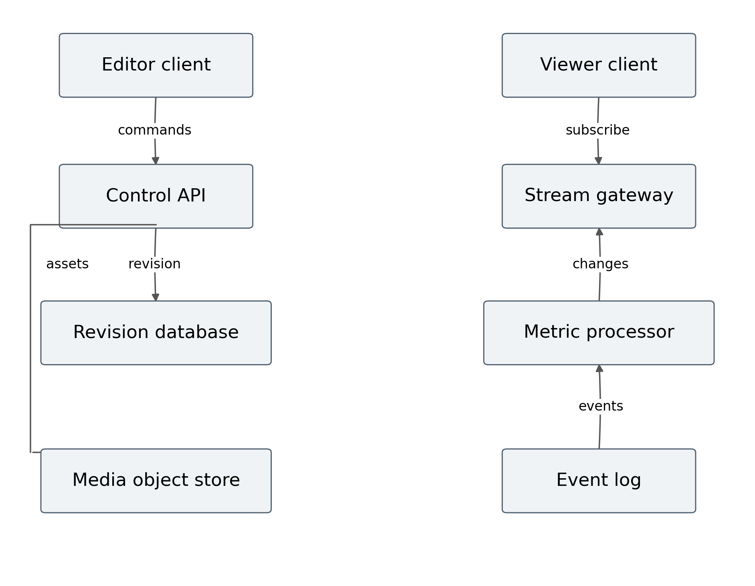
Figure 12 Logical deployment architecture
The control API owns authored changes. It does not directly repaint viewers whenever an editor selection changes. The stream gateway owns viewer delivery. It does not grant authority to modify source business records. This boundary keeps an operational display from becoming an uncontrolled write path into production or finance systems.
Storage is divided by data role. Revision metadata requires transactional integrity. Event history requires durable ordered processing within its partition contract. Media storage requires content identity and authorized retrieval. Materialized metrics require checkpointed state and definition versioning. One storage product may fulfill several roles, but those roles remain separate in the model.
Telemetry follows the same boundaries. An adapter reports source delay, a processor reports checkpoint lag, a gateway reports connection and replay state, and a viewer reports applied version and rendering measures. Combining these observations can explain why a component is stale without assuming that the browser connection is the cause.

3.1.3 Physical architecture and deployment configurations
A candidate physical deployment places the browser and cached static assets at the public boundary, a TLS reverse proxy before the application services, and database, event processing, and media storage behind private service interfaces. Control and stream replicas can scale independently because editing requests and long lived viewing connections have different workloads.
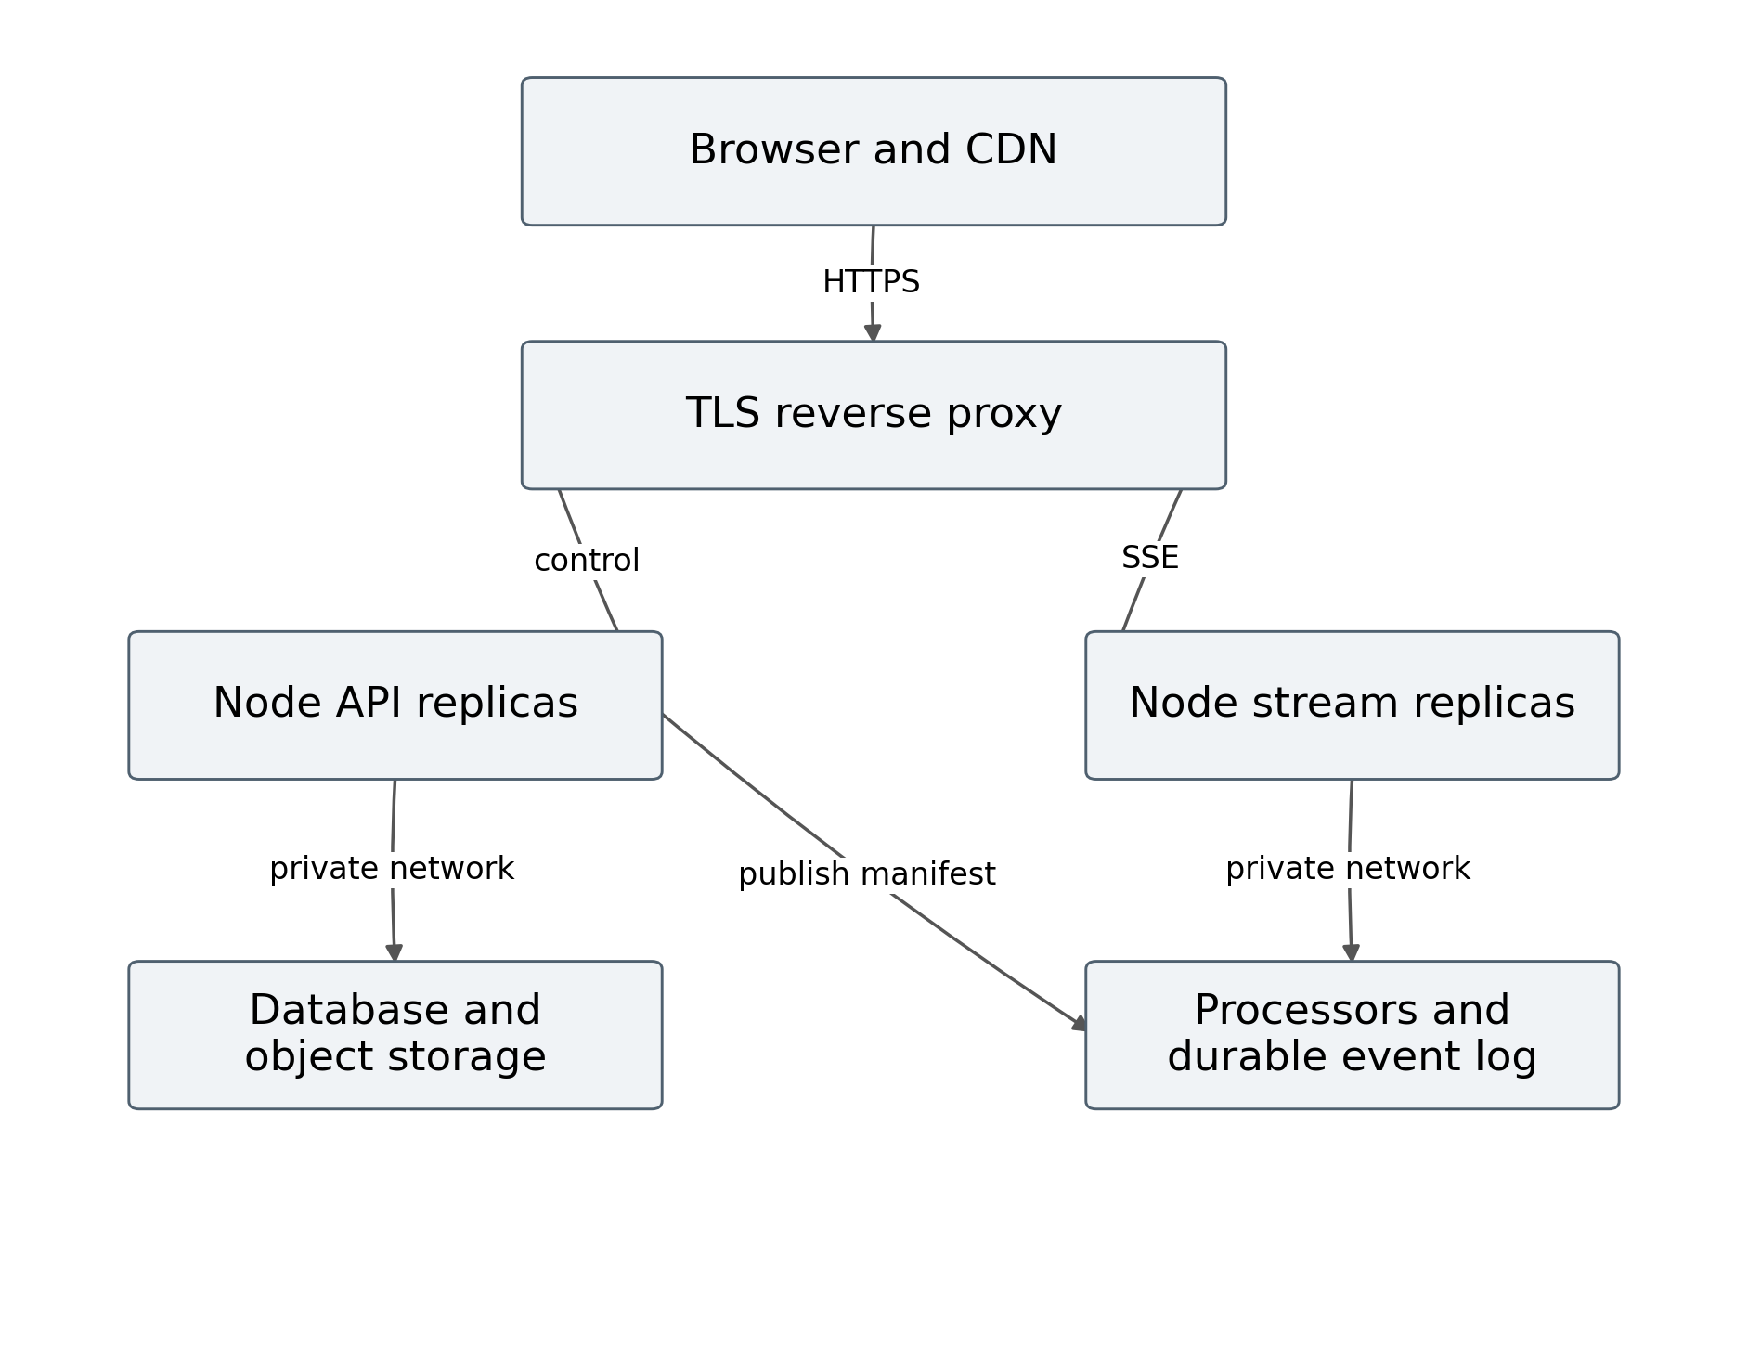
Figure 13 Physical deployment architecture
The reverse proxy must support streaming without unintended response buffering and with an appropriate timeout policy. Stream replicas need access to shared replay history and materialized state so that a reconnect can recover on a different replica. Keeping all history only in one process would make replica changes visible as data gaps.
A small deployment can run the logical modules on one host with persistent storage. A larger deployment can distribute adapters, processors, gateways, and metadata services. The choice should follow measured capacity, failure tolerance, and operating cost. Multiple replicas do not automatically solve source unavailability or an incorrect transformation.
Configuration includes source credentials, permitted schemas, tenant mappings, metric definitions, batch intervals, queue limits, retention windows, asset limits, and telemetry destinations. The actual thesis should record these settings and resource limits for every measured experiment. A diagram without configuration evidence cannot establish that a deployment met its freshness or recovery objectives.

3.1.4 Logical data structure and persistent entities
The persistent model separates authored pages, revisions, component instances, bindings, metric definitions, and assets. A page has many revisions, and a revision has many component instances. A component can reference several metric bindings and media assets. Runtime metric values and event checkpoints are stored separately from authored configuration.
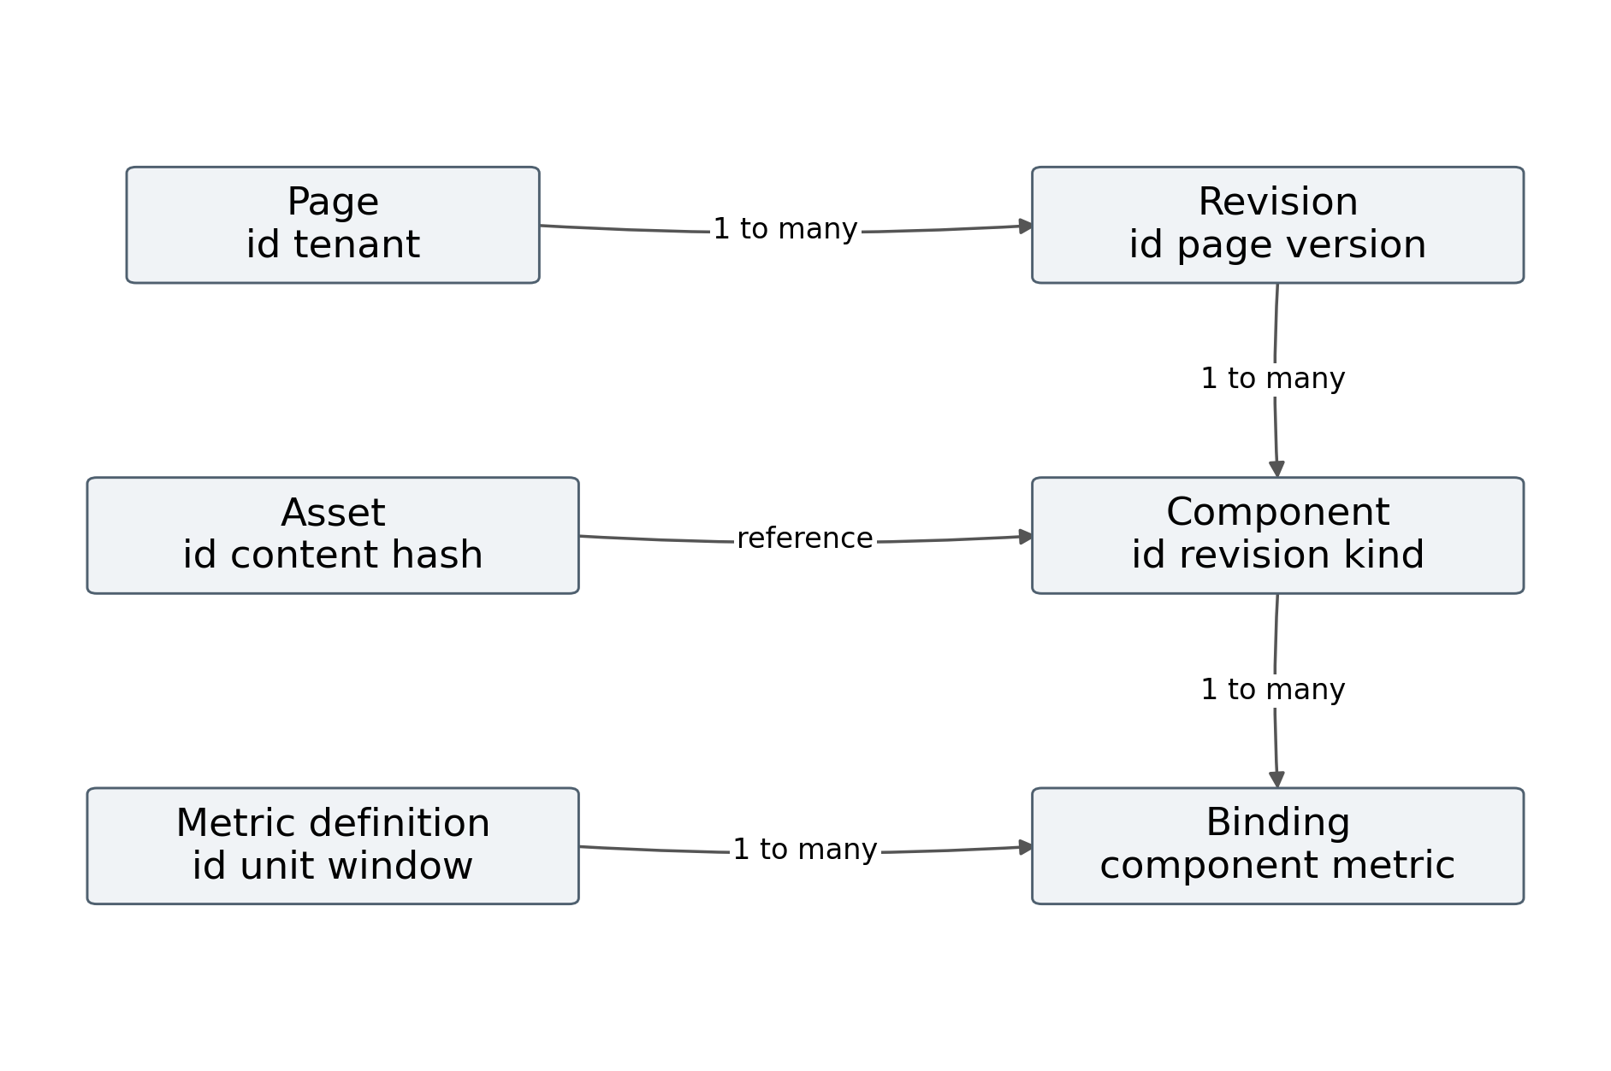
Figure 14 Persistent entity relationships
Each relation requires scoped identifiers. A component identifier is stable within its page history, while its configuration belongs to a particular revision. A metric definition has a version independent of the latest value it produces. An asset identifier can reference immutable content while approval and accessibility metadata evolve through controlled revisions.
The model supports auditability by retaining the manifest hash, registry version, metric definition versions, and publication time. A published revision can be reconstructed without guessing which current plugin or source schema it originally used. Deleting a draft component removes its bindings but does not delete shared metric definitions or historical published revisions automatically.
Foreign key or equivalent application checks prevent orphaned records. Access checks scope every query to the tenant and allowed page. Event state storage uses its own checkpoint rules; the entity relationship diagram is not a substitute for the snapshot and replay consistency model developed in Section 2.1.

3.1.5 Deployment responsibilities and configuration
The deployment maps logical responsibilities to processes and storage while maintaining contract boundaries. The table describes a proposed configuration, not provisioned infrastructure. Exact products and resource allocations should be selected and recorded in the actual implementation study.
Table 21 Proposed deployment responsibilities
Unit | Responsibility | Configuration to record
Browser editor | Commands layout binding and preview | Build hash viewport and registry
Browser viewer | State application and component rendering | Renderer versions and device profile
Control service | Document validation and publication | Concurrency limits and storage settings
Adapter service | Source extraction and normalization | Source intervals schemas and credentials scope
Processor service | Metric graph and checkpoint state | Worker count batch and queue limits
Stream gateway | Authorization snapshots deltas and replay | Connection limits retention and timeout
Metadata storage | Pages definitions revisions and audit | Isolation indexes and backup policy
Event and media storage | Accepted history and immutable assets | Retention object limits and access settings

The deployment should expose a health distinction between a running process and a current dataset. A healthy gateway can serve stale materialized state if its source adapter has stopped. Health responses therefore include processing lag and source status where authorized, while the viewer receives component relevant age and quality state.
Configuration changes that affect semantics require versioning. Changing a financial account mapping or production counting rule is not merely a tuning operation. Changing a batch interval may be operational, but it still affects the benchmark and must be recorded for reproducibility.

3.1.6 API contracts and logical operations
The control API uses revision aware requests, while the viewing API uses snapshot and stream checkpoints. The route names below are illustrative and should be mapped to the author’s actual endpoints. Their contracts matter more than their spelling.
Table 22 API and stream contracts
Operation | Input | Output or behavior
Load draft | Page ID and access context | Current editable revision
Apply command | Command and expected revision | New revision or conflict
Validate revision | Revision and registry version | Errors warnings and valid manifest
Publish | Expected revision and approved policy | Immutable manifest and published pointer
Load snapshot | Manifest and permitted filters | Versioned values with checkpoint
Subscribe | Manifest checkpoint and access context | Authorized ordered delta stream
Recover | Last applied cursor | Replay or new snapshot instruction
Get asset | Asset ID and access context | Authorized content and metadata

API validation includes payload size, schema compatibility, allowed operations, and access scope. A client supplied page identifier is not evidence of permission. Editing and publication rights may differ from viewing rights, and access to an asset may differ from access to the page that references it.
Requests that can be retried need defined idempotency behavior. A publication retry should not create several different revisions from one approved action. An ingestion retry should not count one business event twice. The actual implementation should record operation identifiers and return the prior accepted result where its contract permits that behavior.
The simulator does not call these APIs. They specify the integration work required for a complete system test.

3.1.7 Source ingestion function flow
The ingestion function receives a change, validates its source and schema, checks identity and ordering, appends accepted state to a durable log, and advances the source checkpoint under a defined commit rule. Materialization then consumes accepted events and identifies changed metric keys.
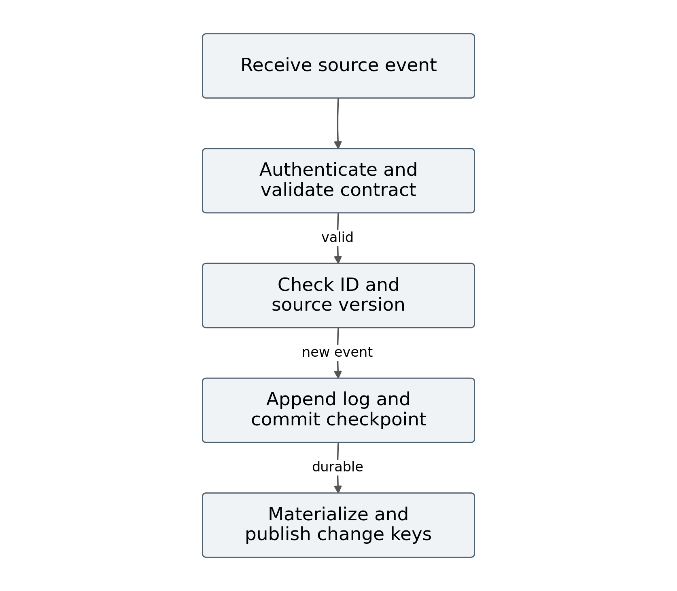
Figure 15 Source ingestion flow
The order of durability and checkpointing matters. If the source checkpoint advances before the event is durable, a crash can permanently skip the event. If the event is appended before the checkpoint advances, a retry may duplicate it; stable event identity and idempotent processing must handle that case. The chosen contract should prefer recoverable duplication over untraceable loss.
Validation failures go to an inspectable rejection record with enough provenance to diagnose the issue, subject to access policy. They should not be silently converted into valid zero values. A source schema change can pause affected metrics while other sources continue.
The in memory LatestState reference demonstrates monotonic replacement for a key, but it is not a durable ingestion function. A production version needs persistent deduplication or source checkpoint semantics, delete handling, schema migration, and crash recovery. This distinction should be retained when discussing implementation evidence in the completed thesis.

3.1.8 Materialization and dirty set functions
Materialization processes accepted changes against versioned metric definitions. For a simple additive aggregate, it can maintain a keyed contribution for each source record and update the aggregate by removing the previous contribution and adding the new one. Keeping the previous contribution is necessary for corrections and deletions. In Equation 31, S is the aggregate and k is an individual record contribution.
$S_{next} = S_{current} − k_{old} + k_{new}$ (31)
For a ratio, the service maintains numerator and denominator state and derives the result after both inputs are aligned to the defined checkpoint or period. It does not increment a percentage as if the percentage were additive. Quality and completeness propagate according to the metric contract.
The processing function returns changed metric keys. BindingIndex.affected unions the consumer identifiers for those keys. The resulting dirty set prevents a component with several changed inputs from being scheduled several times in the same batch. The browser or gateway can then produce one consistent output version for that component.
const changedMetricKeys = ['production.good', 'production.plan'];
const dirtyComponentIds = index.affected(changedMetricKeys);
for (const id of dirtyComponentIds) {
// Full service would derive a versioned component payload here.
// The reference core implements selection, not this service layer.
}
Large transformations should not block the event loop for an unbounded period. The processing layer can use bounded batches, worker tasks, or separate services while preserving checkpoints. Its actual time, memory, and error behavior must be measured with representative data rather than inferred from the existence of asynchronous syntax.

3.1.9 Viewer update flow and logical browsing structure
The browser first loads a published manifest and a snapshot with a checkpoint. It opens an authorized stream after that checkpoint, validates revision and version compatibility, applies accepted values, marks dependent components dirty, and renders them in a controlled batch. Its current interaction state remains separate from incoming source state.
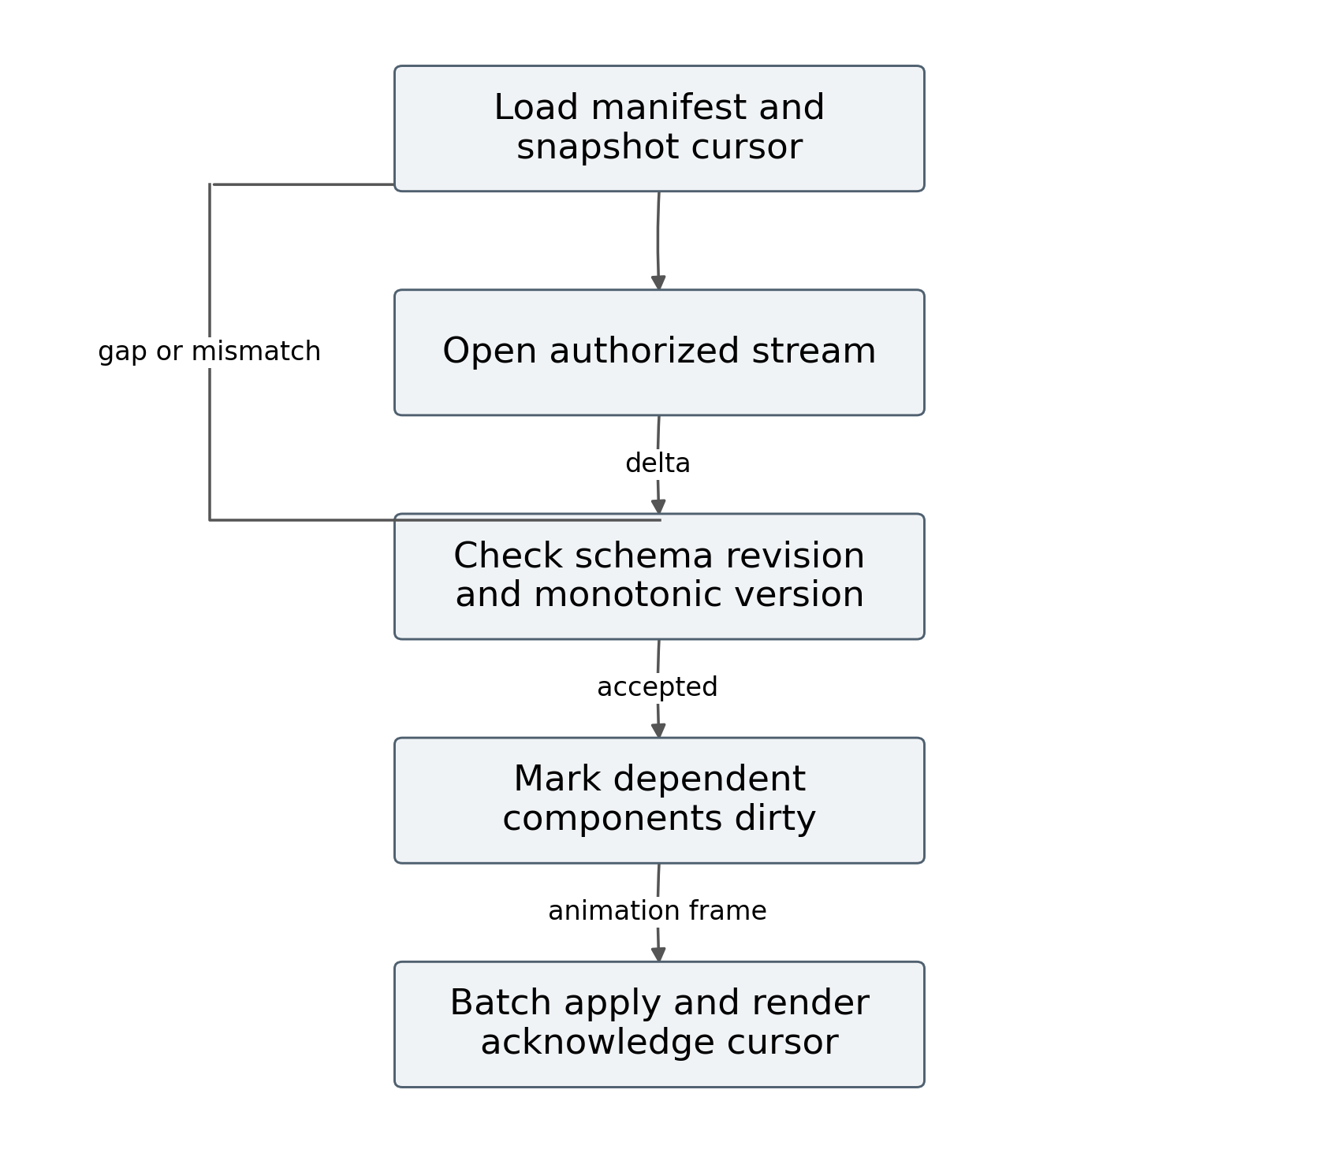
Figure 16 Browser update flow
The viewer applies monotonic versions per scoped key and checks the manifest revision associated with the payload. A payload for an incompatible revision must not be applied to a different layout merely because some component identifiers happen to match. The browser can request a new manifest and snapshot when a publication changes its contract.
Rendering is scheduled so that several accepted updates can share one browser frame when appropriate. A hidden tab may defer visual work while preserving a bounded latest state, but it must recover correctly when visible. Time series and event list components require history semantics beyond a latest value map.
The page’s browsing structure connects filters, entity selection, chart details, media inspection, and quality explanations. Updating a metric should preserve the user’s selected entity and reading position unless the component explicitly requires another behavior. The actual browser tests must measure whether this preservation works under source changes, publication, and reconnection.

3.1.10 Stream output and backpressure in Node.js
A Node.js streaming response must respect backpressure. Writing indefinitely to a slow connection can grow memory even when each message is small. When the write operation reports that the buffer is full, the sender should wait for the corresponding drain condition or apply a bounded queue policy. A disconnected response must release its subscription and pending resources.
The proposed gateway can coalesce pending latest state values by key, preserving only the newest version for that display contract. It cannot use the same policy for an event history component that promises every event. When a bounded queue is exhausted, the gateway should send a recovery instruction or close the stream with a documented reason, allowing a fresh snapshot on reconnect.
// Illustrative service pseudocode, not an implemented gateway.
async function sendFrame(response, frame, waitForDrain) {
if (response.destroyed) return false;
if (!response.write(frame)) await waitForDrain(response);
return !response.destroyed;
}
The real waitForDrain operation must also handle close, error, cancellation, and a maximum wait. The snippet identifies a contract rather than providing a complete reliable server. Subscription authorization must remain valid throughout the connection, and renewed or revoked access must alter delivery accordingly.
Heartbeat messages can detect idle connection failures but do not establish that source information is current. Metrics should report source and processing age separately. The synthetic experiment models a fixed network delay and excludes connection buffers, backpressure, heartbeats, and concurrent viewers. A deployed test is required to evaluate these effects.

3.1.11 Publication function and revision integrity
Publication validates the complete authored revision, compiles an immutable manifest, commits the manifest and pointer under optimistic revision checking, and notifies viewers that a new revision is available. Viewers then load the compatible manifest and state rather than applying layout changes as unversioned side effects.
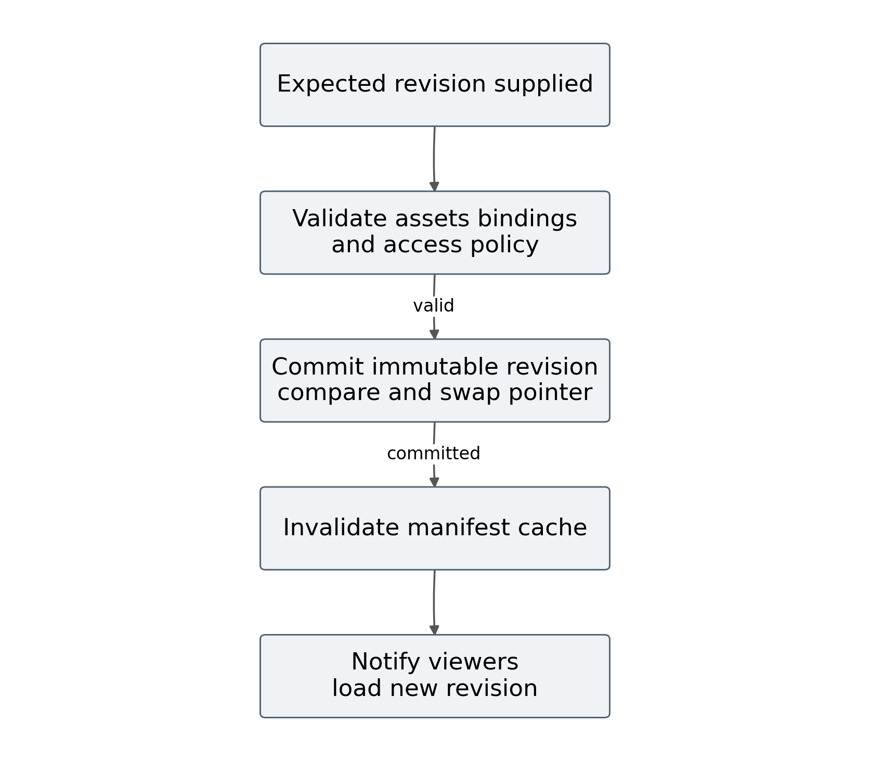
Figure 17 Publication flow
The validation function checks component schemas, metric and asset references, layout rules, transformation dependencies, accessibility metadata, and registry compatibility. The publication operation supplies an expected draft revision. If another edit has occurred, the service returns a conflict instead of publishing a mixture of versions.
A manifest hash supports reproducibility and cache identity. It does not prove that the underlying data are correct, but it identifies the exact configuration used in an experiment. Rollback restores an earlier valid manifest pointer and obtains current authorized data under that manifest’s contracts. It does not replay obsolete business state by default.
The proposed editor should show publication success only after the commit is confirmed. A connection failure after commit creates an uncertain client outcome; an idempotent operation identifier can let a retry discover the accepted result. The actual implementation needs tests for that boundary, because a polished publication dialog alone provides no evidence of revision integrity.

3.1.12 Reconnection replay and recovery
A disconnected viewer may miss updates while source processing continues. On reconnect, it presents its last applied cursor. The gateway checks whether retained history and the current manifest permit replay. If replay is available, it sends subsequent changes. If the cursor has expired or the revision is incompatible, it provides a new snapshot checkpoint.
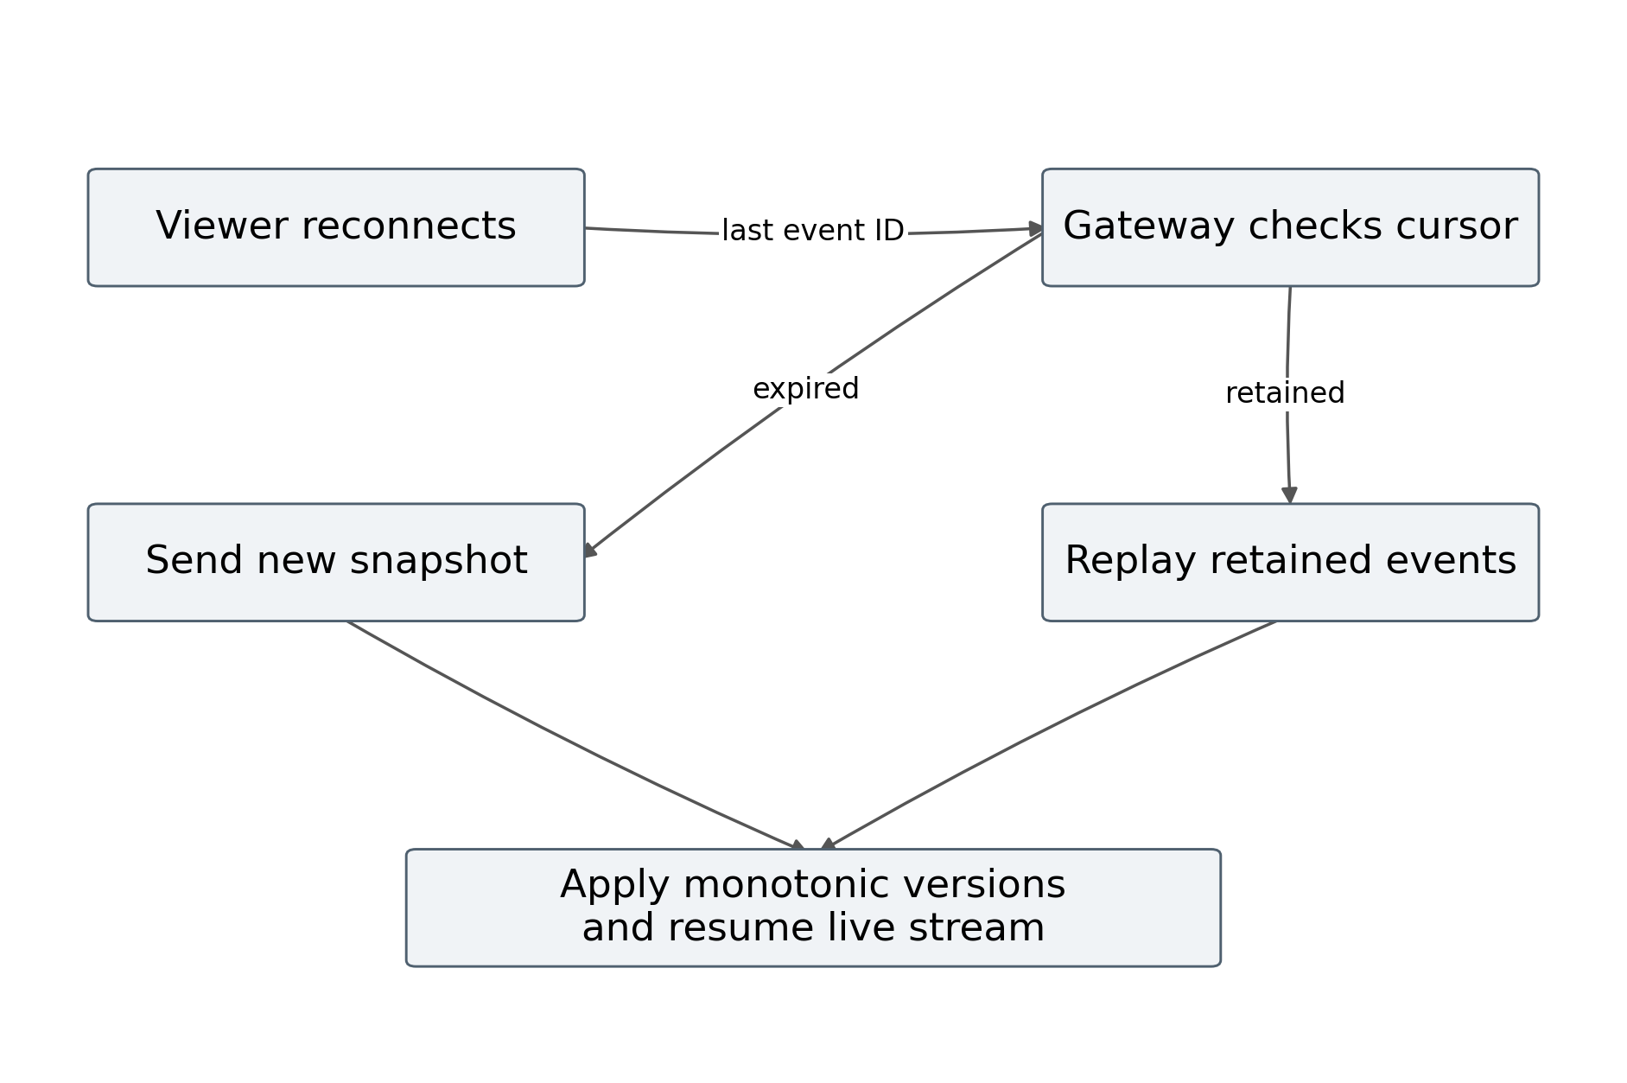
Figure 18 Reconnection and recovery flow
Replay correctness depends on the same ordering and scope rules used during ordinary delivery. Duplicate frames can be accepted safely only when their state application is idempotent or monotonic. A time series component must distinguish a repeated point from a new point, and a delete event must not be lost during resynchronization.
Recovery tests should interrupt a connection before, during, and after a batch. They should expire retained history deliberately, restart a gateway, and change a published manifest while the viewer is offline. The expected final state should be computed independently from the accepted event log and compared with the browser’s state.
The synthetic model consumes all generated events within each trial but does not simulate outages or replay. Its result is therefore not evidence that this recovery design works. The flowchart specifies required behavior for the future deployed implementation and identifies measurable checkpoints and convergence conditions.

3.1.13 Failure states and operational diagnostics
The system should fail visibly and locally where possible. A failed finance adapter need not stop a production chart, but a metric using both sources may become provisional or unavailable. The component policy determines how that state appears without fabricating an ordinary value.
Table 23 Failure handling cases
Failure | Expected response | Measurement
Source unavailable | Keep labelled last valid state or hide under policy | Age and source recovery time
Invalid event | Reject and retain diagnostic provenance | Rejection rate and affected metrics
Duplicate or older event | Do not overwrite accepted newer state | State equality and duplicate counts
Gateway restart | Reconnect replay or resnapshot | Convergence time and gaps
Slow viewer | Bound buffering and recover if required | Queue occupancy and memory
Manifest mismatch | Load compatible revision and snapshot | Revision consistency
Asset unavailable | Show explicit media loading or failure state | Retrieval success and recovery
Access revoked | Stop delivery and clear unauthorized state | Revocation delay and leak test

Diagnostics should connect a visible component to its binding, metric definition, source record, processing checkpoint, and delivered version. A numerical value that cannot be traced through those relationships is difficult to audit. Diagnostic access may itself be restricted, so ordinary viewers can receive a useful explanation without receiving sensitive source details.
The deployment study should verify these cases with controlled fault injection. No fault injection experiment was executed for this draft. The table is an acceptance specification that can guide the author’s tests and prevent the final thesis from treating normal operation as the only relevant evidence.

3.1.14 Verification of the reference implementation
Five automated tests were executed with Node.js 24.19.0. The tests verify that rebinding removes old topic memberships and affected selection deduplicates components; duplicate and older numerical versions do not replace current state; BigInt currency subtraction is exact and zero denominators remain undefined; full dependency coverage removes selective pruning’s component update advantage; and seeded trace generation is deterministic.
All five tests passed. These results are reproducible from core.test.mjs using the Node.js test runner. The test output includes elapsed test execution times, but the thesis does not interpret those times as application performance measurements. They reflect the small test harness and the preparation environment.
The tests address properties that can materially affect correctness. They do not merely check whether a function returns the same constant used in its implementation. Rebinding cleanup exercises a state transition that can otherwise leave obsolete consumers in the index. Out of order rejection exercises an invalid update sequence. Full coverage tests a boundary condition where the predicted optimization ceases to save component work.
Remaining verification includes canonical event validation, deletion and correction semantics, durable checkpoints, snapshot consistency, authorization, browser state preservation, media lifecycle, and crash recovery. The actual editor should add tests for these properties and include implementation identifiers in the thesis.
The logical and physical architecture is now specified sufficiently to define a matched deployment experiment. Section 3.2 presents the executed synthetic evidence and the separate protocol required for comparison with real editing products.

3.1.15 Relational schema for revisions and source mappings
The logical entities in Figure 14 can be implemented through relational tables while keeping event payloads and media objects in their designated stores. The following SQL is a proposed schema fragment. It records immutable revisions and prevents a local source identifier from being mapped ambiguously within one mapping version. Database roles and application authorization remain separate controls.
CREATE TABLE page_revision (
tenant_id text NOT NULL,
page_id text NOT NULL,
revision integer NOT NULL CHECK (revision > 0),
registry_version text NOT NULL,
manifest_hash text NOT NULL,
document_json jsonb NOT NULL,
PRIMARY KEY (tenant_id, page_id, revision)
);
CREATE TABLE source_mapping (
tenant_id text NOT NULL,
mapping_version integer NOT NULL,
source_system text NOT NULL,
local_entity text NOT NULL,
canonical_entity text NOT NULL,
PRIMARY KEY (tenant_id, mapping_version,
source_system, local_entity)
);
The revision key separates two authors' saved states from the currently published pointer. Publishing validates a chosen revision and then advances that pointer in one transaction, conditional on the expected prior publication. A conflicting update is returned to the author for resolution. The document and its compiled manifest must share the recorded revision and registry version; a successful save is not by itself a successful publication.
Mapping versions are retained so that past materializations remain explainable after an entity merger or naming change. Reprocessing a historic event must use the mapping policy chosen for that historic calculation. Applying today's mapping silently can change the meaning of a previously reported indicator.
Additional records are required for bindings, metric definitions, asset metadata, publication pointers, and audit events. Their foreign keys should include tenant identity where appropriate. This fragment illustrates structure and integrity rather than a migration executed against the user's editor. Figure 14 and Tables 21 and 22 define the surrounding services and operations.

3.1.16 Lifecycle of a Node.js viewer stream
A viewer stream should be treated as a resource with a bounded lifetime. Authorization occurs before subscribing, and its result determines the permitted tenant, page revision, and metric scopes. A durable cursor identifies the event position; a metric version identifies state within its scope. These identifiers have different purposes and must not be substituted for one another.
async function viewerStream(req, res, services) {
const scope = await services.authorize(req);
const cursor = services.validateCursor(req);
const stop = new AbortController();
res.on('close', () => stop.abort());
res.writeHead(200, {
'Content-Type': 'text/event-stream',
'Cache-Control': 'no-cache'
});
try {
for await (const event of services.replayAndFollow(
scope, cursor, stop.signal)) {
await services.writeBoundedEvent(
res, event, stop.signal);
}
} finally {
stop.abort();
res.end();
}
}
This code is an interface sketch. The injected functions must enforce authorization, validate replay coverage, encode events, handle cancellation, and bound queued bytes. It is not a deployable server. The write function must await a drain signal when needed and stop on closure; awaiting drain without a closure path can leave a pending operation behind. A bounded queue exceeding its policy should close with a recoverable condition rather than grow indefinitely.
Replay and live subscription require a continuous handover. One design follows the durable log from the checkpoint so that replay and subsequent events use the same ordering mechanism. If separate replay and subscription paths are used, they need a coordinated checkpoint and deduplication to prevent a gap at the boundary.
Heartbeat, idle timeout, reconnect, and permission revocation policies belong to the gateway contract. A published manifest change invalidates incompatible viewer state and triggers a new manifest and snapshot. The physical architecture can place several gateways behind a routing layer because durable state and replay positions belong to shared services rather than one process's memory.

3.2 Comparative evaluation and synthetic evidence

3.2.1 Evidence selection and comparison design
The evaluation uses three evidence layers. The first is a documented functional comparison of selected existing tools. The second is an executed discrete event simulation of four delivery and component update policies. The third is a protocol for testing the author’s actual editor against configured products. Only the first two layers have evidence in this draft, and neither supports a measured product ranking.
The selected page editing comparators are a GrapesJS based application, WordPress Block Editor with required custom integration, and Webflow under a documented configuration. Grafana is included as a contextual dashboard alternative for operational tasks. Each comparator must be configured reasonably for the same task before performance is measured.
The synthetic policies form a two by two comparison: polling or push delivery, combined with full or selective component updating. Polling uses one second intervals; push uses one hundred millisecond batching. This design reveals whether a result comes from shorter delivery opportunities, dependency pruning, or their combination. It also exposes the cost of transmitting full snapshots at a higher frequency.
The strongest current claim concerns the mechanism. At equal delivery policy, selective updates reduce component work when fewer than all components are affected. When delivery frequency differs, that per batch advantage can coexist with higher total work. The simulation explicitly tests both situations.
The product study remains necessary for interface functionality, extension effort, actual browser behavior, and end to end deployment performance. Its protocol is included so that missing evidence is concrete and the final thesis can be completed without changing its research questions after seeing the results.

3.2.2 Indicators and measurement definitions
Indicators should follow the research questions. Functionality measures whether the tool supports required tasks correctly. Performance measures time and resource use under controlled workload. Authoring measures effort, errors, and task completion. Reliability measures state convergence and failure handling. These categories should be reported separately.
Table 24 Comparative evaluation indicators
Indicator | Definition | Evidence route
Functional coverage | Passed required task cases divided by defined cases | Configured acceptance tests
Binding correctness | Correct unit grain period and transform behavior | Contract and data oracle tests
Source to display delay | Display application time minus source event time | Instrumented deployment
State acknowledgement delay | Batch application time minus synthetic event time | Executed simulator
Payload traffic | Transferred payload bytes over a fixed duration | Simulator or network capture
Component work | Component update invocations over a fixed duration | Simulator or browser instrumentation
Intermediate visibility | Distinct latest source states shown divided by events | Simulator or event trace audit
Authoring effort | Time errors and assistance per matched task | Counterbalanced user study
Recovery | Time and state equality after injected failure | Fault injection tests

The simulator’s acknowledgement indicator allows a later same topic state to supersede an intermediate state. It therefore measures when the viewer has incorporated state at least as new as each event, not whether each event’s exact value was visibly displayed. Intermediate visibility is reported separately to make this distinction explicit.
Browser frame rate, memory, server CPU, and commercial editor latency were not measured. They should remain unreported rather than estimated from synthetic update counts.

3.2.3 Functional comparison based on documentation
The matrix records documented capabilities and proposed design commitments. It does not convert unexamined capabilities into failures. A custom integration can change a product’s coverage, so the exact configuration belongs with the eventual acceptance results.
Table 25 Functional evidence matrix
Capability | GrapesJS | WordPress | Webflow | Grafana | Proposed editor
Reusable content or components | Documented | Documented | Documented | Panels documented | Specified
Structured dynamic data | Data API documented | Bindings documented | CMS documented | Queries documented | Specified
Custom operational metrics | Integration to assess | Integration to assess | Integration to assess | Query model documented | Specified
Mixed document and photo page | Configuration to assess | Content blocks documented | CMS content documented | Configuration to assess | Specified
Per component freshness policy | Unmeasured | Unmeasured | Unmeasured | Configuration to assess | Specified
Dependency aware live runtime | Integration to assess | Integration to assess | Integration to assess | Runtime to assess | Reference index tested
Actual benchmark result | Not measured | Not measured | Not measured | Not measured | Actual editor not measured

The observations are grounded in references [9–18]. A documented data binding feature does not establish an end to end source event pipeline. Likewise, an unmeasured freshness policy does not establish that the product lacks it. The proposed editor’s specified features cannot be counted as passed acceptance cases until a complete implementation is tested.
The matrix identifies experiment work rather than declaring a winner. It also helps ensure that the baseline is given a reasonable opportunity to meet the required task through supported extension mechanisms.

3.2.4 Synthetic experiment setup
The simulator generates exponentially distributed interarrival times and uniformly selected topics using a deterministic linear congruential generator. Each rate uses seeds 1 through 30, and all four policies receive the same trace for a given seed. The trial lasts sixty seconds. The initial snapshot is excluded to focus on continuing updates.
Table 26 Synthetic experiment parameters
Parameter | Value
Source event rates | 1 10 and 100 events per second
Trials | 30 seeds per rate and policy
Components and topics | 120 components and 24 topics
Dependencies per component | 2 topics in the main experiment
Polling and push batching | 1000 milliseconds and 100 milliseconds
Network assumptions | 40 milliseconds plus bytes divided by 10 MiB per second
Component application cost | 0.04 milliseconds per updated component
Payload assumptions | 1024 bytes per snapshot component 256 per delta component 128 header bytes
Sensitivity widths | 1 2 6 12 and 24 topics per component
Excluded effects | Source delay server CPU network contention outages media initial load

The parameters are illustrative design assumptions, not measurements from a deployed editor. The simulated viewer serializes component application, but the model does not simulate a contended network queue. Consequently, high traffic does not automatically create congestion delay in these results.
The script was executed with Node.js 24.19.0. It writes 360 primary trial rows, 300 dependency sensitivity rows, summary statistics, and paired differences. Exact outputs are included in the research companion.

3.2.5 Synthetic outcomes across event rates
The table reports means across thirty seeds. Traffic is payload MiB per sixty second trial. Work is the number of component update invocations. Delay is mean state acknowledgement time in milliseconds. Visibility is the fraction of source events retained as the latest topic state at a delivery opportunity.
Table 27 Synthetic mean outcomes
Rate | Policy | MiB | Updates | Mean ms | Visibility
1 | Poll full | 7.039 | 7,200 | 548.7 | 98.4%
1 | Poll selective | 7.039 | 597 | 544.7 | 98.4%
1 | Push full | 6.910 | 7,068 | 105.4 | 99.8%
1 | Push selective | 0.158 | 616 | 89.5 | 99.8%
10 | Poll full | 7.039 | 7,200 | 557.2 | 82.1%
10 | Poll selective | 7.039 | 4,093 | 555.3 | 82.1%
10 | Push full | 44.323 | 45,340 | 106.4 | 97.9%
10 | Push selective | 1.449 | 5,744 | 91.1 | 97.9%
100 | Poll full | 7.039 | 7,200 | 556.9 | 23.6%
100 | Poll selective | 7.039 | 7,198 | 556.9 | 23.6%
100 | Push full | 70.386 | 72,000 | 106.5 | 81.7%
100 | Push selective | 10.006 | 40,685 | 94.6 | 81.7%

At one event per second, selective push traffic is about 0.158 MiB, compared with 7.039 MiB for full polling. At ten events per second, it is about 1.449 MiB with lower acknowledgement delay. At one hundred events per second, it rises to about 10.006 MiB and about 40 685 component updates, exceeding full polling on both indicators.
The high rate result is a deliberate counterexample to universal efficiency claims. The push policy has more delivery opportunities and preserves more intermediate state. The comparison therefore includes a freshness and visibility difference, not merely a different implementation cost for identical displayed history.
Full push performs particularly poorly on traffic because it sends complete snapshots at each nonempty short batch. Selective polling reduces component work but still transfers a full snapshot in the model. The factorial comparison shows why transport frequency, payload representation, and dependency pruning should be assessed separately.

3.2.6 Payload traffic comparison
Payload traffic depends on both message frequency and encoding. The synthetic full policies send 120 component payloads of 1024 bytes plus a fixed header. Selective polling still downloads that snapshot before local dependency checks. Selective push sends affected component payloads of 256 bytes plus the header. These encoding assumptions are part of the mechanism comparison.
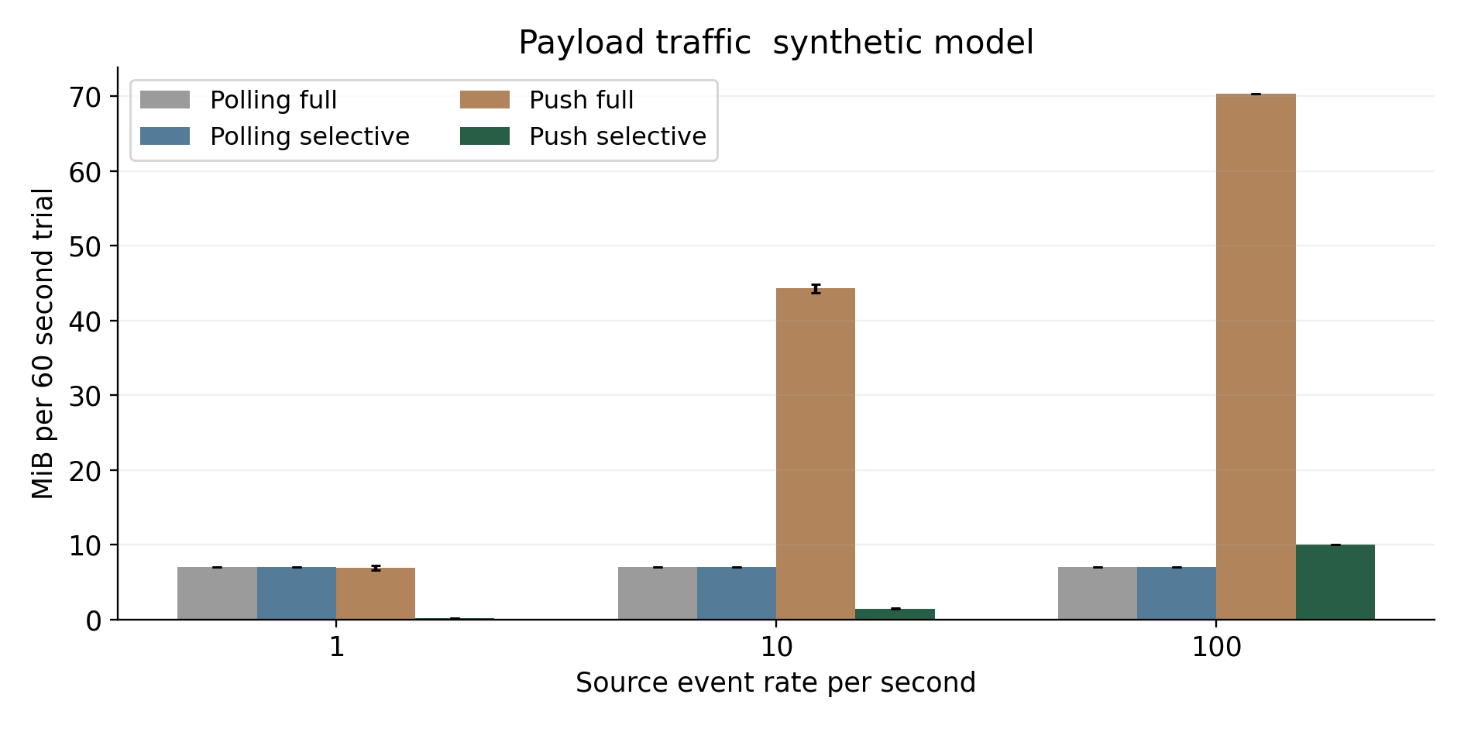
Figure 19 Synthetic payload comparison
Error bars show a t based interval for the mean across thirty seeded trials, conditional on the simulator’s assumptions. They do not express uncertainty about real networks or editor implementations. Polling full and polling selective overlap because they transfer the same snapshots in this model.
At moderate load, delta traffic is much lower because only a small part of the component set changes in each short batch. At high load, many batches contain changes and the affected set grows. Selective push then transmits more total bytes than one second polling while preserving fresher state.
Some bandwidth benefit also comes from the assumed smaller delta representation. It cannot all be credited to dependency pruning. A deployed comparison should measure compressed wire bytes and use equivalent shared value encoding where possible. It should include headers, initial load, reconnect snapshots, and media separately.

3.2.7 Component update work comparison
Component work counts update invocations in the synthetic viewer. It is useful for isolating the scheduling mechanism, but it is not a CPU or frame rate measurement. Different real components may have very different costs, while the simulator assigns the same application cost to every component.
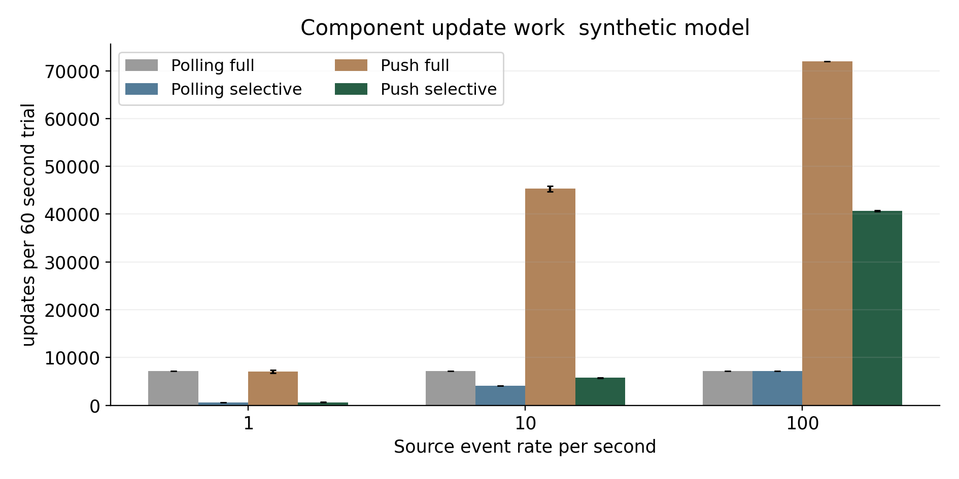
Figure 20 Synthetic component update comparison
At a given push delivery schedule, selective updating invokes fewer components than full updating. At full dependency coverage, that pruning advantage disappears. The main experiment uses two dependencies per component, which produces sparse affected sets at low load and denser sets as more topics change in a batch.
Comparing selective push with one second full polling reveals a different result. At ten events per second, selective push uses about 5744 component updates rather than 7200. At one hundred events per second, it uses about 40 685 rather than 7200. Faster delivery can increase total work even when every batch is selective.
A real browser study should instrument actual component calls, style and layout work, chart rendering, and interaction latency. It should include cheap text components and expensive charts rather than assuming equal costs. The synthetic count establishes a scheduling relationship under fixed assumptions, not a measured resource saving for the author’s editor.

3.2.8 Acknowledgement latency and percentile interpretation
Acknowledgement latency is the simulated time at which the delivered state has incorporated each event or a newer same topic event. It includes waiting until a delivery opportunity, the assumed network term, and serialized component application. It excludes source extraction, server processing, network contention, and actual browser scheduling.
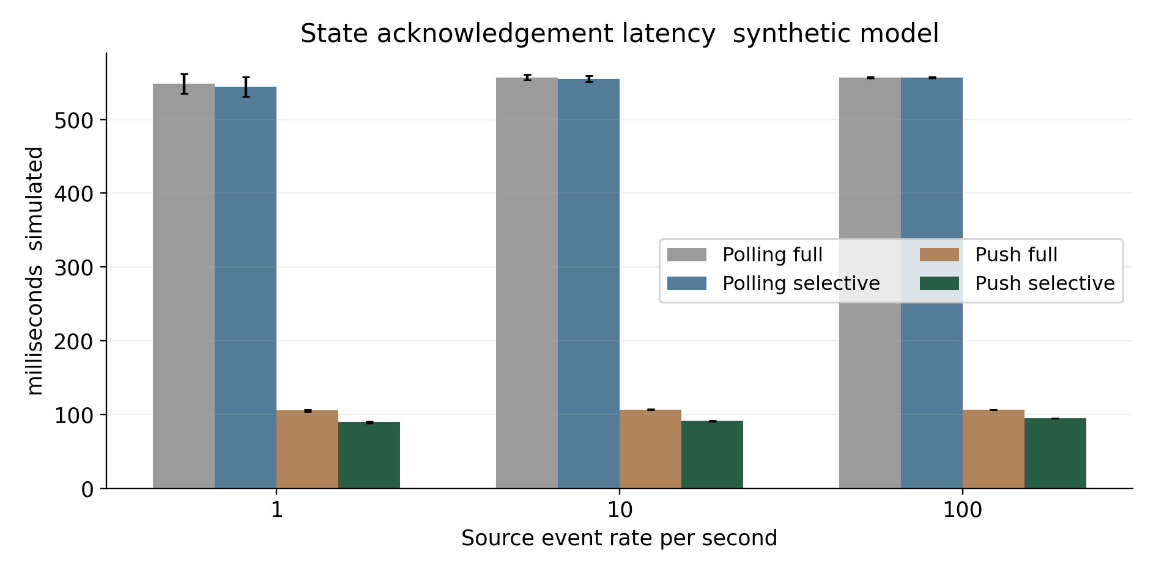
Figure 21 Synthetic acknowledgement latency comparison
Mean full polling delay is approximately 549 to 557 milliseconds across the three rates. Selective push means are approximately 90 to 95 milliseconds. The corresponding mean of trial 95th percentiles is approximately 133, 136, and 140 milliseconds for selective push, compared with approximately 995, 1006, and 1007 milliseconds for full polling.
The percentile summary is the mean of each trial’s empirical percentile, not a percentile computed from one pooled sample. These quantities answer different questions. The raw trial data allow either analysis, but the manuscript uses the former consistently.
The major delay difference follows from the shorter batching interval. Selective component updating contributes a smaller application term. A fair product experiment should also compare policies at an equal freshness target so that lower resource use from deliberately slower updates is not mistaken for a superior implementation.
These numerical delays are model outputs. They must not be quoted as the actual editor’s response time.

3.2.9 Intermediate state visibility and completeness
Latest state displays can coalesce several changes to one topic within a delivery interval. The simulation counts the last event per topic per interval as directly retained state. Earlier events in that interval are superseded. Their acknowledgement latency is still computed, but their exact intermediate value is not counted as visible.
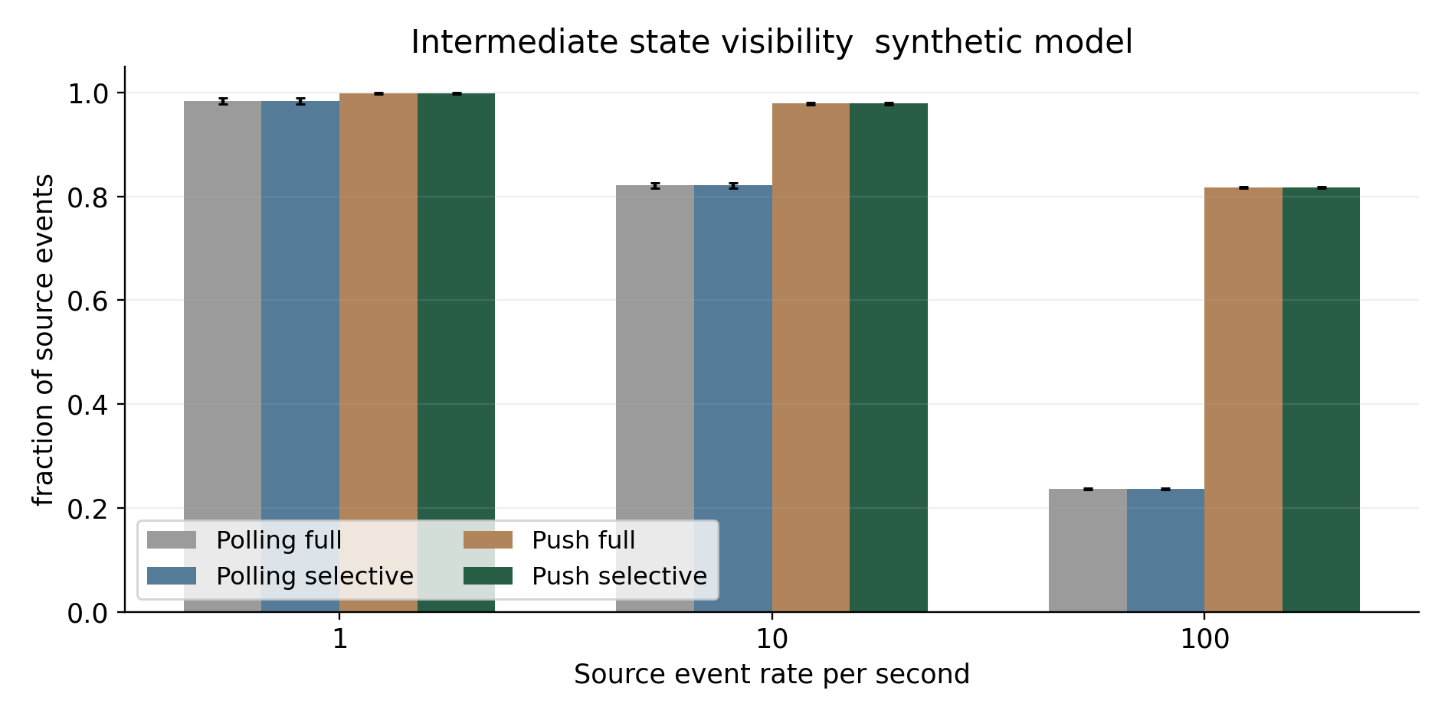
Figure 22 Synthetic intermediate state visibility comparison
At one hundred events per second, full polling retains about 23.6 percent of intermediate states, while short batched push retains about 81.7 percent. At low load, both retain nearly all states. The visibility difference helps explain why high rate push uses more traffic and component work: it delivers a richer temporal view.
This indicator is not a requirement for every component. A current balance or production total may legitimately show only the latest state, while a fault history or audit list may require every event. The durable event log and the displayed latest state therefore have distinct completeness contracts.
The word visible in the simulator means retained for application at the batch boundary. It does not establish that a human perceived each state on a real screen. Actual perceptual visibility depends on frame scheduling, animation, dwell time, and attention. A browser or user study is required for that stronger interpretation.
The editor should expose the selected temporal contract so authors can choose a suitable component and policy rather than assume all live displays preserve history.

3.2.10 Dependency density sensitivity
The sensitivity experiment keeps the event rate at ten events per second and varies the number of topics declared by each component. It compares full and selective push using the same traces and delivery intervals. Dependency widths of 1, 2, 6, 12, and 24 cover sparse through complete topic coverage.
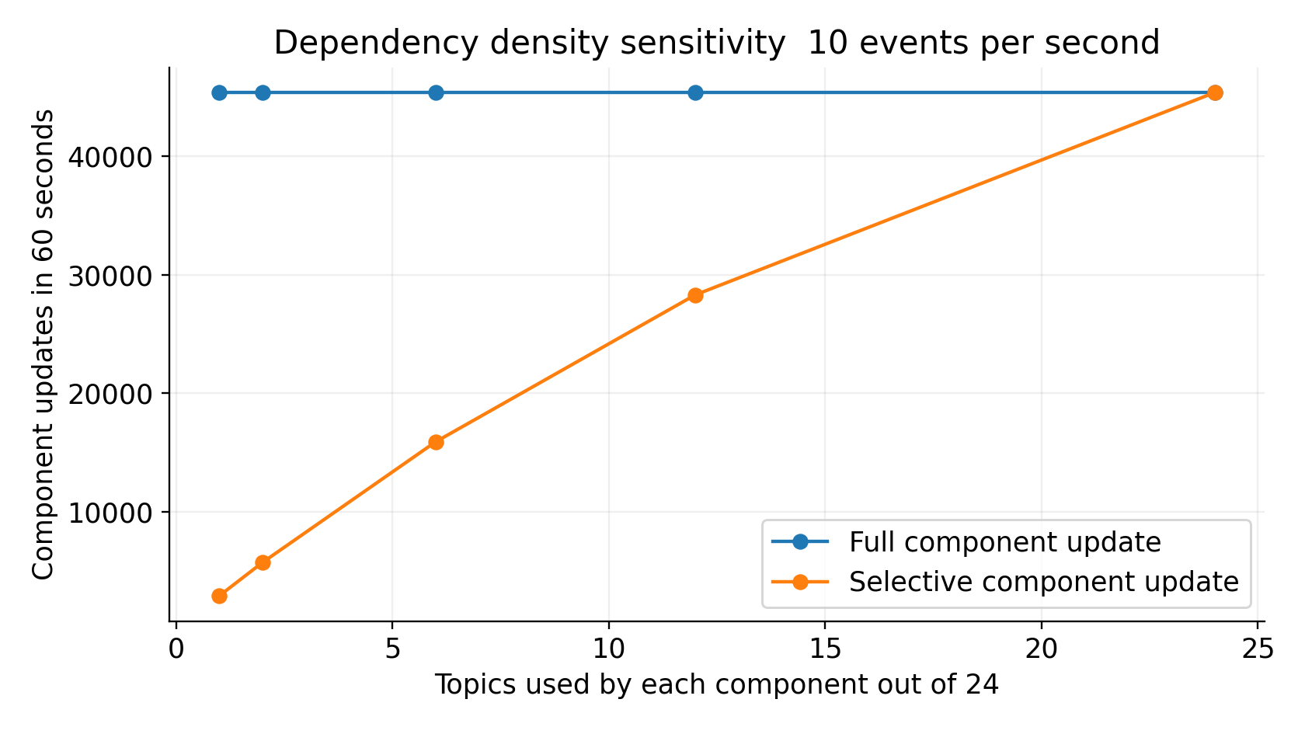
Figure 23 Dependency density sensitivity
Selective work rises as components depend on more topics. At complete coverage, every nonempty batch affects every component and the component counts equal full push. The automated boundary test confirms this behavior. This result supports the dependency model’s conditional prediction and identifies a limitation of the optimization.
The bandwidth difference does not disappear entirely at complete coverage because the model gives delta component payloads a smaller encoding than snapshots. That residual difference belongs to representation size, not dependency pruning. Reporting it explicitly prevents the figure from being interpreted as proof that the index helps when all components are affected.
Real pages can have uneven dependencies and uneven component costs. A small number of heavily shared inputs may dominate updates, while many rarely changing inputs contribute little. Future sensitivity tests should vary popularity skew, correlated changes, bursts, expensive components, and the number of concurrent viewers.
The current experiment demonstrates one mechanism under a reproducible synthetic family of workloads. It does not establish the distribution of dependencies in the author’s existing editor.

3.2.11 Paired differences and statistical limits
For each seed, the study compares selective push with full polling using a proportional reduction. Positive values indicate less traffic, work, or delay. Negative values indicate an increase. Means and t based 95 percent half widths are computed over thirty paired seed differences.
${Reduction}_{i} = 1 − \frac{{Metric}_{pushSelective},i}{{Metric}_{pollFull},i}$ (32)
Table 28 Paired synthetic policy differences
Rate | Indicator | Reduction percent | 95 percent half width
1 | Payload traffic | 97.76 | ± 0.09
1 | Component updates | 91.44 | ± 0.35
1 | Mean acknowledgement | 83.61 | ± 0.50
10 | Payload traffic | 79.42 | ± 0.28
10 | Component updates | 20.22 | ± 1.11
10 | Mean acknowledgement | 83.64 | ± 0.14
100 | Payload traffic | -42.16 | ± 0.47
100 | Component updates | -465.07 | ± 1.88
100 | Mean acknowledgement | 83.01 | ± 0.05

The intervals describe variation across the seeded synthetic traces under fixed parameters. They do not quantify uncertainty about network delay, renderer cost, source behavior, or commercial products. The t approximation is used as a descriptive summary; it should not be interpreted as proof that the PRNG traces are representative of an industrial workload.
The largest practical finding is the direction change at high load. Traffic increases by about 42.2 percent and component work by about 465.1 percent, while mean acknowledgement delay remains much lower. This is a cost and freshness trade off, not a statistical anomaly to remove.
The thirty trials are workload replications, not thirty human participants or thirty deployed machines. The experiment’s effective scope is the supplied simulator. A product comparison should use paired workload replays, multiple runs, effect sizes, confidence intervals, and prespecified stopping rules while keeping configuration and measurement methods constant.

3.2.12 Protocol for comparing actual editors
The actual comparison should build the same mixed content page in the proposed editor and each selected baseline. It should use identical source fixtures, metric definitions, chart libraries where feasible, layout, viewport, access scope, and freshness target. Extensions and implementation effort must be documented rather than hidden.
Table 29 Evidence required for product comparison
Evidence item | Required record
Implementation identity | Source commit build hash package versions and plugins
Page configuration | Manifest component count bindings and metric definitions
Workload | Anonymized traces or generated fixtures with seeds
Environment | Server resources browser device network and storage settings
Functional tests | Expected outputs and recorded pass fail evidence
Performance | Source to display percentiles wire bytes CPU memory and interaction delay
Recovery | Fault schedule final state equality and convergence time
Authoring study | Tasks participant expertise counterbalancing time and errors
Analysis | Paired effects uncertainty exclusions and raw observations

Authoring tasks should include creating a production chart, rebinding a field, detecting a unit mismatch, adding a document and photo, setting a stale policy, publishing, and repairing an invalid configuration. Task order should be counterbalanced to reduce learning effects. Sample size should follow the expected effect and available participants; no completed participant count is invented here.
Performance runs should include low load, moderate load, bursts, dense dependencies, large media, slow viewers, and reconnection. Both equal frequency and equal freshness comparisons are useful. Results should identify which configuration achieves the required behavior at acceptable total cost.

3.2.13 Hypothesis assessment and validity
The evidence supports bounded conclusions. The reference tests establish several algorithmic properties. The synthetic study establishes policy relationships under its assumptions. The documentation establishes selected capabilities of existing tools. It does not establish actual product superiority or improved user performance.
Table 30 Hypothesis assessment and limitations
Hypothesis or claim | Current assessment | Remaining evidence
H1 Selective updates reduce work at equal schedule | Supported by synthetic mechanism and boundary test | Real component cost and index overhead
H2 Shorter batches improve freshness at added possible cost | Supported conditionally by synthetic results | Deployed source network and browser measurements
H3 Typed controls reduce authoring errors | Untested design hypothesis | Representative authoring study
Actual editor outperforms existing tools | Not established | Matched configured product benchmarks
Proposed recovery and authorization are correct | Specified but untested | Integration and fault injection evidence

Internal validity is limited by the simulator’s simplified cost functions and fixed payload encoding. Construct validity is limited because component counts and acknowledgement delay do not directly measure CPU, human comprehension, or every visible event. External validity is limited by the lack of real traces, media behavior, source delays, and concurrent viewers.
Reproducibility is strengthened by the complete script, seeded inputs, raw outputs, and recorded runtime. Narrow confidence intervals do not remove the model’s structural limitations. The final thesis should preserve these limits, replace assumptions where measurements are available, and avoid changing its success criteria after observing unfavorable results.
The strongest present contribution is an inspectable system composition and a reproducible demonstration of its conditional trade offs.

3.2.14 Acceptance criteria for functional comparison
Functional comparison becomes reproducible when each capability is attached to an observable acceptance task. Table 31 defines proposed tasks for the matched product study. The same data fixture, page content, permissions, and expected values should be used in every configured editor. A plug-in or custom extension is permitted if its development effort, version, and maintenance burden are recorded.
Table 31 Proposed functional acceptance tasks
Capability | Task and observable outcome | Evidence to retain
Mixed content | Publish text photo document chart and table on one page | Manifest and capture
Correct binding | Bind a component to a scoped metric with its unit and period | Configuration and values
Selective change | Change one metric and identify every affected component | Dependency and update trace
Correction handling | Replay duplicate older and corrected events | Accepted state log
Recovery | Disconnect then reconnect after retained and expired cursors | Convergence trace
Publication | Publish conflicting author revisions without partial state | Transaction and revision log
Access control | Attempt a binding and stream outside the viewer scope | Denied operation record

Each outcome is recorded as pass, fail, or untested. A capability observed only in documentation is marked documented until the task is run. A proposed feature is marked proposed. These evidence states prevent an unknown result from being scored as failure and prevent a design promise from being scored as a successful implementation.
The test should also record assistance and manual intervention. An editor that reaches the required page through custom code may satisfy the functional task while requiring more effort than a configured component library. This distinction can explain authoring cost without making an unsupported claim about the product's intrinsic limits.
No pass or fail values are assigned here to the actual editor or alternative products. The executed reference tests support only the small algorithms identified in Section 3.1.14. The acceptance matrix defines the evidence needed to extend those results to the complete editing and viewing system.

3.2.15 Decision rule for evidence and comparative conclusions
A comparison should first apply correctness and access requirements as gates. A product that displays incorrect units or unauthorized data cannot compensate through lower latency. Among configurations that pass the required gates, authoring effort, traffic, responsiveness, recovery, and maintenance can be compared as separate outcomes. Reporting their distribution is more informative than hiding the trade offs behind one total.
${Score}_{p} = \frac{Σ_{k∈K} w_{k} s_{pk}}{Σ_{k∈K} w_{k}}$ (33)
Equation 33 defines an optional score for product configuration p over a common tested set K. Weights are nonnegative, have a positive total, and are agreed before measuring, and each normalized score must use a stated direction and scale. Untested indicators cannot receive a zero. If configurations do not share an adequate tested set, the total is withheld and the missing evidence is reported. Any sensitivity analysis of weights must retain the correctness gates.
Table 32 Evidence required by comparative claim
Claim | Required observation | Current conclusion
Less authoring effort | Matched tasks with time errors and assistance | Not established
Lower resource demand | Measured wire bytes CPU and memory at matched freshness | Not established
Fresher display | Measured source to visible state latency | Synthetic mechanism supported
Correct selective propagation | Complete dependency and recovery acceptance tests | Reference core partly verified
Better overall editor | Required gates plus representative comparative study | Not established

The synthetic policy study supports a narrower mechanism claim. With the recorded assumptions, selective push substantially reduces acknowledgement delay and reduces traffic at lower event rates. At the highest tested rate, its traffic and update count exceed one second full polling. A defensible conclusion therefore relates the mechanism to dependency density, event rate, batch duration, and freshness demand.
The complete thesis contribution is the formal composition, component contracts, implementation structures, and reproducible synthetic evidence. Replacing the remaining product evidence with real measurements may confirm, limit, or reject the proposed advantage. That outcome should determine the final comparative conclusion rather than a predetermined requirement that the improved editor must win every indicator.

Conclusions
This study develops a three chapter account of comprehensive displays created through an improved web page editing architecture. The literature analysis connects visualization tasks, data meaning, authoring models, and existing dynamic editor capabilities. The mathematical design represents pages as versioned specifications and models how typed source changes propagate through materialization, dependencies, delivery, and rendering.
The proposed editor combines reusable documents, photographs, charts, tables, KPIs, and diagrams with explicit unit, grain, period, quality, and freshness contracts. Its logical and physical architecture separates authored revisions from live state and specifies snapshot, replay, publication, and failure behavior. The JavaScript reference core demonstrates dependency registration, monotonic numerical state, exact currency subtraction, and production ratio validation.
The executed synthetic study shows that selective updates can avoid unnecessary component work, and short batching can substantially reduce acknowledgement delay. It also shows that frequent delivery at high change rates can increase total traffic and work compared with slower polling. The improvement is therefore workload and objective dependent. A future adaptive policy should balance freshness and resource use while preserving the component’s temporal semantics.
The study does not establish that the author’s existing editor is superior to GrapesJS, WordPress, Webflow, or dashboard tools. That conclusion requires actual implementations, matched workloads, browser and server measurements, recovery tests, and an authoring study. The present manuscript supplies the models, protocol, reference algorithms, and reproducible synthetic evidence needed to carry out that work.
The practical research direction is to make operational meaning and update behavior explicit in the editing model, then verify whether this composition improves the intended tasks in the author’s implementation.

Completion requirements for an implementation specific thesis
Before submission, the author should map every proposed module to the existing editor and identify which features are implemented, partially implemented, or planned. The thesis should describe the actual programming languages, package versions, storage products, chart renderers, deployment configuration, and source integration methods from project evidence rather than from this reference proposal.
Actual screenshots should replace the interface mockup where appropriate, with confidential information removed and the capture date recorded. Operational metric definitions should be confirmed by the relevant domain owners. The intended meaning of floating capital should be resolved, and financial formulas should use compatible accounts, periods, currency policies, and entity scope.
The product evaluation should follow Section 3.2’s protocol. It should include raw observations, expected output checks, matched baseline configurations, failure tests, and uncertainty estimates. If a baseline lacks a required feature in its core, the author should assess a reasonable supported extension and disclose its implementation effort. Untested capability should remain untested rather than being scored as failure.
The university’s required formatting, citation style, declaration, ethics requirements, and authorship policies should be applied. This draft has no fabricated supervisor, institution, participant, deployment, or benchmark evidence. Its title follows the requested wording, and its approximate hundred page layout can be adapted to institutional requirements.
The final abstract and conclusion should then be rewritten around the evidence actually obtained. If the real experiment finds higher cost for fresher state, that trade off remains a valid result. A credible master’s thesis explains the conditions and limitations of improvement instead of requiring every indicator to favor the proposed system.

References 1 to 8
[1] B. Shneiderman. The Eyes Have It A Task by Data Type Taxonomy for Information Visualizations. Proceedings of the IEEE Symposium on Visual Languages, pp. 336–343, 1996. doi 10.1109/VL.1996.545307.
Source www.cs.umd.edu
[2] T. Munzner. A Nested Model for Visualization Design and Validation. IEEE Transactions on Visualization and Computer Graphics, 15(6), pp. 921–928, 2009. doi 10.1109/TVCG.2009.111.
Source www.cs.ubc.ca
[3] M. Brehmer and T. Munzner. A Multi Level Typology of Abstract Visualization Tasks. IEEE Transactions on Visualization and Computer Graphics, 19(12), pp. 2376–2385, 2013.
Source www.cs.ubc.ca
[4] J. Heer and M. Bostock. Crowdsourcing Graphical Perception Using Mechanical Turk to Assess Visualization Design. Proceedings of CHI, pp. 203–212, 2010. doi 10.1145/1753326.1753357.
Source hci.stanford.edu
[5] M. Bostock, V. Ogievetsky, and J. Heer. D3 Data Driven Documents. IEEE Transactions on Visualization and Computer Graphics, 2011. doi 10.1109/TVCG.2011.185.
Source idl.uw.edu
[6] A. Satyanarayan, D. Moritz, K. Wongsuphasawat, and J. Heer. Vega Lite A Grammar of Interactive Graphics. IEEE Transactions on Visualization and Computer Graphics, 2017. doi 10.1109/TVCG.2016.2599030.
Source vis.csail.mit.edu
[7] T. Akidau and colleagues. The Dataflow Model A Practical Approach to Balancing Correctness Latency and Cost in Massive Scale Unbounded Out of Order Data Processing. Proceedings of the VLDB Endowment, 8, pp. 1792–1803, 2015.
Source research.google
[8] F. McSherry, D. G. Murray, R. Isaacs, and M. Isard. Differential Dataflow. Proceedings of CIDR, 2013.
Source www.microsoft.com
The primary research sources above establish conceptual and computational foundations. Their inclusion does not attribute the proposed application specific formulas or system composition to those authors. The numbered citations in the text identify the particular source used for an established concept.

References 9 to 18
[9] GrapesJS. Component Manager. Official framework documentation. Accessed 2 October 2026.
Source grapesjs.com
[10] GrapesJS. Data Sources API. Official framework documentation. Accessed 2 October 2026.
Source grapesjs.com
[11] GrapesJS. Data Sources Overview. Studio SDK documentation. Accessed 2 October 2026.
Source app.grapesjs.com
[12] WordPress. Block Editor Handbook. Official developer documentation. Accessed 2 October 2026.
Source developer.wordpress.org
[13] WordPress. Bindings. Block Editor Handbook, Block API reference. Accessed 2 October 2026.
Source developer.wordpress.org
[14] WordPress. Creating Dynamic Blocks. Block Editor Handbook. Accessed 2 October 2026.
Source developer.wordpress.org
[15] Webflow. Intro to the Webflow CMS. Official Help Center. Accessed 2 October 2026.
Source help.webflow.com
[16] Webflow. How Do I Export My Webflow Site Code. Official Help Center. Accessed 2 October 2026.
Source help.webflow.com
[17] Grafana Labs. Grafana Dashboards Overview. Official documentation. Accessed 2 October 2026.
Source grafana.com
[18] Grafana Labs. Transform Data. Official documentation. Accessed 2 October 2026.
Source grafana.com
Documentation changes over time. A completed implementation study should archive relevant documentation and record the exact product versions, editions, plugins, and hosting configurations used. Access dates alone do not pin software behavior.

References 19 to 26
[19] Node.js. The Node.js Event Loop. Official learning documentation. Accessed 2 October 2026.
Source nodejs.org
[20] Node.js. Do Not Block the Event Loop or the Worker Pool. Official learning documentation. Accessed 2 October 2026.
Source nodejs.org
[21] Node.js. Worker Threads. Official API documentation. Accessed 2 October 2026. The supplied experiment used runtime version 24.19.0.
Source nodejs.org
[22] WHATWG. HTML Living Standard Server Sent Events. Standard specification. Accessed 2 October 2026.
Source html.spec.whatwg.org
[23] I. Fette and A. Melnikov. The WebSocket Protocol. RFC 6455, December 2011. doi 10.17487/RFC6455.
Source www.rfc-editor.org
[24] P. Bryan and M. Nottingham. JavaScript Object Notation JSON Patch. RFC 6902, April 2013. doi 10.17487/RFC6902.
Source www.rfc-editor.org
[25] PostgreSQL Global Development Group. Transaction Isolation. Official PostgreSQL documentation. Accessed 2 October 2026.
Source www.postgresql.org
[26] World Wide Web Consortium. Web Content Accessibility Guidelines WCAG 2.2. W3C Recommendation. Accessed 2 October 2026.
Source www.w3.org
The proposed accessibility design follows the need for alternatives, keyboard operation, understandable status, and accessible structure described by WCAG 2.2 [26]. Compliance is not established by mentioning the standard; the actual editor and its generated pages require an accessibility evaluation.
Standards references define protocol and accessibility requirements. They do not replace application tests for replay consistency, revocation, content semantics, or browser behavior. The mathematical and architectural models in this manuscript remain proposed designs unless the text explicitly identifies executed reference behavior.

Reproducibility and accompanying research files
This expanded manuscript contains 106 pages, 23 figures, 32 tables, 33 numbered equations, and 26 references. The research companion contains the exact manuscript source, reference algorithms, tests, simulator, raw results, figures, and document generation scripts used for this draft. The Word file is the editable manuscript. Equations are stored as native Word mathematical objects. Diagrams and plots are embedded figures, and the separate image files permit reuse in later revisions.
To reproduce the executed mechanism study, run benchmark.mjs with Node.js from the companion directory. It writes results.json and results.csv. Run core.test.mjs with the Node.js test runner to verify the five reference tests. The default script uses sixty second synthetic traces, thirty seeds, three event rates, four policies, and five dependency sensitivity widths. No external source account or commercial editor installation is required for this synthetic study.
The raw primary table has 360 trial rows, and the sensitivity data in results.json have 300 rows. Summary intervals are computed across seeds using a t critical value of 2.045 for twenty nine degrees of freedom. The paired results compare each seed with itself across policies. All time and byte constants are recorded in the JSON assumptions block.
The simulator is not a browser benchmark. It omits source extraction, server CPU, contended network queues, outages, media transfer, initial snapshots, and concurrent viewers. The README states those limits and provides the completion protocol for actual editor experiments.
Future revisions should retain the source commit, environment description, manifest hash, workload, and raw observations. When actual editor measurements are available, they should be added as a separate evidence set and clearly distinguished from the synthetic results rather than replacing their labels.

