MASTER'S THESIS

Research on the System Architecture of
Communication Middleware for Multiple Data Exchange
Full Working Draft: Foundations, Three-Layer Architecture,
Implementation, and Prototype Evaluation
Author: To be supplied
Degree program: Master's program — to be supplied
Institution: To be supplied
Supervisor: To be supplied
Date: September 2026

Editorial and Evidence Status
Evidence boundary. This full working draft contains the literature review, the proposed three-layer architecture, and an empirical Chapter 3 based on a runnable research reference implementation created from that architecture. The observations are real measurements of the disclosed prototype and its frozen benchmark corpus. They are not represented as measurements of the author's separate or proprietary middleware, which was not supplied for inspection.

The working title preserves the phrase “multiple data exchange” from the research brief. In the thesis body, the more precise term heterogeneous data exchange is used for structured records, documents, files, images, and program artifacts originating in different representations. A program artifact is treated as opaque binary content accompanied by media type, digest, signature, and policy metadata. The middleware transports it but does not execute it automatically.
The draft also corrects a key encoding assumption. Base64 is a reversible binary-to-text encoding, not encryption and not a general prevention mechanism for URL encoding. Standard Base64 includes the reserved characters “+”, “/”, and “=”. Accordingly, the proposed interface uses Base64url when encoded content may enter URI-sensitive handling, or confines standard Base64 to a JSON HTTP request body with an exact application/json content type and no form decoding. This distinction follows RFC 3986 and RFC 4648.
The prototype evaluation is deliberately scoped. The core pipeline runs in one CPython process, while the Web API experiment uses a persistent HTTP/1.1 connection over IPv4 loopback. The functional suite, per-run timing data, environment record, independent recalculation, and file digests are retained as the evidence basis. Production claims concerning wide-area networks, durable queues, multi-host failover, hardware security modules, or the author's deployment remain outside the evidence and are stated as future validation work.
Table P.1. Full-draft completion and evidence status
Item | Status in this draft | Evidence basis
Thesis outline and page budget | Complete | Research brief and thesis conventions
Research model and evaluation logic | Complete working draft | Stated objectives, formal properties, and test oracles
Section 1.1 middleware analysis | Complete working draft | Literature, standards, and security guidance
Section 1.2 XML/JSON analysis | Complete working draft | Standards and comparative studies
Chapter 2 architecture | Complete proposed design | Formal architecture, algorithms, profiles, and normative vectors
Chapter 3 evaluation | Complete for reference prototype | 33 functional cases, 6,336 timings, resource and failure experiments

Abstract
Information systems exchange records, documents, media, files, and executable artifacts across heterogeneous platforms whose data models, character encodings, interfaces, and security policies differ. Direct point-to-point integration embeds those differences in each endpoint and produces fragile coupling. This thesis investigates a communication middleware architecture that separates representation exchange, policy and flow control, and secure network communication into three layers. The proposed approach normalizes source content into a canonical JSON envelope, represents opaque byte sequences using Base64url or transport-safe Base64, routes the protected envelope through a Web API control boundary, and applies authenticated encryption in the communication layer before network transmission. The inverse path verifies, decrypts, decodes, validates, and reconstructs content for the destination information system. A formal model defines semantic preservation, byte preservation, integrity, authorization, replay resistance, and observable failure behavior. XML- and JSON-based exchange are analyzed as alternative serializations over an abstract value model, with attention to schemas, ordering, namespaces, numeric precision, canonicalization, binary content, parser security, and processing overhead. A disclosed Python research prototype instantiates six representation profiles, strict unpadded Base64url, allowlisted control, idempotency binding, metadata-only audit events, AES-GCM authenticated encryption, and Ed25519 verification for opaque program artifacts. The frozen evaluation executed 33 functional and security-negative cases, all of which passed, and recorded 6,336 post-warm-up latency observations across 72 scenarios. For 1 MiB data, median in-process full-pipeline latency ranged from 20.81 ms for opaque binary to 103.93 ms for CSV semantic normalization. A paired 5,000-record corpus made the XML representation 1.49 times the JSON size and 1.66 times its median pipeline latency. Thread scaling peaked at two workers in the tested configuration and then regressed. Restarting the volatile replay cache admitted a previously accepted frame, identifying durable replay state as a necessary production control. These findings support the functional architecture within the prototype scope while delimiting claims that require multi-host and production validation.
Keywords: communication middleware; heterogeneous data exchange; XML; JSON; Base64url; Web API; authenticated encryption; system architecture; performance evaluation

Contents
Editorial and Evidence Status 2
Abstract 4
List of Figures and Tables 9
Abbreviations and Symbols 12
Thesis Research Framework and Chapter Plan 15
Chapter 1. Theoretical Foundations and Data-Exchange Methods 19
1.1 Communication Middleware: Concepts, Models, Configuration, and Security 19
1.1.1 Conceptual development in prior literature 19
1.1.2 Definition and scope of communication middleware 21
1.1.3 Classification of middleware 22
1.1.4 Functional configuration 24
1.1.5 Mathematical model 25
1.1.6 Characteristics, advantages, and disadvantages 27
1.1.7 Quality attributes and measurable properties 28
1.1.8 Security problem and trust model 29
1.1.9 Synthesis and research gap 31
1.2 XML- and JSON-Based Data Exchange Methods 32
1.2.1 Common abstraction for data exchange 32
1.2.2 XML data model and exchange method 33
1.2.3 XML exchange example 34
1.2.4 JSON data model and exchange method 35
1.2.5 JSON exchange example 36
1.2.6 XML–JSON transformation and information loss 38
1.2.7 Comparative evaluation of XML and JSON 39
1.2.8 Implications for the proposed middleware 41
1.3 Chapter Summary 42

Chapter 2. Three-Layer Architecture and Multiple Data-Exchange Method 43
2.1 Three-Layer System Architecture 43
2.1.1 Design requirements, assumptions, and scope 43
2.1.2 System boundary and layer decomposition 45
2.1.3 Exchange layer 47
2.1.4 Control layer and Web API boundary 48
2.1.5 Communication layer 49
2.1.6 Preprocessing method and end-to-end sequence 50
2.1.7 Lifecycle state machine and error taxonomy 53
2.1.8 Formal invariants 54
2.1.9 End-to-end correctness argument 56
2.1.10 Security architecture and payload non-persistence 58
2.2 Formalization, Encoding, and Decoding of Multiple Data Types 59
2.2.1 Canonical envelope and payload descriptor 59
2.2.2 JSON Schema and canonicalization rules 61
2.2.3 Representation profiles and selection 63
2.2.4 Text and character-set data 64
2.2.5 JSON and XML structured data 65
2.2.6 CSV, tabular, and fixed-width data 66
2.2.7 Images, documents, archives, and arbitrary binary 67
2.2.8 Program artifacts and the non-execution policy 68
2.2.9 Generic encoding and decoding algorithms 69
2.2.10 Normative test vectors 70
2.2.11 Conformance and accuracy demonstration method 71
2.3 Chapter Summary 72
Chapter 3. Implementation and Performance Evaluation 74
3.1 Implementation Results 74
3.1.1 Evidence boundary and artifact provenance 74
3.1.2 Physical deployment configuration 76
3.1.3 Logical component configuration 77
3.1.4 Exchange-layer implementation 79
3.1.5 Control-layer implementation 80
3.1.6 Communication-layer implementation 81
3.1.7 Web API and information-system connectivity 83
3.1.8 Operating procedure and JSON exchange demonstration 84
3.1.9 Functional conformance and implementation result 85
3.2 Performance Evaluation 87
3.2.1 Indicators, formulas, and interpretation rules 87
3.2.2 Experimental environment, corpus, and procedure 88
3.2.3 Accuracy and security-negative evaluation 89
3.2.4 Latency and throughput results 90
3.2.5 Processing-stage and representation overhead 92
3.2.6 Memory behavior 94
3.2.7 Concurrency and Web API results 95
3.2.8 Paired XML and JSON evaluation 98
3.2.9 Failure, recovery, and replay-state results 99
3.2.10 Threats to validity and limitations 100
3.3 Chapter Summary 102
References 103

List of Figures
Figure R.1 Research traceability model 15
Figure 1.1 Middleware position in a heterogeneous distributed system 21
Figure 1.2 Taxonomy of middleware interaction families 23
Figure 1.3 Abstract communication middleware processing pipeline 25
Figure 1.4 Trust boundaries and representative threat classes 29
Figure 1.5 XML and JSON serializations over a common semantic model 33
Figure 1.6 Contrasting XML and JSON value models 36
Figure 1.7 Representation-selection logic 41
Figure 2.1 Symmetric three-layer middleware architecture 45
Figure 2.2 Allowed dependencies and cross-cutting controls 46
Figure 2.3 JSON and Base64url preprocessing profile P-J64 51
Figure 2.4 End-to-end send and receive sequence 52
Figure 2.5 Message lifecycle state machine 53
Figure 2.6 Commuting correctness diagram 56
Figure 2.7 Security enforcement by boundary 58
Figure 2.8 Canonical JSON envelope anatomy 60
Figure 2.9 Multiple data classes mapped into one exchange contract 63
Figure 2.10 Encoding and decoding gates 69
Figure 3.1 Physical configuration of the research prototype 76
Figure 3.2 Prototype components mapped to the three-layer model 78
Figure 3.3 Implemented Web API and protected-delivery sequence 83
Figure 3.4 Functional and security-negative test coverage 86
Figure 3.5 Full three-layer latency by payload size 91
Figure 3.6 Processing-stage latency at 100 KiB 92
Figure 3.7 Representation expansion by payload size 93
Figure 3.8 Python-visible peak allocation for 1 MiB 95
Figure 3.9 Thread-concurrency throughput and tail latency 96
Figure 3.10 Loopback Web API request latency 97
Figure 3.11 Paired XML and JSON size and latency 98
Figure 3.12 Failure and recovery observations 99

List of Tables
Table P.1 Full-draft completion and evidence status 3
Table F.1 Abbreviations used in the thesis 12
Table F.2 Principal mathematical symbols 14
Table R.1 Thesis research questions and evidence 15
Table R.2 Provisional page budget for the complete thesis 17

List of Tables (continued)
Table 1.1 Representative literature and its architectural contribution 21
Table 1.2 Middleware taxonomy 23
Table 1.3 Advantages and corresponding trade-offs 27
Table 1.4 Quality attributes and candidate measures 28
Table 1.5 Threat-control matrix 31
Table 1.6 XML constructs and exchange implications 34
Table 1.7 JSON value types and exchange implications 36
Table 1.8 Potential information loss in XML–JSON conversion 38
Table 1.9 Comparative evaluation of XML and JSON 39
Table 2.1 Architectural requirements and conformance evidence 44
Table 2.2 Layer responsibilities and prohibited behavior 46
Table 2.3 Exchange-layer components 47
Table 2.4 Control-layer API contract 48
Table 2.5 Communication-layer controls 49
Table 2.6 End-to-end processing obligations 52
Table 2.7 Principal lifecycle transitions 53
Table 2.8 Error taxonomy and retry policy 54
Table 2.9 End-to-end invariants 55
Table 2.10 Correctness obligations and implementation tests 57
Table 2.11 Threat-to-control mapping 58
Table 2.12 Canonical envelope fields 60
Table 2.13 Validation and canonicalization sequence 62
Table 2.14 Core representation profiles 63
Table 2.15 Text formalization rules 65
Table 2.16 JSON and XML profile behavior 66
Table 2.17 Tabular formalization rules 67
Table 2.18 Program-artifact controls 68
Table 2.19 Normative Base64url test vectors 70
Table 2.20 Multiple-data-exchange conformance suite 71

List of Tables (continued)
Table 3.1 Prototype evidence artifacts and provenance 75
Table 3.2 Research execution environment 76
Table 3.3 Implementation-to-architecture traceability 78
Table 3.4 Implemented representation profiles 79
Table 3.5 Control-layer decisions and stored metadata 81
Table 3.6 Communication-layer mechanisms and limitations 82
Table 3.7 Implemented Web API contract 83
Table 3.8 Operating procedure and observable result 84
Table 3.9 Functional and security-negative result groups 86
Table 3.10 Performance indicators and interpretation 87
Table 3.11 Benchmark workload and repetition plan 89
Table 3.12 Observed full-pipeline latency and throughput 91
Table 3.13 Observed 100 KiB processing-stage medians 92
Table 3.14 Observed representation expansion 93
Table 3.15 Observed 1 MiB traced-memory peaks 95
Table 3.16 Thread-concurrency results 96
Table 3.17 Loopback Web API results 97
Table 3.18 Paired XML and JSON results 98
Table 3.19 Failure and recovery experiments 100
Table 3.20 Threats to validity and claim restrictions 101

Abbreviations and Symbols
Table F.1. Abbreviations used in the thesis
Abbreviation | Meaning | Role in this research
AAD | Additional Authenticated Data | Binds visible routing or framing metadata to an AEAD ciphertext
AEAD | Authenticated Encryption with Associated Data | Protects confidentiality and integrity while binding unencrypted metadata
AES-GCM | Advanced Encryption Standard in Galois/Counter Mode | Authenticated encryption used by the research prototype
API | Application Programming Interface | Interface between systems and middleware layers
BASE64 / Base64 | Base 64 binary-to-text encoding | Represents arbitrary octets as text; not encryption
Base64url | URL- and filename-safe Base64 alphabet | Avoids “+” and “/” and may omit padding by agreement
CORBA | Common Object Request Broker Architecture | Example of distributed-object middleware
CSV | Comma-Separated Values | Tabular source profile normalized to a JSON structure
Ed25519 | Edwards-curve Digital Signature Algorithm | Signs and verifies opaque program artifacts in the prototype
HTTP | Hypertext Transfer Protocol | Carries the JSON envelope at the Web API boundary
JSON | JavaScript Object Notation | Canonical envelope and exchange representation
JCS | JSON Canonicalization Scheme | Produces deterministic JSON bytes for compatible profiles
MiB | Mebibyte (1,048,576 bytes) | Unit used for payload size, memory, and throughput
MOM | Message-Oriented Middleware | Asynchronous queue/broker family
p50 / p95 / p99 | Latency percentiles | Median and tail-latency summaries
RPC | Remote Procedure Call | Synchronous invocation family
P-J64 | Proposed JSON-plus-Base64url preprocessing profile | Carries canonical or opaque bytes in a JSON Web API envelope
SHA-256 | Secure Hash Algorithm with a 256-bit digest | Checks byte identity; does not provide confidentiality
TLS | Transport Layer Security | Secure channel for peer communication
URI / URL | Uniform Resource Identifier / Locator | Addressing and interface context with reserved-character rules
XML | Extensible Markup Language | Tree/document-oriented exchange representation
XSD | XML Schema Definition | XML structural and datatype validation
UUID | Universally Unique Identifier | Candidate representation for message identity

Table F.2. Principal mathematical symbols
Symbol | Meaning
B* | Set of finite byte strings
Df | Set of valid documents or artifacts in source format f
V | Abstract semantic value domain
Nf | Normalizer from source format f to V
Gf | Profile-specific reconstruction function
Pf | Versioned representation profile for source format f
σf | Serializer from V to bytes in format f
β / β⁻¹ | Base64url encoder / decoder
Enc / Dec | Authenticated encryption / verified decryption
≈ | Application-defined semantic equivalence
δ | Lifecycle state-transition function
⊥ | Rejection, authentication failure, or undefined result
H | Cryptographic digest function
λ, μ | Arrival and service rates

Thesis Research Framework and Chapter Plan
Central proposition. A communication middleware can preserve heterogeneous data and opaque program artifacts across system and network boundaries when representation normalization, control policy, and secure communication are assigned to explicit layers and when every transformation has a stated inverse, validation rule, and failure state.

The research follows a design-science logic. The artifact is the three-layer middleware and its preprocessing method. The formal model defines what the artifact must preserve; the implementation shows how the model is realized; and the evaluation determines whether the observable behavior satisfies the model under representative workloads. This structure prevents a common thesis weakness in which implementation screenshots are presented without a measurable claim, or performance numbers are reported without linking them to architectural decisions.
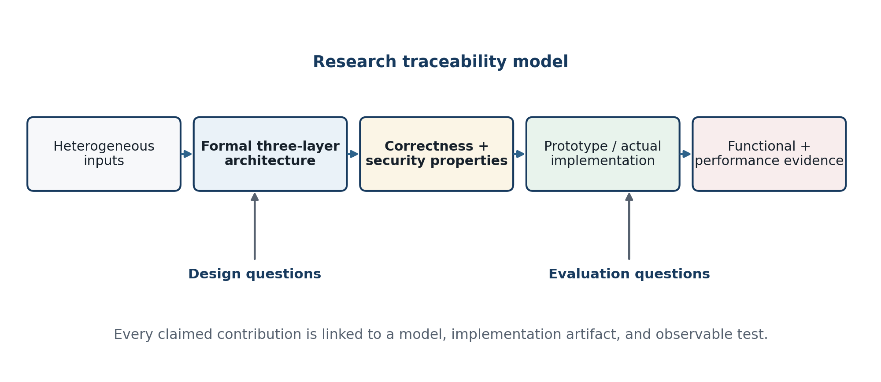
Figure R.1. Research traceability from heterogeneous-input problem to empirical evidence.
Table R.1. Thesis research questions and required evidence
ID | Research question | Primary evidence
RQ1 | How can heterogeneous structured data, documents, files, and program artifacts be represented for uniform interchange without losing required semantics or bytes? | Formal value domain; mapping rules; round-trip test oracle
RQ2 | How should exchange, control, and communication responsibilities be separated to improve interoperability, security, and evolvability? | Component model; interface contracts; dependency analysis; failure isolation
RQ3 | Which preprocessing sequence prevents interface-layer character transformation and preserves arbitrary byte content? | Canonical JSON envelope; Base64url/transport-safe Base64 rules; test vectors
RQ4 | Under which structural and operational conditions is XML or JSON the more appropriate interchange representation? | Standards analysis; feature matrix; representative payload experiments
RQ5 | Does the implemented middleware satisfy functional correctness and acceptable performance under defined workloads? | Conformance suite; latency, throughput, resources, reliability, and negative security tests

Working Contributions
C1 — layered reference architecture. A precise division among the exchange layer, control layer, and communication layer, including allowed dependencies and trust boundaries.
C2 — transport-safe preprocessing. A canonical JSON envelope and binary-to-text encoding rule that preserves arbitrary octets across Web API interfaces while avoiding claims that Base64 provides security.
C3 — formal correctness conditions. Semantic round-trip, byte round-trip, integrity, authorization, replay, and observable-error properties expressed as testable invariants.
C4 — heterogeneous mapping method. Rules for formalizing XML, JSON, text, tabular, multimedia, file, and program artifacts, with explicit representation metadata.
C5 — reproducible evaluation framework. Workload classes, metrics, baselines, sample-size rules, and reporting tables that connect Chapter 3 results to the hypotheses.

Provisional Mathematical Core
Let an input artifact x belong to Df, the domain of valid artifacts in source format f. The normalizer Nf maps x to an abstract value v in V while a metadata function m records information that cannot safely be inferred later, including media type, schema version, character set, byte length, digest, and artifact policy.
Nf : Df → V, m : Df → Meta (R.1)
For structured data, semantic correctness requires a target artifact y in Dg whose target normalization is equivalent to the source normalization under an application-defined relation ≈. For an opaque byte artifact, correctness is stronger: the recovered byte string must equal the original byte string.
Ng(y) ≈ Nf(x) and, for x ∈ B*, Recover(x) = x (R.2)
The complete send transformation is modeled as a composition. E constructs an envelope, β is Base64url encoding when needed, R is the control-layer routing and policy function, Enc is authenticated encryption, and T is network transmission. The receive side applies verified inverses in reverse order.
Send(x) = T ∘ Enc ∘ R ∘ E ∘ β ∘ σJSON ∘ Nf (x) (R.3)
Receive(Send(x)) ≈ x, provided that validation and authorization succeed (R.4)

Complete Thesis Structure and Page Budget
The page budget is a planning control rather than an invitation to add filler. Actual pagination will change after the university template, front-matter rules, figure sizes, and final experiment tables are supplied. The target is approximately 100 pages of substantive material, with appendices used for schemas, test cases, and configuration details that would interrupt the main argument.
Table R.2. Provisional page budget for the complete thesis
Part | Planned pages | Principal content
Front matter | 7–9 | Abstract, contents, lists, abbreviations
Chapter 1 | 27–31 | Literature, middleware model, XML, JSON, comparison, research gap
Chapter 2 | 28–33 | Three-layer architecture, formal algorithms, preprocessing, correctness demonstration
Chapter 3 | 24–29 | Physical/logical implementation, connectivity, use, experiments, results
References | 6–9 | Author–date reference list
Appendices | 8–15 | Schemas, payloads, API definitions, configuration, raw result summaries
Total target | 100 ± 10 | Final count depends on institutional rules and empirical material

Chapter-by-Chapter Logic
Chapter 1 establishes why communication middleware is necessary, identifies the abstractions inherited from earlier middleware families, and compares XML and JSON as exchange representations. It concludes with the research gap: existing formats and middleware services do not by themselves define an end-to-end, testable method for preserving heterogeneous structured and binary content across an API and encrypted network path.
Chapter 2 defines the proposed system. Section 2.1 specifies the exchange, control, and communication layers; their components, interfaces, state machine, invariants, and security controls; the canonical envelope; and the full encode–route–encrypt–transmit–decrypt–decode sequence. Section 2.2 formalizes each supported data class and demonstrates encoding and decoding through normative test vectors. Correctness is argued algebraically and linked to property-based, interoperability, negative-security, and non-persistence tests.
Chapter 3 describes the physical and logical implementation of the disclosed research prototype. Section 3.1 presents component technologies, topology, interfaces, configuration, Web API connectivity, operating procedure, and observed functional results. Section 3.2 defines the performance indicators, corpus, baselines, controls, and statistical reporting, then evaluates the same frozen build. Its claims are limited to the reference prototype; validation of a separate proprietary or production system requires that system's own artifacts and measurements.

Chapter 1. Theoretical Foundations and Data-Exchange Methods
This chapter constructs the conceptual basis for the proposed communication middleware. Section 1.1 analyzes middleware as a distributed-systems abstraction: its evolution, types, configuration, benefits, limitations, formal model, quality attributes, and security problems. Section 1.2 then examines XML- and JSON-based data exchange through formal value models and parallel examples. The comparison is deliberately conditional. XML and JSON are not ranked by a universal score; their suitability depends on the information model, schema needs, toolchain, workload, and trust boundary.
Chapter claim. The decisive architectural problem is not merely choosing XML or JSON. It is defining a stable semantic contract, safe parser behavior, deterministic representation rules, and an end-to-end preservation property across every middleware transformation.

1.1 Communication Middleware: Concepts, Models, Configuration, and Security

1.1.1 Conceptual development in prior literature
Middleware emerged as distributed applications outgrew the assumption that communicating processes shared one machine, language, operating system, or database. Bernstein (1996) provided an influential model in which middleware consists of general-purpose services positioned between distributed applications and lower-level platform services. His classification included transaction-processing monitors, communication services, and distributed object facilities. The enduring contribution is not a particular product category but the idea that recurrent distribution concerns can be implemented once behind a stable interface.
Emmerich (2000) reframed middleware as a software-engineering mechanism: distribution complexity, location, language bindings, failures, and lifecycle behavior are partly hidden by reusable abstractions. He also warned that middleware cannot make distribution disappear. Network latency, partial failure, concurrency, and version evolution remain observable. This warning is central to the present thesis. A communication middleware should reduce accidental heterogeneity without pretending that remote exchange is equivalent to an in-process call.
The distributed-object tradition, represented by CORBA, emphasized language- and platform-independent interfaces, object references, marshaling, and broker-mediated invocation. CORBA's object request broker illustrates strong interface contracts and location transparency, but also the complexity introduced when remote interactions mimic local objects too closely. The service-oriented tradition later favored coarse-grained, self-describing service boundaries. Papazoglou (2003) described services as platform-agnostic computational elements and emphasized composition, coordination, management, and security as concerns beyond a basic service interface.
Message-oriented middleware shifted attention from synchronous invocation to durable messages, queues, brokers, and asynchronous delivery. Curry (2004) organized the field around messaging models and common services, while Eugster et al. (2003) showed how publish/subscribe decouples producers and consumers in time, space, and synchronization. This decoupling supports scale and independent evolution, but transfers complexity into message identity, ordering, duplication, retention, subscription semantics, and observability.
Web architecture and Web services created two related integration directions. SOAP defines an XML-based messaging framework with an envelope, headers, body, processing roles, intermediaries, and protocol bindings. REST, as formalized by Fielding (2000), is an architectural style based on constraints including client–server separation, statelessness, cacheability, uniform interfaces, layered systems, and optional code-on-demand. Pautasso et al. (2008) argued that REST and the WS-* family expose different architectural decision spaces rather than a simple lightweight-versus-heavy dichotomy. Modern API gateways, service meshes, brokers, and event platforms continue this history by separating cross-cutting communication behavior from application code.
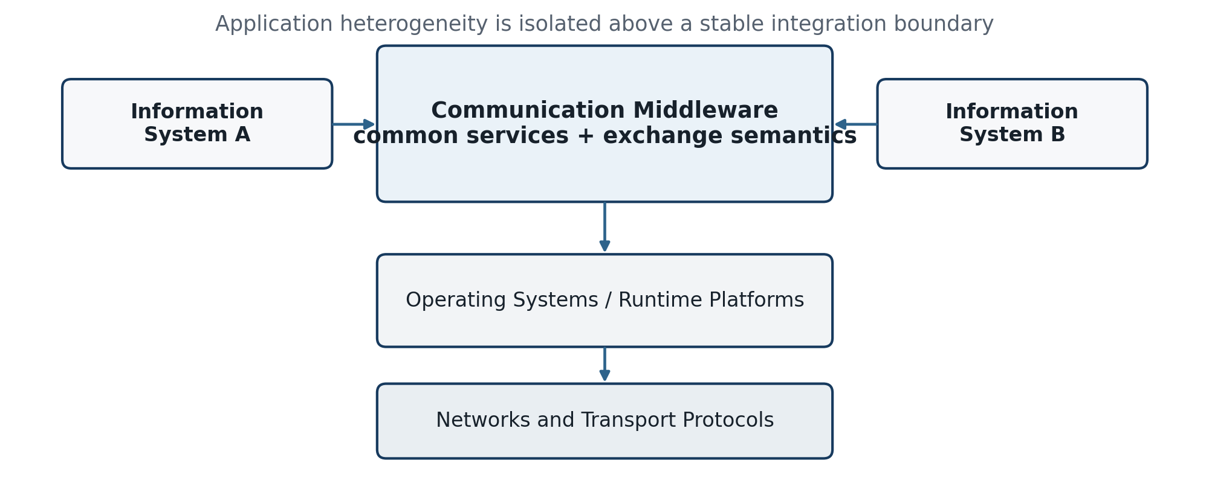
Figure 1.1. Middleware position in a heterogeneous distributed system.
Table 1.1. Representative literature and its architectural contribution
Source | Primary focus | Contribution used in this thesis
Bernstein (1996) | Distributed-system services | Middleware as reusable services between applications and platforms
Emmerich (2000) | Software engineering and middleware | Abstraction reduces but does not remove distribution complexity
Fielding (2000) | Network-based architectural styles | Constraints and induced properties; REST and layered interfaces
Eugster et al. (2003) | Publish/subscribe systems | Temporal, spatial, and synchronization decoupling
Papazoglou (2003) | Service-oriented computing | Platform-agnostic services plus composition, coordination, and management
Curry (2004) | Message-oriented middleware | Queues, messaging models, persistence, and common services
Pautasso et al. (2008) | REST and WS-* comparison | Format/protocol choices are architectural decision trade-offs
W3C SOAP 1.2 (2007) | XML messaging framework | Envelope, processing roles, intermediaries, and bindings
OASIS AMQP 1.0 (2012) | Interoperable business messaging | Wire-level message transfer across vendor implementations
NIST SP 800-204 (2019) | Microservice security | API identity, secure communication, throttling, monitoring, and resilience

1.1.2 Definition and scope of communication middleware
For this research, communication middleware is infrastructure software that mediates exchanges among autonomous information systems by providing stable interfaces and reusable services for representation conversion, message control, routing, security, delivery, and observability. The definition contains four boundaries. First, the endpoints remain autonomous: each system owns its domain data and processing. Second, mediation is explicit: the middleware may transform representations and enforce policy but must expose those transformations as contracts. Third, communication is broader than transport: TCP or HTTP moves bytes, whereas middleware interprets message identity, format, destination, lifecycle, and failure. Fourth, the middleware does not own destination business semantics; it preserves and conveys them according to agreed schemas and adapters.
The phrase multiple data exchange refers to several forms of heterogeneity. Syntactic heterogeneity includes XML, JSON, CSV, fixed-width text, proprietary records, and binary files. Encoding heterogeneity includes character sets, line endings, byte order, and escaping conventions. Structural heterogeneity includes trees, objects, tables, and graphs. Semantic heterogeneity occurs when fields with similar names have different units, identifiers, time zones, or business meanings. Protocol heterogeneity includes HTTP, messaging protocols, sockets, file transfer, and vendor interfaces. A serious architecture must declare which forms it resolves automatically and which require human-authored mappings.
Program interchange is treated conservatively. A program or package is an artifact p in B*, not a trusted command. It can be transported with metadata such as application/octet-stream, file name, version, SHA-256 digest, signer, and intended platform. Execution belongs to an independently authorized deployment or sandboxing process at the destination. If the middleware were to execute transferred programs as part of exchange, the system would cross from communication middleware into remote code execution and software deployment, substantially changing the threat model and assurance obligations.

1.1.3 Classification of middleware
Middleware can be classified by its dominant interaction abstraction. Procedure-oriented middleware presents remote work as calls and responses. Object-oriented middleware extends this model with object identity and interface definitions. Message-oriented middleware makes a message the unit of delivery and can buffer it between independent producers and consumers. Event-oriented systems distribute notifications to interested subscribers. Service and API middleware exposes coarse-grained operations or resources. Transaction and workflow middleware coordinates multi-step activities. Data-access middleware presents common access over heterogeneous stores, while streaming middleware handles ordered, continuing event sequences.
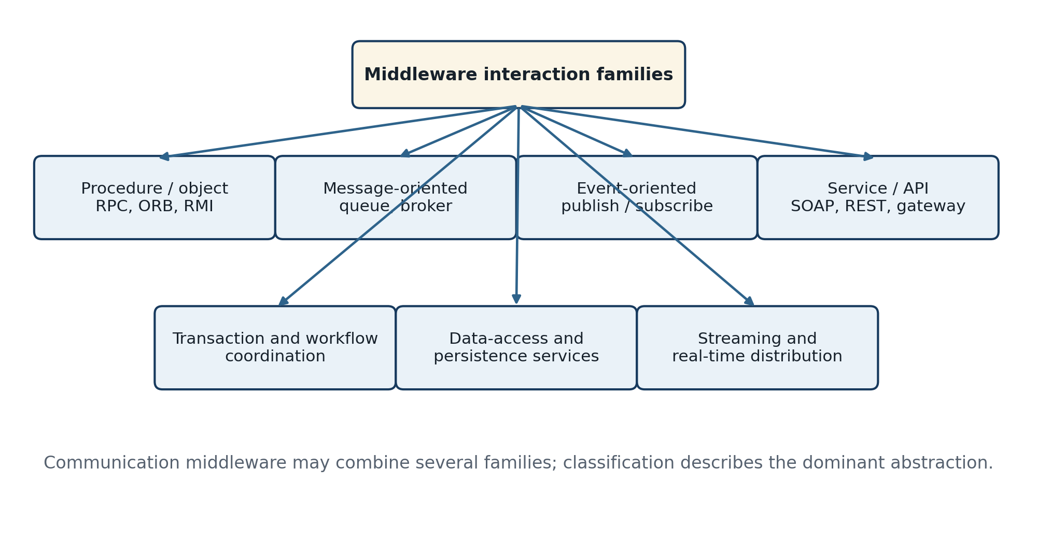
Figure 1.2. Taxonomy of middleware interaction families.
Table 1.2. Middleware taxonomy
Family | Primary abstraction | Strength | Characteristic risk
RPC / RMI | Call and response | Simple request semantics | Temporal coupling and retry ambiguity
Distributed objects / ORB | Remote object and interface | Language/platform interoperation | Complex lifecycle and local-call illusion
Message queue / broker | Durable message | Asynchrony and buffering | Duplicates, ordering, backlog
Publish / subscribe | Event and subscription | Loose coupling and fan-out | Delivery visibility and schema evolution
SOAP / WS-* | Envelope and service contract | Rich extensibility and formal contracts | Protocol and tooling complexity
REST / API gateway | Resource representation and uniform interface | Web interoperability and operational simplicity | Inconsistent conventions and endpoint sprawl
Transaction / workflow | Coordinated unit of work | Consistency across steps | Blocking, compensation, and failure complexity
Streaming / data distribution | Ordered event sequence | High-volume continuous processing | State, replay, and back-pressure complexity

The proposed system is hybrid. Its external Web API resembles service/API middleware; its control layer performs routing and lifecycle decisions associated with message-oriented systems; and its exchange layer provides an integration function through canonicalization and adapters. Classifying it as merely a REST API would omit representation mediation, while classifying it as a message broker would omit its synchronous API boundary and format reconstruction responsibilities.

1.1.4 Functional configuration
A minimal communication middleware contains endpoint adapters, a representation processor, a canonical message model, a control and routing function, a security function, a transport binding, state and observability services, and administrative configuration. Endpoint adapters isolate source-specific and destination-specific behavior. The representation processor parses, validates, normalizes, serializes, and reconstructs payloads. The control function identifies the message, evaluates policy, resolves its destination, schedules delivery, handles idempotency and retry state, and returns structured outcomes. The communication function authenticates peers, protects content, and binds the abstract message to an underlying protocol.
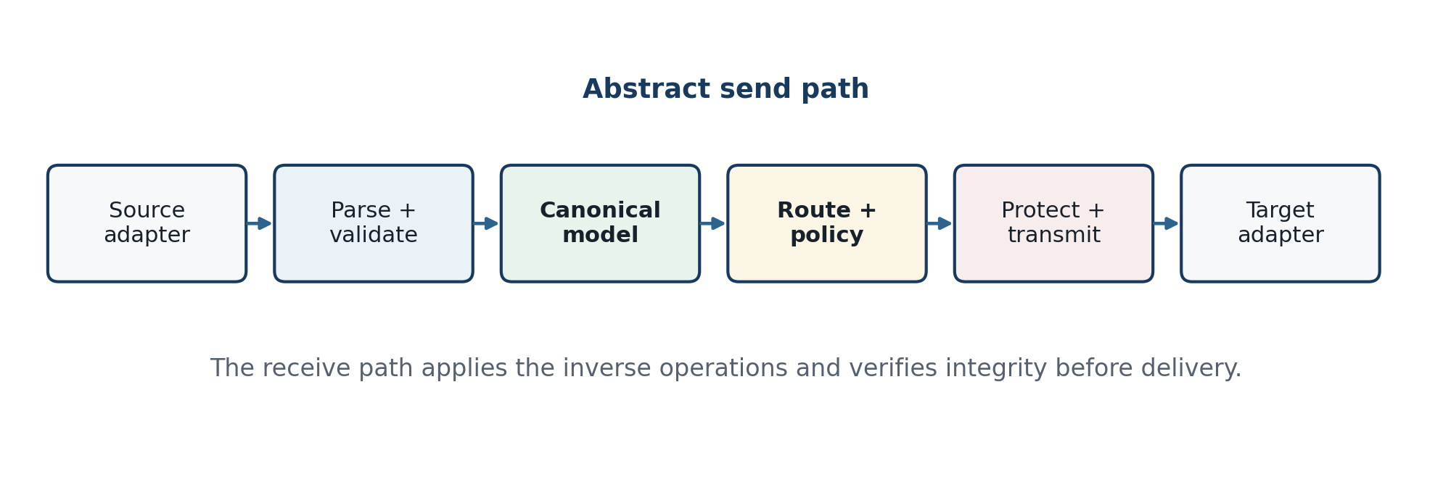
Figure 1.3. Abstract communication middleware processing pipeline.
Cross-cutting services are as important as the main path. A schema registry or version catalog makes representation expectations explicit. A key and trust store controls cryptographic identities. Audit events record metadata and outcomes without unnecessarily exposing sensitive payloads. Metrics expose throughput, latency, error classes, queue depth, retry counts, and resource use. Configuration management ensures that adapter, route, and security changes are versioned and reviewable. These services should not silently alter content; every content-changing operation must be associated with a named mapping or canonicalization rule.

1.1.5 Mathematical model
The middleware is represented as a labeled transition system with data transformations. Let S be the set of processing states, I the set of accepted input events, O the set of observable output events, and δ the transition function. A state contains message identity, route, security context, retry state, and the current representation. Observable outputs include accepted, rejected, delivered, expired, duplicated, quarantined, and failed outcomes.
M = (S, I, O, δ, s₀), δ : S × I → S × O (1.1)
For a valid source artifact x in Df, Nf produces an abstract value v and σJ serializes v as UTF-8 JSON bytes. The envelope constructor E combines the payload representation with metadata m. A routing function R maps the envelope and policy context c to a destination and delivery policy. The communication protection function P produces ciphertext and an authentication tag.
e = E(m(x), β(σJ(Nf(x)))) (1.2)
(d, q) = R(e, c), z = EncK(n, e, aad) (1.3)
End-to-end correctness is conditional: every parser, schema validator, policy check, cryptographic verification, and target adapter must succeed. If any precondition fails, the correct behavior is not best-effort reconstruction but a typed failure with no unauthenticated delivery. For structured data, equivalence may ignore irrelevant surface differences such as JSON member order or XML prefix choice. For binary artifacts, equivalence is exact byte equality, normally verified by length and digest.
Success(x, f, g) ⇒ Ng(Deliver(x)) ≈ Nf(x) (1.4)
x ∈ B* ⇒ |x'| = |x| ∧ H(x') = H(x) (1.5)
Latency is decomposed so that Chapter 3 can attribute cost rather than report a single opaque total. The terms represent parsing and validation, canonical serialization, binary-to-text encoding, control processing, cryptographic protection, network transfer, and destination reconstruction. Queueing delay is separated because it depends on offered load and scheduling policy.
Lend = Lparse + Lcanon + Lb64 + Lcontrol + Lcrypto + Lqueue + Lnet + Lreconstruct (1.6)
For a stable single-stage approximation with arrival rate λ and service rate μ, utilization is ρ = λ/μ and the mean system time in an M/M/1 abstraction is 1/(μ−λ). The final thesis will not claim that real middleware traffic is Markovian; the formula is used only to explain why latency rises nonlinearly near saturation and why benchmark loads must include steady-state points below and near capacity.
ρ = λ/μ < 1, W = 1/(μ − λ) (1.7)
A logical message may pass through components with conditional success probabilities ri. If failures were independent and all components were strictly serial, end-to-end reliability would be their product. Real failures are often correlated, so Chapter 3 must measure observed delivery outcomes and not infer reliability solely from component specifications.
Rseries = ∏ᵢ rᵢ (1.8)

1.1.6 Characteristics, advantages, and disadvantages
The characteristic value of middleware is controlled indirection. Applications depend on a stable middleware contract instead of every remote platform. This can reduce the number of pairwise integrations from approximately n(n−1)/2 to n adapter relationships with a common intermediary, although the exact reduction depends on direction, protocol, and whether adapters are truly reusable. Indirection also creates a policy enforcement and observability point, but it becomes a failure domain and potential bottleneck if designed as a centralized monolith.
Pairwise links = n(n − 1)/2; mediated adapters ≈ n (1.9)
Interoperability is the primary advantage: data models, encodings, and protocols can be reconciled in adapters. Loose coupling is a second advantage when producers and consumers need not share release schedules or runtime availability. Reliability services such as persistence, acknowledgment, retry, dead-letter handling, and idempotency can be centralized. Security controls can be implemented consistently, and operational visibility can cross application boundaries.
The same mechanisms introduce trade-offs. Every transformation adds latency, allocation, and possible semantic loss. A canonical model can become a lowest common denominator or an enterprise-wide schema that is difficult to change. Central routing may create organizational and runtime concentration. Abstracted failures can be harder to diagnose because the apparent source and destination are separated by multiple processing stages. Delivery guarantees are frequently misunderstood: “exactly once” is rarely an end-to-end property without application-level idempotency and transactional boundaries.
Table 1.3. Advantages and corresponding trade-offs
Advantage | Mechanism | Corresponding trade-off
Interoperability | Adapters and canonical representation | Mapping maintenance and possible information loss
Loose coupling | Queues, envelopes, stable contracts | Delayed failures and eventual consistency
Reuse | Shared routing, security, and observability | Common dependency and governance burden
Reliability | Persistence, acknowledgments, retry | Duplicates, storage growth, retry storms
Security consistency | Central identity and policy enforcement | High-value attack surface and key concentration
Scalability | Asynchrony, partitioning, load distribution | Ordering, back-pressure, and partition-key design
Evolvability | Versioned schemas and adapters | Compatibility matrix and long-lived legacy versions
Operational visibility | Correlation IDs, metrics, audit events | Privacy, log integrity, and telemetry cost

1.1.7 Quality attributes and measurable properties
A middleware evaluation should distinguish functional correctness from quality attributes. A system may preserve all test payloads at low load yet fail latency or availability requirements. Conversely, a fast system that silently truncates numeric precision is not correct. The evaluation model therefore begins with conformance and security gates, then measures performance on executions that passed those gates.
Table 1.4. Quality attributes and candidate measures
Attribute | Operational definition | Candidate measure
Semantic correctness | Required meaning survives source-to-target mapping | Passed semantic assertions / total assertions
Byte correctness | Opaque content is recovered exactly | Length equality and digest equality
Interoperability | Independent endpoints implement the contract consistently | Cross-language and cross-platform pass rate
Latency | Elapsed time from accepted input to outcome | Median, p95, p99, confidence interval
Throughput | Successful messages or bytes per unit time | msg/s and MiB/s at defined payload mix
Efficiency | Resources required for useful exchange | CPU time, peak memory, network bytes, storage I/O
Reliability | Correct terminal outcome under faults and load | Delivery success, duplicate, loss, and recovery rates
Security | Policy and protection properties resist negative tests | Blocked unauthorized, tampered, replayed, oversized inputs
Maintainability | Change is localized and testable | Components changed per new format; regression pass rate
Observability | A message lifecycle can be reconstructed safely | Correlation completeness and diagnostic time

Payload expansion is especially relevant to the proposed preprocessing. For n input bytes, padded Base64 produces 4⌈n/3⌉ characters. Ignoring envelope metadata, the asymptotic expansion approaches one third. Compression may alter the network cost for repetitive text, but applying compression to secret-dependent content can introduce side channels and must be evaluated separately.
B64size(n) = 4⌈n/3⌉, limₙ→∞ B64size(n)/n = 4/3 (1.10)

1.1.8 Security problem and trust model
Communication middleware concentrates parsers, credentials, routes, and connectivity, so it must be modeled as a high-value security boundary. Its objectives include confidentiality, integrity, peer and message authenticity, authorization, freshness and replay resistance, availability, accountability, and safe failure. Base64 contributes none of the cryptographic objectives. TLS 1.3 provides channel authentication, confidentiality, and integrity between peers, but end-to-end message protection may still be necessary when messages are stored, relayed, or processed by intermediaries.
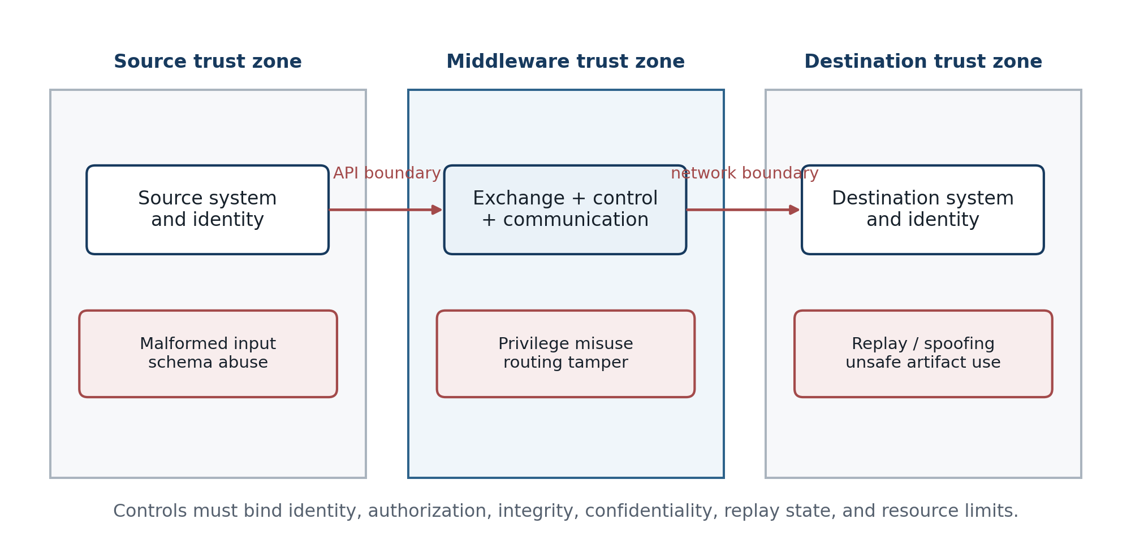
Figure 1.4. Trust boundaries and representative threat classes.
At the source interface, threats include malformed or ambiguous documents, duplicate JSON member names, invalid Unicode, extreme nesting, oversized payloads, decompression bombs, XML entity expansion, external-entity resolution, schema retrieval from untrusted locations, path injection, and content-type confusion. XML parsers should disallow DOCTYPE and external entity resolution unless a narrowly justified controlled use exists. Both XML and JSON parsers require explicit depth, size, numeric, string, and collection limits.
At the control layer, risks include broken object- and function-level authorization, route manipulation, insecure defaults, stale API versions, unbounded retries, message reordering, duplicate acceptance, and sensitive logging. The 2023 OWASP API Security Top 10 emphasizes authorization, authentication, resource consumption, configuration, inventory, server-side request forgery, and unsafe consumption of upstream APIs. These categories map directly to middleware because a routing or adapter service frequently consumes one API on behalf of another.
At the communication layer, an attacker may eavesdrop, modify, inject, replay, redirect, or delay traffic. Peer authentication should be independent of network location, consistent with zero-trust guidance (Rose et al., 2020). A message identifier, sender, destination, timestamp, expiry, sequence or nonce, schema version, and digest should be integrity-bound. Replay state must be checked within a defined window. Authenticated encryption must use unique nonces according to the selected algorithm; “encrypting” without integrity leaves the system vulnerable to active modification.
Program artifacts add software-supply-chain risk. The receiver must validate the media type, expected platform, declared size, digest, and digital signature before any deployment workflow sees the artifact. Policy should default to non-execution, store artifacts in a quarantine area, scan them where appropriate, and require an allowlisted signer and target. The exchange, control, and communication processes themselves should run with least privilege and must not inherit execution permission merely because an artifact was successfully transported.
Table 1.5. Threat-control matrix
Threat | Affected boundary | Required control | Verification
Ambiguous or malformed representation | Exchange input | Strict parser; schema; duplicate-key policy; size/depth limits | Negative corpus and differential parser tests
XML external entity / expansion | XML parser | Disable DOCTYPE, external entities, external DTD and XInclude; expansion limits | Known XXE and entity-expansion payloads rejected
Unauthorized route or object | Control API | Authenticated principal; object/function authorization; deny-by-default policy | Cross-tenant and privilege-negative tests
Tampering | API and network | TLS plus AEAD or message signature; metadata as associated data | Bit-flip and header-substitution tests fail closed
Replay / duplicate | Control and communication | Unique message ID, nonce/sequence, expiry, idempotency store | Same protected message accepted no more than policy allows
Resource exhaustion | All layers | Request quotas, payload caps, timeouts, back-pressure, bounded retry | Stress and adversarial-size tests
Sensitive data leakage | Logs and metrics | Metadata minimization, redaction, access control, retention policy | Log inspection and secret-seeding tests
Unsafe program artifact | Destination boundary | Digest/signature verification, quarantine, allowlist, no automatic execution | Unsigned/modified/wrong-platform artifact rejected
Compromised configuration or key | Administration | Separation of duties, versioning, secret store, rotation, audit | Rotation drill and unauthorized-change test

Logging requires a deliberate distinction between recording state and recording payload. The user brief states that encoded data is “not recorded” at the Web API transition. This thesis interprets the requirement as payload non-persistence: the control API may record message ID, time, route, length, digest, status, and error class, but must not store the sensitive encoded payload in ordinary application logs. Whether transient buffers, queues, crash dumps, or tracing systems count as records must be defined in Chapter 2 and verified in Chapter 3.

1.1.9 Synthesis and research gap
Prior middleware literature explains reusable distribution services, interaction families, decoupling, service contracts, and architectural trade-offs. Standards specify XML, JSON, SOAP, messaging, URI syntax, Base64, and secure transport. Security guidance identifies parser, API, identity, resource, and trust-boundary risks. These contributions are necessary but not sufficient for the stated artifact. None alone defines the exact composition of heterogeneous-format normalization, transport-safe binary representation, three-layer responsibility, encrypted delivery, inverse reconstruction, and a proof-oriented evaluation.
The research gap is therefore an integration and assurance gap. The proposed contribution is not a new text syntax or cryptographic primitive. It is a system architecture and formal method that combines established mechanisms into a traceable exchange pipeline. Its novelty must be demonstrated through the specificity of the layer contracts, the handling of mixed structured and opaque artifacts, the prevention of unintended interface transformations, and the evidence that the implemented composition satisfies end-to-end properties.

1.2 XML- and JSON-Based Data Exchange Methods

1.2.1 Common abstraction for data exchange
A comparison of XML and JSON should distinguish three levels: the application value, the serialization, and the wire bytes. Two documents can have different bytes but represent the same application value; conversely, a conversion can preserve visible strings while losing distinctions that matter to the application. Let V be the application value domain, σf a serializer into format f, and πf a parser back to V. A format implementation is round-trip correct over an allowed domain Vsafe when parsing a serialization returns an equivalent value.
∀v ∈ Vsafe : πf(σf(v)) ≈ v (1.11)
The relation ≈ must be defined for the application. For a business record, object-member order may be irrelevant but decimal precision, units, identifier spelling, time zone, and null-versus-missing may be significant. For a document, mixed-content order and namespaces may be significant. For a signed payload, even semantically irrelevant whitespace can change the digest unless a canonicalization scheme is applied. This explains why “valid JSON” or “well-formed XML” is only a syntactic condition, not proof of interoperable meaning.
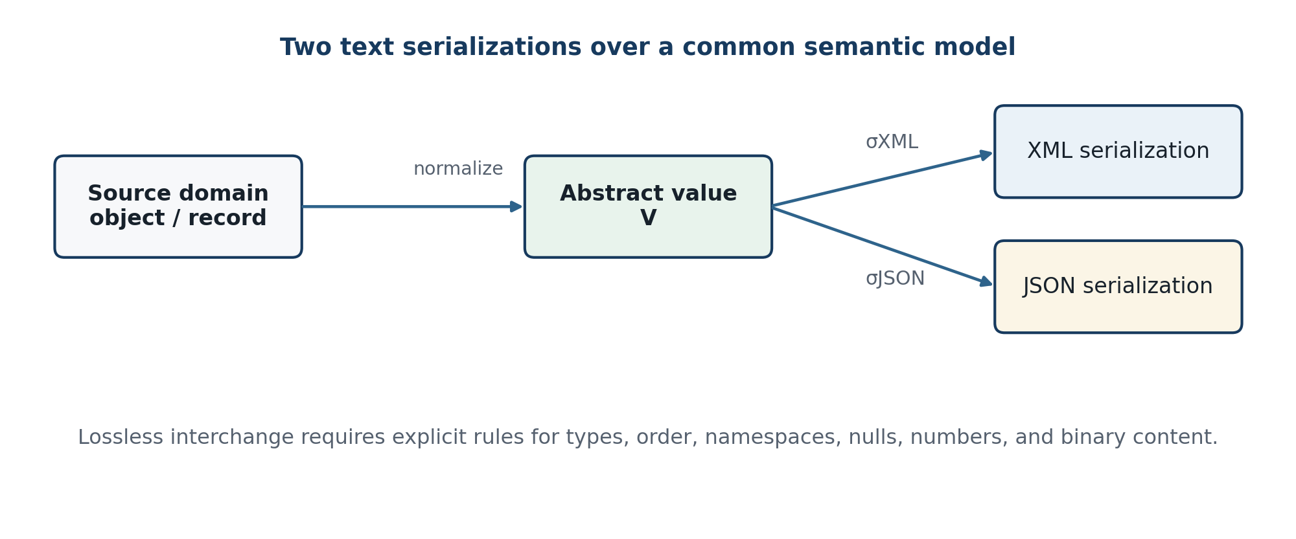
Figure 1.5. XML and JSON serializations over a common semantic model.

1.2.2 XML data model and exchange method
XML 1.0 defines a textual document with exactly one root element and properly nested markup. Its logical structure includes elements, attributes, character data, comments, and processing instructions; its physical structure can include entities. Namespaces qualify names so independently defined vocabularies can coexist. XML is therefore well suited to document-centric information, mixed content, extensible vocabularies, and domains whose contracts depend on namespace-qualified element and attribute names.
A simplified XML information model may be represented as a rooted ordered tree TX = (N, E, r, λ, α, τ). N is the set of nodes, E is the parent–child relation, r is the root, λ labels element names, α maps elements to attribute sets, and τ maps text-bearing nodes to character sequences. Child order is significant. Namespace identity is the pair of namespace name and local name, not the chosen prefix.
TX = (N, E, r, λ, α, τ), E ⊂ N × N (1.12)
Well-formedness is required before application processing. Validity adds constraints from a DTD or schema. XSD 1.1 supports element declarations, type definitions, model groups, attributes, identity constraints, assertions, and post-schema-validation information. This rich contract system is an XML advantage, although it also increases tooling and governance complexity. A secure deployment should resolve schemas from a controlled catalog rather than fetch arbitrary locations declared by untrusted input.
Table 1.6. XML constructs and exchange implications
Construct | Meaning | Interchange implication
Element | Named ordered tree node | Natural for nested records and document structure
Attribute | Name–value property on an element | Requires a mapping rule when target model has no attribute distinction
Text node | Character data between markup | Mixed content can interleave text and child elements
Namespace | URI-qualified name vocabulary | Prevents name collision but complicates naive mappings
Entity | Physical or replacement-text unit | Useful historically; unsafe external resolution must be disabled
XSD type | Schema datatype and constraint | Enables strong validation and typed interpretation
Order | Sequence of child nodes | May carry document or business meaning
Canonical form | Deterministic XML serialization | Required for stable hashing/signing across surface variations

1.2.3 XML exchange example
The following example represents a payment record with a namespaced envelope and a binary attachment. Decimal amount is preserved lexically with an XSD-compatible decimal string; the attachment is Base64 text and includes a digest. In a production contract, the schema would constrain the identifier, currency enumeration, decimal scale, timestamp, digest syntax, maximum payload length, and permitted media types.
XML example 1. Namespaced exchange record with a binary artifact.
<?xml version="1.0" encoding="UTF-8"?>
<ex:exchange xmlns:ex="urn:example:exchange:v1"
messageId="7b7f9ad0-7bfa-4acd-a8e8-5ff8f38a3bd2">
<ex:payment>
<ex:id>TX-17</ex:id>
<ex:amount currency="USD">125.50</ex:amount>
<ex:timestamp>2026-09-07T10:15:30Z</ex:timestamp>
</ex:payment>
<ex:artifact mediaType="application/octet-stream"
encoding="base64"
sha256="f3c1...9a2e">AAECAwQF</ex:artifact>
</ex:exchange>
An XML send path can be expressed as parse → secure validation → namespace-aware mapping → optional canonicalization → transport binding. The receiving implementation reverses the mapping under the same schema version. If the XML document itself is signed, canonicalization rules and reference selection must be identical at sender and receiver. The application must not validate one representation but process another, and signature validation must be resistant to wrapping or selection ambiguity.
XML's verbosity is not uniformly a disadvantage. Repeated element names increase uncompressed size, but descriptive markup can improve diagnostics and document readability, and repetition can compress well. Performance depends on payload shape, parser model (DOM, SAX, StAX/pull), validation, namespace handling, canonicalization, language runtime, and allocation behavior. Consequently, literature reporting JSON as smaller or faster is evidence about tested workloads, not a universal theorem.

1.2.4 JSON data model and exchange method
RFC 8259 defines JSON as a lightweight, text-based, language-independent data interchange format. A JSON value is an object, array, number, string, Boolean, or null. Objects are unordered collections of name–value members and arrays are ordered sequences. JSON exchanged outside a closed ecosystem must use UTF-8. Member names should be unique because implementations disagree on duplicate-member handling, and numeric range or precision beyond common binary64 behavior can cause interoperability problems.
A recursive value domain is defined below. S is the set of Unicode strings and Num is the agreed number domain. The finite-map notation assumes unique object names. Because the abstract object is unordered, a deterministic byte representation requires an additional canonicalization rule such as JSON Canonicalization Scheme (JCS), which constrains serialization and sorts property names.
VJ ::= null | true | false | Num | S | [VJ*] | {S ↦ VJ} (1.13)
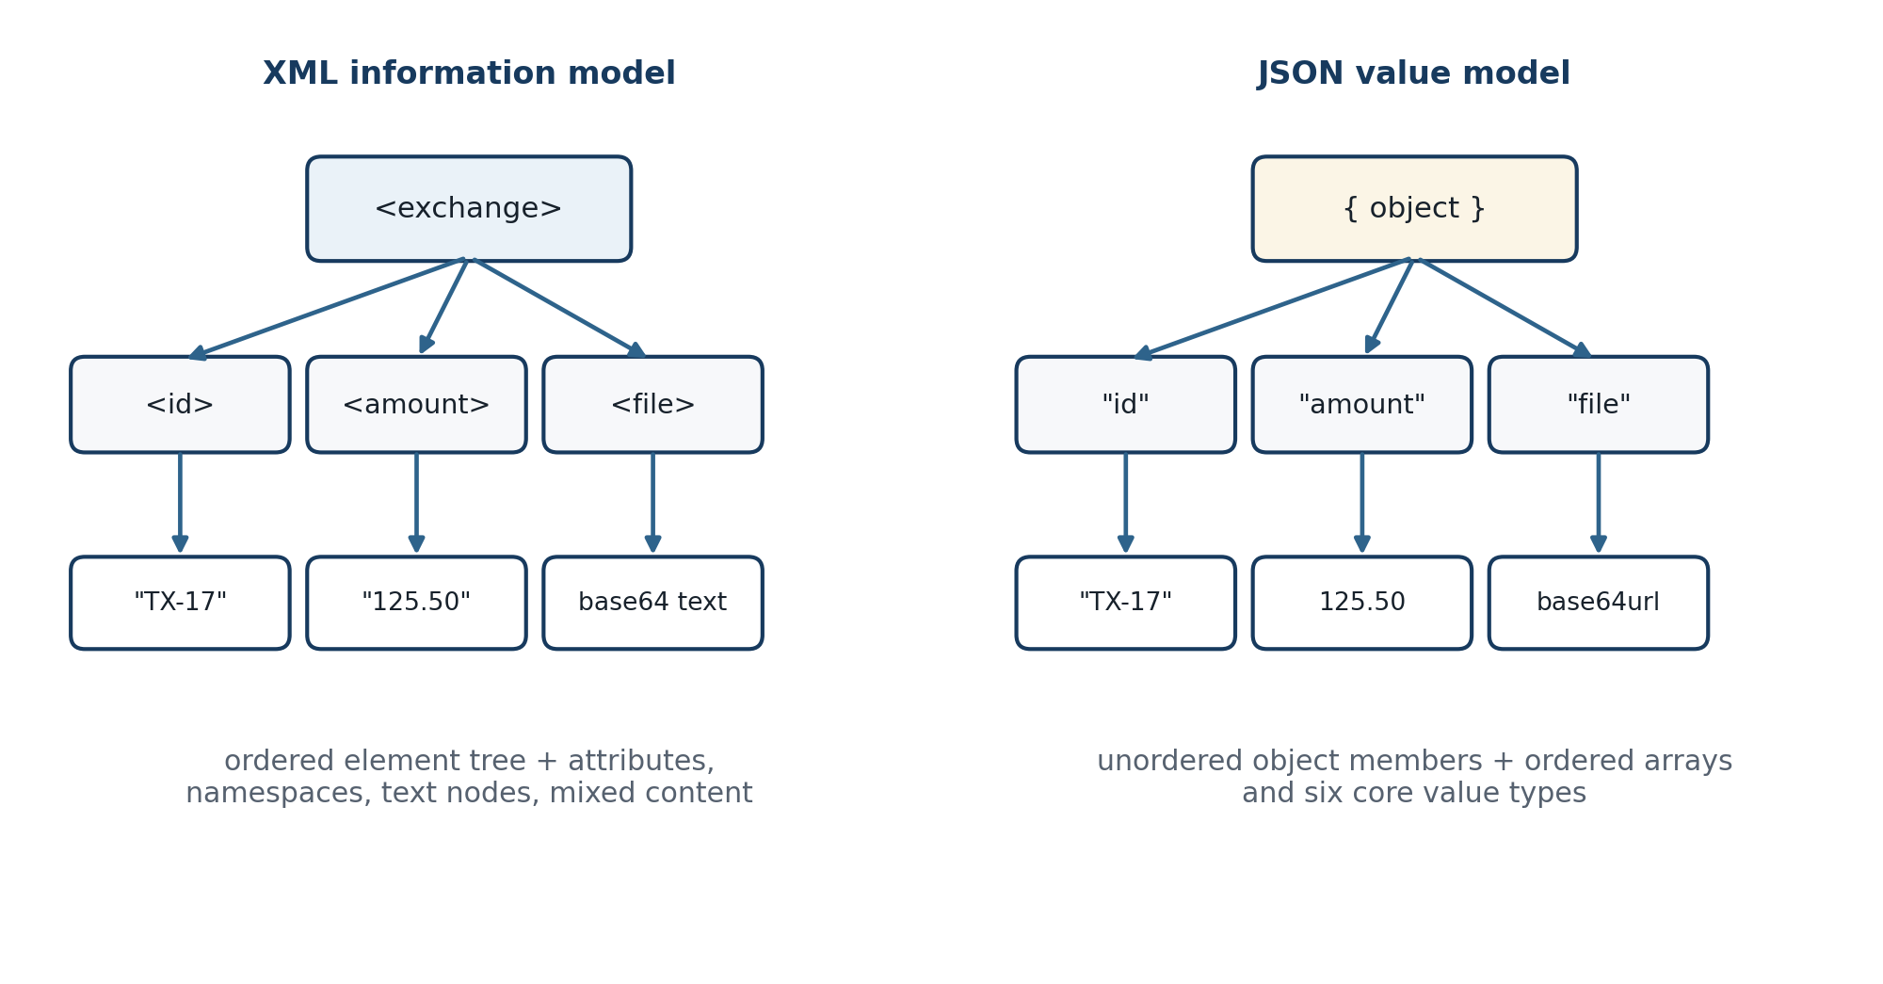
Figure 1.6. Contrasting XML and JSON value models for the same conceptual record.
Table 1.7. JSON value types and exchange implications
Type | Abstract meaning | Interchange implication
object | Unordered unique name–value mapping | Do not depend on member order; reject or define duplicate-name behavior
array | Ordered sequence of values | Order is significant and heterogeneous item types are permitted
string | Unicode code-point sequence | Normalize only by explicit contract; escaping differences may be equivalent
number | Base-10 lexical number | Agree on range, precision, integer limits, and decimal representation
boolean | true or false | Do not coerce strings or numeric flags unless mapping declares it
null | Explicit null value | Distinguish null from an absent object member

1.2.5 JSON exchange example
The JSON version uses a metadata envelope and places a Base64url string in the artifact payload. The encoding value is declared so the receiver never guesses. Decimal amount is represented as a string in this example because the contract requires exact scale across runtimes; an alternative is a JSON number plus an explicit precision profile. The digest covers the decoded bytes, while an envelope signature or AEAD tag protects integrity in transit.
JSON example 1. Canonical envelope with a Base64url artifact.
{
"specVersion": "1.0",
"messageId": "7b7f9ad0-7bfa-4acd-a8e8-5ff8f38a3bd2",
"contentType": "application/vnd.example.payment+json",
"schemaVersion": "2026-09",
"payload": {
"id": "TX-17",
"amount": {"value": "125.50", "currency": "USD"},
"timestamp": "2026-09-07T10:15:30Z"
},
"artifact": {
"mediaType": "application/octet-stream",
"encoding": "base64url",
"length": 6,
"sha256": "f3c1...9a2e",
"data": "AAECAwQF"
}
}
The interface must specify the HTTP representation precisely: request method, media type, maximum body size, character encoding, schema version, authentication, timeout, status model, and retry/idempotency semantics. application/json bodies should not be passed through application/x-www-form-urlencoded processing. If an encoded value must enter a URI component, Base64url should be used because RFC 3986 reserves “+”, “/”, and “=”, while RFC 4648 defines a URL- and filename-safe alphabet using “-” and “_”; padding may be omitted only when both sides know how to restore it.
JSON Schema can describe and validate JSON documents, but validation behavior depends on the declared dialect, vocabulary, reference resolution, and implementation. A schema should set closed or intentional extension points, string patterns and lengths, numeric constraints, array limits, required members, and formats only where the validator actually enforces them. Schema references should be pinned to trusted identifiers or local catalogs. Validation success does not authorize the message and does not prove the artifact digest or signature.
Canonicalization is necessary when a digest or signature covers JSON text rather than decoded content. Whitespace, member ordering, number spelling, and character escaping can differ while representing the same abstract value. JCS produces an invariant form for a restricted interoperable domain. Alternatively, the design can sign a clearly defined byte payload and integrity-bind selected metadata as associated data, avoiding dependence on arbitrary surface formatting.

1.2.6 XML–JSON transformation and information loss
XML and JSON are not isomorphic. A general XML document can contain attributes, namespaces, ordered mixed content, comments, processing instructions, entity boundaries, and multiple text nodes that have no unique JSON equivalent. A JSON object distinguishes neither attributes from child elements nor namespace-qualified names unless a mapping convention is added. Conversely, JSON has native arrays, null, Boolean, and number values that plain XML syntax represents through element/attribute conventions or schema typing.
A lossless subset can be defined by contract. For example, restrict XML to element-only content; prohibit comments, processing instructions, DTDs, and mixed content; map namespace-qualified names to stable keys; map repeated sibling elements to arrays; preserve attributes under a reserved member; and use XSD types for Boolean, number, and null semantics. The reverse mapping must preserve order where the schema makes it significant. Without such rules, a round trip may produce a valid document that is not equivalent to the source.
Table 1.8. Potential information loss in XML–JSON conversion
Source feature | Why naive conversion loses meaning | Required mapping rule
XML attribute vs. child element | Both may become ordinary JSON members | Reserve an attribute container or schema-directed rule
XML namespace | Prefix may be dropped and local names collide | Map expanded name {URI}local or a registered prefix
Mixed content | Text/element order cannot be represented by a plain object | Use an ordered node array with explicit node kinds
Repeated XML siblings | One member may overwrite another | Schema-directed array representation
Element order | JSON object order is semantically unordered | Use arrays where order is meaningful
JSON null vs. missing | Empty XML element may conflate states | Use xsi:nil or an explicit state convention
JSON number precision | Parser may coerce to binary floating point | Use bounded integer/decimal profile or lexical string
Binary bytes | Text decoding may corrupt arbitrary octets | Explicit Base64/Base64url with length and digest
Comments / processing instructions | Often discarded by data-oriented mappings | Declare out of scope or preserve as typed nodes

For the proposed middleware, the canonical JSON envelope does not require every source document to be flattened into ordinary JSON members. An XML document can be carried either as a normalized application value or as an opaque UTF-8/binary artifact with its media type and digest. The first mode enables field-level routing and transformation but needs mapping rules; the second mode guarantees byte preservation but exposes less semantic structure to the middleware. The selected mode must be explicit in message metadata.

1.2.7 Comparative evaluation of XML and JSON
XML offers document-centric constructs, namespaces, mixed content, mature schema languages, canonicalization, XPath and XSLT ecosystems, and standardized envelope frameworks such as SOAP. JSON offers a smaller core value model, natural alignment with common programming-language objects, concise API payloads, and broad Web tooling. XML's additional distinctions are valuable when the distinctions carry meaning; they are overhead when the application only requires objects, arrays, and primitive values.
Comparative studies have often found smaller JSON payloads and lower processing cost for the tested object-oriented workloads, while also demonstrating that results vary by library, platform, and data composition (Maeda, 2012; Sumaray & Makki, 2012). Pezoa et al. (2016) showed that JSON Schema requires a formal semantics beyond JSON's basic syntax. Recent comparative work continues to report workload-dependent size and energy differences. These studies justify benchmarking the two representations in Chapter 3, but they do not justify pre-populating results for the author's system.
Table 1.9. Comparative evaluation of XML and JSON
Criterion | XML | JSON | Architectural implication
Core model | Ordered document tree with attributes and text | Objects, arrays, and primitive values | Choose the model closest to required semantics
Verbosity | Explicit start/end markup and namespaces | Usually fewer structural characters | Measure both raw and compressed size
Schema | DTD, XSD, RELAX NG and mature tooling | JSON Schema with dialect/vocabulary choices | Pin schema version and validator behavior
Namespaces | Native namespace-qualified names | No native namespace construct | XML fits composable vocabularies; JSON needs conventions
Mixed content | Native and ordered | Requires explicit node-array convention | Document exchange often favors XML
Arrays | Schema/convention through repeated elements | Native ordered array | Object-centric APIs often favor JSON
Types | Text syntax plus schema-derived rich types | Six core types; precision profiles needed | Never rely on implicit coercion
Binary | Base64/hex text or external attachment mechanisms | Base64/Base64url string or external object | Both incur expansion unless transport supports binary parts
Canonicalization | W3C canonical XML families | JCS and application profiles | Required for stable text-level hashes/signatures
Parser risk | XXE, expansion, external fetch, depth/size | Duplicate keys, depth/size, number/Unicode divergence | Use hardened parsers and explicit limits
Transformation | XPath/XSLT and document tools | Code, JSON Pointer/Patch, query tools | Select toolchain by transformation complexity
Human readability | Descriptive but potentially verbose | Concise for object data | Operational readability is payload-dependent
Typical fit | Documents, standards-heavy integration, SOAP | Web APIs, configuration, event payloads | Do not treat typical fit as an absolute rule

A weighted selection model can formalize context without pretending that the weights are universal. Let cij be the measured or ordinal score of format j on criterion i, wi be a stakeholder-approved nonnegative weight, and pj be a penalty for a violated mandatory constraint. The chosen format maximizes utility only after hard constraints such as namespace preservation, mixed content, parser policy, or partner compatibility are satisfied.
U(j) = Σᵢ wi cij − pj, wi ≥ 0, Σᵢ wi = 1 (1.14)
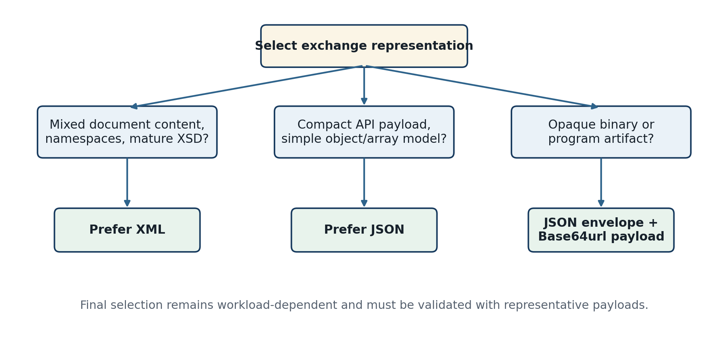
Figure 1.7. Representation-selection logic for common exchange needs.

1.2.8 Implications for the proposed middleware
The proposed architecture uses JSON as the control envelope because its object/array model is sufficient for message metadata, Web API libraries handle it consistently when constrained to UTF-8 and unique member names, and it integrates naturally with a three-layer service interface. This is an architectural choice, not a claim that JSON can faithfully replace arbitrary XML. The payload descriptor states whether content is a normalized JSON value, an XML artifact, a text artifact with declared charset, or opaque bytes.
When arbitrary bytes are embedded, the exchange layer applies Base64url before handing the envelope to the control layer if URI-sensitive transformations are possible. If the interface contract guarantees an application/json body with no form or URI processing, standard Base64 is also interoperable; the implementation must choose one canonical rule and reject undeclared variants. The encoded data is not logged as ordinary payload. The communication layer then uses authenticated encryption or a TLS-protected channel according to the threat model. On receipt, cryptographic verification precedes decoding and delivery.
The design therefore maintains four distinct properties: encoding safety, which prevents an interface from treating payload characters as syntax; confidentiality, which prevents unauthorized reading; integrity/authenticity, which detects modification and identifies an authorized source; and semantic correctness, which reconstructs the intended application value. Conflating these properties would make both the proof and the implementation unsafe.

1.3 Chapter Summary
Communication middleware mediates among autonomous systems by reusing services for representation, control, routing, security, delivery, and observability. Prior literature demonstrates the benefits of abstraction and decoupling while warning that latency, partial failure, versioning, and semantics remain visible. The mathematical model in this chapter translates those concerns into round-trip, state-transition, latency, reliability, and size properties that can be tested.
XML and JSON are complementary text serializations with different information models. XML provides document order, attributes, namespaces, mixed content, and mature schema and transformation mechanisms. JSON provides a smaller object/array value model suited to Web API envelopes. Lossless conversion is possible only over a declared subset with explicit mapping rules. Base64url can protect byte representation from URI-sensitive character handling, but neither Base64 nor Base64url supplies encryption or authentication. These conclusions motivate the three-layer architecture and preprocessing method formalized in Chapter 2.

Chapter 2. Three-Layer Architecture and Multiple Data-Exchange Method
This chapter specifies the proposed communication middleware as a design artifact. It converts the research gap identified in Chapter 1 into explicit layer boundaries, interface contracts, algorithms, state transitions, security invariants, and reconstruction rules. The term proposed is important: the chapter establishes what a conforming implementation must do, while Chapter 3 will determine whether the author's actual implementation realizes the design and meets its measured objectives.
Architectural claim. Representation exchange, lifecycle control, and secure peer communication should be separated into three layers. A message is correct only when the destination recovers an application-equivalent structured value or the exact original byte sequence, after authorization and cryptographic verification, with every failure made observable.

Section 2.1 defines the architecture and proves an end-to-end round-trip property under stated assumptions. Section 2.2 defines the canonical JSON envelope and the format profiles used for JSON, XML, text, tabular data, documents, media, archives, and program artifacts. The design uses a JSON-plus-Base64url preprocessing profile for an interface-safe textual representation, but it does not treat encoding as a security mechanism. Confidentiality and authenticity remain responsibilities of the communication layer.

2.1 Three-Layer System Architecture

2.1.1 Design requirements, assumptions, and scope
The architecture begins with preservation rather than transport. A network connection can deliver bytes while still producing an incorrect application result if an interface changes a character encoding, a parser coerces a number, an XML-to-JSON mapping discards a namespace, or a retry delivers the same operation twice. Therefore, requirements are expressed as observable postconditions. Each requirement is paired with evidence that can later be collected from the implementation.
Table 2.1. Architectural requirements and conformance evidence
ID | Requirement | Observable conformance condition
R1 | Accept declared heterogeneous data classes through adapters. | Every supported media type is either mapped by a named profile or rejected before routing.
R2 | Preserve required semantics for structured data. | Source and recovered normal forms are equivalent under the profile-specific relation ≈.
R3 | Preserve exact bytes for opaque artifacts. | Recovered length, digest, and byte sequence equal the input.
R4 | Prevent URI/form interpretation of encoded payload text. | The P-J64 profile uses Base64url inside an application/json body and forbids query-string payload transport.
R5 | Separate representation, control, and communication concerns. | Dependencies cross only the two declared interfaces; lower layers do not parse application payloads.
R6 | Authorize every source-destination-operation tuple. | A default-deny policy decision precedes peer transmission and local delivery.
R7 | Protect remote traffic against disclosure and modification. | Peer authentication and authenticated encryption or an equivalent protected channel are verified before decoding.
R8 | Detect replay and control duplicate effects. | Freshness state and idempotency keys distinguish safe retries from duplicate business operations.
R9 | Avoid persistent payload recording at layer interfaces. | Logs, traces, metrics, queues, and failure reports contain approved metadata but no payload or encoded payload.
R10 | Expose deterministic failure behavior. | Each rejection maps to a typed error, stable lifecycle state, and auditable metadata event.

The design assumes that each participating node has an authenticated workload identity, trusted configuration, a supported schema/profile registry, and access to valid cryptographic keys. Clocks need not be perfectly synchronized, but replay windows and expiration checks require bounded skew. The adversary may observe, delay, drop, duplicate, replay, or modify network traffic; submit malformed or oversized content; and attempt operations outside an identity's authorization. The model does not assume that Base64 obscures data, that a private network is trustworthy, or that syntactically valid input is semantically safe (Rose et al., 2020).
Three matters remain outside the middleware's autonomous authority. First, the application owner defines semantic equivalence for domain values. Second, a separate key-management authority governs key creation, distribution, rotation, and revocation. Third, program artifacts are transported and verified but never executed by the middleware. These boundaries prevent the integration component from becoming an implicit business-rule engine, certificate authority, or execution platform.

2.1.2 System boundary and layer decomposition
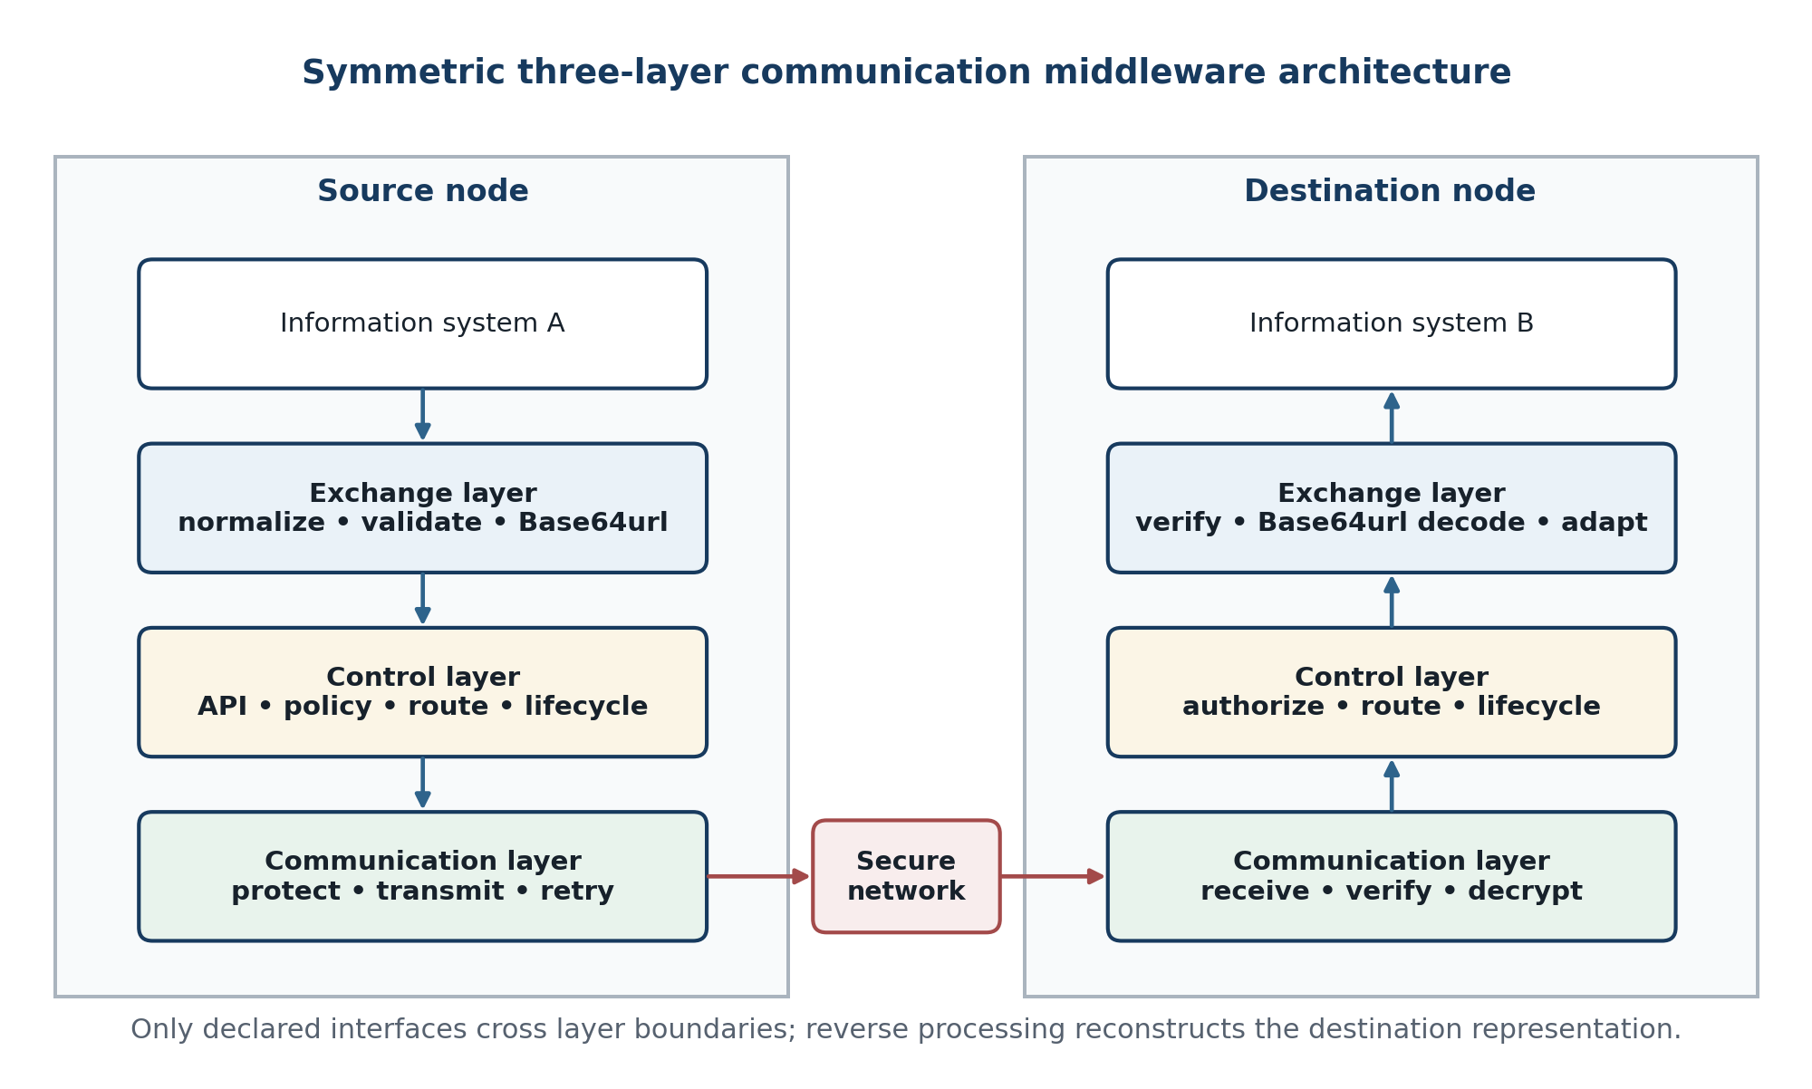
Figure 2.1. Symmetric three-layer middleware architecture between source and destination information systems.
A middleware node contains an exchange layer LX, a control layer LC, and a communication layer LN. A source-side exchange layer receives the endpoint artifact; the control layer makes an authorized routing decision; and the communication layer protects and transmits the resulting envelope. A destination node performs verified decryption in LN, lifecycle and route processing in LC, and Base64url decoding plus endpoint reconstruction in LX. Thus the phrase decoding module in the communication layer refers to cryptographic frame decoding and verified decryption, while binary-to-text decoding remains an exchange-layer operation.
M = (LX, LC, LN, IXC, ICN, Σ, Π) (2.1)
IXC and ICN are typed interfaces; Σ is lifecycle state; Π is the policy set.
The decomposition is behavioral rather than merely organizational. IXC accepts a validated envelope submission and returns a lifecycle result. ICN accepts an authorized peer-send command and returns a protected-delivery result. If an implementation combines layers in one process, it still conforms only when these contracts and dependency directions remain testable. Conversely, deploying each component separately does not create layering when they share mutable payload state or bypass policy checks.
Table 2.2. Layer responsibilities and prohibited behavior
Layer | Owned responsibilities | Required output | Prohibited behavior
Exchange | Adapter selection; parsing; schema validation; normalization; canonical serialization; Base64url processing; reconstruction | Validated canonical envelope or typed representation error | Peer selection, key use, network retry, automatic execution
Control | Identity context; authorization; routing; idempotency; quotas; lifecycle state; metadata-only audit | Authorized peer command or typed policy/lifecycle error | Application-format coercion, Base64 payload mutation, cryptographic plaintext logging
Communication | Peer authentication; AEAD/TLS; framing; transmission; timeout; retry signal; replay defense | Verified plaintext envelope or typed channel error | Business routing, XML/JSON semantic transformation, endpoint delivery

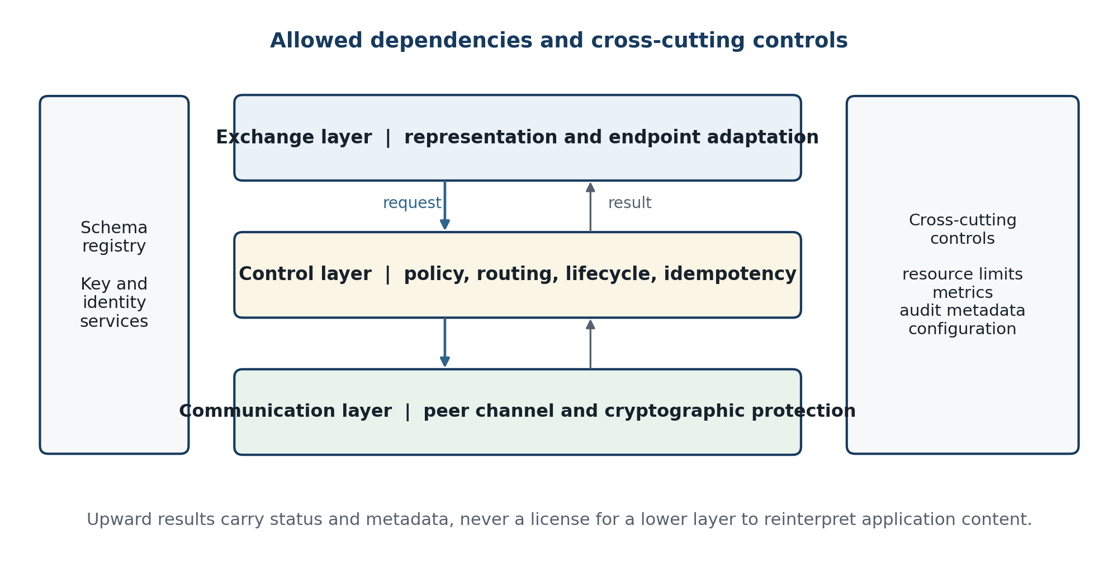
Figure 2.2. Permitted dependency directions and cross-cutting controls.
A layer may reject an input but may not repair fields owned by another layer. For example, the control layer can reject an unsupported profile, yet it cannot replace a malformed Base64url character and continue. The communication layer can report a peer timeout, yet it cannot select a different business destination without a new control-layer decision. This rule makes faults localizable and prevents silent transformations from invalidating the correctness proof.

2.1.3 Exchange layer
The exchange layer is the only layer permitted to understand endpoint representation semantics. It contains an adapter registry, media-type classifier, parser/validator set, normalizer, canonical serializer, Base64url codec, digest calculator, envelope builder, and target reconstructor. The classifier does not trust filenames alone; it uses an interface-declared media type and a configured profile, with optional signature-byte checks as a consistency control rather than an unrestricted content detector.
Table 2.3. Exchange-layer components
Component | Input and operation | Output and rejection conditions
Adapter registry | Endpoint identifier, declared operation, profile version | Specific adapter; reject unknown or disabled combinations
Parser and validator | Bounded source bytes or native value | Typed value; reject malformed syntax, schema violations, external references, or limits
Normalizer | Validated value in source domain Df | Canonical semantic value v plus reconstruction metadata
Canonical serializer | v and profile rules | Deterministic UTF-8 JSON byte string bJ
Base64url codec | Arbitrary byte string | Unpadded or padded string according to one declared profile; reject mixed variants
Integrity descriptor | Original or canonical bytes | Algorithm identifier, byte length, and full digest
Envelope builder | Identity, routing metadata, descriptor, encoded payload | Schema-valid immutable envelope
Reconstructor | Verified envelope and destination profile | Destination artifact; reject non-invertible or unauthorized transformation

Let F be the finite set of enabled format profiles. For f in F, Df is the accepted source domain, Nf maps a validated artifact to the semantic domain V or to the opaque-byte domain B*, and μf records information required for reconstruction. A partial inverse Gf is defined only for values representable by profile f. The exchange layer must reject inputs outside the declared domain rather than project them into a lossy subset.
Nf : Df ⇀ (V ∪ B*) × Meta, Gf : (V ∪ B*) × Meta ⇀ Df (2.2)
Gf(Nf(x)) ≈f x, x ∈ dom(Nf) (2.3)
The equivalence relation ≈f is profile-specific. It may mean exact bytes, equal parsed JSON values under stated number rules, equal XML information sets subject to namespace and ordering requirements, or equal tabular cell values and column types. This explicit relation prevents a test from declaring success merely because two files look similar when opened by one application.

2.1.4 Control layer and Web API boundary
The control layer exposes a bounded Web API to the exchange layer. HTTP supplies request and response semantics; the middleware contract supplies identity, schema, routing, idempotency, and error semantics. Payload-bearing requests use POST with Content-Type application/json and a configured maximum body size. The encoded payload is never placed in a path, query string, form field, cookie, or header. This avoids both URI reserved-character interpretation and the operational tendency for URLs and headers to be logged more widely than request bodies (Fielding, Nottingham, and Reschke, 2022).
Table 2.4. Control-layer API contract
Element | Normative rule | Success behavior | Failure behavior
Submit | POST /v1/exchanges; application/json; authenticated workload identity | 202 Accepted with message_id and state, or synchronous terminal result by profile | 400 syntax; 401/403 identity/policy; 413 size; 415 media type; 422 semantic validation
Idempotency | Idempotency-Key bound to source, operation, and payload digest | Same key and digest returns the existing lifecycle reference | Same key with different digest returns conflict
Status | GET /v1/exchanges/{message_id}; metadata only | Returns authorized lifecycle state and timestamps | 404 for absent/undisclosed identifier; 403 when disclosure policy permits
Errors | application/problem+json with stable type and instance fields | Machine-readable, traceable response | No payload echo, secret, stack trace, peer address, or key material
Limits | Body, decoded bytes, nesting, collection count, and processing time bounded | Request proceeds within assigned quota | Deterministic limit code; no partial transmission

RFC 9457 provides a reusable problem-details structure for HTTP API failures (Nottingham, Wilde, and Dalal, 2023). The middleware extends it with a non-sensitive error_code, message_id when allocated, retryable flag, and lifecycle state. Human-readable detail is not a substitute for the stable code. A schema-validation error may identify a JSON Pointer to the invalid envelope field, but it must not quote the encoded payload.
Routing is modeled as a total decision over authenticated context a, immutable envelope header h, configured policy Π, and current route state q. It returns either an authorized peer/profile pair or a typed rejection. The payload is deliberately absent from the routing function except for approved descriptors such as media type, declared length, and policy label.
Route(a, h, Π, q) → (peer, channel_profile) ∪ Reject (2.4)
same(k, d) ⇒ same_result; same(k, d₁) ∧ d₁ ≠ d₂ ⇒ Conflict (2.5)
k is the idempotency key and d is the bound payload digest.

2.1.5 Communication layer
The communication layer converts an authorized envelope into a protected peer frame. Its minimum responsibilities are peer authentication, algorithm negotiation constrained by policy, authenticated encryption or an equivalent authenticated secure channel, framing, bounded transmission, timeout handling, replay checks, and a verified receive result. Transport Layer Security 1.3 can protect the channel (Rescorla, 2018). Where the threat model requires protection across intermediaries or stored transit frames, an inner AEAD envelope provides message-level confidentiality and integrity in addition to TLS.
Table 2.5. Communication-layer controls
Control | Required property | Design consequence
Peer identity | The destination peer is authenticated and bound to the route decision. | Certificate or workload-identity validation fails closed before plaintext release.
AEAD | Ciphertext confidentiality and tag-verified integrity cover the envelope bytes. | No plaintext is returned on authentication failure; associated metadata is bound as AAD.
Nonce/IV | A nonce is never reused with the same key where the selected algorithm requires uniqueness. | Counter or random construction is monitored and key scope limits are enforced.
Replay | A previously accepted protected frame cannot create a new delivery effect. | Peer/message identity, freshness window, and stored acceptance state are checked.
Framing | Frame length, version, algorithm identifier, and content length are bounded and unambiguous. | The receiver rejects truncation, surplus bytes, unsupported versions, and inconsistent lengths.
Retry | Only classified transient failures are retried with bounded backoff. | Retries retain message and idempotency identity; authentication and validation failures are terminal.

For a message key K, unique nonce n, plaintext envelope bytes m, and associated data a, authenticated encryption produces ciphertext c and tag t. The receiver releases m only when verification succeeds. GCM is one possible AEAD construction; its safety depends critically on nonce discipline and tag verification (Dworkin, 2007). The thesis model is algorithm-agile and does not prescribe GCM unless the implemented profile actually uses it.
(c, t) = AEAD.EncK(n, m, a); m = AEAD.DecK(n, c, a, t) or ⊥ (2.6)
∀i ≠ j : keyi = keyj ⇒ noncei ≠ noncej (2.7)
The layer reports verified plaintext envelope bytes upward; it does not Base64-decode the application payload. This preserves separation of concerns and ensures that unauthenticated content cannot trigger an expensive parser, archive handler, or application adapter. Cryptographic failure is terminal for that frame and produces only metadata sufficient for operations and incident response.

2.1.6 Preprocessing method and end-to-end sequence
The proposed preprocessing profile, P-J64, is designed for the interface between the exchange and control layers. The source value is normalized, serialized to deterministic UTF-8 JSON bytes when it has a semantic JSON mapping, and then encoded with Base64url. The resulting string is placed in a JSON envelope. For opaque sources, the exact source bytes enter the same Base64url step without semantic parsing. This profile therefore separates two choices: what bytes represent the source, and how those bytes are carried safely through the API.
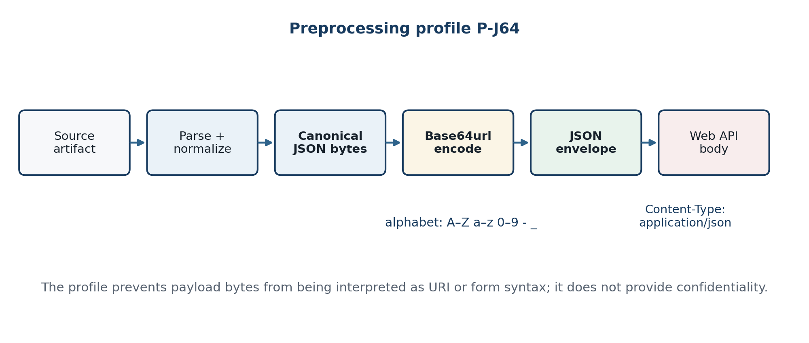
Figure 2.3. JSON formatting and Base64url preprocessing before the control-layer Web API.
b = σJ(Nf(x)); s = βU(b); envelope.payload = s (2.8)
Standard padded Base64 produces four characters for each complete or partial group of three input bytes. Unpadded Base64url has length ceil(4n/3), while padded Base64 has length 4ceil(n/3), excluding JSON-envelope overhead. The approximately one-third expansion is a measurable cost and must be included in Chapter 3's network, memory, and latency evaluation (Josefsson, 2006).
Lpad(n) = 4⌈n/3⌉; Lunpadded(n) = ⌈4n/3⌉ (2.9)
Normative preprocessing algorithm
Algorithm 2.1 Source-side submission under profile P-J64
INPUT: artifact x, source profile f, destination d, operation op
1 classify f and enforce input byte, depth, and time limits
2 (v, meta) ← Nf(x); reject if parsing or schema validation fails
3 b ← canonical UTF-8 JSON serialization of v
or b ← exact source bytes for an opaque profile
4 digest ← SHA-256(b); encoded ← Base64url(b) under declared padding rule
5 M ← envelope(identity, route, f, meta, length(b), digest, encoded)
6 validate M against the envelope schema
7 POST M as application/json with workload identity and idempotency key
8 accept only a typed control-layer result; never log M.payload
OUTPUT: message identifier and lifecycle state, or typed rejection
Base64url reduces ambiguity because its alphabet replaces the standard Base64 characters plus and slash with hyphen and underscore. It does not prevent an intermediary from maliciously or incorrectly rewriting an HTTP body, nor does it make query-string payload transport acceptable. Correctness also requires an exact Content-Type, UTF-8 JSON parsing, declared padding policy, rejection of non-alphabet characters, and no form-decoding stage (Berners-Lee, Fielding, and Masinter, 2005; Josefsson, 2006).
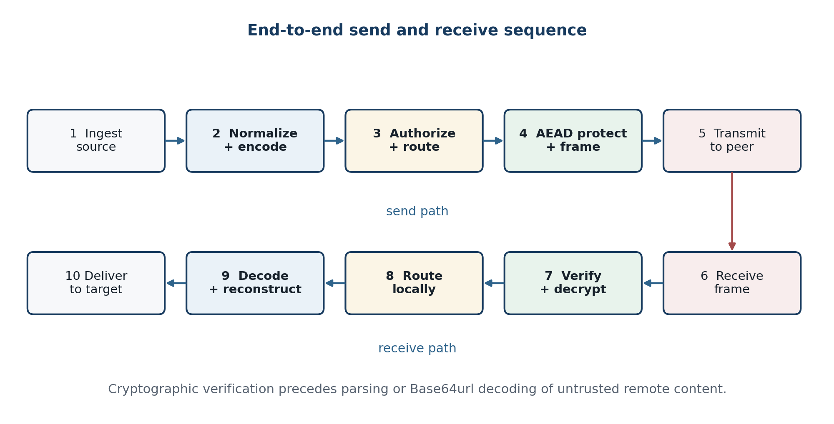
Figure 2.4. Complete source-to-destination processing sequence.
Table 2.6. End-to-end processing obligations
Step | Owner | Precondition | Postcondition
1 | Source adapter | Authenticated endpoint and declared profile | Bounded artifact accepted into exchange memory
2 | Exchange | Valid source syntax and schema | Canonical bytes, metadata, length, digest, Base64url payload
3 | Control | Valid envelope and workload identity | Authorized immutable route and idempotent lifecycle record
4 | Communication | Authorized peer command and usable key/channel | Authenticated protected frame
5 | Network/peer | Frame within limits | Frame received or typed transport failure
6 | Destination communication | Expected peer, version, nonce, and replay state | Verified plaintext envelope bytes
7 | Destination control | Valid envelope and local authorization | Approved target adapter and lifecycle transition
8 | Destination exchange | Declared profile, length, digest, and valid Base64url | Reconstructed artifact satisfying ≈f or byte equality
9 | Target adapter | Destination accepts the operation | Atomic delivery acknowledgment or typed target error

2.1.7 Lifecycle state machine and error taxonomy
A message lifecycle makes partial failure visible. The state represents the last completed invariant, not the thread or process currently handling the message. State transitions use compare-and-set or an equivalent atomic mechanism so concurrent retries cannot advance the same message independently. Terminal states remain queryable for an authorized retention period even though the payload itself is not retained.
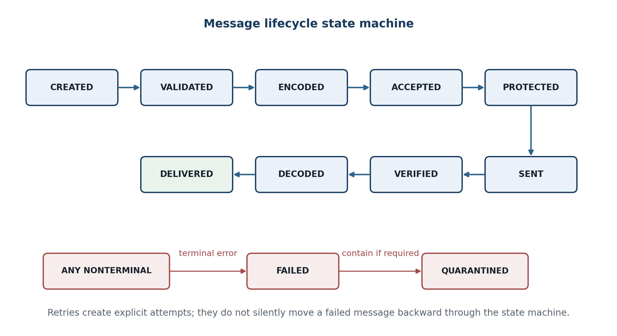
Figure 2.5. Message lifecycle and terminal failure/quarantine paths.
Table 2.7. Principal lifecycle transitions
From | Event or guard | To | Persisted metadata
CREATED | Envelope schema and limits pass | VALIDATED | message_id, profile, sizes, timestamps
VALIDATED | Canonical bytes and Base64url descriptor complete | ENCODED | digest algorithm/value or protected audit token
ENCODED | Identity, route, and quota authorized | ACCEPTED | policy decision id, peer id, idempotency identity
ACCEPTED | AEAD/TLS context established and frame created | PROTECTED | algorithm profile, key id, nonce reference
PROTECTED | Peer accepts frame | SENT | attempt count, duration, response class
SENT | Peer verification and replay checks pass | VERIFIED | peer receipt and verification time
VERIFIED | Base64url, length, digest, and profile checks pass | DECODED | reconstruction profile and validation status
DECODED | Target commits or acknowledges atomically | DELIVERED | target result code and terminal time
Any nonterminal | Terminal validation, policy, authentication, or reconstruction error | FAILED / QUARANTINED | typed error code; no payload

Table 2.8. Error taxonomy and retry policy
Class | Examples | Retry rule | Required response
Representation | Malformed JSON/XML, invalid Base64url, charset error, digest mismatch | Never retry unchanged input | 4xx/typed error; fail before peer or target effect
Policy | Unknown identity, forbidden route, disabled profile, quota exceeded | Retry only after explicit policy/configuration change | Default-deny result and metadata audit
Security | Bad tag, certificate failure, replay, expired message | Never retry same protected frame | Reject, count, alert by threshold; no plaintext release
Transient transport | Timeout, connection reset, temporary peer unavailable | Bounded backoff with same message/idempotency identity | Attempt metadata and eventual terminal result
Target | Destination unavailable, transactional conflict, permanent validation failure | Only target-declared transient codes | Preserve atomicity; distinguish accepted from committed
Internal | Resource exhaustion, invariant violation, dependency failure | Circuit-break or operator-controlled retry | Fail closed; diagnostic correlation without payload

Exactly-once network delivery is not assumed. The practical objective is an idempotent business effect: duplicate submissions with the same authenticated key and digest refer to one lifecycle record, and the target adapter uses that identity inside its commit boundary where supported. When the target cannot participate in such a protocol, the system reports at-least-once or at-most-once semantics explicitly rather than claiming exactly-once behavior.

2.1.8 Formal invariants
The system state S comprises immutable message metadata, lifecycle records, route configuration, identity and authorization policy, cryptographic context, replay state, and transient payload buffers. A transition δ(S, e) is admissible only when all invariants owned by the current layer hold. The following invariants are both design rules and test oracles.
Table 2.9. End-to-end invariants
ID | Invariant | Formal or observable statement
I1 | Envelope validity | Every accepted envelope satisfies exactly one supported schema and profile version.
I2 | Layer immutability | Control and communication operations preserve the authenticated envelope byte string.
I3 | Representation integrity | Decoded length and digest equal the descriptor before reconstruction.
I4 | Authorization | No peer send or local delivery transition occurs without a positive decision for identity, route, operation, and profile.
I5 | Cryptographic release | Destination plaintext is released upward only after peer, tag/channel, freshness, and replay verification.
I6 | Idempotent effect | One authenticated idempotency identity and digest create at most one target effect.
I7 | Payload non-persistence | Approved logs and durable lifecycle state have an empty payload projection.
I8 | Failure atomicity | A terminal failure before target commit produces no declared business effect.
I9 | Program non-execution | Transported program bytes are never loaded or executed by middleware components.
I10 | Bounded resource use | Declared limits bound input size, decoded size, nesting, collections, processing time, attempts, and concurrency.

δ(S, e) is permitted ⇔ ∧k Ik(S, e) = true (2.10)
payload(Log(event, message)) = ⊥ (2.11)
Transient in-memory processing is unavoidable; the invariant forbids durable or telemetry payload capture.
Invariant I7 needs an operational definition. Not recorded means that raw source bytes, canonical plaintext, Base64url payload text, ciphertext samples, and reconstructed artifacts are absent from application logs, access logs, distributed traces, metrics labels, error objects, message-history records, and routine disk spools. The system may persist message identifiers, authorized route identifiers, profile, sizes, times, state, attempt count, and non-sensitive error codes. Crash dumps, heap snapshots, packet capture, and debug tracing are separate recording paths and must be disabled, access-controlled, or governed by an exceptional procedure.

2.1.9 End-to-end correctness argument
Correctness is stated conditionally because a middleware cannot manufacture semantics absent from a profile. Assume A1: Nf and target reconstruction Gg are defined for the chosen source and destination profiles; A2: the JSON serializer and parser agree on UTF-8 and the canonicalization rules; A3: Base64url encoding and strict decoding are inverses; A4: control routing does not mutate the envelope; A5: authenticated decryption either returns the exact plaintext or fails; and A6: the destination validates the same profile version and metadata.
Sendf(x) = Protect(Route(Envelope(βU(σJ(Nf(x)))))) (2.12)
Receiveg = Gg ∘ ParseJ ∘ βU⁻¹ ∘ VerifyDecrypt ∘ Unroute (2.13)
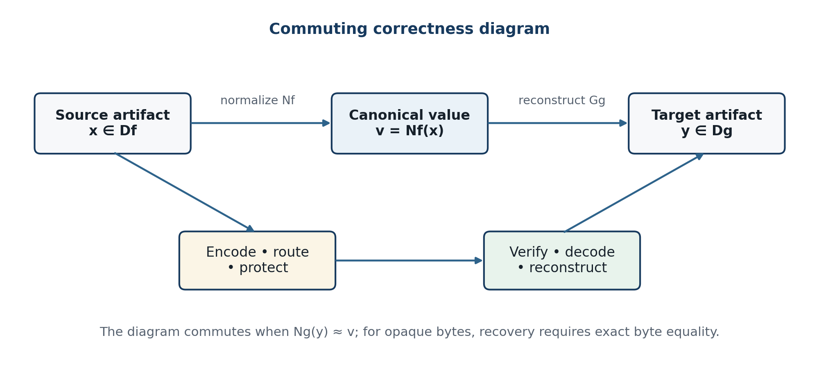
Figure 2.6. Commuting diagram for semantic and byte-preserving round trips.
Proposition 2.1 — structured round-trip preservation. For every x in the supported source domain, if all authorization and validation guards succeed and the network delivers an unmodified authenticated frame, then Ng(Receiveg(Sendf(x))) ≈ Nf(x).

Proof sketch. By A5, verified decryption returns the exact protected envelope bytes. By A4, routing contributes no payload transformation. JSON parsing therefore recovers the validated envelope. By A3, Base64url decoding recovers the serialized bytes exactly. By A2, parsing those bytes recovers the canonical value used by the sender. Finally, A1 and A6 make target reconstruction defined, so target normalization is equivalent to the source normal form. If any assumption fails, the algorithm returns a typed failure instead of a value, so it cannot silently establish a false success state.
Ng(Receiveg(Sendf(x))) ≈ Nf(x) (2.14)
Corollary 2.1 — opaque-byte preservation. When profile f designates x as an opaque byte string and reconstruction is identity over bytes, successful receipt implies recovered(x) = x, length equality, and digest equality.

RecoverBytes(Send(x)) = x ∧ |x'| = |x| ∧ H(x') = H(x) (2.15)
Table 2.10. Correctness obligations and implementation tests
Obligation | Design evidence | Implementation test | Success oracle
Parser/serializer agreement | Profile and canonicalization rules | Generate boundary values and parse after serialization | Equivalent canonical value; no duplicate-name ambiguity
Codec inverse | RFC 4648 alphabet and padding policy | Property test over empty, boundary, random, and maximum-size byte strings | decode(encode(b)) = b
Layer immutability | Typed interface and digest binding | Capture pre-control and post-communication authenticated plaintext in a secure test build | Exact byte equality
AEAD/channel integrity | Algorithm profile and key/nonce rules | Flip ciphertext, tag, nonce, AAD, and frame-length bits | All mutations rejected; no plaintext released
Route authorization | Policy matrix | Enumerate allowed and denied identities, operations, profiles, and destinations | Only allowlisted tuples can send or deliver
Idempotent effect | Key/digest binding and target commit rule | Concurrent duplicate and conflicting submissions | One effect; conflict on key reuse with different digest
Non-persistence | Logging and diagnostic policy | Scan logs, traces, metrics, spools, errors, and crash settings with seeded markers | No raw, canonical, encoded, or reconstructed marker

The proposition demonstrates internal consistency of the architecture, not empirical correctness of a particular build. Chapter 3 must instantiate each obligation with implementation-specific tests and preserve the results, software versions, configuration, and payload corpus. A failed obligation narrows or falsifies the corresponding system claim; it should not be averaged away by aggregate performance statistics.

2.1.10 Security architecture and payload non-persistence
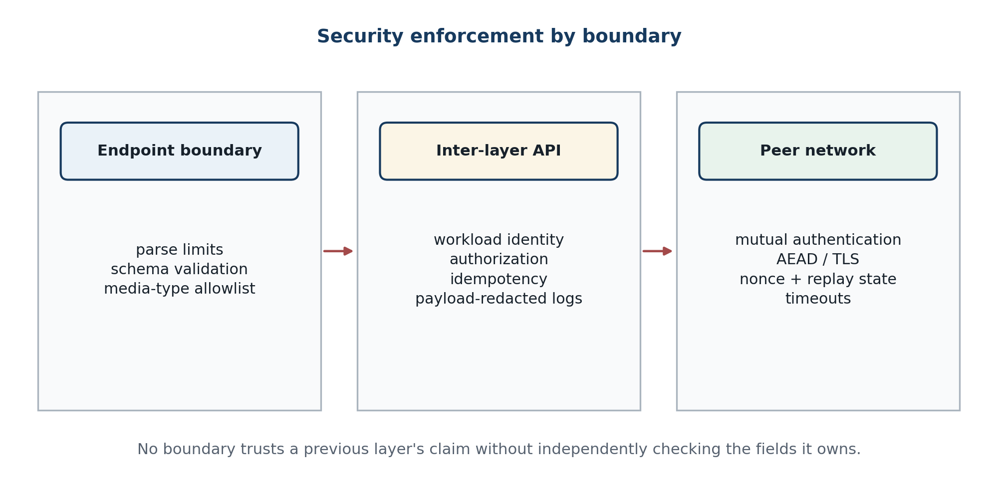
Figure 2.7. Security controls applied independently at each trust boundary.
Security is enforced at three distinct boundaries. Endpoint controls protect parsers and adapters from hostile content. The inter-layer API authenticates workloads and constrains what a compromised or misconfigured component can request. The peer boundary authenticates the remote node, protects traffic, and detects replay. This follows a zero-trust principle: network location and earlier validation are context, not substitutes for the decision owned by the current boundary (Rose et al., 2020).
Table 2.11. Threat-to-control mapping for the proposed architecture
Threat | Primary boundary | Preventive controls | Detective/recovery controls
Malformed or adversarial structured input | Endpoint/exchange | Hardened parser; external entities disabled; schema, depth, count, size, and time limits | Typed error rate; parser sandbox health; corpus regression
Encoded-payload injection or URL transformation | Inter-layer API | Base64url alphabet; application/json body; no query/form payload; strict decoder | Seeded round-trip vectors; invalid alphabet/padding counters
Unauthorized route or operation | Control | Workload identity; default-deny policy; least privilege; signed configuration | Policy-decision audit and anomaly alerting
Disclosure or modification in transit | Peer network | TLS 1.3 and, where required, inner AEAD; authenticated peer binding | Handshake/tag failures; certificate and key-expiry monitoring
Replay or duplicate business effect | Communication/control/target | Nonce discipline; freshness window; replay cache; idempotency and atomic target commit | Duplicate/conflict metrics and reconciliation procedure
Payload leakage through observability | All layers | Structured allowlist logging; body capture disabled; redaction; bounded error detail | Seeded-secret scans of logs, traces, metrics, spools, and dumps
Resource exhaustion | All boundaries | Admission control; quotas; bounded parsing/decoding; concurrency and retry limits | Saturation alarms, circuit breaking, controlled shedding
Malicious program artifact | Exchange/target | Opaque handling; signature/digest policy; quarantine; no execution or dynamic loading | Artifact verification result and manual release audit

Metadata minimization is also a security control. A plain digest may reveal whether a known sensitive object was processed; deployments with this risk can store a keyed audit token or protect the lifecycle record rather than expose a reusable content fingerprint. Message identifiers should be unpredictable, authorization must cover status queries, and retention should be no longer than needed for idempotency, reconciliation, and audit obligations.
Payload non-persistence is compatible with operational observability when the system measures counts, duration, sizes, state transitions, error classes, peer health, and resource use. It is not compatible with logging request bodies, encoded strings, decrypted frames, or reconstructed files for convenience. Exceptional forensic capture, if required, must be an explicit privileged mode with purpose, authorization, encryption, retention, and deletion controls rather than an undocumented debug switch.

2.2 Formalization, Encoding, and Decoding of Multiple Data Types

2.2.1 Canonical envelope and payload descriptor
All supported content is carried by one versioned JSON envelope, while a profile preserves the distinction between semantic values and opaque bytes. The envelope is not a universal replacement for each source format. It is a control contract containing identity, routing, content description, integrity metadata, and a payload representation. A destination selects reconstruction behavior from the profile and schema identifiers rather than guessing from the payload text.
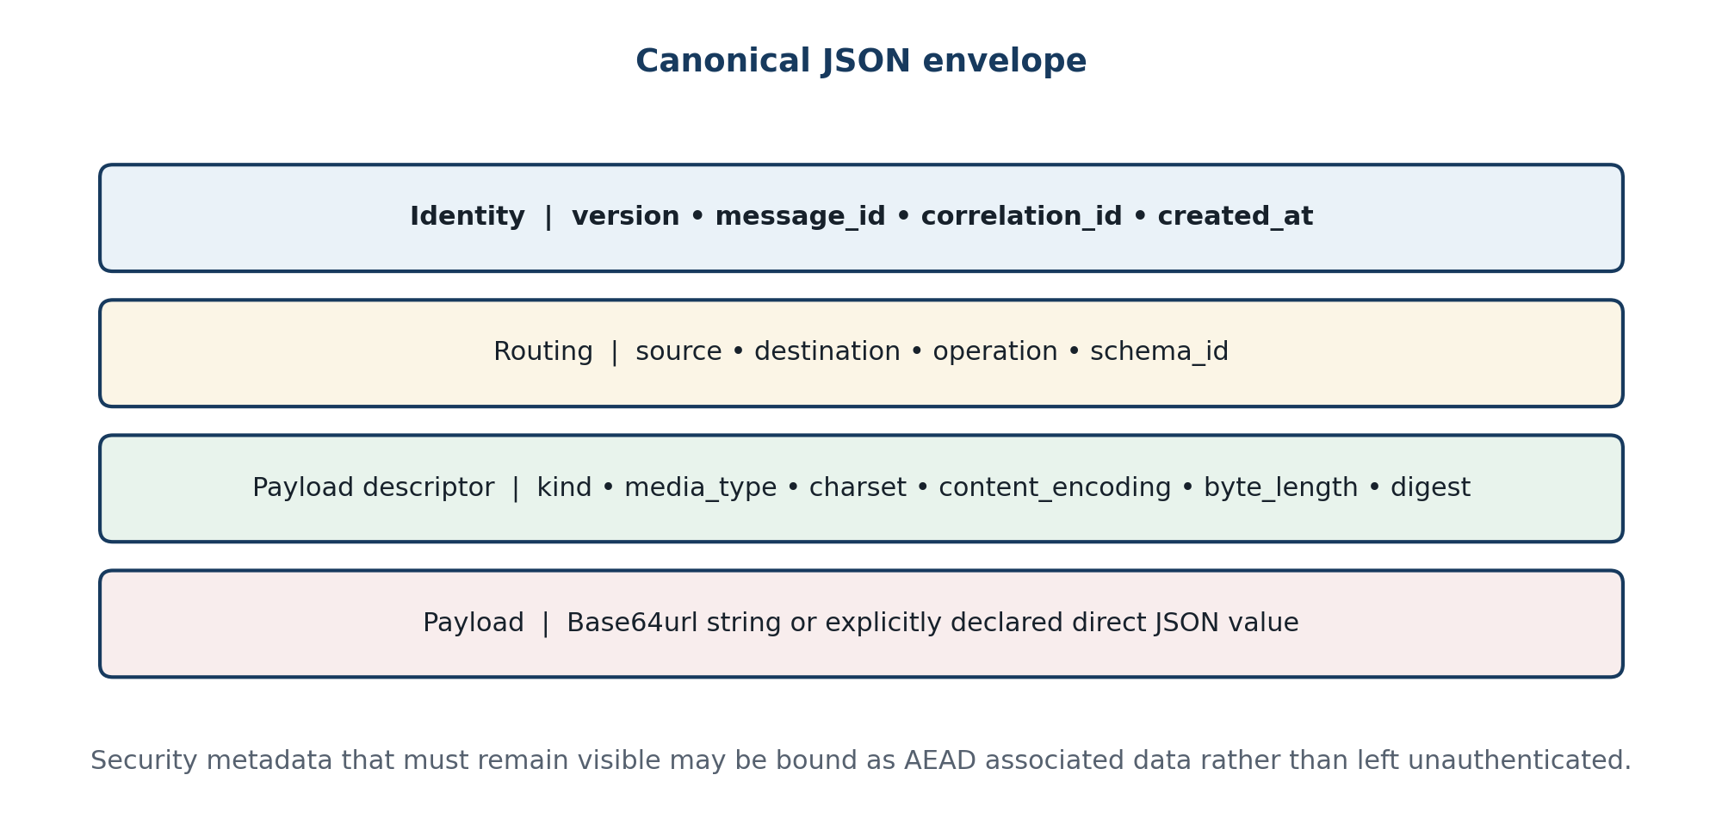
Figure 2.8. Logical anatomy of the canonical JSON envelope.
M = (ver, id, corr, time, src, dst, op, profile, descriptor, payload) (2.16)
Table 2.12. Canonical envelope fields
Field | Type / example | Required meaning and constraint
version | string / 1.0 | Selects one envelope contract; unsupported major versions are rejected.
message_id | UUID or equivalent | Globally unique, unpredictable message identity; never reused.
correlation_id | string | Links business workflow events without changing idempotency semantics.
created_at | RFC 3339 timestamp | UTC creation time used with configured age and clock-skew limits.
source / destination | object identifiers | Stable logical identities, not unauthenticated network addresses.
operation | allowlisted string | Names a configured target action; never evaluated as code.
profile | name + version | Defines source domain, normalization, byte representation, padding, and reconstruction.
schema_id | URI or registry key | Identifies the payload schema when structured validation is required.
descriptor.kind | json, xml, text, tabular, binary, program | Selects policy class; must agree with the profile.
media_type / charset | registered type / UTF-8 | Declares interpretation; charset omitted for arbitrary binary.
content_encoding | base64url | Names the binary-to-text codec and profile-specific padding rule.
byte_length | nonnegative integer | Length after Base64url decoding and before reconstruction.
digest | algorithm + value | Full digest of the protected payload bytes; checked before reconstruction.
payload | string or declared JSON value | Base64url text in P-J64; direct JSON only in a separate explicit profile.

Example 2.1 — abbreviated P-J64 envelope for {"a":1,"b":[true,null]}
{
"version": "1.0",
"message_id": "018f3a67-9b42-7c11-8d31-52dfe663ef10",
"created_at": "2026-09-07T12:00:00Z",
"route": {"source": "sys-A", "destination": "sys-B",
"operation": "record.import"},
"profile": {"name": "json-jcs-b64u", "version": "1"},
"descriptor": {
"kind": "json", "media_type": "application/json",
"charset": "UTF-8", "content_encoding": "base64url",
"byte_length": 23,
"digest": {"alg": "sha-256",
"value": "1cc69c7fa23616ca...942f8668"}
},
"payload": "eyJhIjoxLCJiIjpbdHJ1ZSxudWxsXX0"
}
The displayed digest is abbreviated only for page layout; a transmitted envelope must carry the complete value specified by the profile. Security-critical routing fields are either inside the authenticated plaintext or repeated as AEAD associated data and compared after decryption. An implementation must not authorize one header and deliver a different encrypted header.

2.2.2 JSON Schema and canonicalization rules
The envelope schema rejects unknown required semantics rather than accepting arbitrary extension fields. JSON Schema Draft 2020-12 can express structural types, patterns, bounds, conditional requirements, and closed objects (JSON Schema, 2022; Pezoa et al., 2016). It cannot by itself prove that a Base64url string decodes successfully, that decoded length and digest agree, or that an identity may use a route. Those checks belong to semantic validation and policy after structural validation.
Example 2.2 — structural core of the envelope schema
{
"$schema": "https://json-schema.org/draft/2020-12/schema",
"$id": "urn:middleware:envelope:1.0",
"type": "object",
"required": ["version", "message_id", "created_at", "route",
"profile", "descriptor", "payload"],
"additionalProperties": false,
"properties": {
"version": {"const": "1.0"},
"message_id": {"type": "string", "format": "uuid"},
"created_at": {"type": "string", "format": "date-time"},
"payload": {"type": "string", "pattern": "^[A-Za-z0-9_-]*$"}
}
}
Example 2.3 — abbreviated payload-descriptor schema
"descriptor": {
"type": "object",
"required": ["kind", "media_type", "content_encoding",
"byte_length", "digest"],
"additionalProperties": false,
"properties": {
"kind": {"enum": ["json", "xml", "text", "tabular",
"binary", "program"]},
"content_encoding": {"const": "base64url"},
"byte_length": {"type": "integer", "minimum": 0,
"maximum": 10485760}
}
}
Table 2.13. Validation and canonicalization sequence
Order | Rule | Reason
1 | Decode the HTTP body as UTF-8 JSON; reject invalid Unicode and trailing data. | Creates one unambiguous envelope value.
2 | Reject duplicate object member names before any canonicalization. | Different parsers otherwise may select different values.
3 | Validate the closed envelope schema, formats, ranges, and conditional fields. | Prevents unbounded or structurally inconsistent requests.
4 | Resolve exactly one profile and schema version from the registry. | Stops implicit fallback or schema confusion.
5 | Strictly decode Base64url using the declared padding rule and alphabet. | Rejects covert variant acceptance and malformed payload text.
6 | Check decoded length and digest using constant-time comparison where relevant. | Detects truncation, substitution, and metadata mismatch.
7 | Parse/validate decoded structured content according to the profile. | Separates envelope validity from payload validity.
8 | Canonicalize only the fields/profile that require a deterministic representation. | Avoids treating canonicalization as universal semantic equivalence.

When deterministic JSON bytes are required for a digest or signature, the profile can use the JSON Canonicalization Scheme (Rundgren, Jordan, and Erdtman, 2020). JCS has important domain restrictions: input must already have unambiguous member names and compatible number and string behavior. Applications requiring decimal precision beyond the interoperable JSON number domain should encode the value as a constrained string with an explicit decimal schema, not rely on parser-specific floating-point behavior.

2.2.3 Representation profiles and selection
A representation profile is a versioned tuple defining accepted media types, source validation, normalization, canonical byte construction, content encoding, metadata, reconstruction, equivalence, and resource limits. Profiles are configuration data reviewed and deployed with the middleware; they are not selected from a class name supplied by an untrusted message.
Pf = (Df, Validatef, Nf, σf, β, Metaf, Gf, ≈f, Limitsf) (2.17)
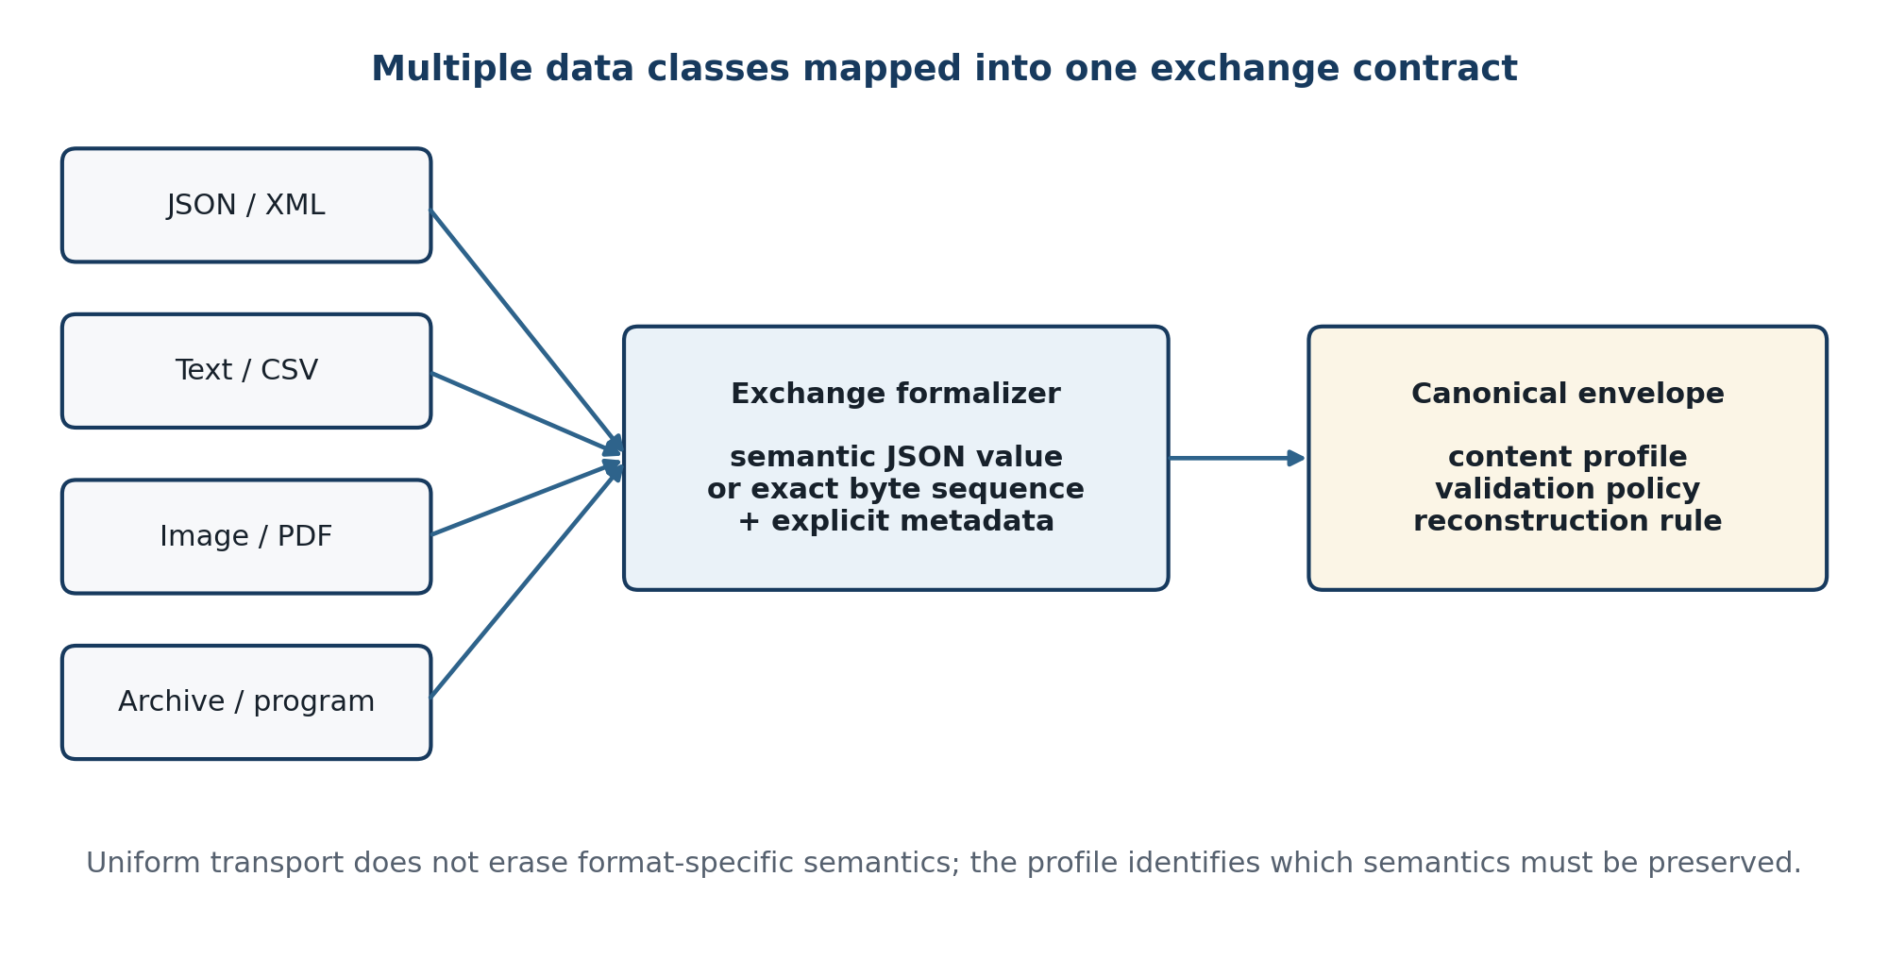
Figure 2.9. Mapping heterogeneous source classes into a common envelope without erasing profile semantics.
Table 2.14. Core representation profiles
Profile | Canonical bytes | Equivalence / reconstruction | Primary use
json-jcs-b64u/v1 | JCS-compatible UTF-8 JSON | Equal canonical JSON value | Structured Web/API records needing deterministic bytes
json-bytes-b64u/v1 | Exact received JSON bytes after syntax validation | Exact byte equality; optional parsed-value check | Signed or whitespace-sensitive JSON artifacts
xml-bytes-b64u/v1 | Exact bounded XML bytes | Exact byte equality; hardened well-formedness/XSD checks | Namespace, mixed-content, signature, or document-preserving XML
xml-map-json-b64u/v1 | Canonical JSON mapping defined by one transformation version | Application equivalence within a declared XML subset | Cross-format XML-to-JSON integration
text-utf8-b64u/v1 | Strict UTF-8 bytes | Equal Unicode scalar sequence; optional declared normalization | Plain text with controlled charset conversion
tabular-json-b64u/v1 | Canonical JSON columns plus row arrays | Equal typed cells, row order, nulls, and column metadata | CSV, delimited, and fixed-width exchange
binary-b64u/v1 | Exact source bytes | Exact byte, length, and digest equality | Images, PDF, office files, audio/video, archives
program-signed-b64u/v1 | Exact source bytes | Exact bytes plus signature/provenance policy | Executable, library, script, package, or firmware artifact

The profile identifier is part of the authenticated message and remains immutable in transit. A new mapping rule, normalization form, number policy, delimiter rule, or padding behavior creates a new profile version. Reusing the same version for changed semantics makes stored test vectors and interoperability results uninterpretable.

2.2.4 Text and character-set data
Text handling begins with an explicit choice between semantic text and byte-exact text. In the semantic profile, the source decoder uses the declared charset in strict mode; malformed byte sequences cause rejection, never replacement characters. The resulting Unicode scalar sequence is serialized as UTF-8. Newline conversion and Unicode normalization are disabled by default because both can alter signatures, identifiers, or visually indistinguishable strings. If an application requires NFC or normalized line endings, the profile names the rule and the source is considered semantically, not byte, equivalent.
Table 2.15. Text formalization rules
Concern | Semantic text profile | Byte-exact profile
Charset | Required at ingress; decode strictly and output UTF-8 | Metadata records declared type, but bytes are not transcoded
BOM | Handled only according to the declared charset/profile | Preserved as ordinary source bytes
Malformed sequence | Reject with charset error | Transport unchanged; target decides whether to interpret
Newlines | Preserve by default; optional versioned LF rule | Preserve CR/LF bytes exactly
Unicode normalization | None by default; optional declared NFC rule | Never normalize
Equivalence | Equal Unicode scalar sequence after declared rules | Exact byte, length, and digest equality

Example 2.4 — UTF-8 text encoded with unpadded Base64url
Source text: Hello, 世界
UTF-8 byte length: 13
Base64url: SGVsbG8sIOS4lueVjA
Receiver check: strict decode → 13 bytes → UTF-8 parse → same scalar sequence

2.2.5 JSON and XML structured data
JSON has two useful profiles. The semantic profile rejects duplicate names, validates a schema, and canonicalizes the value before Base64url encoding. It preserves values but not source whitespace or original member order. The byte profile validates syntax but carries the exact received bytes and can therefore preserve formatting or a pre-existing signature. The receiving adapter must know which property is intended; it cannot claim both source-byte identity and normalized canonical bytes unless the input was canonical already (Bray, 2017).
XML likewise supports an exact-byte profile and an application mapping profile. Exact-byte transport is the safe default when namespaces, attributes, mixed content, comments, processing instructions, lexical form, or XML signature behavior matters. An XML-to-JSON mapping is allowed only when a versioned transform defines element and attribute naming, namespace representation, sibling order, mixed text, nil/null, numeric typing, and repeated elements. The general XML information model is richer than JSON's value model, so an unspecified conversion is not a lossless middleware operation (W3C, 2008; W3C, 2012).
Table 2.16. JSON and XML profile behavior
Input case | Profile decision | Canonical payload | Round-trip claim
JSON business record | json-jcs-b64u/v1 after schema validation | Deterministic UTF-8 JSON bytes | Equal canonical value; lexical formatting may differ
Signed JSON document | json-bytes-b64u/v1 | Exact source bytes | Exact bytes and signature material preserved
XML with namespaces/mixed content | xml-bytes-b64u/v1 | Exact source bytes | Exact bytes; optional safe well-formedness/XSD validation
Restricted XML record | xml-map-json-b64u/v1 with explicit transform | Mapped canonical JSON bytes | Equivalent application record within the declared subset
Unknown XML mapping | Reject cross-format request or use exact-byte profile | No guessed projection | No false lossless-conversion claim

Example 2.5 — declared XML-to-JSON application mapping
XML source: <order id="A7"><amount currency="USD">12.50</amount></order>
Versioned application mapping:
{"order":{"id":"A7","amount":{"currency":"USD","value":"12.50"}}}
Rules: @id → id; @currency → currency; decimal lexical value remains a string.
The mapping is valid only for the schema subset that defines these rules.
XML parser hardening is independent of representation choice. External entity resolution and unrestricted external schema access are disabled; entity expansion, depth, node count, text length, and processing time are bounded. A payload that is well-formed but violates the selected XSD or application profile is rejected before routing. Equivalent controls apply to excessive JSON nesting, array length, object members, string length, and number syntax.

2.2.6 CSV, tabular, and fixed-width data
Delimited and fixed-width files are not self-describing enough for dependable exchange. The tabular profile records column identity, order, logical type, null representation, source delimiter or field positions, quoting/escape rules, header presence, charset, and row-order semantics; even the common CSV format depends on explicit conventions (Shafranovich, 2005). The canonical payload uses a columns array and a rows array so that a value such as 00123 is not silently converted to the number 123 and an empty string is not confused with null.
Table 2.17. Tabular formalization rules
Source feature | Required metadata | Canonical representation | Reconstruction check
CSV/delimited | Delimiter, quote, escape, header, charset, newline | Typed columns plus row arrays | Cell count/type, row count/order, declared lexical preservation
Fixed-width | Start, width, alignment, padding, charset for each field | Typed columns plus row arrays and layout profile | Field boundaries and required padding reconstructed
Decimal | Scale, precision, sign, decimal separator | Constrained decimal string | No binary floating-point coercion
Date/time | Format, zone policy, calendar, missing-zone rule | Constrained canonical string | Parsed instant/local value matches profile
Null/empty | Distinct source tokens and nullable columns | JSON null versus empty string | Distinction preserved
Identifiers | String type and length | JSON string | Leading zeros and case preserved

Example 2.6 — canonical tabular JSON preserving identifiers, decimals, nulls, and empty strings
{
"columns": [
{"name":"account_id", "type":"string"},
{"name":"amount", "type":"decimal", "scale":2},
{"name":"note", "type":"string", "nullable":true}
],
"rows": [["00123", "12.50", ""], ["00124", "0.00", null]],
"row_order": "significant"
}

2.2.7 Images, documents, archives, and arbitrary binary
Images, PDF and office documents, audio/video, archives, proprietary files, and unknown binary content use the binary profile. The exchange layer does not decode or re-encode the file format merely to transport it. It checks the configured media-type allowlist, source byte limit, optional magic-byte consistency, full byte length, and digest; then it Base64url-encodes the exact bytes. The destination verifies encoding, length, and digest before writing to a controlled target or passing an in-memory stream to the authorized adapter.
Archive extraction is not part of generic transport. If a target workflow requires extraction, it occurs after delivery in a sandboxed, policy-specific service with limits on file count, path traversal, symbolic links, nested archives, expanded size, and expansion ratio. Similarly, antivirus or content-disarm processing may be attached as a named policy stage, but any transformation changes the byte-equivalence claim and must produce a new artifact identity and digest.
chunks(n, q) = ⌈n/q⌉; Σi |bi| = n; H(b1 || ... || bk) = H(b) (2.18)
q is the maximum decoded chunk size; ordering and whole-object digest remain mandatory.
For payloads exceeding the single-message limit, the design can use ordered chunks. Every chunk has the parent message identity, index, count, decoded length, and chunk digest; the manifest carries the whole-object length and digest. A destination does not expose a partial object as delivered. It either verifies and atomically assembles all chunks or expires and removes the incomplete set according to retention policy.

2.2.8 Program artifacts and the non-execution policy
A program artifact includes an executable, library, script, package, container layer, firmware image, macro-enabled document, or other content that could cause execution. The middleware treats every such artifact as opaque bytes. Its role is to preserve, authenticate, authorize, and deliver the artifact—not to import, link, install, unpack, render, execute, or dynamically inspect it in the middleware process. This boundary is consistent with secure software-development and provenance practices that require artifacts to be identifiable and verifiable (Souppaya, Scarfone, and Dodson, 2022).
Table 2.18. Program-artifact controls
Control | Required metadata or behavior | Failure disposition
Identity | Artifact name as data, media type, size, digest, producer, build/provenance reference | Reject missing mandatory provenance fields
Signature | Approved signature format, signer identity, certificate/transparency evidence where applicable | Quarantine on absent, invalid, expired, revoked, or unauthorized signer
Authorization | Destination, operation, artifact type, signer, and version policy | Default-deny; no fallback to generic binary delivery when program policy applies
Storage | Non-executable staging location, randomized server-side name, least privilege | Remove/expire incomplete or rejected staging object
Processing | No import, dynamic loading, macro expansion, archive extraction, or execution | Invariant violation triggers fail-closed alert
Delivery | Target acknowledgment identifies accepted artifact digest and policy result | No DELIVERED state until target atomically accepts the verified object

A filename is never used directly as a filesystem path or command argument. The destination adapter creates a safe server-side identifier and stores the original display name only as metadata. If post-delivery execution is a legitimate business action, a separate deployment system performs it under its own authorization, sandbox, signature, rollback, and audit controls.

2.2.9 Generic encoding and decoding algorithms
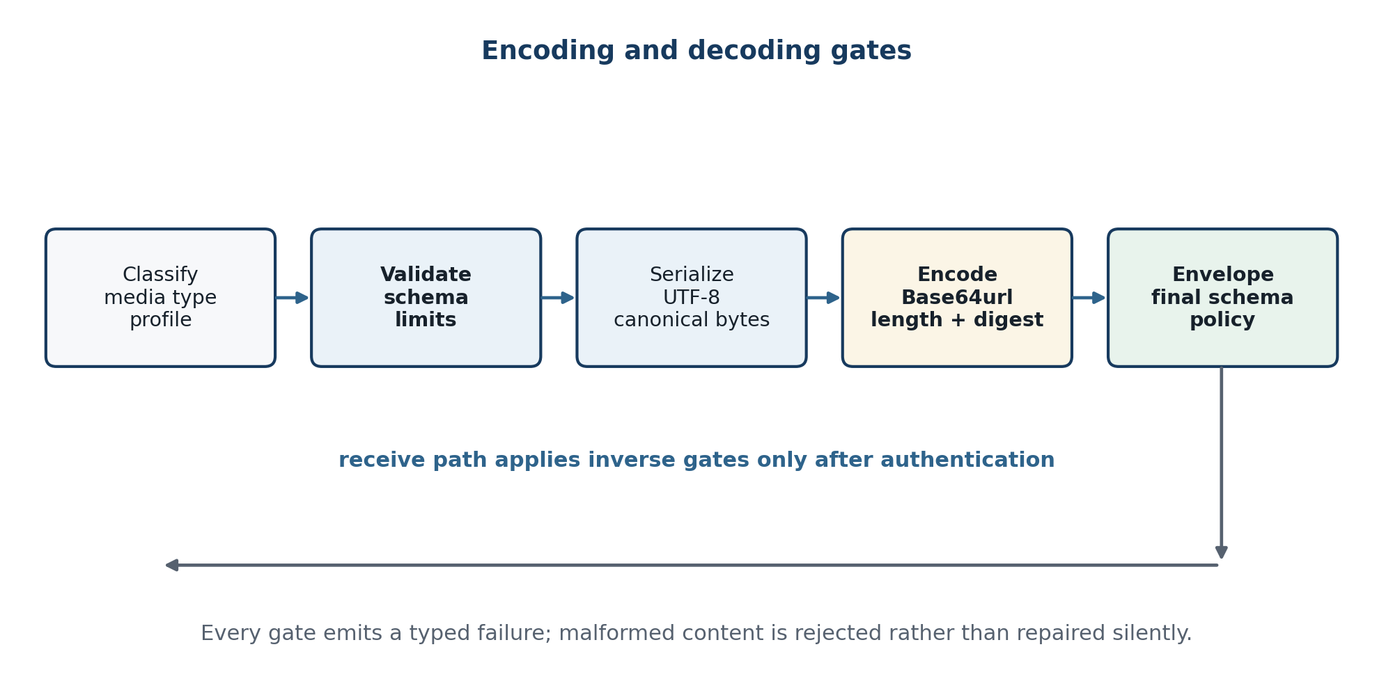
Figure 2.10. Validation gates surrounding encoding and reconstruction.
Normative generic encoding algorithm
Algorithm 2.2 EncodeArtifact(x, profile_id)
1 P ← registry.resolve(profile_id); require P.enabled
2 require size(x) ≤ P.input_limit
3 (value_or_bytes, meta) ← P.normalize_and_validate(x)
4 b ← P.serialize(value_or_bytes)
5 require size(b) ≤ P.decoded_limit
6 s ← strict_Base64url_encode(b, P.padding)
7 d ← {length:size(b), digest:SHA-256(b), ...meta}
8 M ← build_envelope(P, d, s); validate_envelope(M)
9 return immutable M
Normative generic decoding and delivery algorithm
Algorithm 2.3 DecodeArtifact(verified_envelope M, target_profile g)
1 require M arrived from verified communication and authorized control
2 validate_envelope(M); P ← registry.resolve(M.profile)
3 require policy.allows(P, g, M.route.operation)
4 b ← strict_Base64url_decode(M.payload, P.padding, P.decoded_limit)
5 require size(b) = M.descriptor.byte_length
6 require constant_time_equal(SHA-256(b), M.descriptor.digest)
7 v ← P.parse_and_validate(b)
8 y ← g.reconstruct(v, M.descriptor); validate_target(y)
9 deliver y atomically; clear transient payload buffers
10 return target result or typed failure
The receiver checks the decoded-size limit while decoding, not after allocating an attacker-declared length. Length and digest are checked before expensive reconstruction. Failure clears transient buffers as far as the runtime permits and prevents a success acknowledgment. Memory clearing cannot be guaranteed by every managed runtime, so process isolation, least privilege, disabled core dumps, and short buffer lifetime remain relevant.

2.2.10 Normative test vectors
The following vectors are specification examples, not measurements from the author's implementation. They fix expected Base64url behavior at empty, Unicode, alphabet-sensitive, structured, XML, and binary boundaries. Padding is omitted. The digest column shows only a diagnostic prefix; automated tests use the full SHA-256 value.
Table 2.19. Normative unpadded Base64url test vectors
Vector | Input bytes / meaning | Expected Base64url | SHA-256 prefix
V0 | empty byte string | empty string | e3b0c44298fc
V1 | UTF-8: Hello, 世界 | SGVsbG8sIOS4lueVjA | a281e84c7f61
V2 | hex: ff 00 2b 2f 3d | _wArLz0 | 5a05367d6b59
V3 | canonical JSON: {"a":1,"b":[true,null]} | eyJhIjoxLCJiIjpbdHJ1ZSxudWxsXX0 | 1cc69c7fa236
V4 | UTF-8 XML: <m id="7">ok</m> | PG0gaWQ9IjciPm9rPC9tPg | 662da048a033
V5 | PNG signature: 89 50 4e 47 0d 0a 1a 0a | iVBORw0KGgo | 4c4b6a3be131

Negative vectors are equally important. The decoder must reject plus, slash, unexpected equals padding, whitespace, non-ASCII characters, impossible residual lengths, decoded-size overflow, length mismatch, and digest mismatch. A permissive library mode that ignores whitespace or accepts both Base64 alphabets is disabled because different implementations could authenticate or reconstruct different byte sequences from the same textual input.

2.2.11 Conformance and accuracy demonstration method
Accuracy is evaluated by properties, not by visually comparing a few output files. The valid corpus includes schema boundaries, empty values, null/empty distinctions, Unicode and newline cases, extreme numeric values, namespace and mixed-content XML, tabular lexical values, random binary, and signed program artifacts. The invalid corpus applies one controlled mutation at a time so the expected failure layer and code are known.
Table 2.20. Conformance suite for multiple data exchange
Test family | Generation / mutation strategy | Oracle
Semantic round trip | Generate values inside each structured profile, including boundary and nested cases | Target normal form ≈ source normal form
Byte round trip | Random bytes at lengths 0, 1, 2, 3, powers of two, profile limits, and file corpus | Recovered bytes, length, and full digest equal source
Cross-format mapping | Generate values in the declared XML/JSON or tabular subset | Both sides normalize to the same application value
Codec rejection | Mutate alphabet, padding, whitespace, residual length, and decoded size | Strict exchange-layer rejection; no target effect
Envelope validation | Remove, duplicate, add, mistype, or exceed each field constraint | Stable schema/semantic error; no routing
Tamper/authentication | Mutate ciphertext, tag, nonce, AAD, peer identity, and frame length | Communication-layer rejection; no plaintext release
Authorization | Cartesian sample of identities, destinations, operations, kinds, and profiles | Only policy-allowed tuples proceed
Replay/idempotency | Replay protected frames and submit concurrent duplicate/conflicting keys | No repeated effect; conflict for changed digest
Non-persistence | Embed unique marker strings and inspect all telemetry/persistence paths | No source, encoded, decrypted, or reconstructed marker recorded
Resource limits | Oversize, deep nesting, huge arrays, decompression/archive stress, retry storm | Bounded rejection and continued service for allowed traffic
Program safety | Signed, unsigned, invalid-signature, renamed, and archive-contained program artifacts | Verified bytes delivered or quarantined; nothing executed

A_sem = N_correct / N_valid; D_inv = N_rejected / N_invalid (2.19)
A_byte = N_exact / N_opaque; E_FA = N_invalid-accepted / N_invalid (2.20)
A conforming design targets A_sem = 1 and A_byte = 1 over the declared supported domain, with zero false acceptance in the invalid and security-negative suites. These are acceptance conditions, not estimates to be reported without observations. Chapter 3 provides corpus size, generation seeds, exclusions, confidence intervals where sampling is used, and the actual counts from the frozen reference implementation.

2.3 Chapter Summary
The proposed middleware assigns representation semantics to the exchange layer, identity/routing/lifecycle policy to the control layer, and authenticated peer transmission to the communication layer. The source path normalizes or preserves input bytes, forms canonical bytes, Base64url-encodes them under a declared profile, and submits an immutable JSON envelope through an application/json Web API. The control layer authorizes and routes without recording the payload, while the communication layer protects the envelope. The destination verifies and decrypts before the control layer authorizes local delivery and the exchange layer decodes and reconstructs the target artifact.
The formal correctness argument follows from the inverses of canonical serialization, strict Base64url coding, non-mutating routing, and verified cryptographic protection, combined with a defined source/target equivalence relation. Profile-specific rules preserve JSON values, exact XML or JSON bytes, Unicode text, typed tabular values, arbitrary files, and signed program artifacts. Typed errors, state transitions, resource limits, idempotency, replay defense, payload non-persistence, and program non-execution make the round-trip claim operationally testable. Chapter 3 shows how the disclosed reference implementation instantiates and performs against these obligations.

Chapter 3. Implementation and Performance Evaluation
This chapter implements and evaluates the architecture defined in Chapter 2. Because the author's proprietary middleware source, deployment topology, and benchmark logs were not supplied, the empirical object is a disclosed research reference prototype constructed directly from the proposed design. This distinction is substantive: the measurements establish what this implementation did in its recorded environment, not what every conforming system will do and not what an unseen production system has achieved.
Section 3.1 presents the physical and logical configuration, layer implementations, Web API boundary, operating procedure, and functional outcome. Section 3.2 defines the indicators and experimental controls before reporting latency, throughput, representation expansion, memory, thread concurrency, loopback HTTP, paired XML/JSON, and failure observations. Every numeric statement is derived from the frozen CSV or JSON evidence set; development diagnostics and warm-up iterations are excluded from the reported observations by design.
Empirical claim. Within the declared single-host prototype scope, the layered pipeline preserves the required semantic value or opaque byte string for every timed operation, rejects the exercised malformed and tampered inputs, and exposes measurable costs that depend strongly on profile, payload size, and concurrency. One restart experiment also identifies a clear security limitation: replay protection is not restart-safe while nonce state remains volatile.

3.1 Implementation Results

3.1.1 Evidence boundary and artifact provenance
The implemented artifact consists of three compact Python modules and one deterministic harness. middleware.py contains the representation profiles and the exchange, control, communication, and composition classes. web_api.py places the canonical JSON envelope behind a bounded HTTP endpoint. benchmark.py generates a fixed corpus, executes the functional suite, captures raw wall and process time, and writes the environment and result files. The complete run began at 2026-09-08T18:27:50Z and completed at 2026-09-08T18:28:59Z.
Evidence integrity is provided at two levels. First, the manifest binds each source and result file to a SHA-256 digest. Second, an independent validation program rereads the raw CSV observations, recomputes medians, p95 and p99 values, process-time medians, throughput, and Base64url lengths, and checks scenario accounting. It completed 115 of 115 checks with zero failed checks. Its overall assessment is “Share with caveats,” because calculation correctness does not remove the external-validity limits of one virtualized host and a deliberately small reference implementation.
Table 3.1. Prototype evidence artifacts and provenance
Artifact | Role | Frozen evidence
middleware.py | Three-layer core and six profiles | SHA-256 6658cbfd766f6a61…
web_api.py | Bounded application/json endpoint | SHA-256 2cc5c2aa03d3fda7…
benchmark.py | Corpus, tests, timings, and export | SHA-256 7762cff3462431c6…
latency_raw.csv | All post-warm-up per-operation timings | 6,336 rows; ab0958cc4fcd9388…
benchmark_results.json | Consolidated method and summaries | SHA-256 f63ffbe9077d83aa…
manifest.json | Full source/result digest register | Created 2026-09-08T18:28:59Z
validation_report.json | Independent recomputation and caveats | 115/115 checks passed
benchmark_analysis.ipynb | Executed reader-facing companion analysis | Six code cells executed top-to-bottom

The digest prefixes in Table 3.1 are navigation aids; the full 256-bit values remain in the manifest. A result is included in the thesis only if it appears in the final clean run whose source hashes match that manifest. The prototype therefore supplies reproducible evidence for the proposed architecture while preserving the editorial boundary around the author's unavailable system.

3.1.2 Physical deployment configuration
The physical configuration is intentionally controlled. The core benchmark composes the three logical layers in one CPython process so that serialization, policy, encryption, verification, and reconstruction can be measured without an uncontrolled wide-area path. A second experiment exposes the same pipeline through a ThreadingHTTPServer bound to 127.0.0.1 and submits envelopes over a persistent HTTP/1.1 connection. The destination is a test sink that checks equivalence and then releases the reconstructed object from the in-memory result registry.
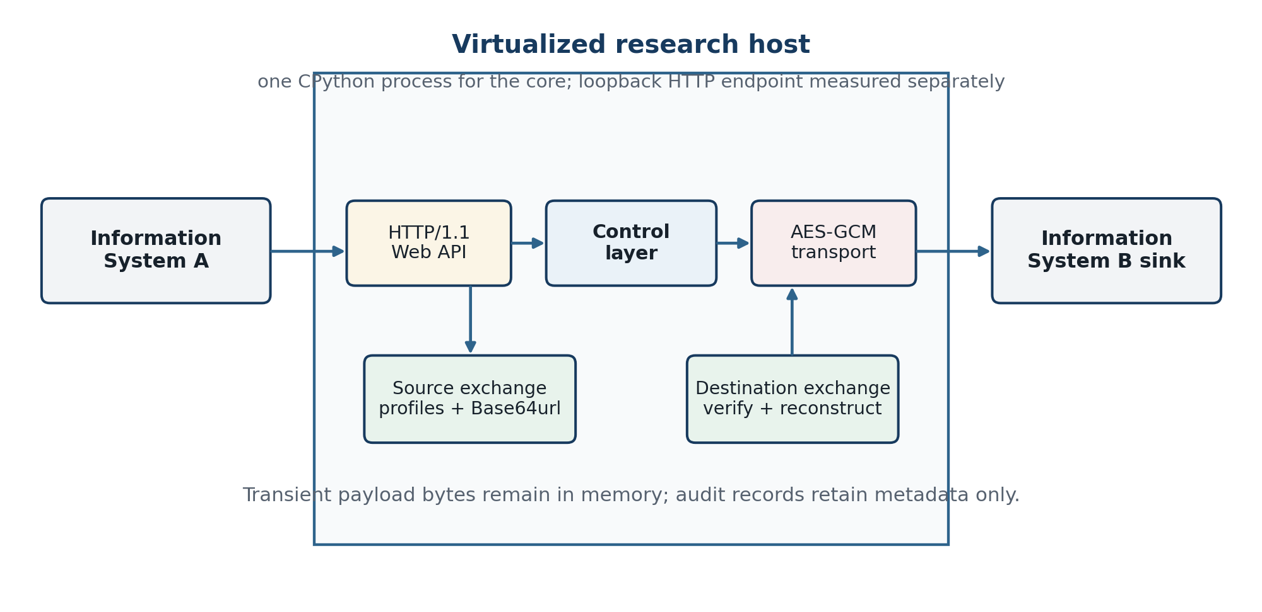
Figure 3.1. Physical configuration of the single-host research prototype.
Table 3.2. Research execution environment
Property | Recorded value | Interpretation
Host class | Virtualized Linux container | No bare-metal or dedicated-host claim
CPU | INTEL(R) XEON(R) PLATINUM 8573C | 9 logical CPUs visible; affinity 0–8
Memory | 15.64 GiB visible | No swap-dependent workload was introduced
Kernel / architecture | 6.18.35 / x86_64 | One x86-64 execution environment
Python | 3.12.13 (main, Aug 7 2026, 02:25:39) | Single CPython process for core timings
Cryptography | cryptography 46.0.0 | AES-GCM and Ed25519 implementation
Analysis stack | NumPy 2.3.5; pandas 2.2.3 | Summary and validation calculations
Timer | perf_counter_ns; 1e-09 s nominal resolution | Monotonic wall clock; process_time_ns for CPU
Network scope | IPv4 loopback for API experiment | No WAN, proxy, TLS handshake, or multi-host delay
Random seed | 20260908 | Deterministic corpus and bootstrap resampling

Logical separation is preserved even though the processes are collocated. This allows direct comparison of profile validation, preprocessing, and the complete protected pipeline. It does not demonstrate independent scaling, fault containment between hosts, routing through a broker, or network confidentiality outside the inner AES-GCM frame. Those deployment properties require a distributed experiment and are retained as limitations in Section 3.2.10.

3.1.3 Logical component configuration
The logical implementation follows the downward dependency rule defined in Section 2.1. The exchange layer knows profiles and representations but not routing policy or cryptographic keys. The control layer reads route and descriptor metadata, binds the message identity, records state, and never decodes the payload. The communication layer receives only canonical envelope bytes plus a route binding and returns plaintext only after authenticated decryption succeeds. The composition object orchestrates these calls without moving format-specific logic into the lower layers.
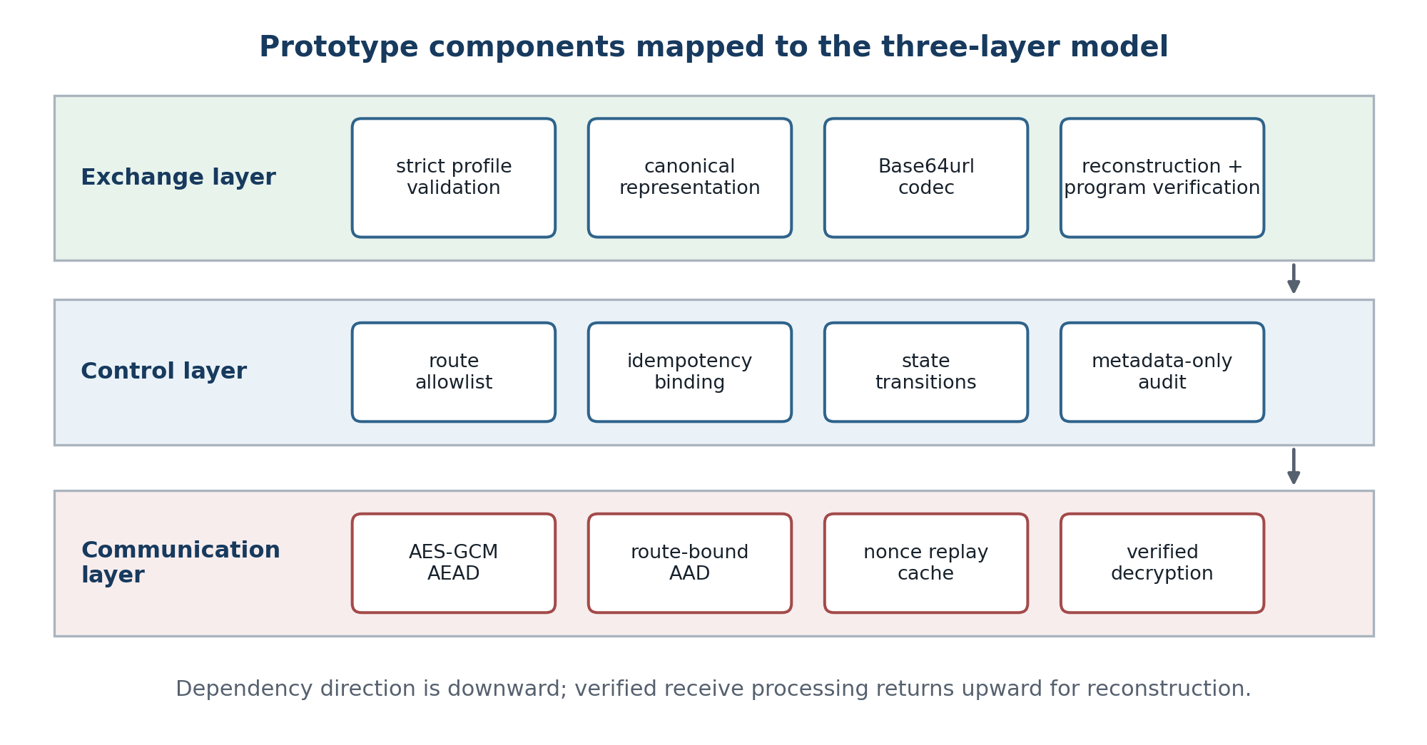
Figure 3.2. Prototype components mapped to the exchange, control, and communication layers.
Table 3.3. Implementation-to-architecture traceability
Design obligation | Implementation element | Observed evidence | Boundary
Format-specific validation | prepare_payload and strict parsers | Malformed JSON, XML, text, and CSV rejected | Declared profiles only
Transport-safe representation | Unpadded Base64url codec | Forbidden alphabet, padding, and impossible length rejected | JSON request body
Uniform envelope | ExchangeLayer.form_envelope | Six data classes use one versioned object | Prototype schema, not a registry service
Default-deny routing | ControlLayer.allowed_routes | Unlisted source/destination/operation rejected | Static in-memory policy
Idempotency binding | message ID → envelope digest | Same retry classified; conflicting reuse rejected | Volatile state
Payload-free audit | ControlLayer._record | Clear and Base64url seed absent from audit events | Application audit only
Authenticated transport | AESGCM encrypt/decrypt | Ciphertext, AAD, and wrong-key changes rejected | Inner frame, no TLS experiment
Replay check | Accepted-nonce set | Same-process replay rejected | Not restart-safe
Safe program handling | Ed25519 verification + bytes return | Signed artifact preserved; sentinel never created | No sandboxed execution service

This traceability table is also an architectural accuracy check. Each design obligation has a concrete code location, an observable result, and a stated boundary. A requirement without one of these elements is not treated as implemented. For example, the Chapter 2 design anticipates restart-resistant replay control; the prototype has a replay module, but the restart experiment demonstrates that its volatile storage is insufficient for the stronger claim.

3.1.4 Exchange-layer implementation
The exchange layer implements six versioned profiles. A profile selects the accepted source domain, canonical byte construction, media type, logical kind, equivalence relation, and reconstruction function. The envelope stores these choices explicitly; the receiver does not infer them from a filename or from payload text. Before Base64url encoding, the implementation computes the canonical byte length and a SHA-256 digest. After decoding, both values are checked before reconstruction.
Table 3.4. Implemented representation profiles
Profile | Kind | Source-to-canonical rule | Reconstruction and equivalence
json-canonical-v1 | JSON | Strict UTF-8 parse; duplicate names and non-finite numbers rejected; keys sorted; compact separators | Strict parse to a JSON value; semantic value equality
xml-exact-v1 | XML | DTD/entity declarations rejected; well-formed XML bytes retained exactly | Revalidate and return identical bytes; byte equality
text-utf8-v1 | Text | Strict UTF-8 validation; text encoded as UTF-8 | Strict UTF-8 decode; Unicode-string equality
csv-semantic-v1 | Tabular | Strict CSV parse; stable column count; header and rows encoded as canonical JSON | Emit normalized RFC-style CRLF CSV; row/field equality
binary-exact-v1 | Binary | Input octets retained without interpretation | Return identical octets; byte equality
program-opaque-signed-v1 | Program | Input octets retained; Ed25519 signature and never-execute policy attached | Verify signature and return bytes; byte equality; no loading or execution

The JSON serializer is deterministic for the prototype domain because it uses UTF-8, sorted object keys, compact separators, and forbids NaN and infinities. It is not presented as a complete implementation of RFC 8785 for every ECMAScript numeric edge case. Therefore, cross-language JCS conformance remains future work even though the Python prototype is internally deterministic. XML is deliberately byte-preserving rather than canonicalized; this keeps namespace prefixes, attribute quoting, whitespace, and declaration bytes unchanged after validation.
The CSV profile demonstrates a different preservation contract. CSV does not carry a universal scalar type system, so fields remain strings and row structure is the semantic object. Reconstruction normalizes line endings and quoting. Consequently, byte equality is neither expected nor asserted for CSV; equality is evaluated by parsing both source and destination and comparing the header and row matrices. This distinction explains part of the additional CPU and memory cost reported later.
Implemented strict, unpadded Base64url acceptance rule
encoded = urlsafe_b64encode(canonical_bytes).rstrip(b"=")
reject_if("=" in text or forbidden_alphabet(text))
reject_if(len(text) mod 4 == 1)
decoded = strict_base64_decode(text + required_internal_padding)
reject_if(base64url_encode(decoded) != text)
The re-encoding comparison in the final line rejects alternate textual forms that decode to the same bytes. Standard Base64 characters “+” and “/” and any external “=” padding are invalid in this profile. The Web API still uses an application/json body, so Base64url is defense in depth against accidental URI-sensitive handling rather than a substitute for correct media-type processing.

3.1.5 Control-layer implementation
The control layer implements a static allowlist of (source, destination, operation) tuples. It extracts this tuple from the envelope, rejects unknown routes before encryption, and applies the same rule on the receive side. A message identifier is then bound to a digest of the canonical envelope excluding created_at. Excluding that timestamp permits a legitimate retry to refresh temporal metadata while keeping route, profile, descriptor, and payload identity fixed. Reuse with any other change raises an idempotency conflict.
b(m) = SHA-256(C14N(m \ {created_at})); duplicate iff id equal and b equal (3.1)
Table 3.5. Control-layer decisions and stored metadata
Decision / state | Input examined | Stored or emitted metadata | Payload treatment
Route authorization | source, destination, operation | Authorized or typed denial | Payload string not decoded
New identity | message_id and canonical binding | Binding plus AUTHORIZED state | Binding covers payload indirectly
Duplicate identity | Same message_id and binding | DUPLICATE event | Completed duplicate is suppressed
Conflicting identity | Same message_id, different binding | Typed conflict | No forwarding
SENT | Envelope and protected-frame sizes | message_id, route, profile, byte counts | No body or encoded string
VERIFIED / COMPLETED | Authenticated receive result | State transition and identifiers | Reconstruction occurs in exchange layer

Audit events are append-only objects in prototype memory. Their fields are event time, message identity, state, source, destination, operation, profile, canonical byte count, and, for the send event, envelope and frame sizes. Functional case F29 sends a deterministic secret marker and then scans the serialized audit sequence for both the clear marker and its Base64url representation. Neither occurs. This demonstrates application-level non-persistence for the exercised path; it does not exclude operating-system buffers, packet capture, process dumps, or infrastructure telemetry outside the prototype.
State and idempotency data are volatile. This is useful for isolating logic in a reference implementation, but a production control plane requires atomic durable state, bounded retention, multi-instance coordination, and an authorization model for status queries. The implementation result is therefore correct at the stated scope and incomplete as a high-availability deployment.

3.1.6 Communication-layer implementation
The communication layer accepts canonical envelope bytes and route-derived additional authenticated data. It creates a fresh 96-bit nonce with the operating system random source and applies AES-GCM with a 256-bit key. The cryptography library returns ciphertext followed by the 128-bit authentication tag. Decryption first requires an exact AAD match, then verifies the tag, and only then exposes plaintext to the destination control and exchange layers.
frame = (n, AES-GCM.EncK(n, envelope, AADroute), AADroute) (3.2)
Table 3.6. Communication-layer mechanisms and limitations
Mechanism | Implemented configuration | Observed enforcement | Unimplemented production concern
Confidentiality + integrity | AES-GCM, 256-bit key, 96-bit nonce | Clear marker absent; bit changes and wrong key rejected | Key vault, rotation, separation of duties
Metadata binding | AAD = source || destination || operation | Altered route binding rejected | Canonical peer-identity federation
Replay detection | Locked in-memory accepted-nonce set | Second acceptance in same process rejected | Shared/durable state and expiry window
Thread safety | Locks around replay checks and updates | 768/768 successes at each worker point | Multi-process/distributed coordination
Transport channel | Inner encrypted frame in process | Verified encryption/decryption path | TLS 1.3 handshake and certificate lifecycle

Nonce uniqueness is a critical AES-GCM precondition. The prototype obtains nonces from os.urandom and rejects a nonce already accepted by the current receiver. It does not persist that set. Section 3.2.9 deliberately reconstructs a receiver with the same key and no prior state; the old frame then decrypts. This negative result prevents the thesis from overstating replay resistance and directly identifies the storage requirement for the next implementation phase.
The program signature is enforced by the exchange layer because it is an artifact property, not transport encryption. The source attaches an Ed25519 signature to the descriptor and the destination verifies it before returning the bytes. A test artifact contains code that would create a sentinel file if executed; the signature verifies, the bytes are preserved, and the sentinel remains absent. Thus the implementation demonstrates verified delivery without conflating transport with execution authorization.

3.1.7 Web API and information-system connectivity
The interface adapter binds only to the loopback address for the experiment and exposes POST /v1/exchange. It requires Content-Type application/json, reads a declared body length no greater than 16 MiB, parses the body with the same strict JSON rules, and passes the resulting envelope to the control layer. Form-encoded bodies receive HTTP 415, and a query string appended to the exchange path is not routed. These rules prevent an intermediary from treating the payload as application/x-www-form-urlencoded data or applying plus-to-space conversion.
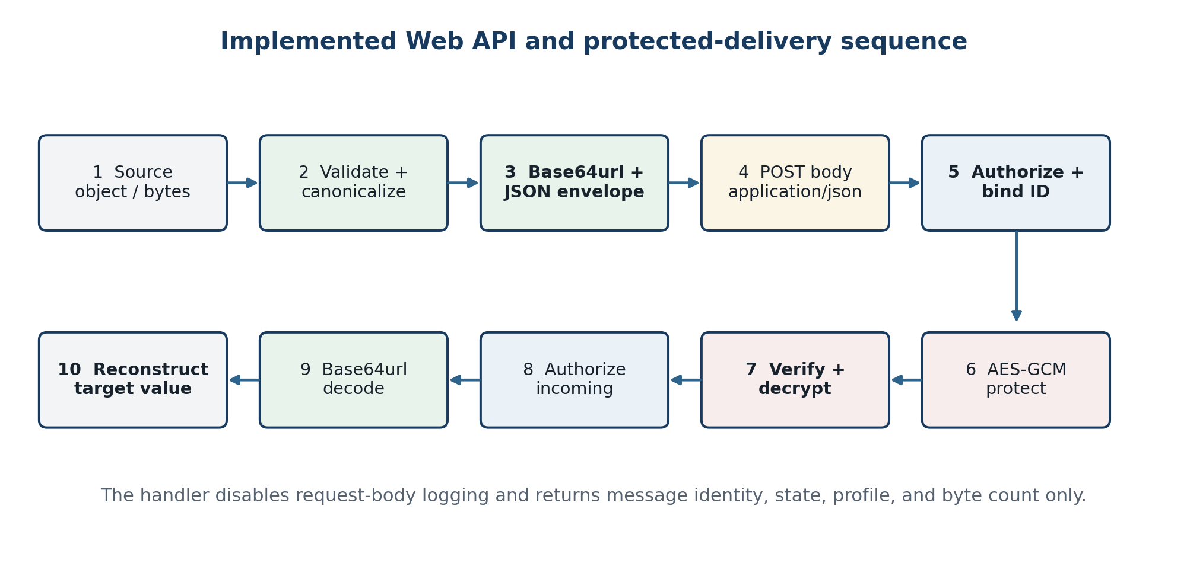
Figure 3.3. Implemented JSON Web API and protected-delivery sequence.
Table 3.7. Implemented Web API contract
Element | Implemented rule | Response / error | Security purpose
Method and path | POST /v1/exchange exactly | 404 for any other path or query variant | One explicit body-bearing operation
Media type | application/json | 415 for form or other media types | Avoid form/URL transformations
Body length | Content-Length required; ≤ 16 MiB | 413 outside bound | Bound memory and parser exposure
Body parse | Strict UTF-8 JSON object | 400 typed invalid-message response | Reject malformed and ambiguous JSON
Authorization | Control-layer route allowlist | 403 authorization response | Default-deny route policy
Idempotency | Identifier/content binding | 409 on conflicting reuse | Prevent ambiguous duplicate effects
Success | Synchronous completed delivery | message_id, profile, state, canonical byte count | Metadata-only response
Caching / log | Cache-Control: no-store; default access log disabled | No body is written by handler | Reduce unintended payload persistence

The API result demonstrates connectivity at the protocol boundary, not interoperability with a named enterprise product. Information System A is represented by the client that constructs an envelope; Information System B is the destination sink that receives the reconstructed value. Connecting a real network requires workload identity, TLS, certificate validation, DNS and service discovery, gateway policies, and destination-specific adapters. None is silently assumed from the successful loopback result.

3.1.8 Operating procedure and JSON exchange demonstration
Use begins with a declared profile and allowlisted route. The caller does not manually create padding or concatenate a URL. It supplies a Python JSON value or source bytes to the exchange layer, which returns the complete envelope. The Web API client sends the envelope as the request body. The destination result is obtained only after route authorization, authenticated decryption, descriptor checks, Base64url decoding, digest verification, and profile reconstruction have succeeded.
Reference operating example for a JSON value
pipeline, route = build_reference_pipeline(key)
source = {"sensor": "S-7", "value": 21, "valid": True}
envelope = pipeline.form(PROFILE_JSON, source, route)
with LoopbackEndpoint(pipeline) as endpoint:
connection = HTTPConnection("127.0.0.1", endpoint.port)
reply = post_envelope(connection, envelope)
delivered = endpoint.state.deliveries[envelope["message_id"]]
assert reply["state"] == "COMPLETED"
assert delivered.reconstructed == source
Table 3.8. Operating procedure and observable result
Step | Actor / layer | Operation | Observable success condition
1 | Source information system | Choose profile, route, and source value | Input lies in declared profile domain
2 | Exchange layer | Validate, canonicalize, digest, and Base64url-encode | Versioned envelope with length and digest
3 | Web API / control | POST application/json; authorize route and identity | AUTHORIZED metadata event; no body log
4 | Communication layer | AES-GCM encrypt with route AAD | Fresh nonce and protected frame
5 | Destination communication/control | Reject replay; verify tag and route | VERIFIED state only after decryption
6 | Destination exchange | Decode, verify descriptor, reconstruct | Semantic or byte-equivalent destination value
7 | Destination information system | Consume the typed value or opaque artifact | COMPLETED metadata state

Functional case F31 executes this interface path with a JSON object and verifies that the returned application result equals the source. Its HTTP response deliberately omits the payload. F32 and F33 then confirm that form transport and query-string payload transport are refused. The three cases jointly demonstrate the intended interface discipline: payload content belongs in a JSON body, while status output contains only operational metadata.

3.1.9 Functional conformance and implementation result
The functional suite contains 33 named cases. Six cases exercise valid round trips for JSON, XML, UTF-8 text, CSV, binary, and signed program data. Twenty-one cases require a malformed, ambiguous, unauthorized, tampered, replayed, or incorrectly transported input to be rejected. The remaining six check a canonical Base64url vector, duplicate classification, program non-execution, audit non-persistence, ciphertext non-disclosure, and successful Web API use. All 33 observed the expected result.
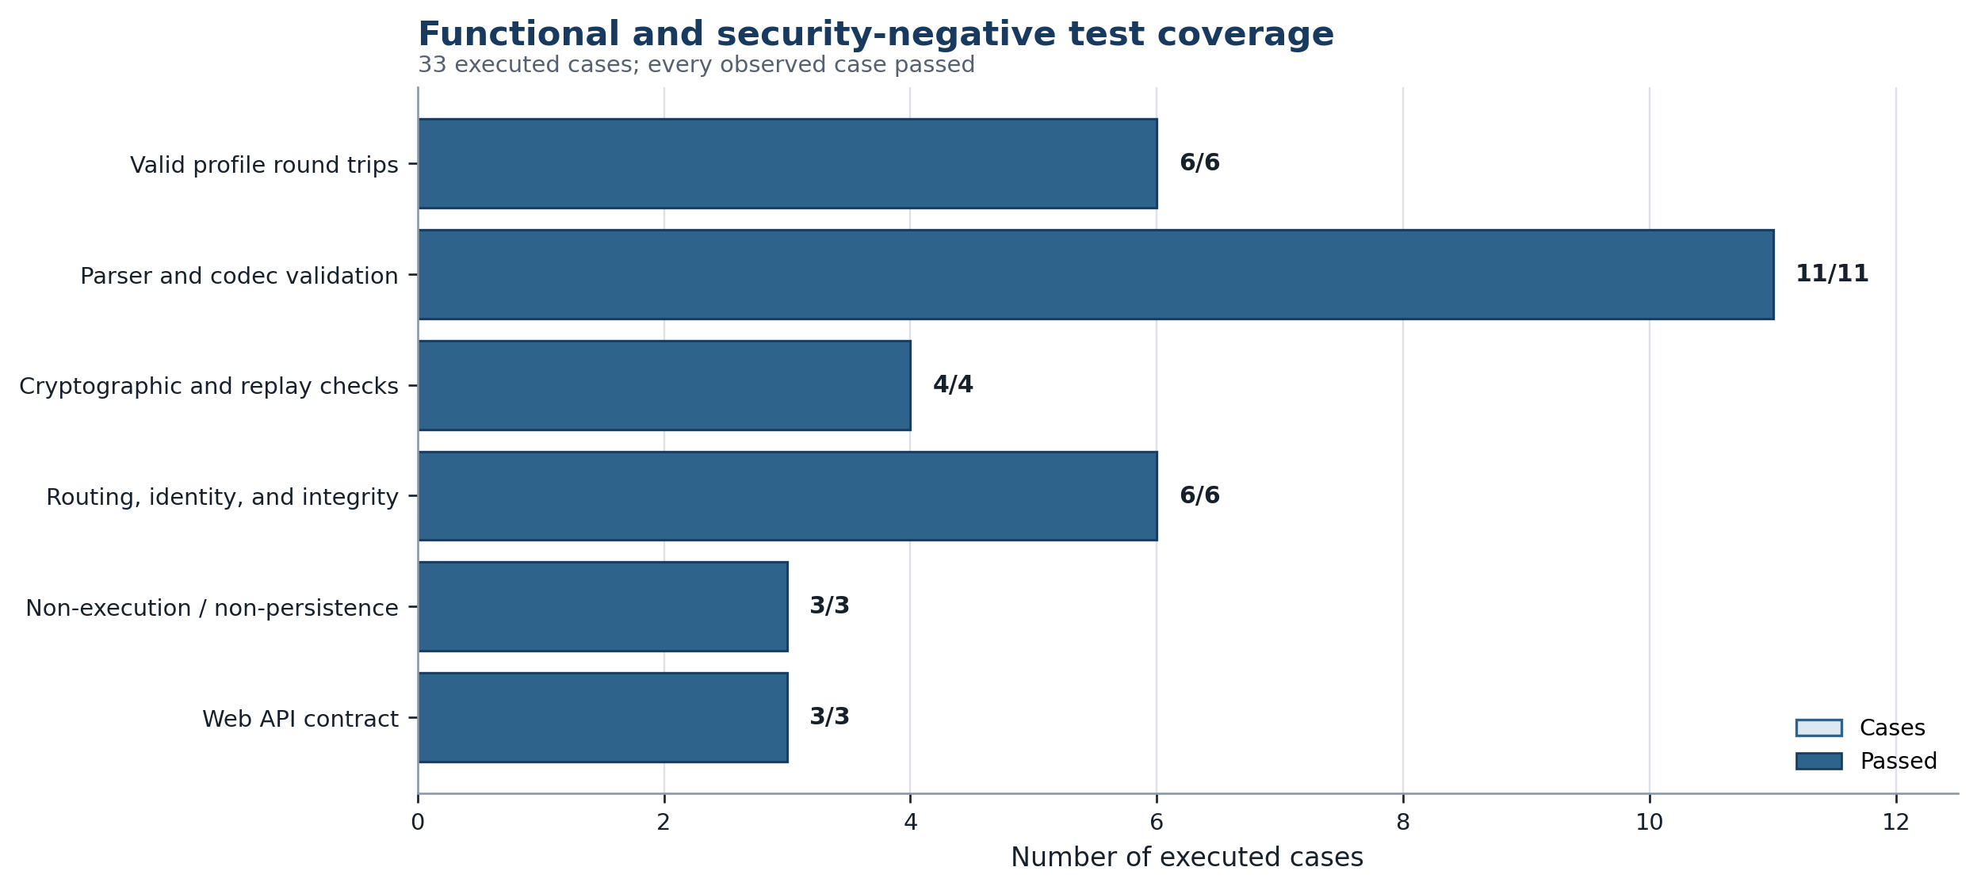
Figure 3.4. Functional and security-negative coverage of the reference implementation.
Table 3.9. Functional and security-negative result groups
Group | Cases | Executed | Passed | Oracle
Valid profile round trips | F01–F06 | 6 | 6 | Semantic/byte reconstruction as declared
Parser and codec validation | F07–F17 | 11 | 11 | Malformed/ambiguous forms rejected; valid vector preserved
Cryptographic and replay checks | F18–F21 | 4 | 4 | Tamper, AAD, replay, and wrong-key inputs rejected
Routing, identity, and integrity | F22–F27 | 6 | 6 | Deny, duplicate/conflict, digest, signature, and kind behavior
Non-execution / non-persistence | F28–F30 | 3 | 3 | Program not run; audit/ciphertext seed checks satisfied
Web API contract | F31–F33 | 3 | 3 | JSON body accepted; form and query transport refused

A_timed = N_equivalent / N_timed = 6336 / 6336 = 1.000 (3.3)
D_negative = N_expected-rejection / N_negative = 21 / 21 = 1.000 (3.4)
Every one of the 6,336 measured operations also performs an equivalence assertion after timing; an incorrect result would terminate the clean run before summaries or manifest creation. This yields an observed timed-corpus accuracy of 1.000. It is not a proof for all possible inputs. The valid corpus is deterministic and representative of the six declared profile classes, while exhaustive Unicode, XML grammar, floating-point, archive, and program-format spaces remain beyond the experiment.
The implementation result therefore supports the compositional argument in Chapter 2 for the exercised domain: each profile's reconstruction relation holds, the control layer does not alter payload text, and authenticated transport returns the exact envelope accepted by the destination. The same result also identifies what the architecture alone cannot guarantee—parser completeness, durable state, distributed availability, or safe execution after delivery.

3.2 Performance Evaluation

3.2.1 Indicators, formulas, and interpretation rules
Performance is evaluated as a vector rather than a single score. The primary response measure is per-operation wall latency. Median latency represents the typical operation, while p95 and p99 expose tail behavior. Throughput converts the original source-byte count—not the larger envelope count—into MiB per second at the median latency. Process CPU time is recorded beside wall time, and tracemalloc supplies a bounded view of Python-visible allocations.
Lp = percentilep({tend,i − tstart,i}); p ∈ {50, 95, 99} (3.5)
Throughput50 = source_bytes / (L50 × 2^20) MiB/s (3.6)
Expansion = represented_bytes / source_bytes (3.7)
Speedup(c) = X(c) / X(1); Efficiency(c) = Speedup(c) / c (3.8)
Table 3.10. Performance indicators and interpretation
Indicator | Unit / statistic | Purpose | Interpretation constraint
Round-trip accuracy | count and ratio | Verify semantic or byte preservation | Defined per profile; not one universal equality
Latency | µs or ms; p50/p95/p99 | Typical and tail response time | Includes only the named processing scope
Process CPU | median µs | Approximate compute demand | Includes whole process; host scheduling still affects it
Throughput | MiB/s at median | Source payload processing rate | Not a sustained capacity or SLA
Base64url expansion | encoded/canonical bytes | Verify 4/3 asymptotic cost | Exact small-size ratio depends on modulo three
Envelope/frame expansion | wire/source bytes | Measure representation and protection overhead | CSV canonical bytes may exceed source bytes
Traced peak | median MiB | Compare Python-visible allocation | Excludes some native allocations; not RSS
Concurrency speedup | ratio vs one worker | Locate best tested thread point | Thread-only result; no process scaling
Recovery outcome | accepted/rejected and time | Verify retry/fail-closed behavior | Fault model limited to named injections

No production service-level objective was provided. Consequently, the chapter does not invent a pass threshold for latency or throughput. Correctness and negative-security outcomes have binary oracles; performance outcomes are descriptive comparisons within the recorded environment. The design expectations are that cost increases with bytes, fixed envelope overhead diminishes with size, semantic parsing costs more than opaque copying, and thread scaling may saturate because shared state and CPython execution serialize parts of the path.

3.2.2 Experimental environment, corpus, and procedure
The main matrix crosses six profiles, four target sizes, and three processing scopes. profile_validation performs the profile's source validation/canonical construction followed by direct reconstruction. preprocess_round_trip adds envelope construction, SHA-256, strict unpadded Base64url encode/decode, and program signature work where applicable. full_three_layer additionally applies allowlist and idempotency logic, metadata state transitions, AES-GCM encryption and decryption, replay checking, destination authorization, and final reconstruction.
The deterministic generator targets 1 KiB, 10 KiB, 100 KiB, and 1 MiB source values. JSON uses records plus a padding field; XML uses a well-formed UTF-8 document; text uses valid UTF-8; CSV uses a header and variable-length rows; binary uses seeded pseudo-random octets; and program data contains a non-executed header plus seeded bytes. Each timed result is followed by a semantic or byte-equivalence assertion outside the timing interval.
Table 3.11. Benchmark workload and repetition plan
Workload | Configuration | Recorded observations
Main latency matrix | 6 profiles × 4 sizes × 3 scopes | 72 scenarios; 6,336 timings
1 KiB | 10 warm-ups; 160 repetitions per profile/scope | 2,880 timings
10 KiB | 8 warm-ups; 120 repetitions per profile/scope | 2,160 timings
100 KiB | 4 warm-ups; 60 repetitions per profile/scope | 1,080 timings
1 MiB | 2 warm-ups; 12 repetitions per profile/scope | 216 timings; tails exploratory
Memory | 6 profiles × 4 sizes; 5 trials through 100 KiB, 3 at 1 MiB | 24 summarized scenarios
Thread concurrency | 1, 2, 4, 8 workers; 768 requests each; 100 KiB binary | 3,072 successful requests
Web API | JSON and binary at 10/100 KiB; persistent loopback HTTP/1.1 | 80 or 40 requests per scenario
Paired structured | Same 10, 100, 1,000, and 5,000 records in JSON and XML | 8 format/size scenarios
Failure | Transient pre-send fault, bit corruption, replay-cache restart | 60, 100, and 1 trials

All reported observations occur after the configured warm-up and none is removed as an outlier. Medians receive a nonparametric 95% bootstrap interval based on 1,500 resamples with a deterministic group-specific seed. The raw file retains wall nanoseconds and process nanoseconds for every operation. Because the 1 MiB groups contain only 12 points, their p95 and p99 values are included for transparency but interpreted as exploratory order statistics rather than stable service-level estimates.

3.2.3 Accuracy and security-negative evaluation
The first evaluation gate is correctness. All 6,336 timed operations returned the expected value or byte string, and the harness reported no scenario error. All 33 named functional cases also passed. The negative suite rejects malformed JSON, duplicate object members, NaN, malformed XML, DTD/entity declarations, invalid UTF-8, malformed CSV quoting, forbidden or padded Base64url, tampered ciphertext, altered AAD, replay, wrong key, unauthorized route, conflicting message identity, digest mismatch, bad program signature, mismatched kind, form encoding, and query transport.
The independent validation reran 115 evidence checks and passed all of them. It verified file hashes, row counts, uniqueness of case IDs, profile and stage coverage, nonnegative and null-free timing data, configured repetitions, recomputed percentiles and throughput to a relative tolerance below 10^-12, the exact unpadded Base64url length formula, memory and request accounting, paired XML/JSON coverage, and environment fields. Accordingly, no calculation blocker remains in the frozen evidence set.
Interpretation limit. A zero observed error rate is a corpus result, not proof that the parser, cryptographic library, or application is defect-free. Fuzzing, cross-language interoperability, dependency review, constant-time analysis, and independent penetration testing remain necessary before production assurance.

3.2.4 Latency and throughput results
Figure 3.5 shows the median full-pipeline result on logarithmic axes. Every profile becomes slower as the payload grows. At 1 KiB, medians range from 0.092 ms for binary to 0.245 ms for the signed-program profile; fixed object creation, timestamp, digest, encryption, state, and signature costs are visible. At 1 MiB, binary records 20.81 ms, UTF-8 text 26.40 ms, signed program 28.83 ms, XML 39.71 ms, JSON 48.67 ms, and CSV 103.93 ms.
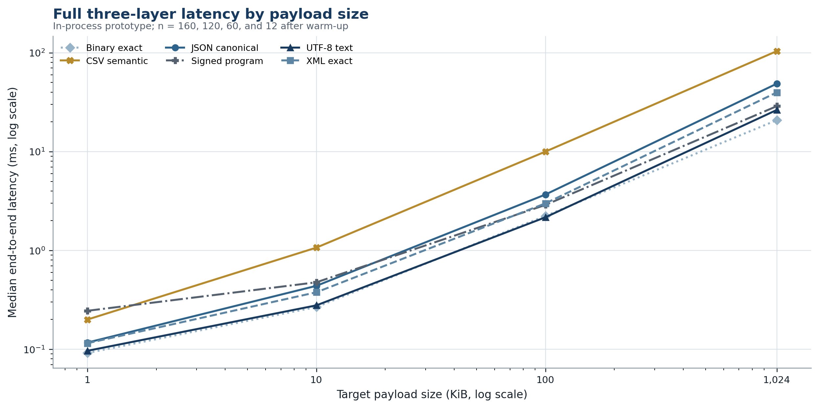
Figure 3.5. Median full three-layer latency by profile and target payload size.
Table 3.12. Observed full-pipeline latency and throughput
Profile | 1 KiB p50  (ms) | 10 KiB p50  (ms) | 100 KiB p50  (ms) | 1 MiB p50  (ms) | 1 MiB p95  (ms) | 1 MiB throughput  (MiB/s)
Binary exact | 0.09 | 0.27 | 2.23 | 20.81 | 23.23 | 48.06
UTF-8 text | 0.10 | 0.28 | 2.17 | 26.40 | 46.15 | 37.88
Signed program | 0.25 | 0.48 | 2.89 | 28.83 | 35.48 | 34.69
XML exact | 0.12 | 0.38 | 2.99 | 39.71 | 113.05 | 25.18
JSON canonical | 0.12 | 0.44 | 3.68 | 48.67 | 95.87 | 20.55
CSV semantic | 0.20 | 1.07 | 10.00 | 103.93 | 125.06 | 9.62

Opaque binary has the highest 1 MiB median throughput at 48.06 MiB/s, followed by UTF-8 text at 37.88 MiB/s and the signed-program profile at 34.69 MiB/s. XML and JSON record 25.18 and 20.55 MiB/s respectively. CSV reaches 9.62 MiB/s because its source bytes are parsed into rows, serialized into canonical JSON, decoded, parsed again, and emitted as normalized CSV. These values are operation-derived rates; they do not include a sustained arrival process or queueing under a service-level load.
Tail variation is material for several groups. The 1 MiB JSON p95 is 95.87 ms and XML p95 is 113.05 ms, substantially above their medians. With n = 12, individual scheduling interruptions strongly influence these percentiles. Even at 100 KiB, binary p95 is 10.47 ms compared with a 2.23 ms median. The thesis therefore reports medians and tails together and does not infer deterministic real-time behavior from the typical value.

3.2.5 Processing-stage and representation overhead
The three timing scopes isolate where the prototype spends time. At 100 KiB, opaque binary profile validation is approximately 0.001 ms because it retains bytes without parsing. Its preprocessing median becomes 1.18 ms after digest, Base64url, envelope formation, decode, and digest verification, and the full pipeline becomes 2.23 ms after control and AES-GCM work. JSON validation alone is 1.24 ms, preprocessing 2.29 ms, and the complete path 3.68 ms. CSV validation already requires 7.38 ms and rises to 10.00 ms for the complete path.
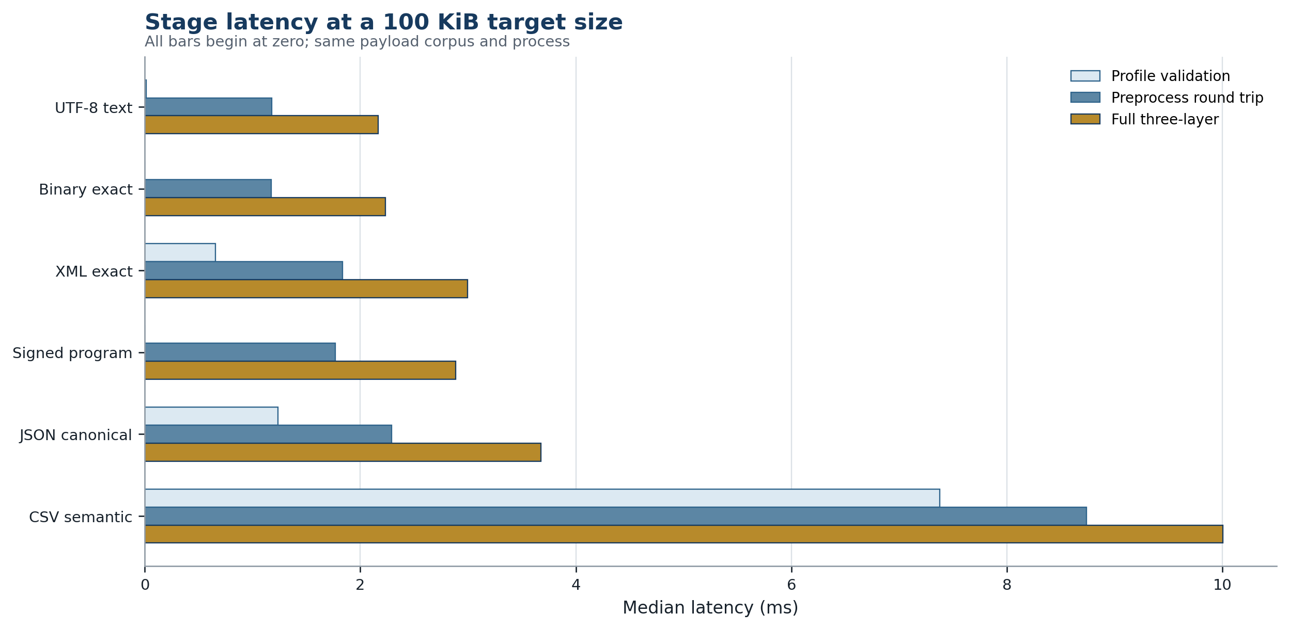
Figure 3.6. Median processing-stage latency for 100 KiB target payloads.
Table 3.13. Observed 100 KiB processing-stage medians
Profile | Validation  (ms) | Preprocess  (ms) | Full p50  (ms) | Full p95  (ms) | Full − preprocess  (ms)
UTF-8 text | 0.01 | 1.18 | 2.17 | 3.06 | 0.99
Binary exact | 0.00 | 1.18 | 2.23 | 10.47 | 1.06
XML exact | 0.66 | 1.84 | 2.99 | 5.59 | 1.16
Signed program | 0.00 | 1.77 | 2.89 | 3.79 | 1.12
JSON canonical | 1.24 | 2.29 | 3.68 | 6.00 | 1.39
CSV semantic | 7.38 | 8.74 | 10.00 | 17.44 | 1.26

The incremental full-minus-preprocess median is roughly 0.99 to 1.39 ms across these 100 KiB profiles. This is not a formal attribution because the scopes are measured independently, but it is consistent with a common control and authenticated-encryption cost layered over profile work. The larger differences between profiles arise primarily in validation and semantic conversion, not in the shared control policy.
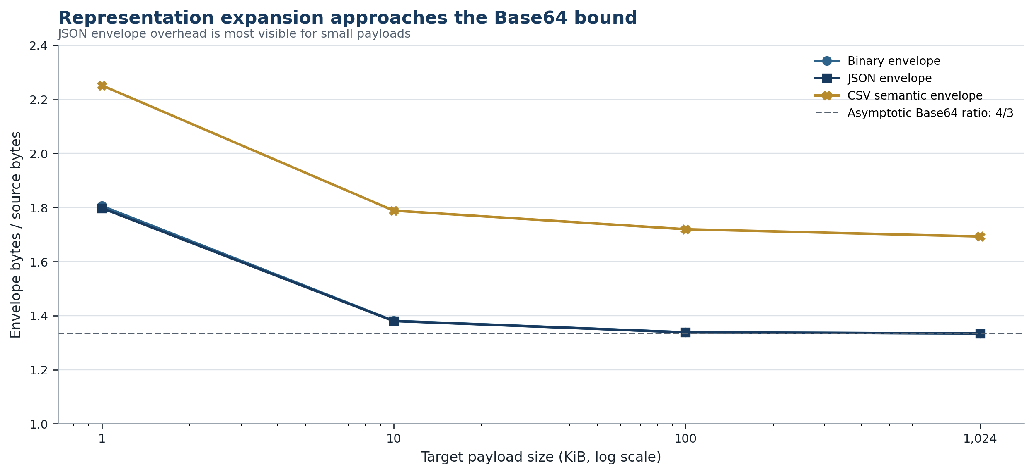
Figure 3.7. JSON-envelope expansion as fixed metadata diminishes with payload size.
Table 3.14. Observed representation expansion
Profile | 1 KiB B64 /  canonical | 1 KiB envelope /  source | 1 MiB B64 /  canonical | 1 MiB envelope /  source | 1 MiB protected frame /  source
Binary exact | 1.3340 | 1.806 | 1.3333 | 1.334 | 1.334
UTF-8 text | 1.3340 | 1.802 | 1.3333 | 1.334 | 1.334
Signed program | 1.3340 | 1.957 | 1.3333 | 1.334 | 1.334
XML exact | 1.3340 | 1.791 | 1.3333 | 1.334 | 1.334
JSON canonical | 1.3340 | 1.798 | 1.3333 | 1.334 | 1.334
CSV semantic | 1.3336 | 2.252 | 1.3333 | 1.693 | 1.693

For byte-preserving and canonical-JSON profiles, the envelope/source ratio converges to about 1.334 at 1 MiB, very close to Base64url's 4/3 asymptote plus fixed metadata. At 1 KiB, the ratio is about 1.79–1.96 because identifiers, routing, descriptors, timestamps, digests, and the program signature are no longer negligible. CSV remains at 1.693 for 1 MiB because its canonical header/rows JSON representation is larger than the generated CSV source before Base64url is applied. This is an explicit cost of semantic normalization, not an encoding error.

3.2.6 Memory behavior
Memory is measured with tracemalloc around one warmed full-pipeline operation. The statistic captures allocations visible to the Python allocator, including canonical bytes, Base64url text, JSON strings and objects, audit metadata, and reconstructed values. It does not capture every native allocation performed by the cryptography backend and is not equivalent to resident-set size. The result is therefore used for relative profile comparison only.
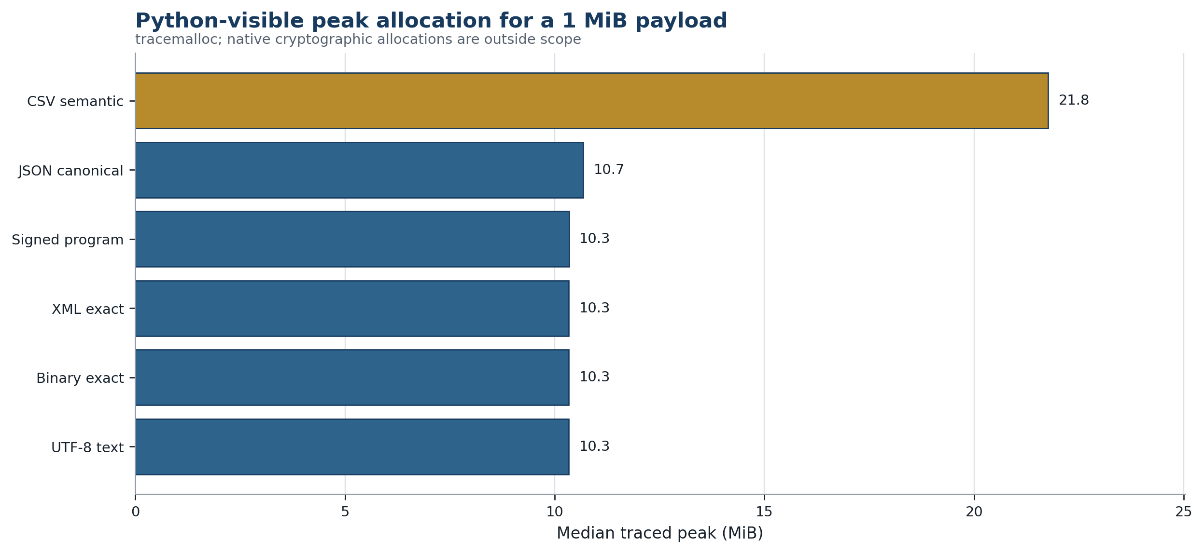
Figure 3.8. Median Python-visible peak allocation for a 1 MiB payload.
Table 3.15. Observed 1 MiB traced-memory peaks
Profile | Median traced peak (MiB) | Maximum traced peak (MiB) | Trials
Binary exact | 10.34 | 10.34 | 3
UTF-8 text | 10.34 | 10.34 | 3
Signed program | 10.34 | 10.34 | 3
XML exact | 10.34 | 10.34 | 3
JSON canonical | 10.68 | 10.68 | 3
CSV semantic | 21.76 | 21.76 | 3

Binary, text, XML, and signed program cluster at approximately 10.34 MiB of traced peak allocation, while JSON reaches 10.68 MiB. CSV reaches 21.76 MiB, about twice the byte-preserving group, because row lists and field strings coexist with canonical JSON, Base64url text, envelope bytes, and reconstructed CSV. Streaming parsers and chunked encoders are therefore the most direct optimization for large tabular or file workloads; the current prototype materializes each representation in full.

3.2.7 Concurrency and Web API results
The concurrency experiment submits 768 full-pipeline operations for a 100 KiB binary payload at each of four thread counts. All 3,072 requests succeed, but throughput is non-monotonic. One worker records 32.86 MiB/s. Two workers reach 41.60 MiB/s, a 1.266× speedup and 0.633 parallel efficiency. Four workers fall to 36.07 MiB/s, and eight workers fall below the single-worker result at 27.70 MiB/s.
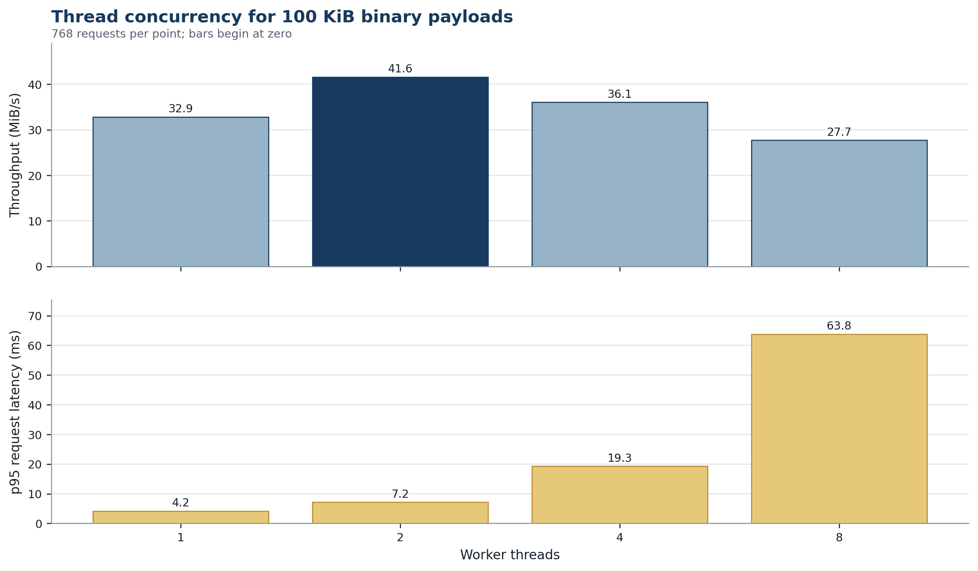
Figure 3.9. Throughput and p95 latency under thread concurrency for 100 KiB binary payloads.
Table 3.16. Thread-concurrency results
Workers | Requests | Req/s | MiB/s | p50 (ms) | p95 (ms) | Speedup / efficiency
1 | 768 | 336.48 | 32.86 | 2.26 | 4.20 | 1.000 / 1.000
2 | 768 | 426.03 | 41.60 | 4.26 | 7.16 | 1.266 / 0.633
4 | 768 | 369.32 | 36.07 | 9.79 | 19.25 | 1.098 / 0.274
8 | 768 | 283.65 | 27.70 | 22.26 | 63.82 | 0.843 / 0.105

Tail latency increases from 4.20 ms at one worker to 7.16 ms at two, 19.25 ms at four, and 63.82 ms at eight. The result is consistent with contention in shared idempotency/audit locks, replay-state locks, Python allocation and garbage collection, and background host scheduling. It does not show that two threads is a universal optimum. It shows that adding threads without partitioning state or using multiple processes can reduce both throughput and predictability.
The loopback Web API experiment includes source envelope formation, HTTP serialization and transfer, server parse, control and AES-GCM processing, reconstruction, and the metadata response. It uses a persistent HTTP/1.1 connection and disables Nagle delay on the server socket. Both JSON and binary complete every request without an error.
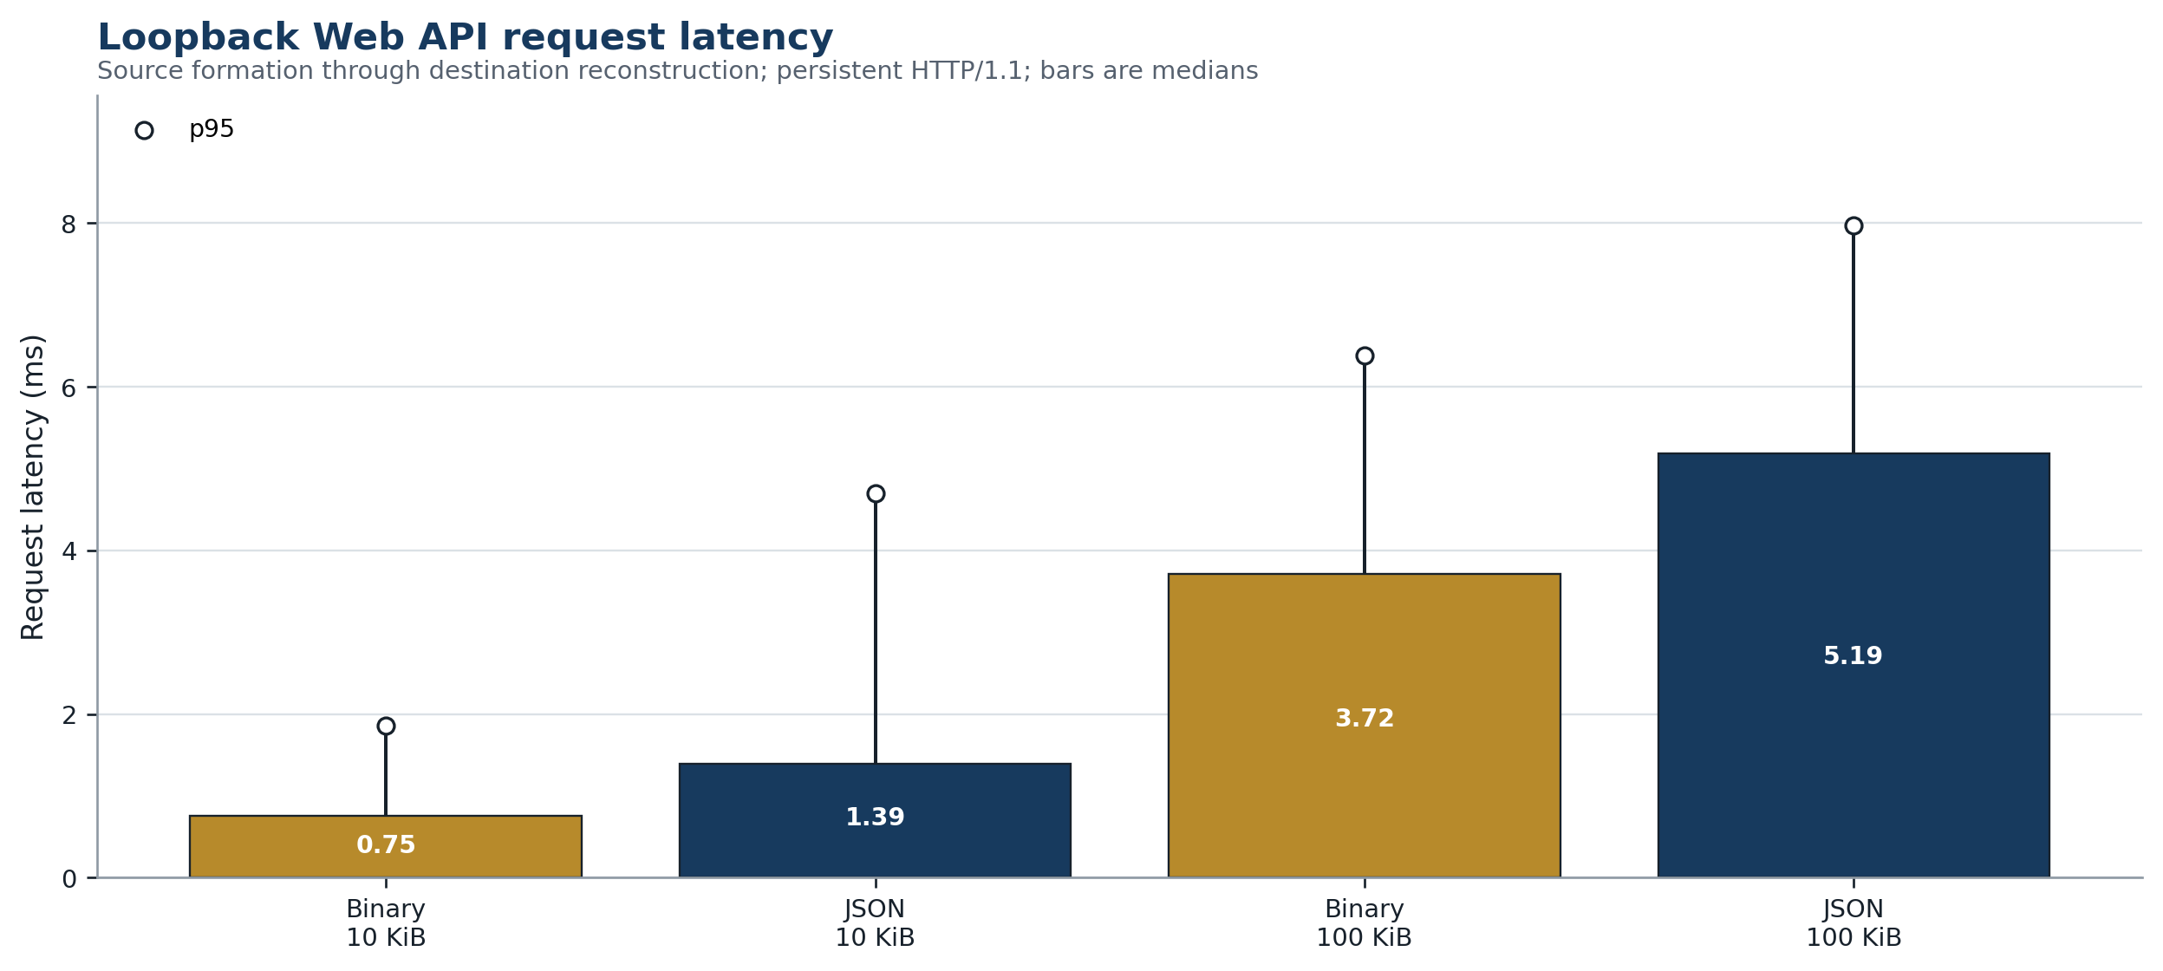
Figure 3.10. Median and p95 loopback Web API latency for JSON and binary payloads.
Table 3.17. Loopback Web API results
Profile | Source  (KiB) | n | Request body  (KiB) | p50  (ms) | p95  (ms) | Throughput  (MiB/s)
Binary exact | 10 | 80 | 13.82 | 0.75 | 1.85 | 12.97
JSON canonical | 10 | 80 | 13.82 | 1.39 | 4.70 | 7.00
Binary exact | 100 | 40 | 133.82 | 3.72 | 6.38 | 26.28
JSON canonical | 100 | 40 | 133.82 | 5.19 | 7.97 | 18.83

Measurement correction. A preliminary development run showed an almost constant delay near 44 ms at both sizes. That pattern identified HTTP/1.1 response buffering rather than middleware work. The handler was corrected to set TCP_NODELAY and flush the response; the entire evidence set was then rerun with new source hashes. No preliminary value appears in the tables.

In the frozen run, binary medians are 0.75 ms at 10 KiB and 3.72 ms at 100 KiB; JSON medians are 1.39 and 5.19 ms. The API result should not be compared directly with a WAN service. It omits DNS, proxying, TLS handshake, packet loss, cross-host scheduling, load balancing, and remote target time. Its value is the verified interface path and the demonstration that representation and parsing overhead remain observable after adding HTTP.

3.2.8 Paired XML and JSON evaluation
The main profile matrix targets similar byte sizes but does not encode identical structured values in XML and JSON. A separate paired experiment therefore represents the same flat records—with id, name, status, and integer value—in both formats. Counts of 10, 100, 1,000, and 5,000 expose the growth of source size and complete-pipeline latency. JSON uses an object containing a records array; XML uses a records document with one element per field.
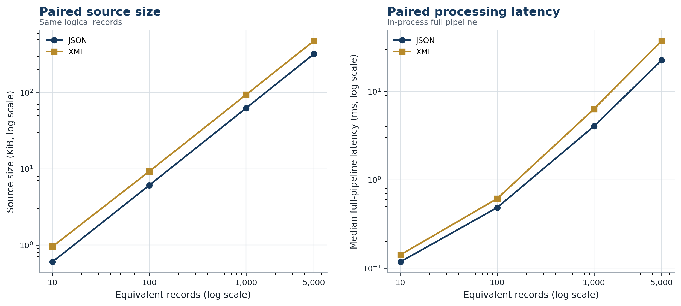
Figure 3.11. Paired XML and JSON source size and full-pipeline median latency.
Table 3.18. Paired XML and JSON results
Records | JSON size  (KiB) | XML size  (KiB) | XML / JSON  size | JSON p50  (ms) | XML p50  (ms) | XML / JSON  latency
10 | 0.60 | 0.96 | 1.591 | 0.12 | 0.14 | 1.199
100 | 6.09 | 9.26 | 1.520 | 0.49 | 0.61 | 1.263
1,000 | 62.74 | 94.04 | 1.499 | 4.04 | 6.33 | 1.567
5,000 | 320.55 | 476.85 | 1.488 | 22.46 | 37.18 | 1.655

XML is 1.59 times the JSON source size at 10 records; the ratio declines toward 1.49 at 5,000 records as fixed document overhead becomes less important. Median XML/JSON latency rises from 1.20 at 10 records to 1.66 at 5,000 records. At the largest point, JSON occupies 320.55 KiB and completes in 22.46 ms, while XML occupies 476.85 KiB and completes in 37.18 ms. Both reconstruct without an observed error.
This experiment supports a conditional result, not the claim that JSON is intrinsically superior. The corpus is record-oriented and does not use mixed content, attributes, namespaces, schema substitution, or document markup—areas where XML may be the better semantic fit. XML is also byte-preserved while JSON is parsed and deterministically serialized. The result therefore quantifies this workload and complements, rather than replaces, the structural comparison in Section 1.2.

3.2.9 Failure, recovery, and replay-state results
Three experiments probe failure behavior. The transient-failure case authorizes an immutable envelope, injects one pre-send transport failure, waits one millisecond, and retries the same envelope. All 60 trials reconstruct correctly; the median time from initial authorization through successful retry is 1.43 ms. The duplicate binding is recognized, and only one COMPLETED business effect is produced in the test model.
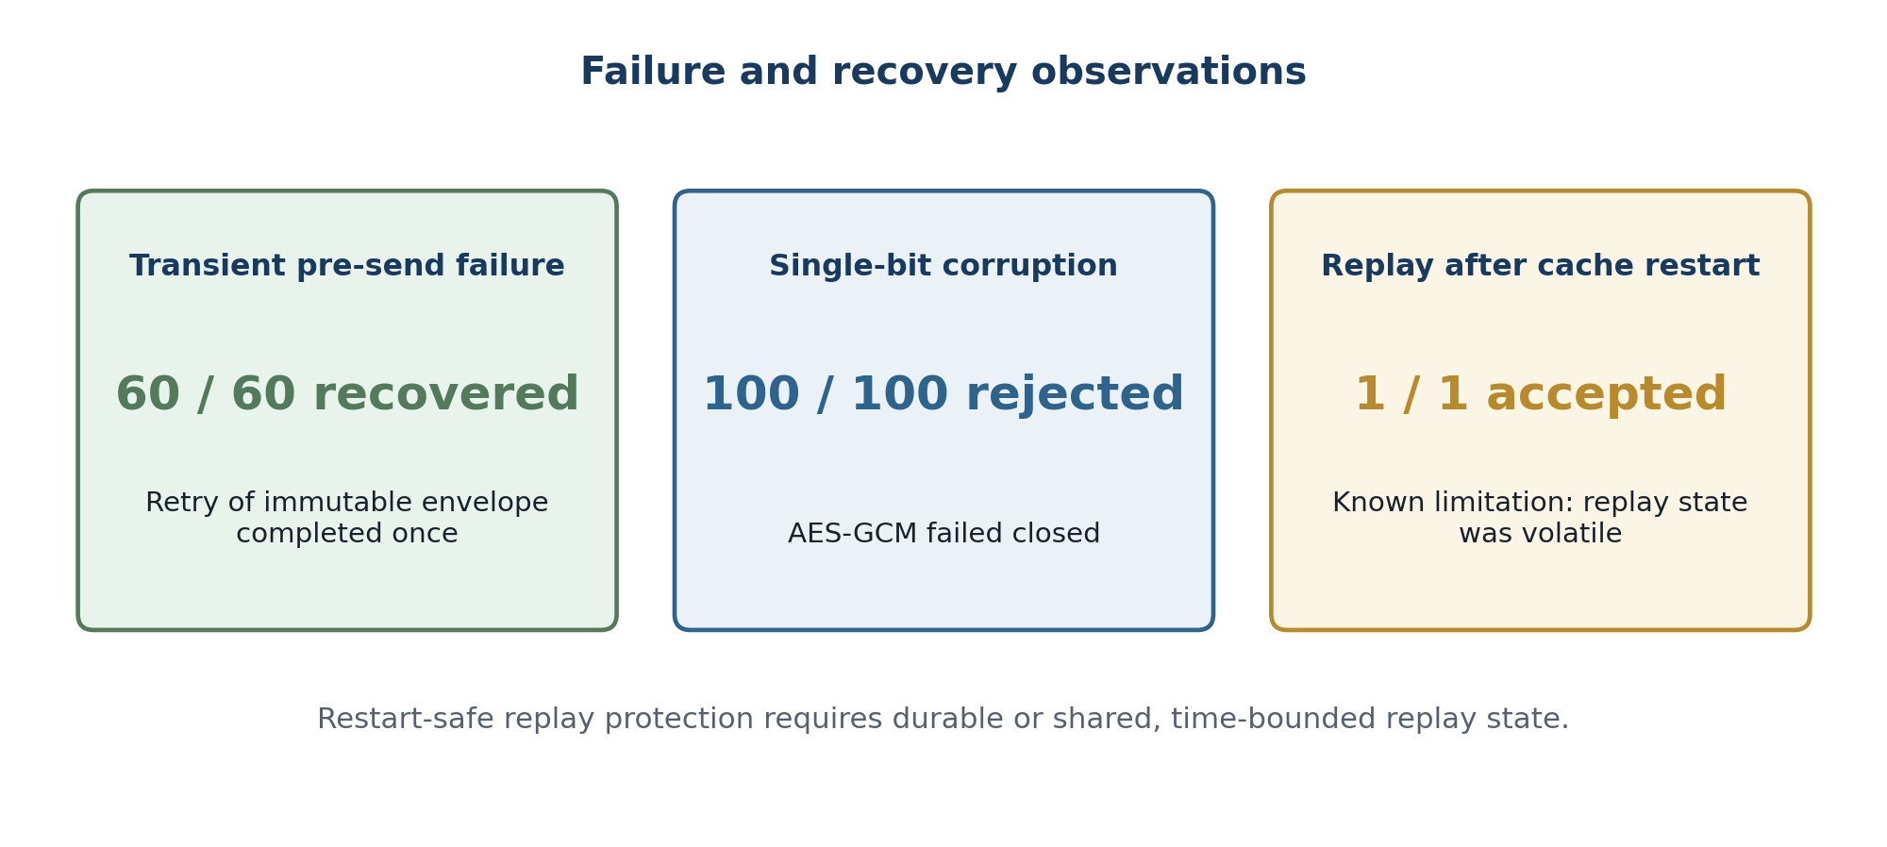
Figure 3.12. Observed retry, corruption, and restart-replay outcomes.
Table 3.19. Failure and recovery experiments
Experiment | Trials | Accepted | Median recovery (ms) | Observed result
one transient pre-send failure followed by one retry | 60 | 60 | 1.43 | PASS: in-memory retry recovered without a second completed business effect
single-bit ciphertext corruption | 100 | 0 | — | PASS: all corrupted frames failed authenticated decryption
replay after receiver replay-cache restart | 1 | 1 | — | KNOWN LIMITATION: volatile nonce cache does not survive restart; durable or time-bounded shared replay state is required

The corruption experiment changes one ciphertext bit at varying positions. All 100 altered frames fail authenticated decryption and none is accepted. The restart experiment is intentionally adversarial: a valid frame is accepted once, a new communication-layer object is constructed with the same AES key, and the old frame is submitted again. Because the accepted-nonce set was not restored, the frame decrypts and is accepted. This is recorded as a KNOWN LIMITATION, not transformed into a pass by narrowing the oracle.
A production design must combine authenticated freshness metadata, a bounded acceptance window, durable or shared replay state, and idempotent target commit. The control layer's message binding may prevent a duplicate business effect when its state survives, but it cannot replace communication-layer replay detection when control state also restarts or when a frame is presented to another instance. The failure result therefore refines the architecture with an explicit deployment requirement.

3.2.10 Threats to validity and limitations
The independent validation assessment is Share with caveats. The evidence is internally consistent and adequate for describing the prototype, but several factors restrict generalization. Table 3.20 maps each threat to its effect and to the language permitted in this thesis. These restrictions are part of the result, not editorial disclaimers added afterward.
Table 3.20. Threats to validity and claim restrictions
Threat | Effect on inference | Control in this study | Permitted claim / next evidence
Prototype construct | May differ from the author's implementation | Code-to-design traceability and explicit label | Claim only reference-prototype behavior; test author system separately
Single virtual host | Scheduler and co-tenancy affect timing | One clean process records environment and raw runs | Report observed distributions; repeat on dedicated hosts
Loopback network | Excludes real network and TLS costs | HTTP scope reported separately | Claim API-path correctness only; add multi-host WAN/LAN matrix
Small 1 MiB sample | p95/p99 are unstable | All 12 points retained; bootstrap median interval | Treat tails as exploratory; run longer duration tests
Synthetic corpus | May miss production distributions and adversarial cases | Six data classes and paired structured records | Claim declared corpus only; add redacted real workloads and fuzzing
Python canonical JSON subset | Not complete cross-language JCS coverage | Strict duplicates/non-finite rules and deterministic serializer | Claim internal determinism; run RFC 8785 conformance suite
Traced allocation | Omits native allocation and RSS | Measurement scope printed in every row | Compare Python-visible peaks only; add process-isolated RSS profiling
Thread-only concurrency | Does not measure horizontal scale | Fixed request count and 1/2/4/8 worker points | Claim non-monotonic threads; test multiprocess and distributed sharding
Volatile state | Restart loses replay/idempotency history | Restart attack executed and reported | No restart-safe claim; externalize bounded state
Security coverage | Tests do not prove absence of vulnerabilities | Typed negative cases and authenticated crypto library | Add dependency audit, fuzzing, code review, and penetration test
No production SLA | Cannot label performance acceptable universally | Metrics and exact environment stated | Use results as baseline; evaluate against user-defined SLOs

The principal internal-validity strength is that the final tables are generated from one clean run and independently recomputed. The principal external-validity weakness is that the same control that improves isolation—a single process and loopback path—removes the distributed effects a communication middleware must ultimately handle. The next study should therefore preserve this corpus and oracle while crossing processes and hosts, adding TLS 1.3, durable state, fault-injected network conditions, key rotation, destination backpressure, and hours-long saturation workloads.
For the author's middleware, Chapter 3 should be rerun rather than merely renamed. The required substitution is the author's physical topology, source revision, configuration, API contract, key and logging controls, payload corpus, raw per-run data, and failure experiments. Once supplied, the same indicators and tables can compare the proprietary system with the reference prototype without treating one as evidence for the other.

3.3 Chapter Summary
The research prototype instantiates the proposed three-layer architecture with six exchange profiles, a strict Base64url JSON envelope, default-deny control decisions, idempotency and metadata-only audit state, AES-GCM protected transport, replay checking, and signed non-executed program artifacts. Its loopback Web API requires application/json and refuses form and query payload transport. All 33 functional cases and all 6,336 timed equivalence assertions pass; an independent validation reproduces the summaries through 115 checks.
Performance is profile- and size-dependent. At 1 MiB, full-pipeline medians range from 20.81 ms for binary to 103.93 ms for CSV semantic normalization. Representation overhead approaches the 4/3 Base64url bound for byte-preserving profiles, while CSV incurs additional canonical-model expansion and memory. Two worker threads improve the tested binary throughput, but four and eight regress and increase tail latency. In paired tabular-shaped records, XML is larger and slower than JSON, a result bounded to that information model.
Failure experiments show successful in-memory retry and fail-closed ciphertext integrity, but a receiver restart accepts an old valid frame because replay state is volatile. The architecture is therefore supported as a functional reference design within the declared scope, while durable replay state, distributed deployment, TLS, production workloads, and the author's own implementation remain explicit next validation steps.

References
Berners-Lee, T., Fielding, R., & Masinter, L. (2005). Uniform Resource Identifier (URI): Generic syntax (RFC 3986). RFC Editor. https://www.rfc-editor.org/rfc/rfc3986
Bernstein, P. A. (1996). Middleware: A model for distributed system services. Communications of the ACM, 39(2), 86–98. https://doi.org/10.1145/230798.230809
Bray, T. (Ed.). (2017). The JavaScript Object Notation (JSON) data interchange format (RFC 8259). RFC Editor. https://www.rfc-editor.org/rfc/rfc8259
Chandramouli, R. (2019). Security strategies for microservices-based application systems (NIST SP 800-204). National Institute of Standards and Technology. https://doi.org/10.6028/NIST.SP.800-204
Curry, E. (2004). Message-oriented middleware. In Q. H. Mahmoud (Ed.), Middleware for communications (pp. 1–28). John Wiley & Sons. https://edwardcurry.org/publications/bibtexbrowser.php?key=Curry2004
Dworkin, M. (2007). Recommendation for block cipher modes of operation: Galois/Counter Mode (GCM) and GMAC (NIST SP 800-38D). National Institute of Standards and Technology. https://doi.org/10.6028/NIST.SP.800-38D
Emmerich, W. (2000). Software engineering and middleware: A roadmap. In Proceedings of the Conference on the Future of Software Engineering. ACM. https://doi.org/10.1145/336512.336542
Eugster, P. T., Felber, P. A., Guerraoui, R., & Kermarrec, A.-M. (2003). The many faces of publish/subscribe. ACM Computing Surveys, 35(2), 114–131. https://doi.org/10.1145/857076.857078
Fielding, R. T. (2000). Architectural styles and the design of network-based software architectures (Doctoral dissertation, University of California, Irvine). https://www.ics.uci.edu/~fielding/pubs/dissertation/top.htm
Fielding, R., Nottingham, M., & Reschke, J. (Eds.). (2022). HTTP semantics (RFC 9110). RFC Editor. https://doi.org/10.17487/RFC9110
Gerrans, J., Richards, K., & Roberts, J. (2024). Comparing XML and JSON characteristics as formats for data interchange. IEEE Embedded Systems Letters. https://doi.org/10.1109/LES.2024.3450576
Hohpe, G., & Woolf, B. (2003). Enterprise integration patterns: Designing, building, and deploying messaging solutions. Addison-Wesley. https://www.enterpriseintegrationpatterns.com/
Josefsson, S. (2006). The Base16, Base32, and Base64 data encodings (RFC 4648). RFC Editor. https://www.rfc-editor.org/rfc/rfc4648
JSON Schema. (2022). JSON Schema core: A media type for describing JSON documents, Draft 2020-12. https://json-schema.org/draft/2020-12/json-schema-core
Maeda, K. (2012). Performance evaluation of object serialization libraries in XML, JSON and binary formats. In 2012 Second International Conference on Digital Information and Communication Technology and its Applications (pp. 177–182). IEEE. https://doi.org/10.1109/DICTAP.2012.6215346
Object Management Group. (2021). Common Object Request Broker Architecture (CORBA), Version 3.4. https://www.omg.org/spec/CORBA/3.4/About-CORBA
OASIS. (2012). Advanced Message Queuing Protocol (AMQP) Version 1.0. https://www.oasis-open.org/2012/10/31/amqp-1-0-approval/
Nottingham, M., Wilde, E., & Dalal, S. (2023). Problem details for HTTP APIs (RFC 9457). RFC Editor. https://doi.org/10.17487/RFC9457
OWASP Foundation. (2023). OWASP API Security Top 10 – 2023. https://owasp.org/API-Security/editions/2023/en/0x11-t10/
OWASP Foundation. (n.d.). XML External Entity Prevention Cheat Sheet. https://cheatsheetseries.owasp.org/cheatsheets/XML_External_Entity_Prevention_Cheat_Sheet.html
Papazoglou, M. P. (2003). Service-oriented computing: Concepts, characteristics and directions. In Proceedings of the Fourth International Conference on Web Information Systems Engineering. https://dl.acm.org/doi/10.5555/960322.960404
Pautasso, C., Zimmermann, O., & Leymann, F. (2008). RESTful Web services vs. “big” Web services: Making the right architectural decision. In Proceedings of the 17th International Conference on World Wide Web (pp. 805–814). ACM. https://doi.org/10.1145/1367497.1367606
Pezoa, F., Reutter, J. L., Suárez, F., Ugarte, M., & Vrgoč, D. (2016). Foundations of JSON Schema. In Proceedings of the 25th International Conference on World Wide Web (pp. 263–273). ACM. https://doi.org/10.1145/2872427.2883029
Rescorla, E. (2018). The Transport Layer Security (TLS) protocol version 1.3 (RFC 8446). RFC Editor. https://www.rfc-editor.org/rfc/rfc8446
Rose, S., Borchert, O., Mitchell, S., & Connelly, S. (2020). Zero trust architecture (NIST SP 800-207). National Institute of Standards and Technology. https://doi.org/10.6028/NIST.SP.800-207
Rundgren, A., Jordan, B., & Erdtman, S. (2020). JSON Canonicalization Scheme (JCS) (RFC 8785). RFC Editor. https://www.rfc-editor.org/rfc/rfc8785
Shafranovich, Y. (2005). Common format and MIME type for comma-separated values (CSV) files (RFC 4180). RFC Editor. https://www.rfc-editor.org/rfc/rfc4180
Souppaya, M., Scarfone, K., & Dodson, D. (2022). Secure Software Development Framework (SSDF) Version 1.1 (NIST SP 800-218). National Institute of Standards and Technology. https://doi.org/10.6028/NIST.SP.800-218
Sumaray, A., & Makki, S. K. (2012). A comparison of data serialization formats for optimal efficiency on a mobile platform. In Proceedings of the 6th International Conference on Ubiquitous Information Management and Communication. ACM. https://doi.org/10.1145/2184751.2184810
World Wide Web Consortium. (2007). SOAP Version 1.2 Part 1: Messaging Framework (Second Edition). https://www.w3.org/TR/soap12-part1/
World Wide Web Consortium. (2008). Extensible Markup Language (XML) 1.0 (Fifth Edition). https://www.w3.org/TR/xml/
World Wide Web Consortium. (2012). W3C XML Schema Definition Language (XSD) 1.1 Part 1: Structures. https://www.w3.org/TR/xmlschema11-1/

