What are disadvantages of using USB memory access method with URB blocking?
Using USB Request Block (URB) blocking for USB memory access (common in low-level drivers or kernel-mode USB communication) has several disadvantages—especially when compared to asynchronous or non-blocking approaches.

🔻 Key Disadvantages of URB Blocking

1. Poor Performance & Throughput
- Blocking calls halt execution until the USB transfer completes.
- This wastes CPU time, especially if the device is slow or latency is high.
- You can’t overlap I/O operations, reducing overall throughput.

2. Reduced Responsiveness
- Threads waiting on URBs become unresponsive.
- In GUI or real-time systems, this can lead to:
  - Freezes
  - Laggy behavior
  - Missed deadlines

3. Inefficient CPU Utilization
- CPU may sit idle while waiting for I/O completion.
- No opportunity to schedule other useful tasks during the wait.

4. Scalability Issues
- In systems handling multiple USB devices or many requests:
  - Each blocking URB may require a dedicated thread.
  - Leads to thread overhead and poor scalability.

5. Risk of Deadlocks
- If multiple resources are involved (locks, buffers, etc.), blocking calls increase chances of:
  - Deadlocks
  - Priority inversion problems

6. Harder Error Recovery
- If a USB device becomes unresponsive:
  - Blocking calls may hang indefinitely (unless timeout is handled properly).
  - Recovery logic becomes more complex.

7. Not Suitable for Real-Time Systems
- Real-time systems require predictable timing.
- Blocking URBs introduce unpredictable delays, making them unsuitable.

8. Limited Parallelism
- Only one operation progresses at a time per thread.
- Cannot take advantage of:
  - Multi-core CPUs
  - Concurrent USB transfers

✅ When URB Blocking might still be okay
- Simple applications or prototypes
- Debugging scenarios
- Systems where:
  - Latency is not critical
  - Only one USB operation is performed at a time

🔄 Better Alternative
Use asynchronous (non-blocking) URBs:
- Submit URB → continue execution → handle completion via callback or event
- Enables:
  - Higher throughput
  - Better responsiveness
  - Efficient resource usage

If you want, I can show a code-level comparison (blocking vs async URB) or explain how this works in Linux USB drivers vs Windows USB stack.
What are limitations of using USB memory access method with URB blocking?
The limitations of using USB memory access with URB (USB Request Block) blocking are mostly about efficiency, flexibility, and system behavior under load. While it’s simple to implement, it introduces several constraints:

🔻 Main Limitations

1. Synchronous Execution Constraint
- URB blocking forces a wait-until-complete model.
- You cannot proceed until the transfer finishes.
- Limits the ability to design event-driven or asynchronous systems.

2. No Overlapping of I/O Operations
- Only one transfer progresses per thread at a time.
- Prevents pipelining or parallel USB transactions.
- Reduces effective bandwidth utilization of the USB bus.

3. Thread Blocking Overhead
- Each blocking URB ties up a thread.
- In systems with many requests:
  - Requires more threads
  - Increases context switching overhead
  - Wastes system resources

4. Latency Sensitivity
- Performance heavily depends on device response time.
- Slow USB devices → longer blocking → system slowdown.
- Makes the system less predictable.

5. Poor Scalability
- Not suitable when:
  - Multiple USB devices are connected
  - High-frequency data transfers are required
- System struggles to scale due to blocking design.

6. Limited Responsiveness
- Blocking prevents the system from reacting quickly to:
  - User input
  - Other I/O events
- Especially problematic in:
  - UI applications
  - Interactive systems

7. Timeout and Error Handling Complexity
- If a device stalls or disconnects:
  - Blocking call may hang until timeout
- Requires careful timeout management
- Harder to implement robust recovery mechanisms

8. Not Suitable for High-Performance Applications
- Applications like:
  - Streaming (audio/video)
  - Real-time data acquisition
- Need continuous, non-blocking data flow
- URB blocking becomes a bottleneck

9. Limited CPU Utilization Efficiency
- CPU cannot perform useful work while waiting
- Leads to underutilization in multi-core systems

⚖️ Summary
Aspect | Limitation with URB Blocking
Execution Model | Fully synchronous
Performance | Lower throughput
Scalability | Poor
Responsiveness | Reduced
Resource Usage | Inefficient (threads idle)
Flexibility | Limited design options

✅ Bottom Line
URB blocking is simple but restrictive. It works for basic or low-load scenarios, but for modern systems requiring performance, scalability, and responsiveness, asynchronous URB handling is the preferred approach.

If you want, I can explain this in a short exam-style answer (2–5 marks) or provide a diagram comparing blocking vs non-blocking USB transfers.
diagram comparing blocking vs non-blocking USB transfers

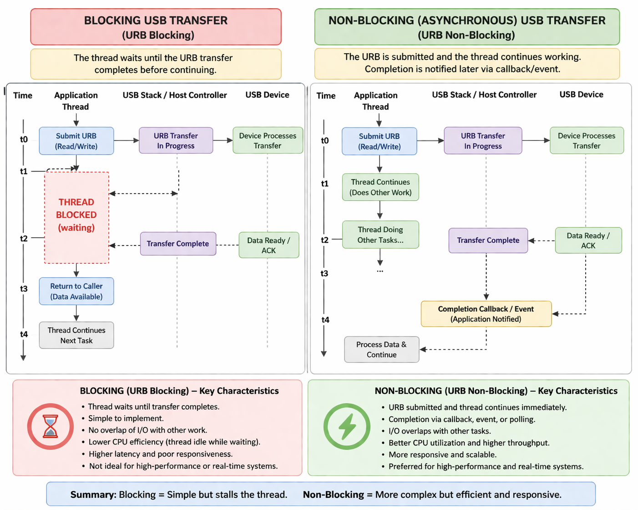

========================================================================

what is urb blocking
Thought for 8s
URB blocking most commonly refers to concepts in USB (Universal Serial Bus) driver development, particularly in the Linux kernel, where URB stands for USB Request Block.⁠Docs.kernel

What is a URB?
A USB Request Block (URB) is the fundamental data structure used for all communication between a USB driver and a USB device (or the USB host controller). It packages:
- The type of transfer (control, bulk, interrupt, isochronous).
- Endpoint details.
- Data buffer and length.
- Completion callback and status.
URBs are submitted asynchronously to the USB core/host controller, and the driver is notified via a completion handler when the transfer finishes (success, error, etc.).⁠Learn.microsoft

What Does "Blocking" Mean in This Context?
"Blocking" refers to whether the operation waits (blocks the calling thread) until the USB transfer completes, or returns immediately (asynchronous/non-blocking).
- Synchronous/blocking URB functions: These wait for completion before returning. Examples include usb_control_msg(), usb_bulk_msg(), or usb_interrupt_msg(). They are simpler to use but can freeze your thread/process if the device is slow or unresponsive.⁠Github
- Asynchronous/non-blocking URBs: You allocate a struct urb, fill it, submit it with usb_submit_urb(), and handle the result later in a completion callback. This is preferred for performance and responsiveness in drivers.
Other related terms:
- usb_block_urb(): A Linux kernel function that marks an URB as blocked, preventing further resubmission (e.g., to cleanly shut down transfers).⁠Android.googlesource
- Memory allocation flags like GFP_ATOMIC (non-blocking) vs. GFP_KERNEL (can sleep/block) when working with URBs.

Why It Matters
- In kernel drivers, blocking calls are dangerous in interrupt context or time-sensitive code.
- Poorly handled blocking URBs can cause hangs, high latency, or system instability (e.g., with webcams, storage devices, or custom USB hardware).

Other Possible Meanings
- Urban blocks (or "urb blocks"): In urban planning/architecture, this refers to city blocks — the basic units of buildings bounded by streets. "Urban block design" or morphology is a common topic in city planning.⁠Archdaily
- Less likely: Typos for "uBlock" (as in uBlock Origin, the ad blocker) or "urban blocking" in some niche contexts like sports (e.g., run blocking schemes discussed by coaches like Urban Meyer).
If this is about Linux USB driver development, a specific error you're seeing, or something else (e.g., urban planning), provide more context for a more detailed explanation!
33 sources
What are disadvantages of using USB memory access method with URB blocking?
Thought for 7s
Disadvantages of using blocking (synchronous) URB methods (like usb_bulk_msg(), usb_control_msg(), usb_interrupt_msg()) for USB memory access or data transfers in Linux kernel drivers include:

1. Thread Blocking and Reduced Responsiveness
- These functions block the calling thread until the transfer completes or times out. This freezes the current thread/process, which is problematic in performance-sensitive or real-time contexts.
- In user-facing drivers or those handling multiple operations, this leads to poor responsiveness, UI freezes (if in user-space wrappers), or overall system lag.

2. Not Usable in Interrupt Context or Atomic Contexts
- Synchronous functions cannot be called from interrupt handlers, bottom halves, or any atomic context (they may sleep).
- This forces workarounds like scheduling workqueues, adding complexity and latency. Asynchronous usb_submit_urb() is required in such cases.

3. Poor Performance for Continuous or High-Throughput Transfers
- Inefficient for streaming, high-speed bulk transfers, or repeated memory access (e.g., USB storage, custom high-bandwidth devices).
- Each call incurs setup overhead (building a URB internally), waiting, and teardown. Asynchronous URBs allow queuing multiple transfers in advance for better pipelining and bus utilization.
- Kernel documentation explicitly recommends against using usb_bulk_msg() for constant reads/writes and suggests setting up your own URBs instead.

4. Limited Cancellation and Control
- No direct handle to the internal URB, so you cannot easily cancel or unlink the transfer mid-operation (e.g., with usb_unlink_urb() or usb_kill_urb()).
- On device disconnect or errors, cleanup is harder — your disconnect() callback must wait for the blocking call to finish, risking hangs or races.

5. Timeout and Error Handling Issues
- Relies on a timeout parameter; long or infinite waits can make the driver unresponsive to device removal.
- Error handling is less flexible compared to checking urb->status in a completion callback.

6. Scalability and Concurrency Limitations
- Harder to handle multiple endpoints, devices, or parallel transfers without spawning extra threads (which adds overhead and synchronization complexity).
- Asynchronous approach allows better CPU utilization and supports more concurrent operations.

7. Debugging and Race Condition Risks
- Blocking calls can complicate synchronization, especially with device hotplug, suspend/resume, or concurrent access.
- Lifetime issues with buffers and URBs are trickier to manage safely.

When Blocking is Acceptable
Blocking methods are fine for simple, infrequent, one-off transfers during initialization, probing, or low-bandwidth control operations in process context. For anything performance-oriented or ongoing (e.g., bulk memory reads/writes on mass storage or custom devices), asynchronous URBs are strongly preferred.
Recommendation: Use usb_submit_urb() with a completion callback for most production drivers. This is the standard, efficient, and flexible way to handle USB memory access.⁠Infradead
If you're seeing specific errors, performance issues, or working on a particular device/driver, share more details for tailored advice!
566ms
65 sources
What are disadvantages of using USB mass storage access method with URB blocking?
Thought for 8s
Disadvantages of using blocking (synchronous) URB methods (such as usb_bulk_msg()) for USB mass storage access in Linux kernel drivers are more pronounced than in general USB memory access, because mass storage involves high-throughput, continuous bulk transfers of large data blocks (often many KB to MB per command) via the Bulk-Only Transport (BOT) or UASP protocols.
Here are the key drawbacks:

1. Severe Performance and Throughput Limitations
- Blocking calls like usb_bulk_msg() wait for each individual transfer (CBW → Data → CSW for BOT) to complete before returning. This creates "stop-and-wait" behavior with high per-transfer overhead.
- Mass storage benefits greatly from pipelining (queuing multiple URBs in flight). Synchronous methods prevent this, leading to much lower effective bandwidth — often wasting significant USB bus time (e.g., the kernel docs note that simple usb_bulk_msg() loops can waste more than half of USB 2.0 bandwidth).
- The official usb-storage driver and modern UASP implementations use asynchronous URBs precisely to achieve high sequential read/write speeds.

2. Inability to Handle Device Latency Efficiently
- Flash drives and HDDs often introduce delays during internal operations (e.g., erase/write cycles, cache flushes). With blocking calls, the entire thread is stalled during NAKs or long command completions.
- This leads to poor responsiveness and lower sustained throughput compared to asynchronous designs that can overlap commands or handle short/not-full responses gracefully.

3. Not Suitable for Interrupt or Atomic Contexts
- You cannot call synchronous bulk functions from interrupt handlers, tasklets, or other atomic contexts (they may sleep). Mass storage drivers often need to handle completions, errors, or resets in such contexts, forcing extra workqueues and added latency/complexity.

4. Poor Error Recovery, Cancellation, and Hotplug Handling
- No direct handle to the underlying URB, making it impossible to easily cancel/unlink ongoing transfers with usb_unlink_urb() or usb_kill_urb().
- On device disconnect, error, or reset, your code may hang waiting for the blocking call to timeout. This complicates the disconnect() callback and increases risk of races or deadlocks.
- Mass storage is prone to stalls, medium errors, or device resets — asynchronous completion handlers allow much better recovery.

5. Scalability and Concurrency Issues
- Hard to support multiple outstanding commands or parallel operations (e.g., in SCSI command queuing).
- Modern mass storage uses command queuing (UASP/USB Attached SCSI) for much better performance; synchronous methods don't scale to this.

6. Higher CPU Overhead and Worse Latency
- Repeated setup/teardown of internal URBs for every call adds overhead.
- In high-load scenarios (large file copies, many small I/Os), this results in more context switches and poorer system responsiveness.

When Blocking Methods Might Still Be Used
They are acceptable only for rare, one-off operations like device initialization, sending test unit ready commands, or simple control transfers during probing. The actual data read/write path in any real mass storage implementation should always use asynchronous URBs.

Official Kernel Recommendation
The Linux kernel documentation explicitly states that usb_bulk_msg() is useful for occasional single transfers, but for constant or high-volume reads/writes (exactly what mass storage does), you should set up and submit your own URBs asynchronously.
This is why the production usb-storage and uas drivers rely heavily on asynchronous bulk URBs, multiple submitted requests, and completion callbacks.
Bottom line: Using blocking URBs for USB mass storage access will result in noticeably slower speeds, higher latency, poorer error handling, and less robust drivers compared to the asynchronous approach used in real implementations.
If you're implementing a custom mass storage gadget/driver, debugging performance issues, or working on a specific device, share more details for targeted advice!
662ms
55 sources
What are limitations of using USB mass storage access method with URB blocking?
Thought for 20s
Limitations of using blocking (synchronous) URB methods (such as usb_bulk_msg()) for USB mass storage access in Linux kernel drivers are significant, particularly because mass storage protocols (Bulk-Only Transport / BOT or UAS) rely on repeated, high-volume bulk transfers of large data blocks (often tens of KB to MB per SCSI command) along with strict command sequences (CBW → Data → CSW).
Here are the main technical limitations:

1. No Support for Interrupt or Atomic Contexts
- Synchronous functions like usb_bulk_msg() cannot be called from interrupt handlers, tasklets, softirqs, or any atomic context because they may sleep.
- Mass storage drivers frequently need to handle completions, errors, stalls, or resets in these contexts. This forces extra scheduling (e.g., workqueues), adding latency and complexity.

2. No Request Queuing or Pipelining
- Each usb_bulk_msg() call is a complete round-trip: it builds an internal URB, submits it, waits, and cleans up.
- You cannot queue multiple transfers in advance on the same endpoint. This prevents overlapping commands and wastes USB bus bandwidth.
- For mass storage, this is especially limiting: BOT/UAS protocols benefit enormously from having several bulk transfers in flight. The kernel explicitly notes that synchronous methods can waste more than half the available bandwidth on high-speed buses.

3. No Cancellation or Fine-Grained Control
- You receive no handle to the underlying URB, so you cannot call usb_unlink_urb(), usb_kill_urb(), or similar mid-transfer.
- On device removal, error recovery, or hotplug events (very common with mass storage devices), your code must wait for the blocking call to finish or timeout. This complicates the disconnect() callback and increases the risk of hangs or races.

4. Poor Performance and Throughput
- Blocking calls are only suitable for occasional, one-off transfers.
- Constant or high-volume reads/writes (the core of mass storage) suffer from high per-transfer overhead and "stop-and-wait" behavior.
- The official Linux usb-storage and uas drivers use fully asynchronous URBs precisely because synchronous methods cannot deliver acceptable sequential read/write speeds or handle modern command queuing.

5. Limited Error Handling and Recovery
- You only get a return code and timeout; there is no access to detailed urb->status, short-packet information, or per-transfer diagnostics in a flexible way.
- Mass storage is prone to stalls, medium errors, phase errors, and resets — asynchronous completion handlers allow much cleaner and faster recovery.

6. Thread Blocking and Responsiveness Issues
- The calling thread is blocked for the entire duration of each transfer (including device-internal delays like flash erase cycles or cache flushes).
- This leads to poor system responsiveness, especially under load or when multiple operations occur.

Official Kernel Guidance
The Linux USB core documentation and driver-writing guides state that usb_bulk_msg() (and similar synchronous calls) is intended only for simple, infrequent operations. For any continuous or performance-sensitive use — exactly what USB mass storage requires — you must allocate and submit your own URBs asynchronously with usb_submit_urb() and completion callbacks.
In short, while blocking URBs work for basic proof-of-concept or initialization code, they impose hard limitations that make them unsuitable for a production-quality USB mass storage implementation. The real usb-storage driver avoids them entirely for the data path.
If you're implementing a custom driver/gadget, debugging a specific performance or stability issue, or targeting a particular kernel version, provide more details and I can give more targeted guidance!
2 / 2
456ms
35 sources
What are limitations of using USB memory access method with URB blocking?
Thought for 10s
Limitations of using blocking (synchronous) URB methods (such as usb_bulk_msg(), usb_control_msg(), usb_interrupt_msg()) for USB memory access (i.e., general bulk/control transfers to read/write device memory buffers in a custom Linux kernel driver) include the following technical constraints:

1. Thread Blocking and Responsiveness Limits
- The calling thread is fully blocked until the transfer completes or times out. This prevents the thread from performing any other work, leading to reduced system responsiveness, UI freezes (in user-space wrappers), or latency spikes during memory reads/writes.

2. Incompatibility with Interrupt and Atomic Contexts
- Synchronous functions cannot be called from interrupt handlers, tasklets, softirqs, or any atomic context (they may sleep).
- This forces you to push work to a workqueue or thread, adding extra latency and code complexity for any time-sensitive memory access.

3. No Pipelining or Request Queuing
- Each call creates, submits, waits for, and destroys an internal URB. You cannot queue multiple transfers in advance on the same endpoint.
- This eliminates the ability to overlap memory operations, resulting in lower effective throughput and under-utilization of the USB bus (especially on USB 2.0/3.x high-speed links).

4. Lack of Fine-Grained Cancellation and Control
- No direct reference to the underlying URB is returned, so you cannot use usb_unlink_urb(), usb_kill_urb(), or usb_block_urb() to cancel or manage an in-flight transfer.
- Device disconnect, suspend, or error scenarios become harder to handle cleanly — your code must wait for the blocking call to finish.

5. Limited Error Handling and Diagnostics
- You only receive a simple return code and optional timeout value. There is no access to detailed per-transfer information such as urb->status, actual transferred length, or short-packet flags in a flexible way.
- Recovery from stalls, NAKs, or partial memory reads/writes is less precise than with a custom completion callback.

6. Scalability and Concurrency Constraints
- Difficult to manage multiple endpoints, concurrent memory accesses, or high-volume repeated transfers without spawning additional threads (which introduces synchronization overhead and potential races).

7. Higher Overhead for Repeated Access
- Each synchronous call incurs full setup/teardown cost. For frequent or streaming memory access patterns (common in custom USB devices), this overhead accumulates and performs worse than a single set of pre-allocated asynchronous URBs.

Official Kernel Guidance
The Linux USB core documentation states that these blocking helper functions are intended only for occasional, simple transfers during probing, initialization, or low-bandwidth control operations. For any ongoing or performance-sensitive USB memory access, the recommended approach is to allocate your own struct urb, fill it, and submit asynchronously with usb_submit_urb() + a completion handler.
In summary, while blocking URBs simplify initial prototyping, they impose hard architectural limitations that make them unsuitable for robust, high-performance, or production USB memory access drivers.
If you are targeting a specific kernel version, device class, or seeing particular errors/behavior, feel free to share more context for more precise guidance!

