**UNIT TEST CASE:**

**React JS**

1. **Positive test case 1**: Search movie based on tittle (name). – User Input : **name** *the*

Where, **name** – search keyword

*the* – search movies containing word “*the*”

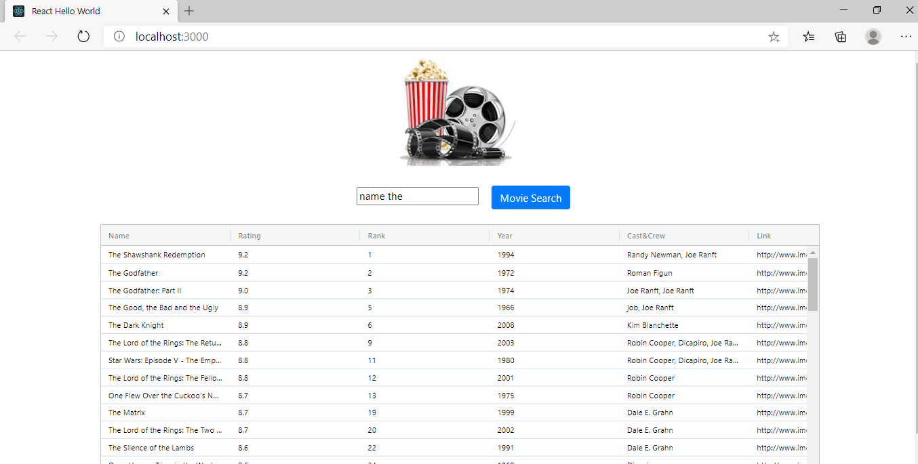

1. **Positive test case 2:** Search movie based on crew/cast – User Input : **crew** *Randy*

Where, **crew** – search keyword

*Randy* – search movies based on crew name *Randy*

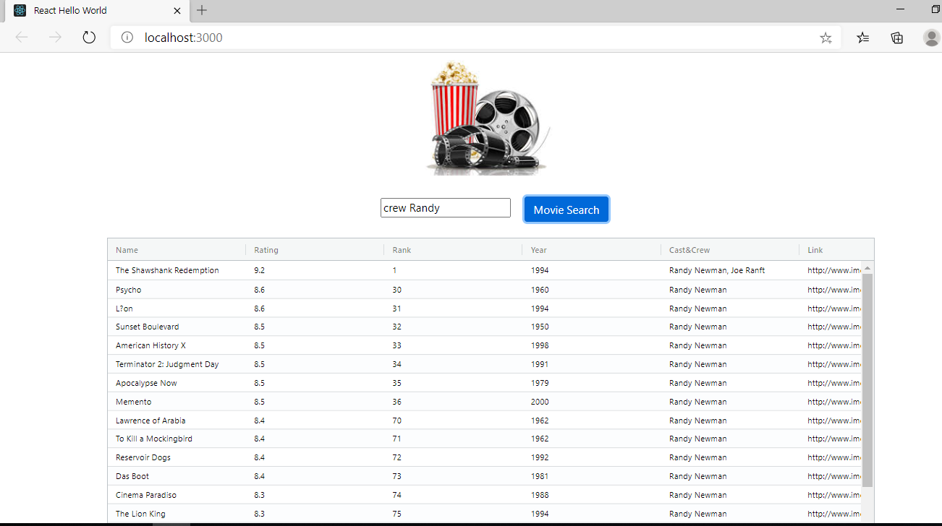

1. **Negative/Exceptional test case 1:** Search movies without using keywords



1. **Negative/Exceptional test case 2:** Empty search



**Spring Boot URL testing**

**URL: *http://192.168.225.226:8080***

**Method: GET(/GetMovie)**

1. **Positive test case:**

**Request:**

***http://192.168.225.226:8080*/*GetMovie?crew=Joe Ranft***

**Response:**

    {

        "name": "The Shawshank Redemption",

        "crew": "Randy Newman, Joe Ranft",

        "rating": "9.2",

        "rank": "1",

        "year": "1994",

        "link": "http://www.imdb.com/title/tt0111161/"

    },

    {

        "name": "The Godfather: Part II",

        "crew": "Joe Ranft, Joe Ranft",

        "rating": "9.0",

        "rank": "3",

        "year": "1974",

        "link": "http://www.imdb.com/title/tt0071562/"

    },

    {

        "name": "The Good, the Bad and the Ugly",

        "crew": "job, Joe Ranft",

        "rating": "8.9",

        "rank": "5",

        "year": "1966",

        "link": "http://www.imdb.com/title/tt0060196/"

    },

    {

        "name": "12 Angry Men",

        "crew": "Color Timer, Joe Ranft",

        "rating": "8.9",

        "rank": "7",

        "year": "1957",

        "link": "http://www.imdb.com/title/tt0050083/"

    },

    {

        "name": "The Lord of the Rings: The Return of the King",

        "crew": "Robin Cooper, Dicapiro, Joe Ranft,test",

        "rating": "8.8",

        "rank": "9",

        "year": "2003",

        "link": "http://www.imdb.com/title/tt0167260/"

    },

    {

        "name": "Star Wars: Episode V - The Empire Strikes Back",

        "crew": "Robin Cooper, Dicapiro, Joe Ranft,test",

        "rating": "8.8",

        "rank": "11",

        "year": "1980",

        "link": "http://www.imdb.com/title/tt0080684/"

    },

    {

        "name": "The Shining",

        "crew": "Joe Ranft",

        "rating": "8.4",

        "rank": "50",

        "year": "1980",

        "link": "http://www.imdb.com/title/tt0081505/"

    },

    {

        "name": "Paths of Glory",

        "crew": "Joe Ranft",

        "rating": "8.4",

        "rank": "52",

        "year": "1957",

        "link": "http://www.imdb.com/title/tt0050825/"

    },

    {

        "name": "Vertigo",

        "crew": "Joe Ranft",

        "rating": "8.4",

        "rank": "53",

        "year": "1958",

        "link": "http://www.imdb.com/title/tt0052357/"

    },

    {

        "name": "American Beauty",

        "crew": "Joe Ranft",

        "rating": "8.4",

        "rank": "54",

        "year": "1999",

        "link": "http://www.imdb.com/title/tt0169547/"

    },

    {

        "name": "Django Unchained",

        "crew": "Joe Ranft",

        "rating": "8.4",

        "rank": "55",

        "year": "2012",

        "link": "http://www.imdb.com/title/tt1853728/"

    },

    {

        "name": "Double Indemnity",

        "crew": "Joe Ranft",

        "rating": "8.4",

        "rank": "56",

        "year": "1944",

        "link": "http://www.imdb.com/title/tt0036775/"

    },

    {

        "name": "The Dark Knight Rises",

        "crew": "Joe Ranft",

        "rating": "8.4",

        "rank": "57",

        "year": "2012",

        "link": "http://www.imdb.com/title/tt1345836/"

    },

    {

        "name": "Taxi Driver",

        "crew": "Joe Ranft",

        "rating": "8.4",

        "rank": "58",

        "year": "1976",

        "link": "http://www.imdb.com/title/tt0075314/"

    },

    {

        "name": "Aliens",

        "crew": "Joe Ranft",

        "rating": "8.4",

        "rank": "59",

        "year": "1986",

        "link": "http://www.imdb.com/title/tt0090605/"

    },

    {

        "name": "The Green Mile",

        "crew": "Joe Ranft",

        "rating": "8.4",

        "rank": "60",

        "year": "1999",

        "link": "http://www.imdb.com/title/tt0120689/"

    },

    {

        "name": "Untouchable",

        "crew": "Joe Ranft",

        "rating": "8.4",

        "rank": "61",

        "year": "2011",

        "link": "http://www.imdb.com/title/tt1675434/"

    },

    {

        "name": "Gladiator",

        "crew": "Joe Ranft",

        "rating": "8.4",

        "rank": "62",

        "year": "2000",

        "link": "http://www.imdb.com/title/tt0172495/"

    },

    {

        "name": "WALL?E",

        "crew": "Joe Ranft",

        "rating": "8.4",

        "rank": "63",

        "year": "2008",

        "link": "http://www.imdb.com/title/tt0910970/"

    },

    {

        "name": "The Lives of Others",

        "crew": "Joe Ranft",

        "rating": "8.4",

        "rank": "64",

        "year": "2006",

        "link": "http://www.imdb.com/title/tt0405094/"

    },

    {

        "name": "Toy Story 3",

        "crew": "Joe Ranft",

        "rating": "8.4",

        "rank": "65",

        "year": "2010",

        "link": "http://www.imdb.com/title/tt0435761/"

    },

    {

        "name": "The Great Dictator",

        "crew": "Joe Ranft",

        "rating": "8.4",

        "rank": "66",

        "year": "1940",

        "link": "http://www.imdb.com/title/tt0032553/"

    },

    {

        "name": "The Prestige",

        "crew": "Joe Ranft",

        "rating": "8.4",

        "rank": "67",

        "year": "2006",

        "link": "http://www.imdb.com/title/tt0482571/"

    },

    {

        "name": "A Clockwork Orange",

        "crew": "Joe Ranft",

        "rating": "8.4",

        "rank": "68",

        "year": "1971",

        "link": "http://www.imdb.com/title/tt0066921/"

    },

    {

        "name": "Amelie",

        "crew": "Joe Ranft",

        "rating": "8.4",

        "rank": "69",

        "year": "2001",

        "link": "http://www.imdb.com/title/tt0211915/"

    },

    {

        "name": "The Apartment",

        "crew": "Joe Ranft",

        "rating": "8.3",

        "rank": "98",

        "year": "1960",

        "link": "http://www.imdb.com/title/tt0053604/"

    },

    {

        "name": "Unforgiven",

        "crew": "Robin Cooper, Dicapiro, Joe Ranft,test",

        "rating": "8.3",

        "rank": "100",

        "year": "1992",

        "link": "http://www.imdb.com/title/tt0105695/"

    },

    {

        "name": "Grave of the Fireflies",

        "crew": "Robin Cooper, Dicapiro, Joe Ranft,test",

        "rating": "8.3",

        "rank": "101",

        "year": "1988",

        "link": "http://www.imdb.com/title/tt0095327/"

    },

    {

        "name": "Indiana Jones and the Last Crusade",

        "crew": "Joe Ranft",

        "rating": "8.3",

        "rank": "102",

        "year": "1989",

        "link": "http://www.imdb.com/title/tt0097576/"

    },

    {

        "name": "The Bridge on the River Kwai",

        "crew": "Robin Cooper, Dicapiro, Joe Ranft,test",

        "rating": "8.3",

        "rank": "104",

        "year": "1957",

        "link": "http://www.imdb.com/title/tt0050212/"

    },

    {

        "name": "Die Hard",

        "crew": "Robin Cooper, Dicapiro, Joe Ranft,test",

        "rating": "8.3",

        "rank": "105",

        "year": "1988",

        "link": "http://www.imdb.com/title/tt0095016/"

    },

    {

        "name": "Yojimbo",

        "crew": "Robin Cooper, Dicapiro, Joe Ranft,test",

        "rating": "8.3",

        "rank": "106",

        "year": "1961",

        "link": "http://www.imdb.com/title/tt0055630/"

    },

    {

        "name": "On the Waterfront",

        "crew": "Joe Ranft",

        "rating": "8.2",

        "rank": "114",

        "year": "1954",

        "link": "http://www.imdb.com/title/tt0047296/"

    },

    {

        "name": "Downfall",

        "crew": "Joe Ranft",

        "rating": "8.2",

        "rank": "116",

        "year": "2004",

        "link": "http://www.imdb.com/title/tt0363163/"

    },

    {

        "name": "Pan's Labyrinth",

        "crew": "Joe Ranft",

        "rating": "8.2",

        "rank": "117",

        "year": "2006",

        "link": "http://www.imdb.com/title/tt0457430/"

    },

    {

        "name": "Up",

        "crew": "Robin Cooper, Dicapiro, Joe Ranft,test",

        "rating": "8.2",

        "rank": "118",

        "year": "2009",

        "link": "http://www.imdb.com/title/tt1049413/"

    },

    {

        "name": "The General",

        "crew": "Robin Cooper, Dicapiro, Joe Ranft,test",

        "rating": "8.2",

        "rank": "119",

        "year": "1926",

        "link": "http://www.imdb.com/title/tt0017925/"

    },

    {

        "name": "The Seventh Seal",

        "crew": "Robin Cooper, Dicapiro, Joe Ranft,test",

        "rating": "8.2",

        "rank": "120",

        "year": "1957",

        "link": "http://www.imdb.com/title/tt0050976/"

    },

    {

        "name": "Fargo",

        "crew": "Joe Ranft",

        "rating": "8.2",

        "rank": "130",

        "year": "1996",

        "link": "http://www.imdb.com/title/tt0116282/"

    },

    {

        "name": "Gran Torino",

        "crew": "Joe Ranft",

        "rating": "8.2",

        "rank": "132",

        "year": "2008",

        "link": "http://www.imdb.com/title/tt1205489/"

    },

    {

        "name": "The Gold Rush",

        "crew": "Joe Ranft",

        "rating": "8.2",

        "rank": "135",

        "year": "1925",

        "link": "http://www.imdb.com/title/tt0015864/"

    },

    {

        "name": "Cool Hand Luke",

        "crew": "Joe Ranft",

        "rating": "8.2",

        "rank": "137",

        "year": "1967",

        "link": "http://www.imdb.com/title/tt0061512/"

    },

    {

        "name": "Les Diaboliques",

        "crew": "Joe Ranft",

        "rating": "8.1",

        "rank": "139",

        "year": "1955",

        "link": "http://www.imdb.com/title/tt0046911/"

    },

    {

        "name": "Lock, Stock and Two Smoking Barrels",

        "crew": "Joe Ranft",

        "rating": "8.1",

        "rank": "141",

        "year": "1998",

        "link": "http://www.imdb.com/title/tt0120735/"

    },

    {

        "name": "The Sixth Sense",

        "crew": "Joe Ranft",

        "rating": "8.1",

        "rank": "142",

        "year": "1999",

        "link": "http://www.imdb.com/title/tt0167404/"

    },

    {

        "name": "Good Will Hunting",

        "crew": "Joe Ranft",

        "rating": "8.1",

        "rank": "143",

        "year": "1997",

        "link": "http://www.imdb.com/title/tt0119217/"

    },

    {

        "name": "Jaws",

        "crew": "Joe Ranft",

        "rating": "8.1",

        "rank": "144",

        "year": "1975",

        "link": "http://www.imdb.com/title/tt0073195/"

    },

    {

        "name": "Casino",

        "crew": "Joe Ranft",

        "rating": "8.1",

        "rank": "145",

        "year": "1995",

        "link": "http://www.imdb.com/title/tt0112641/"

    },

    {

        "name": "Strangers on a Train",

        "crew": "Joe Ranft",

        "rating": "8.1",

        "rank": "146",

        "year": "1951",

        "link": "http://www.imdb.com/title/tt0044079/"

    },

    {

        "name": "Twelve Monkeys",

        "crew": "Robin Cooper, Dicapiro, Joe Ranft,test",

        "rating": "8.1",

        "rank": "183",

        "year": "1995",

        "link": "http://www.imdb.com/title/tt0114746/"

    },

    {

        "name": "inserttest",

        "crew": "Robin Cooper, Dicapiro, Joe Ranft,test",

        "rating": "6",

        "rank": "600",

        "year": "1996",

        "link": **null**

    },

    {

        "name": "inserttest",

        "crew": "Robin Cooper, Dicapiro, Joe Ranft,test",

        "rating": "6",

        "rank": "600",

        "year": "1996",

        "link": **null**

    },

    {

        "name": "inserttest",

        "crew": "Robin Cooper, Dicapiro, Joe Ranft,test",

        "rating": "6",

        "rank": "600",

        "year": "1996",

        "link": **null**

    },

    {

        "name": "inserttest",

        "crew": "Robin Cooper, Dicapiro, Joe Ranft,test",

        "rating": "6",

        "rank": "600",

        "year": "1996",

        "link": **null**

    },

    {

        "name": "inserttest",

        "crew": "Robin Cooper, Dicapiro, Joe Ranft,test",

        "rating": "6",

        "rank": "600",

        "year": "1996",

        "link": **null**

    },

    {

        "name": "inserttest",

        "crew": "Robin Cooper, Dicapiro, Joe Ranft,test",

        "rating": "6",

        "rank": "600",

        "year": "1996",

        "link": **null**

    },

    {

        "name": "inserttest",

        "crew": "Robin Cooper, Dicapiro, Joe Ranft,test",

        "rating": "6",

        "rank": "600",

        "year": "1996",

        "link": **null**

    },

    {

        "name": "inserttest",

        "crew": "Robin Cooper, Dicapiro, Joe Ranft,test",

        "rating": "6",

        "rank": "600",

        "year": "1996",

        "link": **null**

    },

    {

        "name": "inserttest",

        "crew": "Robin Cooper, Dicapiro, Joe Ranft,test",

        "rating": "6",

        "rank": "600",

        "year": "1996",

        "link": **null**

    },

    {

        "name": "inserttest",

        "crew": "Robin Cooper, Dicapiro, Joe Ranft,test",

        "rating": "6",

        "rank": "600",

        "year": "1996",

        "link": **null**

    },

    {

        "name": "inserttest",

        "crew": "Robin Cooper, Dicapiro, Joe Ranft,test",

        "rating": "6",

        "rank": "600",

        "year": "1996",

        "link": **null**

    },

    {

        "name": "inserttest",

        "crew": "Robin Cooper, Dicapiro, Joe Ranft,test",

        "rating": "6",

        "rank": "600",

        "year": "1996",

        "link": **null**

    },

    {

        "name": "inserttest",

        "crew": "Robin Cooper, Dicapiro, Joe Ranft,test",

        "rating": "6",

        "rank": "600",

        "year": "1996",

        "link": **null**

    },

    {

        "name": "inserttest",

        "crew": "Robin Cooper, Dicapiro, Joe Ranft,test",

        "rating": "6",

        "rank": "600",

        "year": "1996",

        "link": **null**

    },

    {

        "name": "inserttest",

        "crew": "Robin Cooper, Dicapiro, Joe Ranft,test",

        "rating": "6",

        "rank": "600",

        "year": "1996",

        "link": **null**

    },

    {

        "name": "inserttest",

        "crew": "Robin Cooper, Dicapiro, Joe Ranft,test",

        "rating": "6",

        "rank": "600",

        "year": "1996",

        "link": **null**

    },

    {

        "name": "inserttest",

        "crew": "Robin Cooper, Dicapiro, Joe Ranft,test",

        "rating": "6",

        "rank": "600",

        "year": "1996",

        "link": **null**

    },

    {

        "name": "inserttest",

        "crew": "Robin Cooper, Dicapiro, Joe Ranft,test",

        "rating": "6",

        "rank": "600",

        "year": "1996",

        "link": **null**

    },

    {

        "name": "inserttest",

        "crew": "Robin Cooper, Dicapiro, Joe Ranft,test",

        "rating": "6",

        "rank": "600",

        "year": "1996",

        "link": **null**

    },

    {

        "name": "inserttest",

        "crew": "Robin Cooper, Dicapiro, Joe Ranft,test",

        "rating": "6",

        "rank": "600",

        "year": "1996",

        "link": **null**

    },

    {

        "name": "inserttest",

        "crew": "Robin Cooper, Dicapiro, Joe Ranft,test",

        "rating": "6",

        "rank": "600",

        "year": "1996",

        "link": **null**

    },

    {

        "name": "inserttest",

        "crew": "Robin Cooper, Dicapiro, Joe Ranft,test",

        "rating": "6",

        "rank": "600",

        "year": "1996",

        "link": **null**

    },

    {

        "name": "inserttest",

        "crew": "Robin Cooper, Dicapiro, Joe Ranft,test",

        "rating": "6",

        "rank": "600",

        "year": "1996",

        "link": **null**

    },

    {

        "name": "inserttest",

        "crew": "Robin Cooper, Dicapiro, Joe Ranft,test",

        "rating": "6",

        "rank": "600",

        "year": "1996",

        "link": **null**

    }

]

1. **Negative test case:**

**Request:**

***http://192.168.225.226:8080*/*GetMovie***

**Response:**



1. Positive test case:

Request:

***http://192.168.225.226:8080/GetMovie?rank=1***

Response:

[

    {

        "name": "The Shawshank Redemption",

        "crew": "Randy Newman, Joe Ranft",

        "rating": "9.2",

        "rank": "1",

        "year": "1994",

        "link": "http://www.imdb.com/title/tt0111161/"

    }

]

