Title
Authors

Heading 1
First paragraph text.

Heading 2
First paragraph text.
Second paragraph text.
Figure 1. Figure caption.

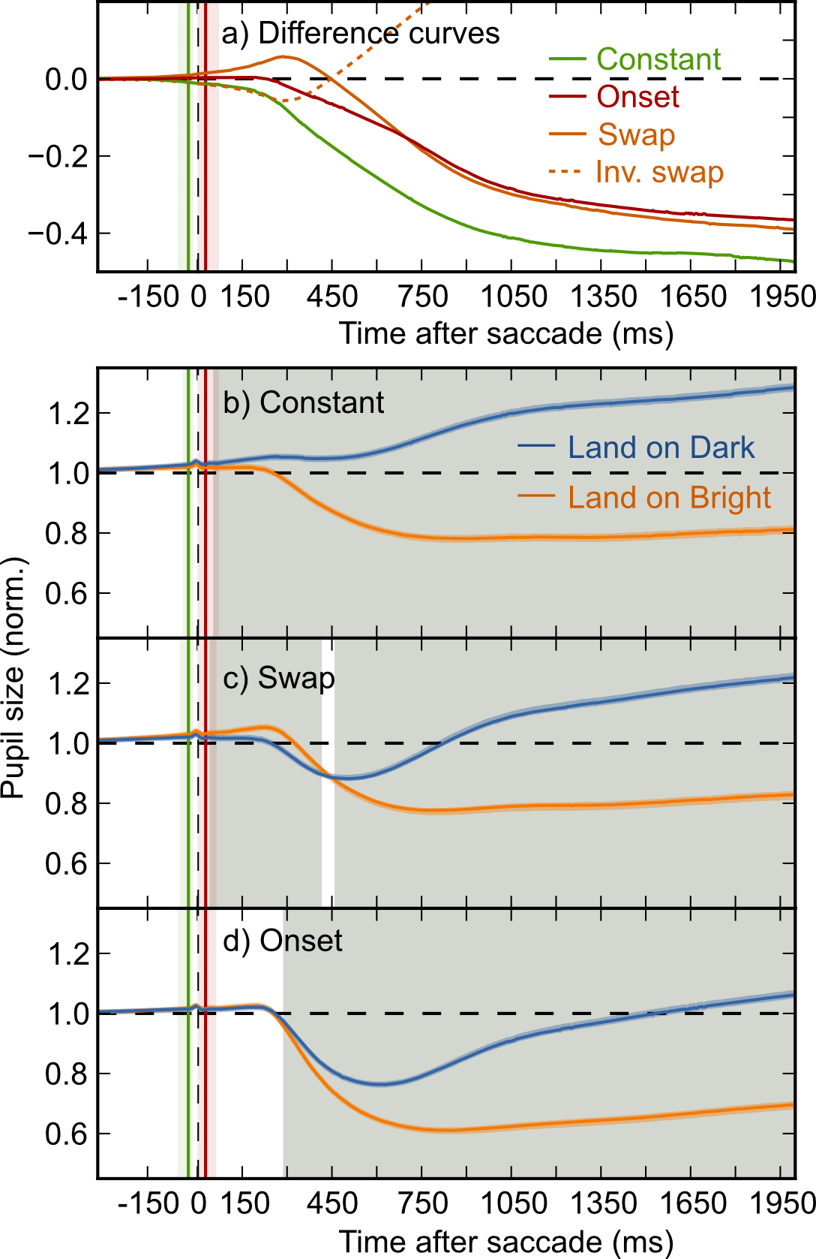
Figure 2. a) The mean difference in pupil size between Land-on-Bright and Land-on-Dark trials over time for the three experimental conditions (solid lines). The orange dotted line shows the inverse of the Swap condition, and is shown for comparison with the Constant condition. b, c, d) Mean pupil size on Land-on-Dark and Land-on-Bright trials over time for the Constant (b), Swap (c), and Onset (d) conditions. Line widths indicate 95% confidence intervals, such that non-overlapping lines correspond to p < .05. Gray shadings indicate significant divergence between Land-on-Dark and Land-on-Bright trials (see main text for criteria). Saccade onset is indicated by the green vertical lines. a, b, c, d) The green and red vertical lines correspond respectively to mean saccade onset and offset. The surrounding shadings indicate the full range of observed values. The display change (a dummy change in the Constant condition) occurred at time 0, indicated by the dashed vertical line.
To determine at which time points there was a significant difference in pupil size between Land-on-Bright and Land-on-Dark trials we conducted a linear mixed-effects (LME) analysis with participant as random effect, target luminance (Land-on-Dark or Land-on-Bright) as fixed effect, and pupil size as dependent measure. This analysis was performed separately for each time point and condition. Markov chain Monte Carlo (MCMC) simulation was used to estimate p values and 95% confidence intervals (Baayen, Davidson, & Bates, 2008). We considered divergence between Land-on-Dark and Land-on-Bright trials significant when p < .05 for at least 200 consecutive samples (cf. Mathôt, van der Linden, Grainger, & Vitu, 2013).
The anticipatory nature of the PLR was evident in two main ways. Firstly, as predicted, divergence occurred much earlier in the Constant condition (58 ms - trial end) than in the Onset condition (292 ms - trial end). Since the latency of the PLR is at least 250 ms (Ellis, 1981), the fact that pupil size is modulated already 58 ms after saccade detection, which corresponds to 30 ms after saccade offset (see Saccade detection), is clear evidence for anticipation.
Secondly, in the Swap condition there was initially an ‘inverse PLR’ (46 - 411 ms). This reflects a response to the brightness of the target as it was before saccade onset, before the polarity of the luminance had changed (Figure 1b). Strikingly, the (inverse of the) Swap condition was indistinguishable from the Constant condition until about 250 ms after the eye movement (compare the dotted-orange and green lines in Figure 2a). This suggests that it takes 250 ms for the pupil to respond to post-saccadic brightness of the target, consistent with estimates of the latency of the PLR (e.g., Ellis, 1981). A ‘normal’ PLR to the post-saccadic brightness of the target arose later in time (464 ms - trial end), and from about 600 ms onwards the Swap condition was indistinguishable from the Onset condition (compare the solid-orange and red lines in Figure 2a). Crucially, the results from the Swap condition show that when you prepare an eye movement towards a bright (or dark) stimulus, an anticipatory PLR is (partly) elicited even when the stimulus is never actually brought into central vision.

Modeling the PLR using exponential decay
In order to characterize the difference between Constant and Onset trials in more detail, we modeled the shape of the PLR using an exponential-decay function. This modeling approach complements the LME analyses described above in two ways. Firstly, by inspecting the model’s parameters we can gain further insight into how the conditions differ qualitatively. Secondly, modeling exposes ‘trivial’ differences, notably differences in noise level between conditions, which could have affected the significance levels of the LME analyses.
The PLR is characterized by an initial latency period followed by a rapid constriction (to brightness) or dilation (to darkness), which gradually slows down as the pupil approaches its new resting size (e.g., Feinberg & Podolak, 1965). This response function is similar (but opposite) for responses to light and darkness (although the darkness response is generally less pronounced), as well as the difference in the response to light and darkness, which is what we model here (Figure 2a). Because the Onset condition is a combination of two opposite responses (to the pre- and post-saccadic brightness of the target, see Figure 2c), it is not properly modeled by exponential decay. Therefore, we model only the Constant and Onset conditions.
In a pilot study, we compared a number of decay functions and found that, given the right parameters, several functions model the PLR very well. Here we use an exponential decay function, adapted from Hoeks & Levelt (1993), because it has parameters with a clear interpretation (see Figure 3): Response latency (t0), initial pupil-size difference (p1), final pupil-size difference (p2), and response speed (the inverse of s).
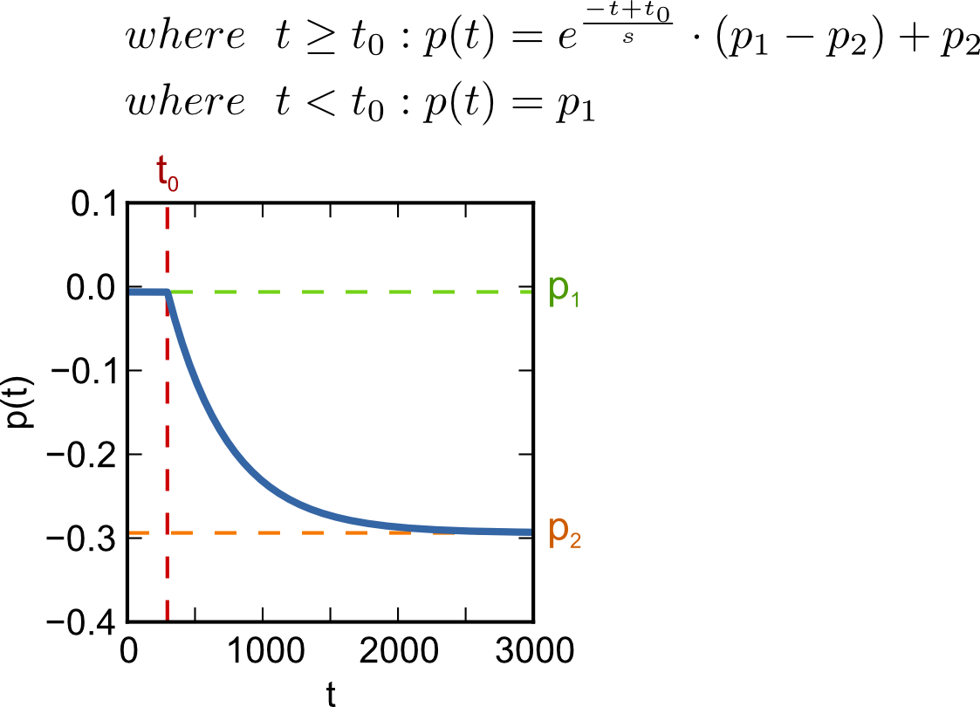
Figure 3. The exponential-decay function used to model the difference between the brightness and darkness response. This function models pupil-size difference (p(t)) over time (t) and has four free parameters: response latency (t0), initial pupil-size difference (p1), final pupil-size difference (p2), and response speed (the inverse of s).
For each participant separately, we determined the model parameters for the mean difference response in the Constant and Onset conditions (Figure 4). Next, we used paired-samples t tests to test for differences between model parameters, using a Bonferroni-corrected alpha level of .0125 (= .05 / 4 comparisons).
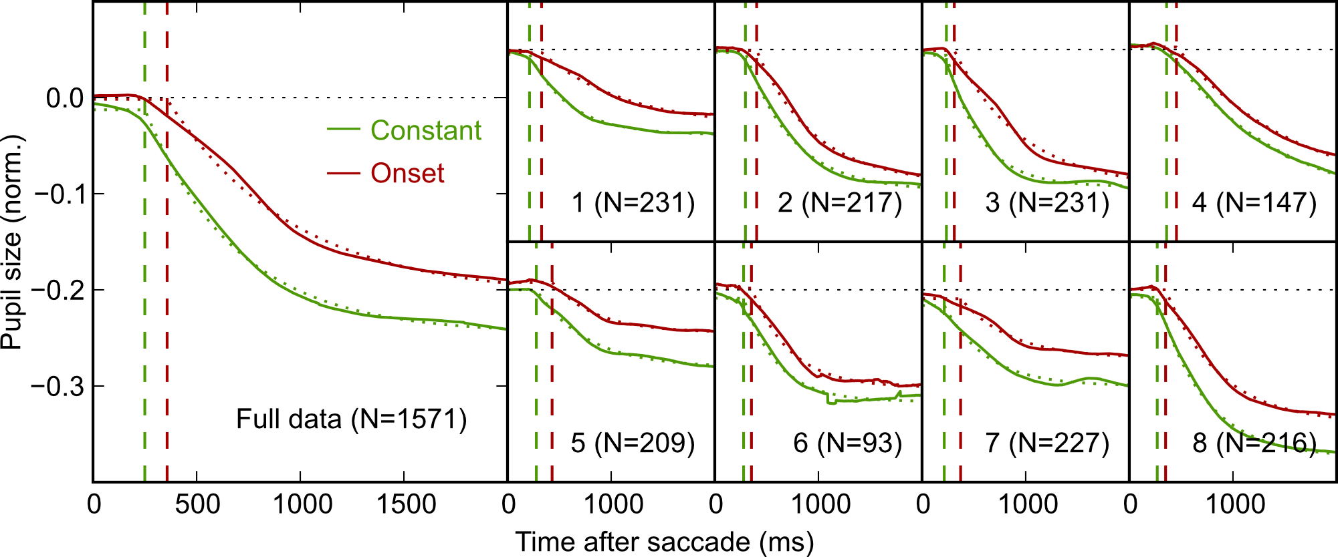
Figure 4. Observed difference between Land-on-Bright and Land-on-Dark trials (solid lines) and model fits (dotted lines) for the Constant and Onset conditions. Vertical dashed lines indicate response latencies (t0). The large pane depicts the grand mean response. Small panes correspond to participant mean responses.
Firstly and most importantly, the latency (t0) of the PLR was 107 ms lower on Constant trials (M = 268, SE = 16.0) than on Onset trials (M = 375, SE = 16.6, t(7) = 9.33, p < 0.0001). In addition, the initial pupil-size difference (p1) was slightly smaller (i.e. more negative) on Constant (M = -0.0110, SE = 0.0038) than on Onset trials (M = -0.0004, SE = 0.0032, t(7) = 4.17, p = .0042), as was the final pupil-size difference (p2; Constant: M = -0.2542, SE = 0.0236; Onset: M = -0.2187, SE = 0.0268; t(7) = 3.56, p = .0093). Response speed is slightly higher (i.e. a lower s) in the Constant condition (M = 491.3, SE = 79.64) than in the Onset condition (M = 623.5, SE = 83.96), but this difference is not significant (t(7) = 2.295, p = .0554).
In sum, the results from the model fits corroborate and extend those from the LME analyses. Most importantly, the latency of the PLR is reduced by 107 ms compared to the Onset condition. In addition, in the Constant there is a small bias in pupil size already before the onset of the PLR proper.

The PLR is locked to saccade onset
To test whether the PLR is locked to the onset of the saccadic response or to the presentation of the auditory cue, we divided trials into ten bins, separately for each participant, based on saccadic response time (SRT). Next, we determined the latency of the PLR (t0) for the Constant and Onset conditions for each bin, as described under Modeling the PLR using exponential decay.
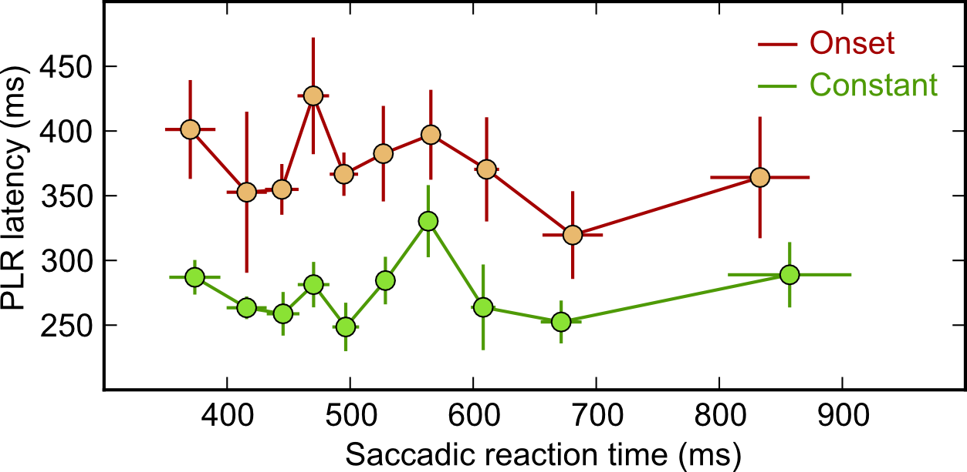
Figure 5. Latency of the PLR (t0) as a function of saccadic reaction time (SRT) for the Constant and Onset conditions. The response latency is about 100 ms lower in the Constant than in the Onset condition, and does not reliably depend on SRT.
As shown in Figure 5, the latency reduction of the PLR in the Constant condition relative to the Onset condition was around 100 ms independent of SRT, indicating that the PLR was locked to saccade onset. This was confirmed by a Repeated Measures Analysis of Variance (ANOVA) with Bin (10 levels) and Condition (Constant; Onset) as within-subject factors and t0 as dependent variable. This revealed a main effect of Condition (F(1, 7) = 106.12, p < .0001), reflecting an overall latency reduction, but no main effect of Bin (F(9, 7) = 1.21, p = .3056), nor a Condition by Bin interaction (F(9,9) = 0.30, p = .9726).

Visual-change-induced constriction
Our analyses focus on the difference between Land-on-Bright and Land-on-Dark trials, because the absolute shape of the pupillary response differs between conditions. Specifically, there is an overall constriction in the Swap and Onset conditions (Figure 2c,d), which is not present in the Constant condition (Figure 2b). This constriction is due to the visual change to the display that occurred in the Swap and Onset conditions (Barbur, Harlow, & Sahraie, 1992). However, visual change is identical across Land-on-Bright and Land-on-Dark trials, and the difference response (Figure 2a) is therefore not distorted by visual-change-induced constriction, as evidenced by the fact that the difference response in the Swap condition (with visual change) initially mirrors the Constant condition (no visual change).

Accounting for bias due to fixational eye movements
When you attend to a stimulus without looking directly at it (i.e. covert attention), small fixational eye movements tend to gravitate towards the attended stimulus (Engbert & Kliegl, 2003). Since every saccadic eye movement is preceded by a covert shift of attention (e.g., Deubel & Schneider, 1996), one might expect that fixational eye movements bring the eyes slightly closer to the saccade target already before the eyes set in motion.
In our data, gaze position was indeed biased towards the saccade target from 242 ms before saccade onset, as determined using an LME analysis with Participant as random effect, Target Side (Left or Right) as fixed effect, and Horizontal Gaze Position as dependent measure. This bias gradually increased to 0.03° just before the onset of the saccade. Although this bias was extremely small, we nevertheless verified that it did not affect our results. First we discarded all trials in which gaze position was, on average, biased towards the saccade target (51.6%). This left a subset of data in which gaze was biased slightly away from the saccade target (0.3°). All analyses described above were repeated on this subset of data.
Compared to the main analysis, there were only two minor differences: When estimating the model parameters, there was no longer a difference in the final pupil-size difference between the Constant and Onset conditions (p2; t(7) = 0.7120, p = 0.4995), and the difference in the initial pupil-size difference (p1) was no longer significant using our Bonferroni-corrected alpha level of .0125 (t(7) = 2.537, p = .0387). Other than that, there were no notable differences between the full dataset and this subset of the data. This illustrates that our results are not due to a gaze-position bias prior to the eye movement.

Discussion
Here we report, for the first time, that the pupillary light response (PLR) is anticipatory: When you prepare an eye movement towards a bright (or dark) stimulus, the pupil already adjusts its size to the anticipated luminance change before the eyes set in motion. This finding contrasts with the traditional view that the PLR is a low-level reflex to light, and shows that the PLR is tightly linked to visual attention and eye movements (see also Binda et al., 2013; Mathôt et al., 2013).
In our data, the anticipatory nature of the PLR is evident in three ways, Firstly, the latency of the PLR is reduced by 107 ms when making an eye movement towards a bright (or dark) stimulus, relative to when a stimulus suddenly appears (Figure 4). This latency reduction closely matches the finding that a covert shift of attention precedes every eye movement by approximately 100 ms (Deubel, 2008; Rolfs & Carrasco, 2012). We propose that this pre-saccadic shift of attention drives the anticipatory PLR: The pupil starts to adjust its size at the moment that attention shifts towards the target of an upcoming eye movement.
Secondly, a PLR is elicited when you prepare an eye movement towards a bright (or dark) stimulus, even when that stimulus is never actually brought into central vision. More specifically, in the Swap condition (Figure 2c), the brightness of the display reversed polarity during the eye movement. Consequently, when preparing an eye movement towards a bright target, the eyes landed on a dark target, and vice versa. The crucial finding is that the pupil initially responded to the pre-saccadic brightness of the target. The latency of this initial response was very low (±19 ms after saccade offset), strongly suggesting that it was anticipatory.
Thirdly, the PLR is qualitatively different during self-generated movement and passive viewing. In passive-viewing experiments, pupil size is initially unaffected by a suddenly presented stimulus, until a PLR is elicited with a latency of 250 - 500 ms (e.g., Ellis, 1981; Feinberg & Podolak, 1965; Lowenstein & Loewenfeld, 1950). We replicate this pattern, but–crucially–only in the Onset condition, in which no anticipation was possible (Figure 2a). In the Swap and Constant conditions, a small change in pupil size is evident almost immediately after the eye movement, followed later by a much more pronounced response, which we might call the ‘real’ PLR. This shows that during self-generated movement, the PLR is not a single all-or-nothing response, but arises more-or-less gradually. Again, this is reminiscent of the pre-saccadic shift of attention, which also arises gradually before the onset of an eye movement (Rolfs & Carrasco, 2012).
Our results complement recent studies that have demonstrated various high-level effects on the PLR. Most relevant are two studies, by Binda et al. (2013) and ourselves (Mathôt et al., 2013), which have shown that the PLR is modulated by covert visual attention: Merely attending to a bright stimulus from the corner of your eye is sufficient to trigger a pupillary constriction. Another striking result, which dates back almost a century, but has recently been re-discovered, comes from binocular rivalry. In these studies, two stimuli of different brightness are presented to each eye (Bárány & Halldén, 1948; Brenner, Charles, & Flynn, 1969; Fahle, Stemmler, & Spang, 2011; Harms, 1937; Lowe & Ogle, 1966; Naber, Frassle, & Einhauser, 2011). At any one time, only one stimulus is perceived, although visual awareness ‘flips’ back and forth between both eyes. With respect to the PLR, the crucial finding is that the pupil constricts when the brighter stimulus dominates awareness, relative to when the darker stimulus dominates. This shows that the PLR reflects visual awareness, rather than objective luminance. Finally, three recent studies have shown that the pupil constricts when viewing images that are interpreted as being very bright, such as pictures of the sun, compared to equiluminant control images (Binda, Pereverzeva, & Murray, 2013; Laeng & Endestad, 2012; Naber & Nakayama, 2013). Taken together, all of these studies show that the PLR is not just a reflexive response to light, but reflects what we (covertly) attend to, what we are aware of, and how we interpret visual input. Our study complements these findings by showing that the PLR anticipates the visual consequences of saccadic eye movements.
In conclusion, we have shown that the pupillary light response (PLR) is anticipatory, and responds to the brightness of stimuli before they are brought into central vision. We have suggested that this finding is linked to the pre-saccadic of attention (Deubel & Schneider, 1996; Kowler et al., 1995): The pupil starts to adjust its size as soon as attention shifts towards the target of an upcoming saccade.

Methods

Materials and availability
Experimental scripts, participant data, and analysis scripts are available from the first author’s website, or from https://github.com/smathot/data_repository.

Participants and ethics statement
Eight observers (six naive participants and two authors; seven women; age range 20-30 years) participated in the experiment. Participants were recruited through the participant pool of Aix-Marseille Université. All participants provided written informed consent. The experiment was conducted with approval of the local ethics committee of Aix-Marseille Université, and was in accordance with the declaration of Helsinki.

Software and apparatus
The right eye was recorded with an EyeLink 1000 (SR Research, Mississauga, Canada, ON), a video-based eye tracker sampling at 1000 Hz. Stimuli were presented on a 21" CRT monitor (1024 x 768 px, 100 Hz). Stimulus presentation was controlled with OpenSesame (Mathôt, Schreij, & Theeuwes, 2012) using the PsychoPy back-end (Peirce, 2007).

Procedure and stimuli
Before the experiment, a nine-point eye-tracker calibration was performed. Before each trial, a single-point re-calibration was performed (‘drift correction’).
Each trial started with the presentation of three green dots (X cd/m2; 0.1°), presented at the display center and 5.00° degrees to the right and left of the center (see Figure 1). Participants were instructed to fixate on the central dot. In the Constant and Swap conditions, the background was divided into a bright (X cd/m2) and a dark (X cd/m2) half, separated by a central luminance-gradient band (10.0°). In the Onset condition, the background was uniformly gray (X cd/m2). After 3 s, a voice saying ‘gauche’ (left) or ‘droite’ (right) was played back through a set of desktop speakers, instructing participants to make a saccadic eye movement to the left or right dot. Saccades were detected on-line as the moment at which horizontal gaze position deviated more than 2.9° from the central dot for at least two consecutive gaze samples. (For the analysis we used an off-line detection algorithm, described under Saccade detection.) As soon as a saccade was detected, one of three things could happen: In the Constant condition, the display did not change at all; In the Swap condition, the dark side of the screen turned bright and vice versa; In the Onset condition, the initially gray display was divided into a bright and a dark half. The trial ended after another 3 s.
Phrased differently, we used a fully crossed 2 x 3 design. The first factor was Landing Luminance (Land on Bright or Land on Dark), corresponding to the luminance of the target region after the saccade. The second factor was Condition (Constant, Swap, or Onset), as described above. For example, on a Land-on-Dark Constant trial, a saccade was prepared towards the dark side of the display, which did not change after the saccade (Figure 1a). On a Land-on-Bright Swap trial, a saccade was prepared towards the dark side of the screen, which turned bright on saccade detection (Figure 1b). Finally, on a Land-on-Bright Onset trial, a saccade was prepared towards a gray area, which turned dark on saccade detection (Figure 1c). Saccade direction (Left or Right) was fully randomized and not entered as a factor into the design.

Pupil-trace analysis
Each trial was divided into three epochs: The baseline epoch, spanning the 100 ms prior to the presentation of the cue; The pre-saccade epoch, from the cue until the detection of the saccade; And the post-saccade epoch, from the detection of the saccade until the end of the trial. We analyzed pupil surface relative to the mean pupil size during the baseline epoch (cf. Mathôt et al., 2013). Missing data during blinks was reconstructed, where possible, using cubic-spline interpolation (Mathôt, 2013). No signal smoothing was applied.

Trial-exclusion criteria
Trials were excluded based on the following criteria: A saccade was executed in the wrong direction or before the cue was presented (8.4%); Saccade latency was less than 50 ms or more than 2000 ms (0.5%); The display change did not occur during the saccade, as determined by off-line saccade detection (4.9%; See Saccade detection); Blinks occurred and could not be reconstructed (4.5%, see Pupil-trace analysis). After exclusion, 2350 trials (81.4%) remained for further analysis.

Saccade detection
For the purpose of the analysis, we used the EyeLink saccade detection algorithm with the default parameters (velocity threshold: 35 °/s; acceleration threshold: 9500 °/s2) and the additional constraint that we only considered the first saccade that was larger than 1.8°. Saccades were executed on average 543.6 ms (SD = 187.4) after the cue. We did not provide any instructions regarding speed, and consequently there was considerable variability in saccadic response time between participants, ranging from 409 ms to 789 ms (participant means). After the display change had occurred, a trigger was sent to the eye tracker to allow off-line verification of timing. This showed that the display change occurred exactly in the middle of the saccade, 27.09 ms (SD = 3.906) after saccade onset and 27.55 ms (SD = 7.852) before saccade offset. The average saccade duration was 54.63 ms (SD = 7.407).

Acknowledgements
This research was supported by ERC grant 230313 to Jonathan Grainger.

References
Baayen, R. H., Davidson, D. J., & Bates, D. M. (2008). Mixed-effects modeling with crossed random effects for subjects and items. Journal of memory and language, 59(4), 390–412. doi:10.1016/j.jml.2007.12.005
Barbur, J. L., Harlow, A. J., & Sahraie, A. (1992). Pupillary responses to stimulus structure, colour and movement. Ophthalmic and Physiological Optics, 12(2), 137–141. doi:10.1111/j.1475-1313.1992.tb00276.x
Bárány, E. H., & Halldén, U. (1948). Phasic inhibition of the light reflex of the pupil during retinal rivalry. Journal of Neurophysiology, 11(1), 25–30. Retrieved from http://jn.physiology.org/content/11/1/25
Binda, P., Pereverzeva, M., & Murray, S. O. (2013). Attention to bright surfaces enhances the pupillary light reflex. The Journal of Neuroscience, 33(5), 2199–2204. doi:10.1523/​JNEUROSCI.3440-12.2013
Binda, P., Pereverzeva, M., & Murray, S. O. (2013). Pupil constrictions to photographs of the sun. Journal of Vision, 13(6), e8. doi:10.1167/13.6.8
Brenner, R., Charles, S. T., & Flynn, J. T. (1969). Pupillary responses in rivalry and amblyopia. Archives of Ophthalmology, 82(1), 23–29. doi:10.1001/archopht.1969.00990020025007
Burns, M. E., & Baylor, D. A. (2001). Activation, Deactivation, and Adaptation in Vertebrate Photoreceptor Cells. Annual Review of Neuroscience, 24(1), 779–805. doi:10.1146/annurev.neuro.24.1.779
Campbell, F. W., & Gregory, A. H. (1960). Effect of size of pupil on visual acuity. Nature, 4743, 1121–1123. doi:10.1038/1871121c0
Carrasco, M., Ling, S., & Read, S. (2004). Attention alters appearance. Nature Neuroscience, 7(3), 308–313. doi:10.1038/nn1194
Castet, E., Jeanjean, S., Montagnini, A., Laugier, D., & Masson, G. S. (2006). Dynamics of attentional deployment during saccadic programming. Journal of Vision, 6(3), 2. doi:10.1167/6.3.2
Crawford, B. H. (1936). The dependence of pupil size upon external light stimulus under static and variable conditions. Proceedings of the Royal Society of London. Series B, Biological Sciences, 376–395. doi:10.1098/rspb.1936.0072
Denton, E. J. (1956). The responses of the pupil of Gekko gekko to external light stimulus. The Journal of general physiology, 40(2), 201. Retrieved from http://www.ncbi.nlm.nih.gov/pmc/articles/PMC2147617/
Deubel, H. (2008). The time course of presaccadic attention shifts. Psychological research, 72(6), 630–640. Retrieved from http://link.springer.com/article/10.1007/s00426-008-0165-3
Deubel, H., & Schneider, W. X. (1996). Saccade target selection and object recognition: Evidence for a common attentional mechanism. Vision Research, 36(12), 1827–1837. doi:10.1016/0042-6989(95)00294-4
Ellis, C. J. (1981). The pupillary light reflex in normal subjects. British Journal of Ophthalmology, 65(11), 754–759. doi:10.1136/bjo.65.11.754
Engbert, R., & Kliegl, R. (2003). Microsaccades uncover the orientation of covert attention. Vision Research, 43(9), 1035–1045. doi:10.1016/S0042-6989(03)00084-1
Fahle, M. W., Stemmler, T., & Spang, K. M. (2011). How much of the “unconscious” is just pre-threshold? Frontiers in Human Neuroscience, 5. doi:10.3389/fnhum.2011.00120
Feinberg, R., & Podolak, E. (1965). Latency of pupillary reflex to light stimulation and its relationship to aging. Federal Aviation Agency, Office of Aviation Medicine, Georgetown Clinical Research Institute. Retrieved from http://libraryonline.erau.edu/online-full-text/faa-aviation-medicine-reports/AM65-25.pdf
Findlay, J. M., & Gilchrist, I. D. (2003). Active Vision: The Psychology of Looking and Seeing. Oxford, UK: Oxford University Press.
Harms, H. (1937). Ort und Wesen der Bildhemmung bei Schielenden. Graefe's Archive for Clinical and Experimental Ophthalmology, 138(1), 149–210. doi:10.1007/BF01854538
Hoeks, B., & Levelt, W. J. (1993). Pupillary dilation as a measure of attention: A quantitative system analysis. Behavior Research Methods, Instruments, & Computers, 25(1), 16–26. Retrieved from http://link.springer.com/article/10.3758/BF03204445
Hoffman, J. E., & Subramaniam, B. (1995). The role of visual attention in saccadic eye movements. Perception & Psychophysics, 57(6), 787–795.
Kowler, E., Anderson, E., Dosher, B., & Blaser, E. (1995). The role of attention in the programming of saccades. Vision Research, 35(13), 1897–1916.
Laeng, B., & Endestad, T. (2012). Bright illusions reduce the eye's pupil. Proceedings of the National Academy of Sciences, 109(6), 2162–2167. doi:10.1073/pnas.1118298109
Laeng, B., Sirois, S., & Gredebäck, G. (2012). Pupillometry: A window to the preconscious? Perspectives on Psychological Science, 7(1), 18–27. doi:10.1177/1745691611427305
Loewenfeld, I. E. (1958). Mechanisms of reflex dilatation of the pupil. Documenta Ophthalmologica, 12(1), 185–448. doi:10.1007/BF00913471
Lowe, S. W., & Ogle, K. N. (1966). Dynamics of the pupil during binocular rivalry. Archives of Ophthalmology, 75(3), 395. doi:10.1001/archopht.1966.00970050397017
Lowenstein, O., & Loewenfeld, I. E. (1950). Role of sympathetic and parasympathetic systems in reflex dilatation of the pupil: Pupillographic studies. Archives of Neurology and Psychiatry, 64(3), 313–340. doi:10.1001/archneurpsyc.1950.02310270002001
Mathôt, S. (2013). A Simple Way to Reconstruct Pupil Size During Eye Blinks. Retrieved from http://dx.doi.org/10.6084/m9.figshare.688002
Mathôt, S., & Theeuwes, J. (2011). Visual attention and stability. Philosophical Transactions of the Royal Society B: Biological Sciences, 366(1564), 516–527. doi:10.1098/rstb.2010.0187
Mathôt, S., Schreij, D., & Theeuwes, J. (2012). OpenSesame: An open-source, graphical experiment builder for the social sciences. Behavior Research Methods, 44, 314–324. doi:10.3758/s13428-011-0168-7
Mathôt, S., van der Linden, L., Grainger, J., & Vitu, F. (2013). The pupillary response to light reflects the focus of covert visual attention. PLoS ONE, 8(10), e78168. doi:10.1371/journal.pone.0078168
Mathôt, S., van der Linden, L., Grainger, J., & Vitu, F. (2013). The pupillary response to light reflects the focus of covert visual attention. PLoS ONE, 8(10), e78168. doi:10.1371/journal.pone.0078168
Naber, M., & Nakayama, K. (2013). Pupil responses to high-level image content. Journal of Vision, 13(6), e7. doi:10.1167/13.6.7
Naber, M., Frassle, S., & Einhauser, W. (2011). Perceptual rivalry: Reflexes reveal the gradual nature of visual awareness. PloS ONE, 6(6), e20910. doi:10.1371/journal.pone.0020910
Peirce, J. W. (2007). PsychoPy: Psychophysics software in Python. Journal of Neuroscience Methods, 162(1-2), 8–13. doi:10.1016/j.jneumeth.2006.11.017
Posner, M. I. (1980). Orienting of attention. Quarterly Journal of Experimental Psychology, 32(1), 3–25. doi:10.1080/00335558008248231
Rayner, K. (1998). Eye movements in reading and information processing: 20 years of research. Psychological Bulletin, 124, 372–422. doi:10.1037/0033-2909.124.3.372
Rolfs, M., & Carrasco, M. (2012). Rapid simultaneous enhancement of visual sensitivity and perceived contrast during saccade preparation. The Journal of Neuroscience, 32(40), 13744–13752a. doi:10.1523/​JNEUROSCI.2676-12.2012
Woodhouse, J. M. (1975). The effect of pupil size on grating detection at various contrast levels. Vision Research, 15(6), 645–648. doi:10.1016/0042-6989(75)90278-3
Woodhouse, J. M., & Campbell, F. W. (1975). The role of the pupil light reflex in aiding adaptation to the dark. Vision Research, 15(6), 649–653. doi:10.1016/0042-6989(75)90279-5

