HomeWork_5

Sijay Matsinye

3/5/2021

library(tidyverse)

## -- Attaching packages -------------- tidyverse 1.3.0 --

## v ggplot2 3.3.2 v purrr 0.3.4  
## v tibble 3.0.3 v dplyr 1.0.2  
## v tidyr 1.1.2 v stringr 1.4.0  
## v readr 1.3.1 v forcats 0.5.0

## -- Conflicts ----------------- tidyverse_conflicts() --  
## x dplyr::filter() masks stats::filter()  
## x dplyr::lag() masks stats::lag()

library(Sleuth3)  
library(broom)

Stockreturns <- c(-8.36, 1.63, -2.27, -2.93, -2.70,  
-2.93, -9.14, -2.64, 6.82, -2.35,  
-3.58, 6.13, 7.00, -15.25, -8.66,  
-1.03, -9.16, -1.25, -1.22, -10.27,  
-5.11, -0.80, -1.44, 1.28, -0.65,  
4.34, 12.22, -7.21, -0.09, 7.34,  
5.04, -7.24, -2.14, -1.01, -1.41,  
12.03, -2.53, 4.33, 1.35)  
Stockreturns

## [1] -8.36 1.63 -2.27 -2.93 -2.70 -2.93 -9.14 -2.64 6.82 -2.35  
## [11] -3.58 6.13 7.00 -15.25 -8.66 -1.03 -9.16 -1.25 -1.22 -10.27  
## [21] -5.11 -0.80 -1.44 1.28 -0.65 4.34 12.22 -7.21 -0.09 7.34  
## [31] 5.04 -7.24 -2.14 -1.01 -1.41 12.03 -2.53 4.33 1.35

1. Use and show R code to find the mean of the sample data.

mean(Stockreturns)

## [1] -1.124615

1. Use and show R code to find the standard deviation of the sample data

sd(Stockreturns)

## [1] 5.977673

1. Assuming a normal distribution, use and show R code to find the proportion of returns that are less than -1.5.

pnorm(q = -1.5, mean = -1.124615, sd = 5.977673)

## [1] 0.4749637

1. Assuming a normal distribution, use and show R code to find return value that is above 70% of the returns

qnorm(p = 0.70, mean = -1.124615, sd =5.977673)

## [1] 2.01008

1. Use and show R code to find Q1 for the data.
   * -3.255

summary(Stockreturns)

## Min. 1st Qu. Median Mean 3rd Qu. Max.   
## -15.250 -3.255 -1.410 -1.125 1.490 12.220

1. Explore the data by producing and examining a boxplot and checking for normality.

boxplot(Stockreturns)

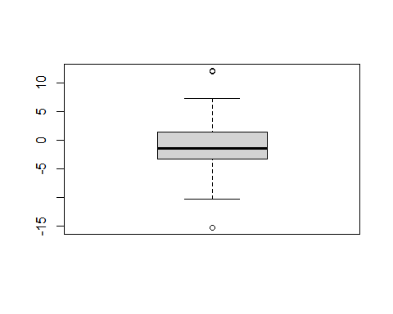

qqnorm(Stockreturns)  
 qqline(Stockreturns)

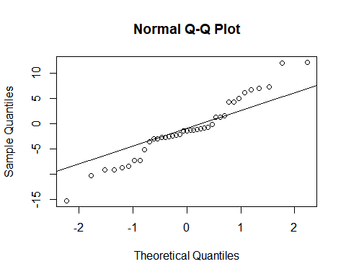

1. State the appropriate null and alternative hypothesis required for the appropriate t test.
   * H(0) : population mean = .0095
   * H(A) : population mean less than .0095
2. Use and show R code that will output the needed p value and confidence interval to determine if the null hypothesis should be rejected.

t.test(Stockreturns,mu=.0095, alternative = "less", conf.level = .95)

##   
## One Sample t-test  
##   
## data: Stockreturns  
## t = -1.1848, df = 38, p-value = 0.1217  
## alternative hypothesis: true mean is less than 0.0095  
## 95 percent confidence interval:  
## -Inf 0.4891698  
## sample estimates:  
## mean of x   
## -1.124615

1. Now answer the question originally stated. Does the broker perform worse than average? (Explain or justify in two or three sentences)
   * The broker does not perform worse than average because the p-value in our T-test is greater than .05 and 0 is in our confidence interval. Therefore there is not enough statistical evidence to reject the null hypothesis and prove that the broker performed worse than average.