Software Requirements Specification
for
Functional Elevator Simulator
Version 0.4.1
Luis Alejandro Barreda Acevedo 2020425927
Rubén Isaí Hurtado Granados 2023282072
Josué Daniel Soto González 2023207915
Samuel Zúñiga Vega 2023029693
Tecnológico de Costa Rica
27/05/2024
Table of Contents
Table of Contents ii
Revision History iii
1. Introduction 4
1.1 Purpose 4
1.2 Document Conventions 4
1.3 Intended Audience and Reading Suggestions 4
1.4 Project Scope 4
1.5 References 6
2. Overall Description 7
2.1 Product Perspective 7
2.2 Product Features 7
2.3 User Classes and Characteristics 16
2.4 Operating Environment 16
2.5 Design and Implementation Constraints 16
2.6 User Documentation 16
2.7 Assumptions and Dependencies 16
3. System Features 17
3.1 System Feature 1 17
3.2 System Feature 2 (and so on) 17
4. External Interface Requirements 17
4.1 User Interfaces 17
4.2 Hardware Interfaces 5
4.3 Software Interfaces 5
4.4 Communications Interfaces 5
5. Other Nonfunctional Requirements 6
5.1 Performance Requirements 6
5.2 Safety Requirements 6
5.3 Security Requirements 6
5.4 Software Quality Attributes 6
6. Other Requirements 6
Appendix A: Glossary 6
Appendix B: Analysis Models 7
Appendix C: Issues List 7

Revision History
Name | Date | Reason For Changes | Version
Initial documentation | 20/02/24 | Initial information on the project filled with requirements. | 0.0.1
Update of requirements | 22/02/24 | Updated the information based on consultation. More information added on the base prototype and requirements. | 0.1.0
Update of sections 1.3 and 1.4 | 21/03/24 | Updated the intended audience explanation and the project scope with user stories. | 0.2.0
Update of the Overall Description | 02/04/24 | Updated the Overall Description of the project with use cases diagram. | 0.3.0
Update of the Use Cases and Diagram | 13/04/24 | Updated all empty requirement boxes with NA and corrected section 2. | 0.3.1
Update of Class Diagrams | 01/05/24 | Updated the use case diagram and added the class, sequence, and activity diagrams | 0.3.2
Update of Class Dictionary | 02/05/24 | Updated the class dictionary and class diagram on section 3. | 0.3.3
Update of empty sections on 2, 5 & 6 | 25/05/24 | Updated some small corrections and added non-functional requirements specifications. | 0.4.0
Update: sequence diagrams | 27/05/24 | Updated the sequence diagrams one for each activity | 0.4.1

Introduction

Purpose
The purpose of this Systems Requirements Specifications (SRS) document is to provide the guidelines necessary to design and implement the Functional Elevator Simulator Software (FESS). Therefore, this document could be used by any member of the development team to build a software application that satisfies the requirements stated by the client.

The SRS describes the components and functionalities that the FESS is expected to accomplish. As well as the Graphical User Interface (GUI) design which meets the use cases proposed by the client. It also includes nonfunctional requirements that can be used as a final criterion to judge if the software fulfills the SRS.

Document Conventions
The following typographical conventions and standards were applied in the making of this SRS. Titles are written with the font Times, size 14 and bold. Normal text is written with the font Times, size 12. To highlight important aspects of the document the same convention in normal text is used but bold.

List of acronyms used in this document:

SRS – Systems Requirements Software, this document which outlines the requirements that the software must fulfill.

GUI – Graphical User Interface

UML – Unified Modeling Language.

FESS – Functional Elevator Simulator Software

EIR – External Interface Requirements

Intended Audience and Reading Suggestions
This SRS document is designed to cater to various entities involved in the development of the FESS. In this case, the professor and students of the Software Requirements course, the technicians that are going to configure the elevator and the elevator logic programmers.

Project Scope
The FESS aims to be a comprehensive simulation tool designed to replicate the operating behavior of elevators in the real world in multiple environments. Its primary purpose is to provide a better understanding of the intricacies that go into developing a functional elevator system, and to comply with the instructions given by the professor of this course.
The main goal is to be able to simulate different case scenarios by modifying variables such as load capacity, height of the buildings and environmental hazards like earthquakes and similar, among others. This with the objective of obtaining a deeper understanding of the elevator systems which can then be used to improve the current models. With this in mind, the FESS also aligns with some more intricate corporate goals as it promotes innovation, improvement of operational efficiency and maintenance of a competitive edge in the industry.

The program is normally used by the people in the building who want to go to another floor. In special occasions a technician can set internal settings of the elevator and do maintenance works.

- The elevator will be able to get to the floor that the user wants simply by pressing the desired floor button. The interface will glow telling the user that his floor is already in the tail of the floors list to reach. When the floor is reached, the light turns off and the screen shows the current floor. To make the user use the smaller number of actions possible, the doors also open automatically when the floor is reached.

As a user of the elevator or maintenance employee
I want to press the floor button.
So that I can reach my desired floor

Acceptance criteria:
- The elevator stops and opens at the desired floor.

- The elevator will have an outdoor panel on every floor with two arrows and a screen that shows where the elevator is now. The first floor will only have the upside arrow and the last one the downside arrow. When the arrow is clicked, the button will glow until the elevator reaches that floor. The outdoor screen will display the floor where the elevator is located to give the user more information about what’s happening.

As a user of the elevator or maintenance employee
I want to press the up button.
So that I can get the elevator to my floor

Acceptance criteria:
- The elevator continues its flow until the process is finished or the floor is coming in the way of the original tail.
- The outdoor screen will be updated every time the elevator moves to a different floor.

As a user of the elevator or maintenance employee
I want to press the down button.
So that I can get the elevator to my floor

Acceptance criteria:
- The elevator continues its flow until the process is finished or the floor is coming in the way of the original tail.
- The outdoor screen will be updated every time the elevator moves to a different floor.

- The elevator will have two buttons in the indoor panel to open/close the doors. These doors need to check if there’s an obstacle between them so a user can pass without getting hurt. The open buttons should not work when the elevator is moving to prevent accidents.

As a user of the elevator or maintenance employee
I want to press the “open door” button.
So that I can control the door behavior

Acceptance criteria:
- Door should not open if it’s not on a floor.

As a user of the elevator or maintenance employee
I want to press the “close door” button.
So that I can control the door behavior

Acceptance criteria:
- The door should not close if there is an obstacle in its way.

- To ensure that the users will have someone to contact when an emergency happens, an alarm button will be placed inside the elevator. When this button is pressed, the building staff will be notified, and the elevator will stop to prevent any more damage.

As a user of the elevator or maintenance employee
I want to trigger the emergency button.
So that the building staff can notice there's an emergency in the elevator.

Acceptance criteria:
- When the alarm button is triggered, the elevator sends an alarm to the building staff.
- The elevator stops at the time the button is pressed.
- The elevator remembers the floor in which it was before getting stopped in order to move to the nearest floor when the emergency passes.

- The elevator needs to be in good condition when operating and must be useful even though the building gets more floors constructed as time passes. Because of this, the maintenance employee will be able to add more floors to the elevator, set the maximum number of users at the same time and shut down the elevator due to malfunctioning.

As a maintenance employee
I want to add floors to the elevator.
So that more floors could be added to it, a maximum limit will be set.

Acceptance criteria:
- The inner panel needs to have the new floor buttons constructed.

As a maintenance employee
I want to remove floors from the elevator.
So that more floors could be removed from it.

Acceptance criteria:
- The inner panel needs to have the floor buttons removed as well.

References
D. L. Pepyne & C. G. Cassandras, "Design and implementation of an adaptive dispatching controller for elevator systems during uppeak traffic," in IEEE Transactions on Control Systems Technology, vol. 6, no. 5, pp. 635-650, Sept. 1998, doi: 10.1109/87.709499.

A. Arrieta, M. Otaegi, L. Han, G. Sagardui, S. Ali & M. Arratibel, "Automating Test Oracle Generation in DevOps for Industrial Elevators," 2022 IEEE International Conference on Software Analysis, Evolution and Reengineering (SANER), Honolulu, HI, USA, 2022, pp. 284-288, doi: 10.1109/SANER53432.2022.00044.

ASME A17.1 (2000). On cars with two entrances, a separate door-close button shall be provided for each entrance if both entrances can be opened at the same landing. Safety Code for Elevators and Escalators.

ACE Lifts (s.f.). Traction Lifts: an infographic on how they work. ACE Lifts. Archived from the original on 19 July 2014. Retrieved from https://web.archive.org/web/20140719082011/http://acelifts.com/news/traction-lifts-work/

Overall Description

Product Perspective
This elevator simulator is a product required for the Software Requirements course. It is new and self-contained, so it doesn’t belong to any previous system. The idea is to simulate the functionality of a conventional elevator. The people flow, the upside-down movement of the elevator, the opening and closing of the door, and the possible emergencies are taken into consideration in the modeling of the elevator’s workflow.

Product Features
The basic functions of the elevator are:
- Inner panel:
  - Select a floor through the numbers in the panel.
  - Open or close the elevator doors.
  - Activate the emergency alarm.
  - Add/remove floors.
- Outer panel:
  - Call an elevator to let it know if the user wants to go up or down.

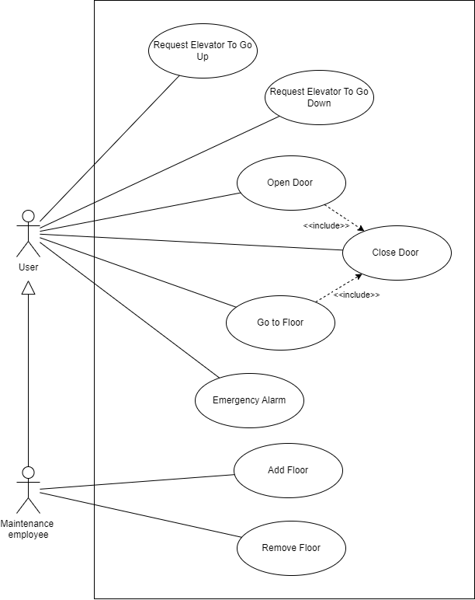
Figure 2.2.1 Use Case Diagram.
2.2.2
Use Case ID: | 1
Use Case Name: | Open Door
Created By: | Samuel Zúñiga | Last Updated By: | Josue Soto
Date Created: | 01/04/2024 | Date Last Updated: | 13/04/2024

Actors: | User
Description: | The elevator door opens if the elevator is stationary in a floor.
Trigger: | The user presses the “open door” button in the elevator.
Preconditions: | - The elevator must be in service.  - The elevator is not in emergency mode.
Postconditions: | - The door is open.
Normal Flow: | - Verification that the door is closed.  - Verification that the elevator is stationary.  - The door opens.  - The door closes after some time.
Alternative Flows: | - The door is already open.
Exceptions: | - The elevator is stationary in a floor.  - The elevator is not in emergency mode.
Includes: | Close door
Priority: | 2
Frequency of Use: | Daily
Business Rules: | NA
Special Requirements: | NA
Assumptions: | NA
Notes and Issues: | NA

2.2.3
Use Case ID: | 2
Use Case Name: | Close Door
Created By: | Samuel Zúñiga | Last Updated By: | Josue Soto
Date Created: | 01/04/2024 | Date Last Updated: | 13/04/2024

Actors: | User
Description: | The elevator door closes if the elevator is stationary in a floor.
Trigger: | The user presses the “close door” button in the elevator.
Preconditions: | - The elevator must be in service.  - The elevator is not in emergency mode.
Postconditions: | - The door is closed.
Normal Flow: | - Verification that the door is open.  - Verification that the elevator is stationary.  - The door closes.
Alternative Flows: | - The door is already closed.  - The door detects an obstacle.  - The door opens.  - Continues in step 3 of Normal Flow.
Exceptions: | - The elevator is not stationary.  - The door remains closed.
Includes: | NA
Priority: | 1
Frequency of Use: | Daily
Business Rules: | NA
Special Requirements: | NA
Assumptions: | NA
Notes and Issues: | NA

2.2.4
Use Case ID: | 3
Use Case Name: | Got to Floor
Created By: | Samuel Zúñiga | Last Updated By: | Josue Soto
Date Created: | 01/04/2024 | Date Last Updated: | 13/04/2024

Actors: | User
Description: | The elevator goes to the floor indicated by the button pressed by the user.
Trigger: | The user presses one of the floor buttons in the elevator.
Preconditions: | - The elevator must be in service.  - The elevator is not in emergency mode.
Postconditions: | - The elevator arrives at the indicated floor and opens the door.
Normal Flow: | - Verification that the requested floor is not the current floor.  - Verification that the requested floor is not in the queue.  - The floor request is added to the queue.  - Close Door.  - The elevator goes to the pre-requested floors in the queue.  - The elevator arrives at the requested floor.  - Open Door.  - Close Door.
Alternative Flows: | 1. The requested floor is the current floor.  2. Open Door.  3. Close Door.  - The requested floor is already in the queue.  - ‘The floor request is not added to the queue.  - Continues in step 5 of Normal Flow.
Exceptions: | The elevator doesn’t move when the number of people inside exceeds the limit.
Includes: | Open Door.  Close Door.
Priority: | 4
Frequency of Use: | Daily
Business Rules: | NA
Special Requirements: | NA
Assumptions: | NA
Notes and Issues: | NA

2.2.5
Use Case ID: | 4
Use Case Name: | Add Floor
Created By: | Luis Alejandro Barreda Acevedo | Last Updated By: | NA
Date Created: | 02/04/2024 | Date Last Updated: | NA

Actors: | Maintenance employee
Description: | The elevator adds one floor to the possible floors the user may want to reach.
Trigger: | The employee presses one add level button on the maintenance panel.
Preconditions: | - The elevator is stopped.
Postconditions: | - The elevator displays one more button for the floor added in the user panel.
Normal Flow: | - The employee clicks the add level button.  - The elevator is set with the new floor.
Alternative Flows: | NA
Exceptions: | NA
Includes: | NA
Priority: | 7
Frequency of Use: | Occasionally
Business Rules: | NA
Special Requirements: | NA
Assumptions: | The new level will also be the highest level once it’s added.
Notes and Issues: | NA

2.2.6
Use Case ID: | 5
Use Case Name: | Remove Floor
Created By: | Luis Alejandro Barreda Acevedo | Last Updated By: | NA
Date Created: | 02/04/2024 | Date Last Updated: | NA

Actors: | Maintenance employee
Description: | The elevator removes one floor to the possible floors the user may want to reach.
Trigger: | The employee presses one remove level button on the maintenance panel
Preconditions: | - The elevator is stopped.
Postconditions: | - The elevator no longer displays the highest floor button on the user panel.
Normal Flow: | - The employee clicks the remove level button.  - The elevator is set without the floor.
Alternative Flows: | NA
Exceptions: | NA
Includes: | NA
Priority: | 8
Frequency of Use: | Occasionally
Business Rules: | NA
Special Requirements: | NA
Assumptions: | The level deleted will be the highest.
Notes and Issues: | NA

2.2.7
Use Case ID: | 6
Use Case Name: | Request Elevator Up
Created By: | Rubén Hurtado Granados | Last Updated By: | NA
Date Created: | 02/04/2024 | Date Last Updated: | NA

Actors: | User
Description: | The system moves the elevator up to the requested floor
Trigger: | The user presses the Request Elevator Up button
Preconditions: | - The elevator must be in service.  - The elevator is not in emergency mode.  - The elevator is not currently moving.  - The elevator doesn’t have any other destinations prior to reaching the designated floor  - The elevator cannot be at the highest level.
Postconditions: | The elevator reaches the designated floor and opens its doors
Normal Flow: | 1. The elevator adds this movement to the queue  2. The elevator moves up to the floor where the request was made  3. The elevator opens its doors for a short period  4. The elevator closes its doors after this period ends or when it receives a command to go to another floor  5. The elevator adds the command to go to another floor to the queue  6. The elevator resumes its movement according to the queue of movements
Alternative Flows: | 6.1.1 If the elevator doesn’t receive a command to switch floors it will resume its movement according to the queue of movements.  6.2.1 If the elevator doesn’t have any movements in the queue it will stay in the current floor until a new command to move is given
Exceptions: | The elevator doesn’t move when it is already in the floor where the request was made
Includes: | Open door.  Close door.  Go to floor.
Priority: | 5
Frequency of Use: | Daily
Business Rules: | NA
Special Requirements: | NA
Assumptions: | NA
Notes and Issues: | NA

2.2.8
Use Case ID: | 7
Use Case Name: | Request Elevator Down
Created By: | Rubén Hurtado Granados | Last Updated By: | NA
Date Created: | 02/04/2024 | Date Last Updated: | NA

Actors: | User
Description: | The system moves the elevator down to the requested floor
Trigger: | The user presses the Request Elevator Down button
Preconditions: | - The elevator must be in service.  - The elevator is not in emergency mode.  - The elevator is not currently moving.  - The elevator doesn’t have any other destinations prior to reaching the designated floor  - The elevator cannot be at the lowest level.
Postconditions: | The elevator reaches the designated floor and opens its doors
Normal Flow: | 1. The elevator adds this movement to the queue  2. The elevator moves down to the floor where the request was made  3. The elevator opens its doors for a short period  4. The elevator closes its doors after this period ends or when it receives a command to go to another floor  5. The elevator adds the command to go to another floor to the queue  6. The elevator resumes its movement according to the queue of movements
Alternative Flows: | 6.1.1 If the elevator doesn’t receive a command to switch floors it will resume its movement according to the queue of movements.  6.2.1 If the elevator doesn’t have any movements in the queue it will stay in the current floor until a new command to move is given
Exceptions: | The elevator doesn’t move when it is already in the floor where the request was made
Includes: | Open door.  Close door.  Go to floor.
Priority: | 6
Frequency of Use: | Daily
Business Rules: | NA
Special Requirements: | NA
Assumptions: | NA
Notes and Issues: | NA

2.2.9
Use Case ID: | 8
Use Case Name: | Emergency Alarm
Created By: | Josué Soto | Last Updated By: | Josue Soto
Date Created: | 02/04/2024 | Date Last Updated: | 13/04/2024

Actors: | User  Emergency System
Description: | The person presses the emergency button in case of eventualities such as earthquakes, stuck elevator, or energy failure. This notifies the emergency system about the elevator and communicates with the personnel of maintenance or emergency systems.
Trigger: | The user presses the emergency button.
Preconditions: | 1. The elevator must have at least one person inside.  2. The emergency power supply must have energy
Postconditions: | 1. The person is communicated with emergency services, or the call is dismissed.  2. An alarm can be turned on outside the elevator location for people to notice.  3. The elevator screens outside show an emergency symbol and don't allow more calls to be accepted.
Normal Flow: | 1. The elevator stops.  2. The elevator communicates or notifies the emergency system.  3. Communication is initiated with personnel.  4. The elevator tries to corroborate the emergency with the emergency system.
Alternative Flows: | 3.1. The user or emergency personnel cancel the communication.  3.2 The emergency state is reset.  4.1 The elevator corroborates a false call of emergency.  4.2 The emergency state is reset.  4.3 Maintenance is notified for false call of emergency.
Exceptions: | Communication fails with the system; this makes the elevator elevate the emergency state and communication attempts are restarted.
Includes: | NA
Priority: | 3
Frequency of Use: | Rarely. Once every year or never
Business Rules: | NA
Special Requirements: | NA
Assumptions: | Emergency system can provide communication assistance.  There is an emergency power supply to run the function.
Notes and Issues: | NA

User Classes and Characteristics
User is the role defined to a person using the elevator normally. They are the primary users of the system and will use it daily. Users want to get in the elevator and go to their destined floor. They interact with the system with the control inside the elevator and outside each floor.

Maintenance Personnel is the role define for giving maintenance to the elevator. They can set the number of floors in which the elevator will be in service. Additionally, they can add or remove floors from the settings of the elevator.

Emergency System is the role defined to the emergency system of the building or elevator system. It oversees communicating emergency calls from the passengers with the personnel or national emergency services. It could also track down real emergencies, but it is not necessary.

Operating Environment
The environment in which the program is intended to operate is a modern web browser able to run html and css, for example: Google Chrome, Firefox, Opera, Edge, etc. Therefore, it is independent of the operating system installed in the device or its hardware.

Design and Implementation Constraints
The software is written in HyperText Markup Language (HTML), Cascading Style Sheets (CSS) and JavaScript. For this reason, the maintainability of the software and all future versions will be limited by the functionalities of those languages.

The software is expected to have practical response times at all cases; however, these will increase as the number of floors goes up. As a result, the program is limited to a certain number of floors before response time becomes slow.

User Documentation
The documentation of the product consists of this SRS file.

Assumptions and Dependencies
The elevator simulator assumes that the building has the floors needed when a new floor is added by the maintenance employee. The software assumes that the user has the device with the requirements needed to run the simulator, it will not be checked if that's true. It is assumed there is an emergency system in the building which can handle the elevator emergency call.

System Features

System Feature 1

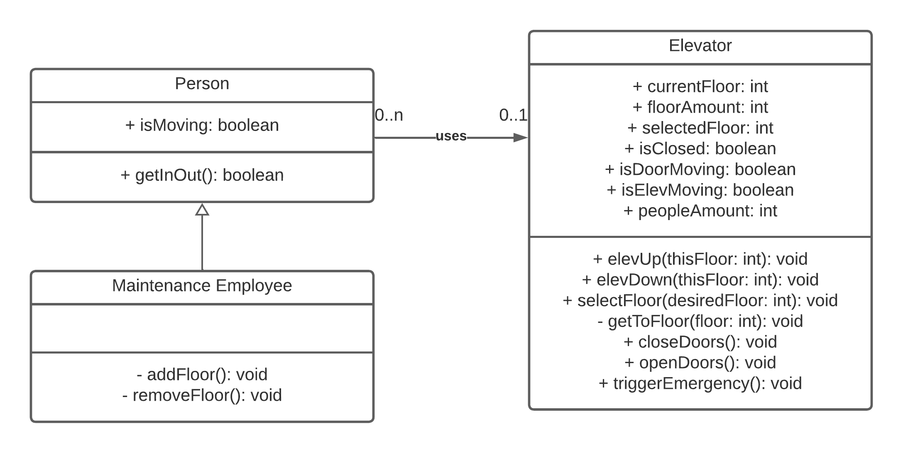
Figure 3.1.1 Class Diagram.

Class: Person
Attribute | Type | Visibility | Description
isMoving | int | public | Variable to store the movement detection in a passenger
Method | Visibility | Entry parameters |  | Return values |  | Description
Method | Visibility | Type | Name | Type | Name | Description
getInOut | public | NA |  | bool | Value of the passenger | Returns the value of the passenger in the elevator
Figure 3.1.2 Person Class Dictionary.

Class: Maintenance Employee
Attribute | Type | Visibility | Description
NA | NA | NA | NA
Method | Visibility | Entry parameters |  | Return values |  | Description
Method | Visibility | Type | Name | Type | Name | Description
addFloor | private | NA |  | NA |  | Adds a floor to the elevator configuration internally.
removeFloor | private | NA |  | NA |  | Removes a floor to the elevator configuration internally.
Figure 3.1.3 Maintenance Employee Class Dictionary.

Class: Elevator
Attribute | Type | Visibility | Description
currentFloor | int | public | Number of the current floor the elevator is located in.
floorAmount | int | public | Number of floors in the elevator configuration.
selectedFloor | int | public | Destination floors the elevator is directed to when moving.
isClosed | bool | public | Boolean value to determine if the door is closed.
isDoorMoving | bool | public | Boolean value to determine if the door is moving.
isElevMoving | bool | public | Boolean value to determine if the elevator is moving.
peopleAmount | int | public | Amount of people in the elevator currently.
Method | Visibility | Entry parameters |  | Return values |  | Description
Method | Visibility | Type | Name | Type | Name | Description
elevUp | public | Int | thisFloor | NA |  | Method to ask the elevator up.
elevDown | public | Int | thisFloor | NA |  | Method to ask the elevator down.
selectFloor | public | Int | desiredFloor | NA |  | Method to select the destination floor in the elevator.
getToFloor | private | Int | floor | NA |  | Method to move the elevator to a floor.
closeDoors | public | NA |  | NA |  | Method to close the elevator's doors.
openDoors | public | NA |  | NA |  | Method to open the elevator's doors.
triggerEmergency | public | NA |  | NA |  | Method to trigger the emergency state in the elevator.
Figure 3.1.4 Elevator Class Dictionary.

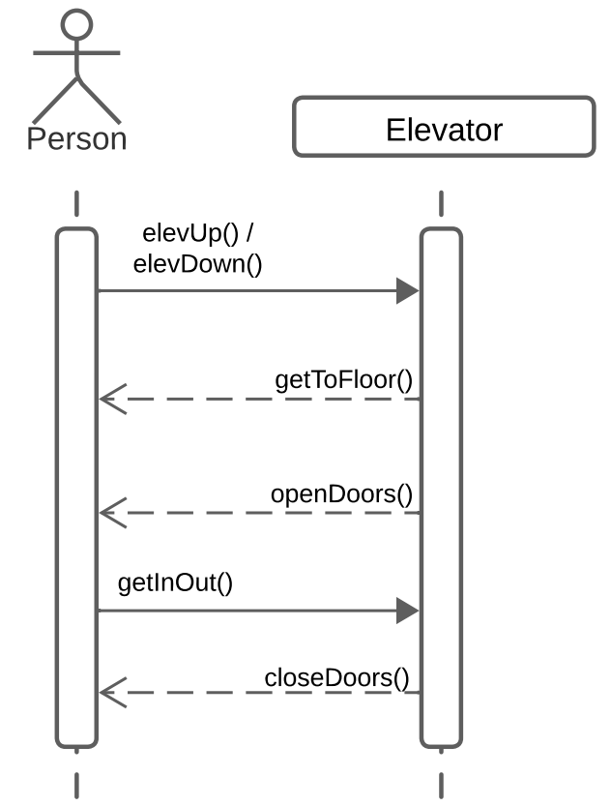
Figure 3.1.5 Request Elevator Up/Down Sequence Diagram.

Description:
Initially, the person initiates the interaction by pressing Request Up or Request Down button to call the elevator. Upon receiving this request, the elevator entity processes the request and moves accordingly, either ascending or descending to the requested floor. Once it has arrived at the designated floor, the elevator opens its doors and people either get in or out of the elevator. After a while the elevator closes its doors and waits for instructions.

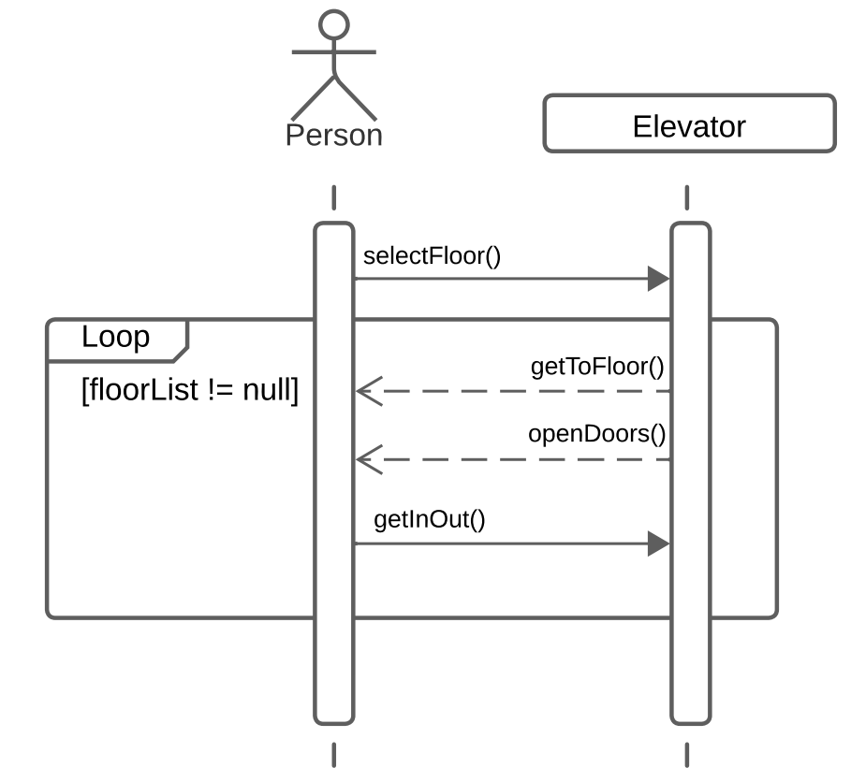
Figure 3.1.6 Select Floor Sequence Diagram.

Description:
When floors are added to the floor list the elevator will move to the floors in the order they were added to the list, upon arriving at the floor it will open its doors and wait for people to either get in or out of the elevator, then it will close its doors and move onto the next floor until no more floors remain on the floor list.

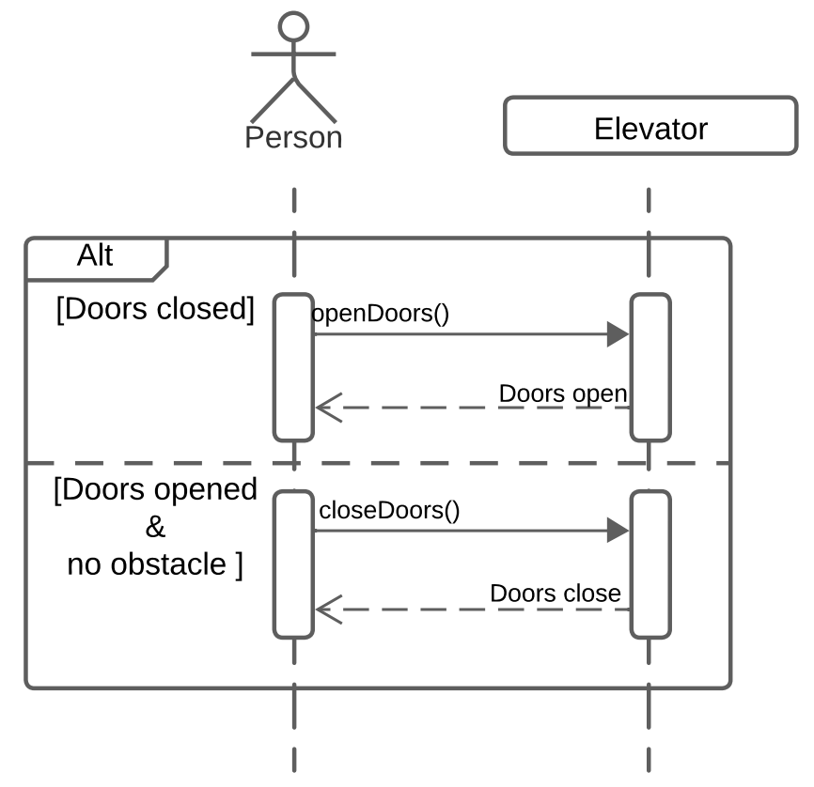

Figure 3.1.7 Open/Close Door Sequence Diagram.

Description:
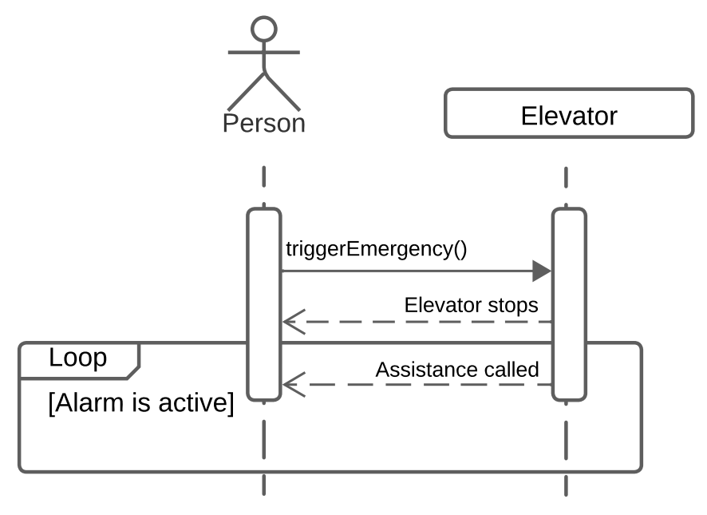
The person can explicitly command the elevator to open its doors using the Open Doors button which sends an “openDoors” message to the elevator. If the elevator is stationary, it complies with the request, opening its doors for a brief duration before automatically closing them. Similarly, the person can command the elevator to close its doors using the Cloose Doors button which sends the “closeDoors” message to the elevator, ensuring the doors are securely shut before the elevator resumes operation.

Figure 3.1.8 Trigger Emergency Sequence Diagram.

Description:
In the event of an emergency, the person can activate the “triggerEmergency” message by pressing the Emergency button, prompting the elevator to cease movement and call for assistance.

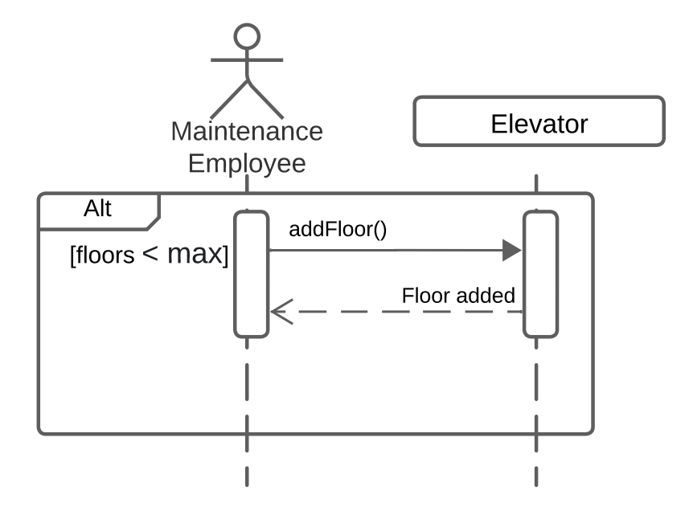
Figure 3.1.9 Add Floor Sequence Diagram.

Description:
The maintenance employee can interact with the elevator to modify its configuration. They can add a new floor to the system using the Add Floor button which sends the “addFloor” message to the elevator, adding a new floor to the system.

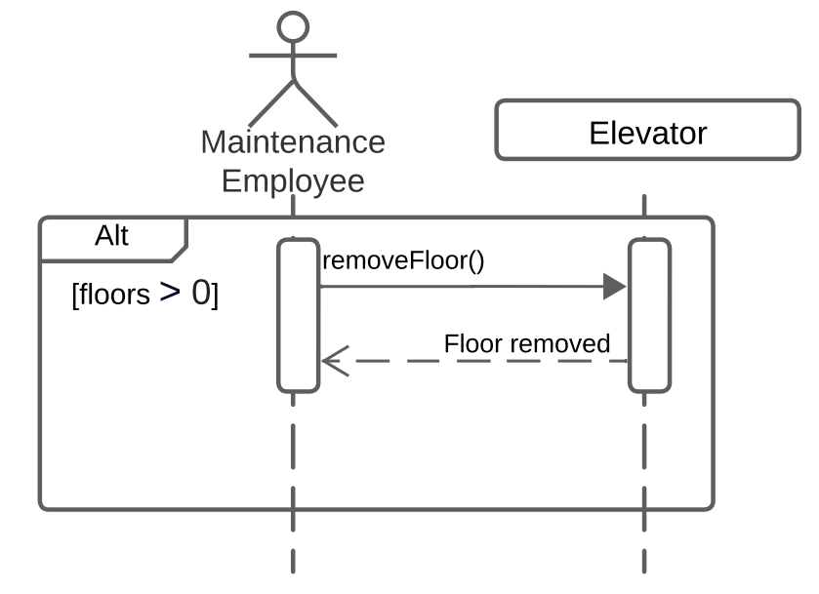
Figure 3.1.10 Remove Floor Sequence Diagram.

Description:
Likewise, the maintenance employee can remove a floor from the system using the Remove Floor button which sends the “removeFloor” message to the elevator, removing a floor from the system if its valid to do so.

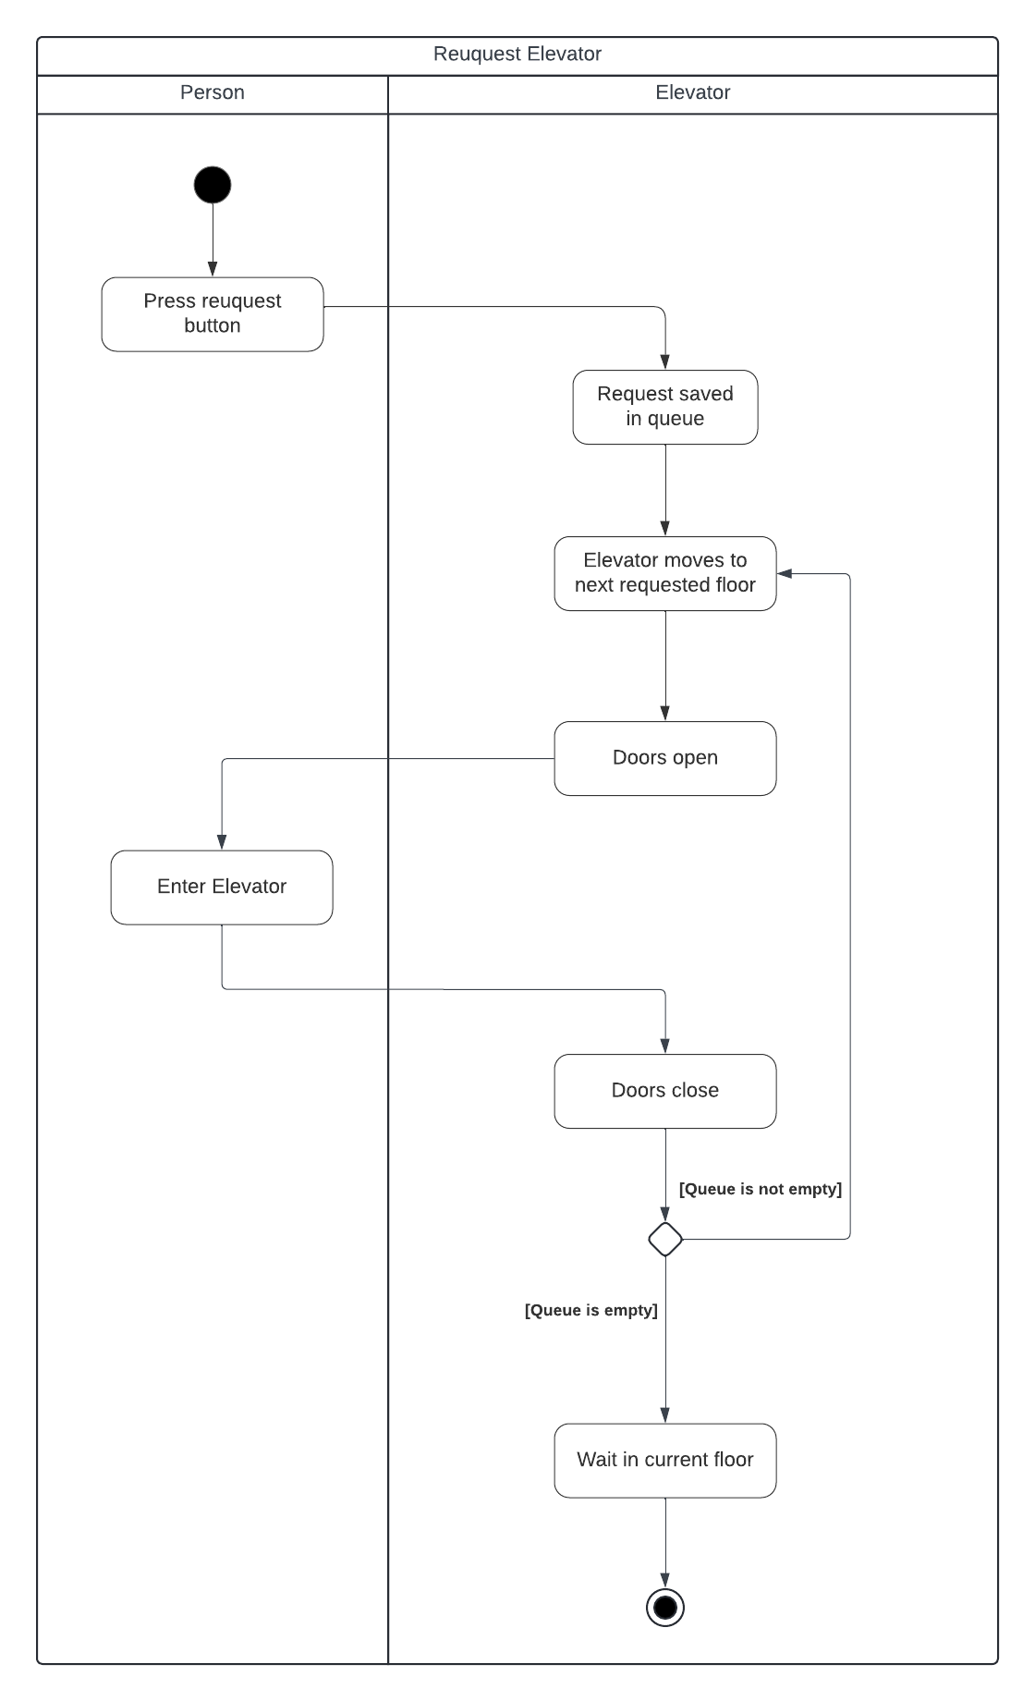

Figure 3.1.3 Request Elevator Activity Diagram.

<Don’t really say “System Feature 1.” State the feature name in just a few words.>
3.1.1 Description and Priority
<Provide a short description of the feature and indicate whether it is of High, Medium, or Low priority. You could also include specific priority component ratings, such as benefit, penalty, cost, and risk (each rated on a relative scale from a low of 1 to a high of 9).>
3.1.2 Stimulus/Response Sequences
<List the sequences of user actions and system responses that stimulate the behavior defined for this feature. These will correspond to the dialog elements associated with use cases.>
3.1.3 Functional Requirements
<Itemize the detailed functional requirements associated with this feature. These are the software capabilities that must be present in order for the user to carry out the services provided by the feature, or to execute the use case. Include how the product should respond to anticipated error conditions or invalid inputs. Requirements should be concise, complete, unambiguous, verifiable, and necessary. Use “TBD” as a placeholder to indicate when necessary information is not yet available.>

<Each requirement should be uniquely identified with a sequence number or a meaningful tag of some kind.>

REQ-1:
REQ-2:

System Feature 2 (and so on)

External Interface Requirements

User Interfaces
A typical modern passenger elevator for a building can have multiple components for different functions. The hardware can vary for each context so the simulation will take in account the most important aspects. The required components that are relevant to the problem of the elevator in this software are the following:
- Buttons outside the elevator: Buttons to make a call from any floor and the specified direction (signaled by an arrow or triangle). Top and bottoms floors only have a down and up button respectively. They should send signals to the elevator for it to attend to.
- Empty space inside: Space to stay as the elevator moves. This is where passengers must stay while it is on normal functioning.
- Overload sensor: Prevents the elevator from moving until the excess load is removed.
- Air conditioning: System that allows air to get inside and outside the elevator.
- Control Panel: A panel with buttons for the distinct functions of the elevator. The buttons are detailed in a separate list below.
- Sets of doors: Doors to keep the passengers in or out while the elevator is moving.
- Door sensors: Sensors that allow the door to detect if there is nothing that could obstruct closing. They should detect moving objects and static objects on the door’s way.
- Telephone: Device that can allow a trapped passenger to call for help if an accident occurs. It should be connected to a local emergency system or the security system of the building.
- Restricted panel: A panel which can only be opened with a key or code that can allow the technicians to repair or see the state of the elevator.
- Walls: Walls that restrict the passengers from leaving or entering by unexpected ways.
- Speaker: A speaker to make defined sounds when entering or leaving a floor or to notify the elevator state. It can also be used to reproduce alarms in case of emergency.
The elevator as addressed in the control panel should have buttons that make it move to the passengers desired destination. The panel should be inside and be the only way that the passengers must interact with the elevator. The buttons on the panel are listed and detailed as follows:
- Floor number button: There should be a button for each floor on the building for the passengers to be able to choose their desired destination. It should send a signal for the elevator to move if the current direction matches with it.
- Emergency or call button: A button should be present to report any anomalies by a trapped passenger. Some can include a telephone that directs them to a central security system of the building.
- Door open and close buttons: There should be buttons for the passengers to manually open or close the doors when the elevator is at a floor. The buttons should make a call for the doors to close or open accordingly to the button pressed. A door should not be closed if the elevator detects an object or passenger obstructing its way. The elevator must not close when it has just opened at a floor even if the button for closing is pressed.
- Screen: A screen should detail the current floor and the direction the elevator is moving to. It can display other messages in case of anomalies or maintenance.

The user interface includes a screen where the elevator is displayed and the n-number of users that are accessing or already accessed the elevator. Simultaneously, the interface provides three additional layouts, the external control pad from the elevator in which the up and down button will be enabled if the level is neither the highest nor the lowest; in case it is, it’ll only show the down button for the highest level and the up button for the lowest one. Next, the internal control pad where a screen will show the current level and where is the elevator going after that (up or down arrow), the level buttons, the close or open door, the emergency button, and two speakers for illustration only. Finally, the master-like control pad to control the environment in which the elevator will perform its tasks (add a person to the elevator, subtract one, or cause an outage to simulate an actual emergency. For a better understanding of the user interface see Figure 4.1.1.
A5
A9
A8
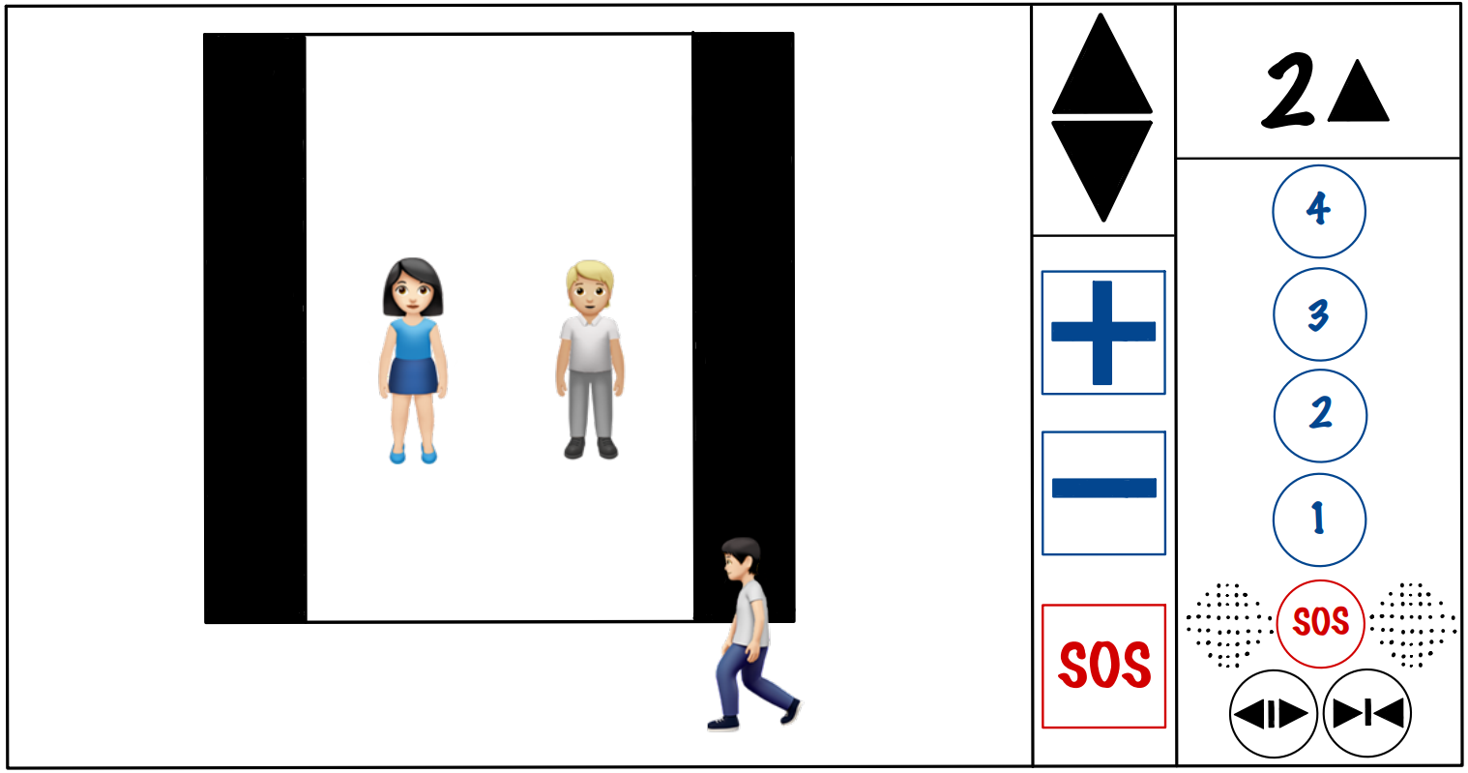
A1
A2
A3
A4
A13
A12
A11
A10
A5
A8
A9
Figure 4.1.1
A6
A7

4.1.1.1
Item | Request Elevator Up
Purpose | Requests elevator letting it know the user wants to go up
Input | Mouse click
Output | - Button light turns on.  - Elevator doors close.  - Current floor label changes.  - Elevator doors open.  - Button light turns off.
Validity | Click within the button
Error Handling | If the elevator already passed the level, it should end the current cycle and then when going up/down again, stop at that level
Relationships | None
Reference | Figure 4.1.1, item A1

4.1.1.2
Item | Request Elevator Down
Purpose | Requests elevator letting it know the user wants to go down
Input | Mouse click
Output | - Button light turns on.  - Elevator doors close.  - Current floor label changes.  - Elevator doors open.  - Button light turns off.
Validity | Click within the button
Error Handling | If the elevator already passed the level, it should end the current cycle and then when going up/down again, stop at that level
Relationships | None
Reference | Figure 4.1.1, item A2

Item | Add user to elevator
Purpose | Add one more person to the elevator
Input | Mouse click
Output | One more user on the elevator.
Validity | Click within the button
Error Handling | If the weight is too much, the elevator shouldn’t work
Relationships | None
Reference | Figure 4.1.1, item A3
4.1.1.3

4.1.1.4

Item | Subtract user from elevator
Purpose | Subtract one user from the elevator
Input | Mouse click
Output | One of all current users gets down from the elevator
Validity | Click within the button
Error Handling | If there´s no more users, the button shouldn’t work
Relationships | None
Reference | Figure 4.1.1, item A4

4.1.1.5

Item | Outage button
Purpose | Simulate an emergency scenario
Input | Mouse click
Output | An earthquake is generated in the screen
Validity | Click within the button
Error Handling | There should be no error
Relationships | None
Reference | Figure 4.1.1, item A5

4.1.1.6

Item | Open elevator
Purpose | Opens elevator’s doors
Input | Mouse click
Output | The doors begin to open
Validity | Click within the button
Error Handling | If there was a process beginning to start, but the button is triggered, the action stops only if the elevator is at a floor level, if not, the process continues
Relationships | None
Reference | Figure 4.1.1, item A6

4.1.1.7

Item | Close elevator
Purpose | Closes elevator’s doors
Input | Mouse click
Output | The doors begin to close
Validity | Click within the button
Error Handling | If there was a person entering the elevator, the doors should stop and reopen
Relationships | None
Reference | Figure 4.1.1, item A7

4.1.1.8

Item | Emergency button
Purpose | Calls the maintenance of the building because the elevator isn´t working as it should
Input | Mouse click
Output | The speakers begin to sound as if they were calling someone in charge
Validity | Click within the button
Error Handling | There should be no error
Relationships | None
Reference | Figure 4.1.1, item A8

4.1.1.9

Item | Select first floor
Purpose | Command the elevator to go to the first floor
Input | Mouse click
Output | - Button light turns on.  - Elevator doors close.  - Current floor label changes.  - Elevator goes to first requested floor on queue.  - Elevator doors open.  - Button light turns off.
Validity | Click within the button
Error Handling | If there were previous commands, the elevator should check and put the floor in order with the previous commands, if not, it can restart the cycle going to that floor directly.
Relationships | None
Reference | Figure 4.1.1, item A9

4.1.1.10

Item | Select second floor
Purpose | Command the elevator to go to the second floor
Input | Mouse click
Output | - Button light turns on.  - Elevator doors close.  - Current floor label changes.  - Elevator goes to first requested floor on queue.  - Elevator doors open.  - Button light turns off.
Validity | Click within the button
Error Handling | If there were previous commands, the elevator should check and put the floor in order with the previous commands, if not, it can restart the cycle going to that floor directly.
Relationships | None
Reference | Figure 4.1.1, item A10

4.1.1.11

Item | Select third floor
Purpose | Command the elevator to go to the third floor
Input | Mouse click
Output | - Button light turns on.  - Elevator doors close.  - Current floor label changes.  - Elevator goes to first requested floor on queue.  - Elevator doors open.  - Button light turns off.
Validity | Click within the button
Error Handling | If there were previous commands, the elevator should check and put the floor in order with the previous commands, if not, it can restart the cycle going to that floor directly.
Relationships | None
Reference | Figure 4.1.1, item A11

4.1.1.12

Item | Select fourth floor
Purpose | Command the elevator to go to the fourth floor
Input | Mouse click
Output | - Button light turns on.  - Elevator doors close.  - Current floor label changes.  - Elevator goes to first requested floor on queue.  - Elevator doors open.  - Button light turns off.
Validity | Click within the button
Error Handling | If there were previous commands, the elevator should check and put the floor in order with the previous commands, if not, it can restart the cycle going to that floor directly.
Relationships | None
Reference | Figure 4.1.1, item A12

4.1.1.13

Item | Screen
Purpose | Show the user information about the elevator’s cycle (shows the current floor represented with a number and the current orientation represented with an up/down arrow). If there’s an outage the screen should say so (assuming it has electricity after the outage) and if the A8 button is pressed, the screen should say (calling assistance)
Input | (Not by the user) Current floor from the cycle and current orientation
Output | Floor and orientation, outage or assistance messages
Validity | N/A
Error Handling | There should be no error
Relationships | None
Reference | Figure 4.1.1, item A13

Hardware Interfaces
<Describe the logical and physical characteristics of each interface between the software product and the hardware components of the system. This may include the supported device types, the nature of the data and control interactions between the software and the hardware, and communication protocols to be used.>

Software Interfaces
<Describe the connections between this product and other specific software components (name and version), including databases, operating systems, tools, libraries, and integrated commercial components. Identify the data items or messages coming into the system and going out and describe the purpose of each. Describe the services needed and the nature of communications. Refer to documents that describe detailed application programming interface protocols. Identify data that will be shared across software components. If the data sharing mechanism must be implemented in a specific way (for example, use of a global data area in a multitasking operating system), specify this as an implementation constraint.>

Communications Interfaces
The FEES does not require any form of communication via internet, email, etc. It is not connected to a database to save and load information because that function is performed using locally saved files. All communication with the software is made through the GUI, including important warning and emergency messages.

Other Nonfunctional Requirements

Performance Requirements
The elevator must be efficient and fast, delivering the maximum number of people in the shortest amount of time. The complexity of each algorithm must be fast enough process the entries in seconds or O(n²) for longer amounts of data.

The most important time-consuming component of the elevator is the queue-based destination algorithm. The algorithm used in the elevator must be linear in the worst-case scenario (O(n)) ensuring the least amount of waiting time for the people using the elevator.

Safety Requirements
The elevator must be able to determine its own current state and determine possible failures as well as keep track of how long it’s been since last maintenance. Safety is the most important non-functional requirement of the elevator since its failure can cost human lives.

The elevator must never harm or let a human be harmed, it should check for door obstruction and never close if an object is detected. It must also keep closed and only open on the determined floors for it, ensuring the people inside to their destination safely.

The brakes should be in good condition as well as the emergency system attached to it. Maintenance calls should be automatically done if detected the least signs of a failure or malfunctioning in any individual physical component.

Security Requirements
The safety requirements require the elevator to not be manipulated externally by common users. The technician must have credentials to log in and be able to modify the elevator configuration.

A log must be kept with all the actions of the elevator, including the technical access, possible failures, emergencies, and normal behavior.

Software Quality Attributes
The software must be able to interact with the individual components of the elevator such as the door, brakes, engine, and screens. The data must be displayed correctly of the elevator position. The interaction with the physical parts must allow the software to move the elevator up, down, brake, open the doors and close them.

The elevator must use flexible ways to communicate with these parts, ensuring the compatibility with any elevator across different manufacturers.

Other Requirements
There were not determined any other additional requirements for the software.
Appendix A: Glossary
<Define all the terms necessary to properly interpret the SRS, including acronyms and abbreviations. You may wish to build a separate glossary that spans multiple projects or the entire organization, and just include terms specific to a single project in each SRS.>
Appendix B: Analysis Models
<Optionally, include any pertinent analysis models, such as data flow diagrams, class diagrams, state-transition diagrams, or entity-relationship diagrams.>
Appendix C: Issues List
<This is a dynamic list of the open requirements issues that remain to be resolved, including TBDs, pending decisions, information that is needed, conflicts awaiting resolution, and the like.>

