

Curriculum Vitae

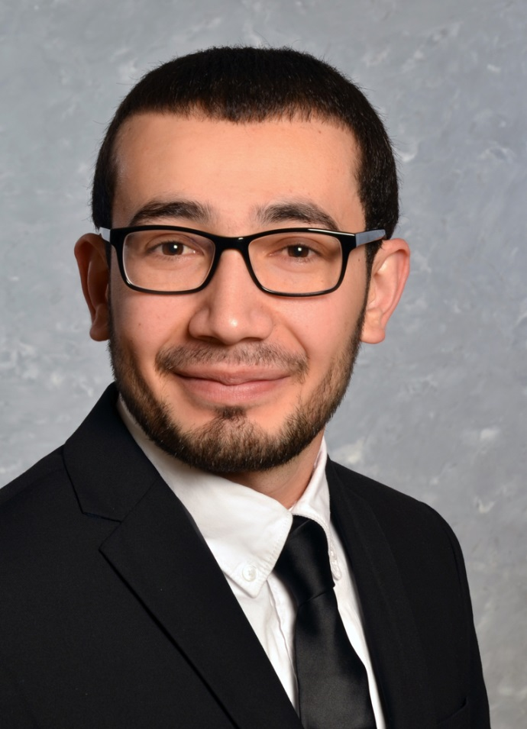


Farhod Rasulov

Curriculum Vitae
.
 | Farhod Rasulov
 | Date of Birth | 27.08.1992
 | Address: | Neuenheimer Landstr, 5
 |  | 69120 Heidelberg, Deutschland
 | Mobile | +49 175 4642 026
 | E-mail | farhod.rasulov@fzd-global.de
Project Experience
03.2024-Present | MS Fabric Consultant/Data Architect
Industry | Medical Technik
Responsibilities | Developed a Data Mesh and Datalakehouse using MS Fabric
 | Technical implementation of MS Fabric, including governance and IT workflow
 | Designed a DWH and Lakehouse using the Medallion architecture
 | Built reports and dashboards for aggregated and live data using Power BI
 | Implemented user permission concepts and data security in MS Fabric
 | Proof of Concept: IoT analytics in MS Fabric for medical devices
 | Developed an asset management tool for IT equipment using Power Apps
 | Developed a Data Mesh and Datalakehouse using MS Fabric
Tools/Technologies | Power BI, DAX, MS Fabric, Fabric Lakehouse, Pipelines, TSQL, Power Apps, Power Automate, SharePoint, Jedox
Departments Involved | IT, Controlling
10.2024 – Present | Automation and MS Power Platform Consultant
Industry | Insurance
Responsibilities | Automated project portfolio management processes
 | Developed Power Automate flows for status tracking in <100 departments
 | Built a Power Automate App for project submissions across all departments
 | Modernized centralized data collection using MS Lists
 | Created Power BI dashboards for project status and statistics
Tools/Technologies | Power BI, DAX, MS Fabric, Fabric Lakehause,, MS Lists, Power Apps
 | SQL, Grafana API, Power Automate, Share Point
Abteilung | Projekt Portfolio Management, CIO
09.2024-01.2025 | Reporting and Migration Expert
Industry | Insurance
Responsibilities | Migrated 200 Power BI dashboards to Grafana
 | Created CIO-level dashboards
 | Enabled dynamic parameterization and auto-refresh
 | Implemented row-level security in dashboards
 | Developed complex real-time SQL queries
 | Conducted training and workshops for departments
Tools & Methods | SQL, Grafana API, Power Automate, Share Point
Departments | IT, Controlling
04.2024-09.2024 | Data Architect/IoT Expert
Industry | Telecommunications
Responsibilities | Created reporting for live-streaming calls and call centers
 | Defined streaming metrics and performed performance analytics
 | Built live call dashboards using ADX and Grafana
 | Managed data lake and storage structures
 | Built forecast dashboards for aggregated call data
 | Optimized dashboard refresh performance
 | Migrated Power BI dashboards to Grafana
Tools & Methods | Power BI, ADX Cluster, Azure SQL, Grafana, Functions, ADF
 | Logic Apps, Genisys, MS Fabric, Power Automate, DAX, MQuery
Departments | Central Call Center Management, IT
08.2023-04.2024 | Power BI/Automation Consultant
Industry | Consumer Goods
Aufgaben | Developed marketing analytics reports for campaigns
 | Defined campaign KPIs and analyzed performance
 | Built pricing dashboards using data from price comparison websites
 | Conducted web scraping for campaign data from Amazon, MediaMarkt, Otto
 | Integrated data from third-party pricing websites using Python
 | Automated Python scripts and established CI/CD pipelines for developers
Tools & Technologies | Power BI, Python, Pandas, Jupyter Notebooks, Azure SQL, SSIS
 | SSAS, Web Scraping, Automatisierung, MS Fabric, Power Automate, SharePoint, Qlik Cloud,
Departments | Controlling, Marketing, Accounting, Sales
 | Sales, Marketing
01.2023-04.2024 | Cloud DWH Consultant/ BI Architekt
Industry | Packaging Industry
Responsibilities | Built cloud-based data warehouse and reporting structures
 | Integrated ERP systems from 5 countries into the DWH
 | Established cloud data governance and security policies
 | Developed custom interface monitoring systems
 | Structured data integration and storage using layer concepts
 | Migrated on-premise DWH to the cloud and SSIS to Azure Data Factory
 | Implemented single point of truth data models with SSIS
 | Connected to SAP BW, HANA, Qlik Sense
 | Migrated data models from Qlik Sense to Power BI semantic model
Tools & Technologies | Azure Data Platform, Azure SQL, MS Fabric, Qlik Sense,
 | Power BI, Azure Databricks, ADF, Power Apps & Automate, PowerShell
Departments | Controlling, Central IT, Executive Management
12.2022-06.2023 | Cloud DWH Consultant / ETL Developer
Industry | Industrial B2B Components
Responsibilities | Further developed the data warehouse and ETL pipelines
 | Monitored and expanded Azure DevOps pipelines for CI/CD
 | Created SQL scripts and ADF pipelines
 | Integrated data from various customer systems
 | Developed DWH structures in Azure Synapse (dedicated pools)
 | Integrated Power Platform and created Power Automate flows
 | Connected to systems like ProAlpha, CRM, and multiple ERPs
 | Delivered Power Platform training and workshops for users and developers
Tools & Technologies | Azure Synapse, Azure SQL, Azure Functions, Dedicated & Serverless Pools,
 | Power BI, Power Automate, ADF, MS Fabric
Departments | Purchasing, Controlling, Data Science Team, Marketing
09.2021-12.2022 | Azure Data Architect
Industry | Public Transportation
Responsibilities | Built a cloud-based data platform
 | Integrated on-premise data into the cloud
 | Established cloud data governance and security guidelines
 | Developed custom monitoring interfaces
 | Created REST API data interfaces
 | Built a document monitoring app using Power Apps & Power Automate
 | Integrated Power Platform and delivered internal IT training and workshops
 | Connected SAP BW, SAP HANA, and Cloudera to Azure Synapse
Tools & Technologies | Azure Data Platform, Azure SQL, Stream Analytics, Azure Functions, Power BI, Azure Databricks, ADF, Azure Monitor, Power Apps, XML, JSON
Departments | IT, Marketing, Data Warehouse Team, Sales
05.2021-09.2022 | Azure Data Architect / Team Lead
 | Energy
Responsibilities | Developed a cloud-based IoT and data platform
 | Integrated on-premise infrastructure with the cloud
 | Designed custom monitoring interfaces
 | Migrated on-prem DWH to Azure Synapse Analytics
 | Integrated Power Platform and held corporate workshops
 | Developed a ticket app for outage alerts using Power Apps & Power Automate
 | Served as Lead Architect for DevOps teams
Tools & Technologies | Azure Synapse Analytics, Event Hubs, Azure SQL, Stream Analytics, Power BI, Azure Databricks, ADF, Azure Monitor, Grafana, InfluxDB, XML, JSON
Departments | Central IT, Renewable Energy, Procurement, Controlling
05.2021-09.2022 | BI Architect
Industry | Retail
Responsibilities | Integrated customer data inputs into the existing BI system
 | Built and automated custom data integration pipelines
 | Developed data marts for the DACH Sales Department
 | Created reports and dashboards for sales analysis
 | Migrated legacy reports
 | Conducted workshops and training sessions for Power BI users
Tools & Technologies | Python, Power BI, Qlick Sense, MS SQL Server, Power Automate
Departments | Sales, Controlling und Marketing
01.2021 – 04.2021 | Azure Data Architect
Industry | Energie
Responsibilities | Designed technical architecture for IoT analytics in Azure
 | Delivered a Proof of Concept (PoC) in Azure Cloud
 | Implemented data pipelines and models
 | Built dashboards and monitoring tools
 | Integrated SAP BW, SAP HANA, and Cloudera with Azure
 | Provided training for Power BI dashboards and Power Apps integration
Tools & Technologies | Azure Cloud, Event Hub, Stream Analytics, Grafana, Power BI, SQL, Python, Kafka, Linux, Networking, IoT, Power Apps
Departments | Engineering, Sales
07.2020 – 12.2020 | BI Consultant
Industry | Insurance
Responsibilities | Developed BI concepts for management reporting
 | Created data models, reports, and dashboards
 | Integrated various data sources
Tools & Technologies | Cognos Analytics, Power BI Desktop, Excel, Cognos TM1
Departments | Executive Management, IT, Sales
02.2020 – 07.2020 | Power BI Trainer
Responsibilities | Provided training and coaching on
 | data modeling, reporting, and dashboarding
 | Connected various data sources
 | Delivered workshops, PoCs, and customized training sessions
Tools & Technologies | Power BI Desktop, Power BI Service, Cloud Self-Service BI
02.2020 – 06.2020 | Power BI Consultant
Industry | Real Estate
Responsibilities | Entwicklung eines Controlling Reportings
 | Developed controlling reports
 | Designed an enterprise reporting concept and architecture
 | Conducted architecture workshops and training
 | Built custom connectors to SAP BW and HANA, including SSO integration
Tools & Technologies | Power BI Desktop, Power BI Service, SAP BW, SAP HANA
Departments | Sales, Controlling
09.2019 – 12.2019 | Data Analysis Consultant
Industry | Medical Technology
Responsibilities | Built an Azure Data Lake for IoT data
 | Designed visualization concepts
 | Implemented anomaly detection ML models
 | Created visual alerting systems
Tools & Technologies | Azure Datalake, Azure Blob Storage, Azure ML, Databricks,
 | Power BI, Azure Data Factory, Python, SQL
Departments | IT, Data Management, Controlling
06.2019 – 09.2019 | Data Scientist
Industry | Insurance
Responsibilities | Developed an insurance analytics platform
 | Created predictive models for customer segmentation
 | Built ML models in Jupyter Notebooks
 | Designed dashboards and held workshops
Tools & Technologies | Jupyter Notebooks, Python, Pandas, SkitLearn, Power BI
Department | Insurance Sales
04.2019 – 08.2019 | Data Analysis Consultant
Industry | Energy
Responsibilities | Built an Azure Data Lake for IoT data
 | Designed visualization concepts with Power BI
Tools & Technologies | Power BI, Azure Data Factory, Data Bricks, Python,
 | PySpark, Azure SQL DWH, Azure Blob Storage
10.2017 – 03.2020 | IBM Cognos BI Consultant
Industry | Banking & Financial Services
Responsibilities | Developed sales management reports
 | Migrated from Cognos 10.2.1 to Cognos 11.0.13
Tools & Technologies | Cognos BI10.2.1, Framework Manager,
 | Cube Designer, Cognos Analytics 11.0.13, Motio CI,
06.2018 – 01.2019 | BI Consultant
Industry | Telecommunications
Responsibilities | Data modeling, report development, data visualization
 | Coaching and dashboard development
Tools & Technologies | Cognos Anlytics 11, Framework Manager
12.2017 - 05.2018 | IBM Cognos Consultant
Industry | Banking & Financial Services
Responsibilities | Data modeling and report development
Tools & Technologies | Cognos BI 10, Framework Manager, Oracle 11, Motio CI
University
Master
10.2015 – 08.2019 | Master Science in Computer Science: Information Systems
 | Cologne University of Applied Sciences, Gummersbach
average grade | 1,8
Focus Areas | Business Intelligence, Data Warehousing, Data Mining,
 | EAM, Analytic Applications, Performance Management
Certifications | Master of Science in Computer Science Information Systems
Bachelor
09.2011 - 10.2015 | Business informatics
technical college | University of Applied Sciences Southwest Germany, Soest
average grade | 2,1
Focus Areas | Business Management, ERP, Business Intelligence,
 | Finance & Accounting, Project Management
Certifications | Bachelor of Art in Business Administration and Informatics
Freshman Course
09.2009-07.2011 | Economic management
Institution | Tashkent Technical University, Taschkent
Focus Areas | Business Management, Finance, Business IT
IT knowledge
BI Applications | Power BI, Cognos BI, Cognos Analytics, Tableau, Grafana. SQL, DWH
Data Analytics | Azure Synapse Analytics, Influx DB, Azure Data Lake, Azure Data Explorer
 | Databricks, Azure Data Factory, Kafka, IoT Hubs, Event Hubs
Cloud Platforms | Azure Data Platform, Azure Synapse Analytics, MS Fabric
Programming Languages | SQL, Python, JavaScript, Bash
Certifications | Azure Solution Architect
 | Azure Data Engineering Associate
 | Azure Administrator Associate
Languages
Uzbek | Native
Englisch | Fluent
German | Fluent
Russian | Good
Turkish | Good
Key Attributes | Team player, creative, quick learner, digital enthusiast
Hobbies & Sports | Chess, Football, Handball, Kickboxing, Surfing, Tennis

