PAMS Frequently Asked Questions

## How do I get my username and password?

The first time you access PAMS, you will need to receive a username and password. To request one, send an email to [PAMSHelp@state.gov](mailto:CTPrograms@msi-inc.com). (CTHelp)

## How do I reset my password?

If you forget your password, email [PAMSHelp@state.gov](mailto:CTPrograms@msi-inc.com) with your username to request a new password.

## Why does my browser have to be Google Chrome?

Certain features of PAMS are not compatible with Microsoft Internet Explorer and other web browsers. In order to ensure compatibility across all systems, Google Chrome should be used when accessing PAMS.

## I can’t find the tabs I’m looking for, where are they?

Different user classes have different amounts of access to areas in PAMS. If you are unable to access an area or page you should have access to, you may have the wrong role associated with your account. Please contact the systems administrator.

## How do I contact support for PAMS?

If you have any issues with the PAMS that are not addressed in this FAQ or if you encounter system errors, please submit your question via email to [PAMSHelp@state.gov](mailto:CTPrograms@msi-inc.com)

## I’m a member of the ‘Submitter’ user group, what can I do with PAMS?

Submitters have the ability to create proposals and to view their proposal status. The creator of an activity also has ‘ownership’ over it, and therefore has certain permissions – such as deleting the proposal if necessary or revising the contents of the proposal form if requested

## I’m a member of the ‘Program Reviewer’ user group, what can I do with PAMS?

You can approve proposals, upload documents, and view all other Bureau activities under the Reports tab However, you cannot create any proposals.

## I’m a member of the ‘Submitter/Program Reviewer’ user group, what can I do with PAMS?

You have all the abilities of the ‘Program group,’ as well as the ability to create and submit proposals.

**I’m an RSI Coordinator, what can I do with PAMS?**

The RSI Coordinator reviews and decides if a proposal needs edits. If the proposal is approved, the RSI Coordinator adds comments. RSI Coordinators have access to the PAMS Reports Page.

**I’m a RAP view-only user, what can I do with PAMS?**

As a RAP view-only user, you can view all RSI proposals in the approvals process, including those that have been placed on-hold or denied, those awaiting AM/CN approval, funding mechanism, and obligation. RAP users also have access to the PAMS Reports Page.

## I’m a member of the ‘Legal’ user group, what can I do with PAMS?

You can see all proposals for the CT Bureau; Legal can pre-clear those proposals that require it. Legal only clears CNs if the funding mechanism type is MOU/IAA.

## I’m a member of the ‘Budget’ user group, what can I do with PAMS?

You can see all proposals for the CT Bureau, can clear CNs & Funding/Implementation Mechanisms, and update obligation status.

## I’m a member of the ‘CT Manager’ user group, what can I do with PAMS?

You can see all proposals for the CT Bureau, including those in-progress.

## What is my ‘Workload Summary?’

This is the screen that opens upon log-in. It lists the tasks that the user needs to complete. The content shown in your Workload Summary tab will depend on your user status, which proposals you are working on, and where the proposal is in the approval process.

For example, the ‘Submitter’ Workload Summary tab will have the ability to create new proposals and view his or her existing proposals.

## What is the AM/CN tab for?

This module of PAMS is where details for AM/CN approval are posted. AM/CN documents are drafted outside of PAMS, submitted by users, tracked by Budget and approved by Legal as well as others.

**What is a “Pivot Table”?** A pivot table is a program tool in Excel that allows you to select columns and rows of data in a [spreadsheet](http://whatis.techtarget.com/definition/spreadsheet) , to manipulate the data to generate a specific report. Simply put, to “pivot” is to turn the data to view the information from different perspectives. For convenience, specially-formatted Excel sheets have been created for users. These are available at the click of a button from the dropdown menu on the Reports page. Users can select from a variety of ready-made charts and tables that can be exported to Excel for inclusion in presentations and reports.  
  
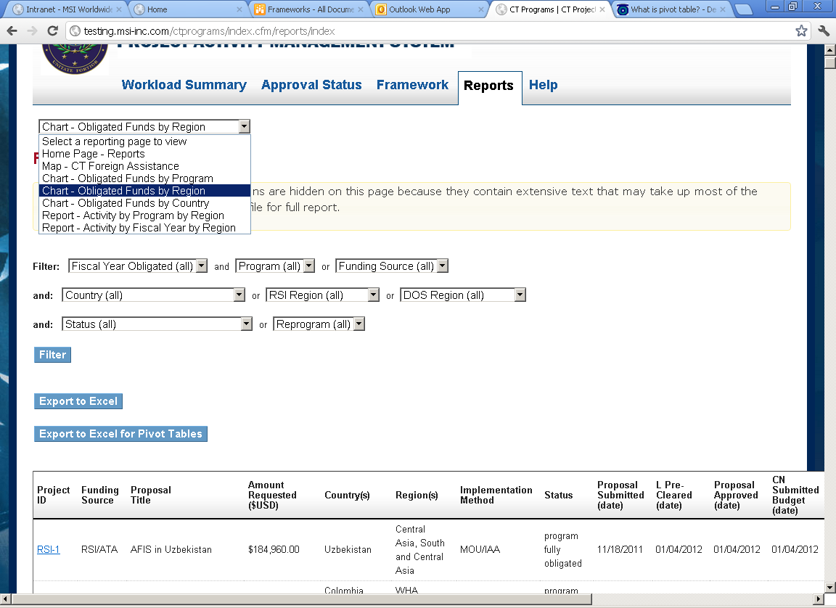

**Are Pivot Tables my only option?**

Not at all. For those users who would prefer not to use pivot tables, an “Export to Excel” button has been included that enables a user to export data into a standard Excel spreadsheet.

**I just submitted a proposal. What now?**The process that follows the submission of a proposal will vary depending on the program.

**ATA:** When the proposal has been reviewed, the Program Reviewer adds comments and either sends the proposal back to the Submitter for changes, or if the proposal is accepted, clicks on the “Approve” button – thereby moving the proposal to the CN stage or sending it to the Funding Mechanism phase.If the proposal requires a CN, the Program Reviewer prepares a CN or AM Draft (this occurs outside of PAMS), and then uploads the completed CN or AM draft to PAMS. NOTE: If field #17 was checked during the creation of the proposal, the proposal bypasses the CN process entirely and is sent directly to the Funding/Implementation Mechanism stage.

**CTF:** The proposal goes to the Program Reviewer, who either approves the proposal or sends it back for changes. Once approved, Reviewer uploads AM/CN draft and sends it to Budget. Budget modifies the draft, uploads the final CN, and updates Legal clearance status to “Pending.” Legal then updates the clearance status. Once CN is approved by Congress and Budget, the Funding/Implementation Mechanism type is set/updated. If mechanism is an MOU/IAA, Grant, or Bureau Transfer, Budget updates funding clearance status. If not, the proposal goes straight to obligation. If proposal is an MOU/IAA, it will need Funding clearance from Legal. It then goes to obligation. If a Grant or Bureau Transfer, no Funding clearance by Legal is needed, and it goes straight to obligation.

**CTE:** Same process as CTF.

**CVE:** The proposal goes to the Program Reviewer, who either approves the proposal or sends it back for changes. If approved, Program Reviewer uploads the final CN and enters the CN number. It then goes to Budget, which sets the Funding/Implementation Mechanism type. If mechanism is an MOU/IAA, Grant, or Bureau Transfer, Budget updates funding clearance status. If not, the proposal goes straight to obligation. If proposal is an MOU/IAA, it will need Funding clearance from Legal. It then goes to obligation. If a Grant or Bureau Transfer, no Funding clearance by Legal is needed, and it goes straight to obligation.

**RSI:** Once submitted, proposal is sent to the RSI Coordinator for edits and approval. Proposal is sent to Program Reviewers, who decide on edits and then send it to Regional for review and notes. If approved, proposal goes to Legal for pre-clear. It then goes back to the Program Reviewer for final approval. Once approved, Reviewer uploads AM/CN draft and sends it to Budget. Budget modifies the draft, uploads the final CN, and updates Legal clearance status to “Pending.” Legal then updates the clearance status. Once CN is approved by Congress and Budget, the Funding/Implementation Mechanism type is set/updated. If mechanism is an MOU/IAA, Grant, or Bureau Transfer, Budget updates funding clearance status. If not, the proposal goes straight to obligation. If proposal is an MOU/IAA, it will need Funding clearance from Legal. It then goes to obligation. If a Grant or Bureau Transfer, no Funding clearance by Legal is needed, and it goes straight to obligation.

PAMS allows you to follow your proposal using the Approval Status tracker.

**How can I incorporate a reprogram into a proposal?**

Budget users can select a box that identifies the proposal as having received/lost funding due to a reprogram. A short description of the nature of the reprogram may be added in the adjacent field. Clicking “Reprogram Funds” locks the comment box and flags the activity as a reprogram. If an activity previously declared as being fully obligated receives or loses funding, the user can change the obligated amounts by restoring the obligation status and then adjusting the obligated amounts through the “Obligate More Funds” field. Inputting a negative amount will subtract that amount from the total obligated. The amount subtracted will show up in the “Obligated Amounts” field in parentheses. Additional funding will be reflected in the “Obligated Amounts” field as well as the total obligated. A comment may be added for any funds added or subtracted.

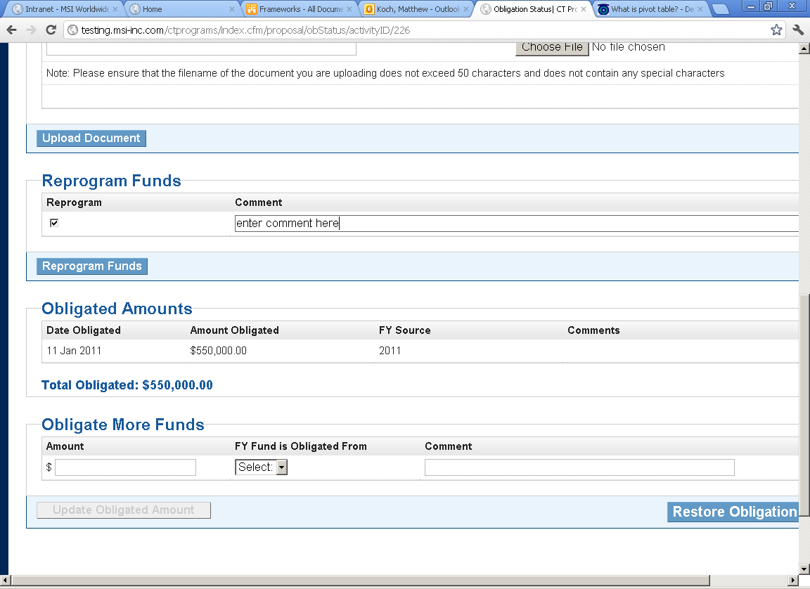

**How can I tell if a proposal has received reprogrammed funds?**

The Reports Page offers users the ability to filter for proposals that have received reprograms.

**Funds were reprogrammed to an activity/a country was dropped from an activity. How do I edit the budget breakdown to reflect these changes?**

It is the responsibility of the Program Reviewer to make changes to the budget breakdowns of activities as needed. PAMS makes it easy to edit the budget breakdown for an activity. Simply click on the obligation status page of the activity and select “edit funding breakdown.” You will see a series of dropdown menus where you can change the countries funded, the budget items, and the dollar amounts for each:

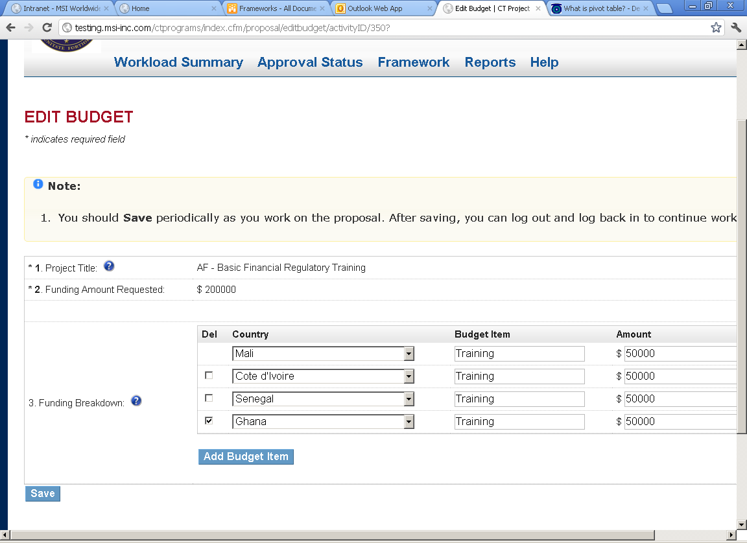

**How do I circulate a proposal for approval outside of PAMS?**Users can circulate a proposal outside of PAMS by clicking the “Export to Word” button, which will generate the proposal’s Application Review page in a Word document. This document can then be circulated to the necessary parties.  
  
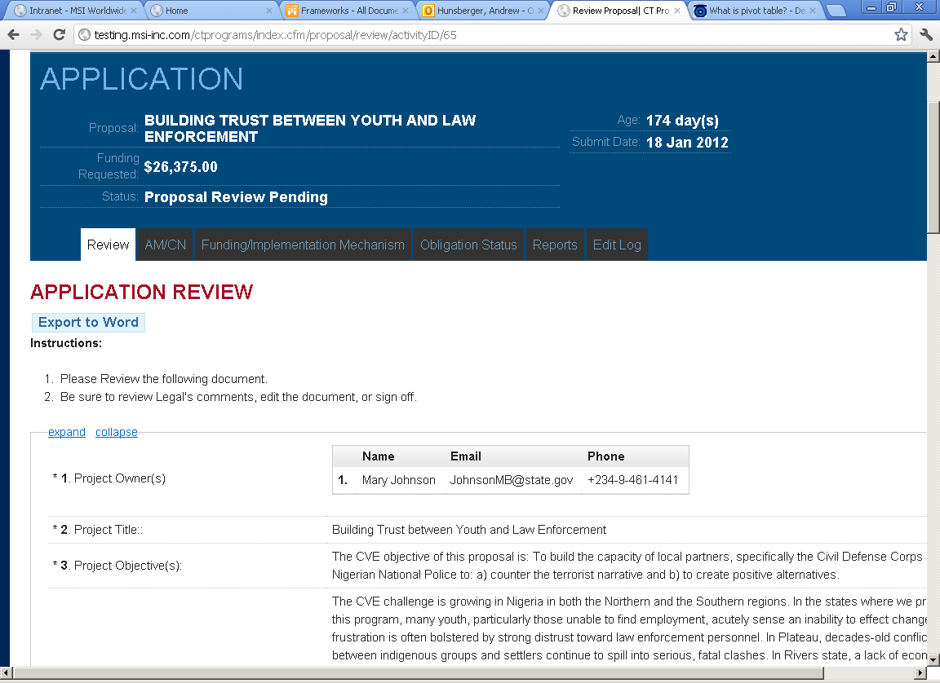

**How can I track changes and edits to proposals in the system?**

Users can track changes and edits made to an activity through the “Edit Log” tab at the top of the proposal. The edit log records when changes were made and by whom.

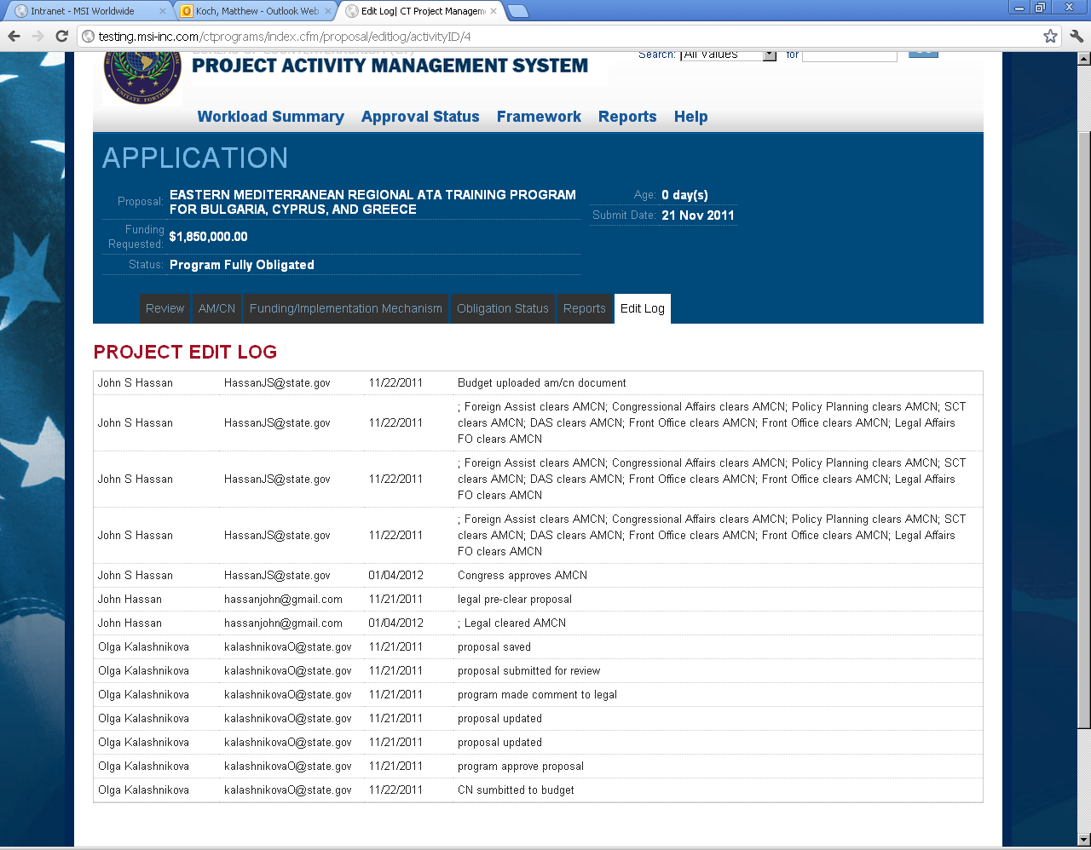

## What is the ID number next to the proposal name?

The ID number (e.g. CTE-174) is an automatically generated number used by the PAMS system for organizational purposes. Users can search for a proposal by its PAMS ID by using the dropdown menu and search box in the top right corner of every page.

**Where can I go to get answers to questions I have about PAMS?**

PAMS features a ‘Help’ tab that is accessible at the top of every page. The page is also accessible through the ‘Support’ link located in the lower right corner of every page. On the page, you will find training videos that offer a walk-through of the entire system as well as specific user roles. A CT System User Guide will also be available on the page. Any further inquiries regarding PAMS can be directed to Ms. Anne Reckitt, whose contact information is available by hyperlink.

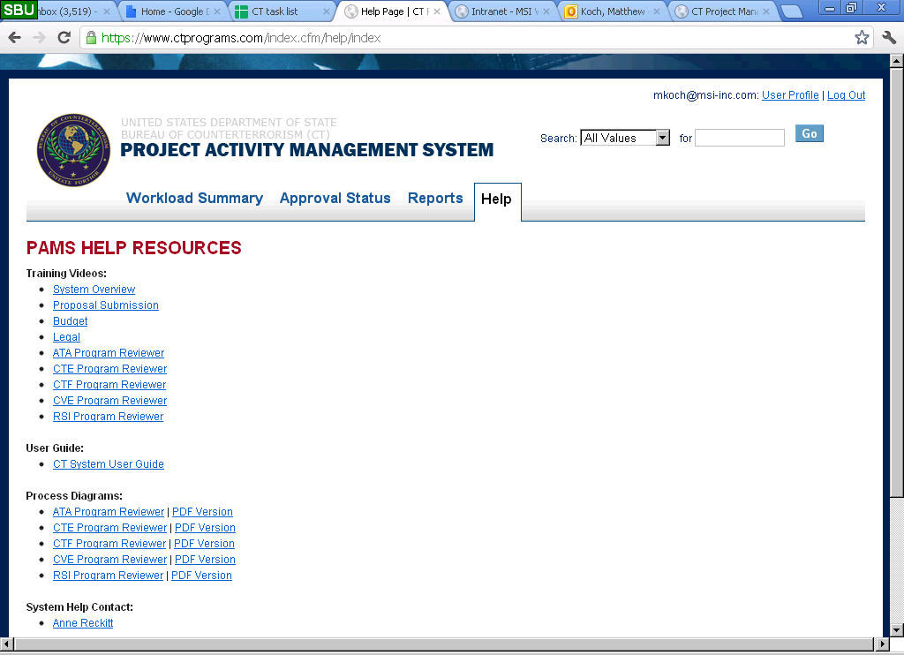

Figure 1: User Details tab

## Where can I update my name and change my password?

Users can click on the ‘User Profile’ link in the upper right-hand corner of the screen. Clicking on this link opens up a page that allows the user to change his or her password. See Figure 1.

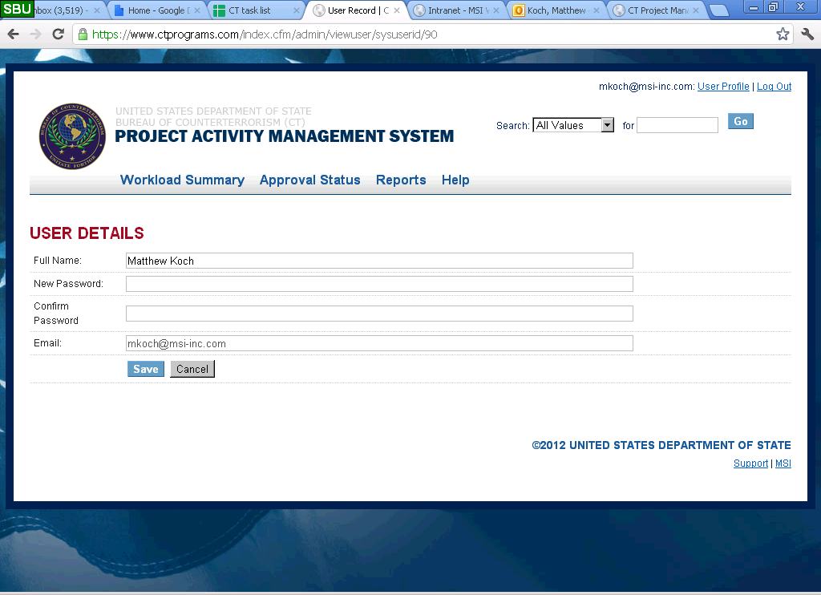

Acronym List

AM – Action Memo

AOU – Agreement of Understanding

AQM – Acquisition Management (Office)

ATA – Anti-terrorism Assistance Program

CN – Congressional Notification

CT – Bureau of Counterterrorism

CTE- Counter Terrorism Engagement

CTF - Counter Terrorism Finance

CVE- Countering Violent Extremism

IAA – Inter-Agency Agreement

MOU – Memorandum of Understanding

MSI - Management Systems International

PAMS – Project Activity Management System

PMP – Performance Measurement Plan

RBM – Results Based Management

RSI – Regional Strategic Initiative